A
Major Project
On

ENERGY AWARE ROUTING ALGORITHM FOR WIRELESS Ad-HOC NETWORKS

Submitted in Partial fulfillment of the requirement
For the award of the degree of

MASTER OF ENGINEERING
(Electronics and Communication)

Submitted by
Akash Jadhav
(University Roll No. 8531)

Under the Guidance of
RAJESH ROHILLA
(ASSOCIATE. PROFESSOR)
Department of Electronics and Communication



DEPARTMENT OF ELECTRONICS & COMMUNICATION ENGINEERING
DELHI TECHNOLOGICAL UNIVERSITY
(FORMLY DELHI COLLEGE O ENGINEERING)
BAWANA ROAD, DELHI -110042
(UNIVERSITY OF DELHI)

2007-2011
CERTIFICATE
This is to certify that the MAJOR REPORT titled as “ ENERGY AWARE ROUTING ALGORITHM FOR WIRELESS Ad-HOC NETWORKS” being submitted by AKASH JADHAV Class Roll No. 06/E&C/07, University Roll No. 8531, in partial fulfillment for the award of “Master of Engineering Degree in Electronics & Communication” in Delhi Technological University (Formly Delhi College of Engineering, Delhi University), Delhi is bonafide work carried out by him to the best of my knowledge and belief.

PROJECT GUIDE PROF.RAJIV KAPOOR
MR. RAJESH ROHILLA HEAD OF THE DEPARTNMENT
ASSOCIATE PROFESSOR DEPARTMENT OF ELECTRONICS AND
DEPARTMENT OF ELECTRONICS AND COMMUNICATION ENGINEERING
COMMUNICATION ENGINEERING DELHI TECHNOLOGICAL UNIVERSITY
DELHI TECHNOLOGICAL UNIVERSITY BAWANA ROAD ,DELHI-42
BAWANA ROAD ,DELHI-42

ACKNOWLEDGEMENT

Firstly, I would like to express my hearty gratitude and thanks to my project guide Mr. Rajesh Rohilla Associate Professor in Deptt. of Electronics and Communication Engg; D.T.U Delhi, for continuous inspiration, encouragement and guidance in every stage of preparation of this major project report.

I am also extremely thankful to Prof. Rajiv Kapoor Head of the Deptt. of Electronics and Communication Engineering, D.T.U Delhi, for the support provided by him during the entire duration of degree course and especially in this thesis.
I am also thankful to all teaching and non-teaching staff at DTU, and my fellows, who have helped me directly or indirectly in completion of this thesis report.

AKASH JADHAV
(M.E. ELECTRONICS AND COMMUNICATION ENGG.)
COLLEGE ROLL NO. 06/E&C/07
DELHI UNIVERSITY ROLL NO. 8531

Abstract

The efficient node-energy utilization in mobile ad-hoc networks has been studied because ad-hoc nodes operate with limited battery power. In ad-hoc networks, nodes perform the function of hosts as well as router as there is no existing infrastructure. Thus, when a node expires one router is lost by network. Hence, increasing network lifetime is one of the important factors in design of ad-hoc networks. Here, AODV is used for further enhancement because of its low overheads and good performance.
The AODV protocols perform routing based on the metric of least number of hops. To extend the lifetime of the ad-hoc networks, AODVEA i.e. AODV energy aware routing protocol is used which performs routing based on the metric of minimum remaining energy. In this project, an efficient AODVM i.e. AODV modified routing protocol is proposed which performs routing based on the combination of least hops and minimum remaining energy.
The performance of the proposed protocol has been examined and evaluated with the NS-2 simulator in terms of network lifetime, end-to-end delay and energy consumption. The proposed protocol gives less delay and energy consumption than AODVEA and improved lifetime than AODV.

Index

1. Introduction
1.1 Overview ………………………………………………………………... 1
1.2 Applications of ad hoc networks ………………………………………... 2
1.3 Energy conservation …………………………………………………….. 4
1.4 Report Overview ………………………………………………………… 5

2. Overview of Ad hoc Routing Protocols
2.1 Classification of Ad hoc routing protocols ………………………………. 6
2.2 Table-Driven Routing Protocols …………………………………………. 7
2.2.1 Destination Sequenced Distance Vector Protocol (DSDV) ……… 7
2.3 Source Initiated On-Demand Routing ……………………………………. 8
2.3.1 Ad Hoc On-Demand Distance Vector Routing (AODV) ………… 8
2.3.2 Dynamic Source Routing (DSR) …………………………………. 11
2.4 Table-driven vs. Source-Initiated Protocols ……………………………… 13
2.5 Comparison ……………………………………………………………….. 14

3. AODV (Ad hoc On-demand Distance Vector)
3.1. Route Request (RREQ) Message Format …………………………………. 15
3.2 Route Reply (RREP) Message Format ……………………………………. 16
3.3 Operation …………………………………………………………………... 17

4. Proposed Modification
4.1 AODVEA (AODV Energy Aware) ……………….……..………….………. 21
4.1.1 Route Request (RREQ) Message Format …………………….……... 21
4.1.2 Route Reply (RREP) Message Format ……………………………… 21
4.1.3 Operation …………………………………………………………..... 22
4.2 AODVM (AODV Modified) ……………………………………………….. 23
4.2.1 Route Request (RREQ) Message Format …………………………… 23
4.2.2 Route Reply (RREP) Message Format ……………………………… 24
4.2.3 Operation …………………………………………………………….. 25
4.3 Analysis of routing protocols ……………………………………………………. 26

5. Ns-2 simulator
5.1 Overview ………………………………………………………………………... 27
5.2 Specific support for mobile ad hoc networks …………………………………… 30

6. Results
6.1 Simulation 1 ……………………………….…………………………………. 32
6.2 Simulation 2 ……………………………….…………………………………. 36
6.3 Simulation 3 …………….……………………………………………………. 40
6.4 Simulation 4 ………………………………………………………………….. 44

7. Conclusion
  - Conclusion………………………………………………..…………………… 48
  - Future scope ……………………………………………….………………….. 49

References ……………………………………………………………….. 50

List of Figures and Formula

Figure
- Classification of Ad-hoc routing protocols ……………………………………5
- Comparison of Ad hoc routing protocols ………………………….…………13
- AODV Route Request (RREQ) Message Format …………………………....14
- AODV Route Reply (RREP) Message Format ………………………………15
- Flooding of RREQ messages …………………………………………………17
- A routing establishing flow between source and destination …………………17
- AODVEA Route Request (RREQ) Message Format …………………………20
- Route Reply (RREP) Message Format ………………………………………..21
- Route selection in AODVEA ………………………………………………….21
- AODVM Route Request (RREQ) Message Format …………………………..23
- Route Reply (RREP) Message Format ………………………………………..23

Formula
1. Calculation of Routing metric for modified AODV …………………………….25

List of Abbreviations

MANET Mobile Ad hoc networks
RREQ Route request
RREP Route reply
RRER Route error
AODV Ad Hoc On-Demand Distance Vector Routing
DSR Dynamic Source Routing
DSDV Destination Sequenced Distance Vector Protocol
AODVEA AODV Energy Aware
AODVM AODV Modified

1. Introduction

  - Overview
Ad hoc in Latin means for this. In English, it is an adjective meaning “for the particular purpose in hand or view". Mobile ad hoc networks (MANET’s) [3] are infrastructure-less networks since they do not require any fixed infrastructure, such as a base station, for their operation. An ad hoc network consists of nodes that exchange data when brought together. These mobile devices can communicate if they are in each other's radio range. The intermediate nodes forward packets from source to destination nodes when the source and destination nodes are unable to communicate directly. Each node in the network acts as both an end-host and as a router due to the limited propagation range of each node’s wireless transmission. The nodes in the network are mobile in nature where the nodes could either be identical or heterogeneous.
A typical ad hoc network consists of nodes that are usually battery-operated devices that come together and spontaneously form a network. Energy conservation is a critical issue as the lifetime of these nodes depends on the life of the system. A wireless sensor network is densely deployed with a large number of sensor nodes, each of which operates with limited battery power, while working with the self-organizing capability in the multi-hop environment. Since each node in the network plays both terminal node and routing node roles, a node cannot participate in the network if its battery power runs out. The increase of such dead nodes generates many network partitions and consequently, normal communication will be impossible as a sensor network. Thus, an important research issue is the development of an efficient batter-power management to increase the life cycle of the wireless sensor network [4].
In this project, an efficient energy aware routing protocol [6] is proposed, which is based upon the on-demand ad hoc routing protocol AODV [5, 7], which determines a proper path with consideration of node residual battery powers. The proposed protocol aims to extend the lifetime of the overall sensor network by using both hop count as well as node residual battery powers.

1.2 Applications of ad hoc networks
Ad hoc networks are specifically designed to cater to a particular application. This section discusses potential applications to motivate the reasons for deploying ad hoc networks. The essential characteristic of an ad hoc network is the ability of forming spontaneous networks between nodes that are in range of each other. This is a feature of a number of military, commercial, and social applications.

1.2.1 Military Application
Military applications require the war fighters and their mobile platforms to be able to move freely without any restrictions imposed by wired communication devices. These applications should thus be self-configuring, independent of any centralized control stations, and should be infrastructure independent in nature. These networks need to be robust in nature, i.e., they should not have a single point of failure. Ad hoc networks are thus an appropriate solution for such applications.

1.2.2 Commercial Application
The lack of infrastructure in ad hoc networks is a motivating factor for deployment in commercial applications as it reduces the cost of infrastructure investments. Ad hoc networks also have other commercial advantages due to the ease of network reconfiguration and reduced maintenance costs. Examples of commercial applications are as follows:

Collaborative Networks
A typical application of a collaborative ad hoc network can be considered a conference room with participant's wishing to communicate with each other without the mediation of global Internet connectivity. In such a scenario, a collaborative network can be set up among the participant devices. Such networks involve exchange of data between devices such as laptops, palmtops, and other information devices. Each participant can thus communicate with any other participant in the network without requiring any centralized routing infrastructure. These networks are thus collaborative in nature and are useful in cases where business network infrastructure is often missing or in scenarios where reduction in the cost of using infrastructure links is important.

Home Networks
These networks involve communications between PCs, laptops, PDAs, cordless phones, smart appliances, and entertainment systems in and around the home. Peer-to-peer communication among these devices will reduce the overhead of going through a centralized node and thus makes ad hoc networks a natural choice for implementing home networking applications.

Distributed Control Systems
Ad hoc wireless networks allow distributed control with remote plants, sensors and actuators linked together through wireless communication. These networks help in coordinating unmanned mobile units and lead to a reduction in maintenance and re-configuration costs. Ad hoc wireless networks are used to co-ordinate the control of multiple vehicles in an automated highway system, coordination of unmanned airborne vehicles, and remote control of manufacturing units.

1.2.3 Community Networks
The concept of a general purpose ad hoc network is identified as a step toward next-generation ad hoc network development. An open community network is a novel information infrastructure for local communities based on wireless multi-hopping technologies, which may support an advanced information-oriented society in the twenty-first century. A community network consists of one or more computers providing services to people using computers and terminals to gain access to those services and to each other. Community network terminals can be set up at public places like libraries, bus stations, schools, community and senior centers, social service agencies, public markets, and shopping malls. Community networks can also be accessible from home via computers and, increasingly, from the Internet. Such networks are excellent example.
This section discussed the applications of ad hoc networks that range from military applications, commercial applications, and the newly forming community networks that are considered to be next generation ad hoc networks.

  - Energy Conservation in ad hoc networks
Many of the devices described in the previous section are battery operated and thus energy constrained. For instance, a typical battery used in laptops and PDAs with wireless adapter has a lifetime of two hours. Nodes in an ad hoc network share a symbiotic relationship where each node acts as an end host as well as a router. Thus, each node carries out its individual processing as well as acts as a forwarding node, thus expending energy in processing and forwarding of packets. This reduces the lifetime of the nodes in an ad hoc network. Energy conservation is thus critical in such networks. This paper dwells on the issue of energy conservation in an ad hoc network consisting of such energy constrained devices.
Research has been carried out to conserve energy at various levels in a system; at the application level, applications have been designed that adapt on the basis of the current energy level of the system. At the operating system level, energy conservation can be brought about by switching systems to an idle or stand-by mode. Energy is conserved at the CPU level by reducing the clock speed and voltage level of the CPU. At the MAC level, schemes that power down the cards when not in use bring about energy savings. Energy can be conserved at the routing level according to by designing cross layered protocols and deploying low power routing algorithms that use power cost of the route as a metric for routing packets. The main characteristic here is to emphasize the fact that it is critical to develop energy conserving cross-layered protocols for ad hoc networks.

1.4 Report Overview
In Chapter 2, the brief description of major ad hoc routing protocols and, their comparison is provided. In Chapter 3, detail message format and operation of AODV is given. Chapter 4, describes the energy aware AODV and the proposed modified AODV. In Chapter 5, simulator NS-2 that is used for project is described. In Chapter 6 the results and graphs obtained for various simulations are shown. Chapter 7 discusses the conclusion obtained and future work that can be carried out. Chapter 8 gives the various references utilized for the project.

2. Overview of Ad hoc Routing Protocols

2.1 Classification of Ad hoc routing protocols [1]
An ad hoc network is a co-operative network of mobile nodes that communicate over a wireless medium. Ad hoc networks differ significantly from existing networks. First, the topology of the nodes in the network is dynamic. Second, these networks are self-configuring in nature and require de-centralized control and administration. Such networks do not assume all the nodes to be in the direct transmission range of each other. Hence these networks require specialized routing protocols that provide self-starting behavior. Energy constrained nodes, low channel bandwidth, node mobility, high channel error rates, and channel variability are some of the limitations in an ad hoc network. Under these conditions, existing wired network routing protocols would fail or perform poorly. Thus, ad hoc network demand specialized routing protocols. In this section, different types of ad hoc routing protocols are discussed.

Ad-hoc Routing Protocols
AODV
DSR
DSDV
Demand-driven

Table-driven

Figure 1. Classification of Ad-hoc routing protocols

Ad hoc routing protocols [2] are classified based on the manner in which route tables are constructed, maintained, and updated. They are classified as
- Table-driven
- Source initiated or demand-driven
Developed for the same underlying ad hoc network, the characteristic of these protocols differs significantly. The following sections describe the protocols and group them according to their characteristics.

2.2 Table-Driven Routing Protocols
Table driven routing protocols have basic characteristics as follows,
- Table-driven routing protocols maintain consistent, up-to-date routing information from each node to every other node in the network.
- Nodes maintain routing tables and respond to the changes in the network topology by propagating updates throughout the network in order to maintain a consistent view of the network.
The different table-driven protocols differ in the number of routing tables and the methods by which changes in the network structure are broadcast. The following sections discuss the different table-driven ad hoc routing protocol DSDV.

2.2.1 Destination Sequenced Distance Vector Protocol (DSDV) [9]
It periodically advertises a node's interconnection topology with the other nodes in the mobile ad hoc network. This protocol is a modified version of the classical Bellman-Ford [5] routing mechanism. Changes were incorporated to reduce routing loops in the face of the dynamic topology.
- Each node in the network maintains a routing table that consists of available destinations and the number of hops needed to get to each of them.
- Each entry in the route table is tagged with a sequence number that is originated by the destination node. These sequence numbers distinguish the stale routes from the new ones and thus avoid routing loops.
- Routing table updates are periodically transmitted through the network to maintain table consistency in the network.
- To help reduce the large amount of network traffic that these updates can generate, route updates employ two possible types of packets. The first is known as the full dump and they carry all available routing information. Smaller incremental packets are used to transmit the information that has changed since the last full dump.
- The mobile nodes maintain an additional table that stores the data sent in the incremental routing information packets.
Packets contain the address of the destination, the number of hops to reach the destination, the sequence number of the information received regarding the destination, as well as sequence number unique to the broadcast. The route labeled with the most recent sequence number is used. If the sequence numbers are equal, the route with a smaller metric is selected. The nodes also keep a track of the settling time of routes to allow the routes to a destination to fluctuate before the route with the best metric is received. By delaying the broadcast of a routing update by the length of the settling time, the network traffic can be reduced and optimized.

2.3 Source Initiated On-Demand Routing
This type of routing creates routes only when desired by the source node. The source node initiates a process called route discovery when it requires a route to the destination. This process is completed when a route is found or when all the possible routes are examined. The process of route maintenance is carried out to maintain the established routes until either the destination becomes unavailable or when the route is no longer required.

2.3.1 Ad Hoc On-Demand Distance Vector Routing (AODV)
The Ad hoc On-Demand Distance Vector routing protocol as described in [5, 11] is a modified version of the DSDV described in Section 2.2.1 and aims at reducing system-wide broadcasts that are a feature in DSDV. Routes are discovered on an as-needed basis and are maintained only as long as they are necessary. Each node maintains monotonically increasing sequence numbers and this number increases as it learns about a change in the topology of its neighborhood. This sequence number ensures that the most recent route is selected whenever route discovery is initiated. In addition to this sequence number, each multicast group has its own sequence number, which is maintained by a group leader. This protocol is used for unicast, multicast, and broadcast communication.
AODV uses both a unicast routing table and a multi-cast routing table. This route table is used to store the destination and next-hop IP addresses as well as the destination sequence number. Associated with each routing table entry is a lifetime, which is updated whenever a route is used. This route expires if not used within its lifetime value and is declared as invalid. The multicast routing table includes fields that are similar to the routing table except that each entry may have more than one next-hop destination associated with it. Each next-hop entry has an Activated flag and a direction. The activated flag is set when the next-hop is selected to add to the multicast tree. The direction is upstream when the communication is towards the leader and downstream when it is away from it.
The process of Route Establishment and Route Maintenance carries out routing in AODV.
Route Establishment:
- Source (S) would like to communicate with Destination (D)
- The node broadcasts a RREQ to find a route to the destination. S generates a Route Request with destination address, Sequence number and Broadcast ID and sent it to his neighbor nodes
- Each node receiving the route request sends a route back (Forward Path) to the node.
- A route can be determined when the RREQ reaches a node that offers accessibility to the destination, e.g., the destination itself.
- The route is made available by unicasting a RREP back to D and is written in the routing table from S. After receiving the route reply every node has to update its routing table if the sequence number is more recent.
- Now node S can communicate with node D.

Route Maintenance:
- Once a route has been discovered for a given source/destination pair, it is maintained as long as needed by the source node.
- Movement within the ad hoc network affects only the routes that contain those nodes.
- If the source node moves, it can re-initiate a route discovery to establish a new route to the destination.
- When a link breaks, a route error (RERR) message is sent to the affected source nodes whenever a packet tries to use the link. The node upstream initiates the route error and it lists each of the destinations that are now unreachable due to the loss of the link.
- If the upstream node of the break has one or more nodes listed as precursor node for the destination, it broadcasts the RERR to these neighbors.
- When neighbors receive the RERR, they mark the route entry as invalid and set the distance to the destination equal to infinity and in turn propagate the RERR to its precursor nodes, if any such nodes are listed for the destinations in their route tables.

An additional aspect of the protocol is the use of Hello messages which are periodic local broadcasts sent by a node to inform each node of other nodes in its neighborhood. These messages are used to maintain local connectivity of a node. Nodes listen for retransmission of data packets to ensure that the next hop is still within reach. Hello messages also list the other nodes from which a node was heard and this yields a better knowledge of the network connectivity.

Advantages
- loop free routing
- optional multicast
- reduced control overhead

Disadvantages
- delay caused by route discovery process
- bidirectional connection needed in order to detect an unidirectional link

2.3.2 Dynamic Source Routing (DSR)
The Dynamic Source Routing protocol is a simple and efficient routing protocol [8]. This protocol is composed of the two mechanisms of Route Discovery and Route Maintenance, which work together to allow nodes to discover and maintain source routes to destinations in the ad hoc network. DSR allows nodes to dynamically discover a source route across multiple network hops to any destination in the ad hoc network. Each data packet sent carries in its header the complete, ordered list of nodes through which the packet must pass, allowing packet routing information in the intermediate nodes through which the packet is forwarded. Since the source route is included in the header, other nodes hearing this transmission can cache this information in their routing table for future use.

Route discovery
- A source (SRC) broadcasts a RREQ packet in search for a path to a destination (DST)
- (SRC_ID, Request_ID) pair uniquely identifies a session request
- For any node, receiving the RREQ
  - if (SRC_ID, Request_ID) found in node’s list of recent requests, discard the RREQ; otherwise
  - Discard RREQ if node‘s address already listed in the route record in the RREQ; otherwise
  - Return a RREP to SRC if node’s address matches the DST address in RREQ (i.e., node is the DST); otherwise
  - Append node’s address to the route record of RREQ and re-broadcast it
  - Nodes forward the RREQ with the same (SRC_ID, request_ID) pair only once

Route Maintenance
- Hop-to-hop acknowledgement at Data Link layer
- Passive acknowledgement from intermediate nodes
- Application- or transport-layer ACK from DST
- Transmitting node soliciting ACK from next-hop node
- End-to-end Acknowledgement also possible
  - if some route links are asymmetric but some other route exists between SRC and DEST
  - SRC may assume only last hop is in error
- RERR sent to SRC either using cached route to source or traversing existing route in reverse direction

Advantages
- Reactive routing protocols have no need to periodically flood the network for updating the routing tables like table-driven routing protocols do.
- Intermediate nodes are able to utilize the Route Cache information efficiently to reduce the control overhead.
- The initiator only tries to find a route (path) if actually no route is known (in cache). Current and bandwidth saving because there are no hello messages needed (beacon-less).

Disadvantages
- The Route Maintenance protocol does not locally repair a broken link.
- The broken link is only communicated to the initiator.
- The DSR protocol is only efficient in MANETs with less then 200 nodes.
- Problems appear by fast moving of more hosts, so that the nodes can only move around in this case with a moderate speed.
- Flooding the network can cause collusions between the packets.
- Also there is always a small time delay at the beginning of a new connection because the initiator must first find the route to the target.

2.4 Table-driven vs. Source-Initiated Protocols
Table-driven protocols have the overhead of route updates with no regard to the frequency of forwarding packets that take place in the ad hoc network. The routing information is constantly propagated within the network. This is not the case with on-demand protocols where routing information is exchanged only when the source wishes to send some information to the destination and has no information about the destination in its route cache. On the other hand, since routing information is constantly propagated and updated in table-driven protocols, information about a particular source-destination route is always available regardless of whether or not this information is required. This feature leads to significant signaling overhead and power consumption.
Since both battery and bandwidth are scarce resources in ad hoc networks, this becomes a serious limitation. From the discussion of table-based protocols provided in Section 2.2 and on-demand protocols presented in Section 2.3, there is a conclusion that table-based protocols incur significantly high routing overhead, etc. and hence lead to increase the energy consumption compared to the on-demand protocols.
In the next section, we will discuss the research work that has been carried out to reduce energy consumption in ad hoc networks.

2.5 Comparison
The comparison of the protocols DSDV, DSR and AODV in regards to various parameters such as protocol type, average end to end delay, routing overhead, power consumption and quality of service above is given.

 | DSDV | AODV | DSR
Protocol Type | Table-driven | Demand-driven | Demand-driven
Average end to end delay | Less | High | High
Routing overhead | Less | Less | High
Power Consumption | High | Less | Less
Quality of service | Poor | Good | Good

Figure 2. Comparison of Ad hoc routing protocols

3. AODV (Ad hoc On-demand Distance Vector)

3.1. Route Request (RREQ) Message Format

Type | J | R | G | D | U | Reserved | Hop Count
RREQ ID
Destination IP Address
Destination Sequence Number
Originator IP Address
Originator Sequence Number

Figure 3. AODV Route Request (RREQ) Message Format

Type 1

J Join flag; reserved for multicast.
R Repair flag; reserved for multicast.
G Gratuitous RREP flag; indicates whether a gratuitous RREP should be unicast
to the node specified in the Destination IP Address field
D Destination only flag; indicates only the destination may respond to this RREQ
U Unknown sequence number; indicates the destination sequence number is
unknown

Reserved Sent as 0; ignored on reception.

Hop Count Number of hops from the Originator IP Address to the node handling
` the request

RREQ ID Sequence number uniquely identifying the particular RREQ when
taken in conjunction with the originating node's IP address

Destination IP Address
IP address of the destination for which a route is desired
Destination Sequence Number
Latest sequence number received in the past by the originator for any
route towards the destination

Originator IP Address
IP address of the node which originated the Route Request

Originator Sequence Number
Current sequence number to be used in the route entry pointing towards
the originator of the route request

3.2 Route Reply (RREP) Message Format

Type | R | A | Reserved | Prefix Sz | Hop Count
Destination IP Address
Destination Sequence Number
Originator IP Address
Lifetime

Figure 4. AODV Route Reply (RREP) Message Format

Type 2

R Repair flag; reserved for multicast.
D Destination only flag; indicates only the destination may respond to this RREQ

Reserved Sent as 0; ignored on reception.

Prefix Size If nonzero, the 5-bit Prefix Size specifies that the indicated next hop may
be used for any nodes with the same routing prefix as the requested
destination

Hop Count Number of hops from the Originator IP Address to the node handling
` the request

Destination IP Address
IP address of the destination for which a route is desired
Destination Sequence Number
Latest sequence number received in the past by the originator for any
route towards the destination

Originator IP Address
IP address of the node that originated the Route Request

Lifetime Time in milliseconds for which nodes receiving the RREP consider the
route to be valid.

3.3 Operation
The AODV (Ad hoc On-demand Distance Vector) protocol is an on-demand routing protocol, which accomplishes the route discovery whenever a data transfer is requested between nodes. The AODV routing protocol searches a new route only by request of source nodes. When a node requests a route to a destination node, it initiates a route discovery process among network nodes. The protocol can greatly reduce the number of broadcasts requested for routing search processes, when compared to the DSDV (Destination Sequenced Distance Vectors) routing protocol, which is known to discover the optimum route between source and destination with path information of all
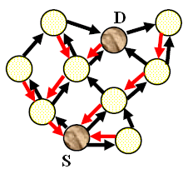
Propagation of RREQ
Reverse Route Entry

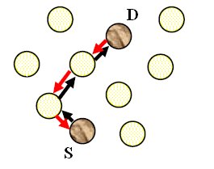
Propagation of RREQ
Reverse Route Entry

Figure 5. Flooding of RREQ messages

Figure 6. A routing establishing flow between source and destination
nodes. Additionally, since each node in the DSDV routing protocol maintains a routing table - data that includes complete route information - the AODV protocol greatly improves some drawbacks of DSR (Dynamic Source Routing) protocol such as the overhead incurred at data transfer.
Once a route is discovered in the AODV routing protocol, the route will be maintained in a table until the route is no longer used. Each node in the AODV protocol contains a sequence number, which increases by one when the location of a neighbor node changes. The number can be used to determine the recent route at the routing discovery The AODV protocol utilizes a similar routing discovery process as the DSV protocol but uses a different process to maintain and manage a routing table. The nodes of the DSV protocol maintains all routing information between source and destination but the nodes of the AODV protocol have path information in a brief routing table, which stores the destination address, destination sequence number, and next hop address.
Each entry of a routing table has a lifetime field which is set when its routing information is updated and changed. An entry will be removed from the routing table when its lifetime is expired. Moreover, to maintain a routing table, the AODV protocol periodically exchanges routing messages between neighbor nodes. Such processes typically raise significant overhead and wastes available bandwidth. However, the AODV protocol reduces the latency time of the routing discovery and determines efficient routes between nodes.
The route discovery process of the AODV protocol is similar to that of DSR. A source node broadcasts a RREQ (Route REQquest) packet to find a route to a destination node. When a neighbor node receives the RREQ packet, it rebroadcasts the packet to intermediate nodes until the packet arrives at a destination node. At the same time, the intermediate node or the destination node, which receives a RREQ packet, replies a RREP (Route reply) packet back to the source node. The destination node collects all RREQ messages during a time interval, determines a least hop-count route, and then sends a RREP message to the source node. The sequence number of a RREQ packet can eliminate a loop generation and make an intermediate nodes reply only on recent route information.
When an intermediate node forwards a RREQ packet to neighbor nodes, the receiver node records the intermediate node into the routing information in order to determine the forwarding path. Such processes repeat until arriving at the destination. Then the destination node sends a RREP message, which includes the routing, to the source via the reverse path. In the case that a node receives duplicated RREQ messages, it uses only the first message and ignores the rest. If errors occur on a specific link of the routing path, either a local route recovery process is initiated on a related node or a RERR (Route Error) message will be issued to the source for a source route recovery process. In such cases, the intermediate nodes receiving the RERR message eliminate all routing information related to the error link.
The AODV routing protocol determines a least hop-count path between a source and a destination, thus minimizing the end-to-end delay of data transfer. Since the protocol uses the shortest route for end-to-end data delivery, it minimizes the total energy consumption.
However, if two nodes perform data transfer for long time on the specific path, nodes belonging in this path use more battery power than other nodes, resulting in earlier powering out of nodes. The increase of power-exhausted nodes creates partitions in the wireless sensor network. The nodes belonging to these partitions cannot transfer any further data, thus killing the lifetime of the network.
In order to extend the lifetime of the network, one possible solution is to make equally balanced power consumption of sensor nodes. Since AODV routing mechanism does not consider the residual energy of nodes at the routing setup, and since it considers only routing hop count as a distance metric, such unbalanced node energy consumptions occurs. An efficient routing algorithm is proposed, which considers both node hop-count and node energy consumption in section 4.

4. Proposed Modification

4.1 AODVEA (AODV Energy Aware)
In AODVEA, routing is based on the metric of minimum remaining energy. The node with minimum remaining energy in the route is selected and the route having maximum minimum remaining energy is selected.

4.1.1 Route Request (RREQ) Message Format

Type | J | R | G | D | U | Reserved | Hop Count
RREQ ID
Destination IP Address
Destination Sequence Number
Originator IP Address
Originator Sequence Number
Minimum Remaining Energy ( Min-RE )

Figure7. AODVEA Route Request (RREQ) Message Format

Min-RE This field gives the node with minimum remaining energy in the route

Other parameters are as same as AODV route request.

4.1.2 Route Reply (RREP) Message Format

Min-RE This field gives the node with minimum remaining energy in the route

Other parameters are as same as AODV route request

Type | R | A | Reserved | Prefix Sz | Hop Count
Destination IP Address
Destination Sequence Number
Originator IP Address
Lifetime
Minimum Remaining Energy ( Min-RE )

Figure8. AODVEA Route Reply (RREP) Message Format

4.1.3 Operation
The source node starts communicating as soon as it receives the first valid route reply. However, once the source S receives the next route reply, it runs a algorithm, which is described as follows with reference to Figure 9.

Remaning Route chosen by AODVEA
energy level Route request

Figure 9: Route selection in AODVEA

The AODVEA protocol finds the optimal route by searching the node with the minimum remaining energy in each route reply (except the source and destination node).
In the example S has route replies for destination D. Considering an ideal environment with no congestion or packet losses, S will first receive the route reply as X!Y!D. The second route reply will be A!B!C!D. The max-min algorithm is run on both route replies. Y has the minimum energy amongst X and Y. B has the least energy among A, B, and C. The next step is to find the maximum among all the minimum energies,. So the remaining energies of Y and B are compared. Since B has a higher remaining energy than Y, the second route reply (A!B!C!D) is chosen as the optimal route to the destination. To maintain the throughput of the protocol, the data packets received before the arrival of the second route reply are not kept on hold. The max-min energy routing scheme is used for all packets that are sent after the arrival of the second route reply. In the case of disruption of the route due to any adverse conditions, the algorithm deletes the obsolete route and reinitiates the route discovery.
The algorithm explained above is as follows,
- Send a ROUTE REQUEST to neighbors.
- Get various routes available to destination.
- Compare parameters of routes with respect to remaining energy level and least count.
- Then the appropriate route for destination is selected.

4.2 AODVM (AODV Modified)
In AODVEA, routing is based on the metric of minimum remaining energy. The node with minimum remaining energy in the route is selected and the route having maximum minimum remaining energy is selected.

4.2.1 Route Request (RREQ) Message Format
The Route request message format is given below.

Energy by Hops This field gives Min-RE divided by Hop Count at the node in the
Route.

Other parameters are as same as AODVEA route request.

Type | J | R | G | D | U | Reserved | Hop Count
RREQ ID
Destination IP Address
Destination Sequence Number
Originator IP Address
Originator Sequence Number
Minimum Remaining Energy ( Min-RE )
Energy by Hops

Figure 10. AODVM Route Request (RREQ) Message Format

4.2.2 Route Reply (RREP) Message Format

Type | R | A | Reserved | Prefix Sz | Hop Count
Destination IP Address
Destination Sequence Number
Originator IP Address
Lifetime
Minimum Remaining Energy ( Min-RE )
Maximum Energy by Hops

Figure 11. AODVM Route Reply (RREP) Message Format

Energy by Hops This field gives Min-RE divided by Hop Count at the node in the
Route.

Other parameters are as same as AODVEA route request

4.2.3 Operation
The proposed protocol performs a route discovery process similar to the AODV protocol. The difference is to determine an optimum route by considering the network lifetime and performance; that is, considering residual energy of nodes on the path and hop count. In order to implement such functions, a new field, called Min-RE (Minimum Residual Energy) field, is added to the RREQ message as shown in Figure 3. The Min-RE field is set as a default value of -1 when a source node broadcasts a new RREQ message for a route discovery process.
To find a route to a destination node, a source node floods a RREQ packet to the network. When neighbor nodes receive the RREQ packet, they update the Min-RE value and rebroadcast the packet to the next nodes until the packet arrives at a destination node. If the intermediate node receives a RREQ message, it increases the hop count by one and replaces the value of the Min-RE field with the minimum energy value of the route. In other words, Min-RE is the energy value of the node if Min-RE is greater than its own energy value; otherwise Min-RE is unchanged.
Although intermediate nodes have route information to the destination node, they keep forwarding the RREQ message to the destination because it has no information about residual energy of the other nodes on the route. If the destination node finally receives the first RREQ message, it triggers the data collection timer and receives all RREQ messages forwarded through other routes until time expires. After the destination node completes route information collection, it determines an optimum route with use of a formula shown in 3.2 and then sends a RREP message to the source node by unicasting. If the source node receives the RREP message, a route is established and data transfer gets started. Such route processes are performed periodically, though node topology does not change to maintain node energy consumption balanced. That is, the periodic route discovery will exclude the nodes having low residual energy from the routing path and greatly reduce network partition.

Min-RE
α = ------------------
Hop Count

Formula 1. Calculation of Routing metric for modified AODV

The optimum route is determined by using the value of α described in Formula1. The destination node calculates the values of α for received all route information and choose a route that has the largest value of α. That is, the proposed protocol collects routes that have the minimum residual energy of nodes relatively large and have the least hop-count, and then determines a proper route among them, which consumes the minimum network energy compared to any other routes.
Here Min-RE is the minimum residual energy on the route and No-Hops is the hop count of the route between source and destination.

4.3 Analysis of routing protocols
To understand the operations of the proposed protocol, we consider three different routing protocols for operational comparison:

Case 1: Choose a route with the minimum hop count between source and destination.
(AODV routing protocol)
Case 2: Choose a route with largest minimum residual energy.
(AODVEA routing protocol)
Case 3: Choose a route with the large minimum residual energy and less hop count
i.e. with the longest network lifetime
(AODVM our proposed routing protocol)

Consider a network illustrated in Figure 12. Here consider a simple routing example to setup route from source node S to destination node D. The number written on a node represents the value of residual node energy. Consider three different cases of routes. Since the Case 1 considers only the minimum hop count, it selects route <S-B-J-D> which has the hop count of 3. In the Case-2, select route <S-A-K-F-L-H-G-D> which has Min-RE 6 is chosen because the route has the largest minimum residual energy among routes. Proposed model needs to compute the value of Min-Re by Hop count, and selects a route with largest value. Thus Case 3 selects route <S-C-E-I-D> which has largest value of (5 / 4) 1.25.

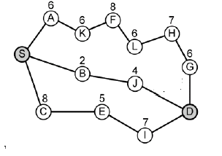`
Figure 12. A sample network for establishment of routing paths

Case 1 selects the shortest path without considering residual energy of nodes, which is the same as the AODV routing algorithm. This case does not sustain a long lifetime in the network as described. Case 2 selects a route with largest minimum residual energy to extend network lifetime but it has serious problem in terms of the hop count. Case-3 improves the drawbacks of Case 1 and Case-2 by considering both residual energy and hop count. It extends network lifetime by arranging almost all nodes to involve in data transfer. The proposed protocol also selects a route with the longest lifetime in the network without performance degradation such as delay time and node energy consumption.

- NS-2 Simulator

5.1 Overview
NS-2 [10] is the most used simulator for studies on mobile ad hoc networks, and it comes with a rich suite of algorithms and models.
The NS-2 architecture closely follows the OSI model. The network model represents the interconnection of network elements. It consists of nodes and links. Single or multiple traffic generators, including statistical generators and other typical generators such as FTP and Telnet, can be attached to any node. In addition, attaching the appropriate agents to the interested nodes simulates network and transport protocol behavior. Tcl procedures are used to provide flexible and powerful control over the simulation (start and stop events, network failure, statistic gathering and network configuration). The OTcl interpreter provides commands to create the networks topology of links and nodes and the agents associated with nodes. Implementation and simulation under NS-2 consists of 4 steps:
- Implementing the protocol;
- Describing the simulation;
- Running the simulation and
- Analyzing the generated trace files.
Implementing a new protocol requires adding C++ code for the protocol's functionality, as well as updating key NS-2 OTcl configuration files in order for NS2 to recognize the new protocol and its default parameters. The C++ code also describes which parameters and methods are to be made available for OTcl scripting. The simulation is configured, controlled and operated through the use of interfaces provided by the OTcl class Simulator. The class provides procedures to create and manage the topology, to initialize the packet format and to choose the scheduler. It stores internally references to each element of the topology. The user creates the topology using OTcl through the use of the standalone classes node and link that provide a few simple primitives. The function of a node is to receive a packet, to examine it and map it to the relevant outgoing interfaces. A node is composed of simpler classifier objects. Each classifier in a node performs a particular function, looking at a specific portion of the packet and forwarding it to the next classifier. Agents are another important type of components of a node: they model endpoints of the network where packets are constructed, processed or consumed. Users create new sources or sinks from the class Agent. NS currently supports various TCP agents, UDP, and other general protocols, including RTP, RTCP, SRM. Links are modeled either as simplex- or duplex-links with a predefined capacity, delay, and queuing discipline. In addition, links can be torn down or restored at any point in time during the simulation, simulating link failures. Links are built from a sequence of connectors objects. The data structure representing a link is composed by a queue of connector objects, its head, the type of link, the ttl (time to live), and an object that processes link drops. Connectors receive a packet, perform a function, and send the packet to the next connector or to the drop object. Various kinds of links are supported, e.g. point-to-point, broadcast, wireless. The queues are considered as part of a link.
NS-2 allows the simulation of various queuing and packet scheduling disciplines. Provided C++ classes include: drop-tail (FIFO) queuing, random early detection (RED) buffer management, CBQ (priority and round-robin), weighted fair queuing (WFQ), stochastic fair queuing (SFQ) and deficit round-robin (DRR). The user has to specify the routing strategy (static, dynamic) and protocol to be used. Supported routing features include asymmetric routing, multi-path routing, link-state and distance vector algorithms, multicast routing, and several ad hoc algorithms. New protocols can be added by specifying new agents in C++ and exposing the relevant parameters to the Tcl interpreter. In particular, OTcl is assumed to be advantageous for quick prototyping purposes. Various types of applications can be simulated. Among them are FTP, Telnet, and HTTP, which use TCP as the underlying transport protocol, and applications requiring a constant bit rate (CBR) traffic pattern, which use the UDP transport protocol. For the purpose of traffic generation NS-2 provides an exponential on/off distribution and it allows also to generate traffic according to a trace file. Packet losses are simulated by buffer overflows in routers, which is also the dominant way packets get lost in the Internet. Other packet losses are related to error models where the unit could be packet, bit or time based. Arbitrary network topologies, composed of routers, links and shared media can be defined either by listing the network nodes and edges in a topology file or using some network generators developed for NS-2 (Tiers and GT-ITM). For collecting output or trace data on a simulation NS-2 uses both traces, records of each individual packet as it arrives, departs, or is dropped at a link or queue, and monitors, record counts of various interesting quantities such as packet and byte arrivals, departures, etc., that can be associated to both packets and flows. The Network Animator (NAM), is a Tcl/Tk based animation tool that can be used for viewing NS-2 trace files for post-processing, analysis and replay of simulations (actually NAM can be used with any simulator, as long as data formats are respected).

5.2 Specific support for mobile ad hoc networks
The class Mobile Node extends the basic capability of the Node object class by adding functionalities of a wireless and mobile node like ability to move within a given topology, ability to receive and transmit signals to and from a network interface with an antenna, etc. In addition, a Mobile Node is not connected by means of Links to other nodes or mobile nodes. Mobile Node is a split object. The mobility features, including node movement, periodic position updates, maintaining topology boundaries etc. are implemented in C++, while plumbing of network components within Mobile Node itself (like classifiers, MAC, Channel, etc.) are implemented in OTcl.
The network stack for a mobile node consists of:
- a link layer,
- an address resolution protocol (ARP)module connected to the link layer,
- an interface priority queue which gives priority to routing protocol packets and supports running a filter over all packets in the queue.
- a MAC layer implementing the specifications of the standard IEEE 802.11 (as well as a single-hop preamble-based TDMA MAC protocol).
- a Tap Agent which receives, if allowed, all the packets from the MAC layer before address filtering is done.
- a network interface which serves as a hardware interface used by the mobile node to access the wireless channel.
The network interface is subject to collisions and to the radio propagation model, which, in turn, receives the packets transmitted by node interfaces to their wireless channel. The interface stamps each transmitted packet with meta-data related to the transmitting interface, like the transmission power, wavelength etc. This meta-data in the packet header is used in turn by the propagation model in receiving network interface to determine if the packet has minimum power to be received and/or captured and/or detected (carrier sense) by the receiving node. Antennas used by the mobile nodes are assumed to be omni-directional and with unity gain. Four ad-hoc routing protocols are currently supported: Destination Sequence Distance Vector (DSDV), AODV, DSR, and Temporally ordered Routing Algorithm (TORA). Nodes are designed to move in a three dimensional topology. However the third dimension is not used, therefore, the nodes are assumed to move always on a flat terrain.
Energy Model is implemented in Ns and is a node attribute. The energy model represents level of energy in a mobile host. The energy model in a node has a initial value which is the level of energy the node has at the beginning of the simulation. This is known as initialEnergy. It also has a given energy usage for every packet it transmits and receives. These are called txPower and rxPower.

6. Results

6.1 Simulation 1

Node initial energy 1.000 J
Receive Power 300 mW
Transmit Power 600 mW
Topography 670 x 670
Packet send rate 4
Number of connections 10
Pause time 600
Speed 20
Application CBR

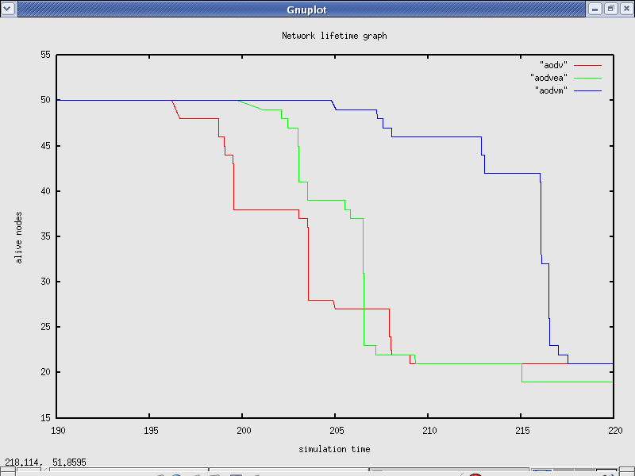

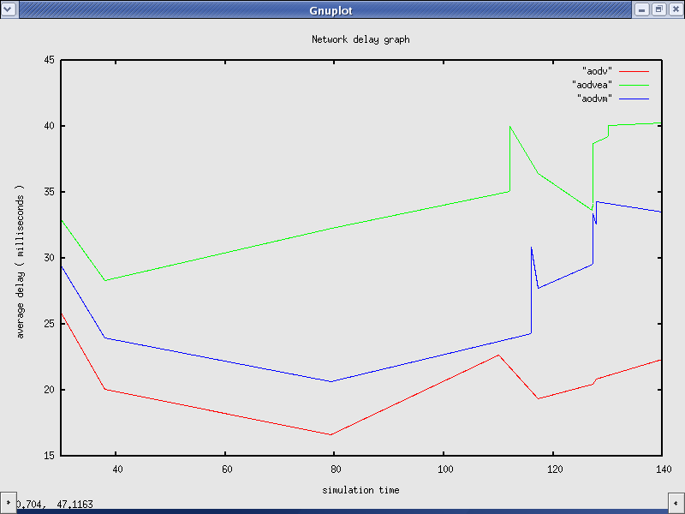

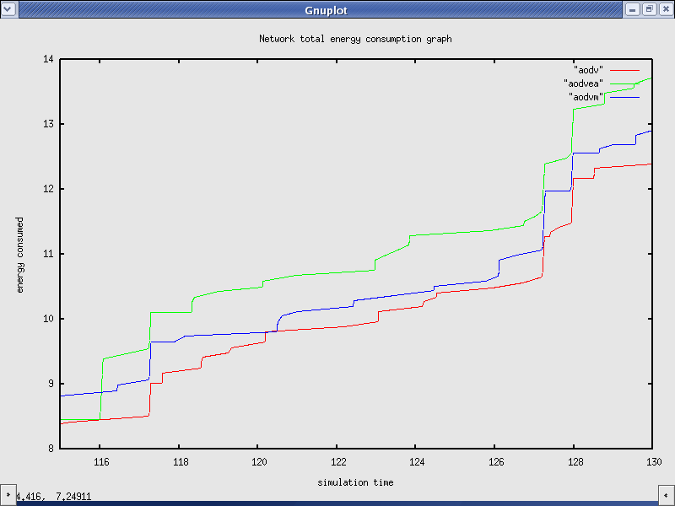

6.2 Simulation 2

Node initial energy 1.000 J
Receive Power 300 mW
Transmit Power 600 mW
Topography 670 x 670
Packet send rate 4
Number of connections 10
Pause time 600
Speed 40
Application CBR

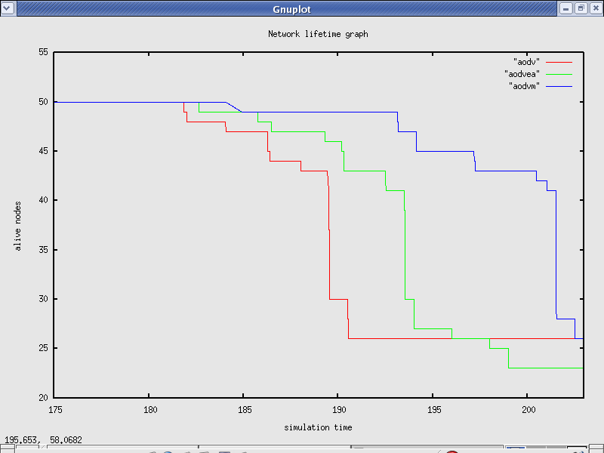

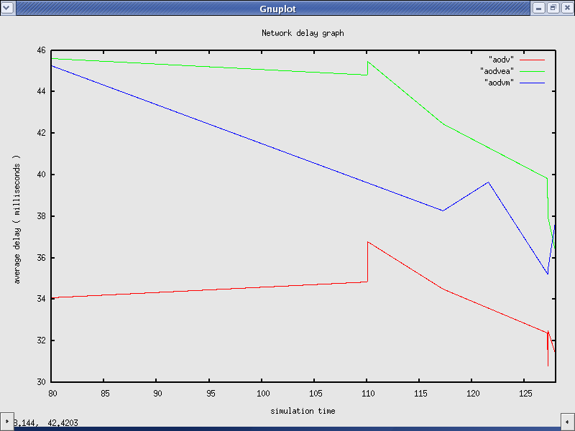
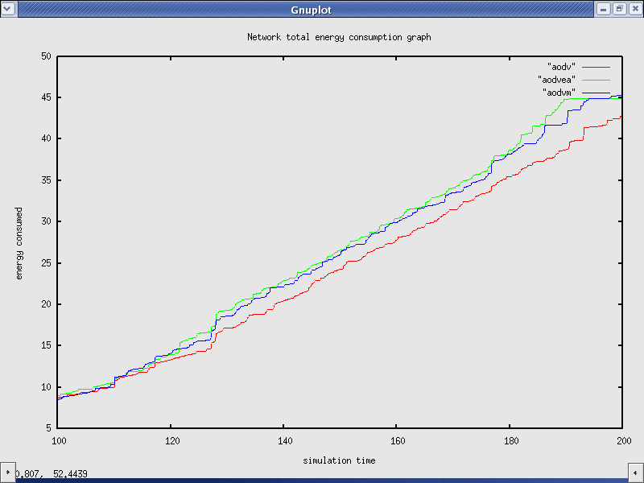

6.3 Simulation 3

Node initial energy 1.000 J
Receive Power 300 mW
Transmit Power 600 mW
Topography 670 x 670
Packet send rate 4
Number of connections 10
Pause time 600
Speed 0
Application CBR

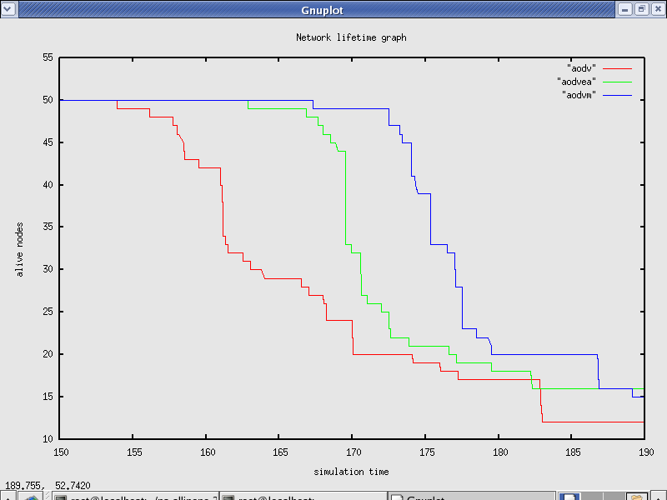
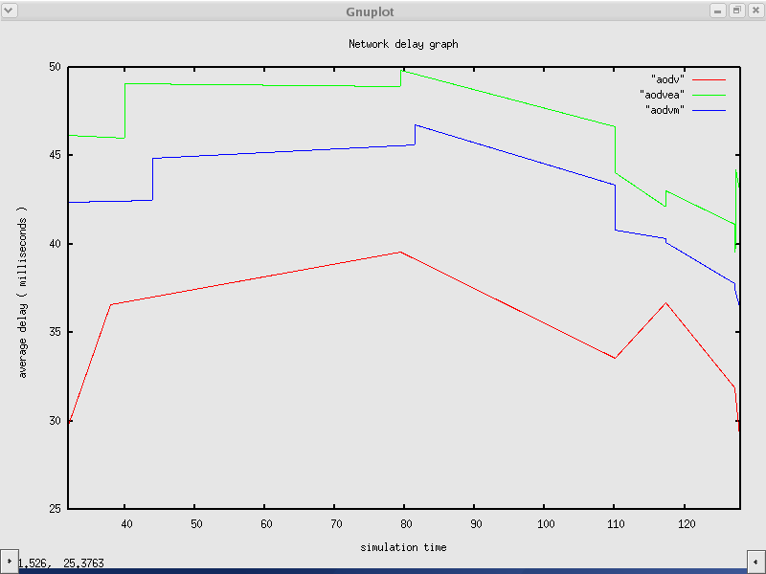
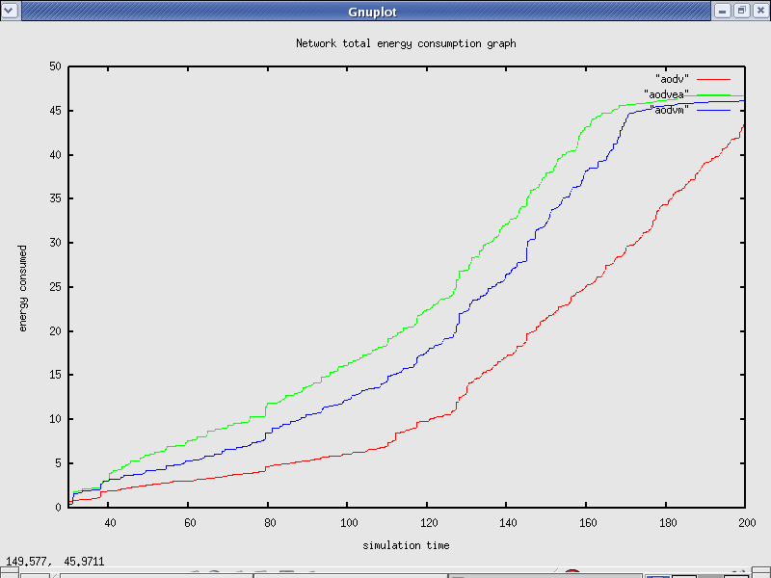

6.4 Simulation 4

Node initial energy 1.000 J
Receive Power 300 mW
Transmit Power 600 mW
Topography 670 x 670
Packet send rate 4
Number of connections 30
Pause time 600
Speed 20
Application CBR

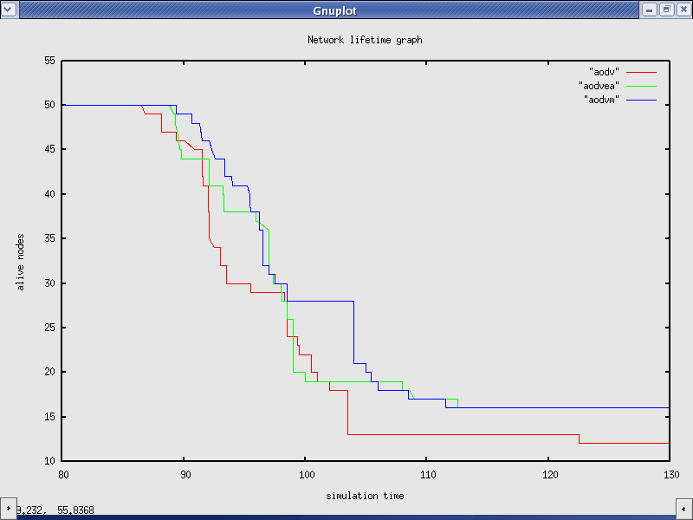
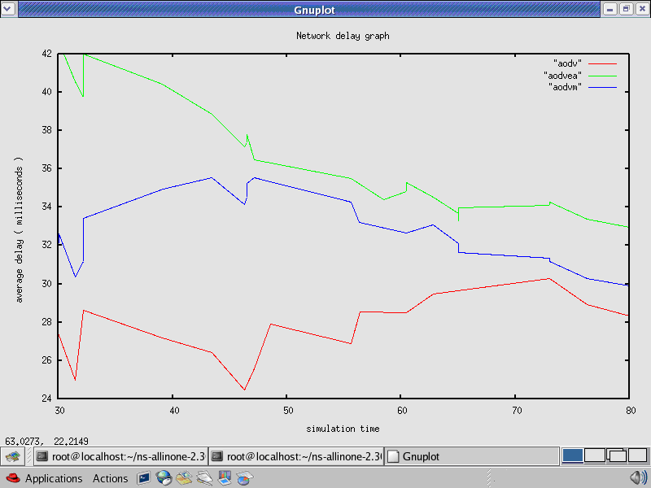
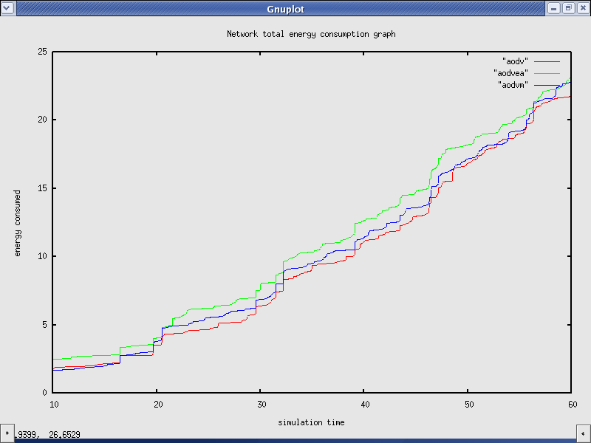

7. Conclusion

7.1 Conclusion
In this paper, the brief survey of ad-hoc routing protocols is provided .From them AODV is chosen for further enhancement. The importance of energy conservation in ad hoc routing is explained. Then the routing is done based on the metric of the remaining energy in energy aware AODV. The modified AODV performs routing based on both hop count and minimum remaining energy.
From the simulation performed for various scenarios, the following conclusions can be made.

Network Lifetime: Modified AODV has the maximum lifetime compared to Energy
aware and normal AODV.
Average Delay: Modified AODV has average delay less than energy aware AODV but
it is more than normal AODV.
Energy Consumption: AODV modified consumes less energy as compared to energy
aware AODV but it is slight more than AODV normal.

Parameters | AODV | AODVEA | AODVM
Lifetime | Minimum | Medium | Maximum
Average Delay | Less | High | Medium
Energy consumption | Less | High | Medium

Thus, AODV modified gives increased network lifetime without greatly affecting average delay and energy consumption.

7.2 Future scope
In future simulation for other parameters such as throughput, packet delivery ratio and many more can be carried out. This approach of routing using a combination of Hop count and remaining energy will give much more better performance in a long simulation time. Simulations are required to be done for it also.
Also various parameters such as link capacity can also be combined in the route selection logic.

8. References

- K. Akkaya and M. Younis, “A Survey of Routing Protocols in Wireless Sensor Networks”, in the Elsevier Ad Hoc Network Journal, Vol 3/3,pp.325-349, 2005.
- Sampo Naski, “Performance of Ad Hoc Routing Protocols: Characteristics and Comparison”, Seminar on Internetworking Sjokulla, 2004.
- Imrich Chlamtac, Marco Conti, Jennifer J.-N. Liu, “Mobile ad hoc networking: imperatives and challenges”, Ad Hoc Networks 1 (2003) 13–64.
- David B. Johnson, David A. Maltz, Yih-Chun Hu., “The Dynamic Source Routing Protocol for Mobile Ad Hoc Networks (DSR)”,. Internet Draft, IETF MANET Working Group, April 2003.
- Veena Venugopa, Radim Barto, Michael J. Carter, and Sai S. Mupparapu, “Improvement of Robustness for Ad Hoc Networks Through Energy-Aware Routing”, University of New Hampshire, Durham, NH 03824, USA,2002.
- Bor-rong Chen and C. Hwa Chang, “Mobility Impact on Energy Conservation of Ad Hoc Routing Protocols” Tufts University Medford, MA 02155, U.S.A,2001.
- C. Perkins, “Ad-hoc on-demand distance vector routing,” in MILCOM ’97 panel on Ad Hoc Networks., Nov. 1997.
- D. B. Johnson and D. A. Maltz, “Dynamic source routing in ad hoc wireless networks,” in Mobile Computing, Imielinski and Korth, Eds. Kluwer Academic Publishers, 1996, vol. 353.
- C. Perkins and P. Bhagwat, “Highly dynamic destination-sequenced distance-vector routing (DSDV) for mobile computers,” in ACM SIGCOMM’94 Conference on Communications Architectures, Protocols and Applications, 1994, pp. 234–244.
- http://www.isi.edu/nsnam/ns/.
- C. E. Perkins, E. M. Belding-Royer, and S. Das, “Ad hoc on-demand distance vector (AODV) Routing”, RFC 3561, July 2003, Category: Experimental, work in progress. http://www.ietf.org/rfc/rfc3561.txt.

