“PERFORMANCE ANALYSIS OF CI ENGINE WITH VARIOUS BLENDS OF E-DIESEL”
A Major Project Report Submitted
Towards the Partial Fulfillment of the Requirements

For the Award of the Degree

Master of Engineering
In
Mechanical Engineering
Submitted by

KRISHAN KUMAR
Class Roll no: 09/ME/2003
University: Roll No. 9023



Under the guidance
Mr. Amit Pal
Department of Mechanical Engineering
Delhi College of Engineering
University of Delhi
Delhi -110042

ACKNOWLEDGEMENT

It is great honor to express my gratitude to the Project Guide, Mr. Amit Pal, Sr. Lecturer in Mechanical Engineering Department, Delhi College of Engineering, Delhi for giving me an opportunity to work on such a valuable project, under his expert guidance. He was not only involved right from the conception of this project but also ensured availability of all necessary equipment and materials. He patiently solved all my problems and guided at each and every stage of this project. His friendly and co-operative nature along with sympathetic and encouraging attitude has been a great source of inspiration to me during this endeavor. Indeed, I am short of words to express my gratitude towards him.

I am equally beholden to our college Principal, Prof. P.B. Sharma for his magnanimous help in every possible manner and showing keen interest in the project. I received substantial inspiration, encouragement and congenial atmosphere, necessary for such academic accomplishment.

The inspiration and motivation by Professor & Head, Department of Mechanical Engineering, Dr.S. Maji, Professor & Head, Department of Training & Placement Dr.O.P.Sharma, Professor Navin Kumar, Professor Raj Kumar Singh and
all faculty members of the department, helped me a lot in timely and successfully completion of the project.

I would also thank Sh. Manmohan, Sh. Chintaram, Sh. Kamal and all my colleagues for extending their kind support and sharing their valuable time for the completion of the project.

Krishan Kumar
09/ME (Thermal)/2003

CERTIFICATE

It is certified that dissertation, entitled “Performance Analysis of Compression Ignition Engine with Various Blends of Ethanol-Diesel.” submitted by Krishan Kumar, ME Thermal Engineering student with university roll number 9023 for partial fulfillment of the requirements for the award of the degree of Master of Engineering in Mechanical Engineering, submitted in the Department of Mechanical Engineering, Delhi College of Engineering, Delhi, is an authentic record of student’s own work carried out by him under my guidance and supervision.

It is also certified that this dissertation has not been submitted for the award of any other degree or diploma in any other college/university.

Sh. Amit Pal
Sr.Lecturer
Department of Mechanical Engineering
Delhi College of Engineering, Delhi

Abstract

As energy crunch loom large, fossil fuel stocks are falling. Oil price have broken the $70 barrier per gallon. Many countries are switching to bio-fuels. The EU has decided to use 5.75% bio fuels like ethanol for motor-cars by 2010.China plans to use 10% bio- fuels by 2010.The US already produces about 10 million tones Ethanol. Interestingly, Henry Ford, the father of modern automobile was an ardent advocate of ethanol as a fuel for motor cars. He was a great believer in recycling. Presently we are using 5% ethanol blend with petrol which can be increased to 10%. When considering an alternative fuel for use in diesel engines, a number of issues are important. These issues include supply and distribution, integrity of the fuel being delivered to the engine, emissions and engine durability. The purpose of this review is to discuss the properties and specifications of ethanol blended with diesel fuel with special emphasis on the factors critical to the potential commercial use of these blends. These factors include blend properties such as stability, viscosity and lubricity, safety and materials compatibility.
The effect of the fuel on engine performance, durability and emissions is also considered. The production and research on ethanol compatible vehicles has increased in recent years with a focus on six areas of importance: the engine, engine control system, cold starting strategy, emissions control, compatible materials, and safety. This minor project report is on high energy content ethanol blends and an effort to cover all the above mentioned areas of concern.
Based on the results of trials on compression ignition engine using ethanol diesel fuel blends and its analysis, with the help of relevant literature, it can be concluded that ethanol can substitute diesel fuel partially for the existing conventional diesel engine without requiring any major engine modifications.

CONTENTS

UNIT 1: INTRODUCTION…………………………………………………1-6

1.1 Ethanol as an automobile Fuel……………………………………..2
1.2 Other Requirements of the Fuel……………………………………4
1.3 Position of India………………………………………………………6

UNIT 2: PRODUCTION OF ETHANOL ………………………………….7-30
2.1 Fermentation …………………………………………………………..10
2.2 Ethanol from Cellulose……………………………………………….. 13
2.3 Dry Milling ………………………………………………………………14
2.4 Wet Milling ……………………………………………………………..17
2.4.1 Inspection and cleaning……………………………………………. 18
2.4.2 Steeping………………………………………………………………19
2.4.3 Germ separation …………………………………………………….19
2.4.4 Fine grinding and screening ………………………………………..20
2.4.5 Starch separation…………………………………………………... .21
2.4.6 Syrup conversion …………………………………………………….21
2.5 Bio- technology Based Production …………………………………...22
2.5.1 What Is Industrial Biotechnology …………………………………...23
2.5.2 Biotech Breakthroughs……………………………………………….24
2.5.3 The First Commercial Production …………………………………..24
2.5.4 More Bio-refineries …………………………………………………..25
2.6 Yeast Growth ……………………………………………………………25
2.7 Ethanol Distillation ……………………………………………………...26
2.8 Ethanol-Diesel Blend Production………………………………………27
2.9 Formulation of ethanol diesel Blends …………………………………28

UNIT 3: Properties…………………………………………………… 31-41
3.1 Physical properties ……………………………………………………..31
3.2 Properties of Ethanol Blend…………………………………………... 32
3.2.1 Specific gravity ……………………………………………………….32
3.2.2 Kinematic Viscosity ………………………………………………….33
3.2.3 Calorific Value of fuel ………………………………………………..34
3.2.4 Flash Point…………………………………………………………….36
3.2.5 Blend stability …………………………………………………………36
3.2.6 Viscosity and lubricity ………………………………………………..37
3.3 Materials compatibility ………………………………………………...39
3.4 Energy content ………………………………………………………….40
3.5 Cetane Number…………………………………………………………40

UNIT 4:OPERATING CONSTRAINTS WITH E-DIESEL………………42-51
4.1 Vapor Lock and Cavitations……………………………………………..42
4.2 Flash Point and Vapor Pressure………………………………………..44
4.3 Solubility, Water Tolerance, and Stability………................................44

4.4 Cold Flow Properties…………………………………………………......45

4.5 Cetane number……………………………………………………………46

4.6 Lubricity…………………………………………………………………….46

4.7 Energy content…………………………………………………………….47

4.8 Pollutant Emissions……………………………………………………….48
4.9 Baseline Emissions ………………………………………………………50

4.10 Materials Compatibility………………………………………………….51

UNIT 5: TECHNIQUES OF USING ETHANOL IN CI ENGINE………….52-60

5.1 Dual-Fuel Mode……………………………………………………………53

5.2 Ignition Improvers………………………………………………………….55

5.3 Surface Ignition…………………………………………………………….56

5.4 Spark Ignition………………………………………………………………57

5.5 Catalytic Combustion……………………………………………………...58

5.5.1 Selection of Catalyst Materials…………………………………………58

5.6 Low Heat Rejection Engine……………………………………………….59

UNIT 6: MODIFICATIONS REQUIRED ……………………………………61-75
6.1 Engine Control……………………………………………………………..61
6.2 Fuel Injector………………………………………………………………..62
6.3 Spark Control………………………………………………………………63

6.4 Catalytic Igniter Concept………………………………………………....63

6.5 Surface Ignition Timing……………………………………………………65

6.6 Gas Phase Ignition Timing………………………………………………..67

6.7 Igniter Core Design………………………………………………………..68

6.8 Engine Design……………………………………………………………..69
6.9 Cold start problems and technologies…………………………………..71
6.9.1 Heat Storage Units………………………………………………………71
6.9.2 Distillation Systems……………………………………………………..72
6.9.3 Fuel Pressure Increases……………………………………………….74
6.9.4 POX Reactor…………………………………………………………….75

UNIT 7: Experimental setup, observation and evaluation of performance Characterstics……………………………………76-91
7.1 Measurement of Various Parameters…………………………………..77
7.1.1 Measurement of Power Output………………………………………..77
7.1.2 Fuel Flow Measurement……………………………………………….78
7.1.3 Smoke and Exhaust Temperature Measurement…………………..79
7.2 Engine System…………………………………………………………….80
7.3 Engine Performance Characteristics Test Procedures……………….82

7.4 Fuel Preperation…………………………………………………………..82
7.5 Theories Used in Calculating the Performance of Engine……………83
7.5.1 Brake Power Output……………………………………………………83
7.5.2 Mass Flow Rate of the Fuel…………………………………………...84
7.5.3 Brake Mean Effective Pressure……………………………………….84
7.5.4 Brake Specific Fuel Consumption (BSFC)…………………………..85
7.5.5 Brake Specific Energy Consumption…………………………………85
7.5.6 Brake Thermal Efficiency……………………………………………...85
7.6 Performance Characteristics Discussions……………………………..90

UNIT 8: SAFETY AND PERFORMANCE ASSESSMENT………………92-105
8.1 Storage and stability………………………………………………………92
8.2 Storage and handling……………………………………………………..92
8.3 Initial FMEA Risk Ranking………………………………………………..94
8.3.1 Gasoline and Diesel Ratings…………………………………………..95
8.3.2 E-Diesel FMEA Rating………………………………………………….97
8.4. Performance Assessment……………………………………………….99
8.5 Initial FMEA Performance Impact Ranking…………………………….100

UNIT 9: PAST MISTAKES AND FUTURE OPPORTUNITIES………….106-115
9.1 Ethanol-In-Diesel: Phase Behavior……………………………………..107
9.2 Vapor Lock and Cavitations……………………………………………..108
9.3 Vapor Pressure & Safety………………………………………………...108
9.4 Recent developments …………………………………………………...110
9.5 Alcohol in Diesel Engines………………………………………………..111
9.6 Ethanol-Diesel Vehicles and Road Trials at IIT Madras……………...113
9.7 Recent Advances in Alcohol Fuel Diesel Technology………………..114

CONCLUSION………………………………………………………………..116-117

REFERENCES………………………………………………………………..118-121

UNIT 1

INTRODUCTION

The global fuel crises in the 1970s triggered awareness amongst many countries of their vulnerability to oil embargoes and shortages. Considerable attention was focused on the development of alternative fuel sources, with particular reference to the alcohols. A blend of 10% dry ethanol and unleaded gasoline (E10) was commercially introduced into the US and continues to be marketed mainly in the Midwestern states. The use of ethanol blended with diesel was a subject of research in the 1980s and it was shown that ethanol–diesel blends were technically acceptable for existing diesel engines. The relatively high cost of ethanol production at that time meant that the fuel could only be considered in cases of fuel shortages. Recently the economics have become much more favorable in the production of ethanol and it is able to compete with standard diesel. Consequently there has been renewed interest in the ethanol–diesel blends with particular emphasis on emissions reductions.
An additional factor that makes ethanol attractive as a fuel extender or substitute is that it is a renewable resource. The dwindling fossil fuel sources and the increasing dependency of the USA on imported crude oil have led to a major interest in expanding the use of bio-energy. The recent commitment by the USA government to increase bio-energy three-fold in 10 years has added impetus to the search for viable bio-fuels. The European Union (EU) have also adopted a proposal for a directive on the promotion of the use of bio-fuels with measures ensuring that bio-fuels account for at least 2% of the market for gasoline and diesel sold as transport fuel by the end of 2005, increasing in stages to a minimum of 5.75% by the end of 2010. In the last two decades of the 20th century, major advances in engine technology have occurred, leading to greater fuel economy in vehicles. The reduction of emissions from engines has become a major factor in the development of new engines and manufacturers are focusing considerable energy and resources in order to meet emissions standards specified by the US Environmental Protection Agency (EPA) and by the EU. As a result the use of non-conventional fuels as a means of meeting these requirements has generated much attention.

When considering an alternative fuel for use in diesel engines, a number of issues are important. These issues include supply and distribution, integrity of the fuel being delivered to the engine, emissions and engine durability. The purpose of this review is to discuss the properties and specifications of ethanol blended with diesel fuel with special emphasis on the factors critical to the potential commercial use of these blends. These factors include blend properties such as stability, viscosity and lubricity, safety and materials compatibility. The effect of the fuel on engine performance, durability and emissions is also considered.

1.1 ETHANOL AS AUTOMOBILE FUEL

Ethanol is a clear, colorless liquid. In dilute aqueous solution, it has a somewhat sweet flavor, but in more concentrated solutions it has a burning taste. Ethanol (CH3CH2OH) is made up of a group of chemical compounds whose molecules contain a hydroxyl group, -OH, bonded to a carbon atom. Ethanol made from cellulosic biomass materials instead of traditional feedstocks (starch crops) is called bioethanol.

There has been strong demand for ethanol as an oxygenate blended with gasoline. In the United States each year, approximately 2 billion gallons are added to gasoline to increase octane and improve the emissions quality of gasoline.

Blends of at least 85% ethanol are considered alternative fuels under the Energy Policy Act of 1992 (EPAct) in U.S. E85, a blend of 85% ethanol and 15% gasoline, is used in flexible fuel vehicles (FFVs) that are currently offered by most major auto manufacturers. FFVs can run on gasoline, E85, or any combination of the two and qualify as alternative fuel vehicles under EPAct regulations.

Ethanol is used as an automotive fuel by itself and can be mixed with gasoline to form what has been called "gasohol" or can be mixed with diesel to form "diesohol or "E-diesel". Because the ethanol molecule contains oxygen, it allows the engine to more completely combust the fuel, resulting in fewer emissions. Since ethanol is produced from plants that harness the power of the sun, ethanol is also considered produced from plants that harness the power of the sun, ethanol is also considered a renewable fuel.

The principal interest in ethanol as motor vehicle fuel lies in its use as blends with gasoline. Its very high octane rating makes it an effective knock suppressor 1ike TEL with an additional, advantage of being a fuel in itself with no hazardous component in like lead TEL, which causes lead pollution.

Its blends can permit higher compression operation of the engine without knock.
Its higher latent heat of vaporization, uniform composition, stoichiometric air requirements, higher flash point etc. impart to its blends certain useful properties which not only improve engine performance but also reduce engine emissions and make the blends safer as compared to gasoline.

Its lower calorific value, higher surface tension, greater solvent power etc. restrict its use as a complete motor vehicle fuel. It can be best utilized as a blend constituent with up to around 30% ethanol -gasoline blends useable in the resent day automobiles without requiring any major engine modifications; and giving reduced levels of exhaust CO and HC emissions.

Merits:

- It is not a fossil fuel thus, manufacturing it and burning it does not increase the greenhouse effect.
- It reduces dependence on imported fuels.
- Refueling is similar to that of gasoline or diesel.
- It can be used in both light and heavy duty vehicles.
- Ethanol is biodegradable without harmful effects on the environment.
- It significantly reduces harmful exhaust emissions, thereby reduces air pollution.
- More energy density compared to gasoline with optimized compression ratio.
- Ethanol's high oxygen content reduces carbon monoxide levels more than any other oxygenate by 25-30%.
- Ethanol reduces nitrogen oxide, sulphur dioxide, hydrocarbon and CO2 emissions.
- It provides high octane at low cost as an alternative to harmful fuel additives.
- As an octane-enhancer, ethanol can cut emissions of cancer-causing benzene and butadiene by more than 50%. [h]

Demerits

- The relatively low boiling point and high vapor pressure of ethanol indicate that vapor lock could be a serious problem, particularly at high altitudes on warm summer days.
- The relatively high latent heat of ethanol causes problems in its mixing with air and transporting it through the intake manifold of the engine. Heating the intake manifold may be necessary in cold weather or before the engine reaches operating temperatures. Without external heat to more completely vaporize the fuel, the engine may be difficult to start and sluggish for a considerable time after starting.
- Although ethanol. When used near its stoichiomctric air-fuel ratio, produces more power, a larger quantity of fuel is required to produce a specified power output. For example, in an automobile, more fuel is required for each mile driven.
- Ethanol has strong affinity for water. Less engine power is produced as the water content of an ethanol increases. Further, vapor lock, fuel mixing and starting problems increase with water.
- Corrosiveness: Ethanol is corrosive to certain materials used in engines and thus can dissolve them. It can also cause injury or physical harm if not used properly. People who use in motor. Fuels should observe warning labels and follow precautions to avoid problems.

1.2 OTHER REQUIREMENTS OF THE FUEL

- It should be produced locally to cut transport cost and supply difficulty, to free foreign currency for other uses, and to reduce local under-employment.
- It should need only simple production process to require low capital and cheap Maintenance
- It should require the minimum alteration to the engine to keep initial cost down and to enable a return to diesel use if the alternative supply fails.
- It should have minimum harmful effect on the engine to ensure reliability and to reduce the need for skilled maintenance.

From above discussion, it can be concluded that, when checked for above
requirements as well as engine compatibility, ethanol provides better option than other alternative fuels. Moreover, in Indian context, as Indian economy is an agricultural economy, use of ethanol as an automotive fuel will not only save precious foreign currency but also give boost to agriculture. Keeping this in mind, Ministry of Petroleum and Natural Gas Launched three pilot projects in the eoul1lry. Based on the experience of these pilot projects. Government of India on 29.11.2001 has taken a decision to introduce petrol blended with 5% ethanol for use in motor vehicles all over the country in a phased manner. Later, it will be increased to 10%. However, it will take some time to introduce ethanol in diesel engines, owing to constraints imposed by properties of ethanol and requirements of diesel engines.

Parameter | Ethanol | Diesel
Boiling point OC | 78.5 | 188-340
Density kg/L | 0.792 | .81-.88
Δ Hfg KJ/Kg | 837 | 225-600
Δ Hc KJ/L | 21,000 | 35900-36580
Flash point C | 21 | 75
Auto-ignition Temp. C | 365-425 | 204-260
Flammability | 6.7-36 | 1.5-8.3
Cetane number | 8 | 50
A/F ratio at stoich | 9.0 | 14.6
Viscosity(20 C) | 1.2 | 3.9

Thus, properties of ethanol vis-a.-vis gasoline and diesel show that it is an ideal
spark ignition engine fuel. However, they are antagonistic to the requirements of
compression ignition engines. Nevertheless it is used in C.!. Engines too and research is going on to explore and increase its compatibility as a C.I. engine fuel. The present work is a small attempt in this direction.

1.3 Position of India
India imports nearly 70% of its annual crude petroleum requirement, which is appox. 110 million tons. The prices are in the range of US$ 50-70 per barrel, and the expenditure on crude purchase is in the range of Rs.1600 billion per year, impacting in a big way, the country's foreign exchange reserves.( Oil Prices touched a record high of $70 per barrel .)
The petroleum industry now looks very committed to the use of ethanol as fuel, as it is expected to benefit sugarcane farmers as well as the oil industry in the long run. Ethanol (FUEL ETHANOL) can also be produced from wheat, corn, beet, sweet sorghum etc. Ethanol is one of the best tools to fight vehicular pollution, contains 35% oxygen that helps complete combustion of fuel and thus reduces harmful tailpipe emissions. It also reduces particulate emissions that pose a health hazard.
In the first phase of the project, ethanol- blended petrol is being supplied through retail outlets in nine States and four Union Territories. These states are Andhra Pradesh, Goa, Gujarat, Haryana, Karnataka, Maharashtra, Punjab, Tamil Nadu and Uttar Pradesh. The four Union Territories include Chandigarh, Dadra and Nagar Haveli, Daman and Diu and Pondicherry. Petrol blended with 5 per cent ethanol would be supplied by petrol pumps all over the country under the second phase towards the end of the year. The content of ethanol blending would be increased to 10 per cent in the third phase of the program scheduled for 2005.
Most industrial ethanol is denatured to prevent its use as a beverage. Denatured ethanol contains small amounts, 1 or 2 percent each, of several different unpleasant or poisonous substances. The removal of all these substances would involve a series of treatments more expensive than the federal excise tax on alcoholic beverages (currently about $20 per gallon). These denaturants render ethanol unfit for some industrial uses. In such industries un-denatured ethanol is used under close federal supervision.

UNIT 2
PRODUCTION OF ETHANOL
India is the largest producer of sugar in the world. In terms of sugarcane production, India and Brazil are almost equally placed. In Brazil, out of the total cane available for crushing, 45% goes for sugar production and 55% for the production of ethanol directly from sugarcane juice. This gives the sugar industry in Brazil an additional flexibility to adjust its sugar production keeping in view the sugar price in the international market as nearly 40% of the sugar output is exported.
The annual projected growth rate in the area under sugarcane at 1.5% per annum has doubled during the last five years. This is because it is considered to be an assured cash crop with good returns to the farmer’s vis-à-vis other competing crops.
India is currently passing through a glut situation with closing stocks at the end of the year of over 100 lakh tons since 1999-2000. Correspondingly, molasses production has also increased. The table below gives the production of molasses, alcohol utilization by the alcohol-based chemical industry, potable sector and the surplus at the end of each year. It is therefore evident that along with sugarcane production, phenomenal growth is also taking place in the production of molasses, the basic raw material for the production of ethanol from sugarcane. Of course, there are also other agro routes available to produce ethanol.
According to MPNG, 5% ethanol blends on an all-India basis would require 500 million liters. The current availability of molasses and alcohol would be adequate to meet this requirement after fully meeting the requirement of the chemical industry and potable sectors.
In the Indian Sugar Mill Association, this matter was recently examined and it was concluded that instead of taking up the scheme on a state-wise basis, it would be appropriate to take it up in metropolitan and other cities where environmental pollution is a major concern. The blending should be taken up to 10% and introduced selectively to make a better impact on the environment, as no changes in the engine or carburetor are required, and other countries are already carrying this out successfully.
There is considerable scope for further reduction in the cost of production of both sugarcane and sugar in India with liberalization of controls on the sugar industry. Consolidation of land holdings and corporate farming on the raw material side and expansion of capacity on the unit size are important developments and would lead to substantial improvements in productivity, thereby rendering India a cost-effective producer of sugar in the world.
The area under sugarcane is presently less than 2% of total cultivable area in the country and about 3% of the irrigated area. There is considerable scope for increasing the area under sugarcane considering the fact that it is more profitable compared to other crops. The Planning Commission has visualized a conservative increase in area under sugarcane by 6 lakh hectares during the 10th Plan period, but considering past trends, the area under cane is likely to exceed 5 million hectares.
During the 10th Plan period, the annual incremental growth in consumption has been estimated at 9 lakh tons per annum. For the first time the Indian Government has fixed a target of 15 lakh tons per annum for export for this period. However, the production target was fixed at 21.3 million tons keeping in view the large carry forward stocks at the beginning of the period and to correct the demand-supply distortions presently caused. These targets are achievable looking at the performance of the industry in the past with a production of 18.5 million tons achieved in 2000-01.
In conclusion, the sugar industry will not be lacking in meeting the requirement of ethanol. In a market economy, there would be a considerable shift from the gur and khandsari sectors which are inefficient producers with poor quality. In the current scenario of glut in sugar production, it may be advisable to divert such additional cane for the production of alcohol after meeting the sweetener requirement. The additional availability of alcohol on the assumption that the entire cane is utilized for the production of sweeteners will be about 200 million liters over and above that indicated in the table. Alternatively, if additional cane available is utilized for the production of alcohol to bring in a balance in the demand and supply of sugar, the alcohol production at the end of the 10th Plan would be around 1,485 million liters. Such flexibility has become very relevant in the current scenario of economy liberalization and more particularly as a means to correct the aberrations in sugar production.
The task force on the sugar industry for the Tenth Five Year Plan has suggested the evolution of a national policy on alternative fuels, which would include the use of ethanol-blended gasoline.
Until such a policy is evolved, sugar factories and distilleries should be encouraged to produce ethanol from the surplus alcohol available with them, a report of the task force says. For this, it suggests providing loans from the Sugar Development Fund at 6 per cent per annum for up to 60 per cent of the project cost.
The ministry of petroleum and natural gas and the oil companies, in consultation with the department of food and public distribution, the All-India Distilleries Association and the apex bodies of the sugar industry, can set a reasonable price for ethanol produced by distilleries for the purpose of blending with gasoline.
There is a need to compare ethanol prices with other oxygenates-cum-octane boosters such as MTBE, and not with gasoline, the report states. As an oxygenate, ethanol contains oxygen, which naturally reduces its calorific value but improves the combustion efficiency and significantly reduces air pollution.
Considering the environment-friendly characteristics of ethanol-blended gasoline as an automobile fuel, the pricing of ethanol needs to be viewed not only in terms of a financial cost-benefit analysis, but also in terms of an economic cost-benefit analysis, the report adds.
In Brazil 20-24 per cent of ethanol is blended in gasoline. In the US, 10 per cent of ethanol, produced mainly from maize, is blended with gasoline. There has been a steady increase in the production of alcohol in India, with the estimated production rising from 887.2 million litres in 1992-93 to nearly 1,654 million litres in 1999-2000. Surplus alcohol leads to depressed prices for both alcohol and molasses.
According to the task force, the projected alcohol production in the country will increase from 1869.7 million litres in 2002-03 to 2,300.4 million liters in 2006-07. Thus the surplus alcohol available in the country is expected to go up from 527.7 million litres in 2002-03 to 822.8 million litres in 2006-07.
Utilization of molasses for the production of ethanol in India will not only provide value-addition to the byproduct, it can also ensure better price stability and price realization of molasses for the sugar mills. This will improve the viability of the sugar mills, which will in turn benefit cane growers.
With gasoline demand expected to increase from 7.9 million tones in 2001-02 to 11.6 million tones in 2006-07, the requirement of ethanol at 5 per cent blending is expected to rise from 465 million liters to 682 million liters.

2.1 Fermentation

Ethanol can be produced by fermentation of organic materials such as sugar, potatoes, rice, and molasses, or it can be produced from mineral oil.
The fermentation of organic matter can produce liquor with 10-15% ethanol. The liquor is distilled to remove the water and other constituents and obtain a high-grade ethanol. The exchanges associated with alcohol fermentation and distillation varies from plant to plant depending on technology, equipment used as well as operational practices.
The ethanol can be produced from various feedstock such as sugarcane, grain sorghum, wheat, barley, or potatoes, corn. Brazil, the world's largest ethanol producer, makes the fuel from sugarcane.

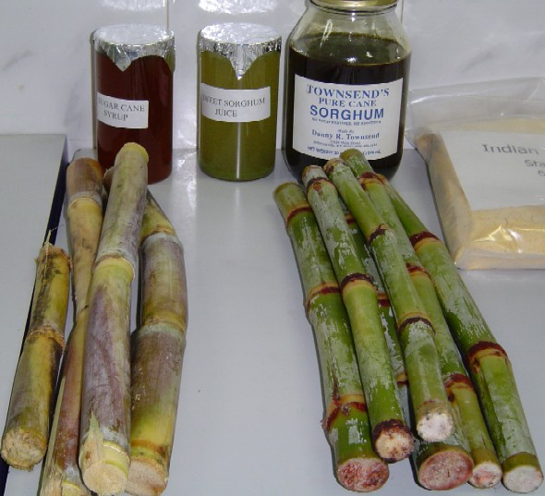
Figure: 2.1 Sugar cane



Figure 2.2: Typical exchanges associated with ethanol production

Table 2.1: Alcohol Production

Alcohol Production
(in million liters)
Alcohol Year | Molasses Prod. | Production of Alcohol | Industrial Use | Potable Use | Other Uses | Surplus Availability
1998-99 | 7.00 | 1411.8 | 534.4 | 5840 | 55.2 | 238.2
1999-00 | 8.02 | 1654.0 | 518.9 | 622.7 | 576 | 455.8
2000-01 | 8.33 | 1685.9 | 529.3 | 635.1 | 588 | 462.7
2001-02 | 8.77 | 1775.2 | 5398 | 647.8 | 59.9 | 527.7
2002-03 | 9.23 | 1869.7 | 550.5 | 660.7 | 61.0 | 597.5
2003-04 | 9.73 | 1969.2 | 578.0 | 693.7 | 70.0 | 627.5
2004-05 | 10.24 | 2074.5 | 606.9 | 728.3 | 73.5 | 665.8
2005-06 | 10.79 | 2187.0 | 619.0 | 746.5 | 77.2 | 742.3
2006-07 | 11.36 | 2300.4 | 631.4 | 765.2 | 81.0 | 822.8

Dextrose is one of the most fermentable of all of the sugars. Following conversion of starch to dextrose, many corn refiners pipe dextrose to fermentation facilities where the dextrose is converted to alcohol by traditional yeast fermentation or to amino acids and other bioproducts through either yeast or bacterial fermentation. After fermentation, the resulting broth is distilled to recover alcohol or concentrated through membrane separation to produce other bioproducts. Carbon dioxide from fermentation is recaptured for sale and nutrients remaining after fermentation are used as components of animal feed ingredients.

2.2 Ethanol from Cellulose:

Cellulosic ethanol is fuel ethanol made from cellulosic biomass – plant matter composed primarily of inedible cellulose fibers that form the stems and branches of most plants. Crop residues (such as corn stalks, wheat straw
and rice straw), wood waste, and even municipal solid waste are potential sources of cellulosic biomass. High-biomass dedicated energy crops, such as switch grass, are also promising cellulose sources.

Cellulosic biomass is a highly undervalued and underutilized energy asset in India and around the world. Many forms of cellulosic biomass can contribute to energy solutions, including grain crops and switch grass, or crop residues like corn stalks, wheat straw, rice straw, grass clippings, and wood residues. These cellulose-containing natural waste products are widely abundant and can be sustainably produced: indeed, cellulose has been estimated to make up half of all the organic carbon on the planet.

2.3 Dry Milling:
Most of the ethanol in the world is made using the dry mill method. In the dry mill process, the starch portion of the corn is fermented into sugar the distilled into alcohol.

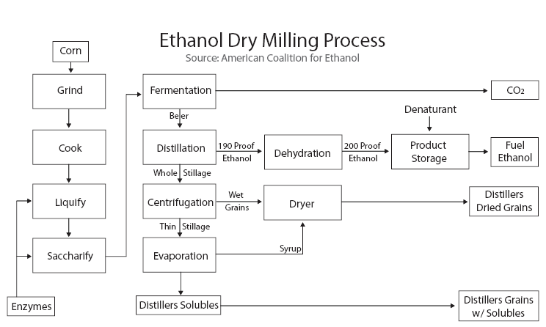
Figure 2.4: Ethanol by Dry milling Process

The major steps in the dry mill process are:
1. Milling. The feedstock passes through a hammer mill which grinds it into a fine powder called meal.
2. Liquefaction. The meal is mixed with water and alpha-amylase, then passed through cookers where the starch is liquefied. Heat is applied at this stage to enable liquefaction. Cookers with a high temperature stage (120-150 degrees Celsius) and a lower temperature holding period (95 degrees Celsius) are used. High temperatures reduce bacteria levels in the mash.
3. Saccharification. The mash from the cookers is cooled and the secondary enzyme (gluco-amylase) is added to convert the liquefied starch to fermentable sugars (dextrose).
4. Fermentation. Yeast is added to the mash to ferment the sugars to ethanol and carbon dioxide. Using a continuous process, the fermenting mash is allowed to flow through several fermenters until it is fully fermented and leaves the final tank. In a batch process, the mash stays in one fermenter for about 48 hours before the distillation process is started.
5. Distillation. The fermented mash, now called beer, contains about 10% alcohol plus all the non-fermentable solids from the corn and yeast cells. The mash is pumped to the continuous flow, multi-column distillation system where the alcohol is removed from the solids and the water. The alcohol leaves the top of the final column at about 96% strength, and the residue mash, called stillage, is transferred from the base of the column to the co-product processing area.
6. Dehydration. The alcohol from the top of the column passes through a dehydration system where the remaining water will be removed. Most ethanol plants use a molecular sieve to capture the last bit of water in the ethanol. The alcohol product at this stage is called anhydrous ethanol (pure, without water) and is approximately 200 proof.
7. Denaturing. Ethanol that will be used for fuel must be denatured, or made unfit for human consumption, with a small amount of gasoline (2-5%). This is done at the ethanol plant.
8. Co-Products. There are two main co-products created in the production of ethanol: distillers grain and carbon dioxide. Distillers grain, used wet or dry, is a highly nutritious livestock feed. Carbon dioxide is given off in great quantities during fermentation and many ethanol plants collect, compress, and sell it for use in other industries.
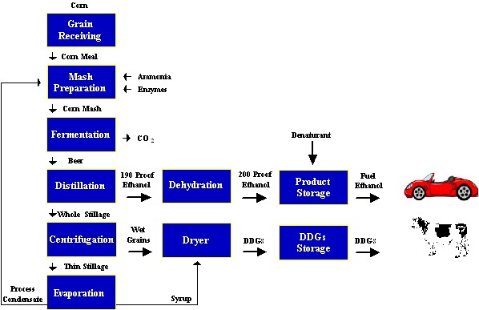
Figure 2.5: Ethanol production from Grains

2.4 Wet Milling:
This process uses both chemical and physical methods of separating the components of the corn. Extractable starch is the key measure of corn value, not just total starch. Waxy corn offers unique starch characteristics that are valued by food manufacturers and industrial users.

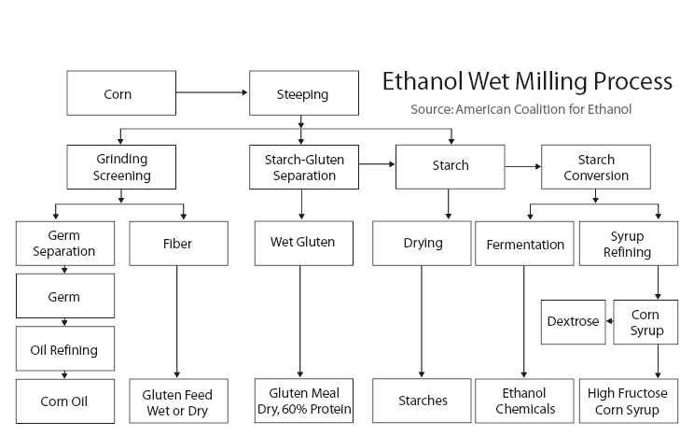

Figure 2.6 Ethanol Wet Milling Process.
2.4.1 Inspection and cleaning

Refinery staff inspects arriving corn shipments and clean them twice to remove cob, dust, chaff and foreign materials before steeping, the first processing step, begins.

Figure 2.7: Corn Delivery to Mills
2.4.2 steeping
Figure 2.8: Steeping Process
Each stainless steel steep tank holds about 3,000 bushels of corn for 30 to 40 hours of soaking in 50 degree water. During steeping, the kernels absorb water, increasing their moisture levels from 15 percent to 45 percent and more than doubling in size. The addition of 0.1 percent sulfur dioxide to the water prevents excessive bacterial growth in the warm environment. As the corn swells and softens, the mild acidity of the steep water begins to loosen the gluten bonds within the corn and release the starch. After steeping, the corn is coarsely ground to break the germ loose from other components. Steep water is condensed to capture nutrients in the water for use in animal feeds and for a nutrient for later fermentation processes. The ground corn, in water slurry, flows to the germ separators.
2.4.3 Germ separation
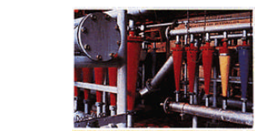
Figure 2.9: Germ separation

Cyclone separators spin the low density corn germ out of the slurry. The germs, containing about 85% of corn's oil, are pumped onto screens and washed repeatedly to remove any starch left in the mixture. A combination of mechanical and solvent processes extracts the oil from the germ. The oil is then refined and filtered into finished corn oil. The germ residue is saved as another useful component of animal feeds.

2.4.4 Fine grinding and screening
Figure 2.10: Fine grinding process

The corn and water slurry leaves the germ separator for a second, more thorough, and grinding in an impact or attrition-impact mill to release the starch and gluten from the fiber in the kernel. The suspension of starch, gluten and fiber flows over fixed concave screens (illustrated) which catch fiber but allow starch and gluten to pass through. The fiber is collected, slurred and screened again to reclaim any residual starch or protein, then piped to the feed house as a major ingredient of animal feeds. The starch-gluten suspension, called mill starch, is piped to the starch separators.
2.4.5 Starch separation

Figure 2.11: Starch separation
Gluten has a low density compared to starch. By passing mill starch through a centrifuge, the gluten is readily spun out for use in animal feeds. The starch, with just one or two percent protein remaining, is diluted, washed 8 to 14 times, re-diluted and washed again in hydro clones to remove the last trace of protein and produce high quality starch, typically more than 99.5 percent pure. Some of the starch is dried and marketed as unmodified corn starch, some is modified into specialty starches, but most is converted into corn syrups and dextrose.

2.4.6 Syrup conversion
Figure 2.12: Syrup conversion
Starch, suspended in water, is liquefied in the presence of acid and/or enzymes which convert the starch to a low-dextrose solution. Treatment with another enzyme continues the conversion process. Throughout the process, refiners can halt acid or enzyme actions at key points to produce the right mixture of sugars like dextrose and maltose for syrups to meet different needs. In some syrup, the conversion of starch to sugars is halted at an early stage to produce low-to-medium sweetness syrups. In others, the conversion is allowed to proceed until the syrup is nearly all dextrose. The syrup is refined in filters, centrifuges and ion-exchange columns, and excess water is evaporated. Syrups are sold directly, crystallized into pure dextrose, or processed further to create high fructose corn syrup (illustrated).

2.5 Bio- technology Based Production

Recently advances in the relatively new field of industrial biotechnology using techniques in genomics, proteomics, and bioinformatics – are making it possible to convert cellulosic biomass to fermentable sugars that can be used as feed-stocks for a new type of “carbohydrate crude oil.”

This technology breakthrough is creating a paradigm shift in the way we make transportation fuel because enzymes can economically convert plant matter to fermentable sugars.

Enzymes that break down cellulose are called celluloses and are found in nature in fungi as well as in microbes that are in the guts of termites. Biotech tools are necessary to identify or produce the most efficient cellulases on a scale useful for ethanol production.
Cellulosic ethanol can substitute for petroleum in many manufacturing processes – such as plastics – and could contribute in a major way to reducing World’s “addiction to oil,” while at the same time helping to address the climate change issue, by reducing our need to burn fossil fuels.

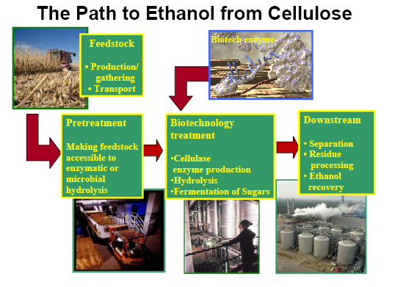

Figure 2.13: Ethanol from Cellulose

2.5.1 What Is Industrial Biotechnology

Industrial biotechnology companies develop biocatalysts, such as enzymes, to be used in industrial manufacturing involving chemical synthesis.
Enzymes are proteins that are present in all living organisms. Enzymes trigger or speed up chemical processes that would otherwise run very slowly, but they are not consumed in the process of changing other molecules. They are unique due to their catalytic activity and their ability to break down compounds such as cellulose. As catalysts, they can also put broken protein fragments back together. Over the past 35 years scientists have learned how to convert these biological systems and enzymes into very useful industrial tools that replace less efficient and possibly toxic chemical processes. Natural enzyme-based processes operate at lower temperatures; produce less toxic waste and fewer emissions than conventional chemical processes. They may also use less purified raw materials because they have precise chemical selectivity. Industrial biotech companies conduct genomic studies on microbes to capitalize on the wealth of genetic diversity in microbial populations.

Researchers then use DNA probes to look for genes that express enzymes with specific biocatalyst capabilities. Once snared, enzymes can be identified and characterized for their ability to function in specific industrial
Processes and, if necessary, they can be improved with advanced biotechnology techniques. This is exactly what scientists have been doing to
Improve enzymes for ethanol production.

Once the needed enzyme is discovered and improved, it may be produced in
commercial quantities using fermentation or systems similar to those that produce human therapeutic proteins or bulk yeast for the brewing industry. To improve the productivity of enzymes, scientists are using not only genomics, but also proteomics and bioinformatics to increase enzyme output rates. Biotechnology enables scientists to maximize the effectiveness and efficiency of enzymes and to custom tailor the specificity of enzymes, improve catalytic properties or broaden the conditions under which enzymes can function so that they are more compatible with existing industrial processes.

Using enzymes in industrial processes has several benefits. Use of enzymes can reduce the amount of harsh chemicals in industrial processes that contaminate the environment. In addition to creating cleaner process outputs, enzymes help conserve energy and raw materials by reducing the amount of inputs in industrial processes. These enzymes are the key to ensuring that older industrial manufacturing processes evolve into cleaner, more sustainable industrial ones.

Biotech companies are producing improved enzymes for converting starch to ethanol production and have been perfecting enzymes for cellulosic ethanol production. Modern biorefineries will be constructed in Idaho, by Iogen, the Midwest, by Cargill, and overseas. These refineries will that take cellulosic biomass, convert the cellulose to sugars, and then fermented the sugar into ethanol.

2.5.2 The First Commercial Production
In 2004, Iogen Corporation became the first company to begin commercial production of cellulosic ethanol. Using biotech enzymes that convert wheat straw to clean burning ethanol, Iogen’s pilot plant in Ottawa, Canada, has an annual capacity of 260,000 gallons. Ethanol from the plant is sold at a nearby Shell gas station. In January 2006, Iogen and Shell announced plans to explore cellulosic ethanol production in Germany, and Iogen is seeking government assistance to construct the first commercial-scale cellulosic bio-refinery in the US.

2.5.3 More Bio-refineries
In August, 2005, Abengoa Bio-energy began construction of the world’s first commercial scale cellulosic ethanol plant. Upon completion in 2006, the plant is expected to process 70 tones of agricultural residues, such as heat straw, each day, producing over 1 million gallons of cellulosic ethanol annually. Advances in cellulose enzymatic hydrolysis and fermentation were key to enabling Abengoa to take their technology to market.

Abengoa has also received a $10 million DOE grant to develop a next generation dry mill corn ethanol plant. This next-generation plant will be capable of producing ethanol from the entire corn kernel – both starch (the only portion currently utilized for ethanol) and the residual fiber (also known as dry distillers grains, or DDGs), which would require processing with cellulase enzymes. The application of cellulosic technology could dramatically increase the ethanol yield of the nations over 100 existing ethanol facilities.

In 2005, Cargill announced plans for two 110-million-gallon bio-ethanol plants that use traditional feed-stocks, in Nebraska and Minnesota, and began construction of a bio-diesel plant in Mainz, Germany. Cargill is exploring incorporating cellulosic feed-stocks into its existing refineries.

2.6 Yeast Growth
Yeast grows rapidly in a glucose- or sucrose-rich medium, with a doubling time of about 60 minutes. High growth rates result in O2 depletion, and the neutral reaction products allow growth to be sustained anaerobic mode. There are strains of yeast able to tolerate as much as 20% ethanol, although strains producing 12-15% may actually grow better.

- Ethanol is the end point of the only metabolic pathway that yeast can use for ATP production. ATP is produced at a low rate, 2 ATP per mole of glucose and per 2 moles of ethanol produced so that substrate is rapidly converted to product to provide the energy needs of cell growth.
- Ethanol can escape into the medium rather than accumulating in the cell. This makes recovery of the product easier. Pure ethanol has to be recovered by distillation, which could represent the most expensive component of the production process. In tropical countries, solar distillation is possible taking ethanol production economically viable.

2.7 Ethanol Distillation:

Absolute Alcohol, C2H5OH, (i.e. 100% Ethanol) is pure anhydrous ethanol. Absolute alcohol has a boiling point of 78.3 deg C. It is a clear colorless liquid with a pleasant smell. It is completely miscible with water and organic solvents and is very hydroscopic.

Absolute Alcohol is obtained from 95% Alcohol by using a ternary azeotrope (i.e. by distillation using a three component Azeotrope).

- A mixture of 7.5% Water, 18.5% Ethanol, and 74% Benzene (boiling point 80 deg C), forms a ternary azeotrope, which is a minimum-boiling mixture.

- Benzene and Ethanol form a binary azeotrope (boiling point 68.2 deg C).

- Thus, when a mixture of 95% ethanol and benzene is distilled, the above ternary azeotrope distills first, followed by the binary azeotrope, and the final fraction is absolute alcohol.

Distillation is the process of heating a solution to its boiling point, passing the vapors through a cooling device called a condenser, and collecting the liquid which condenses. Because the boiling point of alcohol is lower than that of water, almost all of the alcohol will boil off first, followed by the water. Thus if you start with 100 mL of solution, by the time almost 100 mL has distilled, you will have collected all of the alcohol and almost all of the water. If you then q. s. the resulting distillate to exactly 100 mL, you will restore it to its original volume and concentration. Because of the alcohol it contains, the distillate will have a specific gravity lower than that of distilled water. By the use of the table provided, the percentage of alcohol in a solution can be determined by knowing the specific gravity of the solution, assuming that no interfering substances co-distill with ethanol which would affect the specific gravity of the distillate. Interestingly, since the boiling
point of ethanol is 78.5° C, well below the boiling point of water (100° C), the ethanol can be concentrated by the process of fractional distillation (collecting the distillate in aliquots rather than the whole solution). This is the source of liquors with higher alcohol contents.
A liquid must be brought just slightly above its boiling point before bubble initiation can begin to start it boiling. As a bubble of vapor appears within the liquid, it may do one of two things: if it is below a minimum size, it will collapse because of the surface tension of the liquid, or if it is larger than the critical size, grow and rise to the surface of the liquid. If a liquid, which is free of solid impurities or dissolved gases, is heated slowly, a temperature much above the boiling point can be reached without any boiling actually taking place. This superheating occurs because extra energy is required before bubble formation is initiated. If a bubble should start to form in such a superheated solution, it might suddenly grow with almost explosive violence enough to shatter the container. This problem, called bumping, can be overcome by adding a boiling chip, a piece of porous material, to the liquid before it is heated to the boiling point. The pores act as built-in bubbles so that a liquid cannot superheat. As the distillation proceeds, the air in these pores is replaced by vapor of the distilling material, but this vapor cannot condense because the temperature of the liquid is just slightly above its boiling point. However whenever a distillation is stopped and then started again, a new boiling chip will be needed because the vapor in the pores will have condensed and filled the pores with liquids.

2.8 Ethanol-Diesel Blend Production
As noted, blending of ethanol and diesel occurs at the finished product terminal. Each is stored in its respective tank until drawn from inventory. The terminal must have a tank(s), of sufficient size to meet projected e-diesel demand. Blending systems must be installed (or existing blending systems modified) to accommodate ethanol-diesel blending.
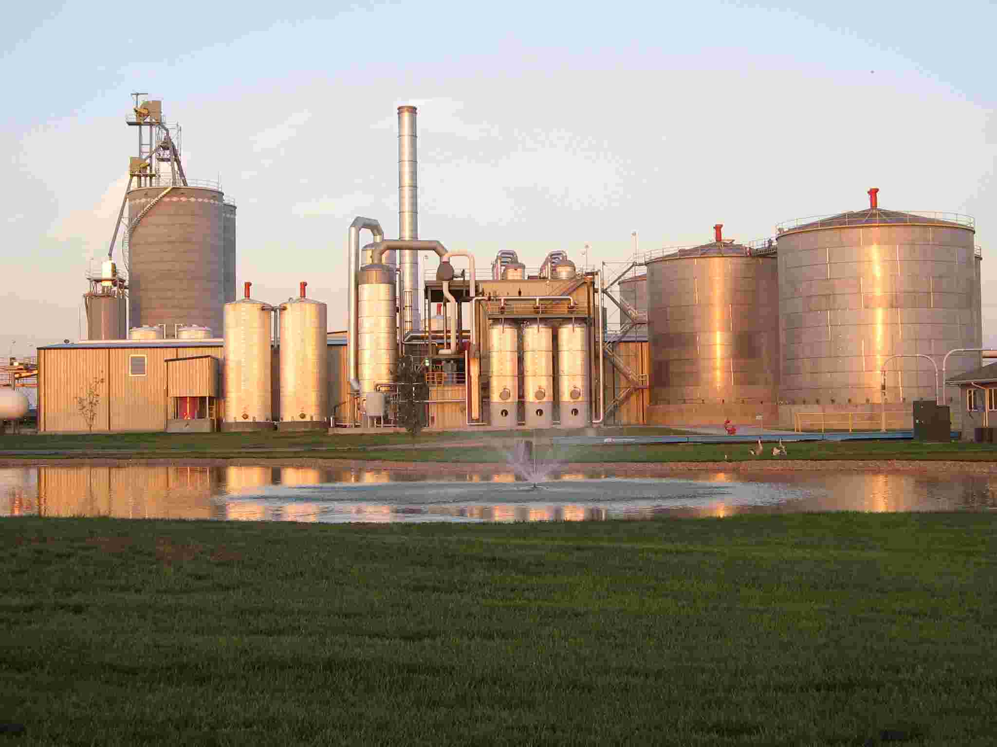
Figure 2.13: Ethanol- Diesel Blend formation Plant
Once blended at the terminal, the ethanol-containing blend is transported via truck to the retail outlet or fleet fueling facility. Facilities already producing ethanol-gasoline blends may not require additional ethanol storage but may require new storage capacity for e-diesel and for the emulsifier additive package that is also required (see below).

E-diesel can be prepared by splash blending the components so no special blending equipment is required. However, as noted below, the flashpoint of e-diesel is much lower than that of conventional diesel so that in storage and transportation e-diesel must be handled like gasoline.

2.9 FORMULATION OF ETHANOL – DIESEL

After going through the literature on formulation of ethanol-diesel fuel blends, following points were noted:
1 Anhydrous ethanol readily mixes with diesel fuel, without need for using surfactant.
2 For lower proof ethanol to mix with diesel, surfactant is needed.

Thus, finding a suitable surfactant became the most crucial part of this work.
At present, research on E-diesel is mainly going on in USA, Switzerland and
Brazil. There, private companies as well as researchers at universities such as
University of Illinois, are developing additive packages which contain surfactant as well' as ignition improvers. However, these additive packages are very costly.
Moreover, they are still at experimental stage. Thus we zeroed in on three easily gettable surfactants viz. gasoline [42], ethyl acetate [31] and bio-diesel. However, the ethanol-diesel fuel blends prepared losing ethyl acetate as a surfactant failed to stabilize, for reasons unknown. Therefore, ethyl acetate as a surfactant was discarded. , Finally, ten samples of ethanol-diesel fuel blends, each of 700 ml. were prepared. These fuel samples were mainly of two types:

Without Surfactant

Two blends were prepared from anhydrous ethanol and diesel fuel, without using any surfactant. Anhydrous ethanol was added to diesel fuel at room temperature. The two, on stirring for some time, formed stable emulsion, which didn't need any heat treatment. However, it needed special care to guard it against any water contamination.

With Surfactant

Anhydrous ethanol is a costly affair and needs utmost care for handling as it has great affinity for water; it is not practical to use its blends with diesel as vehicular fuel. Therefore, anhydrous ethanol shall be used only for research purpose. Thus, it is more practical to blend diesel with commercial grade ethanol, which may have some amount. of water in it, in order to check practical utility of such a fuel. As presence of water may lead to phase separation, it is imperative to lISC surfactant, which helps form ethanol-diesel micro emulsion; in case commercial grade ethanol is used. Therefore, in order to form ethanol-diesel micro emulsions, two different surfactants were used. Of the eight such blends, two were prepared by using bio-diesel as emulsifier and rest, using gasoline as a surfactant.
Research has shown that bio-diesel can act as emulsifier for ethanol-diesel fuel blends. The optimum mixing ratio of ethanol, bio-diesel is 1: I with their maximum
quantity being 20% of the blend. Thus, two blends using 5% and 10% bio diesel with an equal air amount of commercial grade ethanol were prepared by mixing them with diesel at room temperature.
Rest of the six ethanol-diesel blends were prepared by using gasoline as surfactant. In these blends, commercial grade ethanol and gasoline were varied in steps of 5% with maximum of 10% ethanol and 15% gasoline concentration.
Some, addition of ethanol to diesel lowers its cetane rating; it becomes imperative to use some ignition improver in order to ensure knock-free operation of the Engine. This fact was validated by the pilot trials conducted on the engine using ethanol-diesel blends without ignition improver. During these pilot trials, engine knocking resulted in fluctuations in the values of various parameters recorded by recording instruments, which would have adversely affected findings of the study.
Thus, to prevent such an error and to ensure, knock-free operation of the engine, less than one percent of isopropyl nitrate [18] was added to each ethanol-diesel blend, as an ignition improver. It ensured stable operation of the engine.

Table 2.2 Effect of Surfactant on different Fuels
Sr. no | Designation | Diesel fuel(%) | Ethanol  (%) | Surfactant  Bio-Diesel (%) | Surfactant Gasoline (%)
1 | E05 | 95 | 5* | 0 | 0
2 | E10 | 90 | 10* | 0 | 0
3 | E05B05 | 90 | 5 | 5 | 0
4 | E10B10 | 80 | 5 | 10 | 0
5 | E5G5 | 90 | 5 | 0 | 5
6 | E5G10 | 85 | 5 | 0 | 10
7 | E5G15 | 80 | 5 | 0 | 15
8 | E10G5 | 85 | 10 | 0 | 5
9 | E10G10 | 80 | 10 | 0 | 10
10 | E10G15 | 75 | 10 | 0 | 15
11 | Neat Diesel | 100 | 0 | 0 | 0

- Anhydrous Ethanol

UNIT 3

Properties

There are a number of fuel properties that are essential to the proper operation of a diesel engine. The addition of ethanol to diesel fuel affects certain key properties with particular reference to blend stability, viscosity and lubricity, energy content and cetane number. Materials compatibility and corrosiveness are also important factors that need to be considered.
Properties that affect safety should be foremost in any fuel evaluation. These include ash point and flammability. Finally fuel biodegradability has become a significant factor with respect to ground water contamination.

Ethanol (ethyl alcohol, grain alcohol) is a clear, colorless liquid. In dilute aqueous solution, it has a somewhat sweet flavor, but in more concentrated solutions it has a burning taste. Ethanol (CH3CH2OH) is made up of a group of chemical compounds whose molecules contain a hydroxyl group, -OH, bonded to a carbon atom. Ethanol made from cellulosic biomass materials instead of traditional feedstock’s (starch crops) is called bio-ethanol.

3.1 Physical properties of Ethanol

Ethanol's hydroxyl group is able to participate in hydrogen bonding. At the molecular level, liquid ethanol consists of hydrogen-bonded pairs of ethanol molecules; this phenomenon renders ethanol more viscous and less volatile than less polar organic compounds of similar molecular weight. In the vapor phase, there is little hydrogen bonding; ethanol vapor consists of individual ethanol molecules.

Ethanol is a versatile solvent. It is miscible with water and with most organic liquids, including non polar liquids such as aliphatic hydrocarbons. Organic solids of low molecular weight are usually soluble in ethanol. Among ionic compounds, many mono vaent salts are at least somewhat soluble in ethanol, with salts of large, polarizable ions being more soluble than salts of smaller ions. Most salts of polyvalent ions are practically insoluble in ethanol.

Several unusual phenomena are associated with mixtures of ethanol and water. Ethanol-water mixtures have less volume than their individual components: a mixture of equal volumes ethanol and water has only 96% of the volume of equal parts ethanol and water, unmixed. The addition of even a few percent ethanol to water sharply reduces the surface tension of water. This property partially explains the tears of wine phenomenon: when wine is swirled inside a glass, ethanol evaporates quickly from the thin film of wine on the wall of the glass. As its ethanol content decreases, its surface tension increases, and the thin film beads up and runs down the glass in channels rather than as a smooth sheet.

Table 3.1 Physical properties of ethanol

Boiling point | 79 degree C
Melting point | 117 degree C
Relative density (water = 1): | 0.8
Solubility in water | miscible
Vapor pressure, k Pa at 20C | 5.8
Relative vapor density (air = 1): | 1.6
Flash point | 13 degree C
Auto-ignition temperature | 363C
Explosive limits, vol% in air | 3.3-19

3.2 Properties of Ethanol-Diesel Blends

Fuel formation was through blending of anhydrous ethanol and diesel fuel with or without surfactants. In all, there were eleven fuel samples along with neat diesel. Various tests on these samples were performed in laboratories of Delhi College of Engineering in accordance with standard testing procedures. These tests included measurement of higher calorific value, specific gravity, and kinematic viscosity and flash point.

3.2.1 Specific Gravity

Specific gravity will provide more information about how the fuel will perform in a diesel engine than any other single test. Specific gravity will measure the density of the fuel. The density of the fuel is related to its viscosity. A higher specific gravity may indicate an incomplete reaction and the fuel shou1d not be used in an engine.

Table 3.2: specific gravity of fuel

Fuel Sample | Wt. of empty bottle (g) | wt of bottle with sample  (g) | actual wt of the sample (g) | Density (kg/m3) | Specific gravity
E05 | 21.5220 | 42.5570 | 21.0360 | 840.4 | 0.841
E10 | 21.5220 | 42.5030 | 20.9587 | 840.5 | 0.835
E5B5 | 21.5220 | 42.6775 | 22.2568 | 846.5 | 0.845
E10B10 | 21.5220 | 42.6262 | 21.2458 | 843.4 | 0.842
E5G5 | 21.5220 | 42.4200 | 20.2458 | 837.2 | 0.835
E5G10 | 21.5220 | 42.6937 | 20.2145 | 831.2 | 0.831
E5G15 | 21.5220 | 42.2548 | 20.2168 | 826.1 | 0.826
E10G5 | 21.5220 | 42.4000 | 20.2185 | 834.4 | 0.835
E10G10 | 21.5220 | 42.2260 | 20.2789 | 828.2 | 0.827
E10G15 | 21.5220 | 42.1050 | 20.5880 | 823.3 | 0.826
Neat Diesel | 21.5220 | 42.6354 | 21.1587 | 844.4 | 0.850

3.2.2 Kinematic Viscosity

Viscosity of fuel is its resistance to flow. Improper viscosity leads to poor combustion, which result in the loss of power and excessive exhaust smoke. Here we have measured the viscosity of the fuel with the help of apparatus called Setavis Kinematic Viscometer. Viscosities of various fuel samples are tabulated as under.

Table3.3kinematic viscosity of samples at 40 C

Sr. No. | Fuel Sample | Tube constant of capillary tube 1 | Time Taken by fuel to flow through the capillary tube 2 | Kinematic Viscosity  (1*2)
1 | EO5 | 0.0487 | 62.5 | 2.9985
2 | E10 | 0.0487 | 60.5 | 2.9365
3 | 05B05 | 0.0487 | 68.0 | 3.3256
4 | E10B10 | 0.0487 | 65.0 | 3.2000
5 | E05G05 | 0.0487 | 75.0 | 2.8547
6 | E05G10 | 0.0487 | 45.0 | 2.5687
7 | E05G15 | 0.0487 | 42.0 | 2.1045
8 | E10G05 | 0.0487 | 55.0 | 3.0125
9 | E10G10 | 0.0487 | 42.0 | 2.2314
10 | E10G15 | 0.0487 | 36.5 | 1.9365
11 | NEAT DIESEL | 0.1075 | 28.5 | 3.2547

3.2.3 Calorific Value of fuel
One of the important characteristics of good fuel is high calorific value of the fuel as the amount of heat liberated and the temperature attained, thereby depending upon the calorific value of the fuel. Calorific value of the fuel is the amount of heat liberated, when a unit mass of fuel is burnt completely. Calorific value of the fuel is measured by Bomb Calorimeter.

Table 3.4: calorific value of fuel.

Sr. No | Fuel  Sample | wt. of empty crucible  (g) | wt. of crucible with fuel  (g) | wt. of the fuel  (g) | Change in water temp.(ºC) | Calorific Value (kJ/kg) | Water equiva lent of Calorimeter
1 | E05 | 16.0824 | 18.2420 | 2.1659 | 8.45 | 42105.2 | 0.9742
2 | E10 | 16.042 | 18.1537 | 2.0713 | 7.59 | 41310.1 | 0.9742
3 | E05B05 | 16.0532 | 17.9144 | 1.8610 | 7.40 | 41710.1 | 0.9742
4 | E10B10 | 16.0924 | 18.1022 | 2.0121 | 7.75 | 40520.2 | 0.9742
5 | E05G05 | 16.0752 | 17.9410 | 1.8616 | 7.53 | 42132.8 | 0.9742
6 | E05G10 | 16.0616 | 18.0266 | 1.9758 | 7.47 | 42160.2 | 0.9742
7 | E05G15 | 16.0810 | 17.9910 | 1.9128 | 7.20 | 42187.4 | 0.9742
8 | E10G05 | 16.0725 | 18.1044 | 2.0323 | 7.90 | 41337.2 | 0.9742
9 | E10G10 | 16.0534 | 18.1248 | 2.0723 | 7.69 | 41365.1 | 0.9742
10 | E10G15 | 16.0810 | 18.2230 | 2.1420 | 8.42 | 41392.8 | 0.9742
11 | Neat Diesel | 16.0726 | 18.0725 | 1.9956 | 7.46 | 42906.3 | 0.9742

3.2.4 Flash Point:

Flash point of the fuel is the minimum temp. at which it gives enough vapors to from a flammable mixture that ignite for a moment, when a tiny flame is brought near to it. The flash point of oil is generally measured by using Pensky-Marten’s meter. It is desirable that the fuel should have higher flash point. Flash point is important primarily from a fuel-handling standpoint. Tool low a flash point will cause fuel to be fire hazard, subject to flashing, and possible continued ignition and explosion.

Table 3.5: Flash point of the fuel

Sr. No. | Fuel Sample | Specific Gravity | Viscosity at 40ºC (cSt) | Calorific value (kJ/kg) | Flash  Point (ºC)
1 | E05 | 0.832 | 3.0658 | 42105.1 | 33.10
2 | E10 | 0.826 | 2.9216 | 41310.1 | 32.50
3 | E05B05 | 0.826 | 3.3387 | 41710.1 | 39.16
4 | E10B10 | 0.823 | 3.1925 | 40520.2 | 38.98
5 | E05G05 | 0.816 | 2.7754 | 42132.1 | 34.11
6 | E05G10 | 0.812 | 2.2432 | 42160.3 | 37.52
7 | E05G15 | 0.816 | 2.0942 | 42187.2 | 35.35
8 | E10G05 | 0.824 | 2.97982 | 41337.9 | 35.12
9 | E10G10 | 0.818 | 2.1925 | 41365.1 | 34.22
10 | E10G15 | 0.812 | 1.8505 | 41392.3 | 35.12
11 | Neat Diesel | 0.858 | 3.1258 | 42906.1 | 71.32

3.2.5 Blend stability

Ethanol solubility in diesel is affected mainly by two factors, temperature and water content of the blend. At warm ambient temperatures dry ethanol blends readily with diesel fuel. However, below about 10 _C the two fuels separate, a temperature limit that is easily exceeded in many parts of the world for a large portion of the year. Prevention of this separation can be accomplished in two ways: by adding an emulsifier which acts to suspend small droplets of ethanol within the diesel fuel, or by adding a co-solvent that acts as a bridging agent through molecular compatibility and bonding to produce a homogeneous blend (Letcher, 1983). Emulsification usually requires heating and blending steps to generate the ethanol blend, whereas co-solvents allow fuels to be ‘‘splash-blended’’, thus simplifying the blending process. Both emulsifiers and co-solvents have been evaluated with ethanol and diesel fuel. Moses et al. (1980) investigated micro-emulsions of aqueous ethanol (5% water) and diesel fuel using a commercial surfactant. They reported that the blends formed spontaneously and required only minor stirring. They also appeared transparent indicating that the dispersion sizes were less than a quarter of a wavelength of light and were regarded as ‘‘innately’’ stable, i.e. thermodynamically stable with no separation even after several months.
The polar nature of ethanol induces a dipole in the aromatic molecule allowing them to interact reasonably strongly, while the aromatics remain compatible with other hydrocarbons in diesel fuel. Hence aromatics act to some degree as bridging agents and co-solvents. Reducing the aromatic content of diesel fuels will influence the miscibility of ethanol in diesel fuel and will affect the amount of additive require achieving a stable blend.

3.2.6 Viscosity and lubricity

Fuel viscosity and lubricity play significant roles in the lubrication of fuel injection systems, particularly those incorporating rotary distributor injection pumps that rely fully on the fuel for lubrication within the high pressure pumping mechanism. In the common rail accumulator fuel-injection system, the high-pressure pump that delivers fuel to the rail also relies on the fuel for lubrication. In in-line pumps and unit injectors, there is less reliance on the fuel for lubrication; however, there are still some metal interfaces that require lubrication by the fuel such as between plunger and barrel. Injector lubrication also is affected, particularly at the needle guide-nozzle body interface. Lower fuel viscosities lead to greater pump and injector leakage reducing maximum fuel delivery and ultimately power output. Hot restart problems also may be encountered as insufficient fuel may be injected at cranking speed when fuel leakage in the high-pressure pump is amplified because of the reduced viscosity of the hot fuel.

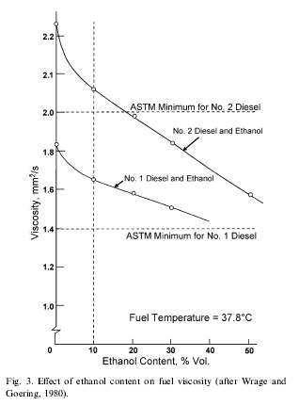
Figure 3.1 Effect of Ethanol on Viscosity
Two ASTM lubricity tests are commonly used to characterize the lubricity of fuels, the Scu.ng Load Ballon- Cylinder Lubricity Evaluator (SBOCLE), D6078-99 and the High Frequency Reciprocating Rig (HFRR), D6079-99. Relatively few lubricity tests have been carried out on ethanol–diesel blends. Speidel and Ahmed (1999) reported a SBOCLE test value of 5200 g for the blend containing 15% dry ethanol, 5% PEC additive and 80% diesel, as compared to the minimum of 3100 g specified for No. 2 diesel. Bio-based oils have been effective in increasing fuel lubricity and are commercially available. Hardenberg and Schaefer (1981) included 1% castor oil in a 95% ethanol fuel that was used successfully in affect of trucks and buses in Brazil. Minimum specifications for viscosity and lubricity of ethanol–diesel blends are required in order to ensure that fuel injection system durability is not compromised relative to diesel fuel usage and that engines are able to start reliably when hot.

Fuel viscosity also affects the atomization and spray characteristics in the combustion chamber. Lower viscosities typically result in smaller Sauter mean droplet diameters, thereby increasing the surface area of droplets and significantly influencing the evaporation characteristic time (Heywood, 1988; Desantes et al., 1998). The lack of reports of specific measurements to corroborate these trends with ethanol–diesel blends indicates a need to investigate their atomization and spray characteristics, as these parameters have a significant effect on the combustion process.

3.3 Materials compatibility

The use of ethanol in gasoline engines in the early 1980s resulted in numerous materials compatibility studies, many of which are also applicable to the e.ect of ethanol–diesel blends in diesel engines and particularly in the fuel injection system. The quality of the ethanol has a strong influence on its corrosive effects (Hardenberg and Schaefer, 1981). In addressing the problems of ethanol corrosion associated with gasoline blends, Brink et al. (1986) divided ethanol corrosion into three categories: general corrosion, dry corrosion and wet corrosion. General corrosion was caused by ionic impurities, mainly chloride ions and acetic acid. Dry corrosion was attributed to the ethanol molecule and its polarity. De la Harpe (1988) reviewed reports of dry corrosion of metals by ethanol and found that magnesium, lead and aluminum were susceptible to chemical attack by dry ethanol. Wet corrosion is caused by azeotropic water, which
Oxidizes most metals (Brink et al.1986). Freshly formulated blends containing pH neutral dry ethanol would be expected to have relatively little corrosive effect. However, if a blend has been standing in a tank for sufficient time to allow the ethanol to absorb moisture from the atmosphere, it may tend to be more corrosive as it passes through the fuel injection system (de la Harpe, 1988). In addition, the fuel may stand in the fuel injection pump for a number of months, for example in
a combine harvester engine, thus allowing the fuel time to corrode parts of the pump internally. Corrosion inhibitors have been incorporated in some additive packages used with ethanol–diesel blends (de la Harpe, 1988). Non-metallic components have also been affected by ethanol with particular reference to elasto-meric components such as seals and O-rings in the fuel injection system. These seals tend to swell and stamen. Resin-bonded or resin-sealed components also are susceptible to swelling and seals may be compromised (Bosch, 2001).

3.4 Energy content

The energy content of a fuel has a direct influence on the power output of the engine. Wrage and Goering (1980) stated that it would be desirable for ethanol– diesel blends to have gross energy contents at least 90– 95% of that for No. 2 diesel to permit existing engines to deliver adequate power for the loads for which the vehicle is designed. The energy content of ethanol–diesel blends decreases by approximately 2% for each 5% of ethanol added, by volume, assuming that any additive included in the blend has the same energy content as diesel fuel.

3.5 Cetane Number

The minimum cetane number specified by ASTM Standard D 975-02 for No. 2 diesel is 40. Typical No. 2 diesel fuels have cetane numbers of 45–50. With the inverse relationship of octane number and cetane number, ethanol exhibits a low cetane rating. Hence, increasing concentrations of ethanol in diesel lower the cetane number proportionately. Hardenberg and Ehnert (1981) stated that using cetane numbers to describe the ignition characteristics of ethanol–diesel blends was unreliable, because of discrepancies in the determination of cetane numbers below 30. However, they estimated that the cetane number of ethanol was between 5 and 15.

Lower cetane numbers mean longer ignition delays, allowing more time for fuel to vaporize before combustion starts. Initial burn rates are higher causing more heat release at constant volume, which is a more efficient conversion process of heat to work. Nevertheless, it is preferable to add an ignition improver to raise the cetane number of ethanol–diesel blends so that they fall within an acceptable range equivalent to that expected of No. 2 diesel fuel.

Schaefer and Hardenberg (1981) evaluated a number of ignition improvers for ethanol fuel with special emphasis on biomass-derived nitrates. They noted a significant dependence of the energy release per equivalent nitrate on the molecular weight of the ignition improving nitrate. Hardenberg and Schaefer (1981) found tri-ethylene glycol di-nitrate (TEGDN) to be the most satisfactory ignition improver in tests performed in Brazil, especially since it could be manufactured from ethanol.

Table 3.6: Property chart

Property | Typical Diesel | E-10 | E-15 | Ethanol | Methanol
Cetane number | 45 to 50 | 52 | 45 | 5 to 15 | 0 to 4
Lubricity (in mm) | 0.54 | 0.52 | 0.50 | 0.48 | 0.28
Viscosity, mm2/s @ 40°C | 2.5 | 2.2 | 2.25 | 1.1 | 0.58
Sulfur, % | 0.035 | <0.035 | <0.035 | Negligible | Negligible
Cloud point, °C (°F) | -19 (-2) | 13 to 27  (55 to 81) | -5, 17  (23, 63)
Pour point, °C (°F) | -29 (-20) | -32 to -54  (-25 to -65) | -46 to -54  (-51 to -65)
Cold filter plugging point, °C (°F) | -19 (-2) | -19 (-2)

Meiring et al. (1983b) added 4.5% octyl nitrate ignition improver to a 30% ethanol–diesel blend to achieve the same ignition delay as for diesel fuel. Moses et al. (1980) found differences in cetane numbers between ethanol–diesel emulsions and stable blends of aqueous ethanol and diesel containing no additive. The emulsified ethanol had less effect on cetane than the ethanol in solution. They speculated that this was due to a shielding effect of the emulsion structure delaying evaporation of the alcohol from the fuel droplets, while in the solution the ethanol molecules were free to evaporate immediately
UNIT 4

OPERATING CONSTRAINTS WITH E-DIESEL

Over-Sized Fuel Injectors - The volumetric heating value of ethanol is less than diesel, and so, injectors must deliver more of an ethanol-in-diesel solution to achieve the same power (as compared to the volume of neat diesel that must be delivered). For some engines, the injectors may have excess capacity that can be utilized; however, if this excess fuel delivery capacity is not provided a reduction in engine power will typically result. Ideally, new engines should be designed with excess fuel delivery capacity based on the anticipation of cleaner-burning lower-heating-value fuels such as ethanol-in-diesel solutions and Fischer-Tropsch fuels. If a larger fuel injector is required, this can impact fuel performance and may diminish the advantages of adding ethanol to diesel. Cetane Number Correction - For typical application rates, ethanol will reduce the cetane number of diesel -7 points for every 10% ethanol in diesel. If this reduction in cetane number results in a fuel cetane < 40, the fuel is no longer within specifications and the engine may not be able to properly change injection timing to compensate for the increased ignition delay time. As a result, more fuel can accumulate prior to ignition leading to a high-temperature premix combustion that produces excess NOx emissions. The best way to correct this problem is to add cetane improver fuel to the extent necessary to bring the fuel within specifications.

4.1 Vapor Lock and Cavitations
The vapor pressure of an ethanol-in-diesel fuel is considerably greater than that of neat diesel. In addition, the viscosity is lower—the lower viscosity results in a lower static pressure in the fuel delivery system. As a result of these combined traits, ethanol-in-diesel has a significantly greater tendency to evaporate and form erratic locations of vapor lock in the fuel delivery system. This vapor lock will happen at the locations of lowest static pressure, such as the fuel intake of the injector, resulting in too little fuel being delivered to the injector and subsequent cavitation inside the injector. Both the vapor lock and cavitation can be detrimental to fuel performance. To prevent the vapor lock and subsequent cavitation, the static pressure of the fuel delivery system must be increased. Either (1) reducing the size of the restrictive orifice on the diesel fuel return line or (2) introducing a backpressure regulator to the diesel fuel return line can achieve this. The good performances of ethanol-in-diesel fuels of Table 1 were achieved only after vapor lock problems were corrected. Vapor Pressure & Safety - Ethanol’s high polarity and tendency toward hydrogen bonding cause ethanol to have a high activity in gasoline and diesel. This high activity leads to both limited miscibility’s and high vapor pressures. In ethanol-gasoline blends (< 20% ethanol), the activity (yixi) of ethanol reaches a maximum of-0.5 at -4% ethanol in gasoline (based on data published in Owen and Coley, 1995)--the activity remains at this level at 2%-20% ethanol in gasoline. Since ethanol has an even higher activity in diesel it would typically have activities between about 0.7 and 0.9 at diesel blending ratios. These activity estimates allow the flash point temperature of ethanol blends in diesel to be estimated as summarized in Table

Table 4.1: Flash points of gasoline, diesel, ethanol, and ethanol blends

.

The ethanol-in-diesel blends have flash point temperatures estimated to be slightly below typical ambient temperatures; this translates to fuel tanks having ignitable mixtures of fuel and air during most operating conditions. By comparison, vapor spaces of diesel storage tanks are typically too fuel lean for ignition while vapor spaces over gasoline and E85 are typically too fuel rich for ignition. This is a safety issue that should be addressed for both ethanol-in-diesel solutions and ethanol-in-diesel emulsions. One method for solving potential vapor pressure problems of ethanol-in-diesel solutions is to add an additional volatile component to the system so as to increase the vapor pressure into a fuel-rich regime that is outside ignition limits-candidate blend stocks include hexane, pentane, naphtha, and diethyl ether.

4.2 Flash Point and Vapor Pressure
Flash point is the lowest temperature at which the vapor pressure of a liquid is sufficient to produce a flammable mixture in the air above the liquid surface in a vessel. Vapor pressure is a related property (not a part of the ASTM D975 diesel specification), which is defined as the pressure exerted by a vapor over a liquid in a container at a specified temperature. Vapor pressure and flash point are important from both a fire safety standpoint and from the standpoint of evaporative hydrocarbon emissions.
Additionally, blends of 10%, 15%, and 20% ethanol in conventional diesel exhibit combustion safety characteristics essentially identical to those listed in following table for pure ethanol. These data were acquired using diesel ethanol blends that contained no emulsifier. There is some possibility that flashpoint could increase for ethanol blending levels below 10%. Thus additional data are required to quantitatively understand the flash point issue. The use of a higher boiling (lower vapor pressure) denaturant such as kerosene may have an impact on flash point

Finally, there are no data available on emissions durability. Acquisition of such data should be an important part of engine durability testing using e-diesel, as discussed below.

Table 4.2 Property comparison of different fuels

4.3 Solubility, Water Tolerance, and Stability

While ethanol is reasonably soluble in diesel fuel at room temperature, the presence of water can lead to phase separation. Conventional diesel fuel can carry very little water, on the order of 0.1%. Emulsifier manufacturers claim that their products make ethanol-diesel blends tolerant of reasonable water content without phase separation. For example, recent presentations and product literature indicate tolerances of up to 3% water under some conditions. It would be desirable for emulsifier manufacturers to publish more detailed data quantifying the water tolerance of their products in diesel fuel of varying properties. For both ethanol solubility and water tolerance, a minimum requirement for e-diesel needs to be specified. No data on the water tolerance of diesel/ bio-diesel /ethanol blends appear to be available.

A related issue is the stability of e-diesel blends. While e-diesel formulation is stable to -30°C (-22°F), stability in a range of diesel fuels over a range of normal temperatures and water content needs to be proven. Stability when e-diesel is blended with conventional diesel already present in a tank is also an issue. Maintenance of a stable micro emulsion for a period of several months would seem to be required at a minimum, although discussions with users and stakeholders will be required to quantify the storage time requirements. In addition to stability with respect to phase separation, oxidative and biological stability also need to be examined. Finally, the stability of the emulsifier additives during storage must also be proven.

4.4 Cold Flow Properties
Cold flow properties are quantified in the United States by cloud point and pour point. Cloud point is the temperature at which initial crystallization or phase separation (i.e. freezing) of the fuel begins (because diesel fuel is a mixture of many components it does not have a well defined freezing point but solidifies over a wide temperature range). Pour point is the temperature below which the fuel will not pour, using a definition specific to the standard procedure. During winter in the northern states many conventional diesel fuels must be modified by blending with No. 1 diesel or kerosene, or low temperature flow improving additives, to avoid phase separation or fuel gelling.
Because of the very low freezing point of ethanol relative to diesel fuel it might be expected that e-diesel would have improved low temperature flow properties, as long as the ethanol remains soluble. All emulsifier manufacturers claim that their products make ethanol soluble to very low temperatures. In fact, most additive manufacturers claim improved low temperature performance. In support of this claim, the data in Table 3 indicate a very significant pour point depression for most e-diesel formulations. However, the cloud point data indicate a significant increase. The cloud point data (thought to be indicative of phase separation) are difficult to interpret in this regard because cloud point appears to increase significantly, and to levels that seem unrealistic for a practical fuel. Engineers in the e-diesel industry believe that upon cooling of e-diesel micro-emulsions the micelles grow to near micron size causing a clouding of the fuel. These ethanol micelles are liquid and will apparently flow through a fuel filter. This is in contrast to the cloud point of a conventional diesel, which indicates the onset of formation of solid wax crystals that can plug a fuel filter. Including the cold filter plugging point (CFPP) test may therefore be desirable in future e-diesel property measurements. Because of the relatively high cost and limited availability of No. 1 diesel and kerosene in some markets, the ability to use e-diesel during the winter months may have an economic advantage should the claims regarding cold flow properties be substantiated.
Additionally, there are reports suggesting that B20 (a blend of 20% biodiesel in conventional diesel) prepared from a 50:50 mixture of biodiesel and ethanol (rather than 100% biodiesel) has low temperature flow properties as good or better than those of the blending diesel (Aulich, 2001). Biodiesel has poor cold flow properties, with B20 blends encountering difficulties at temperatures as high as 20°F (7°C).

4.5 Cetane number
The blending cetane number of ethanol is 8 and ASTM D975 requires a minimum cetane number of 40 for a diesel fuel. There is considerable evidence that cetane numbers below 40 cause poor engine operation and increasing cetane number can improve engine performance and reduce emissions. Adding a cetane-enhancing component is required for e-diesel to retain the performance level of the blending diesel fuel. Because cetane-enhancing additives are expensive, the lowest cost approach is to use only enough cetane additives to bring the cetane number of the e-diesel up to the level of the blending diesel fuel. However use of additional cetane additive may be desirable to reduce NOx emissions and to allow marketing as a premium diesel fuel.

4.6 Lubricity
Lubricity is the ability of the fuel to lubricate metal surfaces and is relevant to wear in fuel pumps and other engine components that are lubricated by the fuel. Severely hydro treated ultra low sulfur diesel fuels as well as Fischer-Tropsch diesel fuels tend to have low lubricity. This can be remedied through the use of a lubricity additive or by blending with higher lubricity components. There is at present no ASTM specification for diesel fuel lubricity, although several engine manufacturers specify a minimum lubricity level for fuel used in their engines. Ethanol is not expected to impart increased lubricity to diesel fuel. However, most emulsifier manufacturers claim that the emulsifier itself can impart improved lubricity.

Demonstration of good lubricity properties will be important for obtaining warranty acceptance for e-diesel by engine and fuel pump/injector manufacturers. Additionally, as the sulfur content of conventional diesel is lowered to 15 ppm in the coming years it is expected that fuel lubricity will decrease. Better quantification of the effect of e-diesel on fuel lubricity for both conventional and ultra-low sulfur fuels is needed. Because this may be an area where e-diesel has premium properties relative to conventional diesel the inclusion of lubricity in an e-diesel standard may be desirable.

4.7 Energy content
The lower heating value of ethanol is 42% lower than that of a typical diesel fuel on a volume basis, as shown in Table below. Blending ethanol with diesel lowers the volumetric energy density in proportion to the ethanol content of the fuel as shown in the calculated heating values in Table below.
The lower fuel energy content will translate directly into lower miles per gallon fuel economy, and a lower maximum horsepower. At some blending level modification to the fuel injection system to allow injection of larger quantities of fuel is likely to be required for engine performance and for fuel injector/pump durability.

Table:4.3 Lower heating value fuels.

There are a number of concerns regarding engine performance. These include the idea that the solvency effect of ethanol might loosen deposits in older vehicles causing breakdowns. Another concern is that because of e-diesel’s higher volatility there may be a greater incidence of pump and injector cavitation, leading to increased wear and hot restart problems. The lower energy content may require changes to governing strategy to prevent stalling under certain conditions such as steep grades, high temperature, and altitude. While some of these concerns may prove to be unfounded, they will likely require investigation. The following sections examine what is known regarding engine performance with this fuel.

4.8 Pollutant Emissions
Regulated pollutant emissions for e-diesel fuels produced by three manufacturers have been reported. As shown in Figure below, studies at three different laboratories show comparable PM emissions benefits for all three forms of e-diesel examined, with the observed particulate matter (PM) reduction a linear function of fuel oxygen content. However closer examinations of the data indicates significant variation in PM emissions with e-diesel formulation, and in some cases PM emissions reductions in excess of 30% have been obtained at 7.7% ethanol. E-diesel developers claim large reductions in smoke opacity as well. Studies of nitrogen oxide (NOx) emissions are not conclusive, with some reporting significant benefit in terms of NOx and others showing no effect. Results for both AAE and PEC e-diesel showed a 15% to 20% decrease in emissions of carbon monoxide (CO) (at 10% ethanol content). CO emissions increased in the study of Betz Dearborn e-diesel but were still one order of magnitude below the emission standard for heavy-duty engines. Total hydrocarbon emissions increased by as much as 100% in all three studies, but were still an order of magnitude below the hydrocarbon emissions standard for heavy-duty engines. It is unknown to what extent emissions can be effected by the emulsifier. A diesel oxidation catalyst or other advanced catalytic after treatment technology could easily reduce hydrocarbon emissions to very low levels

Figure 4.1 Change in PM emissions for e-diesel blends.

The three studies cited above show clear and consistent PM emissions benefits. However other studies have shown a PM increase over the AVL 8-mode tests (Sluder, et al., 2001) or a PM decrease over only a fraction of the engine map (Cole, et al., 2001). Additional studies will be required to understand potential emissions benefits for all engine models and driving cycles. The situation for CO emissions is less clear, but given observed correlations between CO and PM it seems likely that CO emissions are decreasing in concert with PM emissions on a cycle average basis. It is likely that adding ethanol will have no effect on cycle average NOx emissions as long as the cetane number of the e-diesel is matched to that of the blending diesel. If the emulsifier package is formulated to increase the cetane number relative to the base fuel by 5 or more cetane numbers it may be possible to realize NOx benefits. Because of the cost of cetane improving additives there may be significant economic barriers to this approach, and the same NOx benefit could be obtained by adding cetane improver to a conventional diesel.

The increase in hydrocarbon emissions is likely to be all ethanol, but this must be confirmed. It is also possible that the emulsifier could be contributing to hydrocarbon emissions. Additionally, using ethanol might be expected to increase emissions of certain carbonyl compounds such as acetaldehyde and acetic acid. Thus a detailed study of speciated hydrocarbon and carbonyl emissions is needed. Including ethanol in diesel fuel might also be expected to reduce emissions of poly aromatic hydrocarbons (PAH) by both the dilution of fuel aromatic and PAH content and by the oxygenate effect on PM. These effects, should they exist, need to be quantified. All of these data will be required for EPA registration of these fuels, as discussed below.
AAE has made available some data on testing ethanol-biodiesel-diesel blends (Peeples, 2001), which is shown in Table 6. The results show a significant reduction in PM and CO, while NOx is unchanged and HC increases.
Finally, there are no data available on emissions durability. Acquisition of such data should be an important part of engine durability testing using e-diesel, as discussed below.

4.9 Baseline Emissions
Baseline tests were performed on an ARB-equivalent diesel fuel. The CARB-equivalent diesel fuel, the average HC was 0.1 g/bhp-hr, the average CO was 2.4 g/bhp-hr, the average NOx was 4.4 g/bhp-hr, the average particulates were 0.18 g/bhp-hr, and the average BSFC was 0.390 lb/hp-hr. Table 2 summarizes the mission results for these fuels.

Table 4.5 Emission results with blended fuel with CARB- equivalent diesel

4.10 Materials Compatibility
Ethanol is chemically very different from diesel fuel components and will interact differently with elastomers and metal surfaces. This may also be true for emulsifier chemicals.
Demonstrating a similarity between e-diesel and conventional diesel fuel in terms of materials compatibility is a necessary prerequisite to expensive engine durability testing. If similarity cannot be demonstrated, an understanding of what materials must be replaced and of suitable replacements must be obtained. Engine durability testing and fleet studies are, in a sense, the ultimate test of materials compatibility. However, if certain materials need to be replaced on engines using e-diesel this should be known before initiating durability or fleet studies.

UNIT 5
TECHNIQUES OF USING ETHANOL IN CI ENGINE

There are many techniques by which ethanol can be used as a fuel in compression ignition engines. The techniques are
- Solution
- Fumigation
- Dual Injection
- Spark Ignition
- Ignition Improvers
- Surface Ignition
The easiest method by which ethanol could be used is in the form of solutions. But ethanol has limited solubility in diesel; hence ethanol/diesel solutions are restricted to small percentages (typically 20%). This problem of limited solubility has been overcome by emulsions which have the capability of accommodating larger displacement of diesel up to 40% by volume. But the major drawbacks of emulsions are the cost of emulsifiers and poor low temperature physical properties.
Fumigation is a method by which ethanol is introduced into the engine by carbureting or vaporizing the ethanol into the intake air stream and about 50% of the fuel energy can be derived from ethanol under road load conditions. This method requires addition of a carburetor or a vaporizer along with a separate fuel tank, lines and controls. Also the distribution of ethanol would be uneven as the diesel intake manifolds are not designed to handle two phase flows.
Dual injection is a method by which nearly 90% displacement of diesel by ethanol is possible. The drawbacks of this method include the complexity and expense of a second injection system and a second fuel tank and system. Fuel injection pumps and injectors to handle neat ethanol have not yet been developed. Also converting to dual injection requires, space in the combustion chamber be available for a second injector at a location where the injector can be effective.
Spark ignition of neat ethanol in diesel engine provides a way of displacing 100% of diesel. A spark plug and the associated ignition system components must be added to the engine. Room must be available for spark plugs in the cylinder head and its location is also important for proper plug cooling.
Another method of using neat ethanol is to increase their cetane numbers sufficiently with ignition-improving additives to ensure that compression ignition will occur. This method saves the expense and complexity of engine component changes, but adds in fuel cost.
Surface ignition is another method of using 100% ethanol in diesel engines. Surface ignition occurs when the temperature of the air-fuel mixture adjacent to a hot surface exceeds its self ignition limit.

5.1 DUAL-FUEL MODE
In the dual fuel mode in a conventional diesel engine the energy release by combustion comes about partly from the combustion of either carbureted or manifold injected alternative fuel, while the diesel fuel continues to provide throughout, through timed cylinder injection, the remaining part of the energy release. Ideally, in relation to the alternative supply there is a need for optimum variation in the diesel fuel quantity used any time so as to provide the best performance over the whole load range desired. The main aim is to minimize the use of diesel fuel due to environmental reasons and maximize its replacement by alternative fuel throughout the load and speed ranges. The dual fuel engine is an ideal multi fuel engine that can operate effectively on a wide range of fuels with the flexibility of operating it as a conventional diesel engine.
The use of alcohols in compression ignition engines in the dual fuel mode has been successfully demonstrated in the past (Broukhiyan and Lestz [1981] ). This is particularly so in countries where the diesel fleet constitutes a large fraction of the total population.
Some of the distinct advantages associated with dual fuel operation are longer engine life, potential cleaner operation and long lasting lubricants with fewer filter changes. However, dual fuel operation also has certain limitations like the requirement of simultaneous availability of two or more fuels which can bring about increased complexity in controls and additional cost. Moreover, a serious problem associated with dual fuel engine is the relatively poor light load and idling performance associated with low efficiency and inferior emission characteristics. The principle of injecting a small quantity of diesel fuel is to auto-ignite the diesel vapor, so that flames produced by diesel-air mixture burns the lean homogeneous charge available in the rest of the combustion chamber. This behavior of the engine affects the performance of dual fuel engines at light loads adversely.
The introduction of the fuel with the inlet air, even in very small quantities, can also have a significant effect on the cylinder charge during compression, affecting markedly the processes of pre-ignition and subsequent combustion of the pilot and the cylinder charge. This deterioration in performance to a large extent depends on the pilot quantity injected, the fumigated fuel being used, operating conditions and the engine employed. In some cases even idling or light load operation becomes totally impaired, with certain fuels and engines.
In addition to the above problems, the problem of knock is encountered when very high outputs are desired. Thus, a serious practical barrier is set for the maximum load that can be achieved for any engine with any fuel.
The literature on the use of alcohol in the dual fuel mode shows the following observations when compared to diesel:
- Brake thermal efficiency increases at high loads.
- Carbon monoxide and hydrocarbon formation increases.
- No significant effect on carbon monoxide and hydrocarbons with water content and type of alcohol used.
- NOx and particulate matter reduces.
- NOx emissions decrease with higher water content in alcohol.
- Ignition delay increases at all operating conditions.
- Higher water content of alcohol lengthens delay period.
- Delay period for methanol fuels are longer than those of ethanol fuels.
- Methanol produces lower NOx and particulates than ethanol.
- Maximum displacement of diesel is only 80% of the total fuel energy in conventional engines and 85% in the LHR engine.

5.2 IGNITION IMPROVERS
Ethanol has too low an ignition quality for use in a diesel engine. The step towards “adapting the fuel to the engine " is to increase the ignition quality of ethanol such that it is sufficient for all operating conditions. This is done by adding ignition improvers to ethanol or by the introduction of ignition improvers that have very low self ignition temperatures, into the intake manifold.
Most of the effective ignition improvers that are added to improve the cetane rating are nitrogen based compounds, which can aggravate NOx emissions. Iso-amyl nitrate, Ethyl nitrate, Butyl nitrate, Di-Ethylene Glycol Di-Nitrate (DEGDN), Tri-Ethylene Glycol Di-Nitrate (TEGDN) and Kerobrisol are some good ignition improvers. With the addition of up to 25 % by volume it is possible to increase the cetane number of ethanol to about 60 as shown in Fig.1 reported by Eugene Eckland et al [1984].
Other ignition improvers like Di-Methyl ether (DME) and Di-Ethyl ether (DEE) that have very low self ignition temperatures and wider flammability limits are introduced in a small quantity into the intake manifold, that mixes with the combustion air. This mixture would begin a slow combustion in the compression stroke forming a pool of species and raising the temperature and pressure inside the engine cylinder. This would create an ideal environment for igniting the subsequently injected ethanol.The summary of observations made on using ignition improved alcohol fuels in diesel engines is as follows:
- The concentration of DEE required for stable combustion of alcohol varies from 59% by mass at no load to less than 1% at full load.
- Fuel injection system modified to accommodate extra volume of fuel. Compared to normal diesel operation the following observations are made:
- Thermal efficiency is higher.
- Unburnt hydrocarbon emissions are higher.
- Carbon monoxide emissions remain unchanged.
- NOx emissions are lower.
- No soot formation.
- Ignition delay longer.
- Aldehyde emissions doubled with ethanol and methanol.
- Ethanol exhibits lower aldehydes than methanol.

5.3 SURFACE IGNITION
The hot surface assisted ignition concept is commonly applied to overcome the low temperature starting problem in diesel engines. Introducing extremely low cetane fuels like ethanol, require an extended application of the hot surface as continuous ignition assistance. The function of the hot surface is to provide favorable local ignition condition, followed by flame propagating through the fuel air mixture to establish a stable diffusion flame.
Surface ignition occurs when the temperature of the air-fuel mixture adjacent to the hot surface exceeds its self ignition limit. The minimum surface temperature needed for this kind of ignition depends on both physical and chemical properties of the fuel to be ignited and the operating conditions prevailing inside the combustion chamber as well. Material and exposure of the hot surface have also gained some importance.
The hot surface may be provided by concentrating/accumulating the heat of combustion at a position on the piston top or by supplying external energy to the heating elements inside the combustion chamber. Hot surface ignition making use of glow plugs is not a new concept as it is being used in IDI diesel engines to overcome cold starting problems.Following are the observations made on using alcohol in hot surface ignition engine:
- Ignition characteristics of ethanol affected by fuel amount, injection timing, position and length of glow plug, glow plug temperature and water content in ethanol.
- Engine speed, fuel injection timing and position of the glow plugs have a strong effect on the ignition characteristics.
- Combustion difficulties appear as the load decreases, making idling impossible.
- Glow plug surface temperature for proper ignition is around 850ºC.
- Brake thermal efficiency is comparable to that of diesel.
- Higher carbon monoxide and hydrocarbon emissions.
- Larger reduction in NOx emissions.
- Soot free combustion.
- Quieter operation.
- Longer ignition delay.

5.4 SPARK IGNITION
For smooth operation of an engine, combustion must spread smoothly throughout the combustion chamber. This is accomplished in a gasoline engine by having a homogeneous mixture in the cylinder ignited by means of a spark. On the other hand, the heterogeneous mixture in a diesel engine, when using high cetane fuels, combustion depends upon simultaneous auto ignition at different locations rather than flame propagation. However, when using low cetane fuels like alcohol in a diesel engine with spark ignition, the flame propagate from the flame nucleus fast enough to achieve smooth combustion and rapidly induce auto ignition in the rest of the mixture. Thus, for spark assisted diesel, smooth operation depends upon the formation of air vapour mixture through which the flame can propagate.
The conceptual view of combustion process in a direct injection spark assisted alcohol engine reported by Julian Russo and Harry Cikanek [1988] is shown in Fig.2. With reference to the figure, the combustion processes in a spark assisted alcohol engine takes place as follows:
- Ignition and initial flame kernel development away from spark gap along the peripheral, near stoichiometric region of the fuel plume closest to the spark gap,
- Initial flame propagation along adjacent fuel spray plumes, and
- Continued flame propagation along fuel spray plumes followed by compression ignition occurring in the peripheral regions of the fuel spray plumes not yet in contact with the flame which results in multipoint ignition and rapid heat release.
The literature survey made on spark plug assisted alcohol operation shows the following points as made compared to diesel operation:
  - Proper timing of both injection and ignition is vital for ignition of alcohol fuel.
  - Injection timing to be advanced.
  - Higher efficiency at full load.
  - More unburnt hydrocarbons.
  - Reduced NOx and noise.
  - Shorter ignition delay.
  - Lower maximum pressure, temperature and rate of pressure rise.

5.5 CATALYTIC COMBUSTION
The possibility of using a combustion catalyst on the surface of the glow plug could also be of great significance to the use of ethanol in diesel engines. Catalysts coating not only increases the rate at which chemical reactions take place but at the same time decrease the minimum temperatures needed for the reactions to take place. Therefore if the glow plug surface can be used as a catalyst for ignition, lower temperatures would be required thereby reducing the energy requirements for proper operation and also increase the lifetime of the glow plugs. Also the presence of a catalyst in the combustion chamber could affect emissions as well.
Normally, catalytic ignition occurs at temperatures several hundred degrees Celsius lower than the gas phase ignition temperature for the same combustible mixture. The overall reaction rate for a catalytic combustion process is a function of temperature as shown in Fig.3 reported by William L.Mitchell et al [1991]. At low temperatures as in region 1, the reaction rate is controlled by surface kinetics with the reaction rate increasing exponentially with catalyst temperature. As temperature increases, the reaction rate becomes so high that the reaction is limited by the mass transfer between the gas and the surface. This regime shown in region 2, is called the mass diffusion controlled region and the heterogeneous kinetics play a secondary role in determining the reaction rate. Finally further increase in temperature results in gas phase reactions as shown in region 3. In this region, catalytic reactions occur simultaneously with heterogeneous reactions.

5.5.1 Selection of Catalyst Materials
There are two classes of catalyst coating materials available, one is metal oxides and the other one is noble metals. Metal oxide catalysts are made from the oxides of the transition metals. Among the metal oxides, only those with refractory properties have potential combustion applications. Noble metal catalysts appear to be more promising for combustion applications because, metal oxides have lower activities, higher light off temperatures and are more prone to thermal sintering and sulphur poisoning. But the disadvantages of noble metals for actual engine applications are their exclusively high cost and limited high temperature durability.
However, since the catalysts activity is not necessarily a limiting factor under the expected mass transport limited conditions the effectiveness of metal oxide catalysts could be as great as that of noble metals. Physical properties of both metal oxides and noble metals are shown in Table 1.
The summary of observations made on the utilization of alcohol in diesel engines with catalyst coated glow plug is given below:
- Platinum and palladium are used as coating materials on glow plugs.
- Reduction in glow plug temperature of 1000 K using platinum and 150 K using palladium.
- Palladium has better combustion characteristics than platinum.
- NOx emissions are slightly higher for platinum and slightly lower for palladium compared to diesel.
- Lesser aldehyde emissions in the case of platinum and palladium compared to diesel.
- Platinum and palladium catalyst coating on exhaust valves reduces glow plug temperatures by approximately 400 K.
- Palladium catalyst produces more carbon monoxide, lower hydrocarbons and less NOx than platinum.

5.6 Low Heat Rejection Engine
Adiabatic engine implies a no heat loss engine, as adiabatic process is defined as a no-heat loss process since the combustion chamber walls have no thermal capacity or inertia. But, under such imaginary cases, there would be no heat flow relative to the cylinder walls. The ways and means of realization of such a combustion chamber are not realistic in practice. However the insulated combustion chamber either partially or wholly can be assumed to have a large thermal capacity or inertia in such a way that the surfaces of the combustion chamber remain at a constant temperature throughout the operation. Such an engine is called a Low Heat Rejection (LHR) engine. In the development of LHR engine, the reduction of heat loss to the coolant system has always been of considerable interest to engine designers since, this would reduce the cost, weight, power requirement and size of the cooling system. In LHR engine the combustion chamber is insulated with high temperature materials which makes the engine operate at hotter environment with less heat transfer. The components that are normally insulated include piston, cylinder head, valves, cylinder liner, and exhaust ports. It is expected that additional power and improved efficiency is possible with engine insulated because thermal energy that is normally lost to the cooling water and exhaust gas is converted to useful power through the use of turbo machinery and high temperature materials. A simplified schematic diagram of the adiabatic engine with turbo-compounding arrangement is shown in Fig.4 taken from Walter Bryzik and Roy Kamo [1983]. The air from the atmosphere enters into the compressor first and then enters the insulated combustion chamber where combustion takes place and useful energy is extracted. The high temperature and high pressure exhaust gas is then expanded through two turbine wheels to extract as much as possible the remaining energy. Of the two turbine wheels, one is used to drive the compressor and the other one is connected by gears to the engine crankshaft thereby increasing the useful power output of the engine.
:

UNIT 6
MODIFICATIONS REQUIRED
To retain the performance characteristics of a diesel engine using ethanol some modifications are needed in the in-cylinder combustion process central to the engine conversion is a catalytic igniter consisting of a platinum catalyst element enclosed in a small pre-chamber adjacent to the main combustion chamber. The catalytic igniter needs a redesign of the igniter core. The testing was conducted with various blends of ethanol and diesel. More significant performance improvements are likely to occur in future engine testing when ignition timing is optimized. The results to date show promise for adding this technology to turbo-charged diesel engines.
Lean burning in piston engines affords a means of achieving important environmental and fuel economy objectives.. These include increased power output, lower fuel consumption, extended lean-burn limits, reduced emissions, and simplified timing control. Despite its effectiveness as a tool for supporting lean combustion, SMARTPLUG technology has generated little interest in engine manufacturers or spark plug suppliers. This stems from waning interest in lean burn engines and recommitment to proven emissions after-treatment equipment. The primary drawbacks of lean burn engines are de-rated power output per unit displacement and incompatibility with oxidation/reduction catalysts used in conventional exhaust clean-up systems.
6.1 Engine Control
Control systems for cold start and engine operation are the most important aspects of an ethanol powered vehicle. Ethanol’s poor starting characteristics generally require drastic cold start enrichments to start the vehicle. The theory is very similar to the choke on a carburetor. When the engine is cold the choke closes to prevent unusable dense air from entering the cylinders during cranking, and the driver must pump the foot feed to add fuel to the engine for starting. As a result the cold air and fuel combust in roughly the correct ratio. In a fuel injected vehicle, the throttle body is closed, during cranking and additional fuel is added during cold start since the ECM senses the cold air. Proper cold start engine control is needed to allow for enrichments to the fuel injectors. With the aid of a useful cold start system, extensive enrichment is not needed and will decrease emissions during startup.
6.2 Fuel Injector:
Injector used in gasoline run vehicle is not compatible with E85 run vehicle. As mentioned earlier due to lower energy content fuel flow rate will have to be increased to get the same power output from the alcohol run vehicle as that of gasoline run vehicle. An ethanol (E85) run vehicle requires 25% increase in fuel flow as compared to gasoline vehicle. This necessitate 12%increase in the diameter of fuel lines as shown by this equation:
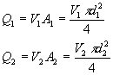
(Assume constant Pressure)
Q -volume flow rate (in³/s)
V -velocity of fuel (in/s)
A- cross sectional area of fuel line (in²)
d- diameter of fuel line (in)
For this calculation it is assumed that V will remain constant, and Q will only increase through an increase in fuel line size.
But flow from injector is limited by the current supplied to the solenoid that opens the plunger and by the hole sizes of the outlet orifices When current is supplied to the plunger a magnetic field is created that pulls the plunger away from the orifice plate allowing fuel flow outwards. Current supply is governed by the ECM and it is generally impossible to alter on a vehicle originally intended for gasoline usage. Thus for electronic as well as flow limited reasons the injectors must be replaced with ethanol-compatible fuel injectors. Injector replacement is also important from a materials aspect, in order to prevent deterioration of the inside of the injectors.
Along with the above, it must be able to provide enrichment during starting to aid in cold starting. Engine control module is modified to increase the pulse width by 30 to 40%. Based on testing, ethanol enrichment requires a 14ms pulse width on the injectors which is reduced back to 6.0ms after 5seconds of engine operation.
6.3 Spark Control
As with fuel injector design and control, fuel injector ignition timing is very important. Dedicated ethanol vehicles must be calibrated for optimal ignition timing. Gasohol (E10) powered vehicles advance ignition timing until knock is sensed by an accelerometer placed on the engine. Vehicles with lower compression ratios can utilize this technology for an ethanol conversion. Vehicles with higher compression ratios of 11.75:1 and 12.0:1 are likely to need the ECM modified to limit spark timing to 15degree advanced - before top dead center (BTDC). This limit is created due to high compression that adds in-cylinder heat and aids in pre-ignition. The pre-ignition will result in knock and lead to damaged engine components.

6.4 Catalytic Igniter Concept

The SMARTPLUG is a self-contained ignition system that may be retrofitted to existing compression-ignition engines. Key design features are illustrated in Fig. 1. The SMARTPLUG consists of a ceramic rod with an embedded heating element and a coating of noble metal catalyst. Cold starting requires up to 25 watts/igniter from an external power source (12 volt), which is no longer necessary after a few minutes of operation at idle. The catalytic core is enclosed in a custom-machined brass shell that forms a pre-chamber adjacent to the main combustion chamber. The shell fits into existing spark plug or direct fuel injection ports. The igniter used in this research has been made specifically for the direct injection ports on the 20-hp engine.



Figure 6.1. SMARTPLUG Catalytic Igniter (US Pat. 5 109 817).
Catalytic ignition in the SMARTPLUG begins as fresh mixture contacts the catalyst during the compression stroke. Because of the reduced activation energy associated with heterogeneous catalysis, this occurs at temperatures far below the normal gas-phase ignition temperature. Combustion products and intermediate species then accumulate in the pre-chamber surrounding the catalytic core. After sufficient temperature is achieved due to compression, multi-point homogeneous ignition results. The mixture is then rapidly expelled through the nozzles at the bottom of the igniter. The nozzles cause the flame torch to swirl and cover the entire combustion chamber in an exceedingly short period of time. The resulting flame pattern is illustrated in Fig. 6.2.

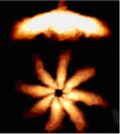 Figure 6.2. SMARTPLUG flame pattern.

Adjusting the location of the catalyst section on the ceramic rod controls ignition timing. To affect an ignition delay, the catalyst must be moved away from the nozzles at the bottom of the igniter. To affect an ignition advance, the catalyst probe must be moved closer to the nozzles. Use of SMARTPLUG technology allows the combustion of very lean fuel/air mixtures in the presence of water vapor.
The outer body of the igniter must be machined to match the combustion chamber opening. The internal volume of each igniter is about 7 percent of the original clearance volume. In the case of the engine, addition of the pre-chamber volume to the top dead center volume reduced the compression ratio from 17.6 to 16.5. The internal diameter of the igniters is .25 in. and the four nozzles present a cross-section larger than the bore.
At present, the process of fabricating the internal parts of the igniter is labor intensive. Platinum wire must be precision wound onto the ceramic rod, and several miniature electrical connections must be made. In order for the igniter to seal properly, the ceramic rod must be bonded to steel feed-through in a vacuum furnace. New designs are being investigated to eliminate many of these steps and to streamline the igniter production.
Pure ethyl alcohol has a gross heating value of 29 MJ/Kg. When diluted to 35 percent water, the mixture has a gross heating value of 19 MJ/Kg. This compares with a heating value of 36 MJ/Kg for diesel fuel. Therefore to maintain a comparable energy input, it is necessary to modify the fuel delivery system to supply nearly twice as much E-diesel as diesel fuel.
E-diesel is environmentally friendly in another important way. Accidental spills biodegrade rapidly in comparison to petroleum-derived fuels, and expensive remediation of spill sites is avoided. For this reason, E-diesel is likely to become a preferred fuel for small watercraft.

6.5 Surface Ignition Timing
Contact angle, and therefore surface ignition, is a function of igniter geometry and compression ratio. Catalytically-assisted ignition in internal combustion engines has two distinct phases. The first phase is catalytic oxidation of the fresh mixture entering the pre-chamber. Provided that the catalyst is above the surface ignition temperature for a given fuel, this begins as soon as the interface between the fresh charge and the residual gas from the previous cycle contacts the catalyst. The second phase is the auto-ignition of the unburned mixture that accumulates in the rear of the pre-chamber. Ideally, the second phase should have a finite and nearly constant duration for all engine-operating conditions. If this is the case, controlling the crank angle at which the fresh mixture contacts the catalyst can set ignition timing.
Since the pre-chamber length greatly exceeds the space between the ceramic rod and the igniter housing, diffusion between the fresh mixture and residual gas occurs slowly, and there is a well-defined interface between the fresh mixture and residual gas throughout the entire compression stroke. Because the nozzle area is approximately the same as the cross sectional area of the pre-chamber, gas dynamic effects during compression are negligible, and the compression ratio in the pre-chamber is the same as the compression ratio in the main chamber. Under these conditions the non-dimensionalized interface position x(θ)/L_{pre} is a function of piston, cylinder, and pre-chamber geometry. This quantity is a function of the non-dimensionalized piston location S_{p}(θ)/L and the compression ratio r:
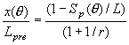………………………………………….... (1)
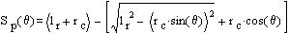………………….. (2)

In Eq. (1) x (θ) is the interface position measured from the CPT nozzles, L_{pre} is the length of pre-chamber. In Equation. (2) S_{p} (θ) represents the piston position measured from top dead center (TDC). L is the stroke, l_{r} is the connecting rod length, and r_{c} is the crank radius. Variables denoted (θ) are a function of theta, which is the crank angle in degrees from TDC.
Figure 3 shows how x (θ)/L_{pre} varies with crank angle for compression ratios of 9:1 and 16:1 in an engine with a bore/stroke ratio of unity. Notice that the interface location is almost identical for both compression ratios. The implication of this is that an igniter optimized for a single compression ratio can be fitted into engines with different compression ratios. This analysis assumes that the fuel composition, equivalence ratio and heat transfer remain unchanged. In previous low-compression engines, the catalyst was located at x/L_{pre} ratios between 0.3 and 0.4. This corresponds to a crank angle at first catalyst contact of more than 90 degrees before top dead center (BTDC). The engine is considerably slower than previously studied spark ignition engines. As such, it would not be surprising if the ideal x/L_{pre} ratio for the catalyst was somewhat higher than 0.4. This corresponds to a shorter igniter core and less ignition advance.

6.6 Gas Phase Ignition Timing
Gas phase ignition, unlike surface ignition, involves factors such as catalyst activity, catalyst reaction rates, densities of both fuel and air and charge energy content. As a first attempt to study gas-phase ignition delays associated with catalytic ignition, the igniter was divided into four zones for a lumped-parameter model. The four zones can be seen in Fig. 4. Each zone is characterized by a single temperature and fuel concentration. Pressure is constant across all zones and is determined solely by piston displacement. Mass is progressively transferred from Zone I to Zone IV as the piston moves upward. The temperature and fuel concentrations in each zone are governed by equations of mass and energy conservation.

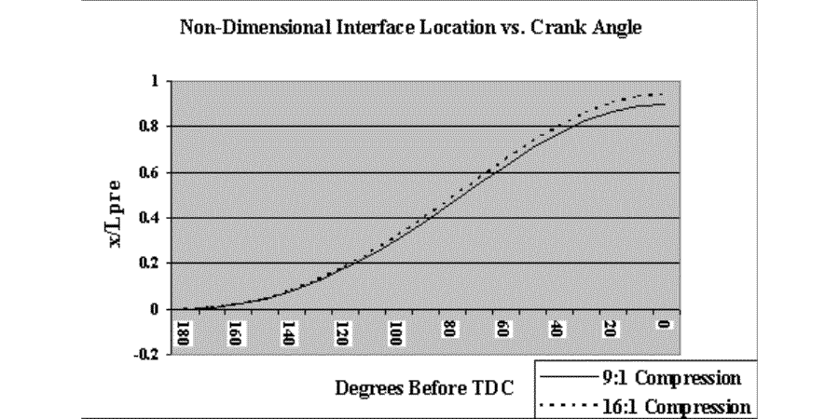

Figure 6.3. Interface location as a function of crank angle.
This model assumes that there is a clearly defined interface between the fresh air/fuel charge and combustion products from the last ignition event. During the compression stroke, the combustion products act like a gas spring. Zone I is the main chamber; Zone II is the region of the pre-chamber that does not surround the igniter core. Zone III is the region of the pre-chamber that surrounds the catalytic portion of the igniter core. This is the only zone
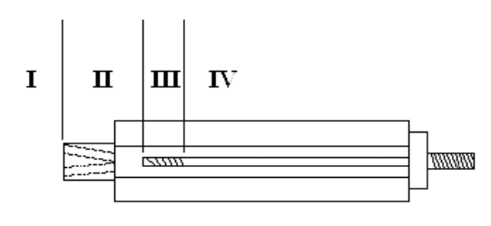

Figure 6.4. Igniter cutaway view with zones for ignition delay calculations.
where catalytic surface reactions take place. Also note that electrical heating is possible in this zone. Zone IV is the region of the pre-chamber that surrounds the non-catalytic portion of the igniter core. This is the only region where gas-phase reactions take place. Gas-phase ignition is assumed to occur when the gas-phase reaction rate exceeds the surface reaction rate.

6.7 Igniter Core Design
Igniter construction poses two major problems: Careful selection of materials that are compatible with the combustion environment and use of methods to streamline construction. The previous design was susceptible to destructive thermal cracking within a short period of use (10 minutes) and often took more than two days to construct. The new design consists of nine parts; all are shown in Fig. 5 except the platinum heating coil. These are assembled to form two main pieces, the electrical feed-through and the catalytic element. The feed-through consists of (from bottom to top in Fig. 5) a body, a pyrofolite washer, a terminal, an alumina washer, and a clamp that holds the terminal and washers in the body to form the gas tight seal. This portion of the igniter is universal and does not vary from engine to engine. The catalytic element consists of a custom alumina extrusion, a platinum heating coil (not shown), a threaded rod that connects the positive lead of the coil to the feed-through, and a conical spring that is used to connect the ground lead of the heating coil. The positive lead goes down the center of the alumina rod and then returns on the outside. A coating of plasma-sprayed alumina is applied over the rod to protect the coil from combustion temperatures, and then platinum paste is applied to the end over the heater. The platinum paste, once cured, serves as the catalytic ignition source. Changing the length of this catalytic element is what controls ignition timing. Currently, new cores must be fabricated to explore different ignition timings.
Finding sources of new materials has been just as important to igniter development as new fabrication techniques have been. The pyrofilite used in the feed-through is a compressible, machine able ceramic. Previous igniters did not use this material, so it was necessary to use an active metal braze (AMB) to form the gas tight seal. The AMB bonded the steel feed-through directly to the alumina rod. Because the process was delicate and lengthy, it would not be feasible for mass production. The AMB also alloyed with the platinum wire in the heating coil and made it extremely brittle. The failure rate of igniters employing the AMB was greater than 75 percent. Sealing defects were eliminated by substituting pyrofilite for AMB in the feed-through. Using a spot welder to attach the positive lead of the heating coil eliminated AMB enbrittlement of the platinum wire.
The final hurdle to overcome in igniter construction was to develop a coating that would protect the platinum heating-coil. This coating needed to be approximately 0.010” thick and uniform in thickness. Several types have been tried, but the most promising is a plasma-sprayed coating of alumina powder. This coating adheres well to the platinum heater wire, but not to the alumina rod at the center. The reason for this is the difference in the melting temperatures of the two materials.

6.8 Engine Design

Several modifications had to be made in order to make the engine compatible with E-diesel fuel. Because E-diesel is somewhat corrosive, stainless steel fuel injectors designed for E85 vehicles were mounted in the intake manifold and polypropylene fuel lines were installed. Removing the diesel fuel injectors yielded a suitable location for the catalytic igniters. With spark ignition engines, the igniters can be placed in the holes designed for the spark plug. A special research head is used with the engine that contains an access port for an in-cylinder pressure sensor. A PCB model 12A piezoelectric transducer was selected for its reliability at high temperatures without requiring water-cooling. An optical encoder manufactured by Encoder Products was used to sense crankshaft position.

With instantaneous pressure and crank angle data available, igniter performance could be monitored and the igniter cores could be adjusted in and out for ideal ignition timing. During the first several hours of break-in when the engine ran on E-diesel, the engine burned an excessive amount of crankcase oil. This was traced to use of conventional piston rings. Conventional rings do not seal at the 150°F temperatures common to engines running on E-diesel. Total seal rings were chosen as more appropriate for this alternative fuels research since they do not rely on thermal expansion to close the gap found in traditional piston rings. Installing total seal rings resolved the oil consumption problem.
Electronic fuel injectors supply fuel to the engine through the intake manifold. The injectors are pulse-width modulated to control fuel flow and are sized to accommodate the elevated flow rates, resulting from the lower energy content of the water fuel. The fuel injectors (Fig. 6) are controlled by a HalTech fuel computer.
The HalTech affords a means by which engine-fueling rates can be adjusted for various loading and operating conditions. Fuel maps can be downloaded from a PC to the HalTech. The fuel computer has several feedback sensors, such as a Hall-effect sensor, to pick up crank location and a throttle position sensor to provide engine speed control. Other sensors used by the HalTech system include an intake air thermocouple and an exhaust oxygen sensor. Unlike engines fueled with diesel or gasoline, an E-diesel-fueled engine can be over-fueled for increased power or run lean for increased fuel economy. This is due to the oxygen present in the fuel.

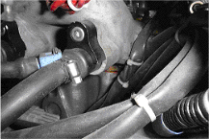

Figure: 6.5 diesel engine intake manifold, fuel injector.

6.9 Cold start problems and technologies

Latent heat of vaporization and vapor pressure of the ethanol fuel are the two main factors responsible for the cold starting. As mentioned earlier latent heat of vaporization of the ethanol fuel is much more than the gasoline and vapor pressure is less than gasoline. During initial startup when the engine is cold the E85 will have less ability to vaporize due to above mentioned reasons. This un-vaporized fuel droplets will remain on fuel injector and create a deposit. This Gum like dark-brown deposit can be removed from the nozzle by 100% pure Hexane. But the permanent solution is to solve the problem that causes deposit.
6.9.1 Heat Storage Units
Engine heat can also be used directly if the heat is stored and used during cold start. A Centaur Thermal Systems heat storage unit performs this task. The Centaur system is originally intended to store hot engine coolant after the engine is shut off and then routed to allow for the hot coolant to enter the engine block upon startup. The volume of coolant is adjustable by the size of the selected Centaur System. Both 5.0 L and 7.0 L units are available. The operation of the system requires that the engine come to full operating temperature which allows the thermostat to open. At this time coolant flows throughout the entire coolant system including the (in series) Centaur system. When the engine is turned off, the power signal is lost to the Centaur control unit which signals the outlet valve to shut. At the same time the Centaur pump fills the system completely full of hot coolant. The hot coolant stored in the Centaur system loses 9degree F/hour which results in 108degree F coolant after a 12 hour rest. Upon starting, the control system can be programmed to accept a key-on or tachometer signal. This signal is used to open both valves in the control unit and activate a pump the pushes the hot coolant into the engine while at the same time pulling the cold coolant out. The hot coolant in the engine block promotes improved atomization of the fuel droplets by preventing in-cylinder quenching that occurs when the droplets contact the cold cylinder walls.

6.9.2 Distillation Systems
The function of a distillation system is to separate the gasoline from ethanol and prevent the need of additional starting fuels. A schematic of the entire system is shown in Figure 5. The fuel enters the distillation column from the fuel tank. Hot engine coolant enters the distillation column and is circulated in coils to vaporize the gasoline. The higher vapor pressure of the gasoline causes the gasoline to vaporize more readily than ethanol and expand. As heat is increased in the distillation column the ethanol will also vaporize and result in a mixture of vapors leaving the column. As it expands, it enters a condenser that cools it back to liquid gasoline and ethanol which are held in a storage tank.

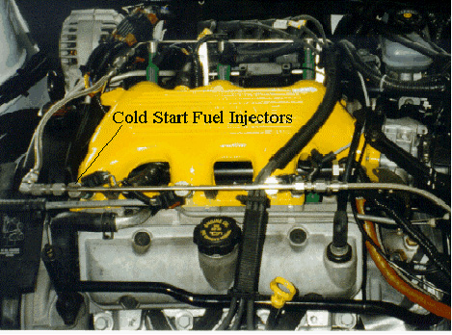
Figure 6.6 - Cold Start Fuel Injectors

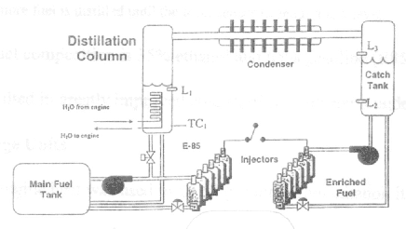
Figure 6.7 - Distillation System
For this system to control the fuel flow, a control module is created and programmed with the following logic:-
1. Fuel enters the re-boiler through a T fitting in the standard fuel line at ambient temperature.
2. The re-boiler is filled to level L₁ where the L₁ sensor detects the fuel level.
3. Approximately 194 – 221 degree F engine coolant passes through re-boiler and heats fuel in the column.
4. Thermocouple sensor (TC), detects the fuel temperature. The logic circuit then controls fuel input/output.
5. If the fuel temperature is less than 140 degree F, heating continues.
6. Distillate vapor passes through the condensing heat exchanger and is collected in the storage tank.
7. The storage tank is filled until level sensor L₃ detects fuel.
8. Once the storage tank level sensor L₃ detects fuel, the distillation re-boiler is purged.
9. Once the distillation column temperature is greater than 140 degree F, fuel is purged and returned to the fuel tank.
10. No more fuel is distilled until the level sensor L₂ reads a low level.
The final fuel composition is 35% ethanol and 65% gasoline (E85). The higher gasoline content resulted in greatly improved cold starting, with starts under 5 seconds.
6.9.3 Fuel Pressure Increases
In addition to heating the fuel droplets, an increase in fuel pressure is needed. Modern fuel injected automobiles operate at 38-43 psi. Increasing fuel pressure will promote increased fuel droplet atomization as it leaves the fuel injectors and thus improve cold starting. Conversion of a gasoline powered vehicle to ethanol will require the use of a fuel pressure regulator that is adjustable from 35 - 90 psi. Tradeoffs between fuel economy, performance and starting ability will have to be considered to determine the appropriate fuel pressure for each vehicle. Minimum and maximum values of 50 and 60 psi respectively are suggested when developing an ethanol powered vehicle. Vehicles originally intended for ethanol usage can be equipped with higher fuel pressure regulators by using springs with a higher spring rate. The material compatibility of these components must be considered before being used as discussed earlier.

6.9.4 POX Reactor:
A system that requires less on-time is a partial oxidation reactor (POX reactor) as shown in Figure 6. The reactor functions by igniting the ethanol and air entering the reaction chamber and being ignited. The heated combustion products from the reactor
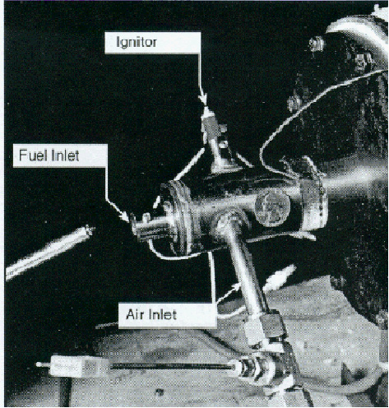
Figure 6.8 - POX Reactor Created by Arthur D. Little Inc.

then enter the air stream to the engine to aid in cold start. This system has been used to achieve smooth cold starts at 0°F in 10 seconds of engine cranking. Isherwood, Linna, and Loftus state that at colder temperatures the cranking time will depend on engine cranking speed which could be improved with the use of the 16 volt battery.

Unit 7

Experimental setup, observation and evaluation of performance Characterstics

The aim of the present work is to study the out comes of the experiment of using macro-emulsion of Conventional Diesel fuel and Ethanol with different concentrations used in a H.S. Diesel by evaluating the performance, combustion and exhaust emission characteristics of a diesel fueled C.I engine. It was also limited to find out the optimal concentration of this Macro-emulsified fuel sample so that it can be directed for the future long run analysis, based on the performance characteristics, also to ascertain whether there was any specific combustion related problem of ethanol fuel with unmodified C.I engine. The various stages of experimentation were planned out as follows.

The experiment initially supposed under the performance characteristics and emission test was to analyze the following engine performance and emission characteristics.
Table 7.1: Engine specifications

Model | Kirloskar
Bore | 80 mm
stroke | 110 mm
Cubic Capacity | 552.92 cc
Length | 531 mm
Height | 356 mm
Weight | 165 kg
Rated Speed | 1300 rpm
Maximum Speed | 2000 rpm
Minimum Speed | 1200 rpm
Minimum Idling Speed | 750 rpm
Nozzle Pressure | 200 bar
Compression ratio | 17:1

With lack of apparatus and some materials related with this experiment, I have managed to perform the test with the following experimental methods.
- To evaluate the relevant performance parameters such as power development fuel consumption rate, brake specific fuel consumption (BSFC), brake specific energy consumption (BSEC), thermal efficiency, and brake mean effective pressure (BMEP) for various samples at different load conditions.
- To find out the optimal concentration of biodiesel in diesel based on the performance characteristics of the engine.
- To measure smoke density experimentally for different blends and comparison with pure diesel operation.
- To analyze the experimental data from biodiesel and diesel fuelled CI engine and comparative evaluation of performance and emission characteristics.
The testing was done in Bio-diesel laboratory, Mechanical Engineering Department, at Delhi College of Engineering, Delhi, Bawana road-42. Engine performance and exhaust emission data were recorded and relevant parameters like Brake power (Bp), Brake Mean Effective pressure (BMEP), Brake Specific Fuel Consumption (BSFC), Brake Specific energy Consumption (BSEC) and thermal efficiency etc were calculated. Based on these parameters, various curves were drawn and compared to base line diesel curve in order to assess the performance of the engine with different samples

7.1 Measurement of Various Parameters

7.1.1 Measurement of Power Output
As it has been mentioned in the introduction part, this experiment's main intention is to see the performance characteristics of the engine with the newly produced fuels from the macro-emulsified of different core fuels. Therefore one way of knowing the performance characteristics is to determine the power output of the engine. This power output helps us to determine other performance characteristics parameters.
Generally there are different methods to measure the power out of an engine. Among them:
- Rope-drum Brake dynamometer
- Hydraulic dynamometer and
- An eddy current dynamometer or Electrical braking device.
As can be seen from the figure, our apparatus is fully mechanical in which the engine is connected with a rope-drum brake dynamometer so that load is applied on the pan weight. The load was applied on the engine by putting weight on the pan and from spring balance reading of resisting force can be noted down. Though eddy current or electrical dynamometer is an accurate apparatus I have used rope-drum brake dynamometer, which is available in our laboratory. In order to help me to get the accurate result, Water flow arrangement was there to cool the drum so that correct reading can be obtained.
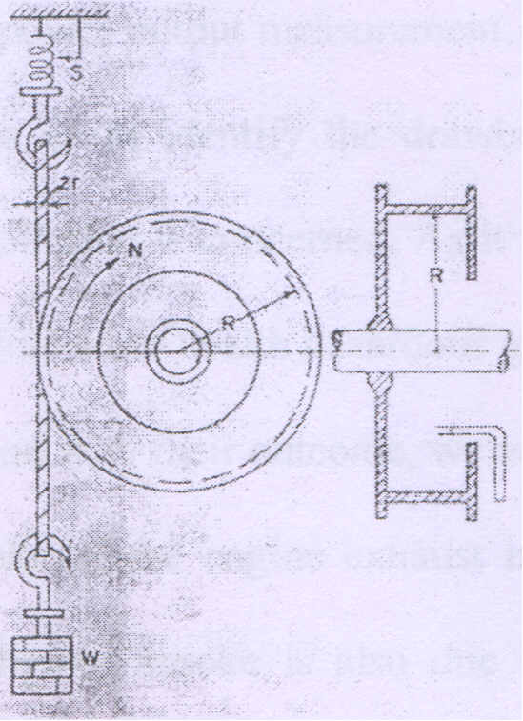

Fig: 7.1 Arrangement of Brake-drum Dynamometer
7.1.2 Fuel Flow Measurement
Measurement of fluid velocity, Flow rate, and flow quantity with varying degree of accuracy are a fundamental necessity in almost all the flaw situations in engineering activiti~s. There are different kinds of fuel measurement techniques used so far. To mention some:

- Venturi meter | - Cylinder and piston
- Flow nozzle | arrangement
- Orifice plate | - Weirs and flumes
- Pitot tube | - Current meters and
- Rota meter | - anemometers etc

Accurate measurement of fuel consumption is very important in engine testing work and simplest method of measurement is to use a glass burette column of calibrated volume measurement. Time taken by the engine to consume the known volume of fuel is measured by a stopwatch. Volume divided by the time gives the volumetric fuel flow rate.

This glass burette column directly attached with the fuel container so that the measured quantity of fuel will pass directly was to the engine. In this case a stopwatch was used to take the time taken by the engine to consume 20ml of fuel of different samples at different loads.

7.1.3 Smoke and Exhaust Temperature Measurement

On the similar manner to the power output measurement, measurement if smoke and exhaust gas temperature helps us to identify the drawback and the quality of the experimental fuels as far as pollution is concerned. As it is widely known, Smoke is the main source of CO2 and some other health hazardous gases. Therefore with a clear determination of these gases and with their outcome, we will be able to know the best fuel for our engine. The smoke of the engine exhaust is a visible indicator of the combustion process in the engine. Smoke is also due to incomplete combustion.
Smoke in the diesel engine, in general, can be divided into two categories viz., blue white smoke and black smoke. The blue- white smoke from the engine is caused by liquid droplets of fuel oil or lubricating oil while it starts from the cold. On the other hand in black smoke carbon particles are suspended in the exhaust gas. It largely depends upon the air fuel ratio and increases rapidly as the load is increased and available air is depleted.

The A VL-437 Smoke meter, manufactured by Mis A VL India Pvt is a widely used apparatus for the indication of the smoke density and the exhaust gas temperature. This equipment has been used in the present work so that we have determined the smoke density. As far as the exhaust gas is concerned, the engine has its own measuring device. Therefore it will be enough to use this device it self.

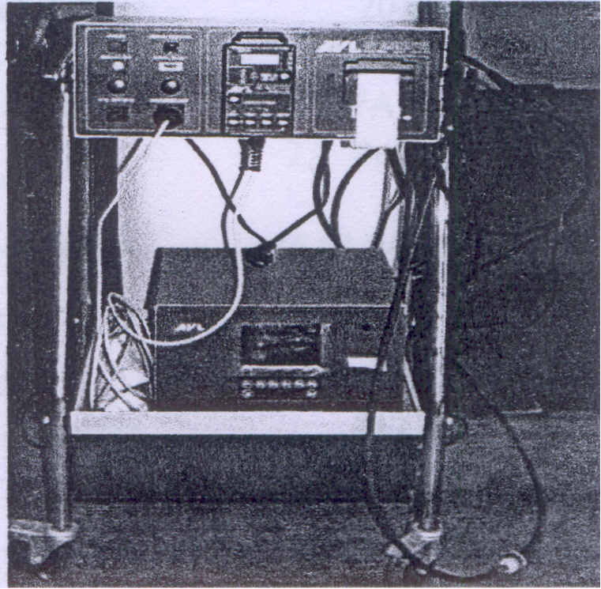

Fig :7.2 smoke density meter( A VL-437 Smoke meter)

7.2 Engine System

As it is known the most engine users in the country are the rural people, in which they used this engine for the cultivation of their agricultural farms utilizing the engine as a tractor for plough their land and as a pump in irrigating their farm land. Therefore we have to select an engine so that it is suitable for rural area. It is a single cylinder, four stroke, direct injection, and water-cooled natural aspirated vertical diesel engine.
Kirloskar India Limited has manufactured the engine, & it develops 5.2 KW power
output at the rated speed of 1500 rpm. This engine is a typical engine of our
requirement.

Below are the specifications of Kirloskar A Vl/TVl/SVl/AK65 water cooled Diesel
Engine where the experiment has been conducted.

No. of Cylinders 1
No. of strokes 4
Fuel H.S. diesel
Cylinder diameter 87.5 mm
Stroke length 110 mm
Compression Ratio 17.5 : 1
Orifice diameter 20mm
Inlet Valve Opens 4.5 degree before TDC
Inlet Valve Closes 35.5 degree after BDC
Fuel Injection 23 degree before TDC
Exhaust Valve opens 35.5 before BDC
Exhaust Valve Closes 4.5 degree after BDC
Rope Diameter 20mm
Drum Brake diameter 347 mm
Pan weight 1.5 kg
Dimension of the engine 617 m x 292 mm x 843 mm

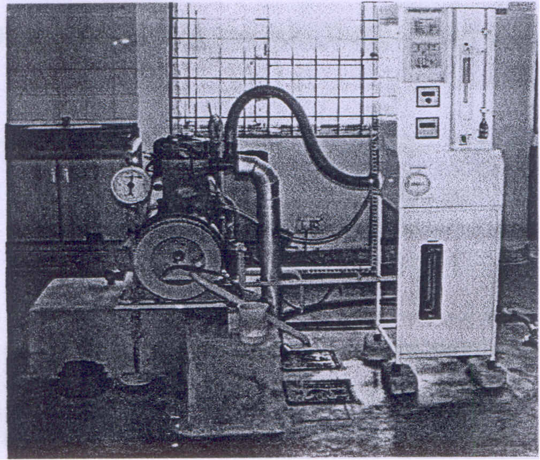

Fig :7.3 Kirloskar A VlrrVlISVlIAK65 water cooled Diesel Engine Set up

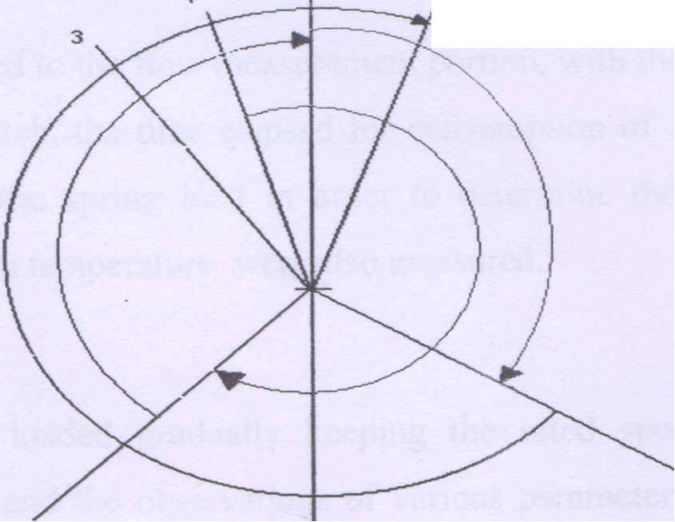
Fig 7.4: Valve Timing Diagram of the engine.

Line 1- Inlet valve opens before TDC: 4.5° Line2- Inlet valve closes after BDC: 35.5° Line3- Fuel Injection starts before IDC: 23° Line4- Exhaust valve opens before BDC: 35.5° Line5- Exhaust valve closes after TDC: 4.5°

7.3 Engine Performance Characteristics Test Procedures

Step 1
The engine was started at no load by pressing the inlet with decompression valve lever and it was released suddenly when the engine was hand cranked at sufficient speed.

Step 2
Feed controlled was adjusted to obtain the engine rated speed and it was allowed to run for about 30 minutes till the steady state conditions reached. To assess the present condition of the engine, a constant speed test with diesel as a fuel was carried out and base line data were generated. Test results with all other fuels were compared with base line data to evaluate the performance of the engine.

Step 3
As it has been stated in the flow measurement portion, with the help of fuel measuring device and stopwatch, the time elapsed for consumption of 20ml of fuel, RPM, the applied load and the spring load in order to determine the effective load, smoke density, exhaust gas temperature were also measured.

Step 4
The engine was loaded gradually keeping the rated speed within variation of permissible range and the observations of various parameter were recorded. Short term performance test were carried out on the engine with various samples.

7.4 Fuel preperation

Many number of the Ethanol-Diesel blends were prepared for taking readings. Characteristics of various fuels such as specific gravity, viscosity. Gross heat of combustion, Flash Point and Carbon residue were tested according to ASTM standards. The characteristics of various fuel sample and diesel fuel have been tabulated in the previous unit.

The fuel samples taken for engine testing are listed as below:

- Pure diesel (100 % neat diesel)
- E05 (5% anhydrous ethanol plus 95% diesel)
- E10 (10% anhydrous ethanol plus 90% diesel)
- E15 (10% anhydrous ethanol plus 85% diesel )

7.5 Theories Used in Calculating the Performance of Engine:

7.5.1 Brake Power Output

- The brake power also termed as shaft power is the actual power available at the drive shaft. As can be seen in Fig 0, the brake power is found by braking the engine. The braking agreement is by a rope brake, or hydraulic device known as hydraulic dynamometer. An eddy current dynamometer is an electrical braking device.
Knowing indicated power by engine indicator, frictional power by a motoring test of the engine, brake power can be obtained. (Pb=Pj-Pf) Which is long proves. Most of the time, the engine is braked by a belt or rope round the flywheel with a hanging load at one end and a spring balance at the other. The brake power is given by:

B p = (W -S)(R +r) 2 π N/60 x 10 ⁻³ Kw

Where:
W = mg = Braking load, N
S = sg = Spring balance force, N
R = radius of Brake Pulley or the flywheel of the engine, m
r = radius of the rope, m
N = engine rpm.
The product (W-S) (R+r) is known as Brake Torque exerted by the braking device
Therefore Brake power = 2 π N T / 60 Kw
Where
T= Brake torque, Nm

7.5.2 Mass Flow Rate of the Fuel
- In the fuel characteristics part I have already obtained the density of each samples of my experiment. In addition to this by the above stated method of measuring the flow measurement has been taken for each sample at different load conditions. Therefore the remaining part is to calculate the mass flow rate by the following relationship.
Mass flow Rate(gm / ml) = Volume Flow Rate( ml /s) x Density(gm /ml)
Here the volume flow rate I have already got is in (ml/second) and the density in (gm/ml) therefore it necessary to convert it in to kg/hr/

Therefore

M = V x px3600Kg /hr
M - Mass flow rate in (kg/hr)
v-Volume flow rate (m ³/sec)
p - Density in (kg/m³)

7.5.3 Brake Mean Effective Pressure

- The torque has a direct relation ship with the brake mean effective mean pressure (bmep), as follows:

Bp = bmep x Lx A x N / 60
Where:
bmep = Brake means effective pressure, Kpa
L=stroke Length which is provided by the engine manufacture, m
A= Area of the piston, in this case, m²
D= Diameter of the Cylinder, similarly it is given by the material manufacturer, m
N= engine RPM
Here N also shows number of working strokes per minute. For a 2- stroke engine, there are N working strokes for N revolutions per minute. For a 4-stroke engine there are N/2 working strokes, for N revolutions per minute of the engine. Therefore the general formula is as follows:
Bmep (kpa) = 60Bp/ LAnK
Bp-Brake Power (kW)
L-Length of Stroke (m),
A-Cross Sectional Area of the cylinder, defined before
n-N/2 for 4-Stroke Engine, and N for 2-Stroke
N-Engine Engine Speed (RPM)

7.5.4 Brake Specific Fuel Consumption (BSFC)

- Brake specific fuel consumption (BSFC) is the fuel consumed by the engine per unit of power out put or produced. It can be calculated as:
The fuel Consumed Per unit time(Kg / hr)
BSFC (kg / Kw-hr) =………………………………………
Brake Power Output(Kw)
BSFC = M
Bp

7.5.5 Brake Specific Energy Consumption

- Brake specific energy consumption (BSEC) is the energy used by the engine to produce unit power. It is the energy input to the system. It is calculated by the following relationship

BSEC(Kj / Kw-hr) = BSFC(Kg / Kw-hr) x Calorific Value(Kj / kg)

BSEC = BSFC x LCV

7.5.6 Brake Thermal Efficiency
- Taking our system as a heat engine, with certain energy input by the fuel, equal to M x LCV, and power output Ph, the over all performance is given by overall efficiency or Thermal efficiency. Brake thermal efficiency is the ratio of the power output of the engine to the rate of heat liberated by the fuel during the combustion.

Sample Name: Neat Diesel (D100)

Table 7.2 Observed Values from Engine Performance Test

S.No |  | Load | Time Taken for | T3 (Exhaust |  | Smoke | Speed
 | Load | Spring Weight | 20ml of Fuel | Gas |  | Opacity | RPM
 | (Kg) | (Kg) | Consumption | Temperature) |  | %
 | (Kg) | (Kg) | (Seconds) | (°C)
I | 0 | 0.98 | 110 |  | 171 | 2.7 | 1580
2 | 2 | 0.62 | 105 |  | 180 | 3.1 | 1570
3 | 3 | 0.68 | 95 |  | 185 | 3.2 | 1565
4 | 4 | 1.20 | 90 |  | 195 | 3.8 | 1560
5 | 5 | 1.75 | 85 |  | 210 | 8.0 | 1555
6 | 6 | 1.92 | 83 |  | 221 | 8.9 | 1545

Table 7.3 Evaluated Values

Applied | Spring | Effective | Brake | Brake | Mass | Brake | Brake | Brake
Brake | Load | Load | Power | Mean | Flow | Specific Fuel | Specific | Thermal
Load | S | (Wt-S) | Ph | Effective | Rate | Consumption | Energy | Efficiency
Wt | N | N | Kw | Pressure | M | BSFC | Consumption | ήth
N |  |  |  | bmep | Kg/hr | Kg/Kw-hr | BSEC | %
 |  |  |  | bar |  |  | KJ/Kw-hr
14.72 | 1.96 | 12.76 | 0.38 | 0.43 | 0.52 | 1.36 | 62856.25 | 5.36
34.34 | 5.89 | 28.45 | 0.85 | 0.97 | 0.55 | 0.62 | 30761.15 | 11.58
44.15 | 6.38 | 37.77 | 1.13 | 1.34 | 0.56 | 0.55 | 23643.16 | 15.95
53.96 | 11.28 | 42.68 | 1.23 | 1.43 | 0.67 | 0.45 | 22135.58 | 16.25
63.77 | 14.72 | 49.05 | 1.54 | 1.74 | 0.68 | 0.40 | 19964.35 | 18.13
73.58 | 17.66 | 55.92 | 1.96 | 1.97 | 0.69 | 0.32 | 17968.84 | 20.48
Sample Name: D95E5

Table 7.4 Observed Values from Engine Performance Test

S.No |  | Load | Time Taken for | T3 (Exhaust |  | Smoke | Speed
 | Load | Spring Weight | 20ml of Fuel | Gas |  | Opacity | RPM
 | (Kg) | (Kg) | Consumption | Temperature) |  | %
 | (Kg) | (Kg) | (Seconds) | °C
I | 0 | 0.16 | 123 |  | 151 | 2.2 | 1582
2 | 2 | 0.41 | 104 |  | 169 | 32 | 1565
3 | 3 | 0.62 | 105 |  | 194 | 3.6 | 1564
4 | 4 | I.1 | 98 |  | 207 | 3.8 | 1559
5 | 5 | 1.26 | 90 |  | 220 | 4.7 | 1560
6 | 6 | 1.69 | 80 |  | 231 | 7.8 | 1557

Table 7.5 Evaluated Values

Applied | Spring | Effecti ve | Brake | Brake | Mass | Brake | Brake | Brake
Brake | Load | Load | Power | Mean | Flow | Specific Fuel | Specific | Thermal
Load | S | (Wt-S) | Ph | Effective | Rate | Consumption | Energy | Efficiency
Wt | N | N | Kw | Pressure | if | BSFC | Consumption | ήth
N |  |  |  | bmep | Kg/hr | Kg/Kw-hr | BSEC | %
 |  |  |  | bar |  |  | KJ/Kw-hr
14.70 | 1.46 | 13.25 | 0.41 | 0.45 | 0.46 | 1.20 | 48752.16 | 7.12
34.33 | 3.90 | 30.40 | 0.91 | 1.07 | 0.54 | 0.57 | 23778.22 | 15.32
44.13 | 5.88 | 38.25 | 1.16 | 1.35 | 0.54 | 0.49 | 19683.32 | 18.12
53.95 | 9.80 | 44.16 | 1.33 | 1.56 | 0.56 | 0.45 | 17955.55 | 20.38
63.76 | 12.25 | 51.52 | 1.56 | 1.82 | 0.62 | 0.43 | 16754.34 | 21.23
73.54 | 15.71 | 57.86 | 1.77 | 2.05 | 0.73 | 0.46 | 16791.34 | 21.58
Sample Name: D90ElO

Table 7.6 Observed Values from Engine Performance Test

S. No |  | Load | Time Taken for | T3 (Exhaust |  | Smoke | Speed
 | Load | Spring Weight | 20ml of Fuel | Gas |  | Opacity | RPM
 | (Kg) | (Kg) | Consumption | Temperature) |  | %
 | (Kg) | (Kg) | (Seconds) | °C
I | 0 | 0.2 | 95 |  | 174 | 3.3 | 1580
2 | 2 | 0.6 | 94 |  | 182 | 3.6 | 1578
3 | 3 | 0.8 | 89 |  | 194 | 4.1 | 1565
4 | 4 | 1.1 | 84 |  | 196 | 3.7 | 1563
5 | 5 | 1.4 | 82 |  | 215 | 4.8 | 1552
6 | 6 | 1.8 | 71 |  | 236 | 11.8 | 1547

Table 7.7 Evaluated Values

Applied | Spring | Effective | Brake | Brake | Mass | Brake | Brake | Brake
Brake | Load | Load | Power | Mean | Flow | Specific Fuel | Specific | Thermal
Load | S | (Wt-S) | Ph | Effective | Rate | Consumption | Energy | Efficiency
Wt | N | N | Kw | Pressure | M | BSFC | Consumption | ήth
N |  |  |  | bmep | Kg/hr | Kg/Kw-hr | BSEC | %
 |  |  |  | bar |  |  | KJ/Kw-hr
14.71 | 1.95 | 12.86 | 0.38 | 0.43 | 0.57 | 1.28 | 63534.78 | 5.65
34.33 | 5.88 | 28.6 | 0.85 | 0.95 | 0.64 | 0.62 | 30492.22 | 11.45
44.14 | 7.86 | 36.28 | 1.08 | 1.26 | 0.62 | 0.48 | 24587.62 | 14.14
53.95 | 10.75 | 43.20 | 1.28 | 1.50 | 0.65 | 0.44 | 21443.28 | 16.95
63.78 | 13.23 | 50.55 | 1.52 | 1.73 | 0.68 | 0.43 | 19416.65 | 18.27
73.57 | 17.64 | 55.93 | 1.65 | 1.93 | 0.75 | 0.40 | 19337.15 | 18.29
Sample Name: D85E15

Table 7.8 Observed Values from Engine Performance Test

S.No |  | Load | Time Taken for | T3 (Exhaust |  | Smoke | Speed
 | Load | Spring Weight | 20ml of Fuel | Gas |  | Opacity | RPM
 | (Kg) | (Kg) | Consumption | Temperature) |  | %
 | (Kg) | (Kg) | (Seconds) | °C
1 | 0 | 0.25 | 120 |  | 160 | 2.7 | 1572
2 | 2 | 0.7 | 110 |  | 170 | 2.8 | 1566
3 | 3 | 0.7 | 120 |  | 86 | 2.9 | 1565
4 | 4 | 0.9 | 98 |  | 186 | 4.5 | 1553
5 | 5 | 1.2 | 82 |  | 218 | 4.9 | 1555
6 | 6 | 1.6 | 81 |  | 225 | 7.8 | 1555

Table 7.9 Evaluated Values

Applied | Spring | Effective | Brake | Brake | Mass | Brake | Brake | Brake
Brake | Load | Load | Power | Mean | Flow | Specific Fuel | Specific | Thermal
Load | S | (Wt-S) | Ph | Effective | Rate | Consumption | Energy | Efficiency
Wt | N | N | Kw | Pressure | M | BSFC | Consumption | ήth
N |  |  |  | bmep | Kg/hr | Kg/K w-hr | BSEC | %
 |  |  |  | bar |  |  | KJ/Kw-hr
14.72 | 2.45 | 12.26 | 0.35 | 0.42 | 0.46 | 1.52 | 54626.56 | 6.20
34.34 | 6.87 | 27.47 | 0.82 | 0.95 | 0.53 | 0.71 | 26743.16 | 13.40
44.15 | 6.87 | 37.28 | 1.13 | 1.35 | 0.54 | 0.55 | 20893.56 | 17.30
53.96 | 8.83 | 45.13 | 1.36 | 1.59 | 0.63 | 0.52 | 19202.16 | 18.50
63.77 | 11.77 | 51.99 | 1.57 | 1.75 | 0.64 | 0.45 | 17841.14 | 20.19
73.58 | 15.70 | 57.88 | 1.77 | 2.15 | 0.69 | 0.45 | 16807.15 | 21.40

7.6 pERFORMANCE cHARACTERSTICS DISCUSSIONS:
The trend of thermal efficiency has generally improved by mixing ethanol with neat diesel. The thermal efficiency of the engine increases as concentration of ethanol is increased. The possible reason for this increase in efficiency may be a more complete combustion since ethanol contains oxygen. Addition of cetane improver might be another reason for improving fuel efficiency.

Though break thermal efficiency increases with increase in ethanol concentration, the rise is steeper in case of the blends having surfactants viz. biodiesel and gasoline. Among two types of blends having surfactant, those with biodiesel perform better with peak thermal efficiency shown by E10B10 blend at full load

which is 5.23% higher, then that for neat diesel. An important observation is that all the blends have higher thermal efficiency than neat diesel.
The break thermal efficiency increases with increase in ethanol concentration. For the same concentration of ethanol, efficiency further improves with increase in concentration of gasoline. It may be because gasoline has high calorific value and acts as good surfactant. All the blends have higher thermal efficiency than neat diesel.
At part loads, break specific fuel consumption for neat diesel is highest and decreases as load increases. At higher loads neat diesel have lower break specific fuel consumption than ethanol diesel blends. As the concentration of ethanol; increases, heating value of fuel decreases. So fuel consumption increases. However, there is also increase in thermal efficiency with increase in ethanol concentration. Therefore, no clear cut trend can be established.
BSFC is not a very reliable parameter to compare the two fuels as the calorific values and specific gravity of the blends follow different trends. Hence Brake Specific Energy Consumption is more reliable parameter. Since BSEC of the given fuel depends upon the quality of combustion process, ethanol diesel blends perform better due to more complete combustion.

From the graph is clear that as the ethanol concentration increases brake specific energy consumption reduces. At higher load the difference in BSEC is less pronounced, may be due to deterioration of combustion quality of ethanol at higher loads. Another observation is that all the samples have BSEC less than that for neat diesel.
It is evident from the observations that all blends produce less carbon monoxide than neat diesel. This is because of more complete combustion because of more oxygen in blends. The relation between mean effective pressure and unburned hydrocarbon emission is exactly same as that of CO emission. At lower value of BMEP (hence lean mixture), HC emissions are substantially low for various blends tested . However, at higher mean effective pressure very step rise in HC emission has been observed due to enrichment of the fuel. The tables show that HC emission for all fuel blends are lower than that for neat diesel.
The graph shows that all the blends emit lesser smoke than neat diesel. This is because of more complete combustion of E-Diesel blends as ethanol contains more oxygen. As ethanol concentration increases the smoke level go down and is least for E10. The result from HC, CO and smoke emission confirm to the finding of researchers working on the use of ethanol in diesel engine. Thus, it supports the claim of ethanol to be a cleaner and eco-friendly automotive fuel.

UNIT 8

Safety and Performance Assessment

Alcohols have much wider flammability limits than gasoline or diesel, making the saturated vapor of alcohol in a fuel tank on a vehicle within the explosive range at ambient temperatures.
The equivalence ratio is a function of temperature and Reid vapor pressure a Reid vapor pressure decreases and temperature increases the flammability limit also increases. The same is true when the temperature decreases and the Reid vapor pressure increases.
If the equivalence ratio of these vapors is between 0.6 and 2.5 the fuels are flammable at atmospheric pressure and ambient temperature.
For this reason it is necessary to have flame arrestors in fuel fill tubes in the event that the static charge of the fuel traveling to the tank from the filling station pump would ignite the vapors in the tank.
8.1 Storage and stability
There is a range of safety issues directly relating to the storage and stability of ethanol blends. However, there is a range of vehicle operability issues that may also have broader safety implications. As a result, this section covers issues that relate to storage and stability of ethanol blends as well as the potential impacts of such blends on general vehicle operability.

8.2 Storage and handling
There are specific storage and handling procedures for ethanol blends at distribution and service stations, these include requirements for: tanks and tank linings, piping and fittings, and pumps and dispensers.70 The Australian Institute of Petroleum is currently developing a code of practice for the storage of ethanol blends. Although some materials used to fabricate storage systems may have evolved over time to accommodate the storage of ethanol and ethanol blends, a recent US study has revealed that some single-walled fiber glass reinforced plastic tanks as well as some gaskets, sealants, adhesives and other component materials, may not be compatible with ethanol.
The major safety risk posed by E-diesel is the increased risk of fire or explosion. Thus, the properties of E-diesel of greatest importance to the safety FMEA are those associated with its combustion. Table 3-1 summarizes many of these properties for an E-diesel blend containing 15% ethanol (E-15). For comparison, the corresponding properties for a typical diesel fuel, ethanol, methanol, and gasoline are also noted. Of particular significance to the FMEA is the observation in the table that E-15 has the same Reid vapor pressure, flammability limits, and flash point (generally the lower flammability limit, or very near it) as ethanol (2, 7). It has the same auto ignition temperature as diesel fuel because the diesel auto ignition temperature is lower than that of ethanol. The properties of only one E-diesel blend are shown in Table 3-1. The E-diesel properties noted above, being the same as for ethanol, would be the same for all E-diesel blends containing 10% or more ethanol, although blends containing less than about 4% ethanol have vapor pressure and flammability characteristics closer to those of diesel fuel. The other properties noted in the table — density, heating values, and latent heat of vaporization — are calculated based on the fraction of ethanol in the blend and the assumption that there is no differential volume change when blending ethanol, additive, and diesel fuel (15 L of ethanol combined with 5 L of additive and 80 L of diesel yields 100 L of blend) and that the additive has the same density, heating value, and latent heat as diesel. Thus, the volumetric heating value (MJ/L) of E-15 is the weighted average (15% ethanol, 85% diesel) of the volumetric heating values of ethanol and diesel. Mass heating values and latent heats factor in component densities. Densities, heating values, and latent heats of other E-diesel blends with different ethanol content can be similarly calculated. Of particular importance to the safety assessment are the flammability limits of E-15, which are the same as ethanol as noted above. Figure 3-1 shows the flammability limit temperature range (range of temperature over which a flammable vapor concentration will exist over the corresponding liquid) for each of the fuels with data in Table 3-1. The figure shows that at temperatures above -20°C gasoline in an enclosed vapor space above the liquid is too concentrated (rich) to be flammable, while diesel fuel at temperatures below 64°C is too dilute (lean) to be flammable. However, the alcohol fuels, including the E-diesel, are flammable at common ambient temperatures above 13°C. This means that, at common ambient temperatures, the vapor in a storage tank or vehicle fuel tank containing E-diesel is flammable or explosive.
All the failure modes defined in the safety FMEA are associated with the risk of fire or an explosion. Many are directly associated with explosions in the ullage of a storage or vehicle fuel tank. All these failure modes apply to one of the various elements of the fuel preparation and storage at the fuel distributor, fuel transportation to the fleet user, fuel storage and dispensing at the fleet fueling facility, and vehicle fuel use process shown in the process flow diagram in Figure

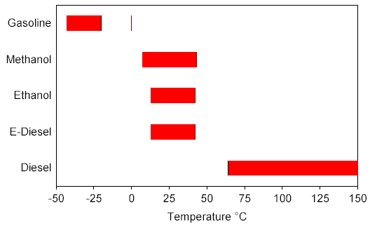

Figure 8.1. Flammability Limit Temperature Range

8.3 Initial FMEA Risk Ranking

Table 3-2 is the completed FMEA worksheet resulting from the initial FMEA identification of potential failure modes, and their causes and effects. Each failure mode combination is numbered and is associated with one of the process elements in the process flow diagram given in Figure 2-1. As noted previously, the main safety concern regarding E-diesel arises from the relatively higher flammability of E-diesel compared to diesel. Ignition of E-diesel fuel leading to an explosion or a pool fire at various points in the fuel chain between bulk storage at a terminal and vehicle operation became the focus of this FMEA.
Following the definition of failure modes, it was decided that a safety risk FMEA be first performed for conventional diesel fuel and gasoline for the defined failure modes. This was deemed a necessary exercise by the FMEA team because it would create benchmarks for assigning relative risk to the E-diesel case. Tables 3-3 and 3-4 are the results of the baseline assessments for diesel and gasoline respectively. In both tables failure modes are ranked in order of decreasing RPN. As can be seen from Tables 3-3 and 3-4, and not surprisingly, the failure modes for diesel in general have lower RPNs than for gasoline. This is a reflection of diesel being a lower combustion hazard.

8.3.1 Gasoline and Diesel Ratings

Risks associated with gasoline and diesel were analyzed throughout the fuel chain from bulk terminal to truck vehicle operation. The risks associated with the fuel itself related to vapors igniting in closed spaces and fuel igniting in open spaces.

The risks of vapor ignitions were considered for vapor spaces in the bulk terminal, tanker truck, underground tank, and the on-board vehicle tank. Occurrence (O) ratings for explosion in tanks for diesel and gasoline typically were 1 or 2 indicating remote to low potential reflecting the fact that vapors in these tanks have little opportunity for forming combustible mixtures.

The effect of failure and the resulting severity (S) ratings for the explosions are, however, always high and are reflected by the high and very-high potential for harm (ratings of 4 and 5). Current controls for either diesel or gasoline fuels in general do not allow the detection and arrest of an explosion. It is not expected to be different for E-diesel either. Consequently, ratings for detection (D) related to explosions were always awarded the highest value of 5 corresponding to non detection.

Table 8.2. Safety Risk FMEA Ratings for Diesel Fuel Use

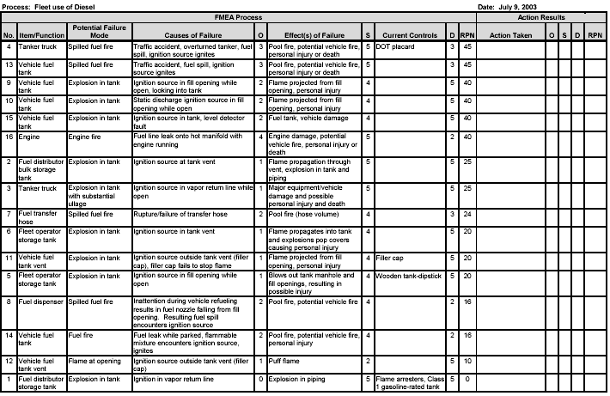

Fuel tanks are typically not exposed to ignition sources, however. Fleet fueling facilities are subject to safety precautions that prevent smoking, idling vehicles, welding, electrical arcs, and other ignition sources. Ignition sources are normally not present near the vehicle fuel tank. Fleet diesel trucks and buses typically do not have in-tank fuel pumps. Possible ignition sources include human error, sparks, or fires from vehicle collisions, or possibly the fuel tank level sensor. Again, the vapor space in fuel tanks is typically not combustible, limiting the opportunity for in-tank vapor ignition. Because of the greater potential to heat up fuel during vehicle operation, scenarios involving explosions in diesel vehicle tanks received an occurrence rating of 2 compared to occurrence ratings of 1 for diesel fuel infrastructure tanks.

8.3.2 E-Diesel FMEA Rating
Table 3-5 presents the results of the initial FMEA rating of the same safety risk failure modes for E-diesel use, again with failure modes ranked in order of decreasing RPN. Some safety related failure modes for E-diesel represented greater risk potential than those for diesel. These failure modes can be grouped into situations involving flammable vapors in closed spaces and fuel leaks or spills in open areas. Fuel vapors in E-diesel tanks and piping typically form a flammable concentration. The presence of a flammable mixture resulted in occurrence ratings of 2 to 4 for the scenarios involving explosions in tanks or piping compared with diesel ratings of 1 to 2. The occurrence rating corresponded to the FMEA team’s assessment of the likelihood of an ignition source being present combined with the flammable vapor concentrations that occur with E-diesel.
The highest occurrence risk appears to be in the vehicle fuel tank. Limited anecdotal experience indicates that ignition leading to an explosion can occur in diesel tanks (perhaps when the truck operator is inspecting the fuel level). Many diesel tanks have very large fill openings (about 3-inch diameter). The large fill opening may provide access for tank maintenance but also provides the careless operator with an opportunity to view the fuel level (perhaps when the level gauge does not appear to work). As a result of this potentially dangerous (and not uncommon) behavior, the occurrence rating for this failure mode for E-diesel (No. 9 in Table 3-5) was raised from 2 to 4 and as a result the RPN increased to 80 compared with 40 for diesel and gasoline. This failure mode resulted in the highest RPN for the E-diesel safety FMEA. Ignition sources other than operator carelessness could also result in an explosion in the vehicle tank. The most likely source of ignition could be a static discharge during fueling when the tank is open. The occurrence rating for a static discharge was estimated to be lower than for operator intervention because there would be opportunities to discharge any potential static charges prior to opening the filler cap.

Flammable E-diesel vapors could pose a significant risk in bulk storage facilities. Igniting a vapor mixture in a bulk fuel facility could result in a piping explosion and possibly affect other fuel storage equipment. Potential ignition sources could reach the piping through a vent or vapor return line from the truck loading rack. Underground E-diesel storage tanks at the fleet operator’s site will contain vapor air mixtures that would be flammable under many ambient temperature conditions. The vapor space would be too lean to burn only when the fuel temperature drops below 13°C. Ignition sources could enter the underground tank either through the vent or the tank opening during filling. E-diesel delivery trucks would operate while containing a flammable vapor mixture that increases in quantity after each fuel delivery. The truck would be sealed while driving on the road and fire safety precautions would be enforced during fuel drops.

Table 8.3. Initial Safety Risk FMEA Ratings for E-Diesel Use

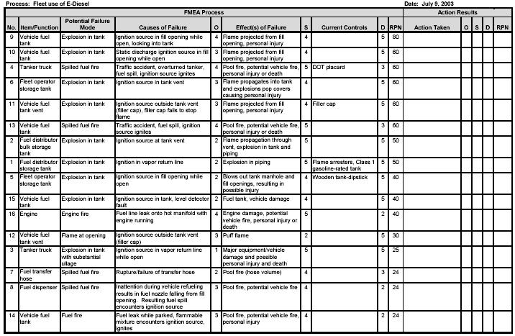

The greatest risk for ignition leading to an explosion would occur during fuel transfers. Because trained personnel who follow safety precautions are responsible for fuel transfers, adding safety measures for fuel delivery trucks would be a lower priority than other steps in the fuel chain. Scenarios involving explosions in the tank caused by a static discharge or ignition source other than operator negligence receive occurrence ratings of 3 and total RPN ratings ranging from 40 to 60 for E-diesel. Overall, explosion related RPNs for E-diesel ranged from 40 to 80, a range twice that for diesel fuel or gasoline use.
Spilled fuel fires resulting from accidents involving tanker trucks or fleet vehicles resulted in the highest RPN for both gasoline and diesel (60 and 45 respectively). For E-diesel use, accident related failure modes were deemed to have the same levels of occurrence and severity as those for gasoline use, with the same RPN of 60. However, the potential for flammable vapors forming with E-diesel spills may be less than that for a gasoline spill. The higher vapor pressure of gasoline combined with a lower lean flammability limit could produce a larger flammable vapor cloud than that formed with the ethanol component of E-diesel vapor. Furthermore, since ethanol represents only 10 to 15 percent of E-diesel, a fuel spill will result in a weathering effect with a smaller vapor cloud forming over time than a pure ethanol spill.

8.4. Performance Assessment

As noted in Section 1, several concerns have been raised regarding potential adverse effects the use of E-diesel may have on engine performance and durability. Ethanol has fuel properties that are different than those of diesel fuel, and does not meet the ASTM D975 specification for diesel fuel. Thus, E-diesel blends may also fail to meet diesel fuel specifications if the additive package does not take this into consideration. Potential associated adverse engine effects could result. Table 4-1 summarizes the specifications for No. 2 diesel fuel, and notes the property values for a typical diesel fuel, for ethanol, and two E-diesel blends, E-10 and E-15. For comparison, properties for methanol, an alternative fuel that was subjected to several demonstration tests in diesel vehicles during the 1980s through early 1990s, are also noted.

The data in Table 4-1 show that ethanol has a much lower cetane number than the diesel fuel specification, so one might expect E-diesel blends to also not meet the specification. However, data on two E-diesel blends show that these blends do meet the specification, most likely because the additive supplier for the blends took the need for a cetane improver into consideration and included a appropriate component into the additive mix. The same could be said for lubricity, as this property for the two blends with data in Table 4-1 not only met the diesel specification, but were comparable to, to superior to typical diesel fuels. The viscosity for the two blends in Table 4-1, while slightly lower than that for a typical diesel, also met the specification. The corrosivity as measured by copper strip corrosion method for the two blends was the same as typical diesel, and also within specification. E-diesel pour points were at lower temperature than for typical diesel, and cold filter plugging point was equivalent.

Table 8.5. Properties Affecting Engine Performance of Several Fuels

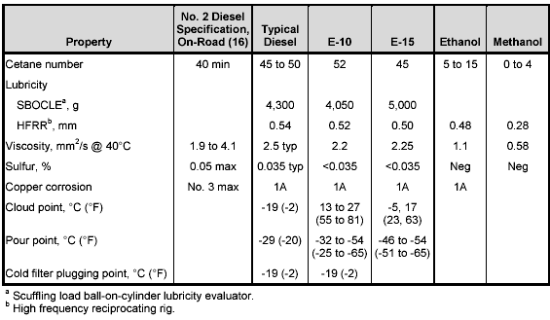

The cloud points for the E-diesel blends were significantly higher than for typical diesel. For diesel fuel, the cloud point is the temperature associated with the formation of wax crystals in the fuel. When the fuel temperature falls below this temperature, problems with fuel filter and other fuel system component clogging can arise. The much higher cloud point for some E-diesel blends in Table 4-1 suggests such problems might arise at typical ambient temperatures. However, clouding in E-diesel blends is thought to be caused by the growth of micelles in E-diesel micro-emulsions to visible micron size range (7). If this were the clouding mechanism instead of the formation of wax crystals, then filter and fuel system clogging problems would not be experienced. The higher cloud point temperatures in Table 4-1 were for blends prepared with emulsifiers (7). The low E-15 cloud point temperature (-5°C) in the table was prepared with an additive the supplier claims is a cosolvent. If the blend were indeed a solution, the micelle growth to become cloudy would not be a mechanism, and lower cloud point, more in keeping with that of diesel fuel would be expected. In any event, for cold flow purposes, cloud point may not be a useful test for E-diesel; cold filter plugging point would be more so.

8.5 Initial FMEA Performance Impact Ranking

Table 4-2 is the completed FMEA worksheet resulting from the initial FMEA identification of potential failure modes, and their causes and effects. Each failure mode combination is numbered and is associated with one on the process elements in the process flow diagram given in Figure 2-1. Many of the concerns noted in Section 1 that could lead to potential adverse engine performance and durability are captured in the failure modes noted in the table.
The performance risk FMEA proceeded in a manner similar to the approach used for the safety risk FMEA discussed in Section 3. Thus, for the performance risk evaluation, occurrence, severity, and detection ratings were assigned for the failure mode, cause, effect, and current controls combinations associated with diesel fuel use first to serve as a baseline from which ratings for E-diesel use could be varied. This would establish the RPN range corresponding to what might be considered acceptable as it reflects current practice. Table 4-3 is the result of this baseline diesel assessment, with failure modes ranked in order of decreasing RPN.
As noted in the table, all failure modes for diesel fuel use have occurrence rankings of either 1 or 2, corresponding remote or low probability because the engine is designed to operate on specification diesel fuel and delivery of off-specification fuel, while it occurs, does so infrequently. Effects having to do with decreased engine power due to off-specification fuel viscosity have negligible to low severity (rating of 1) because variations in fuel viscosity likely to occur would result in potential maximum power output changes that would likely not be noticed. Effects associated with reduced life of easily replaced parts were given severity rankings of low (2). These were felt to be associated with only some annoyance. However, effects associated with the inability of the engine to operate, the replacement of difficult to replace parts such as fuel injectors,

Table 8.6 Performance Risk FMEA Ratings for Diesel Fuel Use

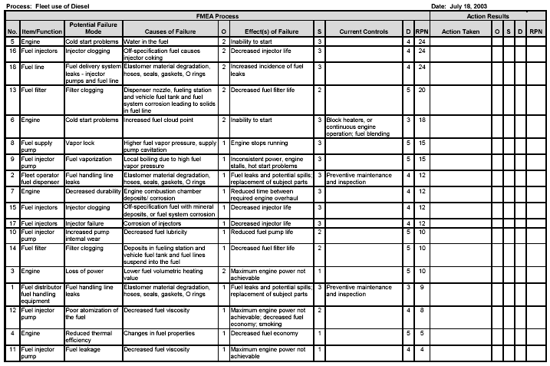

and fuel spills were given severity ratings of moderate (3). These effects were felt to be associated with greater than minor annoyance. Few failure modes had current controls in place, so detection ratings were those for slightly effective or ineffective. Cold start problems could be prevented by fuel blending during periods of expected cold weather, continuous engine operation, or the use of block heaters. These would prevent the effect of the failure in most instances (detection rating of 3). Similarly, a preventive maintenance and inspection program at the fuel distributor would allow relatively frequent detection of elastomer material degradation in fuel handling lines leading to fuel leaks, so a detection rating of 3 was assigned. It was felt that a preventive maintenance and inspection program at the fleet vehicle fueling facility would be less effective. As noted in Table 4-3, the maximum RPN associated with diesel fuel use was 24. This serves as the baseline maximum risk for the reference situation and sets the standard for comparison for the FMEA of the performance risk of E-diesel use. The results of the initial FMEA rating of the same performance failure modes for E-diesel use are summarized in Table 4-4, again with failure modes ranked in order of decreasing RPN. In performing the performance FMEA of E-diesel use starting from the diesel fuel baseline, it was assumed that current controls were not changed. So neither severity nor detection ratings were changed; only occurrence ratings changed because of the replacement of diesel with E-diesel.

The FMEA team believed that there was no reason to expect E-diesel use would have any effect on the probability of increased combustion chamber deposits, increased corrosion of fuel injectors, poor atomization of fuel into the cylinder, or fuel leakage in fuel pumps or injectors, so occurrence ratings for these failure/effects were not changed from the diesel fuel rating, and remained remote (1). There was no reference in the E-diesel literature that substantiated that any of these failures did indeed occur. Similarly, The FMEA team agreed that there was no reason to believe that using E-diesel instead of diesel would increase the frequency of cold start problems due to water in the fuel or increased fuel cloud point (which appears to occur via a different mechanism than diesel fuel clouding as noted above), injector coking, or elastomer degradation in the engine fuel line. Thus, these failure modes retained low occurrence ratings (2). Again, there was no reference in the E-diesel literature that substantiated that any of these failures became more frequent with E-diesel use. The frequency of some failure modes was increased from remote to low. These included:

• Increased fuel pump internal wear due to decreased fuel lubricity; the rating was only increased to low because some blends include lubricity enhancers that would preclude this problem by increasing E-diesel lubricity to levels typical of diesel fuel
• Reduced engine thermal efficiency due to changed fuel properties
• Injector clogging due to mineral deposits or fuel system corrosion products

Table 8.7. Initial Performance Risk FMEA Ratings for E-Diesel Use
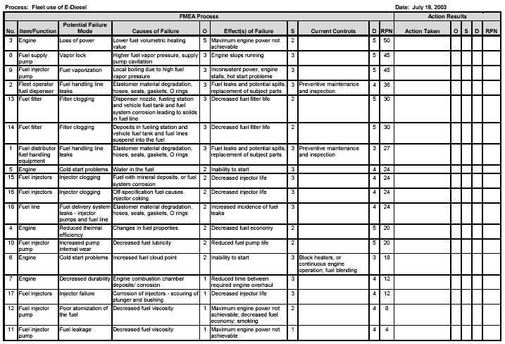

Several failure modes had their occurrence rating increased from remote or low (1 or 2) to moderate (3). These included:
• Fuel distributor and fleet fueling station fuel handling line leaks due to elastomer degradation; the methanol fuel demonstration projects of the 1980s and early 1990s experienced such problems, which could be prevented with methanol-tolerant materials. It bears noting that ethanol should be much less aggressive to elastomers than methanol, and E-diesel, containing only 10 to 15% ethanol would be even less so.
• Fuel filter clogging due to engine fuel system deposits becoming suspended because of the addition of ethanol to the fuel, or fueling station and engine fuel system component corrosion products becoming suspended in the fuel
• Fuel supply pump or fuel injector pump loss of efficiency due to pump cavitation causing vapor lock or local fuel vaporization in injectors One failure mode had its occurrence rating increased from low (2) to certain (5). This was loss of engine maximum power because of the lower volumetric heat content of the E-diesel fuel.
The performance risk ranking in Table 4-4 shows that the most significant failure mode rated was loss of engine maximum power, most heavily influenced by its certainty. Fuel supply pump and injector pump loss of efficiency due to cavitations or fuel vaporization in the injectors were the next highest ranked failures. Other failures ranked moderately high included fuel distributor and fueling station fuel handling line leaks due to elastomer degradation and fuel filter clogging due to suspension of engine fuel system deposits or fueling station and engine fuel system component corrosion. With respect to elastomer degradation, fleet demonstrations to date have not shown that major materials problems occur with E-diesel use (2, 3). However, these demonstrations have not covered all materials in all applications. Consequently the materials compatibility issue remains open until significantly more experience has been developed.

UNIT 9

PAST MISTAKES AND FUTURE SCOPE

Due to the oxygen content of ethanol, ethanol has the potential to significantly lower particulate matter emissions from diesel engines. Unfortunately, this has not been systematically observed since ethanol simultaneously both increases oxygen content and decreases the cetane number of a fuel. In some cases, the adverse impacts of a lower cetane number outweigh the benefits of an increased oxygenate content.

Ethanol high vapor pressure can also lead to both vapor lock and cavitation -leading to performance problems that are often incorrectly attributed to the fuel rather than to the fuel delivery system. To further complicate matters, ethanol has miscibility problems with some types of diesel. Many formulations of ethanol in diesel include emulsifier additives that can add more to the cost of the fuel blend than the ethanol.

This paper summarizes the factors impacting phase behavior and provides procedures for selecting diesel stocks that enhance formation of homogeneous solutions. Safety issues associated with the low flash point of ethanol are also discussed. Finally, the impact on cetane number and approaches for the successful application of cetane improvers are discussed.

Addition of ethanol or similar blend stocks to petroleum-based diesel has been investigated by several researchers. Unlike mixtures of oxygenates with gasoline, mixtures of oxygenates with diesel have not been accepted on a widespread basis as providing performance advantages that justify commercialization.
Eckland et al (1984) present a "State-of-the-Art Report on the Use of Alcohols in Diesel Engines". Techniques that have been evaluated for concurrent use of diesel and alcohols in a compression-ignition engine include (1) alcohol fumigation, (2) dual injection (3) alcohol/diesel fuel emulsions, and (4) alcohol/diesel fuel solutions.

9.1 ETHANOL-IN-DIESEL PHASE BEHAVIOR

As illustrated by Figure l, the phase behavior of the ethanol-diesel system is a strong function of ethanol content and temperature. Most petroleum-based diesel fuels will exhibit the indicated phase behavior. Increasing volatility and increasing aromatic contents will tend to decrease the two-phase region by lowering the curve up to 15 °C-- the curve illustrated by Figure 1 is characteristic of US-2D fuel. Trace amounts of water will sharply increase the two-phase region. Data and models quantifying these trends are available elsewhere.
Based on these trends, the following observations can be made on performance limitations and the best application opportunities:

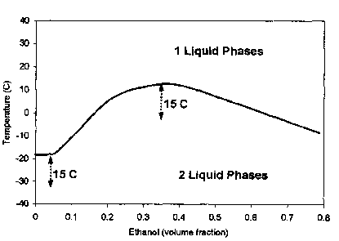
Figure 91. Typical ethanol/diesel phase behavior.

• Lower ethanol concentrations have reduced tendencies toward immiscibility problems,
• At about 5% ethanol (- <0.005% water) in diesel, the low-temperature miscibility limitations are substantially similar to those of the pure diesel, and
• Reduced low-temperature miscibility limits can be achieved by using a diesel with a lower cloud point (winter grades),
By following these guidelines, two-phase regions can be avoided leading to stable ethanol-in-diesel solutions. The primary advantage of solutions over emulsions is the elimination or reduction of costs associated with emulsifiers.

9.2 Vapor Lock and Cavitations
The vapor pressure of an ethanol-in-diesel fuel is considerably greater than that of neat diesel. In addition, the viscosity is lower—the lower viscosity results in a lower static pressure in the fuel delivery system. As a result of these combined traits, ethanol-in-diesel has a significantly greater tendency to evaporate and form erratic locations of vapor lock in the fuel delivery system. This vapor lock will happen at the locations of lowest static pressure, such as the fuel intake of the injector, resulting in too little fuel being delivered to the injector and subsequent cavitations inside the injector. Both the vapor lock and cavitations can be detrimental to fuel performance. To prevent the vapor lock and subsequent cavitations, the static pressure of the fuel delivery system must be increased. This can be achieved by either (1) reducing the size of the restrictive orifice on the diesel fuel return line or (2) introducing a backpressure regulator to the diesel fuel return line. The good performances of ethanol-in-diesel fuels of Table 1 were achieved only after vapor lock problems were corrected.

9.3 Vapor Pressure & Safety - Ethanol high polarity and tendency toward hydrogen bonding cause ethanol to have a high activity in gasoline and diesel. This high activity leads to both limited miscibility and high vapor pressures. In ethanol-gasoline blends (< 20% ethanol), the activity (yixi) of ethanol reaches a maximum of-0.5 at -4% ethanol in gasoline (based on data published in Owen and Coley, 1995)--the activity remains at this level at 2%-20% ethanol in gasoline. Since ethanol has an even higher activity in diesel it would typically have activities between about 0.7 and 0.9 at diesel blending ratios.

The ethanol-in-diesel blends have flash point temperatures estimated to be slightly below typical ambient temperatures; this translates to fuel tanks having ignitable mixtures of fuel and air during most operating conditions. By comparison, vapor spaces of diesel storage tanks are typically too fuel lean for ignition while vapor spaces over gasoline and E85 are typically too fuel rich for ignition. This is a safety issue that should be addressed for both ethanol-in-diesel solutions and ethanol-in-diesel emulsions. One method for solving potential vapor pressure problems of ethanol-in-diesel solutions is to add an additional volatile component to the system so as to increase the vapor pressure into a fuel-rich regime that is outside ignition limits--candidate blend stocks include hexane, pentane, naphtha, and diethyl ether.
Liquid Phase Stability -Based on the phase behavior (Figure 1) of ethanol in diesel, diesel grades (volatility and aromatic) and ethanol contents can be selected that lead to homogeneous fuel solutions; however, this homogeneous phase behavior can and will change when the fuel contacts water. When ethanol-hydrocarbon solutions are initially introduced into a system accustomed to handling gasoline or diesel, the presence of water can cause problems. However, once the free water is removed from these systems, the ethanol-hydrocarbon fuels have increased solubility’s for water and can continuously dissolve small amounts of water, carrying the water through the engine without difficulty. And so, while water can cause problems with ethanol-hydrocarbon fuels, the continuous use of these solutions in a system tends to minimize the likelihood that sufficient water will accumulate to cause problems.

When proper quality control measures are taken, ethanol-in-diesel solutions can be continually used without incident; however, proactive/preventative measures can be of significant value. Such proactive measures are more important in diesel than in gasoline since phase separation in diesel will lead to an ethanol-rich hydrophilic phase that will stall the diesel engine. Ethanol-rich hydrophilic phases of gasoline can continue to power a gasoline engine and avoid stalling.
Two proactive approaches that can lead to avoiding incidents of stalled diesel engines due to phase separation problems include (1) use of hydrophilic cetane improvers that would migrate to a hydrophilic phase (if formed) and boost the cetane to allow the ethanol phase to continue to power the diesel engine and (2) use of emulsifiers that would emulsify a hydrophilic phase formed if water contacts the system. Of these, the emulsifier approach is the most viable since several emulsifiers have been demonstrated and are available for forming ethanol-in-diesel emulsions.

With proactive emulsifier approaches, the application rate can be much lower than is required with typical emulsions. In general, the higher the emulsifier application rate the more water tolerable (toward avoiding engine stalling) the ethanol-in-diesel solution. Emulsifier application rates that provide the proper balance of (1) lower cost with lower application rates and (2) increased protection with higher application rates have yet to be determined and would depend on many factors specific to the application. An ethanol-in- diesel solution that contains an optimal amount of emulsifier would have considerably lower emulsifier costs than ethanol-in-diesel emulsions. As a result of these lower emulsifier costs, the cost of using the fuel would be less and a greater fraction of the cash flow is routed to the ethanol industry,

9.4 Recent developments:
A number of field demonstrations of e-diesel are ongoing or have recently been completed. Only a few of these studies are described here. Marek (2001) recently described several studies and this description is briefly summarized her. In 1999 Archer-Daniels-Midland (ADM) began a test using three new 1999 Mack trucks equipped with Mack E7 engines. Two of the trucks were operated on PEC e-diesel with 15% ethanol (E-15) while the third was operated on diesel as a control. As of this writing these trucks have each accumulated 270,000 miles with no fuel related problems. Fuel economy (mpg) for the e-diesel vehicles was 11% lower than for the diesel truck. A second field test of PEC E-15 was initiated at the Chicago Transit Authority, also in 1999. Fifteen e-diesel buses and fifteen controls were operated for roughly 20,000 miles each.
No fuel related problems were encountered, and fuel economy for the two fifteen vehicle fleets was identical. A number of farm equipment tests have also been reported with no fuel-associated problems. One difficulty with studies of this type is the lack of statistical analysis, a particularly important requirement for field demonstrations because of the relatively high uncertainty associated with real-world data. There are several other ongoing field demonstrations, but those described above are illustrative. While the field demonstrations strongly suggest that e-diesel will not cause engine durability problems, they do not eliminate the need for more carefully controlled laboratory durability studies of engines and engine components. A 500-hour durability test using PEC 15% e-diesel was recently completed by the University of Illinois (Hansen, et al., 2000) using a Cummins B5.9 engine. Because the expense of running a controlled study was too great (i.e. running two 500-hour durability tests in parallel) the study relied on examination of engine components for abnormal wear and analysis of the lubricant for abnormal levels of wear metals. The study found that e-diesel promotes abnormal wear and corrosion on certain parts of the Bosch fuel pump and fuel injectors. There was also a materials incompatibility problem with an electronic sensor on the fuel pump. The excessive fuel pump wear was thought to be caused by excessive backlash in the timing device because of high fueling rates, and thus may have been caused by the lower energy content of the e-diesel. On the positive side there was no increase in metal contaminants in the lubricant and use of e-diesel appeared to reduce the amount of injector nozzle coking relative to petroleum diesel.

To facilitate large-scale commercialization of e-diesel, major vehicle and parts manufacturers must warrantee their products for use with this fuel. Engine manufacturers warrantee the materials and workmanship of their engines, and are able to void the warranty if certain fuels are used in an engine that was not designed for them. The same is true for individual engine parts, such as fuel injectors. Therefore, it is important to gain acceptance of e-diesel by engine manufacturers for warranty coverage. It seems likely that a fuel will have to have a significant number of users before engine manufacturers will become interested in considering warranty issues. The materials compatibility and durability testing requirements suggested above are required so that the ethanol and e-diesel community can provide potential customers with assurance that e-diesel will not harm their engines, and as the initial data for convincing the engine manufacturers that the fuel should not void a warranty.

Top of Form
MIT scientists are exploring the use of ethanol direct injection (DI) to support the use of small, highly turbocharged engines with substantially increased efficiency as a downsizing strategy to reduce fuel consumption and emissions.
The researchers project that ethanol DI could result in a part-load efficiency increase of 30% relative to conventional port-fueled injection engines. The proposed direct injection approach could thus potentially provide a more cost-effective alternative to current generation gasoline-electric hybrids and turbo diesels.
The foundation of the approach is the enhanced knock suppression resulting from such a use of ethanol, which could allow for more than a factor of two increase in manifold pressure relative to conventional, while also supporting an increase in compression ratio.

9.5 Alcohol in Diesel Engines
Alcohol, especially ethanol or ethyl alcohol, has been recognized as a quality motor fuel, since the design of the first automobile (The original Ford Model-T) for the spark-ignition engine because of its high anti-knock value designated by the " Octane Number" and better performance in terms of power and efficiency. It is only recently (since 1970's) interest was shown on the use of ethanol and methanol as diesel fuels. Alcohols are very difficult to burn by compression-ignition because of its low ignition quality usually designated by a low “Cetane number". It is to be emphasized that a high-octane fuel (a virtue for a petrol engine), necessarily has a low cetane value (a curse for the diesel engine). The main research in diesel-alcohol technology was to find ways and means to force alcohol to ignite by compression in the diesel engine.
It is interesting that India was the earliest to recognize the merits of burning ethanol in diesel engines. The bi-fuel system developed by the German Professor H.A.Havemann & his colleagues at the Indian Institute of Science (IISc) Bangalore, in the early 50's, is the earliest original published work in technical literature regarding alcohol diesels. Essentially, this method involves giving carburetor benefits to a diesel engine. Part of the fuel-energy is supplied by inducting ethanol through a carburetor, while only a small quantity of diesel fuel is injected in the conventional injection system. Since alcohol and diesel oil (unlike petrol which can be blended) do not mix, these fuels are sent through two different routes-by induction and injection. Injected fuel, which is a smaller quantity, only serves as an ignition source like millions of distributed spark plugs. By a proper choice of injected fuel, either diesel oil or vegetable oil, a large portion of ethanol from 40 to 90% can be utilized by this method. This pioneering technique did not attract wide spread application since the availability of petroleum fuels eased off and there were no environmental constraints on the use of diesel oil in those days.
Similar approaches were concurrently investigated in the US and UK, but they did not use alcohol. Called by an attractive terminology “Fumigation", Professor Paul Schweitzer of Penn State University, fumigated the induction system of a diesel engine with different volatile fuels, while injecting conventional diesel oil to improve the air utilization of the diesel engine and boost up the power. In an impressive SAE publication on "Hybrid Engines", Professor Schweitzer referred to the research efforts at Bangalore on the novel attempts to burn a low-cetane fuel like alcohol by "fumigating" it to the induction manifold. Pennsylvania State Railway also showed interest to use this method for utilizing alcohol in diesel locomotives. The UK experiences in King's college were aimed at improving combustion characteristics of a diesel engine by introducing small quantities of “Secondary fuels" in the induction manifold and promote smooth pressure rise and low emission of smoke. Beyond the different names adopted, the Indian, USA and UK efforts were all directed to improve diesel combustion and promote use of alternate fuels. It was only the Indian researchers who directed their work on ethanol as partial substitution of diesel fuel using this bi-fuel approach

9.6 Recent Advances in Alcohol Fuel Diesel Technology
IIT Madras is credited with research on the use of alcohol as a sole fuel. Ignition of alcohol on catalytically activated surface in the combustion chamber has enabled its use as a sole fuel. Many results of collaborative work of IIT Madras and Santa Clara University as well as Technical University at Aachen, Germany have become important source of reference for research. Detroit diesel engines working on two-stroke principle used another novel method for force-igniting methanol by hot exhaust gases held back & trapped by partially closing the gate of the turbocharger (recently, this method is also extended to ignite CNG in the diesel engine). MAN diesel buses were tried on neat methanol by hot surface ignition- a method favored by researchers at IIT, Madras. Professor R.K. Pefley, director of Alcohol Energy System, Inc, invited the Indian team to exchange their experiences with the US efforts. IIP Dehradun took a leading role in exchange of alcohol fuel technology in several workshops conducted by them in collaboration with IIT Madras and the Santa Clara University.
Making emulsions of ethanol in diesel fuel by the use of surfactants is an accepted practice in Sweden. Ethanol with ignition improvers has now become an established bus fuel. The Swedish company, Sekab, works in these areas and manufactures this fuel called Etamax D as a sole fuel. Blends of 85% diesel and 15% ethanol under the propriety name Etamix D are also made. In sum, ethanol fuels and ethanol blends are environmentally clean fuels derived from renewable sources like sugar cane molasses and cellulose from bagasse. India can well start diesel-alcohol programmes on fleet buses, locomotives and stationary engines using the potential of IITs, IIP and the Universities. Expertise already developed in India are already used in other places of the globe!

9.7 Ethanol-Diesel Vehicles and Road Trials at IIT Madras
The pioneering experience at IISc, promoted many follow-up investigations at various centers in India- IITs, Universities (especially college of engineering, Guindy) and CSIR research laboratories (IIP). There are significant agreement on the advantages of this method - about 10 to 15% boost of power because of better air utilization and improved charge efficiency arising out of the inflow of cooler charge, increased thermal efficiency and lower smoke density only in certain ranges of load and speed. More significantly, absolute or anhydrous alcohol was not required for fumigation in contrast to blending practice for petrol engines. Anhydrous alcohol is expensive. Rectified spirit as it is could be used for diesel engines. Water indeed proved as a blessing in disguise since the much-blamed nitric oxide emissions characteristic of diesel engine reduced because of water in the alcohol and the low combustion temperatures caused by high latent heat of alcohol.
Vehicle diesel engines are variable speed engines and to reap maximum advantage of fumigation, the ethanol must only be fumigated into the induction system in a controlled way after ascertaining the load and speed at which low smoke; high volumetric and thermal efficiencies were possible. In the year 1980, researchers at IIT Madras, embarked on a collaborative project with the erstwhile Standard Motor Company and Carburetors Ltd on the vehicular application of ethanol in diesel vehicle by fumigation and conduct the road trials. This alcohol-diesel powered vehicle (Standard 20 microbus) was demonstrated in the exhibition held by at Pragati Maidan, New Delhi. The results were presented and published in the International SAE Congress and exposition at Cobo Hall Detroit during February 1981. Experiments and the results are briefly results summarized below. (Details are documented in the Special Publication SP-480 of SAE on alternate fuels).
The heart of the technique was a specially designed air-alcohol inductor, which was designed after extensive tests on a laboratory dynamometer. A rudimentary sketch explains the novelty of this gadget. Under starting and idling conditions, the throttle of the single jet carburetor is closed and there is no flow of alcohol and the vehicle works on neat diesel oil. Note that the throttle in the air arm is fully open when the throttle in the carburetor arm is fully closed. They are complementarily ganged. Together they are linked by a flexible coaxial cable to the control lever of the diesel injection system, which in turn is linked to the accelerator pedal. The relative sizes of the venturi and the carburetor jet and its position relative to the venturi are designed such that the jet does not allow any alcohol till the predetermined speed compatible to efficiency and smoke number (as determined by the static dynamometer tests) is reached. At speeds higher than this there is automatic controlled flow of pre-determined alcohol flow conducive to the fuel efficiency and low smoke number. This technique permits complete working on diesel fuel in case of disruption in the supply of alcohol.
Road trials with the retrofitted diesel vehicle indicated that unto 45% of diesel oil substitution was possible under transient conditions of driving on our roads. Bi-fuel systems can be introduced without major changes in the vehicle hardware excepting that two tanks are needed. Material compatibility with alcohol fuels has already been solved, just as in the case of petrol engines. This system, while admirably suited to stationary engines, works on maximum alcohol substitution on diesel locomotives, which run at high speeds and constant load for long distances. Rectified spirit instead of anhydrous alcohol can be used. Fueling for fleet vehicles can be done without major changes in fuel supply and distribution infrastructure

CONCLUSION

Ethanol has properties antagonistic to the requirements of diesel engines, best way to use it is to blend it with diesel fuel. Ethanol is an important alternative not only for petrol engines but also for diesel engines because of its advantageous properties. Ethanol-in-diesel solutions provide an effective approach in reducing particulate matter emissions in diesel engines, and ethanol may be the most cost effective oxygenate for this application.

Based on the results of trials on compression ignition engine using ethanol diesel fuel blends and its analysis, with the help of relevant literature, it can be concluded that ethanol can substitute diesel fuel partially for the existing conventional diesel engine without requiring any major engine modifications. The important conclusions drawn from present project work are:
- The ethanol- diesel fuel blends have lower values of specific gravity, calorific value, kinematic viscosity and flash point vis-a -vis neat diesel due to presence of ethanol in these blends.
- Overall ethanol- diesel blends performed better than neat diesel. Ethanol - diesel blends showed better thermal efficiency and reduced emissions as compared to neat diesel.
- Of the two blends prepared using bio-diesel as surfactant, the one with 10 % of ethanol and bio-diesel was better.
- Maximum reduction in carbon monoxide, unburned hydrocarbon and smoke Percentage
- Substantial reduction in brake specific fuel consumption and brake specific energy consumption vis-à-vis neat diesel.
- Properties in close proximity with that of neat diesel, except for calorific value. Thus, it gave somewhat higher fuel consumption rate than neat diesel.
On the basis of experiment conducted, it can be concluded that EIOB10 i.e. the fuel sample containing 10% ethanol and 10% bio-diesel along with diesel can be successfully utilized in conventional diesel engine. It could best meet the challenges as has shown the best result in terms of performance and emission reduction.

However, unlike most fuel additives and blend stocks, the benefits of ethanol-in-diesel may not be realized by simply adding ethanol to the diesel for use in an unmodified diesel engine. A multitude of pitfalls exist with the use of ethanol in diesel solutions, fortunately, these pitfalls can be overcome with low or no incremental cost. To avoid miscibility problems, anhydrous ethanol must be used and its application rate should be determined based on the volatility and aromatic content of the diesel blend stock as well as the ambient temperatures where the fuel is to be used. The diesel fuel delivery system should be modified to provide increased fuel pressures at the injector pump inlet--this often translates to placing a smaller restrictive orifice or a backpressure regulator at the diesel fuel return. Cetane improvers should be added as necessary to keep the cetane number more than 40 and emulsifiers should be added as a proactive measure for preventing phase separation if the fuel inadvertently contacts water. Over-sized fuel injectors may also be necessary to compensate for the lower heating value of the ethanol blend so as to avoid reduced maximum power abilities of the engine. Finally, operators should be aware that the ethanol blends may have reduced flash points that can increase fire and explosion hazards--additional blend stocks can be added to avoid this potential problem.
1. The energy content of ethanol will be its most limiting factor in acceptance for fuel economy and performance reasons.
2. Cold start and emission technologies are the most important technologies to develop as related with ethanol usage. Systems such as heating grids and hydrocarbon traps have proven to be effective solutions to both areas of interest.
3. Performance is greatly limited by the NO_{X} emissions created by high compression ratios. Adequate performance can be achieved but cannot be adequately utilized if emissions equipment is not utilized. If emissions can be controlled compression ratios of 11.0 to 12.0 should be used in dedicated ethanol vehicles.
4. Gasohol vehicles modified for dedicated E85 usage must have full emissions modifications to reap the benefits of using a clean air fuel.
5. Do not overlook safety issues involved with ethanol as they are different than those for E10.
REFERENCES
- Scheller, W, A., .and Mohr, B, J. "Gasoline Does Too, Mix with Alcohol" Chem. Tech October 1977.
- Sunggyu, Lee, Alternative Fuels, Taylor and Francis, 2001, pp. 423.
- Renewable Fuels, One Massachusetts Avenue, N.W.
- Author unknown, America’s First, Draft Edition, pp 29.
- Lorenzetti, M, S, Alternative Motor Fuels A Nontechnical Guide, PennWell Publishing Company, 1996, pp 5-13.
- Bryner, Gary, C., Blue Skies Green Politics The Clean Air Act of 1990 and Its Implementation, 1995, Congressional Quarterly Inc.
- Jehlik, Forrest, Jones, Mark, Shepherd, Paul, Development of a Low-Emission, Dedicated Ethanol-Fuel Vehicle with Cold-Start Distillation System, 1998.
- Ryuji, Dalberg, Futami, Henrich, Heriot, Johnson, Kittleson, Messner, Postigo, Quade, E85 2001 CHEVROLET MALIBU: A Conversion by Mankato State University for the "2002 Ethanol Vehicle challenge", 2002.
- Arthur D. Little Inc., Partial Oxidation for Improved Cold-Start in Alcohol Fueled Engines, 1996, NREL.
- Isherwood, Linna, Loftus, Using On-board Fuel Reforming by Partial Oxidation to Improve SI Engine Cold-Start Performance and Emissions, SAE Paper 980939.
- Williams, Patil, Hertl, By-Pass Hydrocarbon Absorber System for ULEV, SAE Paper 960343.
- Noda, Takahashi, Mizuno, In-line Hydrocarbon (HC) Absorber System for Cold Start Emissions, SAE Paper 970266.
- Yaws, Carl L, Handbook of Vapor Pressure, Volume 3, Gulf Publishing Company, 1994, pp 118.
- Goodger, E, M, Alternative Fuels Chemical Energy Resources, Halsted Press, 2002, pp 96.
- Sriram, Bata, A Performance Study of Iso-Butanol-Methanol-, and Ethanol-Gasoline Blends Using a Single Cylinder Engine, SAE Paper 932953.
- Black, Frank, An Overview of the Technical Implications of Methanol and Ethanol as Highway Motor Vehicle Fuels, SAE Paper 912413.
- Ahmed, I., Marek, N.J., 1999. The oxy-diesel project: an ethanol-based diesel alternative. In: Paper presented at National Conference on Ethanol Policy and Marketing, Las Vegas, NV. Battelle, 1998.
- Flammability limits for ethanol/diesel blends. Final Report prepared by Battelle, Columbus, OH, USA. Boru., P.A., Schwab, A.W., Goering, C.E., Pryde, E.H., 1982.
- Evaluation of diesel fuel–ethanol micro emulsions. Trans. ASAE 25 (1), 47–53. Bosch, 2001. VP44 endurance test with E diesel. Internal Report No. 00/47/3156, Robert Bosch Corporation, Farmington Hills, MI, USA. Brink, A., Jordaan, C.F.P., le Roux, J.H., Loubser, N.H., 1986.
- Carburetor corrosion: the e.ect of alcohol–petrol blends. In: Proceedings of the VII International Symposium on Alcohol Fuels Technology, Paris, France. de la Harpe, E.R., 1988.
- Ignition-improved ethanol as a diesel tractor fuel. Unpublished MSc. Eng. Thesis, Department of Agricultural Engineering, University of Natal, Pietermaritzburg, South Africa. Desantes, J.M., Arr_egle, J., Pastor, J.V., Delage, A., 1998.
- Influence of the fuel characteristics on the injection process in a DI diesel engine. SAE Technical Paper 980802.
- Donahue, R.J., Foster, D.E., 2000. E.ects of oxygen enhancement on the emissions from a DI diesel via manipulation of fuels and combustion chamber gas composition. SAE Technical Paper 2000- 01-0512.
- Gerdes, K.R., Suppes, G.J., 2001. Miscibility of ethanol in diesel fuels. Ind. Eng. Chem. Res. 40 (3), 949–956. Hansen, A.C., Vosloo, A.P., Lyne, P.W.L., Meiring, P., 1982. Farmscale application of an ethanol–diesel blend.
- Agric. Eng. S. Afr. 16 (1), 50–53. Hansen, A.C., Mendoza, M., Zhang, Q., Reid, J.F., 2000. Evaluation of oxydiesel as a fuel for direct-injection compression–ignition engines. Final Report for Illinois Department of Commerce and Community A.airs, Contract IDCCA 96-32434.
- Hansen, A.C., Hornbaker, R.H., Zhang, Q., Lyne, P.W.L., 2001. Onfarm evaluation of diesel fuel oxygenated with ethanol. ASAE Paper No. 01-6173. ASAE, St. Joseph, MI. Hardenberg, H.O., Ehnert, E.R., 1981.
- European Fertilizer Manufacturers’ Association (EFMA), 1995, Best Available Techniques for Pollution Prevention and Control in the European Fertilizer Industry, Booklet No. 4: Production of Phosphoric Acid, Brussels, Belgium.
- European Fertilizer Manufacturers’ Association (EFMA), 2000a, Best Available Techniques for Pollution Prevention and Control in the European Fertilizer Industry, Booklet No. 1: Production of Ammonia, Brussels, Belgium.
- European Fertilizer Manufacturers’ Association (EFMA), 2000b, Best Available Techniques for Pollution Prevention and Control in the European Fertilizer Industry, Booklet No. 5: Production of Urea and Urea Ammonium Nitrate, Brussels, Belgium.
- European Fertilizer Manufacturers’ Association (EFMA), 2000c, Best Available Techniques for Pollution Prevention and Control in the European Fertilizer Industry, Booklet No. 2: Production of Nitric Acid, Brussels, Belgium.
- European Fertilizer Manufacturers’ Association (EFMA), 2000d, Best Available Techniques for Pollution Prevention and Control in the European Fertilizer Industry, Booklet No. 6: Production of Ammonium Nitrate and Calcium Ammonium Nitrate, Brussels, Belgium.
- Flessa, H., and P. Dorsch, 1995, “Seasonal Variation of N2O and CH4 Fluxes in Differently Managed Arable Soils in Southern Germany,” J. Geoph. Res., 100:D11, 23.115–23.124.
- Food and Agriculture Organization of the United Nations, 1999, Current Trends in the Production, Trade and Consumption of Chemical Fertilizers, Statistical Analysis Service, Statistics Division, Rome, Italy, Sept.
- General Motors Corporation, Argonne National Laboratory, BP, ExxonMobil, and Shell, 2001a, Well-to-Wheel Energy Use and Greenhouse Gas Emissions of Advanced Fuel/Vehicle Systems: A North American Analysis, Volume 1, Executive Summary Report, ANL/ES/RP-104528, June.
- General Motors Corporation, Argonne National Laboratory, BP, ExxonMobil, and Shell, 2001b, Well-to-Wheel Energy Use and Greenhouse Gas Emissions of Advanced Fuel/Vehicle Systems: A North American Analysis, Volume 2, Report, ANL/ES/RP-104528, June.
- General Motors Corporation, Argonne National Laboratory, BP, ExxonMobil, and Shell, 2001c, Hydrocarbon Processing, 1999, “Hydrocarbon Processing’s Petrochemical Processes 1999,” March, pp.92–96.
- Hydrocarbon Processing, 2001, “Hydrocarbon Processing’s Petrochemical Processes 2001,” March, pp.136.
- Intergovernmental Panel on Climate Change (IPCC), 1996, Revised IPCC Guidelines for National Greenhouse Gas Inventories: Workbook, London, U.K., p.2.15–2.16.
- Intergovernmental Panel on Climate Change (IPCC), 2001, Climate Change 2001: Impacts, Adaptation, and Vulnerability, London, U.K.
- Kaiser, E-A. and O. Heinemeyer, 1996, “Temporal Changes in N2O-Losses from Two Arable Soils,” Plant and Soil 181: 57–63. September 2003 • NREL/SR-540-34817
- L.R. Waterland, S. Venkatesh, and S. Unnasch TIAX LLC Cupertino, California K. R. Gerdes and G. J. Suppes, “Miscibility of Ethanol in Diesel Fuels,” Ind. Eng. Chem. Res. Vol. 40, p 949, 2001.
    - C. Hansen, P.W. L. Lyne, and Q. Zhang, “Ethanol-Diesel Blends: A Step
Towards Bio-based Fuel for Diesel Engines,” ASAE Paper No. 01-6048, July 2001.

Website References :

- www.siamindia.com
- www.altenergy.com
- www.blonnet.com
- www.asae.org
- www.petroleum.nic.in
- www.aaetech.com
- www.aces.uiuc.edu
- www.illinoisbiz.biz
- www.ethanolindia.net
- www.responseonline.com
- www.pure-energy.com
- www.surfactants.net
- www.ethanol.org
- www.blonnet.com

