ABSTRACT

Web portals are implemented in various platforms, technologies and content repository standards. Virtually they integrate data from content repositories, RDBMS and even from other portals. Standards and infrastructures such as SOA [24], Web services [22], Web content Management System, Content repository, Content Frame work [3], Content workflows have to be designed for developing interoperable web portals. National portal of India is a citizen centric portal which provides a unified interface/gateway for accessing Central, State government department web portals.

Presently the National portal of India and its state of art technologies facilitates only URL based integration with the other state and departmental portals. A detailed study and analysis was carried to evolve common portal frame work architecture [2] to facilitate efficient content integration and interoperability. Based on the above architecture, a system called Metadata Producer and Harvester has been designed and developed for seamlessly integrating all State government web portals with National Portal (at national level) and state department portals with State portal (at State level). Moreover using this system, all government portals could exchange data between them using a common metadata standards and semantics. Thus the interoperability between government portals is enhanced.

Metadata producer is a web service based data provider for providing metadata of qualified web portal content using common standard. The tool adopts standards like XML, XML Schema [6], Dublin Core metadata description, SOAP(Simple Object Access Protocol) [6], WSDL(Web Service Description Language) [22], OAI-PMH protocol [20] .

Metadata Harvester is an application responsible for collecting all metadata from various Metadata producers on incremental basis and stores in its Metadata repository which is integrated with National Portal of India. Harvester application is implemented as java application and configured as operating system scheduled job to harvesting metadata in routine. Since it is using date and time stamp, it can resume the harvesting activity and capture metadata during any kind of failure.

- Introduction

Web portals provide seamless access to heterogeneous data resources like Relational Database, File system, Content Repositories through browser based user interface. Interoperability of the portal means the portal content could be access by various browser types, devices, agent applicants and by other portals. Portal content needs to be exchanged between National Portal, State Portals and other department portals by standard means with adequate content descriptions. Using RSS Feeds, and direct hyper linking to other portal content would be manual, and very difficult to manage. Therefore a detailed study has been done for describing portal content using well defined standards and designed an automated system for harvesting metadata of portal contents.

The main challenges for accessing portal content repositories are due to different portal applications and content repositories. Therefore a detailed study on various web content management systems are carried out and their application interface and analyzed the capability for accessing metadata from portal repositories.

  - Interoperable Web Portals
In three-tiered architecture, the user interfaces are locked into particular middle tiers, which in turn are locked into specific back end systems. One possible solution is to define common interfaces to services and agree upon common protocols. Therefore for portals, these common interfaces are best realized in XML [5], which provides a relatively simple, programming-language neutral approach. With Web Services we now have a standards-based set of tools to properly build these XML wrappings and protocols [1].

  - Meta Data Harvesting and Crawling
Meta data harvesting is a process of collecting qualified metadata from web based set of defined metadata producers in a regular time intervals. Meta data providers are web services deployed at portal level responsible for accessing the portal content repository and exposing them after proper validation with the data schema. Dublin core standard [21] and XML technology are used for describing portal data for better interoperability among other portals. Crawling is collecting metadata by sending crawler agent program to the data source called robots and blindly collecting information. Later they are categorized and parsed.

  - Proposed Research work
The proposed work is to design and implementation of standard interface for metadata producers and metadata harvester for harvesting metadata based on date-time on which they created, modified and exited from state portals. Initially existing state portals are studied and proposed a standard architecture for content repositories and management. Feasibility study on accessing web content repositories using their respective CMS SDK has been studied and decided to develop a middle level component to interface metadata provider and web content repositories.

  - Related work
As the existing State portals are implemented based on Relational database as content repositories, an attempt has been made to export the required portal content along with schema definition in RDF have implemented. All exported RDF metadata content are centrally stored at National portal level and integrated with National portal. This was done during my minor project “TRANSFORMING RELATIONAL SCHEMA AND DATA TO SEMANTIC DATA”. The main drawback of this method is data inconsistency due to frequent data update at state portal level and the difference in the data schema of National portal. Also due to the different versions of state portal’s metadata schema, the above method of integration was not successful. Therefore a common way of describing metadata using Dublin Core standard [21] has been selected in this project.

  - Proposed System
As described in section 1.1, web portals needs to follow certain common standards for content representation with defined set of metadata and seamlessly integrated with other portals and exchange data among them. Designed and developed the following portal architectures and applications for integrating National Portal India(India.gov.in) with State Portals.

Common Architecture framework [2] for State Portals
XML based Meta data schema (using Dublin Core standard [21])
Web Service [22] based Metadata Producers for State Portals
Metadata Harvester for National Portal of India

1.5.1 Common Architecture for State Portals
There are large number websites belonging to various government departments, districts and organizations are with different implementations. Their implementation varies in terms of information provided, user interface, technologies used and etc. Absence of common standards makes it impossible to exchange information among them as well as with National portal of India. Therefore a common portal architecture framework [2] was designed to facilitate

- Standardization of state government portals in terms of user experience
- Exchange of content between state government portal and other portals
- Guidance towards development of sharable, accessible and interoperable departmental services to state government portal & National portal of India.

1.5.2 XML based Metadata schema (Dublin Core standard)
Since Dublin Core metadata [21] standard is very popular and widely accepted standard for describing web content with basic details, an XML schema has been designed for Metadata producers application.

1.5.3 Web Service based Metadata Producers for State Portals
As Web Service uses SOAP [23], HTTP, XML for exchanging data on web, decided to develop Metadata Producers based on the above technology and standards. This application is fully developed using JAVA, Tomcat, and AXIS SOAP engine [9] and OAI-PMH [20] protocol. OAI-PMH is an initiative from Open Archives for exposing metadata on web for harvesters.

1.5.4 Metadata Harvester for National Portal of India
It is Java application tool developed for contacting the Metadata producers and collecting the metadata in regular intervals. It has another component called status monitor, which monitors the availability of metadata producers and sends notifications if any failure at producer application, Portal server and Network. After recovery, the system ensures the metadata recovery fully.
1.6 Organization of remaining sections
The remaining parts of this report are organized as follows.

Chapter 2 covers web content repositories and portal content management life cycle in detail. Features technologies of existing web content management systems such as Interwoven,EMC2 - Documentum, VigNette/OpenText, IBM Websphere, Zope/Plone, Microsoft Share point portal, Druple and Alfresco studied and drafted the minimal content management functionalities [2]. At the end of this chapter generic portal frame work architecture for state portals are described. Finally the objectives of integrating Sate Portals with National Portal of India are listed.

Chapter 3 covers an over view of web services and the detailed descriptions about Dublin Core metadata description standard, Metadata providers architecture and protocol for metadata harvesting OAI-PMH. It also gives overviews on CMS SDK for accessing web content repositories.

Chapter 4 covers the details about Metadata harvester application and its functionality. It also covers data integrity and consistence between portal during any systems (Harvester, Producer, and Portal ) failures.

Chapter 5 provides an overview about storing metadata in semantic repositories for better search on the data gathered from state portals. Pros and cons of various metadata repository stores based on XML, RDF and Relational Database Management Systems are described.

Chapter 6 covers the details of design and architecture of Metadata Producer and Harvester in detail. It gives the integral view of Metadata Producer and Harvester and detailed class diagrams, and meta- data schemas in detail.

Chapter 7 gives various implementation scenarios and testing details of Metadata producer and Harvester application.

Chapter 8 concludes the project and provides recommendations for future work in this project.
Chapter: 2 Content Repositories and Portals

Various type of web contents of a website are stored in files system, database and a kind of content repositories. The sheer volume and continuing rapid growth of web contents creates lot of challenges for managing them. Also integrating contents from heterogeneous resources to website requires a standard way of representing the content and full featured content management system is needed. Web content repositories are web content stores for storing all the information related to website are stored in standardized manner along with sufficient metadata. Web Portal is unified web interface of its content repositories and other data resources. The following sub sections gives basic concepts of web content repositories and commercially available WCMS (Web Content Management Systems) are described in detail.

2.1 Content Repositories
A content repository is an information management system that provides various services for storing, accessing, and managing content. In addition to a hierarchically structured storage, common services of a content repository are versioning, access control, full text searching, and event monitoring. A content repository is not a content management system (CMS), although most existing CMSs contain a custom content repository implementation, often based on the file system or a relational database.

2.1.1 Content Repository Standard JSR 170
The Java Content Repository API (JSR-170) [6] is an attempt to standardize an API that can be used for accessing a content repository. One who is not familiar with content management systems (CMS) such as Documentum, Vignette, or FileNet, then he may be wondering what a content repository is. A content repository as a generic application "data store" that can be used for storing both text and binary data (images, word processor documents, PDFs, etc.). One key feature of a content repository is that we no need to worry about how the data is actually stored: data could be stored in a RDBMS or a file-system or as an XML document. In addition to providing services for storing and retrieving your data, most content repositories provide advanced services such as uniform access control, searching, versioning, observation, locking, and more.

Various CMSs from different vendors have been on the market for quite some time, and all of these CMSs ship their own version of a content repository. The problem is, each CMS vendor provides its own API for interacting with the content repository shipped with that vendor's CMS. This is a problem for the application developer, since he has to learn a particular vendor's API and potentially tie up his code with one particular CMS implementation. JSR-170 tries to solve this problem by standardizing the API that should be used for connecting to any content repository. With JCR-170 [6], you develop code by only using the javax.jcr.* classes and interfaces. This should be able to work with any JSR-170 [6] compliant content repository.
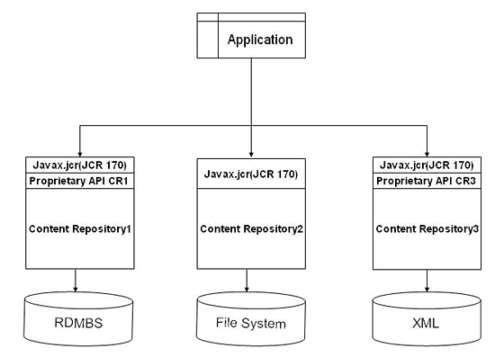
Fig 2.1 Structure of JSR-170 compliant application

2.1.2 JSR-170 Based Content Repository: Apache Jackrabbit
Apache Jackrabbit is a fully featured content repository that implements the entire JCR API. The Jackrabbit project was started when Day Software, the JSR-170 specification lead, licensed their initial implementation of the JCR reference implementation. The Jackrabbit codebase was used for the official reference implementation (RI) and technology compatibility kit (TCK) released along with the final JCR API.

2.2 Web Content Management System
A web-content-management system [2] (WCMS or Web CMS) is content management system (CMS) software, usually implemented as a Web application, for creating and managing HTML content. It is used to manage and control a large, dynamic collection of Web material (HTML documents and their associated images). A WCMS facilitates content creation, content control, editing, and many essential Web maintenance functions. The software provides authoring (and other) tools designed to allow users with little or no knowledge of programming languages or markup languages to create and manage content with relative ease of use.

Most systems use a database to store content, metadata, and/or artifacts that might be needed by the system. Content is frequently, but not universally, stored as XML, to facilitate reuse and enable flexible presentation options.

A presentation layer displays the content to regular Web-site visitors based on a set of templates. The templates are sometimes XSLT [5] files. Administration is typically done through browser-based interfaces, but some systems require the use of a fat client.

2.2.1 Web content authoring and workflow
Web content authoring is a building web content using content creation module along with content category, taxonomy and other metadata. Nowadays all WCMS offers web based interface so that content author can create content and store in content repository for public availability.

Workflow is the process of creating cycles of sequential and parallel tasks that must be accomplished in the CMS. For example, a content creator can submit a story, but it is not published until the copy editor cleans it up and the editor-in-chief approves it.

2.2.2 Web content delivery
Content delivery is retrieving the eligible contents from content repository and displaying in browser for user’s access. Since Presentation layer is separated from business layer, data access layer, the content can be rendered to multiple targets such as browser, devices and as web services for other consumers.

2.3 Overview of existing Web CMS

The following are top 10 content management systems presently existing. The summary of all the products are given below.

- Interwoven
- EMC2 - Documentum
- VigNette/OpenText
- Microsoft Sharepoint Portal Server 2007
- IBM Websphere
- Reddot
- Alfresco , Liferay
- FatWire software
- Percussion
- SQL Tridon

Interwoven: It is one of the leading enterprise content management solution provider, who is specialized in Digital asset Management, Web Content Management and Records Management.
( http://www.interwoven.com)

EMC2 Documentum: EMC provides the tools and solutions that can help customers capitalize on their most important asset-management information. The EMC Documentum enterprise content management platform provides dynamic, robust, and modular capabilities for managing business processes and unstructured content across the enterprise. EMC’s Documentum solution frameworks power multiple hardware and software solutions and speed application development with reusable components and web services. . It uses its own object repository which is build on top of its file server. It supports XQuery, DQL (documentum query language) for querying content from its repository. (www.emc.com)

VigNette/OpenText: Web content management solution from Vignette, which manages content, sites, content types, and objects and the deployment and delivery of content. The Portal provides a platform for personalizing and customizing Web experiences for individuals and groups; collaboration that enables and organization to share knowledge internally and among its key constituencies. (www.vignette.com)

IBM Websphere: It is a Java based application uses DB2 database as content repository. It also supports databases from other vendors. This CMS provides portlet based authoring environment for creating content, workflows and authoring templates. It also provides features for content taxonomy and categorization. (www.ibm.com/websphere)

Microsoft share point: This product provides CMS component for managing is contents which are stored in SQL Server. ASP.Net is the programming environment for developing applications and manipulating its repository contents. (www. sharepoint.microsoft.com)

Reddot: It provides Web-Centric ECM solutions to create, manage and deliver the content that drives actual business. The company’s content management solutions help companies around the world create, manage and deliver personalized Web experiences for their Intranets, Extranets and Web sites. RedDot content management and delivery solutions are recognized for their ease of use and feature leading multilingual support; enterprise Web 2.0 capabilities; content integration; and contextualized delivery. Recognized throughout the industry as the fastest to implement and easiest to use, RedDot’s software products XCMS (Extended Content Management System), CMS (Web Content Management Software) and LiveServer are scalable solutions for Web content and document management, business process workflow, personalization and collaboration. (www.reddot.com)

Alfresco , Liferay: Alfresco and Liferay are small scale content management solutions which are based of Java platform. Alfresco mainly focuses on content Management whereas Liferay’s focus is on webportal and content delivery. (www.alfresco.com, www.liferay.com)

Fatwire: A global leader in content management solutions which are are powered by Content Server, it combines complete business user control over the creation and presentation of content with a scalable architecture for dynamic content delivery and multi-site deployment. The product has a strong Java foundation and is J2EE-based, relying on servlet engine support from market-leading J2EE application servers. FatWire Content Server supports management of both content and code, allowing organizations to not only manage and deploy content but also stage and deploy an entire Web site. The product provides a comprehensive Web services API for the development of dynamic, personalized sites in JSP and ASP.NET. (www.fatwire.com)

Zope/Plone: Plone is an open source CMS frame work. Uses MySQL database for its content Repository. All CMS programming interface are developed in Phyton programming language. Zope id an application server and portal took kit used for building high performance and dynamic web portals. Plone works on top of Zope application server. (www.zope.com, www.plone.com)

2.4 National Portal of India and State Portals
This is the National Portal of India, (india.gov.in) was developed with an objective to enable a single window access to information and services being provided by the various Indian Government entities. The content in this Portal is the result of a collaborative effort of various Indian Government Ministries and Departments, at the Central/State/District level. This Portal is Mission Mode Project under the National E-Governance Plan, designed and maintained by National Informatics Centre (NIC) (External website that opens in a new window), DIT, MoCIT, Government of India. In order to bring all state portals under a common architecture and common content framework [3] , a generic portal architecture framework has been developed by National Portal of India team. The complete document is available at http://spf.india.gov.in.[2]

2.4.1 State Portal Framework Architecture

The below fig 2.2 shows the complete architecture of portal frame work for Indian government states. It has seven major layers which covers portal client, presentation, security, business logic, integration, data, Management and monitoring.

Fig 2.2: Portal Framework Architecture for State, Central government department Portals.

Client layer mainly focuses on applications such as browser and hand held devices such as palm tops, mobile phones etc. Security layer focuses more on secured access using https, SSL and message encryption using PKI and other application security. The presentation layer mainly deals with content formatting for display devices and browsers. Business logic layer contains the complete business logic such as validation, conversation, and normalization and etc. Integration layer is mainly for integrating data from heterogeneous resources. Data and operation layer deals with the database and other data repository management. The management monitoring layer covers overall management of portal functionalities.
2.4.2 National, State and Department portal interoperability

The integral view of National, State and Department portal is shown in the following fig 2.3. It depicts how National portal and other departmental portals/websites effectively work together with state portal. As shown in the fig 2.3 the state portal will integrate with external interfaces such as National Portal, Web sites of government departments & organizations, State government departments, National level service registry/repository, and State level service reigistry/repository to provide services to citizens. The state portal integrate with National Portal using MDP (Meta data provider) Web Service, would be discussed in detail on later sections.

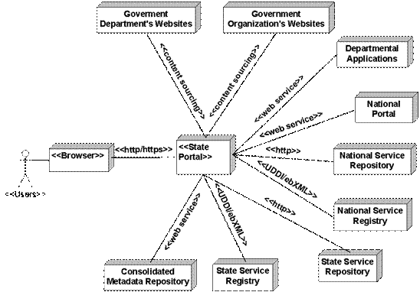

Fig 2.3: Integral view of State portal, India Portal and other Department web sites.

Chapter 3: Metadata Producer

Metadata Provider service would be an integral part of State Portal. It has been designed with the objective of realizing metadata based content integration, consolidating metadata from all State Portals, Integrating State Portals with National portal and facilitating the metadata based content discovery functionality. MDP is implemented as web service with a well defined interface providing standard set of functionality as mentioned below. Its implementation may vary from State Portal to State Portal depending on the specific content management and technologies used for implementing State Portal.

3.1 Web Resource Metadata Standard
WRMS Metadata Standard [2] defined by National Portal India to provide efficient access to Government of India resources – information, services and organizations – on the World Wide Web. This WRMS [2] is an extended metadata set of Dublin core [20] metadata properties. Compliance with the WRMS [2] standard will ensure a nationally consistent approach to description of government resources. This in turn will help people to locate resources without needing a detailed knowledge of government structures.

What is metadata?
Metadata is information in a structured format that describes a resource. A resource may be a publication such as a report or journal, a web page about a particular topic or service, or a digital object such as an image. Good quality metadata improves the efficiency of searching, making it much easier to find something specific and relevant. This contrasts with the general indexing employed by major Internet search engines where a search can often retrieve thousands of results, many of which are irrelevant. (http://www.w3.org/2001/tag/2009/02/metadata-survey.html)

Metadata can be embedded within a resource, i.e. included as part of the HTML code. It may also be created and stored separately from the resource in a metadata repository or data store (similar to a library catalogue). Some measure of searchability is provided by the HTML Meta tag <meta>. But the tag has limited potential for describing complex documents. There are a number of different metadata schemes in use. The proposed WRMS Metadata is based on one of the most widely used metadata schemes – the Dublin Core Element Set [21].

WRMS metadata enables people to locate the resources they need without having to possess a detailed knowledge of where the resources are located or who is responsible for them. With the magnitude of resources available on the Internet, metadata is a unique mechanism that provides a higher quality service for discovery of resources. WRMS metadata will play an important role in publishing resources – via the Internet.

The Proposed WRMS element set consists of 25 elements based on Dublin Core elements. WRMS is intended to describe more than information resources. It was also designed to describe services and organizations. WRMS differs from the Dublin Core standard [21] in its use of qualifiers and the identification of mandatory elements of description.

Table 3.1: List of metadata items designed for a data item from state portal.
 | Attribute | Type | Constraints | Description
 | CreatorDeptName | String / Enum | Mandatory  Max length 64 | The Department primarily responsible for the content of the resource.
 | CreatorOrgName | String | Optional  Max length 64 | The organization primarily responsible for the content of the resource.
 | CreatorEmail | String / Enum | Mandatory  Max length 64 | The Contact person primarily responsible for the content of the resource.
 | CoverageSpatial | String | Optional  Geography  Max length 128 | Spatial topic and spatial applicability may be a named place or a location.
 | CoverageTemporal | String | Optional  Max length 128 | Temporal topic may be a named period, date, or date range.
 | CoverageJurisdiction | String | Mandatory  Max length 128 | A jurisdiction may be a named administrative entity or a geographic place to which the resource applies.
 | Description | String | Mandatory  Max length 1024 | A textual description of the content of the resource, including abstracts in the case of document-like objects or content description in the case of visual resources.
 | DateCreated | Date | Optional | The date the resource was made available in its original form
 | DatePublished | Date | Mandatory | The date when the content item is published on web
 | DateModified | Date | Optional | The date when the content item has been modified
 | Format | String / Enum | Mandatory  MIME/Type  Take sub-set | The data representation of the resource, such as text/html, ASCII, Postscript file, executable application, or JPEG image. FORMAT will be assigned from enumerated lists such as registered Internet Media Types (MIME types). The MIME types are defined according to the RFC2046 standard.
 | Language | String / Enum | Mandatory  Use subset of ISO-639-2 | Language of the content of the resource.
 | PublisherOrgName | String | Optional  Max length 128 | The entity responsible for making the resource available in its present form.
 | PublisherDeptName | String / Enum | Mandatory  Max length 128 | Publisher department name
 | PublisherEmail | String / Enum | Mandatory  Max length 128 | Publisher email
 | PublisherAddress | String / Enum | Mandatory  Max length 1024 | Publisher Address
 | PublisherPhone | String / Enum | Mandatory  Max length 20 | Publisher Phone number
 | Relation | String [] | Optional  Max of 5 URLs  Max URL length 128 | The relationship to other resources. Recommended best practice is to identify the related resource by means of a string conforming to a formal identification system for example list of related URLs
 | Source | String | Optional  Max length 128 | The work, either print or electronic, from which this resource is delivered, if applicable.
 | Title | String | Mandatory  Max length 128 | The name given to the resource by the CREATOR or PUBLISHER
 | TitleAlternate | String | Optional  Max length 128 | The Alternate name of content resource such as form16, act no, etc.
 | SubjectKeywords | String | Mandatory  Max length 1024  Separated by ‘;’ | The topic of the resource, or keywords, phrases, or classification descriptors that describe the subject or content of the resource.
 | SubjectClassification | String[] / Enum | Optional  Max of 5 values  Of Max length 128 | Subject categories such as Audience , sectors, etc.
 | Type | String / Enum | Mandatory | The category of the resource, such as ACTS, RULES, FORMS, DOCUMENTS, SERVICES, etc. It is expected that RESOURCE TYPE will be chosen from enumerated list of types.
 | Identifier | String | Mandatory  Max length 128 | URL of the document/content

3.2 Metadata Producer as Web service
The Metadata Producer module was initially designed as ordinary web application for exposing the metadata from state portal. Using this the consumer application has to send the required parameters such as timestamp, module-verbs(GetStatus, Getallmetadata, Getmodified, Getnewmetadata, Getexpired) and capture XML output for further processing and storage. The major drawback of this method was security and interoperability between other applications developed in different platforms.

Web services [] provide interoperability between various software applications running on different platforms and they use open standards and protocols. Using HTTP, web services can work through many common firewall security measures without requiring changes to the firewall filtering rules. Web services easily allow software and services from different departments/organizations and locations to be combined easily to provide an integrated service. Web services allow the reuse of services and components within an infrastructure. Therefore the Metadata Producer application has been designed as web service and deployed as an integral part of state portal.

3.3 Logical view

The fig 3.1 shows the logical flow of Metadata data producer implemented with necessary functionalities for fetching metadata from web content repositories using CMS-SDK and MDP-CMS-API. On top, the web service interface provides necessary interfaces for harvester to harvest metadata over internet. Using the CMS-UI portal contents care created by content creators for state portal. Other components such as Search-UI, and content Explorer are the proposed applications have be developed based on the consolidated metadata repository at harvester side.

Procedure for retrieving Metadata from CMS and sending response with metadata dataset is given below.

- Connect to CMS
- If ‘end time’ = NOW then ‘End time’ = current time
- Retrieve data for ‘start time’ to ‘end time’
- Send data, start time, end time

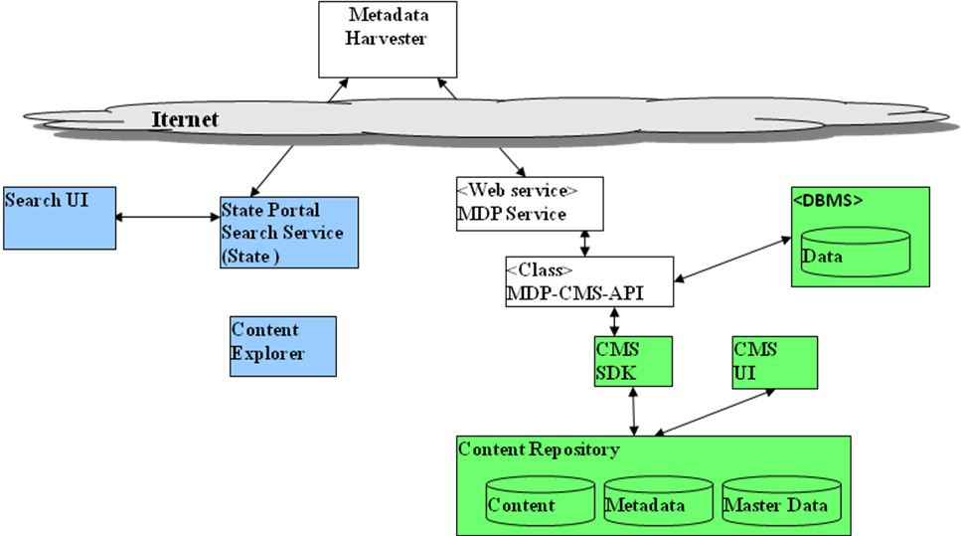

Fig 3.1: Meta Data Producer: logical view

3.3.1 MDP service functionalities

Based on our studies and experiences, the following are some of the essential functionalities of MDP services are described below.
  - It should be implemented as a web service
  - It should implement a well defined WSDL[22] compliant standard interface.
  - Provide metadata of published content from the content repository of State Portal, for following publishing events occurring in the given time period
    - New web page is published
    - Metadata of published web pages is modified
    - Web page is exited or deleted
  - Normalize metadata extracted from content repository, based on defined standard metadata schema (this include attribute names, data type, number of attributes, valid values, max allowed length, data range etc.).
  - Provide metadata of given web pages from the content repository of State Portal.
  - Provide status of MDP service, indicating it’s availability and normal functioning.
  - Provide information about metadata validation errors (if any).
  - Maintain time up to which metadata is propagated to “consolidated metadata repository”.
  - It should be deployed on a highly available infrastructure.
  - It should provide message level authentication based on user-id and password.
  - Ensure that metadata is kept for sufficient time such that request for metadata can be satisfied as and when they come.
  - Provide required error logging, activity logging and email notifications for errors.

3.4 MDP-CMS-API interface between MDP service and CMS Repository

This interface encapsulates all communication with specific content repository. Its implementation depends on specific content repository or content management system. Typically implementation class makes use for software development kit of APIs provided by CMS product. Following is the definition of MDP-CMS-API interface.

3.5 Protocol for Metadata producers

The proposed metadata provider will be developed based on SOAP [23] and HTTP protocol. On above, OAI_PMH protocol for metadata harvesting is used, the provider service can be consumed by other OAI-PMH complaint tools other than Metadata Harvester described on section 4. OAI-PMH (Open Archives Initiative Protocol for Metadata Harvesting) [19] is a protocol developed by the Open Archives Initiative. It is used to harvest (or collect) the metadata descriptions of the records in an archive so that services can be built using metadata from many archives.This protocol is based on HTTP and Request arguments are issued as GET or POST parameters. OAI-PMH supports six request types (known as "verbs" Identify, ListMetadataFormats, ListSets ListIdentifiers, ListRecords, GetRecord).

Responses are encoded in XML [5] syntax. OAI-PMH supports any metadata format encoded in XML. Dublin Core is the minimal format specified for basic interoperability. Error messages are HTTP-based.

Data Providers may define a logical set hierarchy to support levels of granularity for harvesting by Service Providers. Date stamps flag the last change of the metadata set, and thus provide further support for granularity of harvesting. Commercial search engines such as Google, Yahoo have started using OAI-PMH to acquire more resources. Google is using OAI-PMH to harvest information from the National Library of Australia Digital Object Repository. Yahoo acquired content from OAIster (University of Michigan) that was obtained through metadata harvesting with OAI-PMH [20]. The mod_oai project is using OAI-PMH to expose content to web crawlers that is accessible from Apache Web servers.
Chapter 4: Metadata Harvester

A detailed overview about Content repositories and how to expose the metadata from them using web service are described in previous chapters. This chapter covers how metadata service providers are accessed for harvesting metadata from state portals and integrating them with National Portal of India content repository. This Harvester application pulls the metadata from service providers instead of pushing.

4.1 Metadata harvesting methods (Push and Pull)
As stated early the Metadata harvesting is a process of collecting metadata from various data providers and storing them in a consolidated repository for further value added services. Based on our studies [2] [3], basically there are two method for metadata harvesting namely Push or Pull methods. Using Push method the data providers are deployed as agents at state portal and Harvester application should be developed as web service for collecting metadata. As shown in fig 4.1 the Metadata Provider Agent application posts the metadata to Harvester web service. The push method can be best described by the model as shown in fig. 4.1.

Meta Data Provider Agent
Meta Data Provider Agent
Meta Data Provider Agent
Meta Data ProviderAgent
Meta Data
Harvester Web service
Consolidated
Metadata
Repository

Fig 4.1: Meta Data Harvesting Push Model

In Pull method, the Harvester is a standalone application and data providers are implemented as web services. The metadata Harvester application consumes all the Metadata Provider service for pulling metadata. The Pull method of harvesting metadata can be best described by the model shown in fig. 4.2

Meta Data
Harvester Agent
Consolidated Meta Data Repository
Meta Data provider Web Service
Meta Data provider Web Service
Meta Data provider Web Service
Meta Data provider Web Service

Fig 4.2: Meta Data Harvesting Pull Model

Due to the complexity and maintenance difficulty in push model is not suitable integrating harvester and provider as many to many models. Therefore the National Portal of India team has chosen the Pull model for metadata harvesting in this project.

4.2 Protocol for metadata harvester
We shall be using OAI-PMH [20] protocol on combined with HTTP and SOAP [23] for sending harvest request to Metadata Producer service. Actually the harvester asks MDP for metadata to be returned with optional restrictions based on when the metadata has been added or modified (in other words, it can obtain new or changed metadata since its last harvest interaction with a repository). The MDP returns a series of sets of metadata elements (in XML) plus identifiers (i.e., URLs) for the objects that the metadata describes.

4.3 Metadata harvester as OS scheduled job
The Harvester application and Status Monitor applications are two standalone Java Application configured as OS scheduled job. In a scheduled interval the Harvester application is invoked by job scheduler with date-time stamp and address of MDP. The Status monitor polls all the Meta- data providers and records the availability status of in a data table. Later it send email message to respective administrator regarding the status of service. The logical view of harvester is described in fig 4.3. It shows how the harvester application interacts with Metadata service provider service over internet for collecting metadata based on date-time stamp. Behind the Harvester (Metadata consolidator) a structured metadata repository used for storing data from all states. Further the consolidated repository can be used for providing value added search services as shown in fig 4.3.

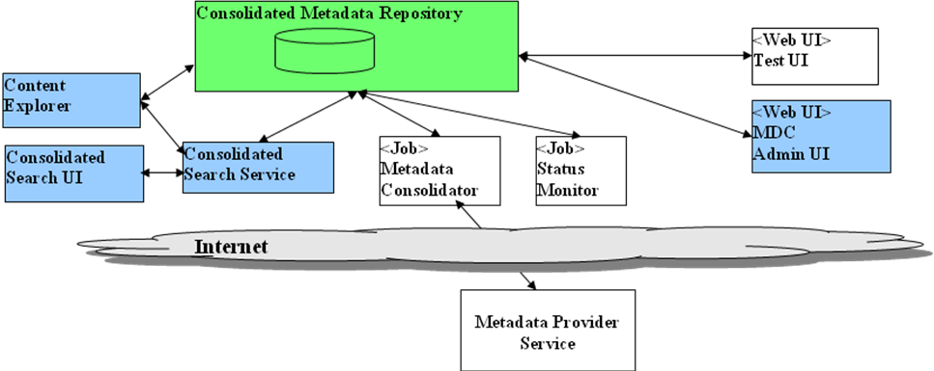
Fig 4.3: Metadata harvester logical view.

The procedure for sending harvesting request to metadata producer and retrieving metadata back by harvester is shown below.

Metadata Harvester | Metadata Producer
Retrive last replication time  Get new metadata for time range  - Set Start-time= Last replication time  - Set End-time = now  Get modified and exited data with end-time as received end-time  Start the transaction  - Retrive Last-replication-time  - Save Metadata  - Set last replication-time= end-time  - Update Last-replication-time  End Transaction | Connect to CMS  If End-Time= now then End-time= now  Retrieve metadata for start-time and end-time  Send metadataset, start-time, end-time

4.3.1 Functionalities of Harvester
Following are some of essential functionalities of metadata harvester application defined in the scope of this project.

The Harvester would provide following functionality:
- Retrieve metadata of published content on State Portal’s using MDP services at configurable periodicity.
- Metadata should be retrieved for following publishing events
  - New web page is published
  - Metadata of published web pages is modified
  - Web page is exited or deleted
- Validate retrieved metadata
- Normalize metadata based on defined standard metadata schema (this include attribute names, data type, number of attributes, valid values, max allowed length, data range etc.).
- Store retrieved metadata into consolidated metadata repository.
- Monitor the status of MDP services at configurable periodicity
- Maintain list of MDP services or State Portals from which metadata to be consolidated
- Maintain time up to which metadata is received from each MDR service
- Provide alerts for various errors such as
  - Non conformance to defined standard of metadata schema
  - Non conformance to defined standard of master data
  - Failing to normalize received metadata
  - Failing to save received metadata to “consolidated metadata repository”
  - Failing to invoke MDP services
- Provide means to take one or more of following actions on detection of above errors
  - Log errors to defined log file or database
  - Display message on system console or event log
  - Send email message to defined email IDs (such as web master of State Portals)
  - Send escalation email message if error condition persists beyond defined amount of time.
  - Recovery from errors
- Ensure that metadata is retrieved even when
  - MDP service temporarily goes down or not reachable due to reasons such as (including but not limited to)
    - Internet connection failure
    - Hardware failure
    - Operating system failure
    - Web server failure
    - Application server failure
    - Content repository failure
    - Web service software failure etc.
ii Harvester goes down temporarily or fails to invoke “MDP service”

4.4 Integral view of Harvester and Metadata Producer

The MDP service, and Harvester described in Chapter 3, 4 are integrated through internet which is shown in fig 4.4. First the metadata is retrieved from State portal content repository using CMS-SDK [2], and the same is validated against the given metadata constrains. After successful validation all the metadata bundled as set and sent harvester as web service response. On the receipt of the web service response, the harvester again validates and normalizes the metadata prior to storing at consolidated repository. As depicted in the integral view, the MDP services from all 37 states would be integrated with Harvester application and harvest the metadata from all state portals to enable seamless metadata integration.

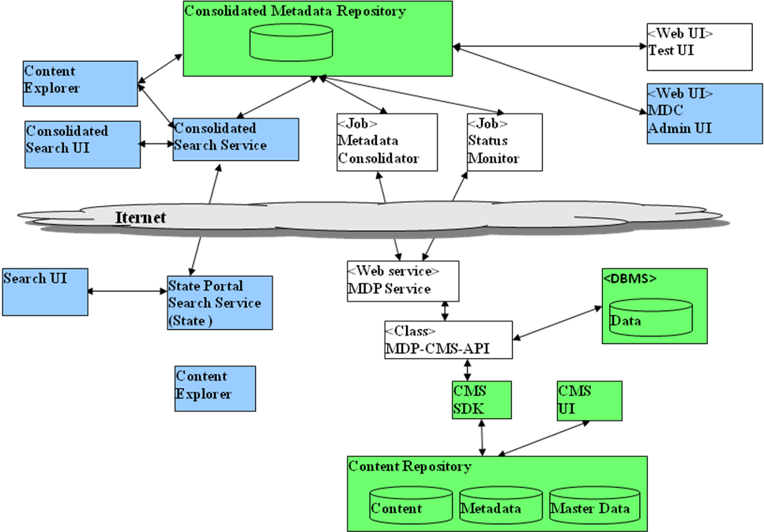
Fig 4.4: Metadata Harvester and Producer an integral view

Monitoring and Failure notification

Metadata Harvester has been designed for logging all status related between Harvester and Producer communication and their status in log file. Also it sends mail when Producer, CMS or the Harvester is down. If the service is continuously down for some period of time and no action taken then an escalation mail sent the respective in charge at higher level.
Chapter 5: Metadata Storage and Retrieval

Consolidating all metadata from state portal and store them in a suitable repository is one of the prime objective of this project. That repository would be utilized by National Portal of India to empower its state specific content search and other portals who wish to integrate data. All possible types of data repositories are studied and implemented the repository in Relational Database. In future a suitable RDF store has to be implemented to facilitate semantic data and semantic search. Even commercially/open source based content repository can be used to store the metadata items in their format. Fallowing sections describes various Repository system used to store metadata and retrieval.

5.1 File System based metadata Repository

The harvested metadata is stored on the file system as well-formed, Unicode XML files. The root file storage location can be specified for each harvested repository, and is stored in the OAIRepository database table in the baseDIR column. Subdirectories from this root may be constructed based on the OAI identifier. For example, the metadata record with an Identifier of Npi:metadata:delhigovt.nic.in\forms\1234 will be stored at this file path: metadata\delhigovt.nic.in\forms\1234.xml.

In addition, for the convenience of directory browsing no more than 5,000 files will be placed in any one directory. This is also configurable. Files beyond 5,000 will be stored in subdirectories, such as metadata\delhigovt.nic.in\forms\starting_at_10000\12345.xml

In our case we have set up (Network File Sharing) NFS between one of our Windows NT machines and our LINUX machine. This allows us to run our harvesting software on our windows machines, but our metadata point to directories on the LINUX box where we also host the XPAT software, so XPAT can index the XML files directly from the LINUX machine. However, this is entirely transparent to our code, so other arrangements are easily possible.

5.2 RDBMS based Metadata Repository

Relational database can be used as metadata store for storing the harvested metadata from various state portal metadata producers. Data tables have to be created based on the node hierarchy. Since the metadata schema is unique for all state portals, the data tables have been created for every state to store the metadata. The metadata in xml format can be directly serialized in to database table for every state. But in this method the consolidated search would be very slow due to the xml parsing and processing field values after fetching the record from database table.

5.3 XML repositories for Metadata storage
An XML repository is a system for storing and retrieving XML data. This data is usually in the form of XML documents and their associated Document Type Definitions (DTDs) or XML Schemas. Because XML data lends itself to a hierarchical structure rather than a relational structure, it may be difficult to store XML data in traditional relational database systems. The repository itself may be a relational database system, but it is more likely to be a custom storage system built exclusively for XML (or hierarchical) data.

An example of a powerful XML database is EMC Documentum XML Store. It is designed for software developers who require advanced XML data processing and storage functionality within their applications. The comprehensive EMC Documentum XML Store Java API contains methods for storing, querying, retrieving, transforming and publishing XML data. EMC Documentum XML Store also has a built-in transaction mechanism that updates both the data and the indexes and that supports load balancing and replication of databases over multiple machines.

EMC Documentum XML Store provides numerous XML-aware features to enable powerful management of XML data structures, including: an XQuery engine for retrieving specific parts of a document a versioning mechanism for tracking differences within XML data various indexing methods to optimize access to frequently used XML data a transformer and formatter for publishing XML data in XHTML or PDF EMC Documentum XML Store uses and supports XML standards including XML 1.0 and 1.1, XQuery 1.0, XML Schema 1.0, XPath 1.0, XSLT 1.0, XPointer, XLink 1.0, and DOM Level 1, 2, and 3.

5.4 RDF repositories for storing Metadata
Sesame[19] is an RDF store which facilitates persistent storage of RDF data and schema information and subsequent querying of that information. For persistent storage of RDF data, Sesame is a scalable repository and Database independent so that can be implemented on any Database Management System. SAIL( Storage And Inference Layer is an application programming interface that offers RDF specific methods to its clients and translates these methods to calls to its specific DBMS. Sesame’s functional modules are clients of SAIL API. There are three such modules namely a) The RQL query engine, b) RDF admin module and c) RDF export module.
HTTP Protocol Header
SOAP Protocol Header
Request Router
Admin Module
Query Module
Export Module
RDF Storage and Interface Layer
HTTP, SOAP client Access

RDBMS Repository
Fig 5.1: Sesame RDF store Architecture
5.4.1 Sesame’s Functional Modules
There are three basic functional module exists in Sesame’s framework. 1. Query Module, 2) Admin Module and 3) RDF export Module.

Query Module: It has further RDF query Parser and Query optimizer modules. The Parser module accepts RDF query and generates RDF query tree. Later the query tree is sent to the optimizer module for query optimization. The optimized model of the query is subsequently evaluated in a streaming fashion, following the tree structure into which the query has been broken down. Each object represents a basic unit in the original query and evaluates itself, fetching data from the SAIL where needed. The main advantage of this approach is that results can be returned in a streaming fashion, instead of having to build up the entire result set in memory first. In Sesame, RQL queries are translated (via the object model) into a set of calls to the SAIL.

Admin Module: In order to be able to insert RDF data and schema information into a repository, Sesame provides an admin module to a) Incrementally adding RDF data/schema information;
b) Clearing the repository.

Partial delete (on a per-statement basis) functionality is not yet available in the current admin module, but support for this feature is under development. The admin module retrieves its information from an RDF(S) source (usually an online RDF(S) document in XML-serialized form) and parses it using a streaming RDF parser (currently, we use the ARP RDF parser that is part of the Jena toolkit. The parser delivers the information to the admin module Sesame: Storing and Querying RDF and RDFS 9 on a per-statement basis: (Subject, Predicate, Object). The admin subsequently tries to assert this statement into the repository by communicating with the SAIL and reports back any errors or warnings that might have occurred. The current implementation makes no explicit use of the transaction-functionality of SAIL yet, but we expect to implement this in the near future.

RDF export module: The RDF Export Module is a very simple module. This module is able to export the contents of a repository formatted in XMLserialized RDF. The idea behind this module is that it supplies a basis for using Sesame in combination with other RDF tools, as all RDF tools will at least be able to read this format. Some tools, like ontology editors, only need the schema part of the data. On the other hand, tools that don't support RDFS semantics will probably only need the non-schema part of the data. For these reasons, the RDF Export Module is able to selectively export the schema, the data, or both.

5.4.2 SAIL API (Storage and Interface Layer API)

The SAIL API [19] is a set of Java interfaces that has been specifically designed for storage and retrieval of RDFS-based information. The main design principles of SAIL are that the API should:
- define basic interface for storing RDF and RDFS in, and retrieving and deleting RDF and RDFS from (persistent) repositories.

- abstract from the actual storage mechanism; it should be applicable to RDBMSs, file systems, or in-memory storage, for example.

- be usable on low end hardware like PDAs, but also offer enough freedom for optimizations to handle huge amounts of data efficiently on e.g. enterprise level database clusters.

d) be extendable to other RDF-based languages like OWL.
Chapter 6: System Design and Development
This chapter focuses all design and development aspect of the application Metadata producer and Harvester. Abstract views of major functional modules and their relationships are given in the subsequent sections. Section 6.2 covers the applications detailed design, where all schema, class definitions of Producer and Harvester application. The last section provides details about development environment, tools, technologies and standards used for developing this application.

6.1 Architectural design

The Fig 6.1 shows the architectural design view of Metadata producer and harvester application with communication relationships. It also shows how the harvester application sends web service request to MDP service and getting response back with metadata set.

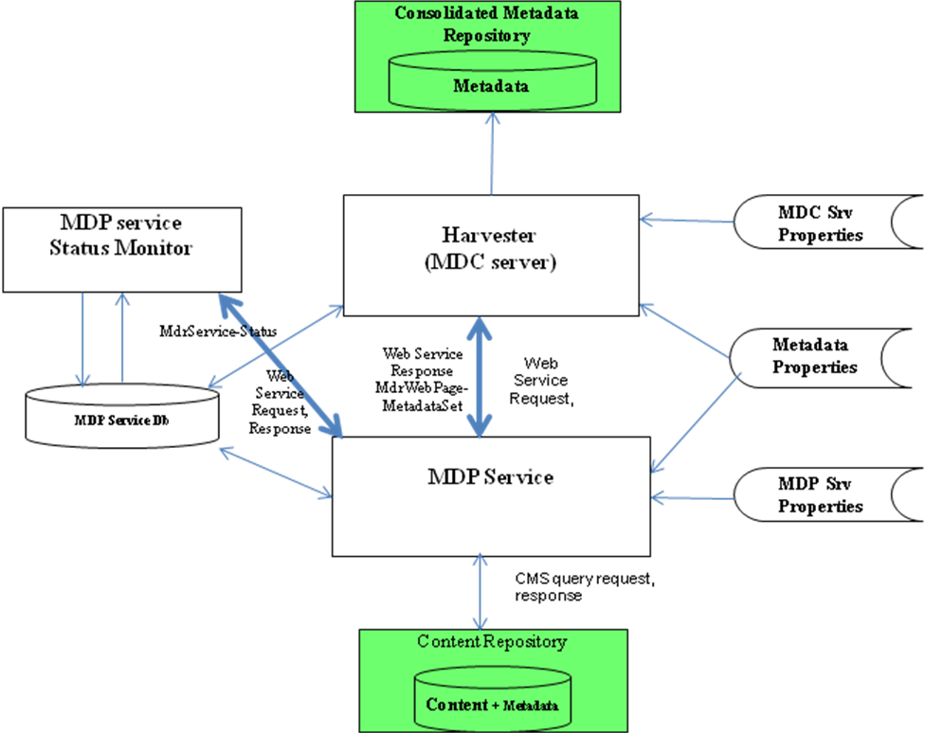

Fig 6.1: Metadata Producer and Harvester: Architectural view
As we described in chapter 3, the MDP service, it is a web service which can be deployable in a suitable application server. The harvester application sends web service request to the MDP service with method, and date-time stamp as argument. On the receipt of request, MDP service invokes the respective method and sends CMS query request to Content repository for capturing metadata. The resulted metadata are validated and returned to Harvester as MdrWebpageMetadataset object. Both the applications Harvester and Producer uses XML based property files for accessing their configurable properties Availability of MDP services are monitored by MDP status monitor job by constantly polling the registered MDP services. Status information related to Harvester and Producer application are stored in MDP service database which is referred during harvest and recovery process.

Consolidated Metadata Repository: As defined in chapter 1, the primary objective of MDP service and Harvester is to harvest and consolidate metadata from various State portal content repositories. Early all state related web contents are created and managed for National Portal at central location. State portals were linked their respective content from national portal using just hyperlink. The web sites of departments, districts are also have to link for their respective content on national portal and maintain them regularly. In the new proposed system, instead in creating web content at central location, the respective contents are created and maintained at state level. In the new approach only the relevant metadata of web contents are harvested automatically from all state portals using Harvester and further consolidated at central metadata repository. This consolidated metadata repository would be integrated with national portal for enriching content and efficient search.

Webservice request: It is calling a remote object method using HTTP and (Simple Object Access Protocol) SOAP [23] . SOAP engine processes the request and sends response over http as SOAP message.

Webservice Response: Response given to the request by SOAP engine after invoking the called method and sending back the rquested data in XML encoded form which can be understandable by the requester. Webservice Description language describes the webservices in terms of input and output datatypes and methods defined for remote call response.
6.2 Metadata Producer- Class hierarchy and their relationships

The MDP service interface and its related modules are implemented in JAVA programming languages with adequate abstraction so that changing one class methods will not affect another. The complete class and subclass hierarchy and their relationships are shown in fig 6.2 in detail.

The class MDPCmsApi contains all business logic related CMS data capturing, validation and sending CMS status information to Harvester. MDP Service monitor and Harvester classes are using the classes which are used by MDP service. MDP Service uses objects MDP-CMS-API, MdrWebPageMetadataSet, Noficiation Manager, MdrService-Properties and MetadataProperties.

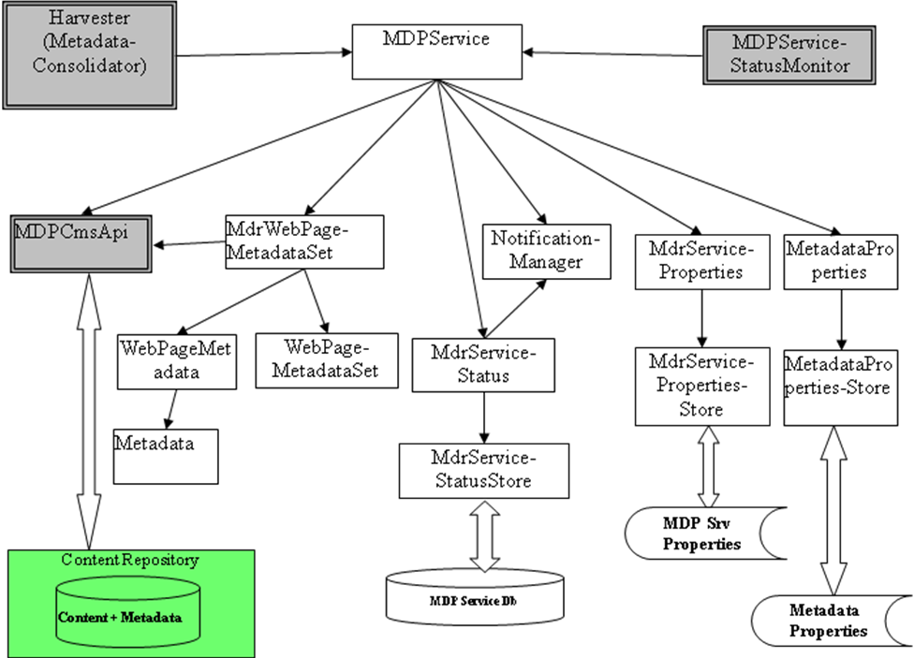

Fig 6.2: Metadata Producer- Class hierarchy and their relationships.

Harvester: Is a Java application for pulling metadata from MDP web service. It will be described in detail on section 6.3.
MdrWebPageMetadataSet: This is class defined with getter and setter functions for array list of WebPageMetadata object primarily used by MDP Service interface.
WebPageMetadataSet: This class contains the reference to the metadata object, URL of the web page and an exception object in case the metadata object fails in the validation.
Noficiation Manager: It provides operations using which messages can be sent to Administrators of CMS system and DB system if the given system is down. This class has the implementation for all the actions.
MDPServiceStatusMonitor: It is the main class for monitoring the status of MDR services. This class is lanched by the system scheduler at defined periodicity to get the status.
MdrService-Properties: This class provides properties and the operations related to properties of MDP Service.
MetadataProperties: This class contains array of the MetadataAttributeVO objects which in turn contains the validation details.
MdrServiceStatus: It provides the operations which checks the status of CMS system and persistent store. Status information will be used by the MDC Server to either notify respective Administrators or invoke the metadata replication.
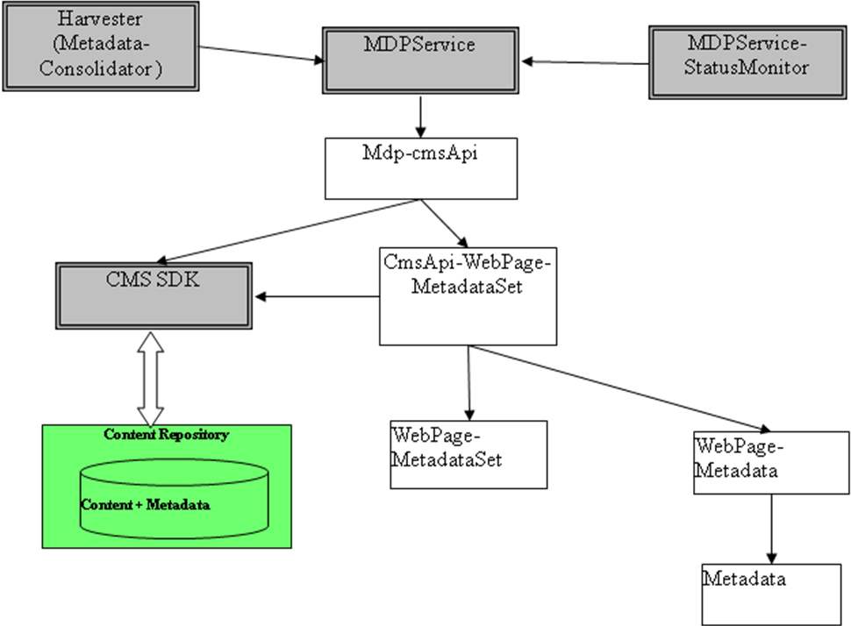
Fig 6.3: MDP-CMS Interface
MDP-CMS-API: It is an interface which encapsulates all CMS related functions such as sending CMS query and receiving the response data for further processing. The design of this API is fully independent from MDP service, therefore the MDP service specifications can be reused if CMS is different. The detailed class description is given at fig: 6.3

CMS-SDK: It is an application programming interface provided by the CMS repository vendor. It contains all necessary functions to send Repository query and fetch metadata from contents stored in CMS repository.

CMS repository : It is a compsite data store build over relational database application. It stores all portal contents and metadata. With the help of CMS-SDK all repository contents can be manipulated.

6.3 Harvester (Metadata Consolidator) & Status Monitor
(Class hierarchy and their relationships)
The fig 6.4 shows the Harvester applications Class interface and their relationships in detail. As per the module definition defined at Chapter 5, it would be responsible for retrieving metadata from MDP services. It would be executed periodically using operating system provided scheduling tool. It would make use of a property files to control its behavior. Monitoring of MDR services would be achieved using this MDP service monitor, which would be executed periodically using operating system provided scheduling tool. It would make use a property file “MdcServer.xml” to control its behavior.

Harvester Proxy: This class encapsulates all necessary properties and methods required for sending and receiving MDP request through AXIS SOAP client libraries.

MdrServiceSoapBindingImpl: It contains the actual SOAP bindings with MDP service interface.

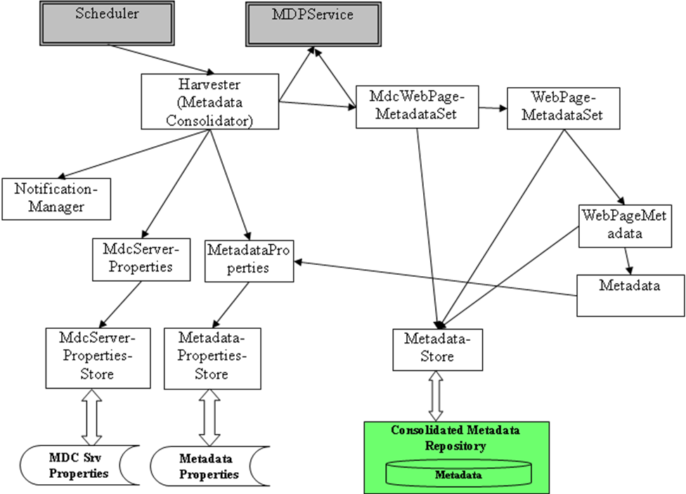

Fig 6.4: Harvester (Metadata consolidator) Class hierarchy and relationships.

The MDP service status monitor is a Java Application which is configured as OS scheduled job for polling the status of MDP service frequently. Basically the status monitor sends web service request to MDP service and retrieves MdrService-Status object as response. The class and subclass hierarchy of this application is shown in fig 6.5

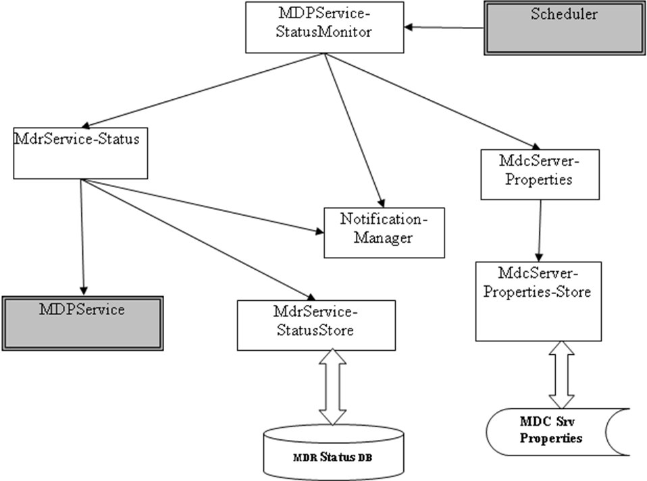

Fig 6.5: Status Monitor ( MDP service) Class Hierarchy and Relationships.

MdcServerProperties: This class provides the collection properties and operations on that properties used by all the classes in mdc server functionality. All the above set MDC properties are loaded from Mdcserver.xml. The details of the property file in xml form is given at Annexure-II.

MDR Status DB: A relational table holds the status of MDP service.
6.4 Detailed Design
All the components such as Metadata, Property files, Metadata Producer and Harvester are described in the previous sections are defined in actual in this section. The code for XML Schema and XML data files are given at Annexure.

6.4.1 Metadata and Schema definition: It represents the actual definition of all metadata properties and their syntactic constraints such as XML Element properties and attributes. The metadata.xml contains constrain values related to metadata fields such as data type and min, max number of occurrences. The detailed xml data and schema definition is provided at Annexure -II.

6.4.2 Interface specification for Metadata Producer

public interface IMdrService
{
public MdrSrvStatusVO getStatus (void) throws RemoteException;

public WebpageMetadataSetVO
getWebpageMetadata (String [] url) throws RemoteException;

public MetadataSizeVO getMetadataSize (Calender startTime, Calender endTime)
throws RemoteException;

public WebsiteMetadataVO getAllMetadata (Calender startTime, Calender endTime)
throws RemoteException;

public WebpageMetadataSetVO
getNewMetadata (Calender startTime, Calender endTime) throws RemoteException;

public WebpageMetadataSetVO getModifiedMetadata (Calender startTime, Calender endTime)
throws RemoteException;

public ExitedWebpageSetVO getExitedWebpages (Calender startTime, Calender endTime)
throws RemoteException;

public NotifyAckVO public void notifyWebsiteAdmin (NotificationInfoVO notn)
throws RemoteException;
}

Web Service Description Language [22] (WSDL) file would be generated using this interface. Following sub-sections explains each of the operations.

Table 6.1: List of MDP service methods and description

Item | Description

getStatus
Functionality | Return status of MDR service.
Return value | Status of MDR service
Input arguments
Void

getWebPageMetadata
Functionality | Return metadata of the given webpage
Return value | Webpage’s metadata
Input arguments
url[] | Arrays of URLs of web pages whose metadata is required.

getMetadataSize
Functionality | Return size of the metadata (new, modified and exited web pages), for the specified time period, which is required to be replicated.
Return value | Size of metadata
Input arguments
startTime | Start time of the time period
endTime | End time of the time period

getAllMetadata
Functionality | Return all metadata (new, modified and exited pages) for the specified time period, which is required to be replicated.
Return value | Website’s metadata
Input arguments
startTime | Start time of the time period
endTime | End time of the time period

getNewMetadata
Functionality | Return new metadata created during the specified time period, which is required to be replicated.
Return value | Web page metadata set
Input arguments
startTime | Start time of the time period
endTime | End time of the time period

getModifiedMetadata
Functionality | Return modified metadata, modified during the specified time period, which is required to be replicated.
Return value | Web page metadata set
Input arguments
startTime | Start time of the time period
endTime | End time of the time period

getExitedWebpages
Functionality | Return exited web pages during the specified time period, which is required to be replicated.
Return value | Set of exited web pages
Input arguments
startTime | Start time of the time period
endTime | End time of the time period

notifyWebsiteAdmin
Functionality | Send specified notification to web site administrator.
Return value | Notification acknowledgement
Input arguments
NotificationInfoVO | Notification information

MDC-CMS-API Specifications
public interface IMdcCmsApi
{
public MdcCmsConnection connect (CmsConPropertiesprop MetadataProperties mdProp)
throws MdcException;

public void disonnect (MdcCmsConnection conxn)
throws MdcException;

public void startTransaction (MdcCmsConnection conxn)
throws MdcException;

public void commitTransaction (MdcCmsConnection conxn)
throws MdcException;

public void abortTransaction (MdcCmsConnection conxn)
throws MdcException;

public void getWebpageMetadata (String[] urlList, WebpageMetadataSet wpMetadata)
throws MetadataValidationException, MdcException;

public void getAllMetadata ( Calender startTime, Calender endTime,WebPageMetadataSet newMetadata,
WebPageMetadataSet modifiedMetadata, WebPageMetadataSet exitedPages)
throws MetadataValidationException, MdcException;

public void getNewMetadata (Calender startTime, Calender endTime, WebPageMetadataSet newMetadata)
throws MetadataValidationException, MdcException;

public void getModifiedMetadata (Calender startTime, Calender endTime, WebPageMetadataSet modifiedMetadata) throws throws MetadataValidationException, MdcException;

public void getExitedWebpages (Calender startTime, Calender endTime, ExitedWebpageSet exitedWebPages)
throws MetadataValidationException, MdcException;
}

Following sub-sections explains each of the operations. Refer source code file of definition of classes.

Table 6.2: List of MDC-CMS-API Interface methods and description

Item | Description

connect
Functionality | Establish connection with content repository or content management system.
Return value | Connection object
Input arguments
ConProp | Connection properties. Any specific properties required based on underlying content management system to implement MDC-CMS-API should be passed using this.
mdProp | Metadata properties

disconnect
Return value | void
Input arguments
conxn | Connection object

commitTransaction
Functionality | Commit transaction, saving all modifications.
Return value | void
Input arguments
conxn | Connection object

abortTransaction
Functionality | Abort transaction without persisting modifications (if any)
Return value | void
Input arguments
conxn | Connection object

getWebpageMetadata
Functionality | Return metadata of web pages identified by given URL list.
Return value | WebpageMetadataSet: Metadata of given web pages. If web page is exited then metadata would not be returned.
Input arguments
urlList | List of web pages (URLs) whose metadata is required
wpMetada | Metadata of given web pages

getAllMetadata
Functionality | Return all metadata (new, modified and exited web pages) for the specified time period.
Return value | void
Input arguments
startTime | Start time of the time period
endTime | End time of the time period
Output arguments
newMetadata | Metadata of new web pages
modMetadata | Metadata of modified web pages
exitedPages | List of exited pages

getNewMetadata
Functionality | Return metadata of web pages created during the specified time period.
Return value | void
Input arguments
startTime | Start time of the time period
endTime | End time of the time period
Output arguments
newMetadata | Metadata of new web pages

getModifiedMetadata
Functionality | Return metadata of web pages, which are modified during the specified time period.
Return value | void
Input arguments
startTime | Start time of the time period
endTime | End time of the time period
Output arguments
modMetadata | Metadata of modified web pages

getExitedWebpages
Functionality | Return list of web pages, which are existed during the specified time period.
Return value | void
Input arguments
startTime | Start time of the time period
endTime | End time of the time period
Output arguments
exitedPages | List of exited pages

6.4.3 Description of Classes

Table 6.3 List of common Classes used at Harvester and Producer

Class Name | Description
Metadata | Represents metadata attributes of a web page
MetadataStore | Data access class for metadata
MetadataProperties | Represents validation rules of metadata attributes
MetadataPropertiesStore | Encapsulates retrieval metadata properties from the properties file
PWCallback | Used for MDR Service security
MdcCmsConnection | Holds status of CMS connection
WebPageMetadata | Represents a webpage and associated metadata
WebPageMetadataSet | Collection of web pages
MdcConstants | Holds all constants values
MdrServiceStatusStore | Data access class for MdrServiceStatus
NotificationManager | Manages processing of notifications as per defined rules
MetadataValidationException | Represents exception related to metadata validation errors
MdcException | Represents exception related to system errors.
CmsApiImpl | Implementation class for CMS-API interface

Table 6.4 List of Class used at MDC server
Class Name | Description
MdcServerProperties | Represents properties of MDC server
MdcServerPropertiesStore | Data access class of MdcServerProperties
MdcWebPageMetadataSet | Responsible for communicating with MDR service
MdrServiceStatusMonitor | Main class for status monitoring functionality
MetadataConsolidator | Main class for metadata consolidation functionality
MdrServiceStatus | Used for status monitoring functionality
MdrSrvProxy | Proxy class for invoking given MDR service. This will invoke generated code, which is dependent on SOAP tool kit.

Table 6.5 List of Classes used at MDP Service

Class Name | Description
MdrService | Main class of MDR service
MdrServiceProperties | Represents MDR service properties
MdrServicePropertiesStore | Data access class for MDR service properties
MdrWebPageMetadataSet | Responsible for interacting with MDC-CMS-API
MdrServiceStatus | Represents MDR service status
Table 6.6 List of Classes used at MDP-CMS-API

Class Name | Description
CmsApiWebPageMetadataSet | Main class of MDC-CMS-API-Responsible for communicating with CMS to extract metadata
CmsConstants | Holds all the CMS related constants
Table 6.7 List of VO (Value Object) Classes
Class Name | Description
WebSiteMetadataVO | All metadata to be replicated
CmsConPropertiesVO | CMS connection properties
DbConPropertiesVO | Database connection properties
EmailServerPropertiesVO | Email server connection properties
MdcServerPropertiesVO | MDC server properties
MdrSrvStatusVO | MDR service status
MetadataPropAttrVO | This class defines all the attributes that contain values for validating a particular Metadata attribute
MetadataValidationErrVO | Metadata validation error information
MetadataVO | Web pages’ metadata attributes
NotificationInfoVO | Notification information
WebPageMetadataSetVO | Collection web page’s metadata
WebPageMetadataVO | Metadata of single web page
MetadataReplInfoVO | Replication details used for Status monitoring
NotifyAckVO | Notification acknowledgement info
ReplTimeSetVO | Contains start time, end time and replication time
MdrSrvPersStatusVO | It's holds the replication details and status details of a MDR service
ExitedWebpageSetVO | Set of exited web-page urls
WebPageMetadataVO | Contains metadata plus webpage url
NotificationPropsVO | Contains notification properties information
MetadataSizeVO | Contains size of all webpage metadata
MetadataEventVO | Contains event information
MetadataAttributeVO | Contains all the metadata attributes
MdrServicePropertiesVO | Contains all properties of mdr-service

6.4.4 Property files of Meta data Producer and Harvester: The property file contains the configuration details of Harvester and Metadata Producer component. The configuration can be changed with respect to installation requirements.

6.4.5 Metadata store schema at Harvester side
Fallowing is the list of database table schema’s defined at Metadata Harvester for storing metadata from state portal.

TN_METADATA_TB
+-----------------------+--------------+------+-----+---------+-------+
| Field | Type | Null | Key | Default | Extra |
+-----------------------+--------------+------+-----+---------+-------+
| MDR_SRV_NM | varchar(10) | NO | | | |
| CREATOR_DEPT_NM | varchar(64) | YES | | NULL | |
| CREATOR_ORG_NM | varchar(64) | YES | | NULL | |
| CREATOR_EMAIL | varchar(64) | YES | | NULL | |
| COVERAGE_SPATIAL | varchar(128) | YES | | NULL | |
| COVERAGE_TEMPORAL | varchar(128) | YES | | NULL | |
| COVERAGE_JURISDICTION | varchar(128) | YES | | NULL | |
| DESCRIPTION | text | YES | | NULL | |
| DATE_CREATED | datetime | YES | | NULL | |
| DATE_PUBLISHED | datetime | YES | | NULL | |
| DATE_MODIFIED | datetime | YES | | NULL | |
| FORMAT | varchar(32) | YES | | NULL | |
| LANGUAGE | varchar(32) | YES | | NULL | |
| PUBLISHER_ORG_NAME | varchar(128) | YES | | NULL | |
| PUBLISHER_DEPT_NAME | varchar(128) | YES | | NULL | |
| PUBLISHER_EMAIL | varchar(128) | YES | | NULL | |
| PUBLISHER_ADDRESS | text | YES | | NULL | |
| PUBLISHER_PHONE | varchar(20) | YES | | NULL | |
| RELATION1 | varchar(128) | YES | | NULL | |
| RELATION2 | varchar(128) | YES | | NULL | |
| RELATION3 | varchar(128) | YES | | NULL | |
| RELATION4 | varchar(128) | YES | | NULL | |
| RELATION5 | varchar(128) | YES | | NULL | |
| SOURCE | varchar(128) | YES | | NULL | |
| TITLE | varchar(128) | YES | | NULL | |
| TITLE_ALT | varchar(128) | YES | | NULL | |
| SUBJ_KEYWORDS | text | YES | | NULL | |
| SUBJ_CLSFN1 | varchar(128) | YES | | NULL | |
| SUBJ_CLSFN2 | varchar(128) | YES | | NULL | |
| SUBJ_CLSFN3 | varchar(128) | YES | | NULL | |
| SUBJ_CLSFN4 | varchar(128) | YES | | NULL | |
| SUBJ_CLSFN5 | varchar(128) | YES | | NULL | |
| TYPE | varchar(32) | YES | | NULL | |
| IDENTIFIER | varchar(128) | NO | PRI | | |
+-----------------------+--------------+------+-----+---------+-------+

MDC_SERVICE_STATUS_TB
+------------------+-------------+------+-----+---------+-------+
| Field | Type | Null | Key | Default | Extra |
+------------------+-------------+------+-----+---------+-------+
| MDR_SRV_NM | varchar(10) | NO | PRI | | |
| DB_STS | varchar(1) | NO | | | |
| CMS_STS | varchar(1) | NO | | | |
| METADATA_REPL_TM | datetime | YES | | NULL | |
| MDR_SRV_STS | varchar(1) | NO | | | |
| STS_CHK_TM | datetime | NO | PRI | | |
| START_TM | datetime | YES | | NULL | |
| END_TM | datetime | YES | | NULL | |
+------------------+-------------+------+-----+---------+-------+

METADATA_REPL_EVENT_TB
+------------+-------------+------+-----+---------+-------+
| Field | Type | Null | Key | Default | Extra |
+------------+-------------+------+-----+---------+-------+
| WEBSITE_ID | varchar(10) | NO | PRI | | |
| EVENT_ID | varchar(10) | YES | | NULL | |
| EVENT_TIME | datetime | YES | | NULL | |
+------------+-------------+------+-----+---------+-------+

METADATA_REPL_INFO_TB
+-------------+-------------+------+-----+---------+-------+
| Field | Type | Null | Key | Default | Extra |
+-------------+-------------+------+-----+---------+-------+
| MDR_SRV_NM | varchar(10) | NO | PRI | | |
| LST_REPL_TM | datetime | YES | | NULL | |
| LST_EXEC_TM | datetime | NO | | | |
| REPL_STS | varchar(1) | NO | | | |
| START_TM | datetime | YES | | NULL | |
| END_TM | datetime | NO | | | |
+-------------+-------------+------+-----+---------+-------+

6.4.6 Web Service Description Language (WSDL)

WSDL [22] stands for Web Services Description Language and it is a document written in XML.
A WSDL document defines services as collections of network endpoints, or ports. In WSDL, the abstract definition of endpoints and messages is separated from their concrete network deployment or data format bindings. This allows the reuse of abstract definitions: messages, which are abstract descriptions of the data being exchanged, and port types which are abstract collections of operations. The concrete protocol and data format specifications for a particular port type constitutes a reusable binding. A port is defined by associating a network address with a reusable binding, and a collection of ports define a service. Hence, a WSDL document uses the following elements in the definition of network services:

Types: a container for data type definitions using some type system (such as XSD).
Message: an abstract, typed definition of the data being communicated.
Operation: an abstract description of an action supported by the service.
Port Type: an abstract set of operations supported by one or more endpoints.
Binding: a concrete protocol and data format specification for a particular port type.
Port: a single endpoint defined as a combination of a binding and a network address.
Service: a collection of related endpoints.

The following xml code is WSDL for describing the remote method getStatus() which is defind in IMdrservice interface in section 6.2.2.

<?xml version="1.0" encoding="UTF-8"?>
<wsdl:definitions targetNamespace="http://mdc.npi.gov.in" xmlns:apachesoap="http://xml.apache.org/xml-soap" xmlns:impl=http://mdc.npi.gov.in xmlns:intf="http://mdc.npi.gov.in" xmlns:wsdl="http://schemas.xmlsoap.org/wsdl/" xmlns:wsdlsoap="http://schemas.xmlsoap.org/wsdl/soap/" xmlns:xsd="http://www.w3.org/2001/XMLSchema">
<schema elementFormDefault="qualified" targetNamespace="http://mdc.npi.gov.in" xmlns="http://www.w3.org/2001/XMLSchema">
<wsdl:types>
<complexType name="MdrServiceStatusVO">
<sequence>
<element name="CMSStatus" type="xsd:boolean"/>
<element name="DBStatus" type="xsd:boolean"/>
<element name="MDRServiceStatus" type="xsd:boolean"/>
<element name="endTime" nillable="true" type="xsd:dateTime"/>
<element name="replTime" nillable="true" type="xsd:dateTime"/>
<element name="startTime" nillable="true" type="xsd:dateTime"/>
</sequence>
</complexType>
</schema>
</wsdl:types>

<wsdl:message name="getStatusRequest">
<wsdl:part element="impl:getStatus" name="parameters"/>
</wsdl:message>

<wsdl:message name="getStatusResponse">
<wsdl:part element="impl:getStatusResponse" name="parameters"/>
</wsdl:message>

<wsdl:portType name="IMdrService">
<wsdl:operation name="getStatus">
<wsdl:input message="impl:getStatusRequest" name="getStatusRequest"/>
<wsdl:output message="impl:getStatusResponse" name="getStatusResponse"/>
</wsdl:operation>
</wsdl:portType>

<wsdl:binding name="IMdrServiceSoapBinding" type="impl:IMdrService">
<wsdlsoap:binding style="document" transport="http://schemas.xmlsoap.org/soap/http"/>
<wsdl:operation name="getStatus">
<wsdlsoap:operation soapAction=""/>
<wsdl:input name="getStatusRequest">
<wsdlsoap:body use="literal"/>
</wsdl:input>
<wsdl:output name="getStatusResponse">
<wsdlsoap:body use="literal"/>
</wsdl:output>
</wsdl:operation>
</wsdl:binding>

<wsdl:service name="IMdrServiceService">
<wsdl:port binding="impl:IMdrServiceSoapBinding" name="IMdrService">
<wsdlsoap:address location="http://localhost:9090/axis/services/IMdrService"/>
</wsdl:port>
</wsdl:service>

</wsdl:definitions>

The interface defined in section 6.2.2 is used for generating MDP as web service. The WSDL format of the interface IMdrService is as given at Annexure II- a.

6.5 Development Environment
This section describes the details about tools and technologies used for the development and integration of Metadata producer and Harvester application.

6.5.1 Tools and Technologies
Eclipse Java Application development tool: An Integrated Development Environment for developing Java applications, web service and other J2EE application component development and integration.

Axis SOAP Engine: The Metadata Producer is a web service deployed under SOAP engine AXIS. Axis is the third generation of Apache SOAP and is essentially a SOAP engine. It is a framework for constructing SOAP processors such as clients, servers, gateways, etc. In this project this engine is deployed under tomcat as Java application. Axis is not simply a SOAP engine but it also includes: a) a simple stand-alone server, b) a server which plugs into servlet engines such as Tomcat, c) extensive support for the Web Service Description Language (WSDL), d) emitter tooling that generates Java classes from WSDL.

JAVA, XML and XML schema: Since the Metadata Producer service application has to be deployed on multi platform , Java programming language(JDK 1.5.0.18) has been chosen for this application development. All property files required for this application is coded in XML and XML schema because it is common generic standard followed worldwide.

OAI-PMH protocol: OAI-PMH (Open Archives Initiative Protocol for Metadata Harvesting) is a protocol developed by the Open Archives Initiative. This protocol was proposed for MDP service during initial stage of this project. Later stage it has been decided to implement in the later version of MDP and Harvester application due to the immaturity and popularity of this protocol.

6.5.2 Web Content Management System: Alfresco is a Java based web content management system used at state portal side as Content repository. MDP service application has to developed and deployed on other content management system such as Websphere, Druple, Documentum, Filenet, and Microsoft Sharepoint Portal system.

6.5.3 Web server, Application server & Database Server

Web server: Apache Web Server is used for processing PHP modules which are used for Searching metadata from Meta data repository.

Application Server: Apache Tomcat 5.5.27 is used for deploying Java applications. In this project it is manly used for deploying AXIS SOAP engine and Alfresco CMs.

Database Server: MySQL version 5.1 has been used for storing the consolidated Metadata Repository at Harvester side.

6.5.4 Operating Platform: The entire application (Metadata Producer and Harvester) was developed to deploy in RedHat Enterprise Linux Edition 5.0. Since the application is platform independent it can be easily deployed in Widows and other platforms.

Chapter 7: Implementation and Testing

In this chapter, the installation and configuration of Metadata Producer and Harvester application are discussed in detail. Later part of this section covers testing the application in terms of functional and integration.

7.1 Installation and configuration

7.1.1 Metadata Producer service installation

Set-Up Tomcat & Axis Environment

- Install tomcat (Create a folder named Apache under c drive. Unzip tomcat installation folder and copy it into a folder under c:\ Apache. Now the tomcat will be installed like c:\Apache\ apache-tomcat-5.5.27)

- Create an environment variable ( preferably system variable in Windows ) named
CATALINA_HOME and point it to Apache root folder i.e c:\Apache\ apache-tomcat-5.5.27

- Check whether JAVA_HOME variable is defined or not. If not, define JAVA_HOME and point it to jdk root folder ( like C:\Program Files\Java\jdk1.5.0_05 )

- Download Axis from Axis Site. Unzip the axis folder and you will see following folder structure

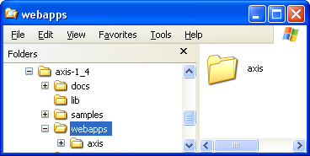

- Copy Axis folder (which is under webapps) into C:\Apache\apache-tomcat-5.5.27\webapps

Develop Metadata Producer Web Service on Axis Environment

Step 1:
Add all axis specific jar files to class path. Axis jar can be found in axis/WEB-INF/lib folder as shown in fig

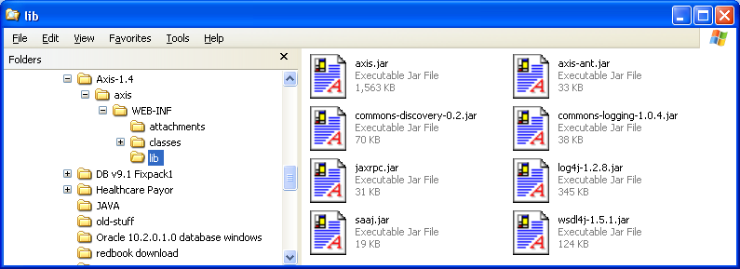

Step 2:
Create an interface class for the operation(s) to be exposed

Step 3:
Generate wsdl file using the interface created in step 2
Use following command to generate wsdl file

java org.apache.axis.wsdl.Java2WSDL -o test25-wrapped.wsdl -l"http:localhost:8080/" in.gov.nic.mdc.IMdrService -y "WRAPPED"

Step 4:
Generate server skeleton files from the wsdl generated in Step 3
Use following command

java org.apache.axis.wsdl.WSDL2Java -s test25-wrapped.wsdl

Take the implementation class (*Impl.java ) , Implement the business logic , compile the file. Create a jar file with *Impl.class file and all other class files ( i.e the class files used for generating the wsdl in step 2 ) say MdrSrv.jar

Step 4 also generates deploy.wsdd and undeploy.wsdd which are used for deploying the web service

Steps to deploy MDR Web Service on Tomcat & Axis

Step 1:
Create a folder named ‘properties’ under any specific folder (say C:\conf ) and place all property files into it. As shown in the fig you can see following 5 property files in properties folder

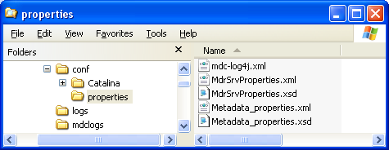

Step 2:
Create an environment variable MDR_HOME and set it to parent folder of properties folder (C:\conf )

Step 3:
Create a custom log folder named mdclogs in the system and specify the folder name in mdc-log4j.xml file

Step 4:
Copy the MdrSrv.jar file created in previous section into C:\Apache\apache-tomcat-5.5.27\webapps\axis\WEB-INF\lib folder
Mdr WebService uses following non-axis jars for different purposes as shown in the table

Table 7.1: list Java Archive files needed for MDP service
s.no | Jar Name | Purpose
1 | mysql-connector-java-5.1.6-bin.jar | MySQL database driver classes
2 | alfresco-web-service-client.jar | Alfresco cms api classes
3 | wss4j.jar | Web Service Security classes
4 | xmlsec-1.4.1.jar | Web Service Security classes
5 | opensaml-1.0.1.jar | Web Service Security classes
6 | log4j-1.2.8.jar | Logging purpose

Step 5:
Use following axis command to deploy the created web service

Java org.apache.axis.client.AdminClient -l http://localhost:8080/axis/services/AdminService deploy.wsdd

Where deploy.wsdd is the deploy file created in previous section

Step 6:
Check the status of the web-service in the axis admin page by clicking List option on
Axis Home Page
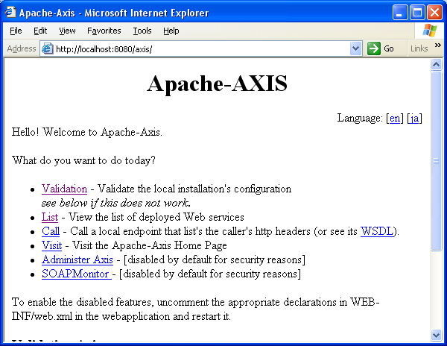

Step 7: It will list all deployed web services
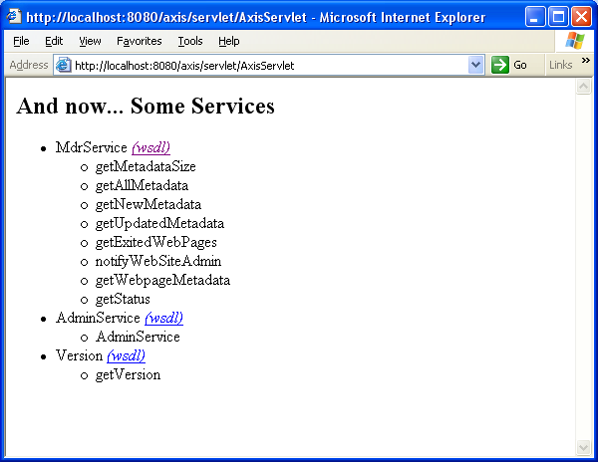

Adding Security to MDR Web Service
User Token security model has been incorporated to MDR Web Service. Following additional steps needs to be executed

Step 1:
Create passwordCallbackClass class
This class will check the user id / password attached to the soap request.

Step 2:
Modify the deploy.wsdd file and add following tags
The following codes has to be inserted after <service > tag.

<requestFlow>
<handler type="java:org.apache.ws.axis.security.WSDoAllReceiver">
<parameter name="passwordCallbackClass" value="in.gov.npi.mdc.PWCallback"/>
<parameter name="action" value="UsernameToken"/>
</handler>
</requestFlow>

Step 3:

Redeploy the service using modified deploy.wsdd

Environment
1. Tomcat 5.5.27
2. Axis 1.4
3. Java 1.5.0_18
4. MySql database server 5.1

Create Database Table
Step 1:
Create a database named ‘nic’

Step 2:
Create a table names ‘mdr_status’
Using following syntax

create table MDR_STATUS (
LST_REPL_TM DATETIME,
REPL_STS VARCHAR (20),
START_TM DATETIME,
END_TM DATETIME
)

Step 3:
Insert a row with initial values using following syntax:

insert into mdr_status (LST_REPL_TM,REPL_STS,START_TM,END_TM) values(STR_TO_DATE('2009-01-01 01:01:01.111','%Y-%m-%e %H:%i:%s.%f'),'INITIAL',STR_TO_DATE('2009-01-01 01:01:01.111','%Y-%m-%e %H:%i:%s.%f'),STR_TO_DATE('2009-01-01 01:01:01.111','%Y-%m-%e %H:%i:%s.%f'))

Step 4:
Update <DataServer> section of MdrService.xml file with appropriate details
<handler type="java:org.apache.ws.axis.security.WSDoAllReceiver">
<parameter name="passwordCallbackClass" value="PWCallback"/>
<parameter name="action" value="UsernameToken"/>
</handler>
</requestFlow>

7.1.2 Metadata Harvester (MDC Server) Installation

Environment

- Java 1.5.0_18
- MySQL database server 5.0
- Linux – RedHat Enterprise Linux 3.2

Installation procedure:

- Create MdcServer folder in the system

- Create environment variable MDC_HOME and give the Mdcserver folder path

- Copy below folders into MdcServer folder.
  - bin ( contains all class files )
  - lib ( contains all jar files )
  - src ( contains all source files )
  - properties ( contains all property files )

- set up java path to environment variable PATH.

- set up classpath with the jar files given below located in lib folder

Table 7.2: List of Jar file required at Harvester Side.
s.no | Jar file | Purpose
1 | activation.jar | Axis specific jar
2 | axis.jar | Axis specific jar
3 | axis-ant.jar | Axis specific jar
4 | commons-discovery-0.2.jar | Axis specific jar
5 | commons-logging-1.0.4.jar | Axis specific jar
6 | jaxrpc.jar | Axis specific jar
7 | junit.jar | Axis specific jar
8 | mail.jar | Axis specific jar
9 | saaj.jar | Axis specific jar
10 | wsdl4j-1.5.1.jar | Axis specific jar
11 | log4j-1.2.15.jar | Log 4j specific classes
12 | mysql-connector-java-5.1.6-bin.jar | MySQL Database driver classes
13 | wss4j.jar | Web Service Security related jar
14 | opensaml-1.0.1.jar | Web Service Security related jar
15 | xmlsec-1.4.1.jar | Web Service Security related jar

- Provide the MdcServer specific properties such as, Database properties, Mail server properties, end point urls, event and respective actions in MdcServer.xml which is available in properties folder.

- Create shell scripts for
a. Metadata Consolidator
b. Status Monitor
Add below commends in respective scripts

  - Metadata Consolidator:

java in.gov.nic.mdc.mdcserver.MetadataConsolidator Args1 Args2

Note: Args1 : First argument to MetadataConsolidator(Mandatory)
Possible values:

- Single website id
- Group of website ids separated by comma.
- ALL

Args2 : Second argument to MetadataConsolidator(Optional)

Possible values: Mdcserver path

Ex 1 : java in.gov.nic.mdc.mdcserver.MetadataConsolidator AP /usr/local/Mdcserver
Ex 2 : java in.gov.nic.mdc.mdcserver.MetadataConsolidator AP,TN

  - Status Monitor :
java in.gov.nic.mdc.mdcserver.MdrServiceStatusMonitor Args1 Args2

Note: Args1 : First argument to MdrServiceStatusMonitor (Mandatory)
Possible values:

- Single website id
- Groups of website ids separated by comma.
- ALL

Args2 : Second argument to MdrServiceStatusMonitor (Optional)
Possible values: Mdcserver path

Example 1: java in.gov.nic.mdc.mdcserver.MdrServiceStatusMonitor AP /usr/local/Mdcserver
Example 2: java in.gov.nic.mdc.mdcserver.MdrServiceStatusMonitor AP,TN

- Schedule a cronjob to call the shell script defined periodicity.

7.2 Testing

7.2.1 Metadata Producer as Java Application
Testing the metadata producer as a web service after deploying the same at TOMCAT and AXIS environment is time consuming job. Therefore a Tester application has been written and all methods of web service interface IMdrservice.class has been invoked with sample data and tested the output.

Access metadata from CMS repository using CMS SDK
This test is required to test the accessibility between the CMS repository and Metadata Producer.
This can be done by instantiating the MDP-CMS-API interface IMdcCmsApi and invoking the methods with necessary input parameters.

Metadata validation using Metadata Property file and schema
Instantiate Metadata.class from tester application and invoke Medatada.validate( metadata_properties) method.
This method loads the metadata.xml and metadata.xsd and validates them first. Later it validates the values assigned on the fields using method validate().

7.2.2 MDP As web service
Prior to deploy MDP web service, Tomcat application server and AXIS soap engine installation and integration has to be verified. For which access the following url from browser and test.

Testing Tomact and SOAP Engine installation
http://localhost:6060/
http://localhost:6060/axis/

Testing MDP web service deployment
http://localhost:6060/axis/servlet/AxisServlet
http://localhost:6060/axis/services/IMdrService?wsdl
( Refer Annexure for output )

7.2.3 Integration testing
Integrating MDP service with Harvester application is by inserting the following xml code with webservice url in MDCserver.xml and running the Harvester application. The log file output gives the exact status of the Integration.

<MdrService>
<WebSiteID>AP</WebSiteID> <EndpointURL>http://164.100.56.214:9090/axis/services/MdrService</EndpointURL>
<UserID>apmdrsrv</UserID>
<Password>security</Password>
</MdrService>
7.2.4 Harvester application
Running the Harvester application and testing the logs generated by this application. After harvesting cycle, the table MDC_SERVICE_STATUS_TB can be verified the exact status of metadata harvesting.
java in.gov.npi.mdc.mdcserver.MetadataConsolidator AP

Chapter 8: Conclusion and Future work

The tools Metadata Producer and Harvester empowered National Portal of India to integrate all state, central government portals. Adoption of standards like XML and Dublin Core for metadata description enabled all government portals interoperable by exchanging metadata between them. In addition to that, the Metadata Provider is developed web service using SOAP
(Simple Object Access Protocol) and WSDL [22] the consumer such as Harvester applications could easily capture incremental metadata based on date-time stamps. The above application is tested with portals which are developed using different technologies and web content management systems such as Documentum, IBM Websphere, Druple, and Alfresco.

The conclusion here is that all portal contents have be described using metadata description standards and they should be made accessible over internet as web service for better interoperability and integrity. Defining a common Ontology and describing portal content using web ontology languages such as RDFS, OWL will help web portals to semantically integrate and be interoperable themselves. Further the Metadata Provider and Harvester application needs to be enhanced for capturing semantic metadata which are based on a given ontology and store them in a suitable semantic repository store for effective semantic search. Though the metadata harvesting protocol OAI-PMH has been discussed, it is further to be implemented to enable the tool: Metadata producer service to be consumed by other OAI-PMH supported applications other than Harvester.
References

- Rakhi Tripathi, M.P. Gupta and Jaijit Bhattacharya (2007) "Selected Aspects of Interoperability in One-stop Government Portal of India" Indian Institute of Technology Delhi, Hauz Khas, New Delhi-110016, India

- National Portal Secretariat (2008), NIC, Department of Information Technology, India "State Portal Frame work", http://spf.india.gov.in

- Neeta Verma, Alka Mishra (2008) "Portal content Framework", http://india.gov.in/cfw/

- Anuj Kumar Nitin Nizhawan Dr. Daya Gupta (2008) "Semantic Search and Annotation ", SWWS'08 - The 2008 International Conference on Semantic Web and Web Services

- "XML, XML schema, SOAP, WSDL" http://w3cSchools.com

- “JSR 170: Content Repository for JavaTM technology API”, http://jcp.org/en/jsr/

- Daya Gupta, Kartar Jat (2008), "Knowledge representaiton with Ontology and Relational Database to RDF converter", International Conference on Enterprise Information systems and Web Technologies EISWT08.

- Nitin Nizhawan, Anuj Chauhan, Dr. Daya Gupta (2007) "An Approach to Semantic Web", International Conference on Enterprise Information systems and Web Technologies EISWT08

- "Apache AXIS - A SOAP engine" (2007) , http://ws.apache.org/axis/java/index.html

- Konstantinos Kotis,(2005) "George Vouros Semantic Integration and Interoperability among Portals", Department of Information and Communication Systems Engineering,University of the Aegean

- M. L. Nelson, H. Van de Sompel, X. Liu, T. L. Harrison, N. McFarland,"mod_oai: An Apache Module for Metadata Harvesting"

- Old Dominion University, Department of Computer Science, Norfolk VA 23508 USA

- William Y. Arms(wya@cs.cornell.edu),Naomi Dushay(naomi@cs.cornell.edu), "A Case Study in Metadata Harvesting: the NSDL", Cornell University

- CTO, State Government of Victoria (2006) "Metadata Implementation Manual", http://www.egov.vic.gov.au/index.php

- e-Government initiative, UK , "e-Government Metadata Standard", http://www.govtalk.gov.uk/schemasstandards/metadata.asp

- e-Government initiative, UK "e-Government Interoperability Framework (e-GIF)", http://www.govtalk.gov.uk/interoperability/gcl.asp

- Government On-Line Metadata Working Group, Canada (2005) "Government of Canada Metadata Implementation Guide for Web Resources" www.tbs-sct.gc.ca

- KoosVoime,(2005),"Estonian IT Interoperability Framework", www.riso.ee/en/files/framework_2005.pdf

- Jeen Broekstra, Arjohn Kampman, and Frank van Harmelen "Sesame: A Generic Architecture for Storing and Querying RDF and RDF Schema"

- Carl Lagoze , Herbert Van de , "The Open Archives Initiative Protocol for Metadata Harvesting", http://www.openarchives.org/OAI/openarchivesprotocol.html

- “Dublin Core Metadata Initiative” , http://dublincore.org/

- “Web Service Description Language” (2002), http://www.w3.org/2002/ws/

- “Simple Object Access Protocol”(2007), http://www.w3.org/TR/soap12-part1/

- “Service Oriented Architechure” , http://www.service-architecture.com/

Annexure – I:

LIST OF FIGURES
Item | Page No.
2.1 Structure of JSR-170 compliant application | 7
2.2: Portal Framework Architecture for State, Central government department Portals | 10
2.3: Integral view of State portal, India Portal and other Department web sites | 11
3.1: Meta Data Producer: logical view | 16
4.1: Meta Data Harvesting Push Model | 19
4.2: Meta Data Harvesting Pull Model | 20
4.3: Metadata harvester logical view | 21
4.4: Metadata Harvester and Producer an integral view | 23
5.1: Sesame RDF store Architecture | 26
6.1: Metadata Producer and Harvester: Architectural view | 29
6.2: Metadata Producer- Class hierarchy and their relationships | 30
6.3: MDP-CMS Interface | 31
6.4: Harvester (Metadata consolidator) Class hierarchy and relationships | 33
6.5: Status Monitor (MDP service) Class Hierarchy and Relationships | 33
LIST OF TABLES
3.1: List of metadata items designed for a data item from state portal | 13
6.1: List of MDP service methods and description | 38
6.2: List of MDC-CMS-API Interface methods and description | 40
6.3: List of common Classes used at Harvester and Producer | 42
6.4: List of Class used at MDC server | 42
6.5: List of Classes used at MDP Service | 43
6.6: List of Classes used at MDP-CMS-API | 43
6.7: List of VO (Value Object) Classes | 43
7.1: List Java Archive files needed for MDP service | 58
7.2: List of Jar file required at Harvester Side | 61

List Abbreviations

Name | Description
API | Application Program Interface
AXIS | AXIS- SOAP Engine
CMS or WCMS | Content Management System (or) Web Content Management System
CMS SDK | Content Management System Software Development Kit
DIT | Department of Information Technology
DOM | Document Object Module
DTD | Document Type Definition
HTTP | Hyper Text Transfer Protocol
JSR-170 | Java Specification Request - 170
MDC | Meta Data Consumer
MDP | Meta Data Producer
MDP-CMS-API | Metadata Producer -Content Management System- Application Program Interface
MOCIT | Ministry of Communication and Information Technology
NFS | Network File System
NIC | National Informatics Centre
OWL | Web Ontology Language
RDBMS | Relational Database Management System
RDF | Resource Document Framework
RDFS | Resource Description Framework
RQL | RDF Query Language
SAIL | Storage and Interface Layer API (Sesame's RDF store architecture)
SOA | Service Oriented Architecture
SOAP | Simple Object Access Protocol
TCK | Technology Compatibility Kit
UDDI | Universal Description Discovery and Integration
URL | Uniform Resource Locator
WRMS | Web Resources Metadata Standard
WSDL | Web Service Description Language
XHTML | eXtented Hypertext Markup Language
XML | eXtented Markup Language
XSLT | eXtented Style-sheet Language Transformation
Annexure – II

Web Service Definition Language file used by Metadata Service Provider and Harvester.
<?xml version="1.0" encoding="UTF-8"?>
<wsdl:definitions targetNamespace="http://mdc.npi.gov.in" xmlns:apachesoap="http://xml.apache.org/xml-soap"
xmlns:impl=http://mdc.npi.gov.in xmlns:intf="http://mdc.npi.gov.in" xmlns:wsdl="http://schemas.xmlsoap.org/wsdl/"
xmlns:wsdlsoap="http://schemas.xmlsoap.org/wsdl/soap/" xmlns:xsd="http://www.w3.org/2001/XMLSchema">
<wsdl:types>
<schema elementFormDefault="qualified" targetNamespace="http://mdc.npi.gov.in" xmlns="http://www.w3.org/2001/XMLSchema">
<element name="getMetadataSize">
<complexType>
<sequence>
<element name="in0" type="xsd:dateTime"/>
<element name="in1" type="xsd:dateTime"/>
</sequence>
</complexType>
</element>
<element name="getMetadataSizeResponse">
<complexType>
<sequence>
<element name="getMetadataSizeReturn" type="impl:MetadataSizeVO"/>
</sequence>
</complexType>
</element>
<complexType name="MetadataSizeVO">
<sequence>
<element name="endTime" nillable="true" type="xsd:dateTime"/>
<element name="errCode" nillable="true" type="xsd:string"/>
<element name="errDescr" nillable="true" type="xsd:string"/>
<element name="exitedPagesSize" type="xsd:long"/>
<element name="modifiedMetadataSize" type="xsd:long"/>
<element name="newMetadataSize" type="xsd:long"/>
<element name="noOfExitedWebPages" type="xsd:int"/>
<element name="noOfModifiedWebPages" type="xsd:int"/>
<element name="noOfNewWebPages" type="xsd:int"/>
<element name="replTime" nillable="true" type="xsd:dateTime"/>
<element name="startTime" nillable="true" type="xsd:dateTime"/>
<element name="totalNoOfAllWebPages" type="xsd:int"/>
<element name="totalSizeOfAllMetadata" type="xsd:long"/>
</sequence>
</complexType>
<element name="getAllMetadata"> <complexType>
<sequence>
<element name="in0" type="xsd:dateTime"/>
<element name="in1" type="xsd:dateTime"/>
</sequence>
</complexType>
</element>
<element name="getAllMetadataResponse">
<complexType>
<sequence>
<element name="getAllMetadataReturn" type="impl:WebSiteMetadataVO"/>
</sequence>
</complexType>
</element>
<complexType name="ArrayOf_xsd_string">
<sequence>
<element maxOccurs="unbounded" minOccurs="0" name="item" type="xsd:string"/>
</sequence>
</complexType>
<complexType name="ExitedWebpageSetVO">
<sequence>
<element name="endTime" nillable="true" type="xsd:dateTime"/>
<element name="errCode" nillable="true" type="xsd:string"/>
<element name="errDescr" nillable="true" type="xsd:string"/>
<element name="exitedWebpagesList" nillable="true" type="impl:ArrayOf_xsd_string"/>
<element name="replTime" nillable="true" type="xsd:dateTime"/>
<element name="sizeInBytes" type="xsd:long"/>
<element name="startTime" nillable="true" type="xsd:dateTime"/>
</sequence>
</complexType>
<complexType name="MetadataValidationErrVO">
<sequence>
<element name="errAttributes" nillable="true" type="impl:ArrayOf_xsd_string"/>
<element name="errDescription" nillable="true" type="xsd:string"/>
<element name="metadataValidationErrVOSize" type="xsd:long"/>
<element name="noOfErrorAttributes" type="xsd:int"/>
</sequence>
</complexType>
<complexType name="MetadataVO">
<sequence>
<element name="coverageJurisdiction" nillable="true" type="xsd:string"/>
<element name="coverageSpatial" nillable="true" type="xsd:string"/>
<element name="coverageTemporal" nillable="true" type="xsd:string"/>
<element name="creatorDeptName" nillable="true" type="xsd:string"/>
<element name="creatorEmail" nillable="true" type="xsd:string"/>
<element name="creatorOrgName" nillable="true" type="xsd:string"/>
<element name="dateCreated" nillable="true" type="xsd:dateTime"/>
<element name="dateModified" nillable="true" type="xsd:dateTime"/>
<element name="datePublished" nillable="true" type="xsd:dateTime"/>
<element name="description" nillable="true" type="xsd:string"/>
<element name="format" nillable="true" type="xsd:string"/>
<element name="language" nillable="true" type="xsd:string"/>
<element name="publisherAddress" nillable="true" type="xsd:string"/>
<element name="publisherDeptName" nillable="true" type="xsd:string"/>
<element name="publisherEmail" nillable="true" type="xsd:string"/>
<element name="publisherOrgName" nillable="true" type="xsd:string"/>
<element name="publisherPhone" nillable="true" type="xsd:string"/>
<element name="relation" nillable="true" type="impl:ArrayOf_xsd_string"/>
<element name="source" nillable="true" type="xsd:string"/>
<element name="subjectClasification" nillable="true" type="impl:ArrayOf_xsd_string"/>
<element name="subjectKeywords" nillable="true" type="xsd:string"/>
<element name="title" nillable="true" type="xsd:string"/>
<element name="titleAlternate" nillable="true" type="xsd:string"/>
<element name="type" nillable="true" type="xsd:string"/>
</sequence>
</complexType>
<complexType name="WebPageMetadataVO">
<sequence>
<element name="identifier" nillable="true" type="xsd:string"/>
<element name="mdValidationErrVO" nillable="true" type="impl:MetadataValidationErrVO"/>
<element name="metadata" nillable="true" type="impl:MetadataVO"/>
<element name="state" nillable="true" type="xsd:string"/>
</sequence>
</complexType>
<complexType name="ArrayOfWebPageMetadataVO">
<sequence>
<element maxOccurs="unbounded" minOccurs="0" name="item" type="impl:WebPageMetadataVO"/>
</sequence>
</complexType>
<complexType name="WebPageMetadataSetVO">
<sequence>
<element name="endTime" nillable="true" type="xsd:dateTime"/>
<element name="errCode" nillable="true" type="xsd:string"/>
<element name="errDescr" nillable="true" type="xsd:string"/>
<element name="noErrWebPages" type="xsd:int"/>
<element name="replTime" nillable="true" type="xsd:dateTime"/>
<element name="sizeInBytes" type="xsd:long"/>
<element name="startTime" nillable="true" type="xsd:dateTime"/>
<element name="webPegMetadataVOList" nillable="true" type="impl:ArrayOfWebPageMetadataVO"/>
</sequence>
</complexType>
<complexType name="WebSiteMetadataVO">
<sequence>
<element name="endTime" nillable="true" type="xsd:dateTime"/>
<element name="errCode" nillable="true" type="xsd:string"/>
<element name="errDescr" nillable="true" type="xsd:string"/>
<element name="exitedPagesVO" nillable="true" type="impl:ExitedWebpageSetVO"/>
<element name="modifiedPagesVO" nillable="true" type="impl:WebPageMetadataSetVO"/>
<element name="newlyCreatedPagesVO" nillable="true" type="impl:WebPageMetadataSetVO"/>
<element name="replTime" nillable="true" type="xsd:dateTime"/>
<element name="startTime" nillable="true" type="xsd:dateTime"/>
<element name="totalByteSize" type="xsd:long"/>
</sequence>
</complexType>
<element name="getNewMetadata">
<complexType>
<sequence>
<element name="in0" type="xsd:dateTime"/>
<element name="in1" type="xsd:dateTime"/>
</sequence>
</complexType>
</element>
<element name="getNewMetadataResponse">
<complexType>
<sequence>
<element name="getNewMetadataReturn" type="impl:WebPageMetadataSetVO"/>
</sequence>
</complexType>
</element>
<element name="getUpdatedMetadata">
<complexType>
<sequence>
<element name="in0" type="xsd:dateTime"/>
<element name="in1" type="xsd:dateTime"/>
</sequence>
</complexType>
</element>
<element name="getUpdatedMetadataResponse">
<complexType>
<sequence>
<element name="getUpdatedMetadataReturn" type="impl:WebPageMetadataSetVO"/>
</sequence>
</complexType>
</element>
<element name="getExitedWebPages">
<complexType>
<sequence>
<element name="in0" type="xsd:dateTime"/>
<element name="in1" type="xsd:dateTime"/>
</sequence>
</complexType>
</element>
<element name="getExitedWebPagesResponse">
<complexType>
<sequence>
<element name="getExitedWebPagesReturn" type="impl:ExitedWebpageSetVO"/>
</sequence>
</complexType>
</element>
<element name="notifyWebSiteAdmin">
<complexType>
<sequence>
<element name="in0" type="impl:NotificationInfoVO"/>
</sequence>
</complexType>
</element>
<complexType name="NotificationInfoVO">
<sequence>
<element name="errorNo" nillable="true" type="xsd:string"/>
<element name="eventDesc" nillable="true" type="xsd:string"/>
<element name="event_id" nillable="true" type="xsd:string"/>
<element name="source" nillable="true" type="xsd:string"/>
</sequence>
</complexType>
<element name="notifyWebSiteAdminResponse">
<complexType>
<sequence>
<element name="notifyWebSiteAdminReturn" type="impl:NotifyAckVO"/>
</sequence>
</complexType>
</element>
<complexType name="NotifyAckVO">
<sequence>
<element name="ackSts" type="xsd:boolean"/>
<element name="errCode" nillable="true" type="xsd:string"/>
<element name="errDesc" nillable="true" type="xsd:string"/>
</sequence>
</complexType>
<element name="getWebpageMetadata">
<complexType>
<sequence>
<element maxOccurs="unbounded" name="in0" type="xsd:string"/>
</sequence>
</complexType>
</element>
<element name="getWebpageMetadataResponse">
<complexType>
<sequence>
<element name="getWebpageMetadataReturn" type="impl:WebPageMetadataSetVO"/>
</sequence>
</complexType>
</element>
<element name="getStatus">
<complexType/>
</element>
<element name="getStatusResponse">
<complexType>
<sequence>
<element name="getStatusReturn" type="impl:MdrServiceStatusVO"/>
</sequence>
</complexType>
</element>
<complexType name="MdrServiceStatusVO">
<sequence>
<element name="CMSStatus" type="xsd:boolean"/>
<element name="DBStatus" type="xsd:boolean"/>
<element name="MDRServiceStatus" type="xsd:boolean"/>
<element name="endTime" nillable="true" type="xsd:dateTime"/>
<element name="replTime" nillable="true" type="xsd:dateTime"/>
<element name="startTime" nillable="true" type="xsd:dateTime"/>
</sequence>
</complexType>
</schema>
</wsdl:types>

<wsdl:message name="getUpdatedMetadataResponse">
<wsdl:part element="impl:getUpdatedMetadataResponse" name="parameters"/>
</wsdl:message>
<wsdl:message name="getWebpageMetadataRequest">
<wsdl:part element="impl:getWebpageMetadata" name="parameters"/>
</wsdl:message>
<wsdl:message name="getNewMetadataResponse">
<wsdl:part element="impl:getNewMetadataResponse" name="parameters"/>
</wsdl:message>
<wsdl:message name="getExitedWebPagesRequest">
<wsdl:part element="impl:getExitedWebPages" name="parameters"/>
</wsdl:message>
<wsdl:message name="getStatusResponse">
<wsdl:part element="impl:getStatusResponse" name="parameters"/>
</wsdl:message>
<wsdl:message name="getAllMetadataRequest">
<wsdl:part element="impl:getAllMetadata" name="parameters"/>
</wsdl:message>
<wsdl:message name="getUpdatedMetadataRequest">
<wsdl:part element="impl:getUpdatedMetadata" name="parameters"/>
</wsdl:message>
<wsdl:message name="getWebpageMetadataResponse">
<wsdl:part element="impl:getWebpageMetadataResponse" name="parameters"/>
</wsdl:message>
<wsdl:message name="getMetadataSizeRequest">
<wsdl:part element="impl:getMetadataSize" name="parameters"/>
</wsdl:message>
<wsdl:message name="getMetadataSizeResponse">
<wsdl:part element="impl:getMetadataSizeResponse" name="parameters"/>
</wsdl:message>
<wsdl:message name="getNewMetadataRequest">
<wsdl:part element="impl:getNewMetadata" name="parameters"/>
</wsdl:message>
<wsdl:message name="getStatusRequest">
<wsdl:part element="impl:getStatus" name="parameters"/>
</wsdl:message>
<wsdl:message name="notifyWebSiteAdminRequest">
<wsdl:part element="impl:notifyWebSiteAdmin" name="parameters"/>
</wsdl:message>
<wsdl:message name="getAllMetadataResponse">
<wsdl:part element="impl:getAllMetadataResponse" name="parameters"/>
</wsdl:message>
<wsdl:message name="notifyWebSiteAdminResponse">
<wsdl:part element="impl:notifyWebSiteAdminResponse" name="parameters"/>
</wsdl:message>
<wsdl:message name="getExitedWebPagesResponse">

<wsdl:part element="impl:getExitedWebPagesResponse" name="parameters"/>
</wsdl:message>
<wsdl:portType name="IMdrService">
<wsdl:operation name="getMetadataSize">
<wsdl:input message="impl:getMetadataSizeRequest" name="getMetadataSizeRequest"/>
<wsdl:output message="impl:getMetadataSizeResponse" name="getMetadataSizeResponse"/>
</wsdl:operation>
<wsdl:operation name="getAllMetadata">
<wsdl:input message="impl:getAllMetadataRequest" name="getAllMetadataRequest"/>
<wsdl:output message="impl:getAllMetadataResponse" name="getAllMetadataResponse"/>
</wsdl:operation>
<wsdl:operation name="getNewMetadata">
<wsdl:input message="impl:getNewMetadataRequest" name="getNewMetadataRequest"/>
<wsdl:output message="impl:getNewMetadataResponse" name="getNewMetadataResponse"/>
</wsdl:operation>
<wsdl:operation name="getUpdatedMetadata">
<wsdl:input message="impl:getUpdatedMetadataRequest" name="getUpdatedMetadataRequest"/>
<wsdl:output message="impl:getUpdatedMetadataResponse" name="getUpdatedMetadataResponse"/>
</wsdl:operation>
<wsdl:operation name="getExitedWebPages">
<wsdl:input message="impl:getExitedWebPagesRequest" name="getExitedWebPagesRequest"/>
<wsdl:output message="impl:getExitedWebPagesResponse" name="getExitedWebPagesResponse"/>
</wsdl:operation>
<wsdl:operation name="notifyWebSiteAdmin">
<wsdl:input message="impl:notifyWebSiteAdminRequest" name="notifyWebSiteAdminRequest"/>
<wsdl:output message="impl:notifyWebSiteAdminResponse" name="notifyWebSiteAdminResponse"/>
</wsdl:operation>
<wsdl:operation name="getWebpageMetadata">
<wsdl:input message="impl:getWebpageMetadataRequest" name="getWebpageMetadataRequest"/>
<wsdl:output message="impl:getWebpageMetadataResponse" name="getWebpageMetadataResponse"/>
</wsdl:operation>
<wsdl:operation name="getStatus">
<wsdl:input message="impl:getStatusRequest" name="getStatusRequest"/>
<wsdl:output message="impl:getStatusResponse" name="getStatusResponse"/>
</wsdl:operation>
</wsdl:portType>

<wsdl:binding name="IMdrServiceSoapBinding" type="impl:IMdrService">
<wsdlsoap:binding style="document" transport="http://schemas.xmlsoap.org/soap/http"/>
<wsdl:operation name="getMetadataSize">
<wsdlsoap:operation soapAction=""/>
<wsdl:input name="getMetadataSizeRequest">
<wsdlsoap:body use="literal"/>
</wsdl:input>
<wsdl:output name="getMetadataSizeResponse">
<wsdlsoap:body use="literal"/>
</wsdl:output>
</wsdl:operation>
<wsdl:operation name="getAllMetadata">
<wsdlsoap:operation soapAction=""/>
<wsdl:input name="getAllMetadataRequest">
<wsdlsoap:body use="literal"/>
</wsdl:input>
<wsdl:output name="getAllMetadataResponse">
<wsdlsoap:body use="literal"/>
</wsdl:output>
</wsdl:operation>
<wsdl:operation name="getNewMetadata">
<wsdlsoap:operation soapAction=""/>
<wsdl:input name="getNewMetadataRequest">
<wsdlsoap:body use="literal"/>
</wsdl:input>
<wsdl:output name="getNewMetadataResponse">
<wsdlsoap:body use="literal"/>
</wsdl:output>
</wsdl:operation>
<wsdl:operation name="getUpdatedMetadata">
<wsdlsoap:operation soapAction=""/>
<wsdl:input name="getUpdatedMetadataRequest">
<wsdlsoap:body use="literal"/>
</wsdl:input>
<wsdl:output name="getUpdatedMetadataResponse">
<wsdlsoap:body use="literal"/>
</wsdl:output>
</wsdl:operation>
<wsdl:operation name="getExitedWebPages">
<wsdlsoap:operation soapAction=""/>
<wsdl:input name="getExitedWebPagesRequest">
<wsdlsoap:body use="literal"/>
</wsdl:input>
<wsdl:output name="getExitedWebPagesResponse">
<wsdlsoap:body use="literal"/>
</wsdl:output>
</wsdl:operation>
<wsdl:operation name="notifyWebSiteAdmin">
<wsdlsoap:operation soapAction=""/>
<wsdl:input name="notifyWebSiteAdminRequest">
<wsdlsoap:body use="literal"/>
</wsdl:input>
<wsdl:output name="notifyWebSiteAdminResponse">
<wsdlsoap:body use="literal"/>
</wsdl:output>
</wsdl:operation>
<wsdl:operation name="getWebpageMetadata">
<wsdlsoap:operation soapAction=""/>
<wsdl:input name="getWebpageMetadataRequest">
<wsdlsoap:body use="literal"/>
</wsdl:input>
<wsdl:output name="getWebpageMetadataResponse">
<wsdlsoap:body use="literal"/>
</wsdl:output>
</wsdl:operation>
<wsdl:operation name="getStatus">
<wsdlsoap:operation soapAction=""/>
<wsdl:input name="getStatusRequest">
<wsdlsoap:body use="literal"/>
</wsdl:input>
<wsdl:output name="getStatusResponse">
<wsdlsoap:body use="literal"/>
</wsdl:output>
</wsdl:operation>
</wsdl:binding>
<wsdl:service name="IMdrServiceService">
<wsdl:port binding="impl:IMdrServiceSoapBinding" name="IMdrService">
<wsdlsoap:address location="http://localhost:9090/axis/services/IMdrService"/>
</wsdl:port>
</wsdl:service></wsdl:definitions>

b) List of Classes used by MDP service and Harvester

public class MdrServiceStatusVO
{
private boolean cMSStatus;
private boolean dBStatus;
private boolean mDRServiceStatus;
private Calendar startTime;
private Calendar endTime;
private Calendar replTime;

// Setters and getters …..
}

public final class ErrorCodes;
{
// Following are error codes

// Operation performed successfully
public static final String ERR_NO_ERROR = “ERR_NO_ERROR”;

// Arguments provided are invalid
public static final String ERR_INV_ARG = “ERR_INV_ARG”;

// One ore more metadata attributed are invalid
public static final String ERR_INV_METADATA = “ERR_INV_METADATA”;

// CMS is down or connection failed
public static final String ERR_CMS_DOWN = “ERR_CMS_DOWN”;
}
public class MetadataSizeVO
{
private int noOfNewWebPages;
private int noOfModifiedWebPages;
private int noOfExitedWebPages;
private int totalNoOfAllWebPages;

private long newMetadataSize;
private long modifiedMetadataSize;
private long exitedPagesSize;
private long totalSizeOfAllMetadata;

private String errCode, errDescr;

private Calendar startTime;
private Calendar endTime;
private Calendar replTime;

// Setters and getters …..
}
public class NotificationInfoVO
{
private String eventDesc;
private String errorNo;
private String source;
private String eventId;

// Setters and getters …..
}

public class NotifyAckVO
{
private boolean ackSts;
private String errCode;
private String errDesc;

// Setters and getters …..
}

public class MetadataValidationErrVO
{
private String errDescription=""; // Description of First error

// all attributes that have error
private String[] errAttributes =
new String[MetadataProperties.AttributeOrder.values().length];

private int noOfErrorAttributes=0;// count of attributes that have error

// Setters and getters …..
}

public class MetadataVO
{
private String creatorDeptName;
private String creatorOrgName;
private String creatorEmail;
private String creatorSpatial;
private String creatorTemporal;
private String creatorJurisdiction;
private String description;

private Calendar dateCreated;
private Calendar datePublished;
private Calendar dateModified;

private String format;
private String language;

private String publisherOrgName;
private String publisherDeptName;
private String publisherEmail;
private String publisherAddress;
private String publisherPhone;

private String[] relation[MdcConstants.RELATIONS_ARRAY_SIZE];
private String source;
private String title;
private String titleAlternate;

private String subjectKeywords;
private String[]
subjectClassification[MdcConstants.SUBJ_CLASSIFICATION_ARRAY_SIZE];

private String type; // Category of information

/** Identifier, which represents URL is not part of this class */

// Setters and getters …..
}

public class WebPageMetadataVO
{
// refers to the url of the web page
private String identifier="";

// state can be either published or exited
private String state;

// represents MetadataValidation Value object
private MetadataValidationErrVO mdValidationErrVO=null;

// represents reference to Metadata object
private MetadataVO metadata=null;

// Setters and getters …..
}

public class WebPageMetadataSetVO
{
private WebPageMetadataVO[] webPegMetadataVOList;

private long sizeInBytes=0;
private int noErrWebPages=0;

private String errCode;
private String errDescr;

private Calendar startTime;
private Calendar endTime;
private Calendar replTime;

// Setters and getters …..
}

public class ExitedWebpageSetVO
{
private String[] exitedWebpagesList;
private long sizeInBytes=0;

private String errCode;
private String errDescr;

private Calendar startTime;
private Calendar endTime;
private Calendar replTime;

// Setters and getters …..
}

public class WebSiteMetadataVO
{
private long totalByteSize;
private WebPageMetadataSetVO newlyCreatedPagesVO;
private WebPageMetadataSetVO modifiedPagesVO;
private ExitedWebpageSetVO exitedPagesVO;
private String errCode;
private String errDescr;

private Calendar startTime;
private Calendar endTime;
private Calendar replTime;

// Setters and getters …..
}

c) List of Property files (Property files of Metadata, MDP Service and Harvester)

Metadata
<?xml version="1.0" encoding="UTF-8"?>
<MetadataProperties xmlns:xsi="http://www.w3.org/2001/XMLSchema-instance" xsi:noNamespaceSchemaLocation="Metadata.xsd">

<CreatorOrgName>
<Mandatory>false</Mandatory>
<MaxLength>64</MaxLength>
</CreatorOrgName>
<CreatorDeptProp>
<Mandatory>true</Mandatory>
<CreatorDept>
<Name>Department</Name>
<Email>creator_1@nic.in</Email>
</CreatorDept>
<CreatorDept>
<Name>Ministry</Name>
<Email>creator_2@nic.in</Email>
</CreatorDept>
<CreatorDept>
<Name>Organization</Name>
<Email>creator_3@nic.in</Email>
</CreatorDept>
</CreatorDeptProp>
<CoverageSpatial>
<Mandatory>false</Mandatory>
<MaxLength>128</MaxLength>
</CoverageSpatial>
<CoverageTemporal>
<Mandatory>false</Mandatory>
<MaxLength>128</MaxLength>
</CoverageTemporal>
<CoverageJurisdiction>
<Mandatory>true</Mandatory>
<MaxLength>128</MaxLength>
</CoverageJurisdiction>
<Description>
<Mandatory>true</Mandatory>
<MaxLength>1024</MaxLength>
</Description>
<DateCreated>
<Mandatory>false</Mandatory>
</DateCreated>
<DatePublished>
<Mandatory>true</Mandatory>
</DatePublished>
<DateModified>
<Mandatory>false</Mandatory>
</DateModified>
<Format>
<Mandatory>true</Mandatory>
<FormatID>gif</FormatID>
<FormatID>jpeg</FormatID>
<FormatID>html</FormatID>
<FormatID>pdf</FormatID>
<FormatID>htm</FormatID>
<FormatID>doc</FormatID>
<FormatID>xls</FormatID>
<FormatID>ppt</FormatID>
<FormatID>xml</FormatID>
<FormatID>txt</FormatID>
</Format>

<Language>
<Mandatory>true</Mandatory>
<LanguageID>asm</LanguageID>
<LanguageID>tel</LanguageID>
<LanguageID>hin</LanguageID>
<LanguageID>mar</LanguageID>
<LanguageID>tam</LanguageID>
<LanguageID>eng</LanguageID>
<LanguageID>ben</LanguageID>
<LanguageID>guj</LanguageID>
<LanguageID>ori</LanguageID>
<LanguageID>mal</LanguageID>
</Language>
<PublisherOrgName>
<Mandatory>false</Mandatory>
<MaxLength>128</MaxLength>
</PublisherOrgName>
<PublisherDeptProp>
<Mandatory>true</Mandatory>
<Publisher>
<Name>HOME</Name>
<Email>publisher_1@nic.in</Email>
<Address>publisher_1,NIC,Delhi</Address>
<Phone>9000000001</Phone>
</Publisher>
<Publisher>
<Name>FINANCE</Name>
<Email>publisher_2@nic.in</Email>
<Address>publisher_2,NIC,Delhi</Address>
<Phone>9000000002</Phone>
</Publisher>
<Publisher>
<Name>CIVIL_AVIATION</Name>
<Email>publisher_3@nic.in</Email>
<Address>publisher_3,NIC,Delhi</Address>
<Phone>9000000003</Phone>
</Publisher>
<Publisher>
<Name>DEFENCE</Name>
<Email>publisher_4@nic.in</Email>
<Address>publisher_4,NIC,Delhi</Address>
<Phone>9000000004</Phone>
</Publisher>
<Publisher>
<Name>EXTERNAL_AFFAIRS</Name>
<Email>publisher_5@nic.in</Email>
<Address>publisher_5,NIC,Delhi</Address>
<Phone>9000000005</Phone>
</Publisher>
<Publisher>
<Name>SPACE</Name>
<Email>publisher_6@nic.in</Email>
<Address>publisher_6,NIC,Delhi</Address>
<Phone>9000000006</Phone>
</Publisher>
<Publisher>
<Name>INCOME_TAX</Name>
<Email>publisher_7@nic.in</Email>
<Address>publisher_7,NIC,Delhi</Address>
<Phone>9000000007</Phone>
</Publisher>
<Publisher>
<Name>ATOMIC_ENERGY</Name>
<Email>publisher_8@nic.in</Email>
<Address>publisher_8,NIC,Delhi</Address>
<Phone>9000000008</Phone>
</Publisher>
<Publisher>
<Name>COMMERCE</Name>
<Email>publisher_9@nic.in</Email>
<Address>publisher_9,NIC,Delhi</Address>
<Phone>9000000009</Phone>
</Publisher>
<Publisher>
<Name>INDUSTRY</Name>
<Email>publisher_10@nic.in</Email>
<Address>publisher_10,NIC,Delhi</Address>
<Phone>9000000010</Phone>
</Publisher>
<Publisher>
<Name>AAI</Name>
<Email>publisher_11@nic.in</Email>
<Address>publisher_11,NIC,Delhi</Address>
<Phone>9000000011</Phone>
</Publisher>
<Publisher>
<Name>BDL</Name>
<Email>publisher_12@nic.in</Email>
<Address>publisher_12,NIC,Delhi</Address>
<Phone>9000000012</Phone>
</Publisher>
<Publisher>
<Name>CBSE</Name>
<Email>publisher_13@nic.in</Email>
<Address>publisher_13,NIC,Delhi</Address>
<Phone>9000000013</Phone>
</Publisher>
<Publisher>
<Name>CBI</Name>
<Email>publisher_14@nic.in</Email>
<Address>publisher_14,NIC,Delhi</Address>
<Phone>9000000014</Phone>
</Publisher>
<Publisher>
<Name>ECIL</Name>
<Email>publisher_15@nic.in</Email>
<Address>publisher_15,NIC,Delhi</Address>
<Phone>9000000015</Phone>
</Publisher>
</PublisherDeptProp>
<Relation>
<Mandatory>true</Mandatory>
<MaxURLS>5</MaxURLS>
<MaxUrlLength>128</MaxUrlLength>
</Relation>
<Source>
<Mandatory>false</Mandatory>
<MaxLength>128</MaxLength>
</Source>
<Title>
<Mandatory>true</Mandatory>
<MaxLength>128</MaxLength>
</Title>
<TitleAlternate>
<Mandatory>false</Mandatory>
<MaxLength>128</MaxLength>
</TitleAlternate>
<SubjectKeyWords>
<Mandatory>true</Mandatory>
<MaxLength>128</MaxLength>
</SubjectKeyWords>
<SubjectClassification>
<Mandatory>false</Mandatory>
<SubjectID>Age Group: Below 18</SubjectID>
<SubjectID>Age Group: 18 - 40</SubjectID>
<SubjectID>Age Group: 41 - 60</SubjectID>
<SubjectID>Age Group: 61 - 80</SubjectID>
<SubjectID>Age Group: Above 81</SubjectID>
<SubjectID>Zone: North zone</SubjectID>
<SubjectID>Zone: South zone</SubjectID>
<SubjectID>Zone: East zone</SubjectID>
<SubjectID>Zone: West zone</SubjectID>
<SubjectID>Category: Act</SubjectID>
<SubjectID>Category: Form</SubjectID>
<SubjectID>Category: Scheme</SubjectID>
</SubjectClassification>
<Type>
<Mandatory>true</Mandatory>
<TypeID>Home Page</TypeID>
<TypeID>White Paper</TypeID>
<TypeID>Article</TypeID>
<TypeID>Technical Paper</TypeID>
<TypeID>Technical Report</TypeID>
</Type>
</MetadataProperties>

MDP service
<?xml version="1.0" encoding="UTF-8"?>
<MdrSrvProperties xmlns:xsi="http://www.w3.org/2001/XMLSchema-instance" xsi:noNamespaceSchemaLocation="MdrService.xsd">
<AdminEmailId>dpmisra@nic.in</AdminEmailId>
<EscalationEmailId>dpmisra@nic.in</EscalationEmailId>
<WebsiteBaseURL>http://www.mdc.npi.gov.in/state</WebsiteBaseURL>
<ServiceUserID>apmdrsrv</ServiceUserID>

<ServicePassword>security</ServicePassword>
<EmailServer>
<HostName>relay.nic.in</HostName>
<UserID></UserID>
<Password></Password>
<MdrSrvEmailId>dpmisra@nic.in</MdrSrvEmailId>
</EmailServer>
<DataServer>
<ConnectionArg>jdbc:mysql://localhost:3306/nic</ConnectionArg>
<UserID>root</UserID>
<Password>admin</Password>
<DriverClassName>com.mysql.jdbc.Driver</DriverClassName>
</DataServer>
<ContentRepository>
<RepositoryID>http://localhost:8080/alfresco/api</RepositoryID>
<WebSiteId>nic</WebSiteId>
<UserID>admin</UserID>
<Password>admin</Password>
</ContentRepository>
<EventHandler>
<EventId>CMS_DOWN</EventId>
<ActionSet>
<Action>SEND_NOTIFICATION</Action>
<Action>LOG2FILE</Action>
<Action>LOG2CONSOLE</Action>
</ActionSet>
</EventHandler>
<EventHandler>
<EventId>DB_DOWN</EventId>
<ActionSet>
<Action>LOG2FILE</Action>
<Action>LOG2CONSOLE</Action>
</ActionSet>
</EventHandler>
</MdrSrvProperties>

Harvester
<?xml version="1.0" encoding="UTF-8"?>
<HarvesterProperties xmlns:xsi="http://www.w3.org/2001/XMLSchema-instance" xsi:noNamespaceSchemaLocation=" HarvesterServer.xsd">
<MaxRoundTripTime>0</MaxRoundTripTime>
<ChunkTimeDuration>1</ChunkTimeDuration>
<EscalationDurationStatus>1</EscalationDurationStatus>
<EscalationDurationMD>1</EscalationDurationMD>
<AdminEmailId>tpmuthu@nic.in</AdminEmailId>
<EscalationEmailId>virbk@nic.in</EscalationEmailId>
<EmailServer>
<UserID>root</UserID>
<Password>xxxxxxxxxx</Password>
<HostName>relay.nic.in</HostName>
<MdcSrvEmailId>tpmuthu@nic.in</MdcSrvEmailId>
</EmailServer>
<DataServer>
<ConnectionArg>jdbc:mysql://Harvesterserver:3306/nic</ConnectionArg>
<UserID>nic</UserID>
<Password>xxxxxxxx</Password>
<DriverClassName>com.mysql.jdbc.Driver</DriverClassName>
</DataServer>
<WebsiteEmailId>
<WebSiteID>TN</WebSiteID>
<AdminEmailId>neeta@nic.in</AdminEmailId>
<EscalationEmailId>tpmuthu@nic.in</EscalationEmailId>
</WebsiteEmailId>
<WebsiteEmailId>
<WebSiteID>AP</WebSiteID>
<AdminEmailId>tpmuthu@nic.in</AdminEmailId>
<EscalationEmailId>tpmuthu@nic.in</EscalationEmailId>
</WebsiteEmailId>
<EventHandler>
<EventId>CMS_DOWN</EventId>
<ActionSet>
<!--Action>SEND_NOTIFICATION</Action-->
<Action>LOG2FILE</Action>
<Action>LOG2CONSOLE</Action>
</ActionSet>
</EventHandler>
<EventHandler>
<EventId>MDR_SERVICE_DOWN</EventId>
<ActionSet>
<Action>LOG2FILE</Action>
<Action>LOG2CONSOLE</Action>
<!--Action>SEND_NOTIFICATION</Action-->
</ActionSet>
</EventHandler>
<EventHandler>
<EventId>DOWN_TIME_ESCLTN</EventId>
<ActionSet>
<Action>SEND_ESC_NOTIFICATION</Action>
</ActionSet>
</EventHandler>
<EventHandler>
<EventId>DB_DOWN</EventId>
<ActionSet>
<Action>LOG2FILE</Action>
<Action>LOG2CONSOLE</Action>
<Action>SEND_NOTIFICATION</Action>
</ActionSet>
</EventHandler>
<EventHandler>
<EventId>RECV_INVALID_MD</EventId>
<ActionSet>
<Action>LOG2FILE</Action>
<Action>LOG2CONSOLE</Action>
<Action>SEND_NOTIFICATION</Action>
</ActionSet>
</EventHandler>
<EventHandler>
<EventId>MD_VALIDATION_ERR</EventId>
<ActionSet>
<Action>LOG2FILE</Action>
<Action>LOG2CONSOLE</Action>
<Action>SEND_NOTIFICATION</Action>
</ActionSet>
</EventHandler>
<EventHandler>
<EventId>SYSTEM_ERROR</EventId>
<ActionSet>
<Action>LOG2FILE</Action>
<Action>LOG2CONSOLE</Action>
<Action>SEND_NOTIFICATION</Action>
</ActionSet>
</EventHandler>
<EventHandler>
<EventId>MD_REPL_FAILED</EventId>
<ActionSet>
<Action>LOG2FILE</Action>
<Action>LOG2CONSOLE</Action>
<Action>SEND_NOTIFICATION</Action>
</ActionSet>
</EventHandler>
<EventHandler>
<EventId>MD_REPL_SUCCESS</EventId>
<ActionSet>
<Action>LOG2CONSOLE</Action>
<Action>SEND_NOTIFICATION</Action>
</ActionSet>
</EventHandler>
<EventHandler>
<EventId>MD_REPL_FAILURE_ESCLTN</EventId>
<ActionSet>
<Action>SEND_ESC_NOTIFICATION</Action>
</ActionSet>
</EventHandler>

<EventHandler>
<EventId>MD_VALIDATION_ERR</EventId>
<ActionSet>
<Action>SEND_NOTIFICATION</Action>
</ActionSet>
</EventHandler>
<EventHandler>
<EventId>MDR_SRV_RECOVERED</EventId>
<ActionSet>
<Action>SEND_NOTIFICATION</Action>
</ActionSet>
</EventHandler>
<EventHandler>
<EventId>RECOVERY_CMS_DOWN</EventId>
<ActionSet>
<Action>SEND_NOTIFICATION</Action>
</ActionSet>
</EventHandler>
<EventHandler>
<EventId>MD_REPL_RECOVERED</EventId>
<ActionSet>
<Action>SEND_NOTIFICATION</Action>
</ActionSet>
</EventHandler>
<MdpService>
<WebSiteID>TN</WebSiteID>
<EndpointURL>http://164.100.56.214:9090/axis/services/MdpService</EndpointURL>
<UserID>apmdrsrv</UserID>
<Password>security</Password>
</MdpService>
</HarvesterServerProperties>

Annexure – III

Testing Tomact and SOAP Engine installation
http://localhost:6060/
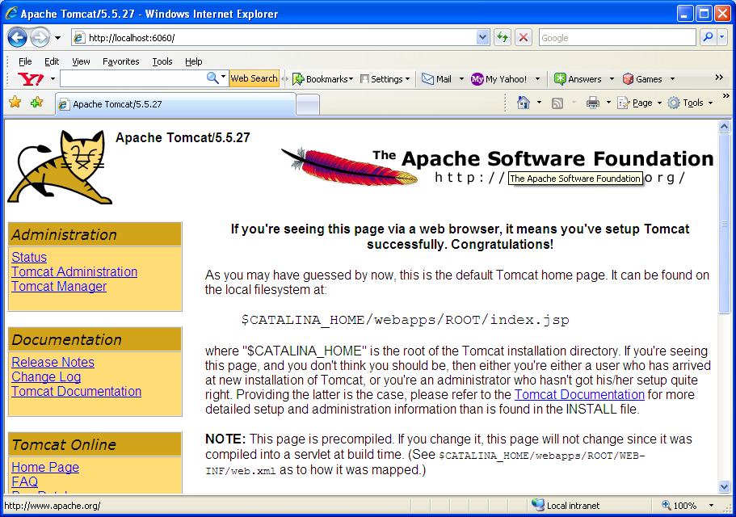
http://localhost:6060/axis/
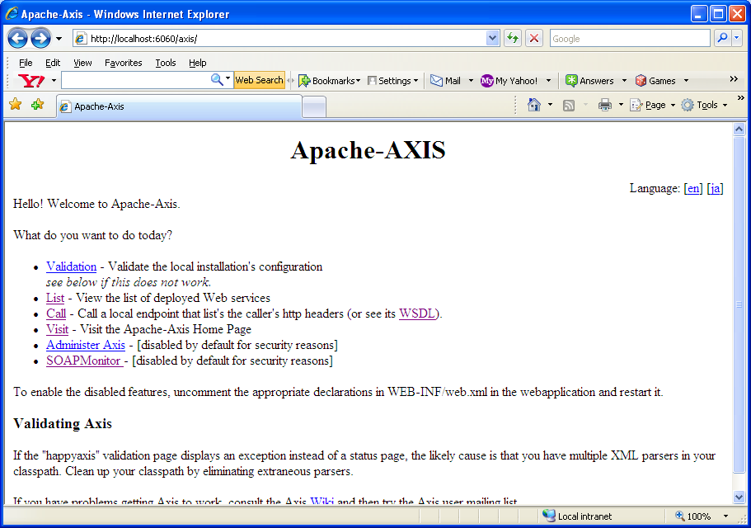

Testing MDP web service deployment
http://localhost:6060/axis/servlet/AxisServlet
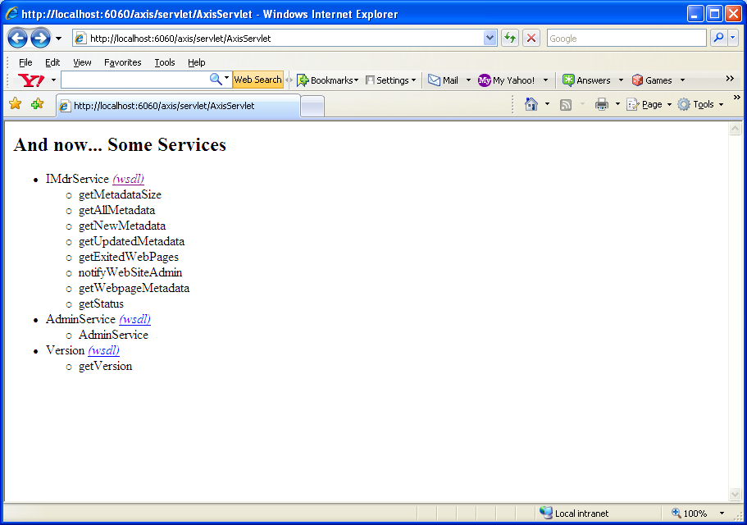
http://localhost:6060/axis/services/IMdrService?wsdl
