Low Power Design investigation
At
Deep sub-micron Technologies

Major Project report submitted in partial fulfillment for the award of the degree of

MASTER OF ENGINEERING
IN
ELECTRONICS & COMMUNICATION

By:-
Ramesh Chandra Sharma
Roll No. 8806
(25/E&C/2007)

Under the guidance of
Prof. Asok Bhattacharyya
(E &C Engg. Deptt.)



DEPARTMENT OF ELECTRONICS & COMMUNICATION ENGINEERING
DELHI COLLEGE OF ENGINEERING
UNIVERSITY OF DELHI, DELHI – 110042
DELHI COLLEGE OF ENGINEERING DELHI
Department of Electronics & Communication Engineering



CERTIFICATE

This is to Certify that the major project work/Thesis entitled, “Low Power Design investigation at Deep sub-micron Technologies”, submitted by Ramesh Chandra Sharma (College Roll No: 25/E&C/2007), in partial fulfillment of the requirement for the award of the degree of Master of Engineering (Electronics & Communication) of University of Delhi, is a record of the student’s own work carried out under my supervision. The work of this Thesis has not been submitted for the award of any other degree to the best of my knowledge and belief.

Dr. Asok Bhattacharyya
Professor, Electronics & Communication Engineering
Delhi College of Engineering, Delhi -110042
(Project Guide)

Forwarded by:

Dr. Rajeev Kapoor
Prof. & Head, E&C Department
Delhi College of Engineering,
Delhi- 110042

ACKNOWLEDGEMENT

It is distinct pleasure to express my deep sense of gratitude and indebtedness to my project guide Prof. Asok Bhattacharyya, Department of Electronics & Communication, Delhi College of Engineering, Delhi, for continuous inspiration, encouragement and guidance in every stage of preparation of this thesis.

I express my gratitude to my esteemed faculty members Dr. Neeta Pandey, Mrs. Rajeshwari Pandey and Mr. J. Panda and Mr. M. S. Choudhry who have evaluated my pre submission presentation. Lastly, I like to pay my sincere thanks to Dr. Rajeev Kapoor for my PG Seminar evaluation and his continuous encouragement.

Ramesh Chandra Sharma
University Roll No.: 8806

Table of Contents

Abstract…………………………………………………….5
- Introduction…………………………………………6
- Power Management………………………….…14
- Multi Voltage Design……………………………28
- Power Gating………………………………………37
- Dynamic Voltage & Frequency Scaling…..44
- Low Power Implementation using CPF…..50
- Result and Conclusion………………………….81
- References
- Appendix “A” Power consumption in CMOS
- Appendix “B” Creating CPF

Abstract

Packaging density of ICs is still following moor’s law but the increasing power consumption levels due to increased number of devices on same die has already become a major concern of the industry. Excessive power dissipation causes overheating, which can lead multiple impacts like, packaging cost, reliability & functionality of IC and other soft errors. This naturally limits battery life of hand held equipments and need urgent solution to enable the proliferation of technology at large.

Low-power design methodology, which uses computer-aided design (CAD) capabilities for estimating and optimizing (reducing) the power consumption of designs has been used. In this Project report I have discussed traditional and advanced Low power techniques to save Dynamic as well as leakage powers. I have used Cadence’s Low Power design methodology and tool suit for implementation.

Chapter 1. Introduction

It’s no secret that power is emerging as the most critical issue in system-on-chip (SoC) design today. Power management is becoming an increasingly urgent problem for almost every category of design, as power density—measured in watts per square millimeter—rises at an alarming rate.

In the last few years, design for low power has started to change again how designers approach complex SoC designs. Each of these revolutions has been a response to the challenges posed by evolving semiconductor technology. The exponential increase in chip density drove the adoption of language-based design and synthesis, providing a dramatic increase in designer productivity. This approach held Moore’s law at bay for a decade or so, but in the era of million gate designs, engineers discovered that there was a limit to how much new RTL could be written for a new chip project.

The result was that IP and design reuse became accepted as the only practical way to design large chips with relatively small design teams. Today every SoC design employs substantial IP in order
to take advantage of the ever increasing density offered by sub-micron technology.

Deep submicron technology, from 130nm on, poses a new set of design problems. We can now implement tens of millions of gates on a reasonably small die, leading to a power density and total power dissipation that is at the limits of what packaging, cooling, and other infrastructure can support. As technology has shrunk to 90nm and
below, the leakage current is increasing dramatically, to the point where, in some 65nm designs, leakage current is nearly as large as dynamic current. These changes are having a significant effect on how chips are designed. The power density of the highest performance chips has grown to the point where it is no longer possible to increase clock speed as technology shrinks.

As a result, designers are designing multi-processor chips instead of chips with a single, ultra-high speed processor. For battery-powered devices, which comprise one of the fastest growing segments of
the electronics market, the leakage of deep submicron processes is a major problem. To combat this problem, designers are using aggressive approaches at every step of the design process, from software to architecture to implementation. These approaches include power gating, where blocks are powered down when not in use, and multi-threshold libraries that can trade-off leakage current for speed.

For all applications, the total power consumption of complex SoCs presents a challenge. To address this challenge, designers are moving from a monolithic approach for power the chip—where a single supply voltage is used for all the non-IO gates of the design—to a multiple supply architecture, where different blocks are run at different voltages, depending on their individual requirements. And in some cases, designers are using voltage scaling techniques to change the supply voltage (and clock frequency) to a critical block depending on its workload and hence required performance. This thesis describes a number of the techniques designers use to reduce the power consumption of complex SoC designs.

From a chip-engineering perspective, effective energy management for an SoC must be built into the design starting at the architecture stage; and low-power techniques need to be employed at every stage of the design, from RTL to GDSII.

Fred Pollack of Intel first noted a rather alarming trend in his keynote at MICRO-32 in 1999. He made the now well-known observation that power density is increasing at an alarming rate, approaching that of the hottest man-made objects on the planet, and graphed power density as shown in Figure 1 below.

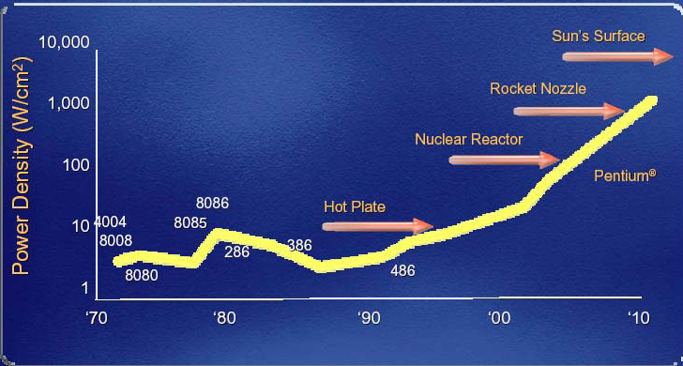

Figure 1. Power density with shrinking geometry. Courtesy Intel Corp.

The power density trend versus power design requirements for modern SoCs is mapped in Figure 2. The widening gap represents the most critical challenge that designers of wireless, consumer, portable, and other electronic products face today.

Figure 2. IC power trends: actual vs. specified. Courtesy Si2 LPC

Meanwhile, the design efforts in managing power are rising due to the necessity to design for low power as well as for performance and costs. This has ramifications for engineering productivity, as it impacts schedules and risk. Power management is a must for all designs of 90nm and below. At smaller geometries, aggressive management of leakage current can greatly impact design and implementation choices. Indeed, for some designs and libraries, leakage current exceeds switching currents, thus becoming the primary source of power dissipation in CMOS, as shown in Figure 3.

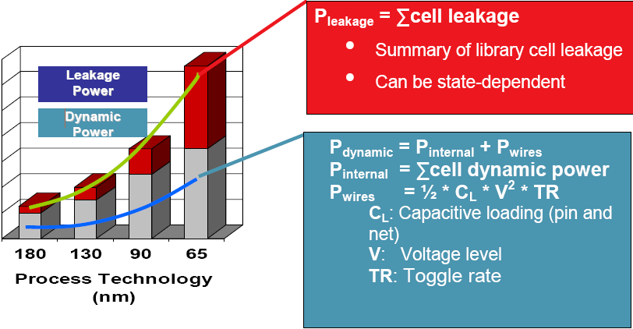
Figure 3. Process technology vs. leakage and dynamic power

Until recently, designers were primarily concerned with improving the performance of their designs (throughput, latency, frequency), and reducing silicon area to lower manufacturing costs. Now power is replacing performance as the key competitive metric for SoC design.

These power challenges affect almost all SoC designs. With the explosive growth of personal, wireless, and mobile communications, as well as home electronics, comes the demand for high-speed computation and complex functionality for competitive reasons. Today’s portable products are expected not only to be small, cool, and lightweight, but also to provide extremely long battery life. And even wired communications systems must pay attention to heat, power density, and low-power requirements. Among the products requiring low-power management are the following:

- Consumer, wireless, and handheld devices: cell phones, personal digital assistants (PDAs), MP3 players, global positioning system (GPS) receivers, and digital cameras
- Home electronics: game consoles for DVD/VCR players, digital media recorders, cable and satellite television set-top boxes, and network and telecom devices.
- Tethered electronics such as servers, routers, and other products bound by packaging costs, cooling costs, and Energy Star requirements supporting the Green movement to combat global warming

For most designs being developed today, the emphasis on active low-power management—as well as on performance, area, and other concerns—is increasing.

Today some of the most powerful microprocessor chips can dissipate 100-150 Watts, for an average power density of 50-75 Watts per square centimeter. Local hot spots on the die can be several times higher than this number.
This power density not only presents packaging and cooling challenges; it also can pose problems for reliability, since the mean time to failure decreases exponentially with temperature. In addition, timing degrades with temperature and leakage increases with temperature.
Historically, the power in the highest performance chips has increased with each new technology node. But because of the issues posed by the power density, the International Technology Roadmap for Semiconductors (ITRS) predicts that the power for
these chips will reach a maximum of 198 Watts in 2008; after that, power will remain constant.

Already, the total power consumption of microprocessor chips presents a significant problem for server farms. For these server farms, infrastructure costs (power, cooling) can equal the cost of the computers themselves.
For battery-powered, hand-held devices, the numbers are smaller but the problem just as serious. According to ITRS, battery life for these devices peaked in 2004. Since then, battery life has declined as features have been added faster than power (per feature) has been reduced.
For virtually all applications, reducing the power consumed by SoCs is essential in order to continue to add performance and features and grow these businesses.
Until recently, power has been a second order concern in chip design, following first order issues such as cost, area, and timing. Today, for most SoC designs, the power budget is one of the most important design goals of the project. Exceeding the power budget can be fatal to a project, whether it means moving from a cheap plastic package to an expensive ceramic one, or causing an unacceptably poor reliability due to excessive power density, or failing to meeting the required battery life.
These problems are all expected to get worse as we move to the next technology nodes. The ITRS makes the following predictions:

Table 1

Node 90nm 65nm 45nm
Dynamic Power per cm2 1X 1.4X 2X
Static Power per cm2 1X 2.5X 6.5X
Total Power per cm2 1X 2X 4X

Needless to say, design teams are working very hard to reduce the growth in power below these forecast numbers, since even at 90nm many designs are at the limit of what their customers will accept.

Chapter 2. Power Management

2-1 Power Dissipation in CMOS

Let’s take a quick look at the sources of power dissipation. Total power is a function of switching activity, capacitance, voltage, and the transistor structure itself.

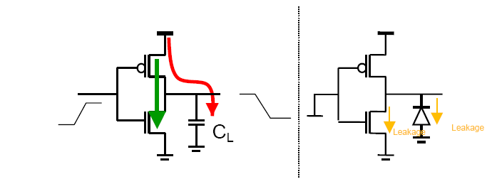
Figure 4. CMOS Power dissipation

Power = P_{switching} + P_{short-circuit} + P_{leakage}

Total power is the sum of dynamic and leakage power.

Dynamic power is the sum of two factors: switching power plus short-circuit power. Switching power is dissipated when charging or discharging internal and net capacitances. Short-circuit power is the power dissipated by an instantaneous short-circuit connection between the supply voltage and the ground at the time the gate switches state.

Pswitching = a .f.Ceff .Vdd²
Where;
a = switching activity
f = switching frequency
Ceff = effective capacitance
Vdd = supply voltage

Pshort-circuit = Isc .Vdd.f
Where;
Isc = short-circuit current during switching
Vdd = supply voltage
f = switching frequency7

Figure 5. CMOS Dynamic power

Dynamic power can be lowered by reducing switching activity and clock frequency, which affects performance; and also by reducing capacitance and supply voltage. Dynamic power can also be reduced by cell selection—faster slew cells consume less dynamic power.

Leakage power is a function of the supply voltage Vdd, the switching threshold voltage Vth, and the transistor size.

PLeakage = f (Vdd, Vth, W/L)
Where;
Vdd = supply voltage
Vth = threshold voltage
W = transistor width
L = transistor length

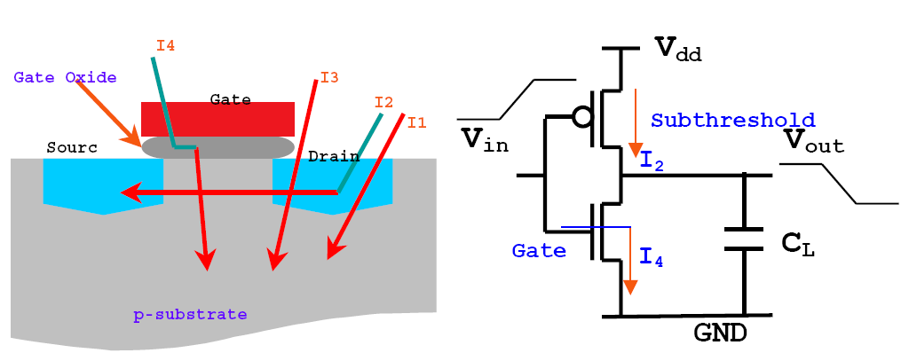

Figure 6. Leakage power in CMOS

Of the following leakage components, sub-threshold leakage is dominant.

- I1: Diode reverse bias current
- I2: Sub-threshold current
- I3: Gate-induced drain leakage
- I4: Gate oxide leakage

While dynamic power is dissipated only when switching, leakage power due to leakage current is continuous, and must be dealt with using design techniques.

Note: Refer appendix “A” for CMOS power calculation and modeling

2-2 Techniques for Switching and Leakage Power Reduction

The following table defines some common power management techniques for reducing power. Some of the power reduction techniques [4,13] will be discussed in more detail in following chapters.

Power  Management  Technique | Definition
Clock tree  optimization and  clock gating | Portions of the clock tree(s) that aren’t being used at any particular time are disabled.
Operand Isolation | Reduce power dissipation in datapath blocks controlled by an enable signal; when the datapath element is not active, prevent it from switching.
Logic Restructuring | Move high switching operations up in the logic cone, and low switching operations back in the logic cone; a gate-level dynamic power optimization technique.
Logic resizing (Transistor resizing) | Upsizing improves slew times, reducing dynamic current. Downsizing reduces leakage current. To be effective, sizing operations must include accurate switching information.
Transition rate buffering | Buffer manipulation reduces dynamic power by minimizing switching times.
Pin swapping | By swapping gate pins, switching occurs at gates/pins with lower capacitive loads.
Multi V_{th} | With the use of multi-threshold libraries, individual logic gates use transistors with low switching thresholds (faster with higher leakage)  or high switching thresholds (slower with lower leakage).
Multi-supply voltage  (MSV or voltage  islands) | Selected functional blocks are run at different supply voltages.
Dynamic voltage  scaling (DVS) | In this subset of DVFS, selected portions of the device are dynamically set to run at different voltages on the fly while the chip is running.
Dynamic voltage and  frequency scaling  (DVFS) | Selected portions of the device are dynamically set to run at different voltages and frequencies on the fly while the chip is running. Used for dynamic power reduction.
Adaptive voltage and  frequency scaling  (AVFS) | In this variation of DVFS, a wider variety of voltages are set dynamically, based on adaptive feedback from a control loop; involves analog circuitry.
Power shutoff  (PSO), or power  gating | When not in use, selected functional blocks are individually powered down.
Memory Splitting | If the software and/or data are persistent in one portion of a memory but not in another, it may be appropriate to split that block of memory into two or more portions. One can then selectively power down those portions that aren’t in use.
Substrate biasing  (body-biasing or  back-biasing) | Substrate biasing in PMOS biases the body of the transistor to a voltage higher than Vdd; in NMOS, to a voltage lower than Vss.

2-2-1 Clock tree optimization and clock gating

In normal operation, the clock signal continues to toggle at every clock cycle, whether or not its registers are changing. Clock trees are a large source of dynamic power because they switch at the maximum rate and typically have larger capacitive loads. If data is loaded into registers only infrequently, a significant amount of power is wasted. By shutting off blocks that are not required to be active, clock gating ensures power is not dissipated during the idle time.

Clock gating [14] can occur at the leaf level (at the register) or higher up in the clock tree. When clock gating is done at the block level, the entire clock tree for the block can be disabled. The resulting reduction in clock network switching becomes extremely valuable in reducing dynamic power.

2-2-2- Operand Isolation

Often, datapath computation elements are sampled only periodically. This sampling is controlled by an enable signal. When the enable is inactive, the datapath inputs can be forced to a constant value. The result is that the datapath will not switch, saving dynamic power.

2-2-3 Multi-Vth

Multi-Vth optimization utilizes gates with different thresholds to optimize for power, timing, and area constraints. Most library vendors provide libraries that have cells with different switching thresholds. A good synthesis tool for low-power applications is able to mix available multi-threshold library cells to meet speed and area constraints with the lowest power dissipation. This complex task optimizes for
multiple variables and so is automated in today’s synthesis tools.

2-2-4 MSV

Multi-supply voltage techniques [4,11,12,13,14] operate different blocks at different voltages. Running at a lower voltage reduces power consumption, but at the expense of speed. Designers use different supply voltages for different parts of the chip based on their performance requirements. MSV implementation is key to reducing power since lowering the voltage has a squared effect on active power consumption.
MSV techniques require level shifters on signals that go from one voltage level to another. Without level shifters, signals that cross voltage levels will not be sampled correctly.

2-2-5 DVS/DVFS/AVFS

Dynamic voltage and frequency scaling (DVFS) [4] techniques—along with
associated techniques such as dynamic voltage scaling (DVS) and adaptive voltage and frequency scaling (AVFS)—are very effective in reducing power, since lowering the voltage has a squared effect on active power consumption. DVFS techniques provide ways to reduce power consumption of chips on the fly by scaling down the voltage (and frequency) based on the targeted performance requirements of the application. Since DVFS optimizes both the frequency and the voltage, it is one of the only techniques that is highly effective on both dynamic and static power.

Dynamic voltage scaling is a subset of DVFS that dynamically scales down the voltage (only) based on the performance requirements.
Adaptive voltage and frequency scaling is an extension of DVFS. In DVFS, the voltage levels of the targeted power domains are scaled in fixed discrete voltage steps. Frequency-based voltage tables typically determine the voltage levels. It is an open-loop system with large margins built in, and therefore the power reduction is not optimal. On the other hand, AVFS deploys closed-loop voltage scaling and is compensated for variations in temperature, process, and IR drop using
dedicated circuitry (typically analog in nature) that constantly monitors
performance and provides active feedback. Although the control is more complex, the payoff in terms of power reduction is higher.

2-2-6 Power Shutoff (PSO)

One of the most effective techniques, PSO [4,14]—also called power gating—switches off power to parts of the chip when these blocks are not in use. This technique is increasingly being used in the industry and can eliminate up to 96 percent of the leakage current.

Power gating is employed to shut off power in standby mode. A specific power down sequence is needed, which includes isolation on signals from the shut-down domain. Erroneous power-up/down sequences are the root cause of errors that can cause a chip re-spin. This needs to be correctly and exhaustively verified along with functional RTL to ensure that the chip functions correctly with sections
turned off and that the system can recover after powering up these units.

Deploying power shutoff also requires isolation logic and possibly state retention of key state elements or, in other words, state retentive power gating (SRPG). For multi-supply voltage (MSV), level shifters are also needed.

2-2-7 Isolation

Isolation logic is typically used at the output of a powered-down block to prevent floating, unpowered signals (represented by unknown or X in simulation) from propagating from powered-down blocks.

The outputs of blocks being powered down need to be isolated before power can be switched off; and they need to remain isolated until after the block has been fully powered up. Isolation cells are placed between two power domains and are typically connected from domains powered off to domains that are still powered up.

In some cases, isolation cells may need to be placed at the block inputs to prevent connection to powered-down logic. If the driving domain can be OFF when the receiving domain is ON, the receiving domain needs to be protected by isolation.

The isolation cells may be located in the driving domain, with special isolation cells, or they may be in the receiving domain.

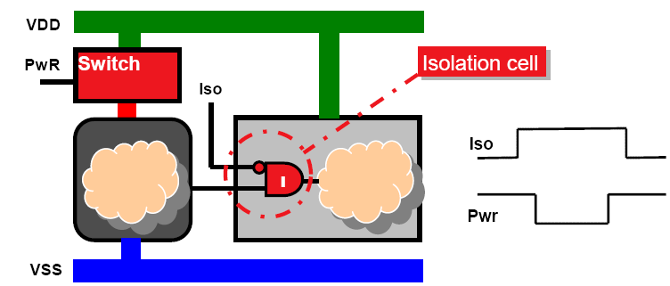

Figure 7. Isolation gate and power-down switch

2-2-8 State Retention

In certain cases, the state of key control flops needs to be retained during poweroff. To speed power-up recovery, state retention power gating (SRPG) flops can be used. These retain their state while the power is off, provided that specific control signaling requirements are met.

Cell libraries today include such special state retention cells. A key area of verification is checking that these library-specific requirements have been satisfied and the flop will actually retain its state.

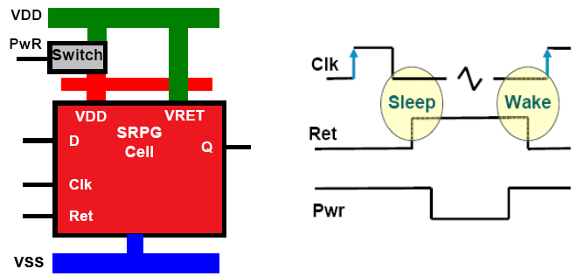

Figure 8. State retention power gating

2-2-9 Power Cycle Sequence

For power-down, a specific sequence is generally followed: isolation, state retention, power shutoff (see Figure 9). For the power-up cycle, the opposite sequence needs to be followed. The power-up cycle can also require a specific reset sequence.
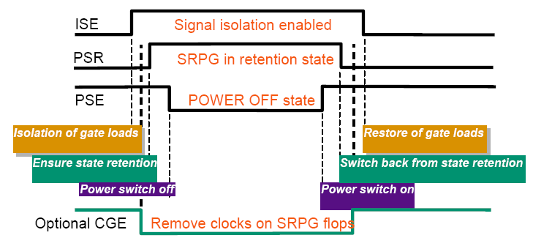

Figure 9. Power-up/down sequence

Given that there are multiple—possibly nested—power domains, coupled with different power sequences, some of which may share common power control signals and multiple levels of gated clocks, the need for verification support is tremendous. The complexity and possible corner cases need to be thoroughly analyzed; functional and power intent must be analyzed and thoroughly verified together using advanced verification techniques.

2-2-10 Memory Splitting

In many systems, the memory capacity is designed for peak usage. During normal system activity, only a portion of that memory is actually used at any given time. In many cases, it is possible to divide the memory into two or more sections, and selectively power down unused sections of the memory. With increasing SoC memory capacity, reducing the power consumed by memories is increasingly important.

2-2-11 Substrate bias (Reverse body bias)

Since leakage currents are a function of device Vth, substrate biasing—also known as back biasing—can reduce leakage power. With this advanced technique, the substrate or the appropriate well is biased to raise the transistor thresholds, thereby reducing leakage. In PMOS, the body of transistor is biased to a voltage higher than Vdd. In NMOS, the body of transistor is biased to a voltage lower than Vss.

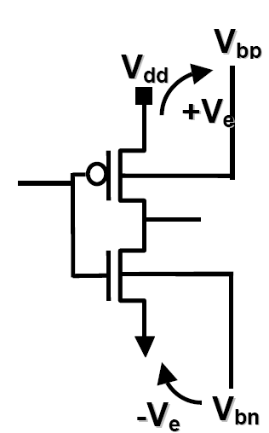
Figure 10. Body bias

Since raising Vth also affects performance, an advanced technique allows the bias to be applied dynamically, so during an active mode of operation the reverse bias is small, while in standby the reverse bias is stronger.

Area and routing penalties are incurred. An extra pin in the standard cell library is required and special library cells are necessary. Body-bias cells are placed throughout the design to provide voltages for transistor bulk. To generate the bias voltage, a substrate-bias generator is required, which also consumes some dynamic power, partially offsetting the reduced leakage.

Substrate bias returns are diminishing at smaller processes in advanced technologies. At 65nm and below, the body-bias effect decreases, reducing the leakage control benefits. TSMC has published information pointing to a factor of 4x reduction at 90nm, and only 2x moving to 65nm. Consequently, substrate biasing is predicted to be overshadowed by power gating.

In summary, there are a variety of power optimization techniques that attack dynamic power, leakage, or both. Figure 11 shows the effect of introducing several power reduction techniques on a raw RTL design, on both active and static power.

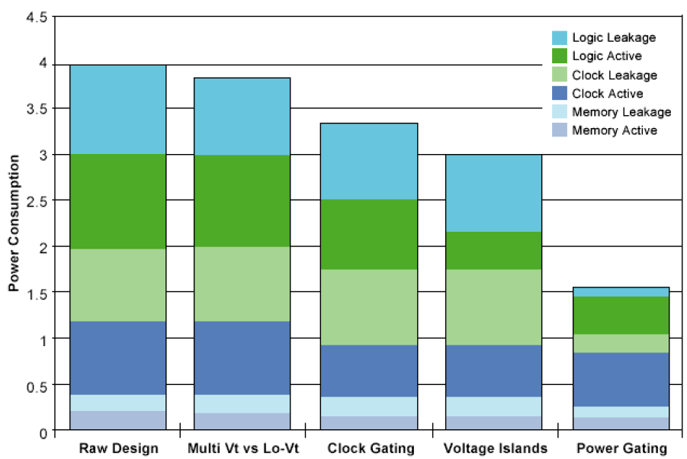
Figure 11. Power reduction techniques. Courtesy Chip Design magazine, 2007

CHAPTER 3 Multi Voltage Design

Since dynamic power is proportional to VDD 2, lowering VDD on selected blocks helps reduce power significantly. Unfortunately, lowering the voltage also increases the delay of the gates in the design.
Consider the example in Figure 2-3. Here the cache RAMS are run at the highest voltage because they are on the critical timing path. The CPU is run at a high voltage because its performance determines system performance. But it can be run at a slightly lower voltage than the cache and still have the overall CPU subsystem performance
determined by the cache speed. The rest of the chip can run at a lower voltage still without impacting overall system performance. Often the rest of the chip is running at a much lower frequency than the CPU as well.

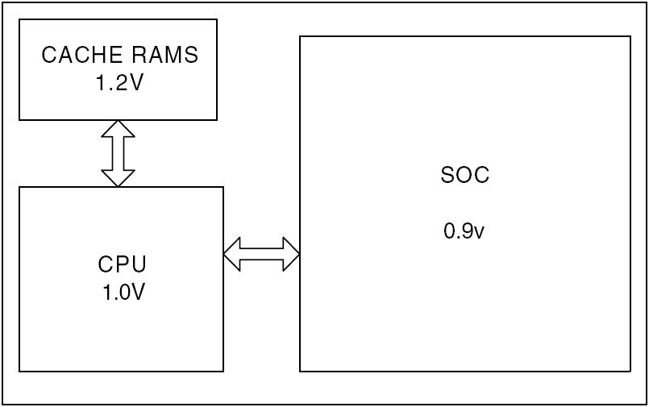
Figure 3-1 Multi Voltage Architecture

Thus, each major component of the system is running at the lowest voltage consistent with meeting system timing. This approach can provide significant savings in power. Mixing blocks at different VDD supplies adds some complexity to the design – not only do we need to add IO pins to supply the different power rails, but we also need a more complex power grid and level shifters on signals running between blocks. These issues are described in more detail later in the book.

3-1 Multiple Voltages Techniques

Because dynamic power is proportional to , even a small reduction in supply voltage causes a quadratic decrease in power consumption. However, a supply voltage reduction influences circuit’s delay negatively. To preserve a constant system throughput using lower supply voltages, there exist three main approaches:

1. To redesign the circuits exploiting the principles of parallelism and pipelining
2. To reduce the threshold voltage, V_{th}, in order to compensate V_{dd} reduction
3. To assign lower V_{dd} to noncritical paths

To preserve performance, while also reducing power consumption, a dual- V_{dd} approach can be used. The main concept is to assign the high
V_{dd}, V_{ddH} to the gates that belong to the critical path, while the low V_{dd}, V_{ddL} is assigned to off-critical path remaining gates; however, the designer should be very careful to avoid the creation of static current. More specifically, the output of V_{ddL} gates cannot be fed directly to V_{ddH} gates because the output of a V_{ddL} gate can never be raised higher than V_{ddL}. Therefore, if connected to a V_{ddH} circuit, static current flows due to the pMOS in the V_{ddH} circuit are never being completely cutoff 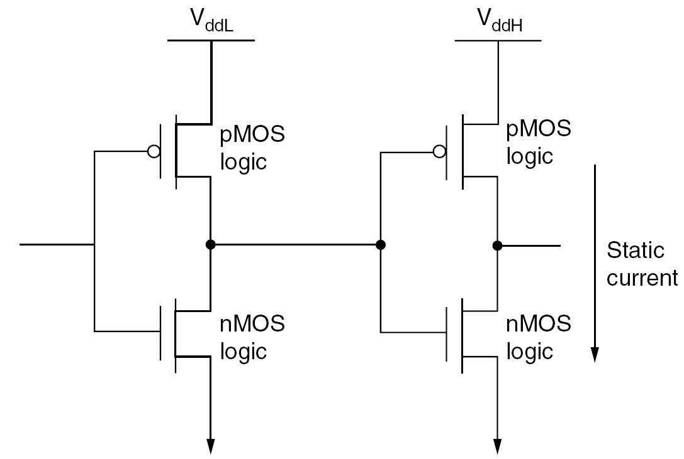
Figure 3-2. Multi voltage concept

to remove the static current, one possible solution is the use of level converters placed between the V_{ddL} - and V_{ddH} -supplied gates, which may increase area and power. To alleviate level converters’ power and area overhead, one approach is to insert the level shifting function of a flip-flop circuit (FFLC). More specifically, the master latch is the same as a conventional flip-flop, while the slave latch also realizes the level-conversion function. This results in the power of the flip-flop being less than that of V_{ddH} flip-flop, while increasing delay slightly. Layout is another important issue when dealing with multiple supply voltages. V_{ddL} and V_{ddH} cells should be separated because they have different n-well voltages. Generally, a row-by-row separation is used due to high performance and applicability to both standard-cell and gate-arrays. Novel algorithms have been developed for optimal assignment of cells to the layout rows with V_{ddH} and V_{ddL} supply voltages.

3-2 Challenges in Multi-Voltage Designs

Even the simplest multi-voltage design [4] presents the designer with some basic challenges:
• Level shifters. Signals that go between blocks that use different power rails often require level shifters – buffers that translate the signal from one voltage swing to another.
• Characterization and STA. With a single supply for the entire chip, timing analysis can be done at a single performance point. The libraries are characterized for this point, and the tools perform the analysis in a straight-forward manner. With multiple blocks running at different voltages, and with libraries that may not be characterized at the exact voltage we are using, timing analysis becomes much more
complex.
• Floor planning, power planning, grids. Multiple power domains require more careful and detailed floorplanning. The power grids become more complex.
• Board level issues. Multi-voltage designs require additional resources on the board – additional regulators to provide the additional supplies.
• Power up and power down sequencing. There may be a required sequence for powering up the design in order to avoid deadlock.

3-3 Level Shifters

When driving signals between power domains with radically different power rails, the need for level shifters is clear. Driving a signal from a 1V domain to a 5V domain is a problem – the 1V swing may not even reach threshold in the 5V domain. But the internal voltages in today’s chips are tightly clustered around 1V. Why would we need level shifters on signals going from a 0.9V domain to a 1.2V domain?

One fundamental reason is that a 0.9V signal driving a 1.2V gate will turn on both the NMOS and PMOS networks, causing crowbar currents. In addition, standard cell libraries are characterized for – and operate best with – a clean, fast input that goes rail to rail. Failure to meet this requirement may result in signals exhibiting significant rise- or fall-time degradation between the driver cell in one domain and the receiver in another voltage domain. This in turn can lead to timing closure problems and even excessive crowbar switching currents.

The best solution is to make sure each domain gets the voltage swings (and rise- and fall-times) that it expects. We do this by providing level shifters between any domains that use different voltages. This approach limits any voltage swing and timing characterization issues to the boundary of voltage domains, and leaves the internal timing of the domain unaffected. This kind of clean interfacing makes timing closure – and reuse – much easier.

3-4 Level Shifter Placement
Multi-voltage designs present significant challenges in placement. Figure 3-3 shows an example of two voltage domains embedded in a third voltage domain.

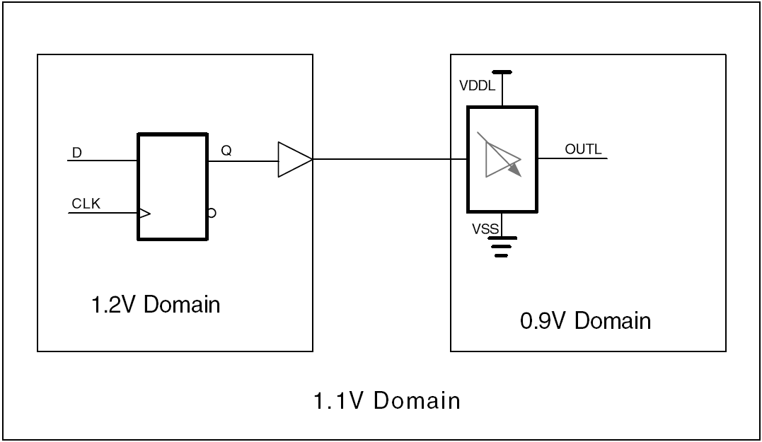
Figure 3-3. Level shifter placement

Because it uses the voltage rail from the lower voltage domain, the high-to-low level shifter is usually placed in the lower voltage domain. If the distance between the 1.2V domain and the 0.9V domain is small enough, and the library has a strong enough buffer, then the driving buffer can be placed in the 1.2V domain. No additional buffering is required. Adding additional buffers in the 1.1V domain clearly presents problems – what supply do the buffers use?

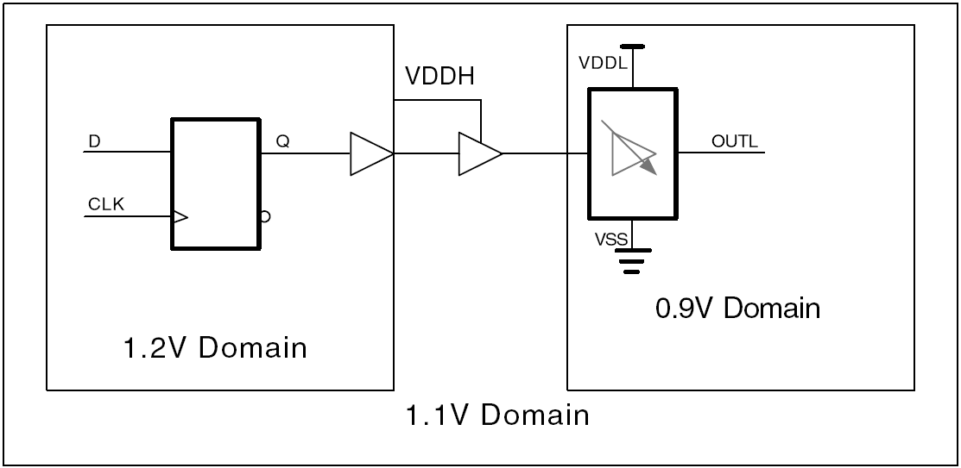
Figure 3-4. Buffering the Level shifter

3-5 Automatic Level Shifter insertion

Level shifters do not affect the functionality of the design; from a logical perspective they are just buffers. For this reason, modern implementation tools can automatically insert level shifters where they are needed. No change to the RTL is required.

Many tools now allow the designer to specify a level shifter placement strategy – to place the low-to-high level shifters in the lower domain, the higher domain, or between them. Note that the output driver has the higher supply current requirements; the low voltage supply only has to power the weaker devices to control the cell. For this reason we recommend placing the level shifters in the destination domain.

As part of defining a level shifter strategy, the designer specifies rules for when level
shifters are inserted. The designer can specify explicitly which blocks require level shifters, or the designer can specify a minimum voltage difference that requires level shifter insertion.

High-to-low level shifters should be inserted based on timing considerations. Using standard gates rather than level shifters at the interface of two different voltage regions causes an error in delay calculation, as mentioned above. If the voltage difference between the two domains is large enough then this timing error becomes unacceptable. In this case, level shifters are required. The exact voltage difference then depends on the library and the design objectives.

Low-to-high level shifters should be inserted based on power as well as timing considerations. If the voltage difference between two domains is large enough, the input stage of a standard gate in the higher domain will not turn all the way off, leading to excessive crowbar current.

CHAPTER 4 Power gating

Leakage power dissipation grows with every generation of CMOS process technology. This leakage power is not only a serious challenge to battery powered or portable products but increasingly an issue that has to be addressed in tethered equipment such as servers, routers, and set-top boxes. To reduce the overall leakage power of the chip, it is highly desirable to add mechanisms to turn off blocks that are not being used. This technique is known as power gating.

Power gating [4,12,13,14] consists of selectively powering down certain blocks in the chip while keeping other blocks powered up. The goal of power gating is to minimize leakage current by temporarily switching power off to blocks that are not required in the current operating mode. The most basic form of power gating control, and the one with the lowest long-term leakage power, is an externally switched power supply. Consider this example: an onchip CPU has a dedicated off-chip power supply; that is, the supply provides power only to the CPU. We can then shut down this power supply and reduce the leakage in the CPU to essentially zero. This approach, though, also takes the longest time and requires the most energy to restore power to a gated block. Internal power gating, where internal switches are used to control power to selected blocks, can be a better solution when powering down blocks for a short time.

Figure 4-1 shows a view of an SoC that uses internal power gating. Unlike a block that is always powered on, the power-gated block receives its power through a power-switching network. This network switches either VDD or VSS to the power gated block. In this example, VDD is switched; VSS is provided directly to the entire chip. The switching fabric typically consists of a large number of CMOS switches distributed around or within the power gated block.

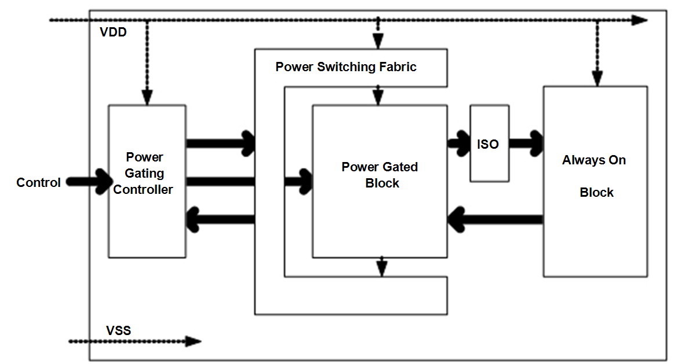
Figure 4-1. Power gating

The power gating controller controls the CMOS switches that provide power to the gated block. One challenge for power gating designs is that the outputs of the power gated block may ramp off very slowly. The result could be that these outputs spend a significant amount of time at threshold voltage, causing large crowbar currents in the always
powered on block.

To prevent these crowbar currents, isolation cells (the “ISO” block in the figure) are placed between the outputs of the power gated block and the inputs of the always on block. These isolation cells are designed so that they do not experience crowbar current when one of the inputs is at threshold, as long as the control input is off. The power gating controller provides this isolation control signal.

For some power-gated blocks, it is highly desirable to retain the internal state of the block during power down, and to restore this state during power up. Such a retention strategy can save significant amounts of time and power during power up. One way of implementing such a retention strategy is to use retention registers in place of ordinary flip-flops. Retention registers typically have an auxiliary or shadow register that is slower than the main register but which has much less leakage current. The shadow register is always powered up, and stores the contents of the main register during power gating.

These retention registers need to be told when to store the current contents of the main register into the shadow register and when to restore the value back to the main register. This control is provided by the power gating controller.

4-1 Power Switching – Fine Grain vs. Coarse Grain

A critical decision in power gating is how to switch power. In general, there are two approaches: fine grain power gating and coarse grain power gating. In fine grain [4] power gating the switch is placed locally inside each standard cell in the library. Since this switch must supply the worst case current required by the cell, it has to be quite large in order not to impact performance. The area overhead of each cell is significant (often 2x-4x the size of the original cell). Figure 4-2 shows an example of a fine grain AND gate.
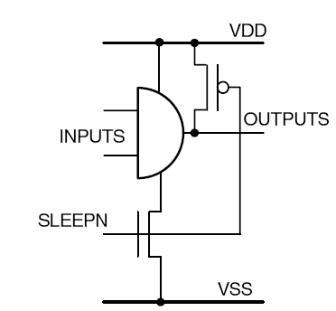
Figure 4-2 Fine grain structure

The key advantage of fine grain power gating is that the timing impact of the IR drop across the switch and the behavior of the clamp are easy to characterize as they are contained within the cell. This means that it is still possible to use a traditional design flow to deploy fine grain power gating.
In coarse grain [4] power gating, a block of gates has its power switched by a collection of switch cells. (Figure 4-4 on page 37). The sizing of a coarse grain switch network is more difficult than a fine grain switch as the exact switching activity of the logic it supplies is not known and can only be estimated. But coarse grain gating designs have significantly less area penalty than fine grain.

Over the last few years, there has been a strong convergence towards coarse grain power gating as the preferred method. The area penalty for fine grain power gating has just not proven worth the savings in design effort. Today, virtually all power gated designs use coarse grain power gating. For that reason, we focus exclusively on coarse grain power gating. One of the key challenges in any power gating design is managing the in-rush current when the power is reconnected. This in-rush current must be carefully controlled in order to avoid excessive IR drop in the power network; otherwise, the function and state of powered-on blocks could be corrupted as the power gated block goes through its sleep/wakeup sequence.

4-2 Power Switch design

The detailed transistor structures for power gating are highly technology specific. We consider here some of the architectural aspects of the switching fabric design.
The first architectural issue is whether to switch VDD (with a “header” switch) or to switch VSS (with a “footer” switch) or both. A number of academic papers have been published on this subject. Some authors
advocate both P-channel “Header” switches gating the VDD supply and N-channel “Footer” switches gating the VSS ground. However, two such high-VT power switches in series with the gate cause a more significant IR voltage drop in the supply as seen by the gate. This drop in turn causes increased delays for the gates in the design.
In many practical designs this performance loss cannot be tolerated, and only one of the rails is switched.
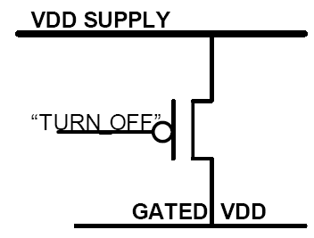
Figure 4-3 Header cell
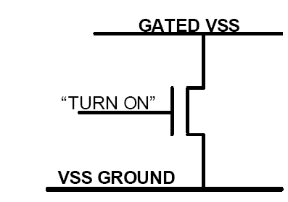
Figure 4-3 Footer cell

With a header-style switch fabric, the internal nodes and outputs of a power gated block collapse down towards the ground rail when the switch is turned off. With a footer-style switch fabric the internal nodes and outputs all charge towards the supply rail when the switch is turned off.
In SoC designs, the use of multiple power supplies is becoming increasingly common. These designs require level shifters on signals between blocks operating at different voltages. Level shifters are typically designed with a common ground and two different supply voltages. In chips using this design approach, switching the ground on power gated blocks can be a problem.

CHAPTER 5 Dynamic Voltage and Frequency Scaling

Scaling the supply voltage of CMOS is possible over a technology-specific range; gate delays, setup and hold times and even memory access times scale monotonically with reduced operating voltage over a limited range. Linear voltage reduction results in a square-law reduction in both dynamic power consumption and in leakage power.
The earlier discussion focused on basic multi-voltage techniques for optimizing dynamic power and on techniques to address leakage on advanced technology nodes.

Voltage Scaling – reducing the supply voltage and clock frequency based on work load – is a more aggressive technique for dynamic power reduction. It can be effective on 0.18u and 0.13u technology nodes (typically 1.8 and 1.2V standard operating voltage
respectively) where there is significant voltage headroom. In generic 90nm nodes (and below) there is not sufficient headroom to use voltage scaling very effectively. But it can be applicable to the “Low-Leakage” technology nodes at 90nm, 65nm and below, since these run at higher voltage than the equivalent generic or high-speed processes.
(The 90nm low voltage processes run at 1.2V nominal voltage compared to 1.0V for the “generic” or high-speed process nodes, for example).

Voltage scaling introduces complications into both the system design and the implementation flow, but can be valuable for portable battery-powered products. Rarely is all the logic on a SOC required to run at the limit of performance at all times, and in many systems there may be several different performance profiles. Dynamically scaling the supply voltage to a processor or multi-media subsystem, for example, may significantly improve battery lifetime in the final product. But every voltage scaled domain introduces another voltage regulator, usually offchip, and the requirement to interface between different analog values across voltage boundaries.

Dynamic voltage scaling (DVS) [4] is recognized as one of the most effective power reduction techniques. It exploits the fact that a major portion of power of CMOS circuitry scales quadratically with the supply
voltage. As a result, lowering the supply voltage can significantly reduce power dissipation. For noninteractive applications, such as movie playing, decompression, and encryption, fast processors reduce device idle times, which, in turn, reduce the opportunities for power savings through hibernation strategies. In contrast, DVS techniques are still beneficial in such cases (i.e., DVS reduces power even when these devices are active); however, DVS comes at the cost of performance degradation. An effective DVS algorithm is one that intelligently determines when to adjust the current frequency-voltage setting (scaling points) and to which frequency-voltage setting (scaling factors), so that considerable savings in energy can be achieved while the required performance is still delivered.

5-1 Dynamic Power and Energy

The dynamic power dissipated by CMOS is largely described by the equation:

P_{dyn} = C_{eff} •V_{dd}² • f_{clock}

Because dynamic power is linearly proportional to switching frequency, dynamically reducing the switching frequency whenever maximum performance is not required can reduce dynamic power significantly. The fact that dynamic power is linearly proportional to the capacitance being switched is more of a design and implementation constraint and is improved primarily by reducing the length of interconnect driven and the design complexity and hence area.

The voltage term has the greatest effect on power, and in the case where frequency can be reduced to allow a reduction in voltage, the power is reduced quadratically. Although generic in terms of technology and exact voltage, there is a region of operation where frequency increases monotonically over voltage, with a max voltage that is specified for the process, and a lower limit below which the circuitry runs out of safe voltage headroom and may fail to operate reliably – or where the delay paths no longer vary monotonically.

5-2 Dynamic Scaling of Frequency and voltage

The structural diagram shown in figure 5-1 The CPU subsystem is powered by a programmable power supply. The rest of the chip is powered by fixed power supply. A PLL provides a high speed clock to the SysClock Generator, which uses dividers to generate the CPU CLOCK and the SOC CLOCK. To execute voltage and frequency scaling, software first decides the minimum CPU clock speed that meets the workload requirements. It then determines the lowest supply voltage that will support that clock speed.
If the target clock frequency is higher than the current frequency, then the execution sequence is as follows:
• The CPU programs the power supply to the new voltage
• The CPU subsystem continues operating at the current clock frequency until the voltage settles to the new value
• The CPU then programs the new clock frequency.
• If the clock frequency change just requires a change in the divider value, it programs the SysClock Generator for this new value. No pause in CPU operation is required.
• If the new clock frequency requires a change in the PLL frequency, then the CPU programs the PLL to the new frequency. Either the PLL or the SysClock Generator suppresses all clocks until the PLL settles.

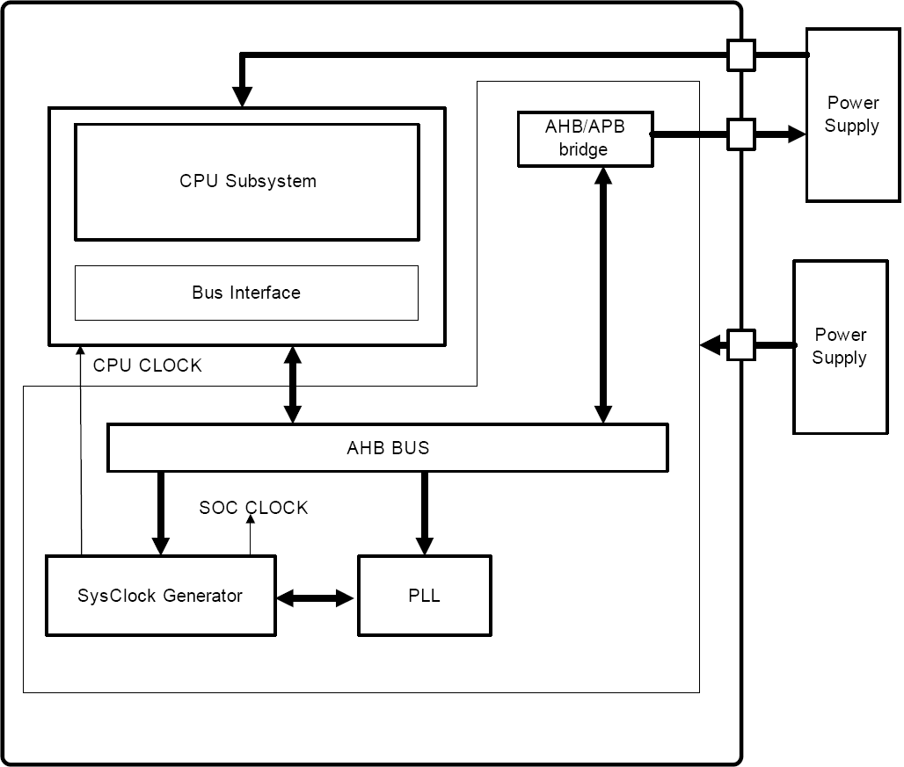
Figure 5-1 DVFS structural diagram

If the target clock frequency is lower than the current frequency, then the execution sequence is as follows:
• The CPU first programs the new clock frequency.
• If the clock frequency change just requires a change in the divider value, it programs the SysClock Generator for this new value. No pause in CPU operation is required.
• If the new clock frequency requires a change in the PLL frequency, then the CPU programs the PLL to the new frequency. Either the PLL or the SysClock Generator suppresses all clocks until the PLL settles.
• The CPU then programs the power supply to the new voltage
• The CPU subsystem continues operating at the new clock frequency while the voltage settles to the new value Varying clocks and voltages during operation is a new paradigm in design and offers some unique challenges:
• Determining which voltage and clock values to support
• Modeling timing
• Dealing with the settling time of clock generators and power supplies

5-3 Timing/Voltage Values

Most DVFS systems use a set of discrete voltage/frequency pairs. Determining which values to support is a key design decision, and is highly application dependent. Too few operating points may result in systems that under some profiles spend a significant time ramping between the two levels – and the energy efficiency savings during the ramping times are typically significantly less than the steady-state values. Most of the time “hunting” between different target voltages.

Initially, we determine the number of operating points analytically:
• what are the appropriate clock frequencies for the different work loads
• which frequencies have clock periods that are multiples of the PLL period and thus require just changing the clock divider, not the PLL frequency
• what voltage is required to support each target frequency performing this timing analysis requires either special library and tool support or significant manual effort.

One approach to refining the selection of operating points is to provide the software developers with prototype, such as an FPGA implementation or a high level simulation model, that can run example workloads. There is no need to actually scale voltage; we simply emulate the performance clock scaling and representative power supply ramp times. This enables us to understand how many distinct performance levels are useful under realistic dynamic workload conditions.

5-4 Power Up Sequencing

DVFS [4] systems typically use at least two external power supplies. In this case we need to pay attention to the power-up control. We need to ensure that there are no deadlocks due to IO pad signaling not being stable until the power rail is valid, for example. We need to control the power up sequence and provide a guaranteed voltage settling time before issuing reset and starting the system. We can do this using a local digital counter, or some form of “voltage ready” handshake signal.

Chapter 6 Low Power Implementation using CPF

6-1 Introduction to Low-Power Implementation

Low-power implementation [4] must correctly deal with the physical implications and penalties incurred by the wide variety of techniques used for power optimization earlier in the flow. In addition, it automatically performs power optimizations that can only be accurately employed once the physical layout is understood.

6-2 Implementation Stages

Low-power implementation consists of multiple steps, automated through CPF and the electronic design automation tool flow:
􀂃 Floor planning with multiple power domains
􀂃 Power delivery, through power planning and routing
􀂃 Insertion of power gating for low-power shutoff
􀂃 Placement, including placement of level shifter, isolation, and SRPG cells
􀂃 Optimization, including multiple threshold voltage (Multi-Vth) optimization, as well as multiple supply voltage (MSV) optimization
􀂃 Clock tree synthesis, and ensuring the clock tree is well balanced and optimized for power
􀂃 Efficient routing, because the shorter the route length, the less power is dissipated, while timing and signal integrity must be preserved
􀂃 Analysis and verification, or signoff power analysis, to make sure power consumption is consistent with estimation, and that timing and IR drop are under control

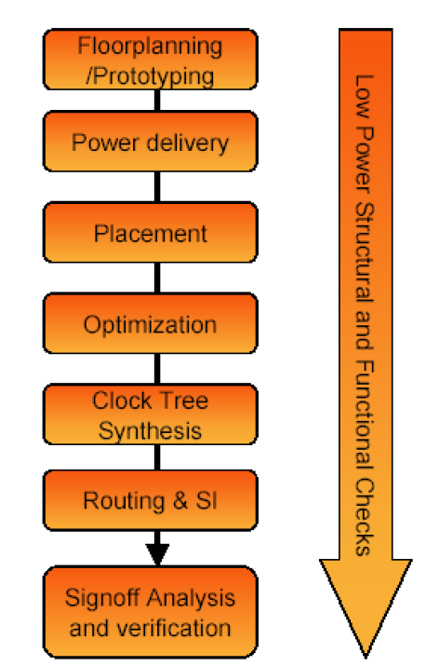
Figure 6-1 Low Power Design Flow

The low-power techniques that have an especially high impact on implementation complexity, as previously discussed, include:

􀂃 Gate-level optimizations—logic resizing, restructuring, and pin swapping
􀂃 Clock gating
􀂃 Multi-Vth optimization
􀂃 MSV
􀂃 Power shutoff (including state retention cell usage)
􀂃 DVFS
􀂃 Back biasing

6-3 Critical Challenges of Low-Power Implementation

The success of the SoC design depends on a physical implementation that obeys the consistent power intent from front-end design and verification. Power intent in this case refers to the implementation of power domains according to definitions, isolation/level [1,4,14] shifter cell usage, etc. For example, in the front end, which power domains belong to which hierarchical instances is established. This has to be maintained consistently between front-end design and implementation, which has special impact on the cell identification, place, route, and verification tasks.

The following shows a multi-block design with ALU, I/O, address, instruction and data registers, a state sequencer, and on-chip power control module. It represents an application of multiple power domains (0.8–1.2v) for power optimization, with the concomitant level shifters and isolation cells.

Figure 6-2 Power Intent illustration

Power Intent specification of design in figure 6-2 follows:

set_design cpu
### Power net definitions ###
create_power_nets -nets VDD -voltage 0.8
create_power_nets -nets VDDH -voltage 1.2
create_ground_nets -nets VSS
create_global_connection -domain ALUP \
-net VDDI -pins VDD
### Low power cell definitions ###
define_power_switch_cell -cells HDRHVT \
-stage_1_enable SLPIN –stage_1_output SLPOUT \
-power VDDH -power_switchable VDDI
define_isolation_cell -cells ISOHVT \
-enable NSLEEP -power VDD -ground VSS
define_level_shifter_cell \
-cells LVLHVT -valid_location from \
-input_voltage_range 0.8 \
-output_voltage_range 1.2 -ground VSS \
-input_power_pin VDD \
-output_power_pin VDDH
### Power domain definitions ###
create_power_domain -name TOP –default
create_power_domain -name ALUP \
-instances ALU \
-shutoff_condition {pcm_inst/pse[0]}
update_power_domain –name ALUP \
-internal_power_net VDDH
### Low power cell creation directives ###
create_power_switch_rule –name PSW_RULE -domain ALUP
create_isolation_rule –name ISO_RULE -from ALUP
-isolation_condition {pcm_inst/pse[0]} -isolation_output high
create_level_shifter_rule –name LS_RULE -from TOP -to ALUP

The physical designer faces many challenging physical realities when implementing low-power constructs defined in front-end design. For example, how many power switches are needed in order to prevent IR drop from causing timing problems or a catastrophic failure? Is current density an issue on the SoC?

This is also the final opportunity to juggle and optimize timing, area, and power requirements. In the implementation stage, timing, area, and power are translated to physical reality. Cells are now known to have actual placement area; routes have real lengths with associated RLC. Therefore, meeting timing, area, and power requirements becomes a hard requirement, which is an iterative process.

Figure below is snapshot of the SoC physical placement and routing layout from the example above, showing MSV techniques implemented in 65nm.

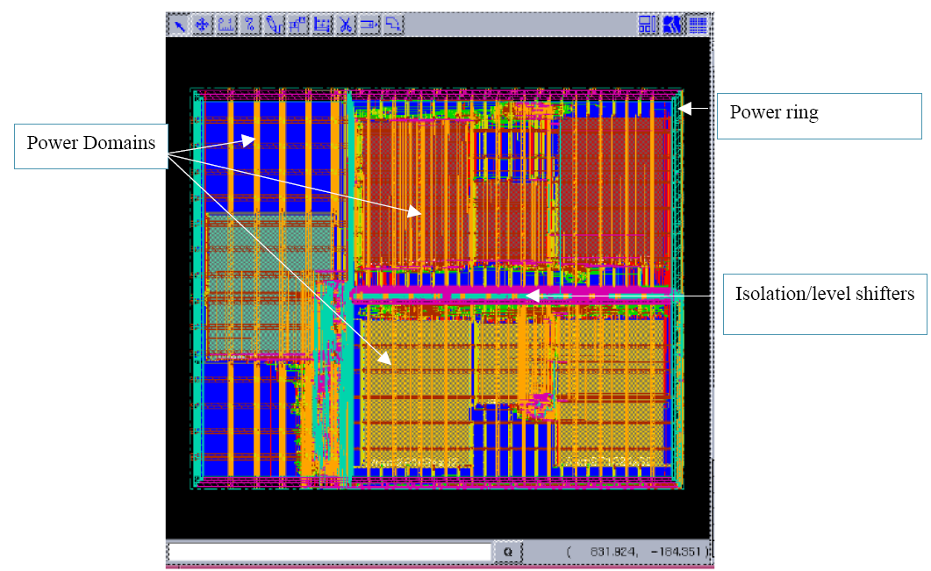

Figure 6-3 Encounter based power planning for physical placement and routing

6-4 Gate-Level Optimization in Power-Aware Physical Synthesis

Perhaps the most basic of low-power techniques in the implementation stage is gate-level optimization. This set of techniques includes transistor resizing, restructuring, and pin swapping. These techniques are not unlike those being used in the synthesis stage; the only difference is that in the implementation stage, the designer and the implementation tool have exact knowledge of physical distance and routing distance between cells. This allows more accurate application of resizing, restructuring, and pin swapping for maximum benefit while incurring minimum timing penalty.

6-5 Clock Gating in Power-Aware Physical Synthesis

Today, clock gating to address dynamic power is done in almost all designs, not just low-power designs. The reason is that clock-gating technology in EDA tools has evolved to where it is automated and easy to implement, and doesn’t break the methodology.

In the synthesis [15] stage, clock-gating elements are inserted; however, in the synthesis stage there usually is no exact information on the physical distance between the clock-gating element and the leaf cell. Clock-gating violations usually occur because the clock-gating cell is too far from the leaf cell. During physical implementation, in order to fix clock-gating violations, the clock-gating cell must be physically moved closer to the leaf cell. However, if the clock-gating cells are completely de-cloned, this isn’t possible until clock-gating cloning is done.

Figure 6-4 Clock Cloning/Decloning

Conversely, overdoing clock-gating cloning will introduce many clock-gating elements, thereby nullifying the power and area advantage provided by clock gating. The designer is caught between Scylla and Charybdis! However, in the physical realm, the implementation tool now knows exactly how far the clock-gating cell is from the leaf pin. This enables the tool to correctly clone the clock-gating element to prevent clock-gating timing violations.

Therefore, the correct methodology to deal with clock gating is to de-clone all the way during synthesis, and then selectively clone based on clock-gating timing during the physical implementation stage. This is a process that is automated by the EDA tool during the clock tree synthesis implementation stage.

6-6 Multi-Vth Optimization in Power-Aware Physical Synthesis

Multi-Vth optimization, which addresses leakage power, is also widely used in today’s physical implementation designs. Current EDA technology has matured so that multi-Vth optimization is automated from RTL through GDS. Basic requirements are different threshold voltage libraries of the same cell’s functionality, and a power-aware implementation tool. High-Vth cells are low power, but lower performance as well. Low-Vth cells consume higher power, but provide higher performance. Usually the trade-off favors power. For example, by using a high-Vth cell instead of low-Vth cell, the user can achieve a significant reduction (up to 80 percent) in leakage power with a small impact to timing (around 20 percent).

Different Vth versions of the same functional cell usually have the same footprint, so the cells can be swapped interchangeably and easily during layout. However, the timing impact of using different Vth cells has to be taken into account during cell swapping. The implementation tool also usually handles this analysis automatically. Multiple threshold voltage swapping usually takes place either in the post clock tree synthesis implementation stage or the post-route stage.

6-7 MSV in Power-Aware Physical Synthesis

MSV implementation is essentially a continuation of MSV synthesis. It is also similar to power shutoff in a number of ways. The tasks involved include:

􀂃 Creation of power domains
􀂃 Placement and optimization
􀂃 Level shifter handling

6-8 Creation of Power Domains

First, during the floor-planning stage, different power domains have to be created, consistent with power domain definitions in the front end. Each power domain has a different set of libraries associated with it for that specific voltage domain, as in the synthesis stage.

6-9 Placement and Optimization

For placement and optimization [16] in a top-down situation where the design is being implemented as a whole, the tool needs to understand that power domain boundaries must be honored. That is, the CPF-aware tool knows that no logic from one power domain can be moved to another power domain. In addition, during placement and optimization, the tool should be able to use the correct timing libraries set for each of the power domains. For example, when the tool is optimizing the 0.8V power domain, it should use the timing libraries characterized at 0.8V. Some less-sophisticated implementation tools do not understand the concept of multiple supply voltages, through CPF, and thus MSV design implemented using those tools will need to be implemented bottom-up, which is less efficient and involves more manual engineering effort.

Figure 6-5 MSMV design and Level shifter

Handling level shifters is another automated task with CPF. Level shifters can be inserted during the synthesis or implementation stage. Every signal that crosses an MSV power domain should have a level shifter attached to it. Although level shifting from a higher-voltage power domain to a lower one is usually optional, level shifting from a lower-voltage power domain to a higher one is mandatory.

A sample CPF for level shifting is shown below:

define_level_shifter_cell \
-cells LVLHVT -valid_location from \
-input_voltage_range 0.8 \
-output_voltage_range 1.2 -ground VSS \
-input_power_pin VDD \
-output_power_pin VDDH
create_level_shifter_rule –name LS_RULE -from TOP -to ALUP

In cases where MSV and PSO are used together, most designers opt for combination level shifter and isolation cells.
Figure 6-6 Level Shifter Isolation Combo Cell

Level shifters are placed in a fashion similar to isolation cells, close to the power domain boundaries. However, level shifters have two power rails:

􀂃 Primary power rail: usually set at the top and bottom edge of the level shifter
􀂃 Secondary power rail: usually set at the center horizontal line of the level shifter The power domain where the level shifter resides depends on which voltage the primary power rail matches. For example, if the primary power rail of the level shifter is a 0.8V rail, that level shifter should be placed in the 0.8V power domain. Therefore, some knowledge about the library is needed in order to decide in which power domain to place the level shifter.

6-10 Challenges in MSV Implementation

6-10-1 Voltage regulators
One of the main challenges of implementing MSV is the requirement of an on-chip voltage regulator to generate different voltages. A voltage regulator is a complex analog block that generates a different voltage from a given voltage. In some designs, an off-chip voltage regulator may be used, but it is usually done on chip.

6-10-2 Implications of using lower operating voltages
Theoretically, since power is proportional to voltage squared, by lowering the voltage we should get an exponential decrease in power consumption. In reality, this is not necessarily so, because in the physical world, lower voltage means timing issues and increased transition time, which translates into more power consumption.

In order to fix timing issues, logic needs to be upsized or inserted, also resulting in more power consumption. Overall, operating at a lower voltage definitely gives power savings, although not as much as theoretically would be possible without reference to timing issues.

6-10-3 Power Shutoff (PSO) in Power-Aware Physical Synthesis
PSO involves shutting down a part of the chip while the other parts remain functioning, and is a relatively sophisticated low-power technique with many implications for timing and implementation complexity. Nonetheless, PSO is becoming increasingly popular today, not only in mobile electronics but also in tethered electronic systems that are plugged into a power outlet. This is because of the strong low-power benefit and the fact that today’s CPF-enabled tools can automate the implementation of PSO with confidence.

Following are the two types of PSO:
􀂃 On-chip power shutoff means that power switches within the SoC control the power shutoff
􀂃 Off-chip power shutoff means the power switches are external to the chip

Figure 6-7 On chip PSO vs. Off chip PSO

PSO (or power gating) can also be either fine- or coarse-grained, referring to the size of each logic block controlled by a single power switch. With fine-grained power gating, power can be shut off to individual blocks or cells without shutting off the power to other blocks—which continue to operate. This can help to reduce active mode leakage power, or leakage during normal operation. With coarse grained power gating, power is gated very coarsely, as with a single sleep signal that powers down the entire chip. This reduces leakage only during standby, naturally.

The following table summarizes aspects of each.

 | Fine-grained | Coarse-grained
Power gate size | Worst-case switching (30% area) | Actual switching (5% area)
Gate control slew rate | Always-on buffer network | Always-on buffer by abutment
Simultaneous switching capacitance | No issue | Needs to be addressed
Power gate leakage | >30% | <5%

6-11 Physical Implementation Implications of PSO

6-11-1 Creation of Power Domains
Power domains must be consistent with front-end design power domain definitions [4]. Usually there will be a hierarchical module that is defined as a PSO power domain in the CPF file. This power domain is then implemented such that all the logic or hard macros in the hierarchical module reside in the correct physical area in the power domain, and all the logic or hard macros that don’t belong in the hierarchical module reside outside the physical area of the power domain. This is important because the physical area generally defines whether that logic/hard macro is powered by an always-on power net or a PSO power net. Power domain creation occurs in the floor-planning or physical prototyping stage of the implementation flow.

Following is an example of the CPF:

create_power_domain -name ALUP \
-instances ALU \
-shutoff_condition {pcm_inst/pse[0]}

6-11-2 Insertion of Power Switch Cells
Insertion of power switch cells (for on-chip PSO) is the next step. Power switch cells can be inserted in a column or a ring fashion.

Figure 6-8 Ring vs. column switch insertion

More advanced, CPF-enabled EDA toolsets will automatically insert the power switch cells for the designer; in less advanced toolsets, the designer has to manually insert these constructs. Power switches are also inserted during the floor planning or prototyping stage of the implementation flow. An example of the CPF for power switches follows:
define_power_switch_cell -cells HDRHVT \
-stage_1_enable SLPIN –stage_1_output SLPOUT \
-power VDDH -power_switchable VDDI
create_power_switch_rule –name \ PSW_RULE -domain ALUP

The number and size of the power switches that are inserted depend heavily on the design’s physical characteristics. Generally, the larger the PSO power domain area, and the more logic and macros in the PSO power domain area, the more power switches are needed. The goal is to have the true optimal number of power switches to satisfy IR drop and current density requirements. Too many power switches leads to wasted area, but too few power switches creates excessive IR drop and risks having too much current (rush current) going through each power switch during wakeup.

Some power switches have built-in buffers/delays that accomplish two things: first, control the skew of the enable signal of the power switch; and second, introduce a delay when the enable signal traverses the power switch array.

6-11-3 Buffered vs. Unbuffered Power switches

Figure 6-9 Buffered vs. Unbuffered Power switches

It may be desirable to introduce a delay, because turning on the PSO power domain causes a large current to be drawn by the domain, causing a current spike or rush current. Introducing a delay between the times when each power switch turns on will spread out the turn-on time of the PSO domain, thereby reducing the current spike. Another method for reducing the current spike is to turn on the power within the domain in stages over time.

It is also desirable to design the power switches in groups of cells and turn them on and off one group at a time. This way, the last group of power switches at the end of the shutoff sequence, or the first group of power switches at the beginning of the power-on sequence, will handle the large current instead of a single power switch.

In many designs, switches are used in a configuration called “mother-daughter” pair. These switches have multiple enable pins; typically, the smaller switch is turned on first to get the voltage up to 95 percent, then the bigger switch is turned on to reduce the IR drop. Figure below illustrates the configuration of such a switch.

Figure 6-10 Mother daughter pair switches

6-11-4 Isolation Cell Handling
As we have seen earlier, isolation cells can be inserted by the synthesis tool early in the design, if the synthesis tool [15] understands the concept of PSO as it is supported in CPF. The physical implementation tool may also insert isolation cells. Isolation cells should be inserted into the netlist in the early floor-planning stage.

Following is a CPF example for isolation cells:

define_isolation_cell -cells ISOHVT \
-enable NSLEEP -power VDD -ground VSS
create_isolation_rule –name ISO_RULE -from ALUP \
-isolation_condition {pcm_inst/pse[0]} -isolation_output high

Isolation cells are placed as close to the PSO domain as possible, but usually reside in the always-on domain. Figure below shows this physical layout.
Figure 6-11 Isolation cell insertion

Again, sophisticated, standards-based EDA tools are available to handle this automatically, while other EDA tools require the designer to manually create regions for isolation cells to be inserted—an error-prone process. Common problems that may occur while inserting isolation cells include placing the isolation cells in the wrong power domain or hooking up the isolation power supply to the switchable power supply instead of the always-on power supply. These are catastrophic issues!

6-11-5 Retention Register Handling

For SRPG, regular registers in PSO domains are transformed or swapped into state retention registers during synthesis.

Figure 6-12 State retention scheme

State retention registers require two types of power supplies: a switchable power supply and an always-on power supply. This introduces some complications and penalties in power routing area requirements. The physical designer, or implementation tool, must allocate extra area to accommodate this additional power routing.

6-11-6 Always-on Buffering
Always-on buffering is required because certain nets in the power shutoff domain have to remain on at all times; for example, control signals for SRPG registers that feed through nets. Always-on buffering is also handled in physical implementation. Figure below shows an always-on domain and a PSO domain. In this case, since the feedthrough buffer resides in the PSO domain, it would be powered down and disabled. So the buffer must be an always-on cell.

Figure 6-13 Always ON and PSO domain

As shown in Figure below, both always-on rows and always-on buffers are supported.
􀂃 Always-on rows provide uninterrupted power for regular buffers
􀂃 Always-on buffers can stay on using a secondary power pin

Figure 6-14 Always On rows and Buffers

With always-on buffering support, always-on nets can be implemented correctly.

Figure 6-15 Transformed always-on and PSO domains

6-11-7 Dynamic Voltage/Frequency Scaling (DVFS) Implementation

In the implementation stage, DVFS [4] is accomplished using a combination of MSV and multimode/multi-corner (MMMC) techniques. Utilizing power domains is a requirement for implementing DVFS designs. In addition, these power domain definitions must be consistent with front-end definitions of power domains, which again are automated with CPF.

DVFS differs from MSV in that with DVFS, a single power domain may operate at different modes, where each mode has a different supply voltage and operating frequency. In implementation with DVFS, the challenges are very similar to DVFS in synthesis: juggling different operating voltages (with their assigned, different timing libraries) and different operating frequencies (different timing constraint files). In more advanced EDA tools, these different combinations are optimized in parallel, automating the process. Although this may result in longer run times to achieve design closure than with traditional, non-DVFS designs, the power benefits are worthwhile.

For example, the design below shows DVFS techniques implemented in the layout. In the baseline or active mode of operation, all blocks operate at 125MHz and 1.08V. In slow mode, one block operates at 66MHz and 0.9V, which conserves power. In standby, two of the blocks are powered down completely.

Figure 6-16. Three modes of operation with DVFS

Mode | Core | Drowsy | Dull
Baseline | 1.08V  125MHz | 1.08V  125MHz | 1.08V  125MHz
Slow | 1.08V  125MHz | 1.08V  125MHz | 0.9V  66MHz
Standby | 0.0V | 1.08V  125MHz | 0.0V

6-11-8 Substrate Biasing Implementation
Substrate biasing, also known as back biasing, involves biasing the voltage of the body (bulk) of the transistors. The PMOS bulk is biased to a voltage higher than Vdd, and the NMOS bulk is biased to a voltage lower than Vss. This reduces the leakage current of the transistors. For single-well technology, the bulk of the PMOS is connected to the n-well and the bulk of the NMOS is connected to the P-substrate. For dual-well technology, the bulk of the NMOS is connected to a pwell.

6-11-9 Charge Pumps
Depending on the library, substrate biasing can be done for the PMOS, NMOS, or both. To bias the bulk of the NMOS and PMOS of the standard cells, voltages are created by charge pumps, which are custom blocks that output VDDbias and VSSbias voltages. These charge pumps, which are custom macros about the size of PLLs, provide VDDbias and VSSbias. These voltages then need to be distributed across the parts of the chip that utilize substrate biasing. There are two methods for distributing the bias voltages to standard cells:
􀂃 Using well-tap cells (body-bias cells)
􀂃 In-cell taps, having VDDbias and VSSbias pins for each standard cell, then tapping those pins to n-well and p-sub, respectively

6-11-10 Well-Tap or Body-Bias Cells
Well-tap or body-bias cells tap VDDbias and VSSbias to n-well and p-sub, respectively. Theoretically, each standard cell row must have at least one well-tap cell. In reality, multiple body-bias or well-tap cells are needed per standard cell row to prevent latch-up. Designers usually have a rule of one tap cell placed in a standard cell row per every certain distance, at regular intervals. Adding well-tap cells actually saves area, because compared with the second method listed below, the only area increase is for the well-tap cells (which are smaller than the average 1x inverter).

Figure below shows a typical body-bias cell. It looks similar to a normal non-bias cell, except for two differences: The n-well is tapped to VDDbias instead of Vdd, and the p-sub is tapped to VSSbias instead of Vss. Placing this cell at multiple points in every standard cell row will tap the n-well and p-sub of that row to VDDbias and VSSbias, respectively.

Figure 6-17 Well Tap or Body Bias cell

6-11-11 In-Cell Taps
In-cell taps means having VDDbias and VSSbias pins for each standard cell, then tapping those pins to the n-well and p-sub, respectively. Extra pins are used to connect VDDbias and/or VSSbias to n-well and p-substrate, respectively, in each standard cell. This method provides a consistent bias voltage level to the n-well and p-sub, but uses more area, since each standard cell has to reserve area for the bias voltage pins as well as the tap area. It also takes up a significant amount of routing resources, due to the need for routing every VDDbias and VSSbias pin to the bias voltage sources.

Figure below shows a standard cell that employs VDDbias and VSSbias pins. Here, the separate body-bias cell is not needed, because the taps to n-well and p-sub are embedded in the standard cells. Each standard cell has an extra VDDbias and VSSbias pin, which is connected to metal shapes. The metal shapes are then tapped to n-well and p-sub.

Figure 6-18. In-cell tap approach

6-11-12 Potential Issues with Substrate Biasing
Designers who choose to utilize substrate biasing may run into two potential issues, involving p-substrate separation and bias voltage distribution.

6-11-13 P-Substrate Separation
For single-well technologies, the entire chip silicon is the p-substrate. That is, except for the parts of the chip that have been made into the n-well, the entire chip die is essentially the p-sub. That means if the designer chooses to bias the psubstrate, the entire substrate of the chip would be biased. This is rarely desirable, because usually certain parts of the chip (for example, any analog blocks) should not be biased.

This is not a problem for n-well biasing, since the n-well of the chip is easily separated. This is also not a problem for dual-well technologies, which have a p-well and nwell. Therefore, the p-well can be separated from the rest of the chip, just like the n-well.

6-11-14 Bias Voltage Distribution
Regardless of the bias voltage distribution method, the bias voltage nets (VDDbias and VSSbias) still have to be routed from the charge pump to the well-tap cells or standard cells. Most EDA tools today do not have special functionality for substrate biasing. Therefore, the designer might run into issues while routing the bias voltage distribution nets. More important, these distribution nets take up a significant amount of routing resources and might adversely affect the routability of the design.

6-11-15 Diffusion Biasing
An alternative to substrate biasing is diffusion biasing, which bypasses the substrate separation issue. In this technique, the diffusion of the transistor is biased instead of the bulk (see Figure below).

Figure 6-19 Diffusion biasing

Note that as processes shrink, substrate biasing is predicted to be overshadowed by power shutdown. This is because the power-saving returns for substrate biasing are diminishing with smaller processes, thereby making PSO a more attractive choice.

6-12 CPF Implementation Summary
The implementation phase for low-power devices brings about its own
complexities and challenges, but these can be solved with the correct knowledge, standards, tools, and methodology.
􀂃 Power intent consistency can be solved using a standard power format such as Si2’s Common Power Format (CPF)
􀂃 Physical handling of low-power constructs (e.g., isolation cells, level shifters, power switches, etc.) are automatically handled in advanced EDA implementation tools However, the designer still needs to have conceptual knowledge of these low power constructs.

As low-power design emerges and becomes more automated based on CPF, juggling power, performance, and area can be seen as just a progression of design and implementation. Trade-offs for power simply add another axis for the design space. While traditional flows were a trade-off between timing and area, designers now face the challenge of power as another constraint in designs going forward.

Chapter 7 Result & conclusion

7-1 The Design
Design diagram of DTMF are arranged into row (horizontal) and column (vertical) for showing the design complexity (see figure below). The row shows the signal building blocks; and the column shows signal type and physical design structure as the following:

(a) Horizontally, the design structure consists of three major blocks as:
7-1-1. Input
The input block accepts serial digital data (u-law compressed Pulse-Code-Modulation data), when user presses the phone button. The input signals are:
- Serial data clock with Phase-Lock-Loop, pllClk
- Serial data frame strobe
- Serial stream input data in u-law compressed PCM (Pulse-Code-Modulation).

The PLL block plays an important roll to clocks in this design. Mainly, it generates and supplies two clock signals to DTMF block as
- 100MHz for DTMF system clock and
- 25MHz for synchronize “Serial data clock” (DTMF input) to the ADPMC output.

The PLL input is 25MHz square-wave frequency formthe master clock. It will accordingly adjust clock speed of master clock which uses as a reference for “Serial data clock” of ADPMC ( see Figure1-26). The clock speed variation will not impact to DTMF functionality since its system clock and serial input data are always synchronized from the PLL.

7-1-2 Signal Processing
The signal processing block detects the input data, compute for frequency response, and determine for the pressed button:
The signal processing unit uses RAM as an elastic buffer to store the PCM data which run through a serial-to-parallel interface and uncompressed after it streamed into the input block. The DSP core is running an embedded application which performs a partial discrete cosine transform of the PCM data samples and stores the results in 8 data register (one for each possible DTMF frequency). Finally, a result conversion block is used to detect which character was present (if any) based on the magnitudes of each of the spectral components stored in the 8 data register (Scratch Data RAM). Once detected, the DSP writes the ASCII value of the character into an 8-bit data output register and generates a flag to indicate that the data contains a valid character.

7-1-3 Output
The output block registers the processed result in 8-bit ASCII register

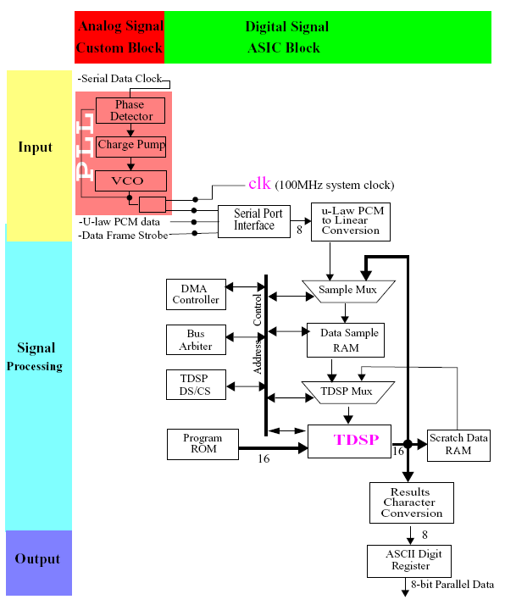

Figure 7-1 Block diagram

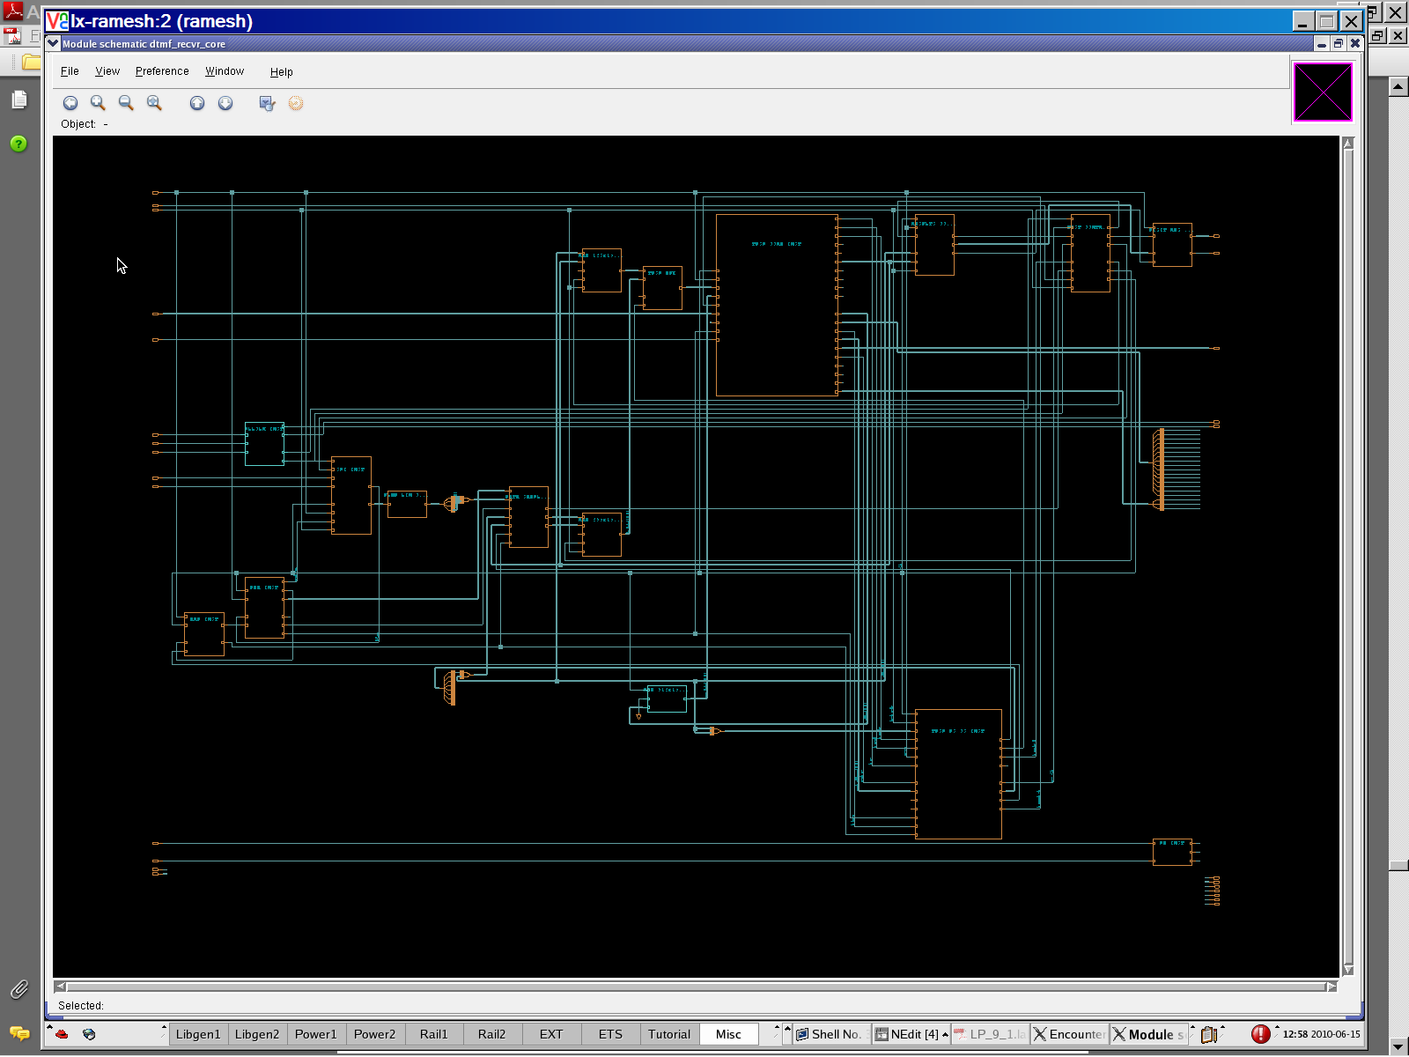
Figure 7-2 Schematic diagram

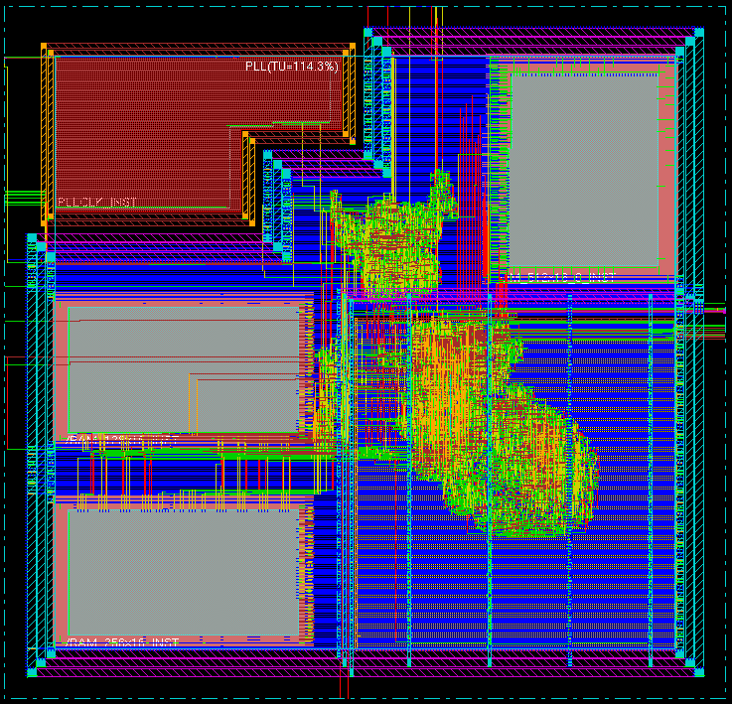
Figure 7-2 DTMF layout using SOC encounter

The DTMF design represents a common telecommunications application. It is mixed-signal and mixed-layout approach. The following information summaries the PLL/DTMF design:
❑ 16-bit DSP with single cycle instruction execution (6 clocks per cycle) and direct and indirect addressing modes
❑ Single chip solution with on-chip SRAM for small footprint
❑ DFT algorithm investigation resulting selection of Goertzel algorithm for fast and efficient execution in DSP firmware
❑ Micro-architecture supports dynamic range calculation on PCM data resulting in 16-bit DSP architecture versus 32-bit while maintaining frequency response requirements
❑ The PLL provides two main clocks to the system as below:
❍ 25MHz as the system clock to DTMF
❍ 8KHz clock to the serial data clock for synchronize the input signals to the system clock (25MHz).

7-2 Library description:
The Library used for this project is TSMC 65nm LP process:
Follows the details of various libs:
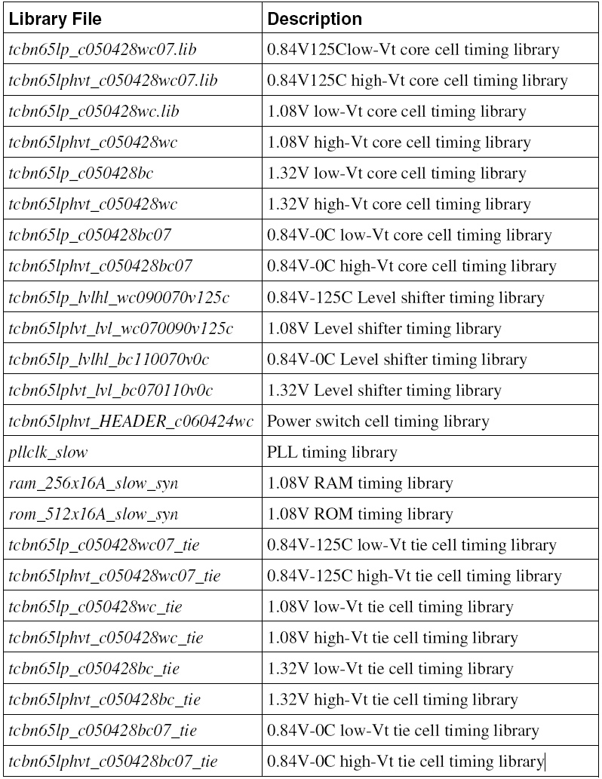

7-3 Result

The result was obtained using 3 modes of operation using Cadence’s Low Power methodology [4, 15]:
- Base run using clock gating & multi approach for power optimization
- Multi Supply Multi Voltage (MSMV) approach by creating 4 voltage Islands and insertion of level shifters
- Power Shutoff (PSO) approach using MSMV+Power switch insertion

    - Base Run:
Generated by: EncounterI RTL Compiler v09.10-s106_2
Generated on: Jun 15 2010 11:28:09 AM
Module: dtmf_recvr_core
Library domain: tdsp_ao_1_32v
Domain index: 0
Technology libraries: tcbn65lp_c050428bc 010
ram_256x16_slow 010
rom_512x16A_slow 010
pllclk_slow 010
Operating conditions: _nominal_ (balanced_tree)
Wireload mode: top
Area mode: timing library

Library Leakage Dynamic Total
Instance Domain Cells Power(uW) Power(uW) Power(uW)
dtmf_recvr_core 0 5367 6.248 9780.809 9787.057
TDSP_CORE_INST 0 3450 3.791 755.643 759.434
MPY_32_INST 0 1319 1.167 226.352 227.520
M16X16_INST 0 1102 0.971 187.020 187.991
mul_8_14 0 1102 0.971 187.020 187.991
inc_add_63_54_7 0 62 0.066 10.960 11.026
EXECUTE_INST 0 690 1.001 146.874 147.874
RC_CG_HIER_INST30 0 1 0.003 4.849 4.852
RC_CG_HIER_INST27 0 1 0.003 7.145 7.147
RC_CG_HIER_INST32 0 1 0.002 2.790 2.792
RC_CG_HIER_INST26 0 1 0.002 2.046 2.048
RC_CG_HIER_INST33 0 1 0.002 1.562 1.564
RC_CG_HIER_INST29 0 1 0.002 1.367 1.369
RC_CG_HIER_INST34 0 1 0.002 1.462 1.464
RC_CG_HIER_INST28 0 1 0.002 1.310 1.312
RC_CG_HIER_INST31 0 1 0.002 1.310 1.312
ALU_32_INST 0 638 0.559 61.723 62.282
sub_84_22 0 156 0.144 19.268 19.411
add_81_22 0 156 0.143 18.492 18.635
inc_add_54_27_1 0 62 0.058 4.083 4.142
TDSP_CORE_GLUE_INST 0 473 0.439 67.654 68.093
sll_120_49 0 101 0.085 12.967 13.051
sll_121_36 0 65 0.060 7.028 7.089
DECODE_INST 0 138 0.227 53.605 53.832
RC_CG_HIER_INST25 0 1 0.002 3.376 3.378
RC_CG_HIER_INST24 0 1 0.002 3.470 3.472
DATA_BUS_MACH_INST 0 49 0.119 58.661 58.781
RC_CG_HIER_INST22 0 1 0.003 4.885 4.888
RC_CG_HIER_INST23 0 1 0.002 3.113 3.115
PROG_BUS_MACH_INST 0 42 0.108 51.671 51.778
RC_CG_HIER_INST36 0 1 0.002 3.665 3.667
PORT_BUS_MACH_INST 0 42 0.097 16.803 16.900
RC_CG_HIER_INST35 0 1 0.002 1.310 1.312
TDSP_CORE_MACH_INST 0 37 0.061 71.498 71.559
RC_CG_HIER_INST37 0 1 0.003 5.724 5.727
ACCUM_STAT_INST 0 17 0.010 0.269 0.279
RESULTS_CONV_INST 0 1423 1.781 124.446 126.227
lower770 0 10 0.030 3.956 3.986
RC_CG_HIER_INST9 0 1 0.003 0.898 0.901
lower1336 0 10 0.030 2.681 2.711
RC_CG_HIER_INST8 0 1 0.002 0.624 0.626
upper770 0 10 0.030 3.515 3.545
RC_CG_HIER_INST19 0 1 0.003 0.898 0.901
upper1336 0 10 0.030 2.240 2.270
RC_CG_HIER_INST18 0 1 0.002 0.624 0.626
RC_CG_HIER_INST4 0 1 0.003 6.845 6.848
RC_CG_HIER_INST11 0 1 0.003 5.771 5.773
RC_CG_HIER_INST16 0 1 0.003 1.030 1.032
RC_CG_HIER_INST15 0 1 0.003 1.200 1.202
RC_CG_HIER_INST13 0 1 0.002 0.794 0.796
RC_CG_HIER_INST12 0 1 0.002 0.624 0.626
RC_CG_HIER_INST14 0 1 0.002 0.624 0.626
RC_CG_HIER_INST17 0 1 0.002 0.624 0.626
RC_CG_HIER_INST10 0 1 0.002 1.310 1.312
RC_CG_HIER_INST5 0 1 0.002 1.310 1.312
RC_CG_HIER_INST6 0 1 0.002 1.310 1.312
RC_CG_HIER_INST7 0 1 0.002 1.310 1.312
PM_INST 0 171 0.208 2.563 2.771
pd_inst 0 99 0.119 1.127 1.247
power_state_i 0 67 0.067 0.647 0.715
counter_i 0 31 0.049 0.405 0.454
RC_CG_HIER_INST3 0 1 0.003 0.075 0.078
counter_inst 0 32 0.052 0.896 0.948
state_inst 0 38 0.033 0.401 0.435
RC_CG_HIER_INST2 0 1 0.002 0.131 0.134
SPI_INST 0 49 0.109 11.606 11.715
RC_CG_HIER_INST20 0 1 0.002 0.790 0.792
RC_CG_HIER_INST21 0 1 0.002 1.310 1.312
DMA_INST 0 59 0.096 23.605 23.701
RC_CG_HIER_INST1 0 1 0.003 4.885 4.888
RC_CG_HIER_INST0 0 1 0.002 1.310 1.312
ULAW_LIN_CONV_INST 0 65 0.057 0.000 0.057
ARB_INST 0 24 0.034 10.855 10.889
DIGIT_REG_INST 0 10 0.033 9.158 9.191
DATA_SAMPLE_MUX_INST 0 30 0.032 6.892 6.924
TDSP_MUX 0 19 0.027 1.916 1.943
RAM_256x16_TEST_INST 0 19 0.025 1438.465 1438.490
RAM_128x16_TEST_INST 0 18 0.025 1438.529 1438.554
TDSP_DS_CS_INST 0 20 0.018 0.676 0.694
TEST_CONTROL_INST 0 8 0.015 155.237 155.252

    - MSMV

Generated by: EncounterI RTL Compiler v09.10-s106_2
Generated on: Jun 15 2010 11:55:54 AM
Module: dtmf_recvr_core
Library domain: ao_wc_1v08
Domain index: 0
Technology libraries: tcbn65lp_c050428wc 010
tcbn65lphvt_c050428wc 010
tcbn65lp_c050428wc_tie 010
tcbn65lphvt_c050428wc_tie 010
tcbn65lplvt_lvl_wc070090v125c 010
pllclk_slow 010
ram_256x16_slow 010
rom_512x16A_slow 010
Operating conditions: WCCOM (balanced_tree)
Library domain: ao_bc_1v08
Domain index: 1
Technology libraries: tcbn65lp_c050428bc 010
tcbn65lphvt_c050428bc 010
tcbn65lp_c050428bc_tie 010
tcbn65lphvt_c050428bc_tie 010
tcbn65lplvt_lvl_bc070110v0c 010
pllclk_slow 010
ram_256x16_slow 010
rom_512x16A_slow 010
Operating conditions: BCCOM (balanced_tree)
Library domain: ao_wc_0v84
Domain index: 2
Technology libraries: tcbn65lp_c050428wc07 010
tcbn65lphvt_c050428wc07 010
tcbn65lp_c050428wc07_tie 010
tcbn65lphvt_c050428wc07_tie 010
tcbn65lplvt_lvl_wc070090v125c 010
tcbn65lp_lvlhl_wc090070v125c 010
pllclk_slow 010
ram_256x16_slow 010
rom_512x16A_slow 010
Operating conditions: _nominal_ (balanced_tree)
Library domain: ao_bc_0v84
Domain index: 3
Technology libraries: tcbn65lp_c050428bc07 010
tcbn65lphvt_c050428bc07 010
tcbn65lp_c050428bc07_tie 010
tcbn65lphvt_c050428bc07_tie 010
tcbn65lplvt_lvl_bc070110v0c 010
pllclk_slow 010
ram_256x16_slow 010
rom_512x16A_slow 010
Operating conditions: BC07COM (balanced_tree)
Library domain: tdsp_wc_0v84
Domain index: 4
Technology libraries: tcbn65lp_c050428wc07 010
tcbn65lphvt_c050428wc07 010
tcbn65lp_c050428wc07_tie 010
tcbn65lphvt_c050428wc07_tie 010
tcbn65lp_lvlhl_wc090070v125c 010
tcbn65lphvt_HEADER_c060424wc 120
Operating conditions: WC07COM (balanced_tree)
Library domain: tdsp_bc_0v84
Domain index: 5
Technology libraries: tcbn65lp_c050428bc07 010
tcbn65lphvt_c050428bc07 010
tcbn65lp_c050428bc07_tie 010
tcbn65lphvt_c050428bc07_tie 010
tcbn65lp_lvlhl_bc110070v0c 010
tcbn65lphvt_HEADER_c060424wc 120
Operating conditions: BC07COM (balanced_tree)
Library domain: tdsp_ao_1_32v
Domain index: 6
Technology libraries: tcbn65lp_c050428bc 010
tcbn65lplvt_lvl_wc070090v125c 010
ram_256x16_slow 010
rom_512x16A_slow 010
pllclk_slow 010
Operating conditions: _nominal_ (balanced_tree)
Wireload mode: segmented
Area mode: timing library

Library Leakage Dynamic Total
Instance Domain Cells Power(uW) Power(uW) Power(uW)
dtmf_recvr_core 6 7113 5.331 9381.198 9386.529
TDSP_CORE_INST 2 5135 2.576 337.939 340.516
MPY_32_INST 2 2386 1.526 128.323 129.849
M16X16_INST 2 2058 1.307 108.956 110.263
mul_8_14 2 2058 1.307 108.956 110.263
inc_add_63_54_7 2 83 0.051 5.935 5.986
TDSP_CORE_GLUE_INST 2 755 0.475 28.042 28.517
sll_120_49 2 214 0.162 8.374 8.536
sll_121_36 2 62 0.006 2.963 2.969
EXECUTE_INST 2 726 0.241 53.231 53.472
RC_CG_HIER_INST34 2 1 0.000 1.546 1.546
RC_CG_HIER_INST31 2 1 0.000 2.411 2.411
RC_CG_HIER_INST37 2 1 0.000 1.112 1.113
RC_CG_HIER_INST28 2 1 0.000 0.615 0.615
RC_CG_HIER_INST29 2 1 0.000 0.615 0.615
RC_CG_HIER_INST30 2 1 0.000 0.615 0.615
RC_CG_HIER_INST38 2 1 0.000 0.634 0.634
RC_CG_HIER_INST32 2 1 0.000 0.500 0.500
RC_CG_HIER_INST33 2 1 0.000 0.600 0.600
RC_CG_HIER_INST35 2 1 0.000 0.500 0.500
RC_CG_HIER_INST36 2 1 0.000 0.500 0.500
RC_CG_HIER_INST39 2 1 0.000 0.510 0.510
ALU_32_INST 2 875 0.127 26.228 26.355
sub_84_22 2 211 0.035 9.124 9.159
add_81_22 2 201 0.033 8.253 8.286
inc_add_54_27_1 2 79 0.008 1.760 1.767
DECODE_INST 2 137 0.078 24.766 24.845
RC_CG_HIER_INST27 2 1 0.000 1.639 1.639
RC_CG_HIER_INST24 2 1 0.000 1.044 1.045
RC_CG_HIER_INST25 2 1 0.000 1.026 1.026
RC_CG_HIER_INST26 2 1 0.000 1.034 1.035
DATA_BUS_MACH_INST 2 48 0.064 20.266 20.330
RC_CG_HIER_INST22 2 1 0.000 1.541 1.542
RC_CG_HIER_INST23 2 1 0.000 1.078 1.078
CPF_LS_HIER_INST_1 2 53 0.031 7.260 7.291
TDSP_CORE_MACH_INST 2 35 0.008 25.259 25.267
RC_CG_HIER_INST42 2 1 0.000 1.798 1.798
PROG_BUS_MACH_INST 2 43 0.008 17.981 17.989
RC_CG_HIER_INST41 2 1 0.000 1.284 1.285
PORT_BUS_MACH_INST 2 41 0.008 5.316 5.324
RC_CG_HIER_INST40 2 1 0.000 0.500 0.500
ACCUM_STAT_INST 2 19 0.001 0.083 0.084
RESULTS_CONV_INST 6 1420 1.759 120.982 122.741
lower770 6 10 0.030 3.895 3.925
RC_CG_HIER_INST9 6 1 0.003 0.892 0.894
lower1336 6 10 0.030 2.661 2.691
RC_CG_HIER_INST8 6 1 0.002 0.624 0.626
upper770 6 10 0.030 3.458 3.488
RC_CG_HIER_INST19 6 1 0.003 0.892 0.894
upper1336 6 10 0.030 2.224 2.254
RC_CG_HIER_INST18 6 1 0.002 0.624 0.626
RC_CG_HIER_INST4 6 1 0.003 5.909 5.912
RC_CG_HIER_INST11 6 1 0.003 5.195 5.197
RC_CG_HIER_INST16 6 1 0.003 1.019 1.021
RC_CG_HIER_INST15 6 1 0.003 1.185 1.187
RC_CG_HIER_INST13 6 1 0.002 0.789 0.792
RC_CG_HIER_INST12 6 1 0.002 0.624 0.626
RC_CG_HIER_INST14 6 1 0.002 0.624 0.626
RC_CG_HIER_INST17 6 1 0.002 0.624 0.626
RC_CG_HIER_INST10 6 1 0.002 1.310 1.312
RC_CG_HIER_INST5 6 1 0.002 1.310 1.312
RC_CG_HIER_INST6 6 1 0.002 1.310 1.312
RC_CG_HIER_INST7 6 1 0.002 1.310 1.312
CPF_LS_HIER_INST_2 6 57 0.329 86.943 87.272
PM_INST 6 171 0.208 2.373 2.581
pd_inst 6 99 0.119 1.041 1.161
power_state_i 6 67 0.067 0.590 0.657
counter_i 6 31 0.049 0.386 0.435
RC_CG_HIER_INST3 6 1 0.003 0.066 0.068
counter_inst 6 32 0.052 0.854 0.906
state_inst 6 38 0.033 0.355 0.389
RC_CG_HIER_INST2 6 1 0.002 0.117 0.119
SPI_INST 6 50 0.109 11.297 11.405
RC_CG_HIER_INST20 6 1 0.002 0.773 0.775
RC_CG_HIER_INST21 6 1 0.002 1.310 1.312
DMA_INST 6 59 0.095 23.317 23.413
RC_CG_HIER_INST1 6 1 0.003 4.597 4.600
RC_CG_HIER_INST0 6 1 0.002 1.310 1.312
ULAW_LIN_CONV_INST 6 65 0.057 0.000 0.057
ARB_INST 6 24 0.034 10.729 10.762
DIGIT_REG_INST 6 10 0.033 9.158 9.191
DATA_SAMPLE_MUX_INST 6 30 0.031 5.824 5.855
TDSP_MUX 6 19 0.027 1.636 1.663
RAM_256x16_TEST_INST 6 18 0.023 1438.301 1438.325
RAM_128x16_TEST_INST 6 18 0.023 1438.351 1438.374
TDSP_DS_CS_INST 6 20 0.018 0.584 0.603
TEST_CONTROL_INST 6 15 0.009 96.603 96.612

    - PSO

Generated by: EncounterI RTL Compiler v09.10-s106_2
Generated on: Jun 15 2010 12:21:52 PM
Module: dtmf_recvr_core
Library domain: ao_wc_1v08
Domain index: 0
Technology libraries: tcbn65lp_c050428wc 010
tcbn65lphvt_c050428wc 010
tcbn65lp_c050428wc_tie 010
tcbn65lphvt_c050428wc_tie 010
pllclk_slow 010
ram_256x16_slow 010
rom_512x16A_slow 010
tcbn65lp_lvlhl_wc090070v125c 010
tcbn65lplvt_lvl_wc070090v125c 010
Operating conditions: _nominal_ (balanced_tree)
Library domain: ao_bc_1v08
Domain index: 1
Technology libraries: tcbn65lp_c050428bc 010
tcbn65lphvt_c050428bc 010
tcbn65lp_c050428bc_tie 010
tcbn65lphvt_c050428bc_tie 010
tcbn65lplvt_lvl_bc070110v0c 010
tcbn65lp_lvlhl_bc110070v0c 010
pllclk_slow 010
ram_256x16_slow 010
rom_512x16A_slow 010
Operating conditions: BCCOM (balanced_tree)
Library domain: ao_wc_0v84
Domain index: 2
Technology libraries: tcbn65lp_c050428wc07 010
tcbn65lphvt_c050428wc07 010
tcbn65lp_c050428wc07_tie 010
tcbn65lphvt_c050428wc07_tie 010
tcbn65lp_lvlhl_wc090070v125c 010
pllclk_slow 010
ram_256x16_slow 010
rom_512x16A_slow 010
tcbn65lplvt_lvl_wc070090v125c 010
Operating conditions: WC07COM (balanced_tree)
Library domain: ao_bc_0v84
Domain index: 3
Technology libraries: tcbn65lp_c050428bc07 010
tcbn65lphvt_c050428bc07 010
tcbn65lp_c050428bc07_tie 010
tcbn65lphvt_c050428bc07_tie 010
tcbn65lplvt_lvl_bc070110v0c 010
tcbn65lp_lvlhl_bc110070v0c 010
pllclk_slow 010
ram_256x16_slow 010
rom_512x16A_slow 010
Operating conditions: BC07COM (balanced_tree)
Library domain: tdsp_wc_0v84
Domain index: 4
Technology libraries: tcbn65lp_c050428wc07 010
tcbn65lphvt_c050428wc07 010
tcbn65lp_c050428wc07_tie 010
tcbn65lphvt_c050428wc07_tie 010
tcbn65lp_lvlhl_wc090070v125c 010
tcbn65lphvt_HEADER_c060424wc 120
tcbn65lplvt_lvl_wc070090v125c 010
Operating conditions: WC07COM (balanced_tree)
Library domain: tdsp_bc_0v84
Domain index: 5
Technology libraries: tcbn65lp_c050428bc07 010
tcbn65lphvt_c050428bc07 010
tcbn65lp_c050428bc07_tie 010
tcbn65lphvt_c050428bc07_tie 010
tcbn65lp_lvlhl_bc110070v0c 010
tcbn65lplvt_lvl_bc070110v0c 010
tcbn65lphvt_HEADER_c060424wc 120
Operating conditions: BC07COM (balanced_tree)
Library domain: tdsp_ao_1_32v
Domain index: 6
Technology libraries: tcbn65lp_c050428bc 010
ram_256x16_slow 010
tcbn65lplvt_lvl_wc070090v125c 010
tcbn65lp_lvlhl_wc090070v125c 010
rom_512x16A_slow 010
pllclk_slow 010
Operating conditions: _nominal_ (balanced_tree)
Wireload mode: segmented
Area mode: timing library

Library Leakage Dynamic Total
Instance Domain Cells Power(uW) Power(uW) Power(uW)
dtmf_recvr_core 6 5602 2.858 4753.598 4756.456
RESULTS_CONV_INST 6 1422 1.777 92.034 93.811
upper770 6 10 0.030 3.987 4.017
RC_CG_HIER_INST19 6 1 0.002 0.516 0.519
upper1336 6 10 0.030 3.158 3.188
RC_CG_HIER_INST18 6 1 0.002 0.331 0.334
lower770 6 10 0.030 3.873 3.903
RC_CG_HIER_INST9 6 1 0.002 0.516 0.519
lower1336 6 10 0.030 3.044 3.074
RC_CG_HIER_INST8 6 1 0.002 0.331 0.334
RC_CG_HIER_INST11 6 1 0.003 2.590 2.593
RC_CG_HIER_INST4 6 1 0.003 2.955 2.957
RC_CG_HIER_INST16 6 1 0.003 0.414 0.416
RC_CG_HIER_INST13 6 1 0.003 0.414 0.416
RC_CG_HIER_INST14 6 1 0.003 0.465 0.468
RC_CG_HIER_INST15 6 1 0.002 0.350 0.353
RC_CG_HIER_INST12 6 1 0.002 0.312 0.314
RC_CG_HIER_INST17 6 1 0.002 0.312 0.314
RC_CG_HIER_INST10 6 1 0.002 0.655 0.657
RC_CG_HIER_INST5 6 1 0.002 0.655 0.657
RC_CG_HIER_INST6 6 1 0.002 0.655 0.657
RC_CG_HIER_INST7 6 1 0.002 0.655 0.657
TDSP_CORE_INST 0 3663 0.406 230.952 231.359
MPY_32_INST 0 1312 0.158 104.590 104.747
M16X16_INST 0 1046 0.135 88.959 89.094
mul_8_14 0 1046 0.135 88.959 89.094
inc_add_63_54_7 0 70 0.005 3.834 3.840
EXECUTE_INST 0 718 0.078 30.184 30.262
RC_CG_HIER_INST34 0 1 0.000 0.638 0.638
RC_CG_HIER_INST31 0 1 0.000 0.836 0.836
RC_CG_HIER_INST37 0 1 0.000 0.413 0.413
RC_CG_HIER_INST28 0 1 0.000 0.273 0.274
RC_CG_HIER_INST29 0 1 0.000 0.273 0.274
RC_CG_HIER_INST30 0 1 0.000 0.273 0.274
RC_CG_HIER_INST33 0 1 0.000 0.244 0.244
RC_CG_HIER_INST38 0 1 0.000 0.322 0.322
RC_CG_HIER_INST39 0 1 0.000 0.250 0.250
RC_CG_HIER_INST32 0 1 0.000 0.216 0.216
RC_CG_HIER_INST35 0 1 0.000 0.216 0.216
RC_CG_HIER_INST36 0 1 0.000 0.216 0.216
ALU_32_INST 0 716 0.056 21.183 21.238
add_81_22 0 143 0.015 7.323 7.338
sub_84_22 0 184 0.015 7.408 7.423
inc_add_54_27_1 0 68 0.005 0.923 0.928
TDSP_CORE_GLUE_INST 0 530 0.053 18.084 18.137
sll_120_49 0 140 0.012 3.921 3.933
sll_121_36 0 62 0.005 1.748 1.753
DECODE_INST 0 139 0.018 14.259 14.277
RC_CG_HIER_INST27 0 1 0.000 0.718 0.718
RC_CG_HIER_INST24 0 1 0.000 0.479 0.479
RC_CG_HIER_INST25 0 1 0.000 0.474 0.475
RC_CG_HIER_INST26 0 1 0.000 0.474 0.475
CPF_LS_HIER_INST_1 0 53 0.015 2.067 2.082
DATA_BUS_MACH_INST 0 48 0.008 11.043 11.052
RC_CG_HIER_INST22 0 1 0.000 0.608 0.608
RC_CG_HIER_INST23 0 1 0.000 0.380 0.381
PROG_BUS_MACH_INST 0 43 0.008 11.267 11.274
RC_CG_HIER_INST41 0 1 0.000 0.637 0.637
PORT_BUS_MACH_INST 0 41 0.007 2.217 2.224
RC_CG_HIER_INST40 0 1 0.000 0.216 0.216
TDSP_CORE_MACH_INST 0 36 0.004 15.629 15.633
RC_CG_HIER_INST42 0 1 0.000 0.741 0.742
ACCUM_STAT_INST 0 17 0.001 0.052 0.053
PM_INST 6 173 0.207 2.686 2.893
pd_inst 6 100 0.118 1.587 1.705
power_state_i 6 67 0.066 1.135 1.201
counter_i 6 32 0.050 0.386 0.436
RC_CG_HIER_INST3 6 1 0.003 0.066 0.068
counter_inst 6 32 0.052 0.717 0.770
state_inst 6 38 0.033 0.297 0.331
RC_CG_HIER_INST2 6 1 0.002 0.075 0.078
SPI_INST 6 50 0.109 5.797 5.906
RC_CG_HIER_INST20 6 1 0.002 0.356 0.358
RC_CG_HIER_INST21 6 1 0.002 0.655 0.657
DMA_INST 6 61 0.094 11.676 11.771
RC_CG_HIER_INST1 6 1 0.003 2.299 2.301
RC_CG_HIER_INST0 6 1 0.002 0.655 0.657
ULAW_LIN_CONV_INST 6 71 0.067 0.000 0.067
ARB_INST 6 24 0.034 5.171 5.204
DIGIT_REG_INST 6 10 0.033 4.589 4.622
DATA_SAMPLE_MUX_INST 6 30 0.029 7.232 7.261
TDSP_MUX 6 19 0.025 1.450 1.475
RAM_256x16_TEST_INST 6 20 0.023 720.047 720.070
RAM_128x16_TEST_INST 6 18 0.022 720.101 720.123
TDSP_DS_CS_INST 6 21 0.018 0.358 0.376
TEST_CONTROL_INST 6 18 0.012 48.943 48.955

    - Power saving Comparison

Power type | Base (uW) | MSMV(uW) | PSO(uW) | Gain
 |  |  |  | Base vs MSMV * | MSMV vs PSO | Base vs PSO
Dynamic | 9780.81 | 9381.20 | 4753.60 | 4.09% | 49.33% | 51.40%
Leakage | 6.25 | 5.33 | 2.86 | 14.68% | 46.39% | 54.26%
Total | 9787.06 | 9386.53 | 4756.46 | 4.09% | 49.33% | 51.40%

* Even though significant power saving is not seen from top, there is significant power saving achieved in hierarchical instances despite the fact that MSMV implementation added quite a good number of instances in the design. See total NUMBER OF instances in base vs. MSMV run

7-4 Conclusion

7-4-1 Summary

I have implemented Cadence’s Low power methodology using Common Power Format (CPF) [4]. The advanced low power techniques like Power Shut-off (PSO) [1,4] and Multi supply multi voltage (MSMV) [1] techniques combined showed the average power saving of 51.4%. Additionally using PSO implementation the power saving achieved was over 54% which is phenomenal and can be very useful for battery operated devices especially in mobile applications. Using PSO technique can be of great help if the chip has sufficient “idle” time during normal usage.

The implementation used Cadence’s Common Power Format (CPF) to keep power intent definition. CPF is Si2 standard developed as part of Cadence’s initiative for Low Power Design methodology.

The usage of multiple supply voltages helps all around as both dynamic and static power are dependent on voltage. Hence it makes sense to place the blocks which run on a lower clock frequency to a lower voltage domain.

7-4-2 Future work

Future work may include few things which couldn’t implement in this project:

- Implementation of Dynamic Voltage and frequency Scaling (DVFS) [4]. Since the voltage and frequency both impact the power consumption considerably, this implementation might fetch greater benefit.
- I would also like to see the impact of Rush current [2] during powering up of the design. Since this design employs power switches banks which when switched on will draw significant current from power grid and will have certain impact on neighboring blocks.

References:

- Cadence Design Systems “A Practical guide to Low Power Design, User experience with CPF”. Cadence Power ForwardTM Initiative 2006
- Cadence Design Systems “Encounter® Power System User Guide”
- Cadence Design Systems “Encounter® Power System Text Command Reference”
- Cadence Design Systems “Common Power Format User Guide” Version 1.0
- A. Khan+, Senior Member, IEEE, P. Watson et. al. IEEE 2005 CUSTOM INTEGRATED CIRCUITS CONFERENCE “A 90nm Power Optimization Methodology and its’ Application to the ARM 1136JF-S Microprocessor”
- Hailin Jiang et. Al. “Benefits and Costs of Power-Gating Technique”. Proceedings of the 2005 International Conference on Computer Design (ICCD’05)
- S.Mutoh and et al, “A 1V power supply high-speed digital circuit technology with multi threshold voltage CMOS”, IEEE Journal of Solid-State Circuit, pp. 847-854, 1995
- Tohru Furuyama Center for Semiconductor Research and Development, Semiconductor Company, Toshiba Corp. Deep Sub-100 nm Design Challenges. Proceedings of the 9th EUROMICRO Conference on Digital System Design (DSD'06)
- Hao Dongyan et. Al. Zheng Wei College of Information Science and Engineering, Zhejiang University, Hangzhou. Design Methodology of CMOS Low Power. 0-7803-9484-4/05/$20.00 ©2005 IEEE.
- Sung-Mo (Steve) Kang Univ. of California, Santa Cruz “Elements of Low Power Design for Integrated Systems” ISLPED '03, August 25-27,2003, Seoul, Korea. Copyright 2003 ACM 1-581 13-682-X/03/000
- Christian Piguet CSEM Neuchâtel, Switzerland. Low Power Design in Deep Submicron 65 & 45 nm Technologies. 1-4244-1378-8/07/$25.00 ©2007 IEEE
- Vivek K. De et. Al. Intel Corp., “Low Voltage Low Power CMOS Design Techniques for Deep Submicron ICs. IEEE conference.
- P. Chandrakasan, S. Sheng and R. W. Brodersen, \Low-Power CMOS Digital Design", IEEE Journal of Solid-State Circuits, Vol.27, No.4, 1992, pp. 473-484.
- Bodhisatya Sarker Calypto Design Systems, Vineet Sreekumar Cadence Design Systems. “Methodology and Design Challenges for Low Power Implementation at sub 90nm”, 1-4244-1029-0/07/$25.00 ©2007 IEEE
- Cadence Design System “RTL compiler User Guilde”
- Cadence Design system “Encounter Digital Implementation user Guide”

Appendix “A” Power consumption in CMOS

There are mainly 3 types power consumption in CMOS:
  - Switching power
  - Short circuit or internal power
  - Leakage power

- Switching Power

- Capacitor energy equation

Switching power is consumed due to Load Capacitance charging and discharging. Let first understand the Capacitor energy equations

Suppose at time t, a charge q is transferred from one
plate to the other
- The potential v is q/C
- For a charge transfer increment of dq, the additional work is :

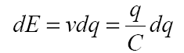
- For the total charge transfer Q :
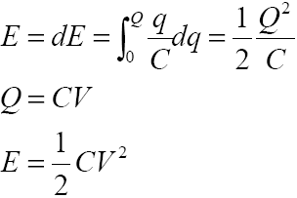

- CMOS switching energetics

CMOS energetics can be analyzed and understood from the CMOS inverter.
• Charge is conserved
• Energy is conserved
• Neglect leakage current
• Neglect short-circuit current

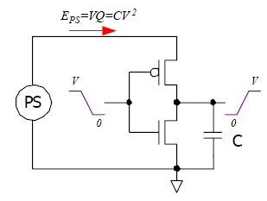

- The charging event

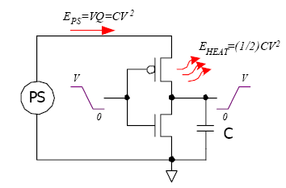
- Power supply delivers a charge packet of size Q=CV
EPS = CV • V = CV2
EC = (1/2)CV2
EPS – EC = (1/2)CV2 = EHEAT
- This much energy is dissipated in the pFET

- The discharging event

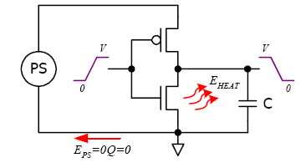
• Power supply gets the charge at potential 0
EPS = 0
• The energy on the capacitor goes from (1/2)CV2 to 0
EC – 0 = (1/2)CV2 = EHEAT
• This much energy is dissipated in the nFET
• All of the charge is returned to the PS at potential 0

- Short circuit or internal Power
Internal Power, which is the power consumed in charging and discharging of interconnect and device capacitances internal to cell. Internal power can be divided into two parts
a. Pin Power
b. Arc Power
Internal power is calculated by using the internal power tables provided in the .lib, which capture the characterized internal power over a range of input slew rates and external loading. The tables reflect the combination of both the internal switching and internal feedthough power. Tables are generated as a result of spice simulation during library characterization. If k-factor power scaling parameters (for process, temperature, and voltage) are specified in the .lib file

PSC = T_{sc}.VDD. I_{peak}. f
where f = P. F_{Clk}
P = Probability of switching from 0->1 or 1->0

Example of Internal power in .lib:

internal_power() {
related_pin : "I";
fall_power(energy_template_7x7) {
index_1 ("0.0012, 0.0132, 0.0252, 0.0292, 0.0364, 0.0424, 1.0528");
index_2 ("0.0009, 0.0022, 0.0049, 0.0101, 0.0207, 0.0418, 0.0839");
values("0.0000, 0.0000, 0.0000, 0.0000, 0.0000, 0.0000, 0.0000", \
"0.0001, 0.0001, 0.0001, 0.0000, 0.0000, 0.0000, 0.0000", \
"0.0002, 0.0001, 0.0001, 0.0001, 0.0000, 0.0000, 0.0000", \
"0.0002, 0.0002, 0.0001, 0.0001, 0.0001, 0.0000, 0.0000", \
"0.0001, 0.0001, 0.0001, 0.0001, 0.0001, 0.0001, 0.0000", \
"0.0000, 0.0000, 0.0000, 0.0001, 0.0001, 0.0001, 0.0000", \
"0.0005, 0.0004, 0.0003, 0.0001, 0.0001, 0.0000, 0.0000");
}
rise_power(energy_template_7x7) {
index_1 ("0.0012, 0.0132, 0.0252, 0.0292, 0.0364, 0.0424, 1.0528");
index_2 ("0.0009, 0.0022, 0.0049, 0.0101, 0.0207, 0.0418, 0.0839");
values("0.0017, 0.0017, 0.0017, 0.0017, 0.0017, 0.0017, 0.0017", \
"0.0016, 0.0016, 0.0017, 0.0017, 0.0017, 0.0017, 0.0017", \
"0.0016, 0.0016, 0.0016, 0.0017, 0.0017, 0.0017, 0.0017", \
"0.0016, 0.0016, 0.0016, 0.0016, 0.0017, 0.0017, 0.0017", \
"0.0016, 0.0016, 0.0016, 0.0016, 0.0016, 0.0017, 0.0017", \
"0.0017, 0.0017, 0.0017, 0.0016, 0.0016, 0.0017, 0.0017", \
"0.0021, 0.0020, 0.0019, 0.0018, 0.0018, 0.0017, 0.0017");

- Leakage Power

Leakage power, which is the power consumed by devices when they are not switching. It includes state-dependent leakage, which is leakage that depends on the state of the gate, that is, whether a transistor is on or off. This value comes from the .lib file if it exists. If k-factor power scaling parameters (for process, temperature, and voltage) are specified in the .lib file.

P_{Leakage} = VDD.I_{Leak}
Example of leakage modeling in .lib:

cell (INV1X) {
cell_leakage_power : 0.287 ;
leakage_power() {
when : "!I" ;
value : 0.462 ;
}
leakage_power() {
when : "I" ;
value : 0.411 ;
}

Appendix “ B” Creating CPF

- Example For MSMV design

A Multiple Supply Voltage (MSV) design uses multiple supply voltages for the core logic. A portion of the design that operates at the same operating voltage (that is, uses the same main power supply) belongs to the power domain that corresponds to that operating voltage.

A steady state of the design is called a power mode. Pure MSV designs have only power mode because the operating voltage of the power domains is assumed not to change. A power mode will also have a typical set of timing constraints associated with it.

To pass signals between portions of the design that operate on different voltages, level shifters are needed. The majority of cells in a power domain are driven by the same power supply, except for the level shifters which are driven by multiple power supplies

Table 1 MSMV design domain definition
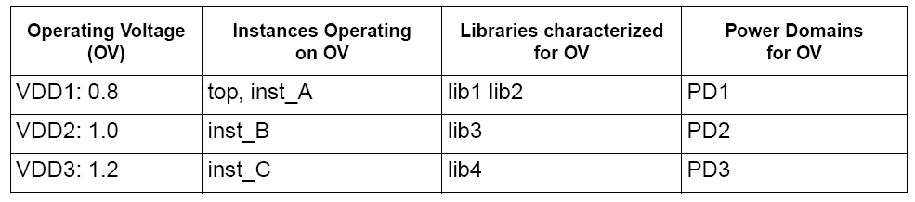

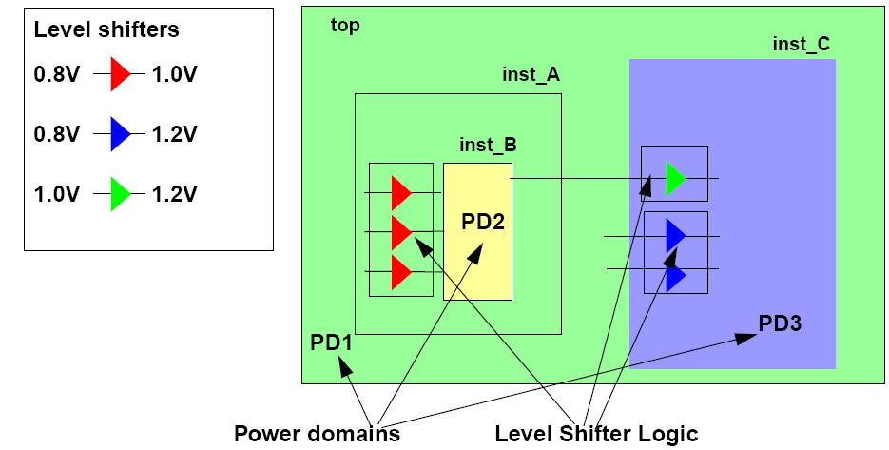
Fig.1 MSMV design

CPF File for MSV Example

set_cpf_version 1.1
#################################################
# Technology part of the CPF
#################################################
# define the library sets
define_library_set -name set1_bc -libraries {lib1_bc lib2_bc}
define_library_set -name set1_wc -libraries {lib1_wc lib2_wc}
define_library_set -name set2_bc -libraries lib3_bc
define_library_set -name set2_wc -libraries lib3_wc
define_library_set -name set3_bc -libraries lib4_bc
define_library_set -name set3_wc -libraries lib4_wc
# define the level shifters
define_level_shifter_cell -cells LVLLHEHX* \
-input_voltage_range 0.8 \
-output_voltage_range 1.0 \
-output_power_pin VDD \
-ground VSS \
-direction up \
-valid_location from
define_level_shifter_cell -cells LVLLHX* \
-input_voltage_range 0.8 \
-output_voltage_range 1.2 \
-output_power_pin VDD \
-direction up \
-ground VSS \
-valid_location to
define_level_shifter_cell -cells LVLLHELX* \
-input_voltage_range 1.0 \
-output_voltage_range 1.2 \
-output_power_pin VDD \
-direction up \
-ground VSS \
-valid_location to
#################################################
# Design part of the CPF
#################################################
set_design top
# create power domains
create_power_domain -name PD1 -default
create_power_domain -name PD2 -instances instance_B
create_power_domain -name PD3 -instances instance_C
# create nominal conditions
create_nominal_condition -name low -voltage 0.8
create_nominal_condition -name medium -voltage 1.0
create_nominal_condition -name high -voltage 1.2
# create power mode
create_power_mode -name PM -domain_conditions {PD1@low PD2@medium PD3@high} \
-default
# associate library sets with nominal conditions
update_nominal_condition -name low -library_set set1_wc
update_nominal_condition -name medium -library_set set2_wc
update_nominal_condition -name high -library_set set3_wc
# create rules for level shifter insertion
create_level_shifter_rule -name lsr1 -from PD1 -to PD2
create_level_shifter_rule -name lsr2 -from PD2 -to PD3
create_level_shifter_rule -name lsr3 -from PD1 -to PD3
#####################################################
# Additional Information for Logic Synthesis
#####################################################
# specify power targets
set_power_target -leakage 30 -dynamic 250
# specify timing constraints
update_power_mode -name PM -sdc_files top.sdc
# specify activity information
update_power_mode -name PM -activity_file top.tcf -activity_file_weight 100
# update the rules
update_level_shifter_rules -names lsr1 -location from
update_level_shifter_rules -names {lsr2 lsr3} -location to
#####################################################
# Additional Information for Physical Implementation
#####################################################
# declare power and ground nets
create_ground_nets -nets VSS
create_power_nets -nets VDD1 -voltage 0.8
create_power_nets -nets VDD2 -voltage 1.0
create_power_nets -nets VDD3 -voltage 1.2
# (optional) create global connections
# create_global_connection -net VSS -pins VSS
# create_global_connection -domain PD1 -net VDD1 -pins VDD
# create_global_connection -domain PD2 -net VDD2 -pins VDD
# create_global_connection -domain PD3 -net VDD3 -pins VDD
# add implementation info for power domains
update_power_domain -name PD1 -primary_power_net VDD1 -primary_ground_net VSS
update_power_domain -name PD2 -primary_power_net VDD2 -primary_ground_net VSS
update_power_domain -name PD3 -primary_power_net VDD3 -primary_ground_net VSS
# create operating corners
create_operating_corner -name BC_PD1 \
-process 1 -temperature 0 -voltage 0.88 -library_set set1_bc
create_operating_corner -name BC_PD2 \
-process 1 -temperature 0 -voltage 1.0 -library_set set2_bc
create_operating_corner -name BC_PD3 \
-process 1 -temperature 0 -voltage 1.32 -library_set set3_bc
create_operating_corner -name WC_PD1 \
-process 1 -temperature 125 -voltage 0.72 -library_set set1_wc
create_operating_corner -name WC_PD2 \
-process 1 -temperature 125 -voltage 0.9 -library_set set2_wc
create_operating_corner -name WC_PD3 \
-process 1 -temperature 125 -voltage 1.08 -library_set set3_wc
# create analysis views
create_analysis_view -name AV_BC -mode PM \
-domain_corners {PD1@BC_PD1 PD2@BC_PD2 PD3@BC_PD3}
create_analysis_view -name AV_WC -mode PM \
-domain_corners {PD1@WC_PD1 PD2@WC_PD2 PD3@WC_PD3}
end_design

- PSO

A design using power shut off (PSO) implementation is a design of which some portions can be switched on and off as needed (or possibly) to save leakage and dynamic power. Logic blocks (hierarchical instances), leaf instances, and pins that use the same main power supply and that can be simultaneously switched on or off are said to belong to the same power domain. The example design in Figure below has three power domains:

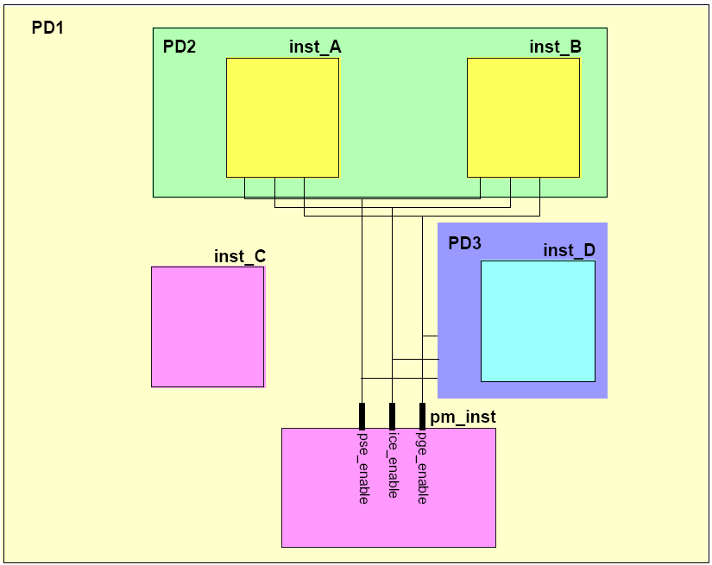
Fig. 2 Design with PSO

Table 2 Power modes
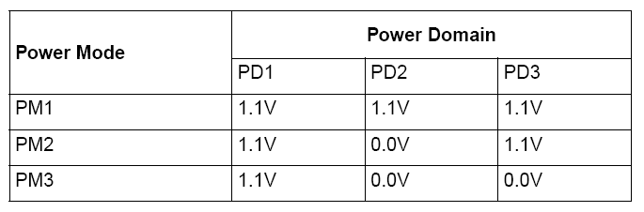

CPF File for PSO Example

set_cpf_version 1.1
#################################################
# Technology part of the CPF
#################################################
# define the library sets
define_library_set -name set1_wc -libraries {lib1_wc lib2_wc}
define_library_set -name set1_bc -libraries {lib1_bc lib2_bc}
# define the isolation cells
define_isolation_cell -cells ISOLN* -enable EN -valid_location on
# define the always on cell
define_always_on_cell -cells "BUFGX2M BUFGX8M INVGX2M INVGX8M"
# define the state retention cell
define_state_retention_cell -cells *DRFF* -restore_function RETN
# define the power switch cells
define_power_switch_cell -cells "hd8DM hd16DM hd32DM hd64DM" \
-stage_1_enable SLEEP -type header
define_power_switch_cell -cells "hd8M hd16M hd32M hd64M" \
-stage_1_enable !SLEEP -type header
define_power_switch_cell -cells "ft8DM ft16DM" \
-stage_1_enable !SLEEPN -type footer
define_power_switch_cell -cells "ft8M ft16M" \
-stage_1_enable SLEEPN -type footer
#################################################
# Design part of the CPF
#################################################
# identify the design for which the CPF file is created
set_design top
# create power domains
create_power_domain -name PD1 -default
create_power_domain -name PD2 -instances {inst_A inst_B} \
-shutoff_condition {pse_enable[0]} -base_domains PD1
create_power_domain -name PD3 -instances inst_D \
-shutoff_condition {pse_enable[1]} -base_domains PD1
# create nominal conditions
create_nominal_condition -name off -voltage 0
create_nominal_condition -name on -voltage 1.1
# create power modes
create_power_mode -name PM1 -domain_conditions {PD1@on PD2@on PD3@on} -default
create_power_mode -name PM2 -domain_conditions {PD1@on PD3@on}
create_power_mode -name PM3 -domain_conditions {PD1@on}
# associate library sets with nominal conditions
update_nominal_condition -name on -library_set set1_wc
# create rules for isolation logic insertion
create_isolation_rule -name iso1 -from PD2 \
-isolation_condition {pm_inst.ice_enable[0]}
create_isolation_rule -name iso2 -to PD1\
-isolation_condition {pm_inst.ice_enable[1]} -isolation_output high
# create rules for state retention insertion
create_state_retention_rule -name st1 -domain PD2 \
-restore_edge {!pm_inst.pge_enable[0]}
create_state_retention_rule -name st2 -domain PD3 \
-restore_edge {!pm_inst.pge_enable[1]}
#####################################################
# Additional Information for Logic Synthesis
#####################################################
# specify power targets
set_power_target -leakage 30 -dynamic 250
# specify timing constraints
update_power_mode -name PM1 -sdc_files pm1.sdc
update_power_mode -name PM2 -sdc_files pm2.sdc
update_power_mode -name PM1 -activity_file top.tcf -activity_file_weight 100
# update the rules with implementation info
update_isolation_rules -names iso1 -location to -cells ISOLNX2M
update_isolation_rules -names iso2 -location to -cells ISOLNX2M
#####################################################
# Additional Information for Physical Implementation
#####################################################
# declare power and ground nets
create_power_nets -nets VDD -voltage 1.1
create_power_nets -nets {VDD_SW1 VDD_SW2} -internal
create_ground_nets -nets VSS -voltage 0
# (optional) create global connections
create_global_connection -net VDD -pins VDD
create_global_connection -net VSS -pins VSS
# rules for power switch insertion
create_power_switch_rule -name SW1 -domain PD2 -external_power_net VDD
create_power_switch_rule -name SW2 -domain PD3 -external_power_net VDD
update_power_switch_rule -name SW1 -cells hd32M -prefix CDN_
update_power_switch_rule -name SW2 -cells hd32M -prefix CDN_
# add implementation info for power domains
update_power_domain -name PD1 -primary_power_net VDD -primary_ground_net VSS
update_power_domain -name PD2 -primary_power_net VDD_SW1 -primary_ground_net VSS
update_power_domain -name PD3 -primary_power_net VDD_SW2 -primary_ground_net VSS
# create operating corners
create_operating_corner -name BC \
-process 1 -temperature 0 -voltage 1.21 -library_set set1_bc
create_operating_corner -name WC \
-process 1 -temperature 125 -voltage 0.99 -library_set set1_wc
# create analysis views
create_analysis_view -name AV_PM1_bc -mode PM1 \
-domain_corners {PD1@BC PD2@BC PD3@BC}
create_analysis_view -name AV_PM1_wv -mode PM1 \
-domain_corners {PD1@WC PD2@WC PD3@WC}
create_analysis_view -name AV_PM2_bc -mode PM2 \
-domain_corners {PD1@BC PD2@BC PD3@BC}
create_analysis_view -name AV_PM2_wc -mode PM2 \
-domain_corners {PD1@WC PD2@WC PD3@WC}
create_analysis_view -name AV_PM3_bc -mode PM3 \
-domain_corners {PD1@BC PD2@BC PD3@BC}
create_analysis_view -name AV_PM3_wc -mode PM3 \
-domain_corners {PD1@WC PD2@WC PD3@WC}
# indicate when the power information for the design ends
end_design

