
Under the Guidance of
Sh. RAJESH ROHILLA
ASSISTANT PROFESSOR
ELECTRONICS AND COMMUNICATION DEPT.
DELHI COLLEGE OF ENGINEERING
Submitted by:

AJAI KUMAR GAUTAM
Delhi University Roll No. 4603
Class Roll No. 28/E&C/04
M.E. (ELECTRONICS AND COMMUNICATION)
VIth SEMESTER
MAJOR THESIS
ON

“ DESIGN AND IMPLEMENTATION OF TIME SLICED/SHARED SDH TRIBUTARY POINTER PROCESSING AND ALIGNMENT,
USING VHDL”

A dissertation submitted in partial fulfillment of the requirements for the award of the degree of

MASTER OF ENGINEERING
IN
ELECTRONICS AND COMMUNICATION
CERTIFICATE
DEPARTMENT OF ELECTRONICS AND COMMUNICATION
DELHI COLLEGE OF ENGINEERING
UNIVERSITY OF DELHI
DELHI

This is to certify that the Major project thesis entitled "Design & implementation of Time Sliced/Shared SDH Tributary pointer processing and Alignment using VHDL”, being submitted by Ajai Kumar Gautam in the partial fulfillment of the requirement for the degree of Master of Engineering in Electronics and Communication in the Department of Electronics and Communication, Delhi College of Engineering, University of Delhi is a record of bonafide work done by him under my supervision and guidance. It is also certified that the dissertation has not been submitted elsewhere for any other degree.
He has worked under my supervision and guidance during the period August 2006 to June, 2007. He has fulfilled all the requirements for submission of the Major Project thesis, which has reached the requisite standard.
_____________________ ____________________

Prof. Asok Bhattacharyya Rajesh Rohilla
Head of the Depatment, Assistant Professor,
Dept. of E&C Engineering, Dept. of E&C Engineering,
Delhi College of Engineering, Delhi College of Engineering,
Bawana Road, Bawana Road,
New Delhi. New Delhi.

Date:
Place: Delhi

ACKNOWLEDGEMENT

I am highly indebted to my Project supervisor Sh. Rajesh Rohilla (Assistant Professor), Department of Electronics & Communication Engineering, for giving me the opportunity to work under his invaluable supervision. He had encouraged and guided me to accomplish this research work.

I must acknowledge Dr. Asok Bhattacharyya (Professor & H.O.D) of Electronics & Communication Engineering Department, Delhi College of Engineering, for his invaluable guidance during the research work.

I must also acknowledge the staff of Department of Electronics & Communication Engineering laboratories, Delhi College of Engineering, for their support and help during
the research work.

I would also like to express my gratitude to all my colleagues in particular to those at the Department of Electronics & Communication engineering for their support, co-operation and fruitful discussions on diverse research topics.

I want to thank my family & friends for their sincere interest in my work and their moral support.

Finally I sincerely thank all the persons who have helped and supported me directly or in directly in the course of this research work.

__________________________

Ajai Kumar Gautam
M.E (E&C) VIth SEM,
Delhi University Roll No. 4603
Class Roll No. 28/E&C/04.

TABLE OF CONTENTS

CERTIFICATE…………………………………………………………………………………..…I

ACKNOWLEDGEMENT………………...………………………………..…..………….………II
1 ABSTRACT 5
2 INTRODUCTION TO SDH 6
3 SYNCHRONIZATION OF DIGITAL SIGNALS 7
3.1 SDH Advantages 7
3.2 Plesiochronous Digital Hierarchy (PDH) 8
3.2.1 Limitations of PDH Network 9
4 NETWORK SYNCHRONIZATION ( Brief Historical Background ) 10
4.1 Clock Characteristics 10
4.2 Network Wander 11
4.3 Frame Alignment for Time Multiplex Switching 11
4.4 The Buffer Approach 11
4.5 SDH/SONET Pointer Alignment 12
4.5.1 Pointer Justification Events 12
4.5.2 Effects of Pointer Justification Events 12
4.5.3 Effects Generating PJEs 13
5 BASIC SDH SIGNAL 15
5.1 SDH Frame Structure 15
5.1.1 Virtual Container 15
5.1.2 Multiplexing of Tributary Units into VC-4 18
5.1.3 Numbering of TU-3s in a VC-4 19
5.1.4 Numbering of TU-12s in a VC-4 19
5.1.5 SDH Pointers 20
5.1.6 Positive Pointer Justification 21
5.1.7 Negative Pointer Justification 22
5.2 SDH Multiplexing 23
5.3 Tributary Payload Pointer 26
5.3.1 TU-3 Pointer 26
5.3.2 Frequency justification 27
5.3.3 Pointer interpretation 28
5.3.4 Pointer generation 29
5.3.5 TU-12 Pointer 29
6 GENERAL ARCHITECTURE OF THE SDH SYSTEM 31
6.1 Application of the Time Slice/Shared SDH Tributary Pointer Processor & Alignment Design 33
6.2 Design Block Descriptions 35
6.2.1 Loss of Multiframe/H4 Block : 35
6.2.2 Incoming Timing Generator Block: 37
6.2.3 Pointer Interpretation Block: 38
6.2.4 Pointer Interpretation State Vector Ram Block: 41
6.2.5 Outgoing Timing Generator Block 43
6.2.6 Payload FIFO Block 44
6.2.7 Pointer Generator Block 50
6.2.8 Pointer Generator State Vector RAM Block 51
6.3 VHDL CODES 56
6.3.1 PROJECT HIERARCHY 56
6.3.2 VHDL CODE of Pointer Interpretation Block 57
6.3.3 VHDL CODE of Pointer Interpretation State Vector Ram Block 70
6.3.4 VHDL CODE of Pointer Generator Block 72
6.3.5 VHDL CODE of Pointer Generator State Vector RAM Block 83
7 CONCLUSION 86
6.1 Future Enhancements 86
8 SIMULATION RESULTS. 87
9 BIBLOGRAPHY: 102
10 LIST OF ACRONYMS: 103

LIST OF FIGURES

Figure 1 STM-N Frame structure. 16
Figure 2 STM-N Payload structure 17
Figure 3 Multiplexing of three TUG-3s into a VC-4 17
Figure 4 Multiplexing of a TU-3 via a TUG-3 18
Figure 5 Pointer in action (Positive Justification) 21
Figure 6: Pointer in action (Negative Justification) 22
Figure 7 SDH Multiplexing Hierarchy 24
Figure 8 TU-3 Pointer Location in STM-1 Frame 27
Figure 9 TU-12 Pointer Location & Status of H4 byte 30
Figure 10A typical general architecture of the SDH system is shown 32
Figure 11 Application of the Tributary Pointer Processor & Alignment design in a
Typical SDH System. 33
Figure 12 Architecture of the Time sliced/Shared SDH Tributary Pointer Processor &
Alignment Design 34
Figure 13 Loss of Multi-frame/ H4 State Machine 35
Figure 14 Loss of Multi-frame/H4 alignment block. 36
Figure 15 Incoming Timing Generator Block 37
Figure 16 Pointer State Machine 38
Figure 17 Pointer Interpreter Block for one TUG-3. 40
Figure 18 Outgoing Timing Generator Block 43
Figure 19 TU Buffer fills level and Buffer Thresholds 44
Figure 20 16x9 FIFO for TU-12 46
Figure 21 Payload FIFO Block 48
Figure 22 DPRAM FILL Monitor Block 49
Figure 23 Pointer Generator State Machine 50
Figure 24 Pointer Generator Block for one TUG-3. 54

LIST OF TABLES

Table 1 VC types and capacity 16
Table 2 SDH Multiplexing Structure. 25

ABSTRACT

Time sliced/shared SDH Tributary Pointer Processor and Alignment design, compensates for the plesiochronous relationship between incoming and outgoing higher level (AU-4) synchronous payload envelope frame rates through processing of the lower level (TU12 or TU3) Tributary pointers. By processing the Tributary pointers with in the SDH frames, it passes the AU level justification into Tributary level justification by adjusting TU pointers and thus it aligns the Tributary columns with in the SDH frame. These aligned tributaries occupy the fixed columns with in the SDH frames.

For cross connecting an incoming Tributary Unit (TU) into an outgoing STM-1 stream, One way is to use Time slot Interchange switching (TSI). In TSI switching to maintain a constant data delay in the output lines, irrespective to the position of the time slot in the frame, at least three frames need to be stored. This not only requires a huge memory but also introduce a large delay in the output, which is highly undesirable in communications networks.

The other way is to convey the columns occupied by the specified TU to the desired column locations in the STM-1 frame of the output stream. This is carried out by correctly setting up the switching matrix. The assumption for the column switching method is that every TU to be cross-connected occupies the fixed columns in the input frames. This fixing of columns is accomplished by this Tributary Pointer processor and alignment design.

This design preprocesses the AU-4 frame such that AU justifications are absorbed into TU pointer adjustments by processing the TU pointers with in the STM-1 frame. The design takes the local timing reference H4 as input for aligning the TU or the H4 byte from the incoming STM-1 frame. The time sliced multiplexing method is implemented to reduce the logic.

This design of the Time sliced/shared pointer processor and alignment, process all the 63 TU12’s pointers or three TU3 pointers, or a combination of both in the incoming STM-1 frame and generates the pointers in such a way so that TU are aligned in the outgoing frames.

INTRODUCTION TO SDH

SDH (Synchronous Digital Hierarchy) is a standard for telecommunications transport formulated by the International Telecommunication Union (ITU), previously called the International Telegraph and Telephone Consultative Committee (CCITT).

SDH was first introduced into the telecommunications network in 1992 and has been deployed at rapid rates since then. It’s deployed at all levels of the network infrastructure, including the access network and the long-distance trunk network.

It’s based on overlaying a synchronous multiplexed signal onto a light stream transmitted over fiber-optic cable. SDH is also defined for use on radio relay links, satellite links, and at electrical interfaces between equipment.

The increased configuration flexibility and bandwidth availability of SDH provides significant advantages over the older telecommunications system.
These advantages include:
- A reduction in the amount of equipment and an increase in network reliability.
- The provision of overhead and payload bytes – the overhead bytes permitting management of
the payload bytes on an individual basis and facilitating centralized fault sectionalization.
- The definition of a synchronous multiplexing format for carrying lower-level digital signals
(Such as 2 Mbit/s, 34 Mbit/s, 140 Mbit/s) which greatly simplifies the interface to digital
switches digital cross-connects, and add/drop multiplexers.
- The availability of a set of generic standards, which enable multi-vendor interoperability.
- The definition of a flexible architecture capable of accommodating future applications, with a
variety of transmission rates.
In brief, SDH defines synchronous transport modules (STM’s) for the fiber-optic based transmission hierarchy.

SYNCHRONIZATION OF DIGITAL SIGNALS

To understand correctly the concepts and details of SDH, it’s important to be clear about the meaning of Synchronous, Plesiochronous, and Asynchronous.

In a set of synchronous signals, the digital transitions in the signals occur at exactly the same rate. There may however be a phase difference between the transitions of the two signals, and this would lie with in specified limits. These phase differences may be due to propagation time delays, or low-frequency wander introduced in the transmission network.
In a synchronous network, all the clocks are traceable to one Primary Reference Clock (PRC). The accuracy of the PRC is better than ±1 in 10¹¹ and is derived from a cesium atomic standard.

If two digital signals are plesiochronous, their transitions occur at “almost” the same rate, with any variation being constrained within tight limits. These limits are set down in ITU-T recommendation G.811. For example, if two networks need to interwork, their clocks may be derived from two different PRCs. Although these clocks are extremely accurate, there’s a small frequency difference between one clock and the other. This is known as a plesiochronous difference.

In the case of asynchronous signals, the transitions of the signals don’t necessarily occur at the same nominal rate. Asynchronous, in this case, means that the difference between two clocks is much greater than a plesiochronous difference. For example, if two clocks are derived from free-running quartz oscillators, they could be described as asynchronous.

SDH Advantages
The primary reason for the creation of SDH was to provide a long-term solution for an optical mid-span meet between operators; that is, to allow equipment from different vendors to communicate with each other. This ability is referred to as multi-vendor interworking and allows one SDH-compatible network element to communicate with another, and to replace several network elements, which may have previously existed solely for interface purposes.

The second major advantage of SDH is the fact that it’s synchronous. Currently, most fiber and multiplex systems are plesiochronous. This means that the timing may vary from equipment to equipment because they are synchronized from different network clocks. In order to multiplex this type of signal, a process known as bit-stuffing is used.

Bit-stuffing adds extra bits to bring all input signals up to some common bit-rate, thereby requiring multi-stage multiplexing and de-multiplexing. Because SDH is synchronous, it allows single-stage multiplexing and de-multiplexing. This single stage multiplexing eliminates hardware complexity, thus decreasing the cost of equipment while improving signal quality.

In plesiochronous networks, an entire signal had to be de-multiplexed in order to access a particular channel; then the non-accessed channels had to be re-multiplexed back together in order to be sent further along the network to their proper destination. In SDH format, only those channels that are required at a particular point are de-multiplexed, thereby eliminating the need for back-to-back multiplexing. In other words, SDH makes individual channels “visible” and they can easily be added and dropped.

Plesiochronous Digital Hierarchy (PDH)
Traditionally, digital transmission systems and hierarchies have been based on multiplexing signals, which are plesiochronous (running at almost the same speed). Also, various parts of the world use different hierarchies which lead to problems of international interworking; for example, between those countries using 1.544 Mbit/s systems (U.S.A. and Japan) and those using the 2.048 Mbit/s system.
To recover a 64 kbit/s channel from a 140 Mbit/s PDH signal, it’s necessary to de-multiplex the signal all the way down to the 2 Mbit/s level before the location of the 64 kbit/s channel can be identified. PDH requires “steps” (140-34, 34-8, 8-2 de-multiplex; 2-8, 8-34, 34- 140 multiplex) to drop out or add an individual speech or data channel (see Figure 1). This is due to the bit-stuffing
used at each level.

Limitations of PDH Network
The main limitations of PDH are:
- Inability to identify individual channels in a higher order bit stream.
- Insufficient capacity for network management;
- Most PDH network management is proprietary.
- There’s no standardized definition of PDH bit rates greater than 140 Mbit/s.
- There are different hierarchies in use around the world. Specialized interface equipment is
required to interwork the two hierarchies.

NETWORK SYNCHRONIZATION ( Brief Historical Background )

Network Synchronization has been required since the introduction of digital exchanges in Public Switched Telephone Network (PSTN) and their interconnection by digital primary rate signals (2 Mbpsl.5 Mbps). This is due to the synchronous, byte-oriented data structure of the primary rate signals where each byte in a frame represents a telephone circuit. This structure is optimized with respect to the cost-efficient implementation of time multiplex-based switch fabrics, as well as the cost efficient implementation of primary-rate multiplexing equipment, because no bit-rate adaptation (justification) needs to be performed.
While the digital telephone switches had to replace their analogue counterparts and a cost-efficient implementation of the switching function was the major concern, the digital transmission equipment was expected to replace analogue transmission lines characterized by low delay, almost no time dependent delay variations (wander), and low cost per telephone channel. The low delay was achieved by employing bit rate justification instead of frame buffers. The low cost could only be achieved by the use of cheap free-running clocks (accuracy 15 . . . .50 x which leads to the label plesiochronous digital hierarchy (PDH).

The use of bit rate adaptation results in a decoupling of the bit rate of the aggregate signal (e.g., 140 Mbis) and the tributary signals (e.g., 2 Mbis), respectively, which allows the transport of both data and timing information via the payload of high-bit rate transmission signals.

Clock Characteristics

The objective of network synchronization is to keep to a minimum the occurrence of byte slips due to frame buffer overflows or underflows in digital exchanges. The slip performance is covered by the CCITT Recommendation G.822. In order to avoid frequent byte slips, the network nodes of a telecom service provider (e.g., British Telecom, France Telecom, DBP-Telekom, AT&T, . . . ) is generally operated synchronously: the clocks of the synchronous switching equipment (exchanges) are locked to a common clock, the Primary Reference Clock (PRC, Stratum 1).
The quality of PRCs is determined by the slip performance of connections between synchronous islands and corresponds to one slip in 70 days. This results in a stability requirement of 1 x l0⁻¹¹
as per CCITT-Rec. G.811 with respect to Universal Time Co-ordinated (UTC). The performance of slave clocks (Stratum 2.3, and 4) is specified in CCITT Rec. G.812. Compared to PDH equipment clocks, they are characterized by a higher stability as well as by their reliability. The higher stability is required in case of loss of synchronization reference (holdover mode).

Network Wander

In the digital networks based on the Plesiochronous Digital Hierarchy (PDH) both data and timing is transported via 2/1.5 Mbps links. The timing content is degraded by jitter and wander. While the high frequency jitter can he reduced by filtering, wander, once generated, cannot be eliminated due to its low frequency spectrum. The maximum wander amplitude is an important design parameter for exchanges determining the size of the wander buffers necessary to prevent byte slips and related data corruption.
CCITT Recommendations G.823/824 [specify network limits for wander]: Network nodes in a synchronous network, i.e. exchanges, must be able to cope with the permissible wander tolerance of 18 ps between synchronization and data inputs. The underlying assumption, based on a wander reference model, is that the synchronization link wander is limited to 7 ps (including cascaded slave clocks) and the data link between two synchronized nodes may contribute up to 4 ps.

Frame Alignment for Time Multiplex Switching

The need to increase the flexibility of the transmission network creates a demand for cost effectively implemented, bit rate-independent, switching fabrics capable of switching all kinds of signals. Switch fabrics can be efficiently implemented using time multiplex switching techniques presently used to implement digital PSTN switches. This type of switch fabric requires a “synchronous” frame structure providing direct access to each tributary channel (just like the access to 64 kbis channels in a primary rate signal of 1.512 Mbis) in contrast to the well-known hierarchical multiplexing structure of the PDH where a separate demultiplexing function is required in addition to the bit rate specific switch matrix.

The Buffer Approach
The technique used in the digital PSTN exchanges requires a synchronization of the switching nodes, and buffers at the input of the nodes to compensate the different transmission delay of the links connecting the switching nodes. Two types of buffers can be distinguished: a frame buffer to compensate the static delay differences and a wander buffer for the time dependent delay variations. Applying this concept to transmission nodes (e.g., digital cross-connects: DXC) introduces an additional delay to the service channels (e.g., telephone circuits) due to the buffers which could result in the need for echo cancellers. This is not acceptable.

SDH/SONET Pointer Alignment
The solution to this problem is the introduction of the well known SDH/SONET multiplexing technique utilizing pointers that allow the flexible allocation of the payload channels within a transport frame so that the payload frames may have almost any position with respect to the transport frame. Frame alignment is performed by generating transport frames in a node synchronous to the node clock and mapping the tributary (payload) channels from the received unaligned transport frames into these new synchronous frames. Payload channels occupy well defined time slots in these transport frames. The payload frame (the phase of the payload signal) is indicated by the pointer residing at fixed locations in the transport frame. Switching is performed by moving time slots representing a tributary channel from one synchronous transport frame to another . This technique introduces only a marginal delay compared to the frame buffer delay. While a constant delay would only require a static pointer corresponding to the frame buffer, substituting the wander buffer requires the implementation of a dynamic pointer.

The advantage of such a (dynamic) pointer solution is the lower delay and the fact that phase deviations larger than 18 ps can be accommodated without any corruption of data. Even in the case of plesiochronous operation (e.g. a connection between networks of different operators)-where in the classical synchronous networks, implemented with frame alignment and wander buffers, slips are unavoidable -the introduction of dynamic pointers eliminates data corruption due to slips.

Pointer Justification Events
SDH/SONET standard specify that pointer value may change frequently (every 4th frame i.e. after 500 μs/2 ms depending on the VC) which corresponds to a maximum frequency offset of approx. 3 x that can be handled by this scheme. From this it is evident that the dynamic pointer performs bit rate adaptation: the pointer is actually used to perform byte justification!

Effects of Pointer Justification Events
The change of a pointer value (increasing or decreasing the value as required by the phase drift) is
called a Pointer Justification Event (PJE). Justification events produce a well known effect-phase hits that translate into jitter when the payload is demultiplexcd. In the case of PDH, each time a tributary signal is demapped and subsequently multiplexed into another aggregate signal the intermediate signal appears as a physical signal that has to fulfil stringent jitter requirements at well defined interfaces. This avoids excessive jitter accumulation along a PDH trail. PJEs correspond to phase hits of the payload of about 150 ns (3 VC-4 bytes) in the case of 140 Mbis transported in a VC-4. Approximately 50 ns (1 VC-3 byte) in case of 45 Mbis and 3.5 ms (1 VC-12 byte) in case of 2 Mbis transported via VC-12. Within the SDH/SONET network there arc no physical interfaces where jitter due to PJEs becomes apparent. From an equipment perspective it is therefore not necessary to eliminate the phase hits or PJEs representing jitter as in the case of PDH. This may be why the problem was not recognized by the SDH community and the proposal to specify a “pointer adjustment jitter transfer function” [2] was not supported at that time.

At gateway network elements of the SDH network the PDH payload is demultiplexed by the SDH/PDH desynchronizer. The STM signal and the Virtual Container (VC) comprise overhead and stuff bytes in addition to the 140-Mbls data. By means of a PLL the desynchronizer removes the jitter (high frequency components) is associated with all regular gap sin the PDH payload resulting from the SDH overhead and stuff bytes. However, PJEs representing irregular gaps are superimposed on the PDH signal. The corresponding jitter amplitude requires appropriate filtering to achieve compatibility with existing PDH transmission equipment (input jitter tolerance). The elastic store in the desynchronizer has
to be optimized with respect to the resulting delay (small buffer required) and jitter amplitude (large buffer required). CCITT recommendation G.783 specifies that SDH/PDH desynchronizers have to provide a PDH compatible output jitter (and no data corruption) in the case of ”sing1e” and “doub1e” pointers. To achieve this jitter requirement the time constant of the desynchronizer has to be of the order of at least 0.5 second.

Effects Generating PJEs
A variety ofeffectscontribute to the creation of PJEs. Two basic scenarios can be distinguished concerning the quality of the synchronization network: the synchronous mode of operation with 1s ps wander and the plesiochronous mode of operation. The plesiochronous mode of operation is the typical case for a connection between networks synchronized to their individual PRCs.

Plesiochronous mode of operation - In the plesiochronous mode of operation the frequency offset introduces PJEs independently of the buffer size. Assuming a maximum frequency offset of 1 x l0⁻¹¹ as specified for primary reference clocks (PRC, G.811) about 1 PJE will occur every second day in the case of 2 Mbps and I PJE within two hours in the case of 140 Mbis.

Synchronous mode of operation - In this case both buffer size and clock noise have to be considered. If the buffer size is > 18 ps a static pointer value is sufficient to adjust the constant transmission delays due to different distances. When the buffer size is reduced below 18 ps down to about 1 ps the wander of the synchronization network and the wander of the transmission links create PJE. Due to the factors responsible for the wander (i.e. changing temperature of the transmission media, . . . ) these PJEs occur fairly infrequently: a couple of PJEs per day (18 ps max. wander vs. 3.5 ps and 150 ns, respectively). The clock noise becomes predominant when the buffer size is reduced below approximately 1 ps, because the high quality clocks (G.812/Stratum 2) in current use are characterized by a very narrow and
low frequency noise spectrum combined with a well limited noise amplitude (MTIE < 1 ps). In contrast.
cheap clocks (and SDH equipment clocks are expected to be cheap) exhibit a wider noise spectrum
with random (unlimited) amplitudes. The probability or mean frequency of PJEs depends mainly on the short term stability of the related slave clocks. As the clock noise is a random process the PJEs are also randomly distributed.

Pointer Accumulation
In order to minimize the transmission delay of the payload, buffer sizes in SDH/SONET equipment should be as small as possible; the pointer, implemented as a dynamic pointer, performs the required bit rate adaptation within the SDH/SONET network. As outlined above, in the case of a synchronized network PJEs occur randomly due to the non-deterministic nature of the clock noise. Each transit equipment in a chain randomly creates PJEs. This may lead to an accumulation of PJEs, i.e., consecutive pointers in the same direction within a certain (short) time interval, if PJEs are simply passed through by the equipment. Whether a PJE is fed through or absorbed depends on the actual buffer fill when the PJE arrives. Pointer accumulation is not critical inside of the SDH/SONET network, but becomes a problem when the PDH payload is recovered. Depending on the implementation of the desynchronizer, the big phase step of several consecutive pointers (in the same direction within the time constant of the desynchronizer) results either in a buffer overflow/underflow or a jitter amplitude unacceptable for PDH equipment. Therefore, special precautions have to be taken to prevent pointer accumulation.

BASIC SDH SIGNAL

The basic format of an SDH signal allows it to carry many different services in its Virtual Container (VC) because it is bandwidth-flexible. This capability allows for such things as the transmission of high-speed packet-switched services, ATM, contribution video, and distribution video. However, SDH still permits transport and networking at the 2 Mbit/s, 34 Mbit/s, and 140 Mbit/s levels, accommodating the existing digital hierarchy signals. In addition, SDH supports the transport of signals based on the 1.5 Mbit/s hierarchy.

SDH Frame Structure
The STM-1 frame is the basic transmission format for SDH. The frame lasts for 125 microseconds, therefore, there are 8000 frames per second.
The STM-1 frame consists of overhead plus a virtual container capacity as shown in Figure 1. The first nine columns of each frame make up the Section Overhead, and the last 261 columns make up the Virtual Container (VC) capacity. The VC plus the pointers (H1, H2, and H3 bytes) is called the AU (Administrative Unit). Carried within the VC capacity, which has its own frame structure of nine rows and 261 columns (see Figure 2). The first column is for Path Overhead; followed by the payload container, which can carry other containers.

Virtual Containers can have any phase alignment within the Administrative Unit, and this alignment is indicated by the Pointer in row four, as described later in the Pointers section. Within the Section Overhead, the first three rows are used for the Regenerator Section Overhead, and the last five rows are used for the Multiplex Section Overhead.

The STM frame is transmitted in a byte-serial fashion, row-by-row, and is scrambled immediately prior to transmission to ensure adequate clock timing content for downstream regenerators.

Virtual Container
SDH supports a concept called virtual containers (VC). Through the use of pointers and offset values, VCs can be carried in the SDH payload as independent data packages. VCs are used
to transport lower speed tributary signals. Figure 2 illustrates the location of a VC-4 within the STM-1 frame. Note that it can start (indicated by the J1 path overhead byte) at any point within the STM-1 frame.
The start location of the J1 byte is indicated by the pointer byte values.
Virtual containers can also be concatenated to provide more capacity in a flexible fashion.
Table 1 lists the names and some of the parameters of the virtual containers.

Table 1VC types and capacity
VC type | VC bandwidth | VC payload size
VC-11 | 1 664 kbit/s | 1 600 kbit/s
VC-12 | 2 240 kbit/s | 2 176 kbit/s
VC-2 | 6 848 kbit/s | 6 784 kbit/s
VC-3 | 48 960 kbit/s | 48 384 kbit/s
VC-4 | 150 336 kbit/s | 149 760 kbit/s

Section Over Head

Section Over Head
AU pointers
STM-N Payload
261 x N Columns
9 Rows
9xN
1

3
4

5

9
Frame 125 μs
Frame 125 μs
Frame 125 μs

Figure 1 STM-N Frame structure.

Section Over Head

Section Over Head
AU pointers
STM-N Payload
261 x N Columns
9 Rows
9xN
1

3
4

5

9
J1
B3
C2
C -4

Figure 2 STM-N Payload structure

261
T1518080-95
A
A
B
C
A
B
C
A
B
C
A
B
C
7
4
5
6
1
2
3
10
8
9
. . . .
1
86
1
86
1
86
TUG-3
(A)
TUG-3
(B)
TUG-3
(C)
FIXED STUFF
VC-4 POH

Figure 3 Multiplexing of three TUG-3s into a VC-4

Multiplexing of Tributary Units into VC-4

Multiplexing of Tributary Unit Group-3s (TUG-3s) into a VC-4
The arrangement of three TUG-3s multiplexed in the VC-4 is shown in Figure 3. The TUG-3 is a 9-row by 86-column structure. The VC-4 consists of one column of VC-4 POH, two columns of fixed stuff and a 258-column payload structure. The three TUG-3s are single byte interleaved into the 9-row by 258-column VC-4 payload structure and have a fixed phase with respect to the VC-4. The AU-4 pointer gives the phase of the VC-4 with respect to the AU-4.

Multiplexing of a TU-3 via TUG-3
The multiplexing of a single TU-3 via the TUG-3 is depicted in Figure 4. The TU-3 consists of the VC-3 with a 9-byte VC-3 POH and the TU-3 pointer. The first column of the 9-row by 86-column TUG-3 is allocated to the TU-3 pointer (bytes H1, H2, H3) and fixed stuff. The phase of the VC-3 with respect to the TUG-3 is indicated by the TU-3 pointer.

Figure 4 Multiplexing of a TU-3 via a TUG-3

Numbering of TU-3s in a VC-4

The VC-4 can comprise three TUG-3s which shall be numbered #1, #2, and #3.
- TUG-3 #1 [Corresponding to TUG-3 (A) in Figure 3] is accommodated in columns 4, 7, 10, …, 259
of the VC-4;
- TUG-3 #2 [Corresponding to TUG-3 (B) in Figure 3] is accommodated in columns 5, 8, 11, …, 260
of the VC-4;
- TUG-3 #3 [Corresponding to TUG-3 (C) in Figure 3] is accommodated in columns 6, 9, 12, …, 261
of the VC-4.
Each TUG-3 can comprise a TU-3.
Thus any TU-3 can be allocated a three-figure address in the form #K, #L, #M, where K designates the TUG-3 number (1 to 3); L and M are always 0. The location of the columns in the VC-4 occupied by TU-3 (K,0,0) is given by the formula:
Xth column = 4 + [K–1] + 3*[X–1] For X = 1 to 86
Thus TU-3 (1,0,0) resides in columns 4, 7, 10, …, 259 of the VC-4, and TU-3 (3,0,0) resides in columns 6, 9, 12, …, 261 of the VC-4.

Numbering of TU-12s in a VC-4

Each TUG-3 can comprise seven TUG-2s which shall be numbered #1 to #7 and each TUG-2 can comprise three TU-12s which shall be numbered #1 to #3.
Thus any TU-12 can be allocated a number in the form #K, #L, #M, where K designates the TUG-3 number (1 to 3), L designates the TUG-2 number (1 to 7), and M designates the TU-12 number (1 to 3). The location of the columns in the VC-4 occupied by TU-12 (K,L,M) is given by the formula:
Xth column = 10  [K–1]  3*[L–1]  21*[M–1]  63*[X–1] for X = 1 to 4
Thus TU-12 (1,1,1) resides in columns 10, 73, 136, and 199 of the VC-4, and TU-12 (3,7,3) resides in columns 72, 135, 198 and 261 of the VC-4. A full listing of the location of the TU-12 columns within the VC-4 frame is given in ITU-T recommendation G.707.

SDH Pointers
SDH provides payload pointers to permit differences in the phase and frequency of the Virtual Containers (VC-N) with respect to the STM-N frame. Lower-order pointers are also provided to permit phase differences between VC-11/VC-12 and the higher order VC-3/VC-4.

On a frame-by-frame basis, the payload pointer indicates the offset between the VC payload and the STM-N frame by identifying the location of the first byte of the VC in the payload. In other words, the VC is allowed to “float” within the STM-N frame capacity. To make this possible, within each STM-N frame, there’s a pointer, known as the VC Payload Pointer, that indicates where the actual payload container starts. For a VC-4 payload, this pointer is located in columns 1 and 4 of the fourth row of the Section Overhead.

The bytes H1 and H2 (two 8-bit bytes) of the Overhead can be viewed as one value (see Figure 1 & 2). The pointer value indicates the offset in bytes from the pointer to the first byte of the VC, which is the J1 byte. Because the Section Overhead bytes are not counted, and starting points are at 3-byte increments for a VC-4 payload, the possible range is:

Pointer value range = [Total STM-1 bytes – Section Overhead bytes]

For example for VC-4 valid pointer positions are: (2430 – 81)/3 = 783

That is, the value of the pointer has a range of 0 to 782. For example, if the VC-4 Payload Pointer has a value of 0, then the VC-4 begins in the byte adjacent to the H3 byte of the Overhead. If the Payload Pointer has a value of 87, then the VC-4 begins in the byte adjacent to the K2 byte of the Overhead in the next row.

The pointer value, which is a binary number, is carried in bits 7 through 16 of the H1-H2 pointer word. The first four bits of the VC-4 payload pointer make provision for indicating a change in the VC-4, and thus an arbitrary change in the value of the pointer. These four bits, the N-bits, are known as the New Data Flag. The VC-4 pointer value that accompanies the New Data Flag will indicate the new offset.

Payload Pointers
When there’s a difference in phase or frequency, the pointer value is adjusted. To accomplish this, process known as byte stuffing is used. In other words, the VC payload pointer indicates where in the container capacity a VC starts, and the byte stuffing process allows dynamic alignment of the VC in case it slips in time.

Positive Pointer Justification
When the data rate of the VC is too slow in relation to the rate of the STM-1 frame then the bits 7, 9, 11, 13, and 15 of the pointer word are inverted in one frame. Thus it allows 5-bit majority voting at the receiver (these bits are known as the I-bits or Increment bits). Periodically, when the VC is about one byte off, these bits are inverted, indicating that positive stuffing must occur. An additional byte is stuffed in, allowing the alignment of the container to slip back in time. This is known as positive
stuffing, and the stuff byte is made up of non-information bits. The actual positive stuff byte immediately follows the H3 byte (that is, the stuff byte is within the VC portion). The pointer increments by one in the next frame and the subsequent pointers contain the new value.

Simply put, if the VC-4 is running more slowly than the STM-1 frame, every now and then “stuffing” an extra byte in the flow gives the VC-4 a one-byte delay as shown in Figure 5.

Previous VC-4

Current VC-4

Next VC-4
RSOH
MSOH
RSOH
MSOH
Pointer
Stuff Byte
Start of Payload

Figure 5 Pointer in action (Positive Justification)

Negative Pointer Justification
Conversely, when the data rate of the VC-4 is too fast in relation to the rate of the STM-1 frame, bits 8, 10, 12, 14, and 16 of the pointer word are inverted, thus allowing 5-bit majority voting at the receiver (these bits are known as the D-bits, or Decrement bits). Periodically, when the VC-4 is about one byte off, these bits are inverted, indicating that negative stuffing must occur. Because the alignment of the container advances in time, the payload capacity must be moved forward. Thus, actual data is written in the H3 byte, the negative stuff opportunity within the Overhead; this is
known as negative stuffing. The pointer value decrements by one in the next frame and the subsequent pointers contain the new value. Simply put, if the VC is running more quickly than the STM-1 frame, every now and then pulling an extra byte from the flow and stuffing it into the Overhead capacity (the H3 byte) gives the VC-4 a one-byte advance as shown in Figure 6.
In both positive and negative cases, there must be at least three frames in which the pointer remains constant before another stuffing operation (and, therefore a pointer value change) can occur.
Previous VC-4

Current VC-4

Next VC-4
RSOH
MSOH
RSOH
MSOH
Pointer
Start of Payload

Figure 6: Pointer in action (Negative Justification)

SDH Multiplexing
The multiplexing principles of SDH follow, using these terms and definitions:

Mapping – A process used when tributaries are adapted into Virtual Containers (VCs) by adding justification bits and Path Overhead (POH) information.

Aligning – This process takes place when a pointer is included in a Tributary Unit (TU) or an Administrative Unit (AU), to allow the first byte of the Virtual Container to be located.

Multiplexing – This process is used when multiple lower-order path layer signals are adapted into a higher-order path signal, or when the higher-order path signals are adapted into a Multiplex Section.

Stuffing – As the tributary signals are multiplexed and aligned, some spare capacity has been designed into the SDH frame to provide enough space for all the various tributary rates. Therefore, at certain points in the multiplexing hierarchy, this space capacity is filled with “fixed stuffing” bits that carry no information, but are required to fill up the particular frame.

Figure 7 illustrates the ITU-T SDH multiplexing structure defined in Recommendation.G.707. The notations in the boxes, such as C-1, VC-3, and AU-4, are explained in Table 2. At the lowest level, containers (C) are input to virtual containers (VC). The purpose of this function is to create a uniform VC payload by using bit-stuffing to bring all inputs to a common bit-rate ready for synchronous multiplexing.

The SDH hierarchy covers various containers (ranging from VC-11 at 1.728 Mbit/s to VC-4 at 150.336 Mbit/s). Next, VCs are aligned into tributary units (TUs), where pointer-processing operations are implemented.
These initial functions allow the payload to be multiplexed into TU groups (TUGs). As Figure 7 illustrates, the xN label indicates the multiplexing integer used to multiplex the TUs to the TUGs.

The next step is the multiplexing of the TUGs to higher level VCs, and TUG-2 and TUG-3 are multiplexed into VC-3 (ANSI mappings) and VC-4.
These VCs are multiplexed with fixed byte-stuffing to form administration units (AUs) which are finally multiplexed into the AU group (AUG). This payload then is multiplexed into the Synchronous Transport Module (STM).

Figure 7 SDH Multiplexing Hierarchy

Table 2 SDH Multiplexing Structure.

Term | Contents | User
C-N | N = 1 to 4 | Payload at lowest multiplexing level
VC-N | N = 1, 2(Lower-Order) | N Single C-n plus VC POH
VC-N | N = 3, 4 (Higher-Order) | C-N, TUG-2s, or TUG-3s, plus POH for the specific level
TU-N | N = 1 to 3 | VC-N plus tributary unit pointer
TUG-2 | 1, 3 or 4 (TU-N) | Multiplex of various TU-Ns
TUG-3 | TU-3 or 7 TUG-2s | TU-3 or multiplex of 7 TUG-2s
AU-N | N = 3, 4 | VC-N plus AU pointer
AUG | 1, 3 (AU-n) | Either 1 AU-4 or multiplex of 3 AU-3s
STM-N | N = 1, 4, 16, 64 AUGs | N synchronously-multiplexed STM-1 signals

POH = Path Overhead
C = Container
TU = Tributary Unit
AU = Administrative Unit
VC = Virtual Container
TUG = Tributary Unit Group
STM = Synchronous Transport Module

In order to accommodate mixes of different TU types within a VC-4, the TUs are grouped together (refer to the previous SDH Multiplexing Hierarchy diagram – Figure 7). A VC-4 that is carrying Tributary Units is divided into three TUG-3, each of which may contain seven TUG-2s or a single TU-3. There can be a mix of the different TU Groups. For example, the first TUG-3 could contain twelve TU-12 and three TU-2, making a total of seven TUG-2 groups.

The TU groups (TUG) have no overhead or pointers; they are just a way of multiplexing and organizing the different TUs within the VC-4 of a STM-1. The columns in a TU Group are not consecutive within the VC; they are byte-interleaved column-by-column with respect to the other TU groups (see Figure 3).

Tributary Payload Pointer
The TU Payload Pointer allows dynamic alignment of the lower-order VC-M within the TU Multi-frame in much the same fashion as described for the higher-order VC-N. The alignment of any one lower-order VC-M is independent of the other VC-Ms; in other words, all VCs with in an STM can float independently of each other. This payload pointer, which is located in positions V1 and V2 of the TU Multi-frame, is made up of two 8-bit bytes, and it can be viewed as one word. The value of the pointer is a binary number found in bits 7 to 16 of V1 and V2. This value indicates the offset in bytes from the end of the pointer (byte V2) to the first byte of the VC; the V3 and V4 bytes are not counted. The range of the offset differs for each TU type.
That is, the value of the pointer for a TU-12 has a range of 0 to 140. For example, if the TU Payload Pointer has a value of 0, then the VC-M begins in the byte adjacent to the V2 byte; if the TU Payload Pointer has a value of 35, then the VC-M begins in the byte adjacent to the V3
byte. The V5 byte is the first byte of the VC-M in the first multi-frame.

TU-3 Pointer
The TU-3 pointer provides a method of allowing flexible and dynamic alignment of VC-3 within the TU-3 frame, independent of the actual content of the VC-3.

TU-3 pointer location
Three individual TU-3 pointers are contained in three separate H1, H2 and H3 bytes as shown in Figure 8.

Figure 8 TU-3 Pointer Location in STM-1 Frame

TU-3 pointer value
The TU-3 pointer value contained in H1 and H2 designates the location of the byte where the VC-3 begins. The two bytes allocated to the pointer function can be viewed as one word as shown in Figure 8. The last ten bits (bits 7-16) of the pointer word carry the pointer value.
The TU-3 pointer value is a binary number with a range of 0-764, which indicates the offset between the pointer and the first byte of the VC-3 as shown in Figure 8.

Frequency justification
If there is a frequency offset between the TU-3 frame rate and that of the VC-3, then the pointer value will increments or decrements as needed accompanied by a corresponding positive or negative justification byte. Consecutive pointer operations must be separated by at least three frames in which the pointer value remains constant.

If the frame rate of the VC-3 is too slow with respect to that of the TU-3 frame rate, then the alignment of the VC-3 must periodically slip back in time and the pointer must be incremented by one. This operation is indicated by inverting bits 7, 9, 11, 13 and 15 (I-bits) of the pointer word to allow 5-bit majority voting at the receiver. A positive justification byte appears immediately after the individual H3 byte in the TU-3 frame containing inverted I-bits. Subsequent TU-3 pointers will contain the new offset.

If the frame rate of the VC-3 is too fast with respect to that of the TU-3 frame rate, then the alignment of the VC-3 must be periodically advanced in time and the pointer must decrements by one. This operation is indicated by inverting bits 8, 10, 12, 14 and 16 (D-bits) of the pointer word to allow 5-bit majority voting at the receiver. A negative justification byte appears in the individual H3 byte in the TU-3 frame containing inverted D-bits. Subsequent TU-3 pointers will contain the new offset.

New Data Flag (NDF)
Bits 1-4 (N-bits) of the pointer word carry an NDF, which allows an arbitrary change of the value of the pointer if that change is due to a change in the VC-3.

Four bits are allocated to the flag to allow error correction. Normal operation is indicated by a "0110" code in the N-bits. NDF is indicated by inversion of the N-bits to "1001".
An NDF should be interpreted as enabled when three or more of the four bits match the pattern "1001".
An NDF should be interpreted as disabled when three or more of the four bits match the pattern "0110".
The remaining values (i.e., "0000", "0011", "0101", "1010", "1100" and "1111") should be interpreted as invalid. The new alignment is indicated by the pointer value accompanying the NDF and takes effect at the offset indicated.

Pointer interpretation
The following summarizes the rules for interpreting the TU-12/TU-3 pointers:
1) During normal operation the pointer locates the start of the VC-12/VC-3 within the TU-12/TU-3 frame.
2) Any variation from the current pointer value is ignored unless a consistent new value is received three times consecutively or it is preceded by one of rules 3, 4 or 5. Any consistent new value received three times consecutively overrides (i.e., takes priority over) rules 3 or 4.
3) If the majority of the I-bits of the pointer word are inverted, a positive justification is indicated. Subsequent pointer values will increments by one.
4) If the majority of the D-bits of the pointer word are inverted, a negative justification is indicated. Subsequent pointer values will decrements by one.
5) If the NDF is interpreted as enabled, then the coincident pointer value shall replace the current one at the offset indicated by the new pointer value unless the receiver is in a state that corresponds to a loss of pointer.

Pointer generation
The following summarizes the rules for generating the TU-12/TU-3 pointers:
1) During normal operation, the pointer locates the start of the VC-12/VC-3 within the TU-12/TU-3 frame. The NDF is set to "0110".
2) The pointer value can only be changed by operation 3, 4 or 5.
3) If a positive justification is required, the current pointer value is sent with the I-bits inverted and the subsequent positive justification opportunity is filled with dummy information. Subsequent pointers contain the previous pointer value incremented by one. If the previous pointer is at its maximum value, the subsequent pointer is set to zero. No subsequent increment or decrement operation is allowed for at least three frames following this operation.
4) If a negative justification is required, the current pointer value is sent with the D-bits inverted and the subsequent negative justification opportunity is overwritten with actual data. Subsequent pointers contain the previous pointer value decremented by one. If the previous pointer value is zero, the subsequent pointer is set to its maximum value. No subsequent increment or decrement operation is allowed for at least three frames following this operation.
- If the alignment of the VC-12/VC-3 changes for any reason other than rules 3 or 4, the new pointer value shall be sent accompanied by the NDF set to "1001". The NDF only appears in the first frame that contains the new value. The new VC-12/VC-3 location begins at the first occurrence of the offset indicated by the new pointer. No subsequent increment or decrement operation is allowed for at least three frames following this operation.

TU-12 Pointer
The TU-12 pointers are contained in the V1 and V2 bytes as illustrated in Figure 9. The same rules applied for pointer interpretation and for pointer generation as for TU-3 pointer except here in TU12 pointer, the pointer range varies from 0 to 139 as illustrated in the Figure 9

Figure 9 TU-12 Pointer Location & Status of H4 byte
V1
V2
V3
V4
V5
J2
N2
K4
125 μs
State of H4 byte
XXXXXX00
XXXXXX01
XXXXXX10
XXXXXX11
250 μs
375 μs
500 μs
VC-12
35
35
35
35
140
0
34
35
69
70
104
105
139

Notes:

V1, V2 are pointer bytes
V3 is pointer action byte
V4 is reserved for future use.
V5, J2, N2, & K4 are VC12 POH bytes

TU-12 multi-frame indication byte (H4) relates to the lowest level of the multiplexing structure and provides a 500 μs (4-frame) multi-frame identifying frames containing the TU-12 pointers. Above Figure 9 shows the VC-12 mapping in the multi-framed TU-12.
The value of the H4 byte, read from the VC-4/VC-3 POH, identifies the frame phase of the next VC-4/VC-3 payload as shown in Figure 9. The coding of the H4 byte is also illustrated.

GENERAL ARCHITECTURE OF THE SDH SYSTEM

General architecture of a typical SDH system is shown in Figure 10. In this architecture in downstream direction “PHY & Overhead” block receives the STM-N line data. This block extracts the clock & data. It also extracts the section overhead bytes from the STM-N frame and processes these bytes.

The “AU level Pointer processing” block takes the data and recovered clock as input and adapt this data to system clock by processing AU-4 pointer. The output of this block is VC-4 frame data with its first byte (J1) marked by the signals ISPE & IC1J1. Where these two signal are high that byte corresponds to the J1 byte of VC-4 frame. ISPE signal marks the whole VC-4 frame data, it is active high at all the bytes of the VC-4 frame. IC1J1 signal is active high at the C1 location & J1 location of the STM-N frame. This data is passed to the cross-connect. The cross connect switches the data at TU-level and pass it to the DeMapper block. DeMapper block extracts the E1 / E3 data from TU-12/TU-3 frames.

In the upstream direction PDH data is received by the “PHY” block (Tributary side interface) this data is sent to “Mappers” block, which maps this E1/E3 data to TU-12/TU-3 frames with fixed pointers and send it to the cross connect block for switching to the outgoing STM-N line.

In this architecture the cross connect (X) block switches the Tributary Units (TU-12/TU-3) with in the STM-1 frames, coming from/ going to, different lines. Here 2 lines are coming from Mappers (tributary interface), 2 lines coming from AU pointer processor block (SDH Line side interface), 2 lines going to DeMapper, and 2 lines going to “Phy & Overhead Block”

The lines coming from the Mappers side are already aligned to fixed AU-4 pointers. However the lines coming from SDH line interface side has the floating pointers. Therefore to switch the TU among these lines, these floating AU-pointers has to be fixed to the same value as others lines have. This requires the column switching implementations of cross connect. Column switching implementation is fast and requires a less memory space.

Fixing of AU-4 pointers on the SDH line side interface is accomplished by processing the Tributary Pointers and hence passing the AU-4 pointer justifications/movements to TU pointers. This block comes after the AU level pointer-processing block as illustrated below in the Figure 11.

Phy & Overheads
Phy & Overheads

AU level Pointer processing

AU level Pointer processing
X
Mappers
DeMapper
Mappers
DeMapper

PHY

PHY
SDH Line Side Interface
Tributary Side Interfaces

Figure 10A typical general architecture of the SDH system is shown

Application of the Time Slice/Shared SDH Tributary Pointer Processor & Alignment Design

Figure 11 shows where the Time sliced/shared SDH Tributary pointer processor and alignment design will be placed in a SDH system which may be a general Add & Drop Multiplexer (ADM), Adding & Dropping TU-12/TU-3, or a Digital Cross Connect capable of cross connecting up to TU-12 level.

The detailed block diagram of the Tributary pointer processor and alignment design is shown in the Figure 12.

PHY & Overheads
PHY & Overheads

AU level Pointer processing

AU level Pointer processing
X
Mappers
DeMapper
Mappers
DeMapper

PHY

PHY
SDH Line Side Interface
Tributary Side Interface
Time sliced
Tributary Pointer Processor & Alignment

Time sliced
Tributary Pointer Processor & Alignment

Figure 11 Application of the Tributary Pointer Processor & Alignment design in a Typical SDH System.

Incoming Timing Generator Block
Loss of Multi-Frame /H4 Alignment

Pointer Interpretation Block

Pointer Interpretation State Vector RAM

PAYLOAD FIFO

Pointer Generation Block

Pointer Generation State Vector RAM

Aligned Outgoing Timing Generator Block
FIFO Overflow / Underflow Detection Block

Output MUX Block

Microprocessor Interface Block
F_OFUF
F_OFUF
VC4_PDATA
C1J1
SPE
MFP H4
VC4_PDATA
InV5/ J1
OV5 / J1
Aligned VC4_PDATA
CONF_DATA
CONF_DATA
OV5 J1
OV5 J1
OC1 J1
SCLK
Pointer Bytes

Figure 12 Architecture of the Time sliced/Shared SDH Tributary Pointer Processor & Alignment Design

Design Block Descriptions

Loss of Multiframe/H4 Block :
This blocks extracts the H4 byte from the VC4 frames input in the from the parallel VC4_PDATA bus. It validate the H4 sequence that is 00, 01, 10, & 11 found in the Least Significant Bits(LSB) of the H4 byte. If the same sequence is maintained then it goes to IN_FRM state and generates the H4 synch pulse to be used by the other blocks.
If the sequence is changed then it will go to OOF State. In OOF state it will again validate the sequence for four consecutive multi-frames, if the sequence is maintained it will go to IN_FRM state and generate the new H4 Synch pulse. However if the sequence is not maintained it will wait for another four consecutive multi-frames before going to LOM.
In LOM state it will not generate the H4 Synch. The state machine is shown below in Figure-13.
IN_FRM
OOF
LOM
RESET
Mis_A

gn_H4
4 X Con
Align frm
8 X Con Mis_align_frm
8 X Con Align_frm

Figure 13 Loss of Multi-frame/ H4 State Machine

The Details of the Loss of Multi-frame/ H4 Alignment block is shown in Figure 14. It consists of three counters
RX_H4 register – to hold the incoming H4 byte LSB’s.
IN_H4 counter – resets to “00” when ever it receives “00” in the RX_H4 register and
Increments at every H4 location.
EXP_H4 counter – this counter is reset to “00” by the H4_Synch generated by this block.

It compares the RX_H4 byte, both with IN_H4 counter and EXP_H4 counter. If there is a mismatch between the IN_H4 count and the receive H4 byte it immediately updates the IN_H4 counter while it still maintains the previous valid H4_synch. It also increments the corresponding mismatch counter.
If the change is stable (i.e. with proper sequence ) and consistent for 4 consecutive multi-frames it updates the EXP_H4 counter and hence H4_Synch used by other blocks.

However if the change is not stable it waits for another 4 consecutive multi-frame each time incrementing mismatch counter, when the miss match counter reaches to 8 it declares a loss of multi-frame /H4(LOM).
This LOM alarm disables the pointer interpreter and generator to process further any pointer in TU-12 case.
Figure 14 Loss of Multi-frame/H4 alignment block.
Rx H4
Reg.
Exp H4 CNT
In H4 CNT
Comparator
Comparator
Match CNT
Mismatch CNT
Match CNT
Mismatch CNT

H4 / Multi-frame Detection STATE
m/c
IN H4
EXP H4
Norm

Oom
H4 Synch internal
PDATA
LOM
OOM
Load
en
Loss Of Multi-frame/H4 Alignment Blk
H4 Synch

Incoming Timing Generator Block:
Incoming Timing Generator block basically identifies the incoming Tributary Unit (TU) being processed at any given point of time. Based upon the configuration, set by the host processor, it can process both TU-12 and TU-3 inside a TUG-3 structure of the STM-1 frame.
This identification of specific Tributary being processed allows the time slicing/sharing of the pointer interpreter across a mix (TU-12/TU-3) of tributaries.
This block has column and row counter which counts all the bytes of the VC-4 frame. The start of the VC-4 frame is identified by the J1 location, which is identified by the inputs ISPE & IC1J1. The column counter runs from 1 to 261 while the row counter counts each of the 9 rows i.e. it runs from 0 to 8. The row counter increments after each cycle of column counter.

The counts are decoded to generates the timing signals required by the other blocks.
As one pointer interpreter is used to process all TU’s inside a TUG-3 therefore 21 TU-12’s inside this TUG-3 are addressed form 0 to 20. It also consists of 2 bit divide by 3 counter to generate the divide by 3 clocks to be used by all the three time sliced /shared pointer processor. The block diagram of this block is shown in Figure 15.

INPUT DEMUX &
RETIME
Block

RE-TIMING Block
PDATA
SCLK
ISPE
IC1J1
Div 3 CLK’s
RDATA1
RDATA2
RDATA3

Column & Row Counter’s Block
RISPE
RIC1J1
P1, P2 , P3, P31 ENB
TU1 – TU63 ENB
INCOMING TIMING GENERATOR & RETIME BLOCK

Figure 15 Incoming Timing Generator Block

Pointer Interpretation Block:
This blocks Interprets the TU-3/TU-12 pointer and hence identifies the J1/V5 byte location of VC-3 /VC-12 The pointer bytes for TU-3 are received in H1& H2 bytes and for TU-12 pointer bytes are V1 & V2. This block works according to the pointer interpretation rules specified in section 4.3. This block has pointer state machine specified in the ITU-T recommendation G.707 as shown below in Figure 16. This blocks works in a Time-Sliced architecture.
In stead of having 63 dedicated pointer processor for processing the pointers of each of the 63 TU-12 which will consume lots of logic resources in the FPGA. Three time sliced/shared pointer processors for processing the TU’s with in the TUG-3 unit are used here. Input data bus is re-timed and then de-multiplexed using divide by 3 clock and then distributed to these three TUG-3 processor. As the TUG-3 bytes are interleaved this will gives 4 clock cycles to process a TU-12. For TU-3 these three time-shared pointer processor will work as dedicated pointer processor.

Figure 16 Pointer State Machine

The detailed block diagram of the pointer interpreter along with the interfaces to pointer state vector RAM is shown in Figure 17. All the V1 in incoming VC-4 frame are stored in the V1 RAM.
At V2 location V1 and the pointer state vectors, corresponding to the TU data currently being processed, are read from the state RAM (DPRAM). Pointer V1V2 or H1H2 are processed and the new state vectors generated are stored in the state RAM after 3 clock cycles.

POINTER DECODER

POINTER INTERPRETATION STATE m/c

DOWN COUNT BLOCK
IN_V5/J1
Pointer Interpretation Block

DPRAM
BLOCK
Pointer State Vector RAM Block
TU RADD
TU WADD
PI STATE VECTOR OUT
PI STATE

VECTOR IN
P2_EN
WEN
TU JUSTIFICATION IDENTIFICATION BLOCK
TU# ENB
TU_JUST# ENB
INC / DEC Indication
TUG-3 PROCESSOR

V1 RAM
P1_EN
WEN
MU
X

Figure 17 Pointer Interpreter Block for one TUG-3.

Pointer Decoder block receives the V1V2 or H1H2 byte it decodes these bytes to identify the pointer and hence the start of the VC-12 (V5 byte) or VC-3 (J1 byte) frame. This byte is marked in the payload buffer. The buffer is of 9 bit wide with 8 LSB’s for data and MSB for V5 or J1 tag.
This block also consists of various pointer event counters. These counters count the consecutive events only such as “normal pointer counter” counts the normal pointer received event in three consecutive multi-frames (for TU-12). It resets to 0 if any frame receives invalid pointer.

TU Justification block takes the increment or decrement (INC/DEC) signals from the pointer state RAM and use it to generate TU_JUST_ENB signal. This signal identifies all the payload bytes of the VC-12 or VC-3 frame. Normally this signal is active at all the locations of the VC-12 (VC-3) frame except at V3 (H3) pointer. During negative justification DEC signal is active and this block generates an extra pulse at V3 (H3) location which writes the data at V3 (H3) in the buffer.
During positive justification INC signal is active and this block suppress an extra pulse at the location following the V3 (H3) location, which disables the write in the payload buffer.

Down counter Block consists of a 10 bit down counter which is loaded by the current working pointer at V2 (H3) location. It starts decrements after V2 (H3) at each location of the VC-12 (VC-3) frame. When this down counter value reaches to zero, the corresponding byte in the VC-12 (VC-3) frame is marked asV5 (J1) byte.

Pointer Interpretation State Vector Ram Block:
This block works along with the three time-shared pointer processor. This block has Dual Port RAM (DPRAM). This block saves the pointer state vectors in the DPRAM such as

INC_IND = increment indication (I bits inverted) received,
DEC_IND = decrement indication (D bits inverted) received,
AIS_CNT = All ones received in pointers in consecutive frames
NDFEN_CNT = NDF enabled bits received in pointers in consecutive frames
INVPTR_CNT = SS bits are not valid or invalid pointer received in consecutive frames
VALJUST_CNT = No. of consecutive frames in which neither justification nor NDF is received
EQNEWPTR_CNT = No. consecutive frames in which equal new pointer is received.
PI_ST = Pointer interpreter state
PREV_PTR = Previous received pointer
CURRW_PTR = current working pointer
DWN_CNT = Pointer interpreter down counter value.

These state vectors are accessed twice at V2 (H2) location where the pointer state machine runs and at V3 (H3) location where the justification byte either has to be taken or a byte after V3 (H3) byte has to be ignored. These vectors are updated in the DPRAM at V2 (H2) location to save the state machine vectors.
various state vectors which are stored in the DPRAM are:-

Outgoing Timing Generator Block
Outgoing Timing Generator block basically identifies the outgoing Tributary Unit (TU) being processed at any given point of time. Based upon the configuration, set by the host processor, it can process both TU-12 and TU-3 inside a TUG-3 structure of the STM-1 frame.
This identification of specific Tributary being processed allows the time slicing/sharing of the pointer generator across a mix (TU-12/TU-3) of tributaries.
This block has column and row counter which counts all the bytes of the outgoing VC-4 frame. The start of the VC-4 frame is identified by the J1 location, which is identified by the OSPE & OC1J1, or simply a system frame pulse (C1 Pulse) can also be used to generate the timing for outgoing VC-4 frame.

The column counter runs from 1 to 261 while the row counter counts each of the 9 rows i.e. it runs from 0 to 8. The row counter increments after each cycle of column counter. The column counter is synchronized with the system C1 reference.
The counts are decoded to generate the timing signals required by the other blocks.
As one pointer generator is used to process all TU’s inside a TUG-3 therefore 21 TU-12’s inside this TUG-3 are addressed form 0 to 20. It also consists of 2 bit divide by 3 counter to generate the divide by 3 clocks to be used by all the three time sliced /shared pointer processor. The block diagram of this block is shown in Figure 18.

Outgoing frame
COLUMN & ROW COUNTER BLOCK
OC1J1
OSPE
SCLK

COUNT DECODER
BLOCK
OSPE1, OSPE2, OSPE3
OTU1_EN … OTU63_EN
OP1_EN, OP2_EN, OP3_EN, OP31_EN
TU3/TU12

Figure 18 Outgoing Timing Generator Block

Payload FIFO Block
This block contains the 21 FIFO’s for storing the data of each of the VC-12/VC-3. The width of each FIFO is of 9 bits. 8 bits for data and MSB 9th bit is used to flag the V5/J1 byte. This flag is used to pass the information of V5/J1 location to the pointer generator block. The write address counters for VC-12/VC-3 data are running by the timing generated by the incoming timing generator block. While the read counter for VC-12/VC-3 data are running at the timing generated by the outgoing timing generator block

V2
V3
V4
V1
V2
V3
V4
V1
V2
V3
V4
V1
Read
Write
Buffer Fill
Buffer Fill
Buffer Fill
Buffer Fill
+ ive
- ive
+ ive
+ ive
+ ive
+ ive
- ive
- ive
- ive
- ive
Buffer Fill
(a) No pointer activity
(b) Positive PJE on input
(c) Positive PJE on output
(d) Negative PJE on input
(e) Negative PJE on output
TU Pointer Processor
Buffer Clock Gapping
Negative justification opportunity
Positive Justification opportunity

Figure 19 TU Buffer fills level and Buffer Thresholds

TU Buffer Fill Level and Buffer Thresholds

Lets look at the TU buffer fill level and Buffer Thresholds, which are the important design parameters for Time Slice Tributary pointer processor & alignment design.
The fixed justification due to the TU pointer itself and the frame phase quantization increment resulting from a PJE are both equal to 1 byte. The fixed justification from the HVC POH and HVC fixed justification is scaled down to a small fraction of a byte phase offset in the LVC. The resulting behaviour of the buffer fill parameter in the presence of the PJEs is illustrated in Figure 19.
The minimum buffer size therefore, to allow for justification and fixed stuff, is between 3 and 4 bytes. PJEs are much less frequent in a TU pointer processor than in a similar AU pointer processor. This is because the hysteresis built into AU pointer processor will have suppressed those PJEs resulting from short term effects such as short term instability in oscillators and in many sub-networks even the diurnal variations. ITU-T has therefore set the threshold spacing hysteresis for TU pointer processor at 2 bytes.

Allowance must also be made for practical limitations connected with FIFO/Buffer head-room, phase sampling at plesiochronous boundaries and waiting time between threshold crossing and justification opportunity. All these consideration combine to set a minimum value on the threshold spacing. The maximum threshold values, efficiency considerations aside are only limited by the need to confine the absolute and differential transit delay within reasonable bounds. Values in the range 3-5 μsec might be considered reasonable.
In this time-sliced pointer processor & alignment design the buffer is calculated for each TU12 tributary is as follows:
Supposing write pointer(address counter for a TU-12) points to 1'st location of its FIFO.
- 1 byte space is given for SOH gapping of STM-1 frame.
- 1 byte space is for AU level justification or pointer movements.
- 1 byte space is for TU level justification
- 2 at least byte for ITU-T specified threshold spacing(dead band).
- 1 byte space is for frame offset between incomming & outgoing frames(i.e offset
between IC1J1 and OC1J1).
- 1 addiitonal byte space is given here in this design.

1
2
3
4
5
6
7
8
9
10
11
12
13
14
15
16
Write Address.
Pointer
Read Address
Pointer
DPRAM 16X9

Figure 20 16x9 FIFO for TU-12

Now the read pointer points after (1+1+1+2+1+1 = 7 ) 8th location that is to 9th location of FIFO. As the FIFO is implemented as a circular buffer manner, such that read or write pointer roll over to the top after reaching the bottom of the FIFO. The difference between read and write pointer must be same in both directions.
Therefore the size of the FIFO for TU-12 is of 16 byte sas shown in Figure-20.
For TU-3 we have choosen the size to be of 32 bytes. The calulation for the TU-3 is given below:-
- 3 byte space is given for SOH gapping of STM-1 frame.
- 1 byte space is for AU level justification or pointer movements.
- 1 byte space is for TU level justification
- 4 byte at least for ITU-T specified threshold spacing (dead band).
- 1 byte space is for frame offset between incomming & outgoing frames(i.e offset
between IC1J1 and OC1J1).
- 1 addiitonal byte space is given here in this design.
That is 3+1+1+4+1+1=10 bytes following the read address pointer. Again as the difference between read and write has to be same in both direction. Therefore the size of FIFO buffer comes out to be 20 bytes and here in this design we have taken it to 32 bytes for simiplicity of implementation.

Thresholds are set to 2 bytes for TU-12, and 8 bytes for TU-3 as specified by the ITU. Therefore for TU-12 upper threshold if of then 13 bytes that is if FIFO is filling above 13 bytes then a negative justifaction must be done to transmit an extra byte, in order to avoid overflow. Similarly the Lower threshold is of 2 bytes that is if FIFO has only 2 bytes left then a positive justification must be done so as to slow down the read from FIFO and hence avoiding underflow condition. How ever if the justificatio rate in the incoming frame is high then FIFO overflow or underflow conditon can not be avoided resulting in data errors. In this condition a case may arise where both read & write pointer may point to the same location in the FIFO in that case data error has occurred and both read & write pointer are reseted to their initial position. Read pointing to top of FIFO and write pointing to 9th location of FIFO.

The block diagram of the Payload FIFO block is shown in Figure-21. The 512x9 DPRAM is used to hold the 21 FIFO’s of 16x9 size corresponding to each TU-12 inside a TUG-3 in a STM-1 frame.
The address of this DPRAM is divided into two parts:- lower parts consists of 4 bits to address 16 location corresponding to a TU-12 while the upper part consists of TOURED/TOWARD (5 bits) to identify the TU-12 being processed inside a TUG-3.
There is three such payload FIFO blocks processing 21 TU-12’s or a single TU-3.

This blocks also contains a DPRAM Fill Monitor Block as shown in the block diagram and in Figure-22. It compares the read address pointer with the write address pointer of the TU currently being processed. It calculates the difference between the pointers and compares it with the predefined thresholds and generates FIFO upper threshold or FIFO lower threshold signals for pointer generator block to take necessary actions.

WADD1
TU WADD
WADD2
WADD21

DPRAM
512X9

MUX

21:1

MUX

21:1
RADD21
RADD2
RADD1
TU RADD
In_VC4 DATA
In_V5/ J1
Aligned_V5/ J1
Aligned_VC4 DATA
V5
DATA
WADD
RADD

MUX

21:1

DPRAM FILL MONITOR
BLOCK
FIFO OF/UF
FIFO LTH/UTH
RADD_C

Figure 21 Payload FIFO Block

RADD_C
WADD_C

Comparator
> or =

MUX
2:1

MUX
2:1

SUBTRACT

Predefined
Thresholds

Comparator

F_U^{th}
F_OF/UF
F_Lth

Figure 22 DPRAM FILL Monitor Block

Pointer Generator Block
This block continuously monitors the V5/J1 tag from the payload FIFO block. If the pointer interpreter block is in normal state and V5/J1 tag is received at the same location with respect to the outgoing frame it generates the valid pointer corresponding to the location where it receives the V5/J1 tag. It also receives the inputs from payload buffer monitor block such as FIFO upper/lower threshold FIFO overflow/underflow etc in these cases it runs the pointer generator state machine in a time sliced manner as specified in ITU-T recommendation G.707 as shown below in Figure-23:-
NORM
AIS
INC
DEC
NDF
PI_LOPAIS
FIFO_Lth
FIFO_Uth
INC_IND
DEC_IND
FIFO_OF_UF
PI_LOPAIS
PI_LOPAIS
NDF_TXED
PI_LOPAIS
PI_NORM

Figure 23 Pointer Generator State Machine

Instead of having 63 dedicated pointer generators for generating the pointers of each of the 63 TU-12 which will consume lots of logic resources in the FPGA. Three time sliced/shared pointer generators for 21 TU-12’s with in the TUG-3 unit are used here.
The detailed block diagram of the pointer generator along with the interfaces to pointer generator state vector RAM is shown in Figure 24.

At P1-1, P1, P2& P3 location the pointer state vectors, corresponding to the TU data currently being processed, are read from the state RAM (DPRAM). Pointer V1V2 or H1H2 are processed/generated and the new state vectors generated are stored in the state RAM after 3 clock cycle.
At P1-1(means exactly one time slot earlier than the actual P1/V1/H1 locations in VC-4 frame) Buffer thresholds received from payload FIFO monitor block are checked and if no justification is done in the last three consecutive frame and there is a requirement to provide justification in the outgoing frame then pointer generator state machine changes its state form NORM(normal) to either INC (increment) or DEC(decrement).
In INC/DEC state it generates the pointer with either I bits inverted or D bits inverted as the case may be and in case of INC state it inserts the stuff byte at the location followed by V2.
While it inserts an extra byte at the location just before the V3 location in DEC State.
This block also consists of a 10 bit down counter, which counts the number of bytes in each VC-12/VC-3 frame. At very first V5/J1 it resets to ‘0’ there after decrements at each location of VC-12/VC-4 frame bytes and at V2/P2 location its value consists of actual pointer value to be transmitted.
In any of the pointer generator state, if the corresponding tributary pointer interpreter state machine goes to AIS/LOP state the pointer generator state also goes to AIS state. In AIS state Pointer generator block inserts all ones in V1/H1 & V2/H2 bytes location. The corresponding read & write address counters are held in their reset state i.e write pointing to the top of FIFO and read pointing to the 9th location.
This block also consists of pointer multiplexer which multiplexes the various values of the pointer to be transmitted depending upon the state of the pointer generator state machine. For example in case of pointer generation state machine is in normal state then it will transmit the normal pointer in NDF flags and the down counter value.

Pointer Generator State Vector RAM Block
This block works along with the three-time sliced/shared pointer generator. This block has Dual Port RAM (DPRAM), which saves the pointer state vectors in the DPRAM such as-

INC_IND = increment indication (I bits inverted) has been transmitted,
DEC_IND = decrement indication (D bits inverted) has been transmitted,
VALJUST_CNT = No. of consecutive frames in which neither justification nor NDF is
transmitted.
V1V2_PREV_TX = Previous value of V1& V2 transmitted.
PG_ST = Pointer generator state
PG_DWN_CNT = Pointer generator down counter value.

These state vectors are accessed at V1-1,V2, V3 locations At V1-1 pointer generator state machine runs and at V3 (H3) location where the justification opportunity byte is send by inverting either I or D bits of the pointer byte.

PI_STB
OP1_1EN

POINTER GENERATOR S/Mc Block

DOWN COUNT BLOCK
O_V5/J1
Pointer Generation Block

DPRAM
BLOCK
Pointer Generator State Vector RAM Block
O_TU RADD
O_TU WADD
PG STATE VECTOR OUT
PG STATE

VECTOR IN
OP1_1_EN
WEN
OTU JUSTIFICATION
IDENTIFICATION BLOCK
OTU# ENB
OTU_JUST# ENB
INC / DEC Indication
TUG-3 PROCESSOR
MUX
2:1

Pointer Tx MUX
AIS
V1/V2
I Bits inv
D Bits inv
OP1_EN, OP2_EN
F_LTH , F_U^{TH}
V1 /V2 Txed
Prev Ptr

Figure 24 Pointer Generator Block for one TUG-3.

VHDL CODES

PROJECT HIERARCHY
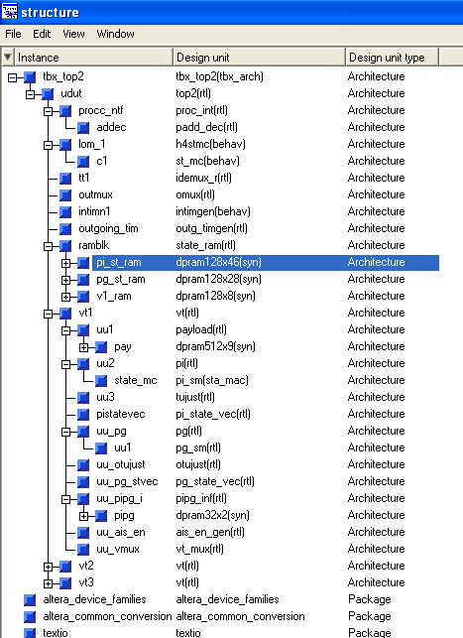

IMPLEMENTATION
The above Time Sliced/Shared SDH Tributary pointer processor and alignment design was implemented using VHDL and synthesized in Altera FPGA Stratix series EP1S10F484C5. The ciruit was simulated on Modelsim simulator.
Following are the VHDL code and simulation results for the proposed Time Sliced/Shared SDH Tributary pointer processor and alignment design:

VHDL CODE of Pointer Interpretation Block

library ieee;
use ieee.std_logic_1164.all;
use ieee.std_logic_arith.all;
use ieee.std_logic_unsigned.all;

entity pi is
port (v1_curr :in std_logic_vector(7 downto 0);-- from v1 ram
indata :in std_logic_vector(7 downto 0);-- from i/p demux
state_vec_p :in std_logic_vector(35 downto 0);-- from st vec ram
dcnt_valp :in std_logic_vector(9 downto 0);--
tuj_en :in std_logic;--from tujust
reset :in std_logic;
sclk :in std_logic;
tu3 :in std_logic;
clk3_p1 :in std_logic;
clk3_p2 :in std_logic;
clk3_p3 :in std_logic;
p1_en :in std_logic;
p2_en :in std_logic;
p3_en :in std_logic;
p31_en :in std_logic;
h3pre_enb :in std_logic;
dis_v5 :in std_logic;
pi_state :out std_logic_vector(1 downto 0);--- to pipg_inf
state_vec_n :out std_logic_vector(35 downto 0);
dcnt_valn1 :out std_logic_vector(9 downto 0);
tu_lop :out std_logic; -- to processor i/f block
tu_ais :out std_logic; -- ""
pi_stb :out std_logic;
inc_just :out std_logic;
dec_just :out std_logic;
pje :out std_logic;---to processor i/f
nje :out std_logic;--- ""
curr_pist :out std_logic_vector(1 downto 0);--to rtop block for
v5_in :out std_logic;
b3_in :out std_logic;
g1_in :out std_logic);
end pi;

architecture RTL OF pi is

component pi_sm
port(reset : in std_logic;
sclk : in std_logic;
frame_en :in std_logic;
ndf_enable1 : in std_logic;
ais_3_ind : in std_logic;
ndf_8_en : in std_logic;
inv_ptr_8 : in std_logic;
eq_new_ptr3 : in std_logic;
pi_st_p : in std_logic_vector(1 downto 0);
pi_st_n : out std_logic_vector(1 downto 0) );
end component;

signal ndf_enable,ss_valid, ndf_disable : std_logic;
signal ndf_invalid , ptr_in_range : std_logic;
signal maj_i_bit,maj_d_bit : std_logic;
signal norm_ptr,ndf_en,ais_ind,inc_ind,dec_ind : std_logic;
signal inv_point,new_ptr,load_en : std_logic;
signal ais_cntn1,ais_cntn,ais_cntp : std_logic_vector(1 downto 0);
signal ndfen_cntn1,ndfen_cntn,ndfen_cntp : std_logic_vector(2 downto 0);
signal invptr_cntn1,invptr_cntn,invptr_cntp : std_logic_vector(2 downto 0);
signal eqnewptr_cntn1,eqnewptr_cntn,eqnewptr_cntp:std_logic_vector(1 downto 0);
signal maj_vot :std_logic_vector(9 downto 0);
signal i_bits,d_bits :std_logic_vector(4 downto 0);
signal valjust_cntp,valjust_cntn,valjust_cntn1 :std_logic_vector(1 downto 0);
signal frame_en,load_dwn_cnt,ptr_en :std_logic;
signal currw_ptr_n1,currw_ptr_n,currw_ptr_p :std_logic_vector(9 downto 0);
signal ndf_8_en :std_logic;
signal ais_3_ind :std_logic;
signal inv_ptr_8 :std_logic;
signal eq_new_ptr3 :std_logic;
signal v1_byte,v2_byte :std_logic_vector(7 downto 0);
signal rx_ptr :std_logic_vector(15 downto 0);
signal inc_indp,dec_indp,inc_indn1,dec_indn1 :std_logic;
signal inc_indn,dec_indn,valjust_cnt,eq_new_ptr :std_logic;
signal pi_st_p, pi_st_n,pi_st_n1 :std_logic_vector(1 downto 0);
signal prev_ptr_p,prev_ptr_n,prev_ptr_n1 :std_logic_vector(9 downto 0 );
signal down_cnt_n,dwn_cnt_valp_d :std_logic_vector(9 downto 0);
signal in_v5_int :std_logic;
signal p2_en_d :std_logic;
signal en_dec,load_en_int,je_p :std_logic;
signal ptr_mod_d,ptr_mod_i :std_logic_vector(9 downto 0);
signal en_dec2,en_dec_int,en_dec_d1 :std_logic;
signal sel_cntval :std_logic;
signal in_b3_int,in_g1_int :std_logic;
signal state_vec_pd :std_logic_vector(35 downto 0);
signal dwn_cnt_valp :std_logic_vector(9 downto 0);
signal max_pval :std_logic_vector(9 downto 0);

begin
state_mc: pi_sm
port map(ndf_enable1 => ndf_en,
ais_3_ind => ais_3_ind,
ndf_8_en => ndf_8_en,
inv_ptr_8 => inv_ptr_8,
eq_new_ptr3 => eq_new_ptr3,
reset => reset,
sclk => sclk,
pi_st_p => pi_st_p,
pi_st_n => pi_st_n,
frame_en => clk3_p2 );
----------------------------------------------------
curr_pist <= pi_st_p;
----------------------------------------------------

process( p2_en,p3_en,p31_en,ais_cntn,ndf_en,invptr_cntn,eqnewptr_cntn,
currw_ptr_n,prev_ptr_n,ndfen_cntn, invptr_cntp,eqnewptr_cntp,
currw_ptr_p,prev_ptr_p,ais_cntp,ndfen_cntp,inc_indn,dec_indn,
valjust_cntn, valjust_cntp, pi_st_n, pi_st_p, inc_indp,dec_indp,
p2_en_d )
begin
if ( p2_en_d='1') then
ais_cntn1 <= ais_cntn;
ndfen_cntn1 <= ndfen_cntn;
invptr_cntn1 <= invptr_cntn;
eqnewptr_cntn1 <= eqnewptr_cntn;
currw_ptr_n1 <= currw_ptr_n;
prev_ptr_n1 <= prev_ptr_n;
inc_indn1 <= inc_indn;
dec_indn1 <= dec_indn;
pi_st_n1 <= pi_st_n;
valjust_cntn1 <= valjust_cntn;
else
ais_cntn1 <= ais_cntp;
ndfen_cntn1 <= ndfen_cntp;
invptr_cntn1 <= invptr_cntp;
eqnewptr_cntn1 <= eqnewptr_cntp;
currw_ptr_n1 <= currw_ptr_p;
prev_ptr_n1 <= prev_ptr_p;
inc_indn1 <= inc_indp;
dec_indn1 <= dec_indp;
pi_st_n1 <= pi_st_p;
valjust_cntn1 <= valjust_cntp;
end if;
end process;

process (sclk,reset)
begin
if reset ='0' then
p2_en_d <= '0';
elsif sclk'event and sclk='1' then
p2_en_d <= p2_en;
end if ;
end process;

--rxed ptr val
process (sclk,reset)
begin
if reset='0' then ---por rxed ptr should be ais
v1_byte<="00000000";
v2_byte<="00000000";
elsif sclk'event and sclk='1' then
if load_en='1' then---*******
v1_byte<= v1_curr;
v2_byte<= indata ;
end if;
end if;
end process;
---------------------------------------------------------------------------
rx_ptr <= v1_byte & v2_byte;
ss_valid<='1' when (rx_ptr(11 downto 10) ="10") else '0';
ndf_enable<='1' when (rx_ptr(15 downto 12)="1001" or
rx_ptr(15 downto 12)="1000" or
rx_ptr(15 downto 12)="0001" or
rx_ptr(15 downto 12)="1101" or
rx_ptr(15 downto 12)="1011" ) else '0';
ndf_disable<='1' when(rx_ptr(15 downto 12)="0110" or
rx_ptr(15 downto 12)="0111" or
rx_ptr(15 downto 12)="1110" or
rx_ptr(15 downto 12)="0010" or
rx_ptr(15 downto 12)="0100" ) else '0';

ndf_invalid<='1' when (ndf_enable='0' and ndf_disable='0')else '0';
max_pval <= "0010001100" when tu3='0' else --140 for tu12
"1011111101"; --765 for tu3

ptr_in_range <='1'when(rx_ptr(9 downto 0)< max_pval )else '0';
maj_vot <=(rx_ptr(9 downto 0) xor currw_ptr_p(9 downto 0));

i_bits <= maj_vot(9) & maj_vot(7) & maj_vot(5) & maj_vot(3) & maj_vot(1);
d_bits <= maj_vot(8) & maj_vot(6) & maj_vot(4) & maj_vot(2) & maj_vot(0);

maj_i_bit<='1' when (i_bits="11111" or
i_bits="01111" or
i_bits="00111" or
i_bits="10111" or
i_bits="10011" or
i_bits="11011" or
i_bits="11001" or
i_bits="11101" or
i_bits="11100" or
i_bits="01110" or
i_bits="01101" or
i_bits="11110" or
i_bits="10101" or
i_bits="11010" or
i_bits="10110" or
i_bits="01011" ) else '0';

maj_d_bit<='1' when (d_bits="11111" or
d_bits="01111" or
d_bits="00111" or
d_bits="10111" or
d_bits="10011" or
d_bits="11011" or
d_bits="11001" or
d_bits="11101" or
d_bits="11100" or
d_bits="01110" or
d_bits="01101" or
d_bits="11110" or
d_bits="10101" or
d_bits="11010" or
d_bits="10110" or
d_bits="01011" ) else '0';

norm_ptr<='1'when (ndf_disable='1'and ss_valid='1'and ptr_in_range='1')else '0';
ndf_en <='1'when (ndf_enable='1'and ss_valid='1'and ptr_in_range='1') else '0';
ais_ind <='1' when (rx_ptr="1111111111111111") else '0';
inc_ind <='1' when (ndf_disable='1' and ss_valid='1' and maj_i_bit='1'
and maj_d_bit='0' and valjust_cnt='1') else '0';
dec_ind <='1' when (ndf_disable='1' and ss_valid='1' and maj_d_bit='1'
and maj_i_bit='0' and valjust_cnt='1') else '0';
inv_point<='1'when((norm_ptr='0' and ndf_en='0' and ais_ind='0'
and inc_ind='0' and dec_ind='0')or new_ptr='1') else '0';
new_ptr <='1'when(norm_ptr='1'and maj_vot/="0000000000") else '0';

--maj_vot also indicates that there is a chg. in rx ptr as comp. to cuurwptr.
eq_new_ptr<='1'when(norm_ptr='1'and rx_ptr(9 downto 0)=prev_ptr_p(9 downto 0))
else '0';

-------------------------------------------------------
-- VARIOUS COUNTERS FOR COUNTING CONSEC. EVENT
--------------------------------------------------------
ptr_en <= (p1_en or p2_en );
load_en_int<= (p2_en and clk3_p1 );
--------------------------------------------------------
---IN TU3 MODE DWN CNT IS LOADED ONLY AT P3 LOCATION WITH INCOMING PTR
--- THAT IS STORED IN RAM AT P2 LOCATION.

process(clk3_p1,clk3_p2,ptr_en,tu3)
begin
if tu3='0' then
load_dwn_cnt <= (clk3_p1 and (not ptr_en));
else
load_dwn_cnt <= (clk3_p2 and p3_en);
end if;
end process;
--------------------------------------------------------
pi_state <= pi_st_n;-- pi next state
--------------------------------------------------------

process(sclk,reset)----added for gen. frame_en signal used for
-----inc/dec the counters
begin
if reset='0'then

frame_en<='0';
load_en <= '0';
elsif sclk'event and sclk='1'then
load_en <= load_en_int;
frame_en<= load_en;
end if;
end process;

ais : process(sclk,reset)
begin
if reset='0' then ais_cntn<="00" ;
elsif (sclk'event and sclk='1') then
if load_en='1' then
ais_cntn<=ais_cntp;
elsif (ais_ind='1' and frame_en='1' and ais_cntn< "11" ) then
ais_cntn<=ais_cntn+1;
elsif (ais_ind='0' and frame_en='1' ) then
ais_cntn<="00";
else ais_cntn<=ais_cntn;
end if;
end if;

end process;
--------------------------------------------------------------------------------
ais_3_ind<= '1' when (ais_cntn="11" ) else '0' ;
--------------------------------------------------------------------------------

process(sclk,reset)
begin
if reset='0' then ndfen_cntn<="000" ;
elsif (sclk'event and sclk='1') then
if load_en='1' then
ndfen_cntn <= ndfen_cntp;
elsif (ndf_en='1' and frame_en='1' and ndfen_cntn< "111" ) then
ndfen_cntn<=ndfen_cntn + 1;
elsif (ndf_en='0' and frame_en='1' ) then
ndfen_cntn<="000";
else ndfen_cntn<=ndfen_cntn;
end if;
end if;
end process;
-------------------------------------------------------------------------------
ndf_8_en<='1' when (ndfen_cntp="111"and ndf_en='1') else '0';
-------------------------------------------------------------------------------

process(sclk,reset)
begin
if reset='0' then invptr_cntn<="000" ;
elsif (sclk'event and sclk='1') then
if load_en='1' then
invptr_cntn<=invptr_cntp;
elsif ((inv_point='0'or(eqnewptr_cntp="01"and eq_new_ptr='1'))
and frame_en='1' ) then
invptr_cntn<="000";
elsif (inv_point='1' and frame_en='1' and invptr_cntn< "111" ) then
invptr_cntn<=invptr_cntn + 1;
else invptr_cntn<=invptr_cntn;
end if;
end if;
end process;
-------------------------------------------------------------------------------
inv_ptr_8<='1' when (invptr_cntp="111"and inv_point='1') else '0';
------------------------------------------------------------------------------

process(sclk,reset)
begin
if (reset='0') then eqnewptr_cntn<="00" ;
elsif (sclk'event and sclk='1') then
if load_en='1' then
eqnewptr_cntn<=eqnewptr_cntp;
elsif (eq_new_ptr ='1' and frame_en='1' and eqnewptr_cntn < "10" ) then
eqnewptr_cntn <= eqnewptr_cntn + 1;
elsif (eq_new_ptr='0' and frame_en='1' ) then
eqnewptr_cntn<="00";
else eqnewptr_cntn<=eqnewptr_cntn;
end if;
end if;
end process;
--------------------------------------------------------------------------------
eq_new_ptr3<= '1' when (eqnewptr_cntn="10")else '0';
--------------------------------------------------------------------------------

process(sclk,reset)
begin
if reset='0' then valjust_cntn<="00" ;
elsif (sclk'event and sclk='1') then
if load_en='1' then
valjust_cntn<=valjust_cntp;
elsif((ndf_enable='1'or inc_ind='1'or dec_ind='1')and frame_en='1') then
valjust_cntn<="00";
elsif (frame_en='1' and valjust_cntn< "11" ) then
--elsif (norm_ptr='1' and frame_en='1' and valjust_cntn< "11" ) then
valjust_cntn<=valjust_cntn + 1;
else valjust_cntn<=valjust_cntn;
end if;
end if;
end process;
--------------------------------------------------------------------------------
valjust_cnt<='1' when (valjust_cntp="11")else '0';
--------------------------------------------------------------------------------

--- IF PREV JE HAS OCCURED THEN IN NEXT FRAME AT V2 IT IS NOT POSSIBLE FOR
--- JE TO OCCUR
process(inc_indp,inc_ind)
begin
if inc_indp = '1' then
inc_indn <= '0';
else
inc_indn <= inc_ind;
end if;
end process;

process(dec_indp,dec_ind)
begin
if dec_indp = '1' then
dec_indn <= '0';
else
dec_indn <= dec_ind;
end if;
end process;

---PJE AND NJE GENERATION FOR PROCESSOR I/F----
---INC_INDN,DEC_INDN ARE VALID ONLY AT V2/H2 LOCATION
process(reset,sclk)
begin
if reset='0' then
pje <= '0';
nje <= '0';
elsif sclk'event and sclk='1' then
pje <= inc_indn and p2_en_d and clk3_p3 ;
nje <= dec_indn and p2_en_d and clk3_p3;
end if;
end process;
--------------------------------------------------------------------------------
inc_just<= inc_indp;
dec_just<= dec_indp;
je_p <= (inc_indp or dec_indp)and p2_en_d;
--------------------------------------------------------------------------------

--CURR WORKING POINTER MUX---------------------------------------------
-----------------------------------------------------------------------
process(reset,ndf_en,eq_new_ptr3,rx_ptr,prev_ptr_p,currw_ptr_p,je_p,pi_st_p,
sclk)
begin
case pi_st_p is
when "10" => ---norm
if ndf_en='1' then
currw_ptr_n<= rx_ptr(9 downto 0);
elsif (eq_new_ptr3 ='1') then
currw_ptr_n<= prev_ptr_P;
elsif ( je_p = '1') then
currw_ptr_n<= prev_ptr_p;
else currw_ptr_n<= currw_ptr_p;
end if;

when "01" => ---lop
if (eq_new_ptr3 ='1') then
currw_ptr_n<= prev_ptr_p;
else currw_ptr_n<= currw_ptr_p;
end if;
when others => ---ais

if ndf_en='1' then ----******
currw_ptr_n<= rx_ptr(9 downto 0);
elsif (eq_new_ptr3 ='1') then
currw_ptr_n<= prev_ptr_P;
else currw_ptr_n<= currw_ptr_p;
end if;
end case;
end process;

---PREV FRAME PTR---------------------------------
process(sclk,reset)
begin
if reset='0' then prev_ptr_n<="0000000000";

elsif sclk'event and sclk='1' then
case pi_st_p is
when "10" =>---norm
if ndf_enable='1' then
prev_ptr_n <= rx_ptr(9 downto 0);
elsif (inc_ind='1') then
prev_ptr_n <= ptr_mod_i;
elsif (dec_ind='1') then
prev_ptr_n<= ptr_mod_d ;
else
prev_ptr_n <= rx_ptr(9 downto 0);
end if;

when others =>
prev_ptr_n<= rx_ptr(9 downto 0);
end case;
end if;
end process;

--max_pval <= "0010001011" when tu3='1' else--tu12 max ptr val 139
-- "1011111100"; --tu3 max ptr val 764
--min_pval <= "0000000000";

process( tu3, currw_ptr_p)
begin
case tu3 is
when '0' => ---tu12
if currw_ptr_p = "0010001011" then --139
ptr_mod_i <= "0000000000" ;
else
ptr_mod_i <= currw_ptr_p + 1;
end if;

when '1' => ---tu3
if currw_ptr_p = "1011111100" then --764
ptr_mod_i <= "0000000000" ;
else
ptr_mod_i <= currw_ptr_p + 1;
end if;
when others =>
ptr_mod_i <= "0000000000" ;
end case;
end process;

process(tu3, currw_ptr_p)
begin
case tu3 is
when '0' => ---tu12
if currw_ptr_p = "0000000000" then
ptr_mod_d <= "0010001011" ; ---139
else
ptr_mod_d <= currw_ptr_p - 1;
end if;
when '1' => ---tu3
if currw_ptr_p = "0000000000" then
ptr_mod_d <= "1011111100" ;--764
else
ptr_mod_d <= currw_ptr_p - 1;
end if;
when others =>
ptr_mod_d <= "0000000000" ;
end case;
end process;

------LOADING FROM RAM------------------------------------
process(sclk,reset)
begin
if reset ='0' then
state_vec_pd <= (others=>'0');
elsif sclk'event and sclk ='1' then
if clk3_p3 ='1' then--to hold ram contents for 3 clk cyc in case of dis.ram
state_vec_pd <= state_vec_p;
end if;
END IF;
end process;

process ( sclk, reset)
begin
if reset ='0' then
inc_indp <= '0';
dec_indp <= '0';
ais_cntp <= (others => '0');
ndfen_cntp <= (others => '0');
invptr_cntp <= (others => '0');
valjust_cntp <= (others => '0');
eqnewptr_cntp <= (others => '0');
pi_st_p <= (others => '0');
prev_ptr_p <= (others => '0');
currw_ptr_p <= (others => '0');

elsif sclk'event and sclk='1' then
inc_indp <= state_vec_pd(35);
dec_indp <= state_vec_pd(34);
ais_cntp <= state_vec_pd(33 downto 32);
ndfen_cntp <= state_vec_pd(31 downto 29);
invptr_cntp <= state_vec_pd(28 downto 26);
valjust_cntp <= state_vec_pd(25 downto 24);
eqnewptr_cntp <= state_vec_pd(23 downto 22);
pi_st_p <= state_vec_pd(21 downto 20);
prev_ptr_p <= state_vec_pd(19 downto 10);
currw_ptr_p <= state_vec_pd(9 downto 0);
end if;
end process;

--- DWN CNT HOLD FOR DWNCNT RAM---
process(reset, sclk)
begin
if reset ='0' then
dwn_cnt_valp <= (others=>'0');
elsif sclk'event and sclk='1' then
if clk3_p3 ='1' then
dwn_cnt_valp<= dcnt_valp;
end if;
end if;
end process;

-------------------------------------------------------------------------------
state_vec_n<= inc_indn1 & dec_indn1 & ais_cntn1 & ndfen_cntn1 & invptr_cntn1 &
valjust_cntn1 & eqnewptr_cntn1 & pi_st_n1 & prev_ptr_n1 &
currw_ptr_n1;
pi_stb <='1' when pi_st_p="10" else '0'; ---to payload block
-------------------------------------------------------------------------------
--- downcounter updation----
process(reset,sclk)
begin
if reset ='0' then
down_cnt_n<="0010001011";--por default to TU12
elsif sclk'event and sclk='1' then
if load_dwn_cnt ='1' then
down_cnt_n <= dwn_cnt_valp;
elsif tuj_en='1' then
if down_cnt_n ="0000000000" then
case tu3 is
when '1' =>
down_cnt_n<="1011111100";--764
when others =>
down_cnt_n<="0010001011";--139
end case;
else down_cnt_n <= down_cnt_n - 1;
end if;
end if;
end if;
end process;
-------------------------------------------------------------------------------sel_cntval <= h3pre_enb or p2_en_d;
-------------------------------------------------------------------------------process( sel_cntval, currw_ptr_n1,down_cnt_n,h3pre_enb)
begin
case sel_cntval is
when '1' =>
dcnt_valn1 <= currw_ptr_n1;
when others =>
dcnt_valn1 <= down_cnt_n;
end case;
end process;

--- INCOMING V5/J1 DETECTION ---

process(reset, sclk)
begin
if reset='0' then dwn_cnt_valp_d <=(others => '0') ;
elsif sclk'event and sclk='1' then
---if clk3_p1='1'then--- use only incase of blk.ram used to hold the cnt
dwn_cnt_valp_d <= dwn_cnt_valp;
--end if;
end if;
end process;
-------------------------------------------------------------------------------
in_v5_int <= '1' when ( (dwn_cnt_valp_d = "0000000000" and tu3 ='0' )or
(down_cnt_n ="0000000000" and tu3 ='1' )
) else '0';
-------------------------------------------------------------------------------

--- DELAYING EN_DEC FOR SYNCHRONIZING V5 SIGNAL ----
process(reset,sclk)
begin
if reset ='0' then
en_dec_d1 <= '0';
elsif sclk'event and sclk='1' then
en_dec_d1 <= en_dec_int;
end if;
end process;
----------------------------------------------------------------------
en_dec_int <= ((p3_en and (not dec_indp)) or (p31_en and inc_indp));
en_dec2<= ((ptr_en or p2_en_d) or dis_v5) ;
EN_DEC <= EN_DEC_D1 OR EN_DEC2;
----------------------------------------------------------------------

--V5 HIGH FOR 3 CLK CYC.
process(reset, sclk)
begin
if reset='0' then v5_in <='0' ;
elsif sclk'event and sclk='1' then
if clk3_p2 ='1' then
if (en_dec = '0' ) then
v5_in <= in_v5_int;
else
v5_in <= '0';
end if;
end if;
end if;
end process;

--- INCOMING B3 & G1 DETECTION FOR TU-3 CASE ---
------------------------------------------------------------------------------
in_b3_int <= '1' when (down_cnt_n = "1010101000" and tu3='1' ) else '0';--680
in_g1_int <= '1' when (down_cnt_n = "0111111110" and tu3='1' ) else '0';--510
------------------------------------------------------------------------------
process(reset, sclk)
begin
if reset='0' then
b3_in <='0' ;
g1_in <='0' ;
elsif sclk'event and sclk='1' then
if clk3_p2='1' then
if en_dec='0' then
b3_in <= in_b3_int;
g1_in <= in_g1_int;
else
b3_in <= '0';
g1_in <= '0';
end if;
end if;
end if;
end process;
---LOP & AIS DETECTION----
-- THESE ARE VALID ONLY AT4'TH CLK CYC IN WHICH WRITE OF THE PREV
-- TU STATE TAKES PLACE.
------------------------------------------------------------------------------
tu_lop <= '1' when (pi_st_p ="01") else '0';
tu_ais <= '1' when (pi_st_p ="00") else '0';
------------------------------------------------------------------------------
end RTL ;

library ieee;
use ieee.std_logic_1164.all;
use ieee.std_logic_misc.all;
use ieee.std_logic_arith.all;
use ieee.std_logic_unsigned.all;

entity pi_sm is
port(reset : in std_logic;
sclk : in std_logic;
frame_en : in std_logic;--from pi block
ndf_enable1 : in std_logic;--"
ais_3_ind : in std_logic;--"
ndf_8_en : in std_logic;--"
inv_ptr_8 : in std_logic;--"
eq_new_ptr3 : in std_logic;--"
pi_st_p : in std_logic_vector(1 downto 0);-- from st vector ram
pi_st_n :out std_logic_vector(1 downto 0) );
end pi_sm;

architecture sta_mac of pi_sm is

type state_type is (NORM, AIS,LOP);
signal curr_state,next_state : state_type ;
attribute STATE_VECTOR : string;
attribute STATE_VECTOR of state_type : type is "10 00 01";

begin

process(reset, pi_st_p,sclk)
begin
if reset='0' then curr_state <= ais;
elsif sclk'event and sclk='1' then
if frame_en='1' then
case pi_st_p is
when "10" => curr_state<= norm;
when "01" => curr_state<= lop;
when others => curr_state<= ais;
end case;
end if;
end if;
end process;

process (curr_state,ais_3_ind,inv_ptr_8,ndf_8_en,eq_new_ptr3,ndf_enable1)
begin
case curr_state is
when NORM =>
if (ais_3_ind='1') then --1
next_state<=AIS;
elsif( eq_new_ptr3='1') then --1
next_state<=NORM;
elsif (inv_ptr_8='1' or ndf_8_en='1') then --2
next_state<=LOP;
else
next_state<=NORM; --3
end if;

when LOP=>
if( eq_new_ptr3='1') then --1
next_state<=NORM;
elsif( ais_3_ind='1') then --2
next_state<=AIS;
else
next_state<=LOP; --3
end if;

when AIS=>
if(eq_new_ptr3='1' or ndf_enable1='1') then --1
next_state<=NORM;
elsif(inv_ptr_8='1') then --2
next_state<=LOP;
else
next_state<=AIS; --3
end if;

when others=>
next_state<=ais;
end case;
end process;

pi_st_n <= "10" when (next_state = norm) else
"01" when (next_state = lop) else
"00";---ais
end sta_mac;

VHDL CODE of Pointer Interpretation State Vector Ram Block

library IEEE;
use IEEE.std_logic_1164.all;
use IEEE.std_logic_misc.all;
use IEEE.std_logic_arith.all;
use IEEE.std_logic_unsigned.all;

entity pi_state_vec is
port ( reset : in std_logic;
sclk : in std_logic;
tu3 : in std_logic;
ispe : in std_logic;-- form tim gen
add_en : in std_logic;
tuj_en : in std_logic;-- from tu just
p1_en : in std_logic;
p2_en : in std_logic;
p3_en : in std_logic;
p31_en : in std_logic;
clk3_p1 : in std_logic;
clk3_p2 : in std_logic;
clk3_p3 : in std_logic;
h3pre_enb : in std_logic;
vtpptu_wadd : out std_logic_vector(4 downto 0);
vtpptu_radd : out std_logic_vector(4 downto 0);
vtpptu_add : out std_logic_vector(4 downto 0);
pist_we : out std_logic;
picnt_we : out std_logic;
pi_stvec_address: out std_logic_vector(4 downto 0) );
end pi_state_vec;

architecture RTL of pi_state_vec is

signal wadd_st_vec,radd_st_vec,wadd_v1 :std_logic_vector(4 downto 0);
signal we_v1_int,we_v1,we_dwn_cnt :std_logic;
signal en_wadd, en_wadd_int :std_logic;
signal vtpptu_addcnt, VTPPTU_WADDINT :std_logic_vector(4 downto 0);
signal vtpptu_raddint,pi_stvec_addr1 :std_logic_vector(4 downto 0);
signal pi_stvec_addr :std_logic_vector(4 downto 0);
signal we_dwn_cnt_int,add_en_gen :std_logic;

begin
---------------------------------------------------------------
pist_we<=clk3_p3 and p2_en ;
picnt_we <= (( p2_en and clk3_p3) or tuj_en) when tu3='0' else
( h3pre_enb and clk3_p3) ;
---------------------------------------------------------------
---tu indentifier address counter----
---vtpp -- tu state vector read and write addresss---
-------------------------------------------------------------------------------
add_en_gen <= '1' when ( ispe ='1' and clk3_p1 ='1' and add_en ='1' ) else '0';
-------------------------------------------------------------------------------
process(reset,sclk)
begin
if sclk'event and sclk='1'then
if ( reset='0'or tu3 ='1') then
vtpptu_addcnt<="00000";
elsif add_en_gen='1' then--qual with clk3p3
if (vtpptu_addcnt="10100" ) then
vtpptu_addcnt<="00000";
else
vtpptu_addcnt<=vtpptu_addcnt + 1;
end if;
end if;
end if;
end process;

---FOR DELAY for other blocks i.e payload ---
process(reset,sclk)
begin
if (reset='0' )then
vtpptu_raddint <="00000";
elsif sclk'event and sclk='1'then
if clk3_p3='1' then
vtpptu_raddint <= vtpptu_addcnt;
end if;
end if;
end process;

process(reset,sclk)
begin
if (reset='0' )then
vtpptu_Waddint <="00000";
elsif sclk'event and sclk='1'then
vtpptu_Waddint <= vtpptu_raddint;
end if;
end process;
-----------------------------------------------------------------------
vtpptu_wadd <= vtpptu_waddint;
vtpptu_radd <= vtpptu_raddint;
vtpptu_add <= vtpptu_addcnt;
pi_stvec_address <= pi_stvec_addr;
-----------------------------------------------------------------------
--- address gen for pi_stvec ram-------
process( clk3_p2,vtpptu_addcnt,vtpptu_waddint)
begin
if clk3_p2 ='1' then
pi_stvec_addr1 <= vtpptu_addcnt;
else pi_stvec_addr1 <= vtpptu_waddint;
end if;
end process;

process(sclk,reset)
begin
if reset ='0' then
pi_stvec_addr <= "00000";
elsif sclk'event and sclk='1' then
pi_stvec_addr <= pi_stvec_addr1;
end if;
end process;
end RTL;
configuration CFG_pisvec of pi_state_vec is
for RTL
end for;
end CFG_pisvec;

VHDL CODE of Pointer Generator Block
library IEEE;
use IEEE.std_logic_1164.all;
use IEEE.std_logic_misc.all;
use IEEE.std_logic_arith.all;
use IEEE.std_logic_unsigned.all;

entity pg is
port (reset : in std_logic;
sclk : in std_logic;
pg_stvec_p : in std_logic_vector(16 downto 0);
pgdcnt_valp : in std_logic_vector(10 downto 0);
tu3 : in std_logic;
otuj_en : in std_logic;
tu_lop : in std_logic;---from alarm sec
tu_ais : in std_logic;---from alarm sec
f_of_uf : in std_logic;---from buff monitor in payload
---should be high for 3 sclk cyc
f_uth : in std_logic;
f_lth : in std_logic;
ov5_enb : in std_logic;-- from payload buffer block
oclk3_p1 : in std_logic;
oclk3_p2 : in std_logic;
oclk3_p3 : in std_logic;
op1_1en : in std_logic;
op1_en : in std_logic;
op2_en : in std_logic;
op3_en : in std_logic;
op31_en : in std_logic;
dis_ov5 : in std_logic; ---from outimgen
inc_je : out std_logic;---to otu just block
dec_je : out std_logic;---"
opje : out std_logic;
onje : out std_logic;
otv5_en : out std_logic;-- to omux block
pg_stvec_n : out std_logic_vector(16 downto 0);
pg_dwn_cnt_n: out std_logic_vector(10 downto 0);
v1v2_txed : out std_logic_vector(7 downto 0) );
end pg;

architecture rtl of pg is

component pg_sm
port(reset : in std_logic;
sclk : in std_logic;
pi_ais : in std_logic;
pi_lop : in std_logic;
fo_discnt : in std_logic;
op1_1en : in std_logic;---- pulse on last data byte but
---- before v1/ h1 pulse
frame_en : in std_logic;
ES_lth : in std_logic;
ES_uth : in std_logic;
ram_st : in std_logic_vector(2 downto 0);
pg_st_n : out std_logic_vector(2 downto 0));--to pg_st. vec
end component;

signal load_st_p, load_just, inc_indp,dec_indp : std_logic;
signal val_just_cntp,val_just_cntn,val_just_cntn1: std_logic_vector(1 downto 0);
signal pg_st_p, pg_st_n,pg_st_n1 : std_logic_vector(2 downto 0);
signal load_pg_dwncnt : std_logic;
signal pg_dwncntn,pg_dwncntn_tu3,pg_dwncntn_1 : std_logic_vector(9 downto 0);
signal v1v2_prev_txn, v1v2_prev_txn1 : std_logic_vector(9 downto 0);
signal v1v2_prev_txp : std_logic_vector(9 downto 0);
signal ndf_req,fo_discnt : std_logic;
signal load_just_cnt : std_logic;
signal fo_discntn1 : std_logic;
signal v1v2_txed_int : std_logic_vector(7 downto 0);
signal V1V2_PREV_II, v1v2_prev_di : std_logic_vector(9 downto 0);
signal inc_indn, dec_indn : std_logic;
signal inc_indn1,dec_indn1,op1_1_mod,op1_1en_d : std_logic;
signal inc_just_cnt,valid_just,just_lth,just_uth : std_logic;
signal pg_dwncntn_v5 : std_logic_vector(9 downto 0);
signal v1_lsbs : std_logic_vector(1 downto 0);
signal lat_tu3ptr : std_logic;
signal pg_dwncntn_2 : std_logic_vector(9 downto 0);
signal pgdcnt_valp1,pg_dwn_cnt_p : std_logic_vector(10 downto 0);
signal pg_stvec_pd : std_logic_vector(16 downto 0);
signal t_cnt : std_logic;
signal fo_discnt_p : std_logic;
signal pg_dwn_cnt_pd : std_logic_vector(9 downto 0);
signal max_ptrval : std_logic_vector(9 downto 0);
signal en_dec,en_dec_int : std_logic;
signal tc_dwncnt12,tc_pgdwncnt12,tc_pgdwncnt3: std_logic;
signal tc_dwncnt3 : std_logic;

begin

uu1 : pg_sm
port map(
reset => reset,
sclk => sclk,
pi_ais => tu_ais,
pi_lop => tu_lop,
fo_discnt => fo_discnt,
op1_1en => op1_1_mod,
frame_en => load_st_p,
ES_lth => just_lth,
ES_uth => just_uth,
ram_st => pg_st_p, -- for tu12 mode
pg_st_n => pg_st_n);

process(tu3,oclk3_p2,oclk3_p1,op1_1en,op1_1en_d)
begin
if tu3='0' then
load_st_p <= oclk3_p1;
op1_1_mod <= op1_1en;
else
load_st_p <= oclk3_p2;
op1_1_mod <= op1_1en_d;
end if;
end process;

process(reset,sclk)
begin
if reset ='0' then
op1_1en_d <='0';
elsif sclk'event and sclk='1' then
op1_1en_d <= op1_1en;
end if;
end process;
----------------------------------------------------
load_just <= oclk3_p1;
just_lth <= f_lth and valid_just;
just_uth <= f_uth and valid_just;
----------------------------------------------------

------ loading data from state vec dpram-------
--------------------------------------------------------
pg_stvec_pd <= pg_stvec_p;
-------------------------------------------------------
process(reset,sclk)
begin
if reset ='0' then
inc_indp <= '0';
dec_indp <= '0';
val_just_cntp <= (others => '0');
v1v2_prev_txp <= (others => '0');
pg_st_p <= ("000");-- ais

elsif sclk'event and sclk='1' then
if oclk3_p3 ='1' then
inc_indp <= pg_stvec_pd(16);
dec_indp <= pg_stvec_pd(15);
val_just_cntp <= pg_stvec_pd(14 downto 13);
v1v2_prev_txp <= pg_stvec_pd(12 downto 3);
pg_st_p <= pg_stvec_pd(2 downto 0);
end if ;
end if;
end process;

---dwn cnt data hold reg.----
---hold the tu12 dwn cnt for 3 clk cyc.
---for tu3 dwncnt itself contains cnt
---and is updated only at v5 loc.with 764 max tu3 ptr val
----------------------------------------
process(tu3, pgdcnt_valp)
begin
if tu3 ='1' then
pgdcnt_valp1 <= pgdcnt_valp(10) & "1011111100";--764
else
pgdcnt_valp1 <= pgdcnt_valp;
end if;
end process;

process(reset,sclk)
begin
if reset ='0' then
pg_dwn_cnt_p<=(others=>'0');
elsif sclk'event and sclk='1' then
if oclk3_p3 ='1' then
pg_dwn_cnt_p <= pgdcnt_valp1;
end if;
end if;
end process;

-- ram o/p are given to otujust block
-- for gen otu just enb sig.
---------------------------------------------------
inc_je <= inc_indp;
dec_je <= dec_indp;
---------------------------------------------------

--- otv5 signal gen by disabling it at ptr & soh location---
--- otv5 " is also disabled during ais state
-------------------------------------------------------------------------------
en_dec_int <= ((op3_en and (not dec_indp)) or (op31_en and inc_indp));
en_dec <= en_dec_int or dis_ov5;
-------------------------------------------------------------------------------
process(reset, sclk)
begin
if reset='0' then otv5_en<='0' ;
elsif sclk'event and sclk='1' then
if oclk3_p1 ='1' then
if (en_dec = '0'or pg_st_p/="000") then
otv5_en <= ov5_enb;
else
otv5_en <= '0';
end if;
end if;
end if;
end process;

process(reset,sclk)
begin
if reset ='0' then
fo_discnt <='0';
elsif sclk'event and sclk ='1' then
fo_discnt <= pg_dwn_cnt_p(10);
end if;
end process;

--control signal gen for valjust cnt.
------------------------------------------------
load_just_cnt <= oclk3_p1;
inc_just_cnt <= oclk3_p2 and op2_en;
------------------------------------------------
----- vaild just frame counter-------
process( reset, sclk)
begin
if reset ='0' then val_just_cntn <= "00";

elsif sclk'event and sclk='1' then
if load_just_cnt ='1' then
val_just_cntn <= val_just_cntp;
elsif inc_just_cnt ='1' then
if (pg_st_p /= "110") then -- other than normal
val_just_cntn <= "00";
elsif val_just_cntn < "11" then
val_just_cntn <= val_just_cntn + 1;
end if;
end if;
end if;
end process;
----------------------------------------------------
valid_just <= '1' when val_just_cntp="11" else '0';
----------------------------------------------------

---- v5 tracking downcnt updation-----
---- dwn cnt val is dec at each vc byte location and written back its dec val.
---- at v2 location dwncnt val is used to gen ptr to be
---- txed.

process(oclk3_p1,op1_en,tu3,oclk3_p2,ov5_enb)
begin
if tu3='0' then
load_pg_dwncnt <= oclk3_p1 and ( not op1_en);
else
load_pg_dwncnt <= (oclk3_p1 and ov5_enb);
end if;
end process;

process(tu3)
begin
if tu3='0'then
max_ptrval <="0010001011";--139
else
max_ptrval <="1011111100";--764;
end if;
end process;

process( reset, sclk)
begin
if reset ='0' then pg_dwncntn <=(others => '0');
elsif sclk'event and sclk='1' then
if load_pg_dwncnt ='1' then
pg_dwncntn <= pg_dwn_cnt_p(9 downto 0);
elsif (otuj_en ='1') then
if pg_dwncntn ="0000000000" then
pg_dwncntn<= max_ptrval;
else pg_dwncntn <= pg_dwncntn - 1;
end if;
else pg_dwncntn <= pg_dwncntn;
end if;
end if;
end process;

---downcnt val is SET TO MAX VAL if v5_enb comes, which is stored in ram
---Incase of tu12 downcnt val is SET TO MAX VAL if v5_enb comes, which is stored in ram
---Incase of tu3 no need to store the cnt val as there is one counter per TU3
process(tu3,ov5_enb,pg_dwncntn,max_ptrval)
begin
if (ov5_enb='1' )then
pg_dwncntn_v5 <= max_ptrval;
else
pg_dwncntn_v5 <= pg_dwncntn;
end if;
end process;

-- frame off set discnt is set high if v5 is not found in its prev. pos and is
-- cleared only at op1_1 en location where the pg sm runs.

---term cnt dec in order to detect fo_discnt.
-------------------------------------------------------------
tc_pgdwncnt12 <= '1' when pg_dwn_cnt_p="0000000000" else '0';
tc_pgdwncnt3 <= '1' when pg_dwncntn ="1011111100" else '0';
-------------------------------------------------------------

process(reset,sclk)
begin
if reset='0' then
tc_dwncnt12 <='0';
tc_dwncnt3 <='0';
elsif sclk'event and sclk='1' then
tc_dwncnt12 <= tc_pgdwncnt12;
tc_dwncnt3 <= tc_pgdwncnt3;
end if;
end process;

process(tu3,tc_dwncnt12,tc_dwncnt3)
begin
if tu3='0' then
t_cnt <= tc_dwncnt12;
else
t_cnt <= tc_dwncnt3;
end if;
end process;

process(tu3,fo_discnt,pg_dwn_cnt_p)
begin
if tu3='0' then
fo_discnt_p <= fo_discnt;
else
fo_discnt_p <= pg_dwn_cnt_p(10);
end if;
end process;

fo_discntn1 <= (f_of_uf or ndf_req) or( fo_discnt_p and ( not op1_1en)) ;
---------------------------------------------------------------------- --------

---mux for tu3 and for tu12 ptr to be txed ---
process(tu3,pg_dwncntn, pg_dwncntn_tu3,pg_dwn_cnt_p)
begin
if tu3 ='0' then
pg_dwncntn_1 <= pg_dwn_cnt_p(9 downto 0);
else
pg_dwncntn_1 <= pg_dwncntn_tu3;
end if;
end process;
--reg for storing the tu3 ptr val at p3 location to be txed.
---------------------------------------------------------------
lat_tu3ptr <= '1' when(op31_en ='1' and oclk3_p2 ='1')else '0';
---------------------------------------------------------------
process(inc_indp,pg_dwncntn,v1v2_prev_txp)
begin
if inc_indp='1' then
if v1v2_prev_txp ="1011111100" then --764
pg_dwncntn_2 <= "0000000000";
else
pg_dwncntn_2 <= v1v2_prev_txp + 1;
end if;
else --- dec_indp='1' or norm st
pg_dwncntn_2 <= pg_dwncntn;
end if;
end process;

process(reset, sclk)
begin
if reset ='0' then
pg_dwncntn_tu3 <=(others=>'0');
elsif sclk'event and sclk='1' then
if lat_tu3ptr ='1' then
pg_dwncntn_tu3 <= pg_dwncntn_2;
end if;
end if;
end process;

----mux for v1v2 to be txed

process( pg_dwncntn_1,op1_en, op2_en,pg_st_p,v1v2_prev_ii,v1v2_prev_di
,sclk,v1_lsbs )
begin
case pg_st_p is
when "110" => ---norm
if op1_en ='1' then
v1v2_txed_int(7 downto 2) <= "011010";---ndf norm
v1v2_txed_int(1 downto 0) <= v1_lsbs;
else v1v2_txed_int <= pg_dwncntn_1(7 downto 0);----
end if;
when "001" => ---ndf
if op1_en ='1' then
v1v2_txed_int(7 downto 2) <= "100110";----ndf enb
v1v2_txed_int(1 downto 0) <= v1_lsbs;
else v1v2_txed_int <= pg_dwncntn_1(7 downto 0);----
end if;
when "011" => --inc
if op1_en ='1' then
v1v2_txed_int(7 downto 2) <= "011010";---ndf norm
v1v2_txed_int(1 downto 0) <= v1v2_prev_ii(9 downto 8);
else
v1v2_txed_int <= v1v2_prev_ii(7 downto 0);
end if;
when "010" => --dec
if op1_en ='1' then
v1v2_txed_int(7 downto 2) <= "011010";---ndf norm
v1v2_txed_int(1 downto 0) <= v1v2_prev_di(9 downto 8);
else
v1v2_txed_int <= v1v2_prev_di(7 downto 0);
end if;
when "000" => ----ais
v1v2_txed_int <= "11111111";
when others =>
v1v2_txed_int <= "11111111";-----to be check??....
end case;

end process;

process(op1_en,pg_dwncntn_tu3, tu3)
begin
if (op1_en ='1'and tu3='1') then
v1_lsbs <= pg_dwncntn_tu3(9 downto 8);
else
v1_lsbs <= "00";
end if;
end process;

process(reset,sclk)
begin
if reset ='0' then
v1v2_txed <=(others=>'0');
elsif sclk'event and sclk='1' then
v1v2_txed <= v1v2_txed_int;
end if;
end process;

------tx ptr encoding in case of just. event to be gen---
-------------------------------------------------------------------------------
v1v2_prev_di <= v1v2_prev_txp(9)& (not v1v2_prev_txp(8))&v1v2_prev_txp(7)&
(not v1v2_prev_txp(6))& v1v2_prev_txp(5)& (not v1v2_prev_txp(4)
)&v1v2_prev_txp(3)&(not v1v2_prev_txp(2))&
v1v2_prev_txp(1)&(not v1v2_prev_txp(0));

v1v2_prev_ii <= (not v1v2_prev_txp(9))&v1v2_prev_txp(8)&(not v1v2_prev_txp(7))&
v1v2_prev_txp(6)& (not v1v2_prev_txp(5))&v1v2_prev_txp(4)&
(not v1v2_prev_txp(3))&v1v2_prev_txp(2)& (not v1v2_prev_txp(1)) &v1v2_prev_txp(0);
-------------------------------------------------------------------------------
----inc dec signal gen for ram block-----
process(pg_st_p)
begin
case pg_st_p is
when "011" => --inc
inc_indn <= '1';
dec_indn <= '0';
when "010" => --dec
dec_indn <= '1';
inc_indn <='0';
when others => ---ais, ndfenb, norm
inc_indn <='0';
dec_indn <= '0';
end case;
end process;

------prev ptr updation ----
process( op2_en,pg_dwncntn_1 ,v1v2_prev_txp)
begin
if op2_en ='1' then
v1v2_prev_txn <= pg_dwncntn_1 ;
else v1v2_prev_txn <= v1v2_prev_txp;
end if;
end process;

---generation of opje and onje for processor i/f -----
--- signle pulse is generated
process(reset,sclk)
begin
if reset ='0' then
opje <= '0';
onje <= '0';
elsif sclk'event and sclk='1' then
opje <= inc_indn and op2_en;
onje <= dec_indn and op2_en;
end if;
end process;

---mux for ram block ----
---gen. new st. vec to be stored in ram
process(inc_indn,dec_indn,inc_indp,dec_indp,val_just_cntp,v1v2_prev_txp
,v1v2_prev_txn,val_just_cntn, pg_st_n, pg_st_p,op1_1en_d,op2_en)
begin
if op1_1en_d ='1' then
inc_indn1 <= inc_indp;
dec_indn1 <= dec_indp;
val_just_cntn1 <= val_just_cntp;
v1v2_prev_txn1 <= v1v2_prev_txp;
pg_st_n1 <= pg_st_n;
elsif op2_en ='1' then ---if blk dpram used at the top level
inc_indn1 <= inc_indn;
dec_indn1 <= dec_indn;
val_just_cntn1 <= val_just_cntn;
v1v2_prev_txn1 <= v1v2_prev_txn;
pg_st_n1 <= pg_st_p;
else
inc_indn1 <= inc_indp;
dec_indn1 <= dec_indp;
val_just_cntn1 <= val_just_cntp;
v1v2_prev_txn1 <= v1v2_prev_txp;
pg_st_n1 <= pg_st_p;
end if;
end process;
------------------------------------------------------------------------------
pg_dwn_cnt_n <= fo_discntn1 & pg_dwncntn_v5;
pg_stvec_n <= inc_indn1 & dec_indn1 & val_just_cntn1 & v1v2_prev_txn1 &
pg_st_n1;
-----------------------------------------------------------------------------
end RTL ;

library IEEE;
use IEEE.std_logic_1164.all;
use IEEE.std_logic_misc.all;
use IEEE.std_logic_arith.all;
use IEEE.std_logic_unsigned.all;

entity pg_sm is
port (reset : in std_logic;
sclk : in std_logic;
pi_ais : in std_logic;
pi_lop : in std_logic;
fo_discnt : in std_logic;
op1_1en : in std_logic;---- pulse on last data byte but
---- before v1/ h1 pulse
frame_en : in std_logic;
ES_lth : in std_logic;
ES_uth : in std_logic;
ram_st : in std_logic_vector(2 downto 0);
pg_st_n : out std_logic_vector(2 downto 0));--- to pg_state_vec ram
end pg_sm;

architecture RTL of pg_sm is

type state_type is ( norm, ndf, inc ,dec, ais);

signal curr_state, next_state : state_type;
attribute STATE_VECTOR : string;
attribute STATE_VECTOR of state_type : type is
"110 001 011 010 000";
signal pi_lopais : std_logic;

begin
----loading of curr state------
process(reset, sclk)
begin
if reset='0' then
curr_state <= ais;
elsif sclk'event and sclk='1' then
if frame_en ='1' then
case ram_st is ---
when "110" => curr_state<= norm;
when "001" => curr_state<= ndf;
when "011" => curr_state<= inc;
when "010" => curr_state<= dec;
when "000" => curr_state<= ais;
when others => curr_state<= ais;
end case;
end if;
end if;
end process;
----------------------------------------------------------
pi_lopais <= pi_lop or pi_ais;
-----------------------------------------------------------
----next state dec------------
process( curr_state,pi_ais,pi_lop, op1_1en,pi_lopais,es_uth,es_lth,fo_discnt)
begin
case curr_state is
when norm =>
if pi_lopais='1' then
next_state <= ais;
elsif fo_discnt ='1' then
next_state <= ndf;
elsif es_lth ='1' then
next_state <= inc;
elsif es_uth ='1' then
next_state <= dec;
else next_state <= curr_state;
end if;
when inc =>
if (pi_lopais='1' )then
next_state <= ais;
elsif (op1_1en ='1') then
next_state <= norm;
else next_state <= curr_state;
end if;
when dec =>
if (pi_lopais='1' )then
next_state <= ais;
elsif (op1_1en ='1') then
next_state <= norm;
else next_state <= curr_state;
end if;
when ndf =>
if pi_lopais ='1' then
next_state <= ais;
elsif fo_discnt='1' then
next_state <= curr_state;
elsif op1_1en ='1' then
next_state <= norm;
else next_state <= curr_state;
end if;
when ais =>
if pi_lopais ='0' then
next_state <= ndf;
else next_state <= curr_state;
end if;
when others =>
next_state <= ais;
end case;
end process;

pg_st_n <="110" when next_state = norm else
"001" when next_state = ndf else
"011" when next_state = inc else
"010" when next_state = dec else
"000"; ---ais
end RTL;

VHDL CODE of Pointer Generator State Vector RAM Block

library ieee;
use ieee.std_logic_1164.all;
use ieee.std_logic_arith.all;
use ieee.std_logic_unsigned.all;
library WORK;
use WORK.all;

entity pg_state_vec is
port ( reset : in std_logic;
sclk : in std_logic;
ospe : in std_logic;--
tu3 : in std_logic;--
oadden : in std_logic;--
ov5_enb : in std_logic;--
otuj_en : in std_logic;-- from otu just
p1_1en : in std_logic;
p1_en : in std_logic;
p2_en : in std_logic;
p3_en : in std_logic;
p31_en : in std_logic;
clk3_p1 : in std_logic;
clk3_p2 : in std_logic;
clk3_p3 : in std_logic;
pgst_we : out std_logic;
pgcnt_we : out std_logic;
ovtpptu_add : out std_logic_vector(4 downto 0);
ovtpptu_radd : out std_logic_vector(4 downto 0);
ovtpptu_wadd : out std_logic_vector(4 downto 0) );
end pg_state_vec;

architecture RTL of pg_state_vec is

signal p2_en_d,otuj_en_d : std_logic;
signal we_st, we_dwn_cnt : std_logic;
signal wadd_st_vec, radd_st_vec : std_logic_vector(4 downto 0);
signal ovtpptu_raddint,ovtpptu_waddint : std_logic_vector(4 downto 0);
signal ovtpptu_addcnt : std_logic_vector(4 downto 0);
signal pg_stvec_addr1,pg_stvec_addr,pg_dwncnt_add:std_logic_vector(4 downto 0);
signal pg_dwncnt_valint,pg_dwncnt_valint1: std_logic_vector(10 downto 0);
begin
-- add gen for pg state vec ram
------------------------------------------------
radd_st_vec <= ovtpptu_addcnt;
wadd_st_vec <= ovtpptu_waddint;
------------------------------------------------
process(reset, sclk)
begin
if reset ='0' then
p2_en_d <= '0';
elsif sclk'event and sclk='1' then
p2_en_d <= p2_en;
end if;
end process;

process(reset,sclk)
begin
if reset ='0' then
otuj_en_d <= '0';
elsif sclk'event and sclk='1' then
otuj_en_d <= otuj_en;
end if;
end process;

pgst_we <= clk3_p3 and(p2_en or p1_1en) when tu3='0' else
clk3_p3 and(p2_en or p1_1en);
pgcnt_we<=( ((clk3_p3 and p2_en) or otuj_en_d)and not tu3);

---vtpp -- tu state vector read and write addresss---
process(reset,sclk)
begin
if sclk'event and sclk='1'then
if (ospe='0' or reset='0'or tu3 ='1') then
ovtpptu_addcnt<="00000";
elsif oadden='1' then--qual with clk3p3
if (ovtpptu_addcnt="10100" ) then
ovtpptu_addcnt<="00000";
else
ovtpptu_addcnt<=ovtpptu_addcnt + 1;
end if;
end if;
end if;
end process;

process(reset, sclk)
begin
if (reset='0' )then
ovtpptu_raddint <="00000";
elsif sclk'event and sclk='1'then
if clk3_p3 ='1' then
ovtpptu_raddint <= ovtpptu_addcnt;
end if;
end if;
end process;

process(reset,sclk)
begin
if (reset='0' )then
ovtpptu_waddint <="00000";
elsif sclk'event and sclk='1'then
ovtpptu_waddint <= ovtpptu_raddint;
end if;
end process;
---------------------------------------------------
ovtpptu_wadd <= ovtpptu_waddint;
ovtpptu_radd <= ovtpptu_raddint;
ovtpptu_add <= ovtpptu_addcnt;
---------------------------------------------------
---pg stvec RAM address generation ------
process(clk3_p1,ovtpptu_addcnt,ovtpptu_waddint)
begin
if clk3_p1 ='1' then
pg_stvec_addr1 <= ovtpptu_addcnt;
else
pg_stvec_addr1 <= ovtpptu_waddint ;
end if;
end process;

process(reset,sclk)
begin
if reset ='0' then
pg_stvec_addr <= (others=>'0');
elsif sclk'event and sclk='1' then
pg_stvec_addr <= pg_stvec_addr1;
end if;
end process;

---dwn cnt ram address gen block ----
process(reset,sclk)
begin
if reset ='0' then
pg_dwncnt_add <= (others=> '0');
elsif sclk'event and sclk='1' then
pg_dwncnt_add <= pg_stvec_addr;
end if;
end process;

end RTL;
configuration CFG_pgsvec of pg_state_vec is
for RTL
end for;
end CFG_pgsvec;

CONCLUSION

Time sliced/shared Tributary pointer processor and alignment design reduces the logic associated with using a dedicated pointer processor for each TU-12 /TU-3 with in the STM-1 frame.
Dedicated pointer processor requires 63 dedicated pointer interpreter & 63 dedicated pointer generator blocks as against the 3 pointer interpreters & 3-pointer generator required in a time sliced pointer processor and alignment design. The time sliced pointer processor requires additional memory for storing the pointer vector’s associated with each Tributary (TU-12/TU-3 in STM-1). As the FPGA’s are rich of memory (block as well as distributed) therefore this time sliced architecture is most suitable for FPGA devices.

Each pointer processor, in a time sliced pointer processor, is used to process 21 TU-12’s or one TU-3 with in a TUG-3 structure of the STM-1 frame.

The VHDL implementation further gives the flexibility to map the design in any FPGA making it device technology independent. Also the same core can be used as a basic building block to process Tributaries in higher STM-N frames.

Future Enhancements
The Time Slot Interchange (TSI) may be implemented together with the time sliced Tributary pointer processor sharing the same RAM and much of the control circuitry. The time slot interchange function may be achieved by translating the sequential read address supplied by the outgoing timing generator block that selects the TU-specific RAM segment operated on by the read address generator according to the look up table supplied by the microcontroler and held locally. The memory capacity allocated to TSI must be large enough that bytes written near the beginning of an incoming frame can be read near the end of an outgoing frame.

SIMULATION RESULTS.

The design is implemented in altera FPGA and the implemented VHDL design is simulated using the VHDL test bench in Modelsim simulator tool. The test bench generates the STM-1 frame with floating AU-4 pointer. Further the various combinations of Tributary pointer is also inserted to check the decoding of pointer and marking of the V5/J1 byte in the TU-12/TU-3 frames. This V5/J1 is passed into FIFO buffer.
In pointer generator block the tributary whose pointer interpretation is in normal state its corresponding pointer generate state machine must be in normal state is checked and whether the valid pointers are generated or not is also checked.
The resulting simulation waveforms of the various blocks for various typical cases are attached here in this section.
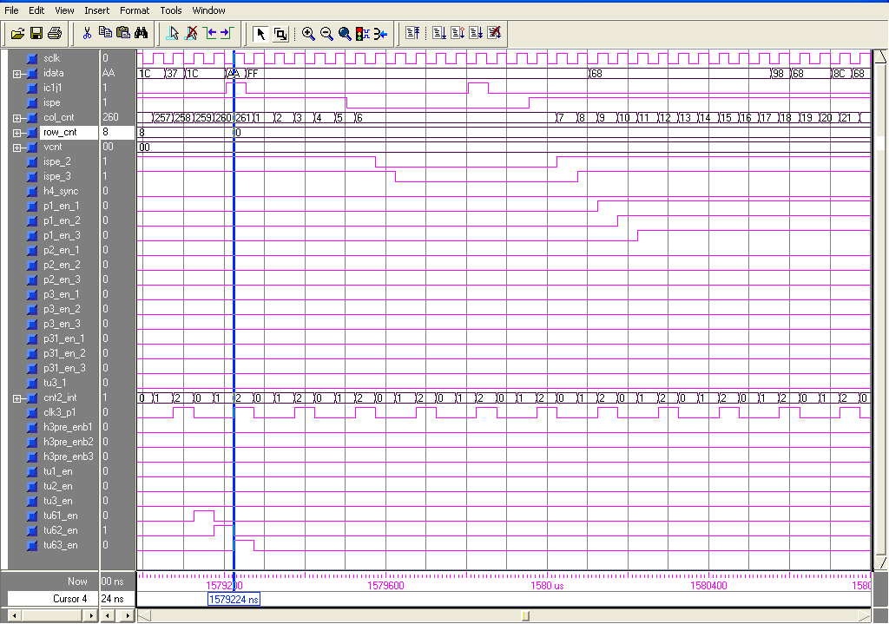
Incoming Timing Generator Block simulation.
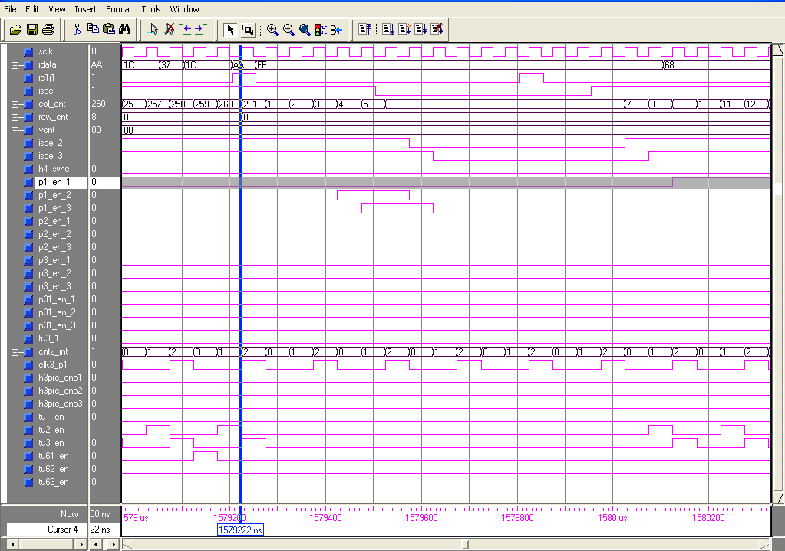
Incoming Timing Generator Block simulation.
.
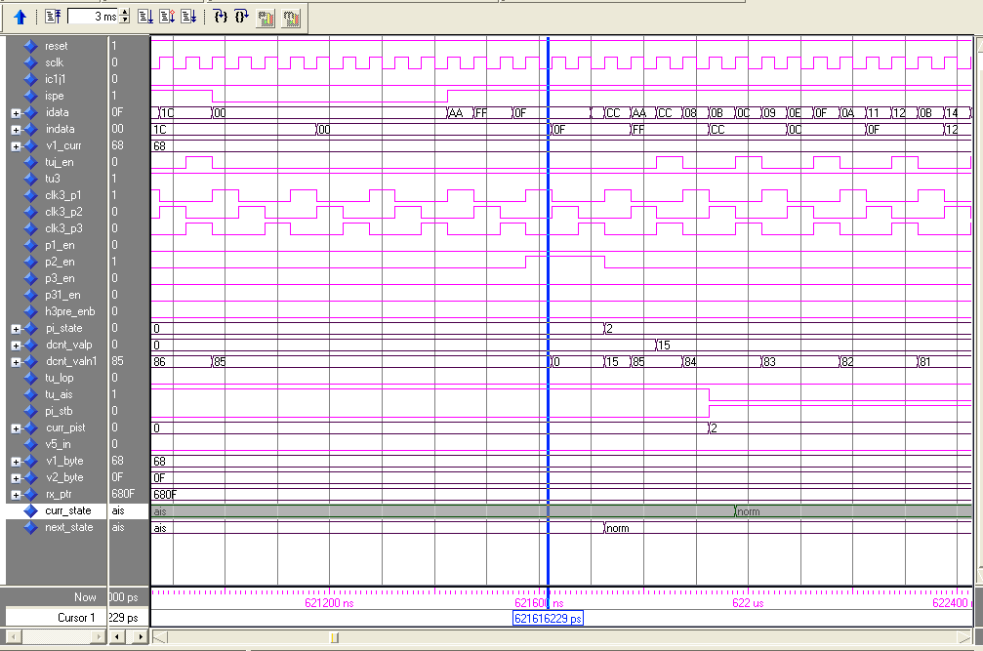 Pointer interpreter simulation for TU-3
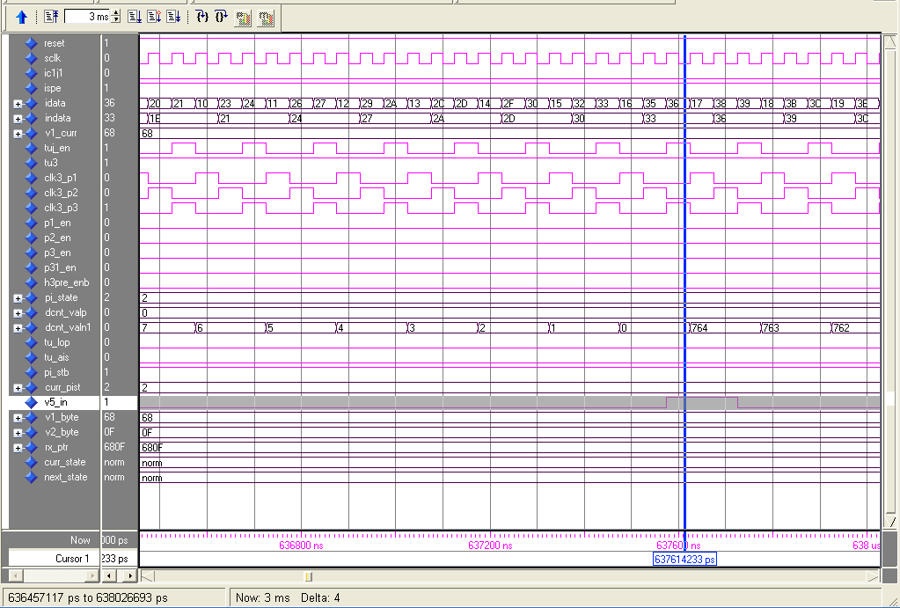
Pointer Down count block simulation identifying J1 (Here named V5_in) byte of VC-3 frame.

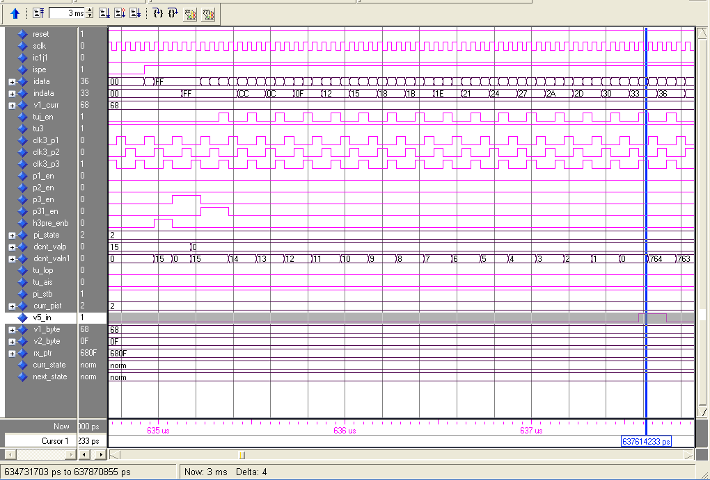
Pointer Down count block simulation identifying J1 (Here named V5_in) byte of VC-3 frame along with P3 & P31_en signals.
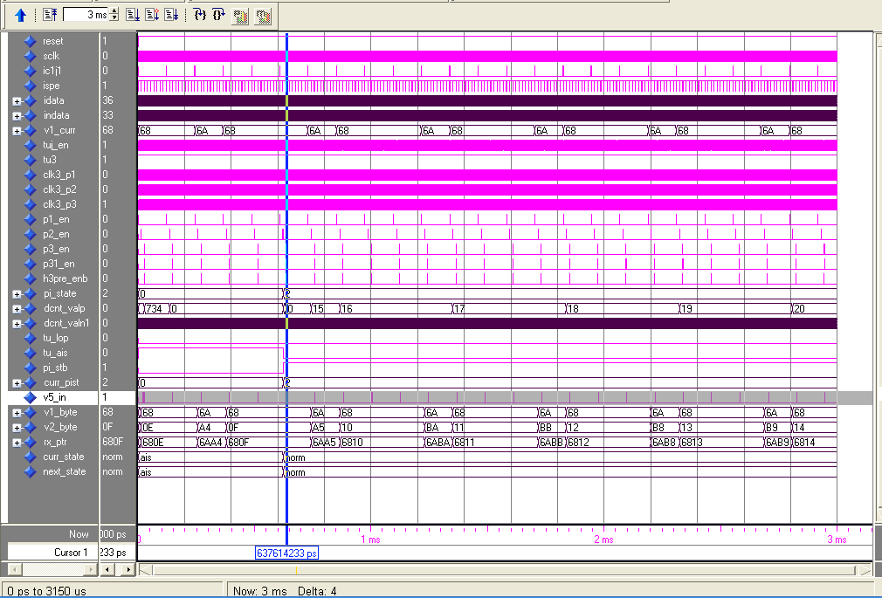
Pointer block simulation for TU-3 with positive justification in TU pointer.
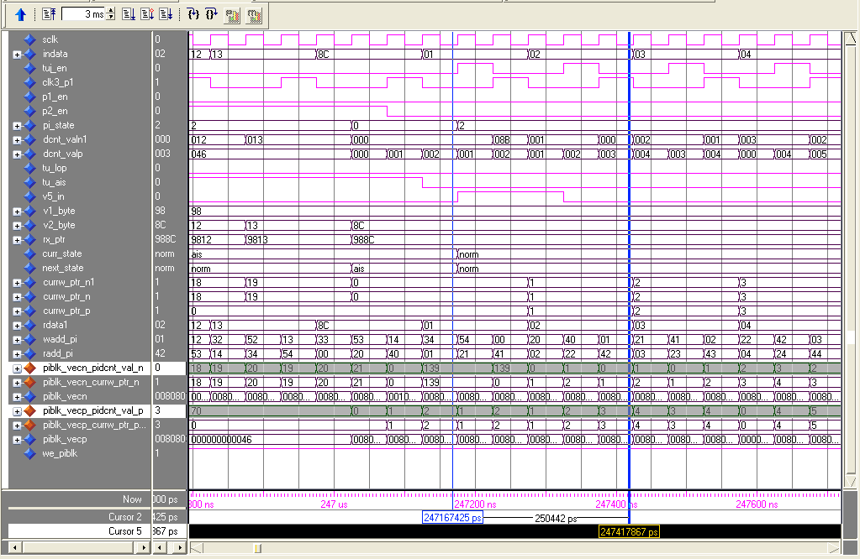
Pointer State vectors block simulation for TU-12.
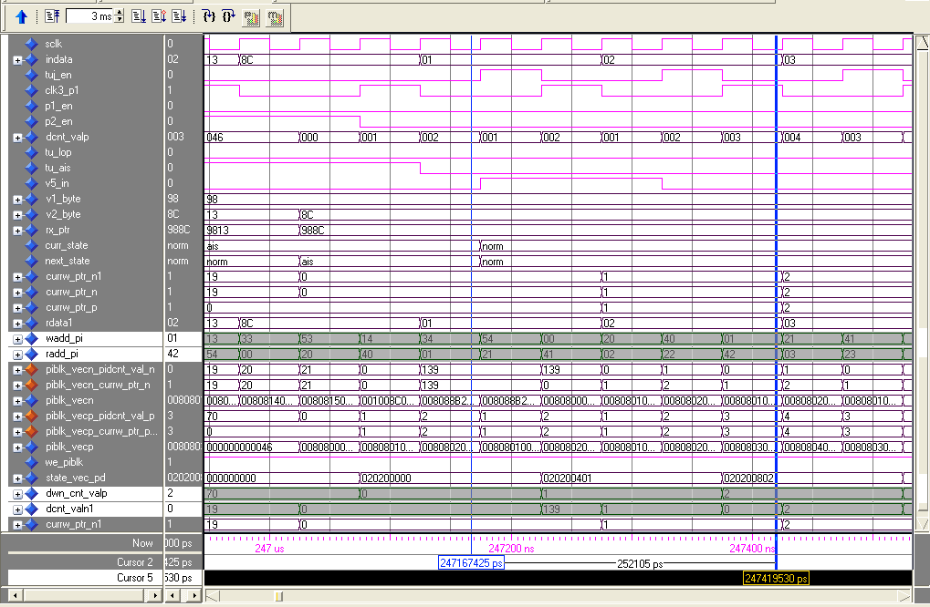
Pointer State vector block simulation for TU-12.
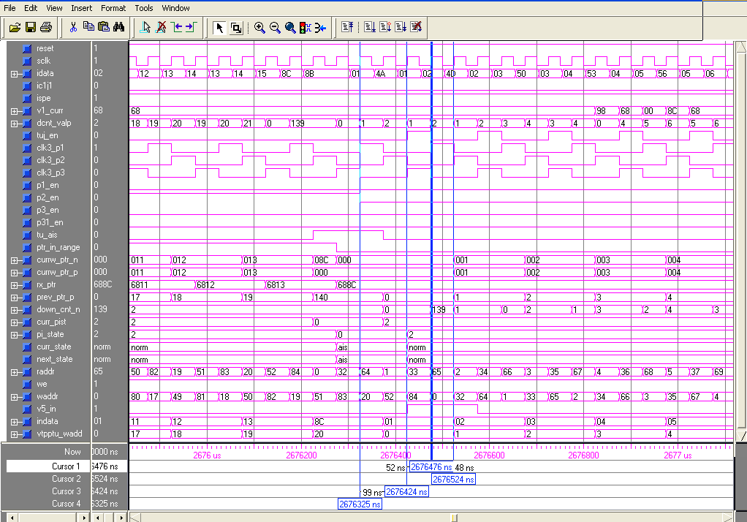
Simulation showing how the processing of TU-12 take place in 4 clock cycle.
Pointer interpreter Simulation showing V5 byte of TU-12 frame along with TU identifier address counter.
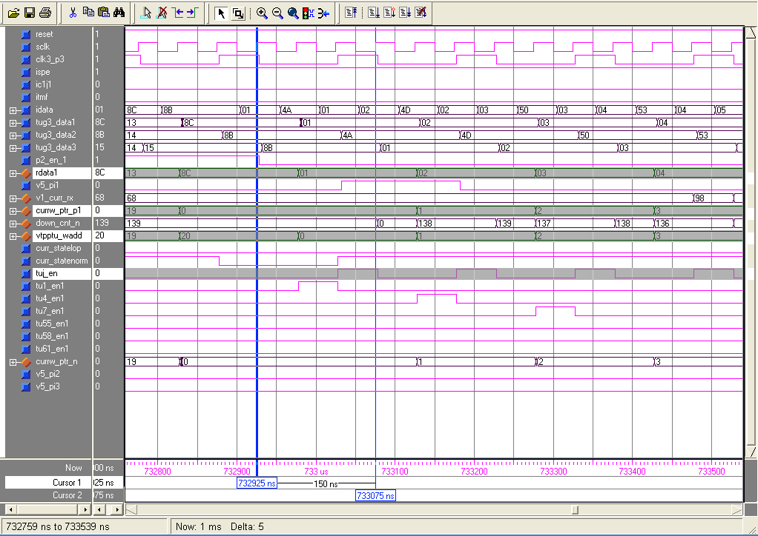
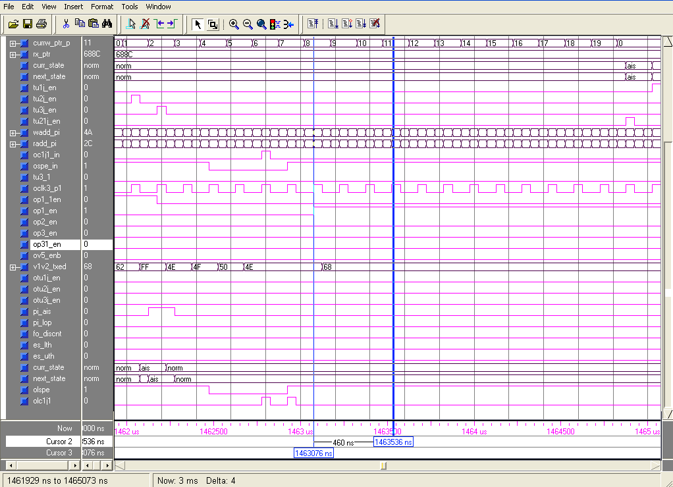 Pointer generator simulation showing at V1 (OP1_EN) normal V1 is transmitted as the pointer generater is in normal state.

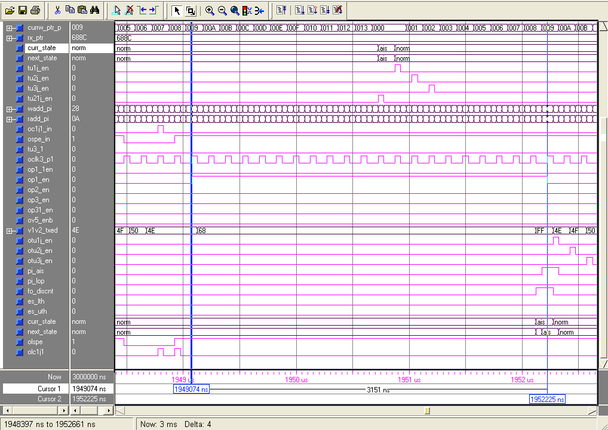Pointer generater simulation showing the Tributary (21’st) is in AIS state. Its corresponding pointer interpreter state m/c is also in AIS state.
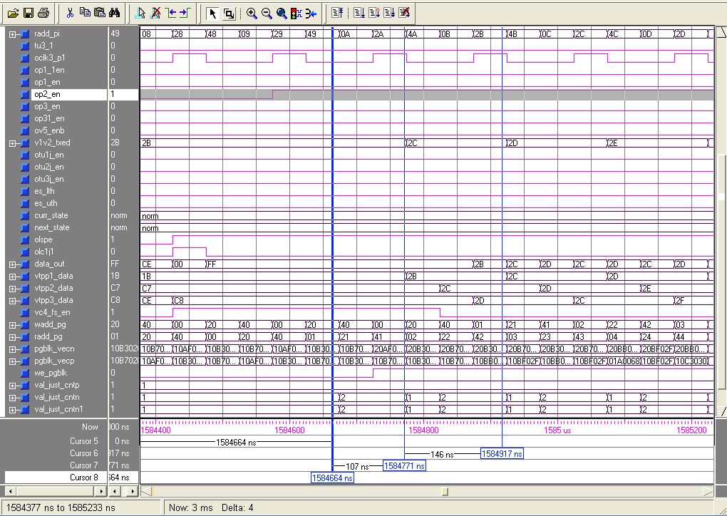 Ponter generater state vectors are read and loaded into counter (val_just_cnt) and write back to state ram after updation at P2 location.

BIBLOGRAPHY:

- Michael J. Klein, Ralph S. Urbansk Philips Kommunikations lndustrie AG “SONET/SDH Pointer Processor Implementation”, Global Telecommunications Conference, 1994. GLOBECOM '94. 'Communications: The Global Bridge'., IEEE.
- Xin Gua, Depeng Jin, Lieguang, Zeng State Key Laboratory on Microwave and Digital communication, Dept of Electronics Engineering, T singhua University, 100084 Beijing China Design And Application of Pointer leakage ASIC MXTULPx8-5, 2002 IEEE
- ITU Recommendation G.707/Y.1322, “Network Node Interface for the Synchronous Digital Hierarchy”, December 2003.
- ITU Recommendation G.783, G.831.
- Michael J. Klein and Ralph Urbansky Network Synchronization - A Challenge for SDH / S0NET?
- M. Sexton and A. Reid, "Transmission Networking: SONET and the Synchronous Digital Hierarchy", Artech House, Norwood, MA, 1992.
- Stefano Bregni, “Synchronization of Digital Telecommunication Networks”, John Wiley & Sons, Ltd
- http://www.altera.com

TOOL USED:
- MODELSIM ALTERA 5.8E Revision 2004.08
- ALTERA QUARTUS-II 4.2 SP1

LIST OF ACRONYMS:

ADM Add & Drop Multiplexer
AIS All Ones Signal
ATM Asynchronous Transfer Mode
AU-4 Administrative Unit –4
C Container
DPRAM Dual Port RAM
FIFO First In First Out
LOP Loss Of Pointer
MSB Most Significant Bit
MSOH Multiplex Section Over Head
NDF New Data Flag
NORM Normal State
NPI Null Pointer Indicators
PDH Plesiocronous Digital Hierarchy
PHY Physical Layer Device
POH Path Overhead
RSOH Regenerator Section Over Head
SDH Synchronous Digital Hierarchy
SOH Section Over Head
STM-1 Synchronous Transport Module-1
TSI Time Slot Interchange
TU Tributary Unit
TU-12 Tributary Unit-12 carrying 2 Mbps data
TU-3 Tributary Unit-3 carrying 34 Mbps data
TUG Tributary Unit Group
VC Virtual Container

