Cost Penalty Of Various Parameters Of Gas Turbine Power Plants

A Thesis/ Dissertation submitted to the University of Delhi,

In partial fulfillment of the requirements for the award of the degree of

Master of Engineering

In

Thermal Engineering



Submitted By

Raghvendra Gautam

Roll No.: 8571

Under Guidanceof

Prof. Samsher

Department of Mechanical Engineering,
Delhi College of Engineering, University of Delhi
Session 2005-06

CERTIFICATE

This is to certify that the major project entitled “Cost Penalty of Various Parameters of Gas Turbine Power Plant” is a bonafide account of the work carried out by Mr. Raghvendra Gautam, under our supervision in partial fulfillment of the requirements for the award of the degree of Master of Technology.

This is to further certify that this work has not been submitted anywhere else for the award of the degree or diploma.

Dr. Samsher& Dr. S.S. Kachhwaha
Astt. Professors

Deptt. of Mechanical Engineering

Delhi College of Engineering, Delhi

ACKNOWLEDGEMENT

At the outset, I express my gratitude to my thesis supervisors, Dr. Samsher & Dr. S.S. Kachhwaha for their valuable and inspiring guidance throughout my project work. Without their encouragement and support this project would not have been possible. I thank them for their always been there wherever I was struck with difficulties. I am grateful to them for their guidance and motivation because of which my Ideas and thoughts were able to see the light of the day. They helped me to mould my ideas and channelised them in the right direction that ultimately resulted in the present work.

I am also thankful to Mr. A.K. Ahuja, Asst. Manager Pragati Power Plant Delhi, Mr. k.S. Yadav Manager G.T.P.S. Delhi , and staff of Central Library D.C.E, Delhi for their kind cooperation and spontaneous help at the time of difficulties arises during my project.

Finally, I take this opportunity to acknowledge the help and encouragement received from my friends and well-wishers who has provided a favorable atmosphere to work.

Raghvendra Gautam

Nomenclature

P Pressure
C.C Combustion Chamber
T Temperature
rp pressure ratio
η_{t} Turbine efficiency
η_{c} Compressor efficiency
s.f.c Specific fuel consumption
wt Turbine work
w_{c} Compressor Work
w_{net} Net work
q_{A} Heat supplied
Cp Specific Heat at Constant Pressure
Qout Heat output
Qin Heat input
η_{th} Thermal Efficiency
η_{comb} Combustion Efficiency
∈ _{r} Regenerator Effectiveness
Super/Subscripts
t Turbine
th Thermal
comb Combustion
` Actual Condition

3 Turbine inlet temperature, Intercooler exit temperature
4 H.P.C. exit temperature
5 High pressure turbine inlet temperature
6 High pressure temperature turbine exit
7 Low pressure turbine inlet temperature
8 Low pressure exit temperature

ACKNOWLEDGEMENT

It is a great pleasure to have the opportunity to extent my heartiest felt gratitude to everybody who helped me throughout the course of this seminar.

I would like to express my heartiest felt regards to Dr, Samsher Asst. Prof., Department of Mechanical Engineering for the constant motivation and support during this project. It is my privilege and owner to have worked under the supervision. His invaluable guidance and helpful discussions in every stage of this project really helped me in materializing this project. It is indeed difficult to put his contribution in few words.

I am thankful to my friends and classmates for their unconditional support and motivation during this project

Raghvendra Gautam
M.E. (Thermal Engineering)
Roll No. 8571

LIST OF FIGURES

Figure 1.1 Total installed Capacity (M.W) 2
Figure 2.1 Open cycle gas Turbine. 5
Figure 2.2. Closed Cycle gas Turbine 5.
Figure 2.3 An Axial-Flow compressor. 6
Figure 2.4 A combustion chamber. 7
Figure 2.5 inside a Turbine Chamber. 8
Figure 2.6 T-s and P-v Diagrams of an Ideal Brayton Cycle. 9
Figure 2.7 hs diagram of simple gas turbine cycle for actual condition 11
Figure 2.8 Simple-Cycles, Single- Shaft Gas Turbine. 13

Figure 2.9 Compressor inlet temperature (T1) against thermal 15

efficiency (ηth) for different loads.
Figure 2.10 Compressor efficiency (η_{c}) against thermalefficiency 16
(η_{th}) and specific consumption (S.F.C) for different loads.
Figure 2.11 Turbine efficiency (η_{T}) against thermal 17
efficiency (η_{thth}) for different loads.
Figure 2.12 Compressor efficiency (η_{c}) against energy 18
cost for different loads.
Figure 2.13 Turbine efficiency (η_{T}) against energy cost for
different loads 19
Figure 2.14 Pressure ratio (rp) against thermal efficiency (ηth) 20
and specific fuel consumption (SFC).

Figure 2.15 Turbine's inlet temperature (T₃) against net work output t 21.
Figure 2.16 Turbine's inlet temperature (T₃) against thermal 22
efficiency (η_{th}) and specific fuel consumption (SFC).
Figure 2.17(a) open cycle with regeneration 23
Figure 2.17 (b). Thermal Efficiency of simple cycle Regeneration 24
Figure 2.18 Process on T-S chart with Regeneration 26
Figure .2.19: s.f.c .vs. Compressor pressure ratio 28
Figure 2.20(a). Open cycle gas turbine with reheat 29
Figure 2.20 (b) h-s Representation of open cycle gas turbine with reheat 29
Figure 2.21(a) & 2.21(b). Thermal Efficiency and Specific Work 30
with Pressure ratio .
Figure 2.22. Open cycle Gas Turbine with intercooling 32
Figure 2.23 h-s Representation of Gas Turbine with intercooling 32
Figure2.24 Gas Turbine with Reheat and Regeneration 35
Figure 2.25 h-s. Representation of Gas Turbine with 36
Reheat and Regeneration
Figure2.26 Open Gas Turbine Cycle with intercooling and 37 Regeneration
Figure 2.27 Open gas Turbine Cycle with Reheat & Intercooling 38
Figure 2.28. h-s. Representation of open Gas Turbine with 39
Reheat & Intercooling
Figure 2.29 OGTC with intercooling, Reheat and 41

Regeneration (Complete Cycle)
Figure2.30 h-s Representation of OGTC with Intercooling, 42
Reheat and Regeneration
Figure.2.31. Effect of Turbine Inlet Temperature & Pressure 44
Ratio
Figure.2.32. Effect of component Efficiencies 45
Figure 2.33 Effect of compressor inlet Temperature 46
Figure.2.34. Effect of pressure Ratio on Specific fuel 46
consumption
Figure 2.35. Effect of Turbine Inlet Temperature & Pressure 47
Ratio on Air Rate
Figure 2.36 Effect of Compressor inlet Temperature on air Rate 47
Figure 2.37. Effect of Intercooling, Reheating &Regeneration 48
Figure 2.38. Effect of component Efficiencies on Air Rate 48
Figure 2.39. Effect of Compressor Inlet Temperature on work 49
Ratio
Figure 2.40 Effects of Turbine Inlet Temperature & Pressure 50
Ratio on Work Ratio
Figure 2.41. Effect of regeneration, intercooling and reheating 50
on the work ratio:

Figure 2.42 Closed Gas Turbine Cycle 51
Figure 2.43. Semi Closed Cycle Gas Turbine 54

Figuere 3.1 Flow chart of Simple cycle gas turbine 56
Figure 3.2 Flow chart of Simple cycle gas turbine with 57
Reheating, Intercooling and Regeneration

Figure 4.1 Ambient Temperature (Kelvin) Vs Thermal Efficiency60

Figure 4.2 Thermal Efficiency Vs Cost of Generation 61
Figure 4.2 Thermal Efficiency Vs Cost of Generation 61
Figure 4.4 Thermal Efficiency Vs Cost of Generation 62
Figure 4.5 Ambient Temperature Vs Thermal Efficiency 63
Figure 4.6 Thermal Efficiency Vs Cost of Generation 63
Figure 4.7 Intercooler Exit Temperature Vs Thermal Efficiency64
Figure 4.8 Thermal Efficiency Vs Cost of Generation 65
Figure 4.9 Turbine Inlet Temperature Vs Thermal Efficiency 66
Figure 4.10 Thermal Efficiency Vs Cost of Generation 66

Figure 4.11 Low pressure Turbine inlet Temperature Vs Thermal 67 Efficiency
Figure 4.12 Thermal Efficiency Vs Cost of Generation 68

CHAPTER 1
INTRODUCTION

1.1 Energy Scenario
Power generation in India began more than a century ago in 1898 when the first hydro power unit was set up at Darjeeling. When India achieved freedom in 1947, the country had an installed capacity of 1,360 MW. The present installed generating capacity in the country is 1,24,287 MW. The share of hydro with 32,325.8 MW capacities is about 26%. Thermal accounts for maximum share of 66% with 82,410.54 MW, out of which Gas turbine power plant contributes 12,690 Mw. The progress in modele wise installed capacity is shown in table- 1.1
Power sector in India has been undergoing in major change. The installed capacity addition in the recent 5 year planned stood at 19241 MW. For supplying quality power to the consumers many national programs and policies have been drawn by the nation to supply power to all by 2012.

The responsibility of generating, transmitting and distributing power within the respective states has been interested on various public and private units. To supplement the efforts of state electricity board (SEB) central generating utilities NTPC and NHPC were set up in the year 1975. In the year 1991 a central transmission company POWER GRID was set up, which was entrusted the responsibility of transmitting power to various states.

Table No.1.1 Total Installed Capacity (MW) of Power Plants
Year | Hydro | Thermal | NCER | Nuclear | Total
March 2000 | 23857 | 70493 | 1154.58 | 2680 | 98184
March 2001 | 25142 | 72355 | 1269 | 2860 | 101626
March 2002 | 26269 | 74549.54 | 1507.46 | 2720 | 105046
March 2003 | 26901.2 | 76606.91 | 1735.66 | 2720 | 107973
March 2004 | 29500.2 | 77968.53 | 1869.66 | 2720 | 112058
March 2005 | 30935.6 | 80902.45 | 3811.01 | 2770 | 118419
March 2006 | 32325.8 | 82410.54 | 6190.86 | 3360 | 124287

Figure No.1.1

1.2 Gas Turbine Power Plant: The turbine in many respects is the most satisfactory means of producing mechanical power among the other various means. Further Gas Turbine is very compact as compared to water and steam turbine. The gas turbine obtains its power by utilizing the energy of burnt gases and air which are at high temperature and pressure by expanding through the several rings of fixed and moving blades.
Gas turbines have been constructed to work on the like, natural gas, coal gas and producer gas. When gas turbine is used for electricity generation it is called as Power Turbine. In the case of Power turbine the expansion of high pressure and high temperature gas takes place fully up to atmospheric pressure. Gas turbines are extensively used as base load electrically power plant, stand by power plant, industrial gas turbine, rocket, and combined cycle power plant.
Some time the Gas turbine power plants run at off-design condition and their parameters are away from the design values. Compressor inlet temperature depends on ambient conditions, similarly the case of temperature after intercooler. The temperature after Regenerator depends on effectiveness of it hence the variation may as taken place in the flue gas temperature after regenerator. The hp and lp turbine inlet temperatures also varies according to load variation in these parameters result in variation in cost of generation of electricity and ultimately this put additional burden on the consumer. The cost penalties of various parameters have been calculated in terms of increase in cost of generation, considering only operating cost as the fixed cost remain the same. The reason for doing this project is only to give an idea about cost penalty on account of the variation in temperatures of gas turbine.
Daily electricity generated by a plant of 200 MW is 4.8 MU when plant run at full load. Even Rs. 0.01/Kwhr increase in the cost of generation result in loss of Rs. 48,000 per day. This has motivated me to do work on this issue. The cost penalty for a day has been calculated considering 10º C variation in each parameter. In chapter 2 of thesis contain literature available on the topic has been discussed.
Chapter3 is about the modeling and flow charts of the programme. Chapter 4 includes the result and discussions and conclusion in chapter 5. The reference has been placed at the end of thesis followed by program coding as annexure A & B.

prices for crude oil make fuels such as diesel, kerosene, jet-engine fuel, and clean gaseous fuels (such as natural gas) the most desirable for gas turbines. However, these fuels will become much more expensive and will eventually run out. Provisions must therefore be made to burn alternative fuels
2.2 Brayton Cycle Components:
Gas turbines usually operate on an open cycle, as shown in Figure2.1. Fresh air at ambient conditions is drawn into the compressor, where its pressure is raised. The high-pressure air proceeds into the combustion chamber, where the fuel is burned at constant pressure. The resulting high-temperature gases then enter the turbine, where they expand to the atmospheric pressure through a row of nozzle vanes. This expansion causes the turbine blade to spin, which then turns a shaft inside a magnetic coil & electrical current is produced. The exhaust gases leaving the turbine in the open cycle are not recirculated.

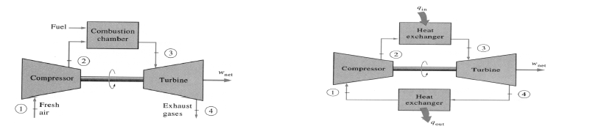

Figure 2.1. Open cycle gas Turbine Figure 2.2.Closed Cycle gas Turbine

The open gas-turbine cycle can be modeled as a closed cycle as shown in Figure 2.2. by utilizing the air-standard assumptions. Here the compression and expansion process remain the same, but a constant-pressure heat-rejection process to the ambient air is included. The ideal cycle that the working fluid undergoes in this closed loop is the Brayton cycle, which is made up of four internally reversible processes:
1-2 Isentropic compression (in a compressor)
2-3 Constant pressure heat addition
3-4 Isentropic expansion (in a turbine)
4-1 Constant pressure heat rejection
2.2.1. Compressor: Efficient compression of large volumes of air is essential for a successful gas turbine engine. This has been achieved in two types of compressors, the axial-flow compressor or radial-flow compressor. Most power plant compressors are axial-flow compressors. The object of a good compressor design is to obtain the most air through a given diameter compressor with a minimum number of stages while retaining relatively high efficiencies and aerodynamic stability over the operating range. Compressors contain a row of rotating blades followed by a row of stationary (stator) blades. A stage consists of a row of rotor and a row of stator blades. All work done on the working fluid is done by the rotating rows, the stators converting the fluid kinetic energy to pressure and directing the fluid into the next rotor. The fluid enters with an initial velocity relative to the blade and leaves with a final relative velocity at a different angle Figure 2.3
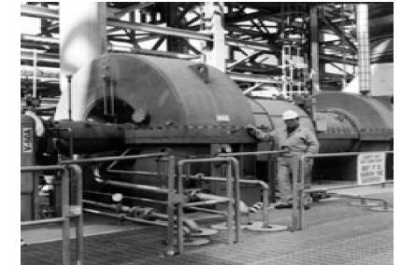

Figure 2.3 – An Axial-Flow compressor
2.2.2. Combustion/Combustor: Combustion is the chemical combination of a substance with certain elements, usually oxygen, accompanied by the production of a high temperature or transfer of heat. The function of the combustion chamber is to accept the air from the compressor and to deliver it to the turbine at the required temperature, ideally with no loss of pressure. Essentially, it is a direct-fired air heater in which fuel is burned with less than one-third of the air after which the combustion products are then mixed with the remaining air. For the common open-cycle gas turbine, this requires the internal combustion of fuel. This means the problem of fuel operation, mixing and burning, must be addressed. Fuel is commonly gaseous or liquid. Solid fuel has not yet advanced beyond the experimental stage. Gaseous or liquid fuels are usually hydrocarbons. Gases usually being natural gas, mostly methane, and butane. Liquids may range from highly refined gasoline through kerosene and light diesel oil to a heavy residual oil. Combustion itself is seldom difficult. Almost any fuel can be burnt successfully if sufficient pressure drop is available to provide the necessary turbulence for mixing of air and fuel and if sufficient volume is available to give the necessary time for combustion to be completed

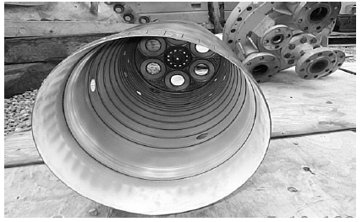
Figure 2.4. A combustion chamber

2.2.3. Turbine: Gas turbines move relatively large quantities of air through the cycle at very high velocities. The gas turbine engines are very smooth operation and absence of vibration due to absence of reciprocating action. The high rotational speeds require very accurate rotor balancing to avoid damaging vibration. Rotor parts are highly stressed with low factors of safety. Blades are very finely tuned to avoid resonant vibration. Gas turbines have relatively few moving (and no sliding) parts and are not subjected to vibratory forces. As a result, they are highly reliable, when properly designed and developed. The gas turbine in its most common form is a heat engine operating through a series of processes. These processes consist of compression of air taken from the atmosphere, increasing of gas temperature by the constant-pressure combustion of fuel in the air, expansion of the hot gases, and finally, discharging of the gases to atmosphere, in a continuous flow process. It is similar to the gasoline and Diesel engines in its working medium and internal combustion, but is like the steam turbine in the steady flow of the working medium. The compression and expansion processes are both carried out by means of rotating elements in which the energy transfer between fluid and rotor is effected by means of kinetic action, rather than by positive displacement as in reciprocating machinery
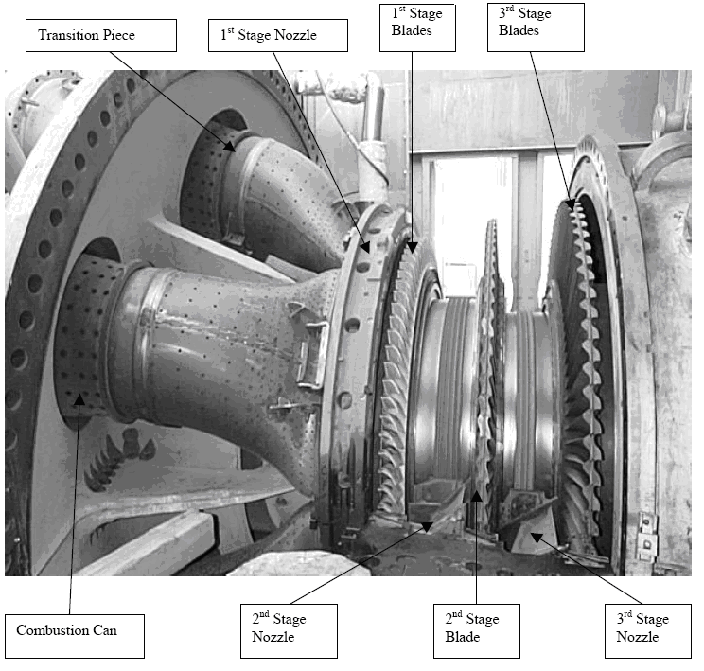
Figure 2.5 – Inside a Turbine Chamber

2.2.4. Air-standard assumptions: Assumptions that the compression and expansion processes are adiabatic (insulated) and reversible (isentropic), that there is no pressure drop during the heat addition process, and that the pressure leaving the turbine is equal to the pressure entering the compressor.
2.3. Internally reversible processes: Thermodynamics states that, for given temperature limits, a completely reversible cycle has the highest possible efficiency and specific work output, reversibility being both mechanical and thermal. Mechanical reversibility is a succession of states in mechanical equilibrium, i.e. fluid motion without friction, turbulence, or free expansion. Thermal reversibility is a consequence of the Second Law of thermodynamics, which states that heat must be added only at the maximum temperature of the cycle and rejected at the minimum temperature.
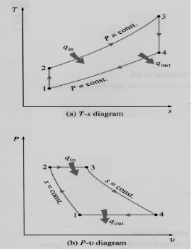
Figure 2.6 – T-s and P-v Diagrams of an Ideal Brayton Cycle

The T-s and P-v diagrams of an ideal Brayton cycle are shown in Figure 2.6. All four processes of the Brayton cycle are executed in steady flow devices so they should be analyzed as steady-flow processes. When the changes in kinetic and potential energies are neglected, the energy balance for a steady-flow process can be express, on a unit-mass basis, as
(Qin-Qout)+(Win-W out) =(h exit-h inlet) …..(2.1)
Therefore, heat transfers to and from the working fluid are
Qin = h3-h2 = Cp(T3-T2) ....(.2.2)
Qout =h4-h1= Cp(T4-T1) ........(2.3) .

Then the thermal efficiency of the ideal Brayton cycle under the cold air-standard assumptions becomes
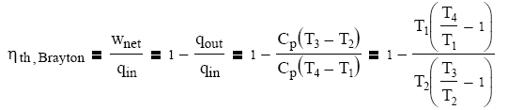….(2.4)
$\begin{aligned} η_{\text{th}} = 1–\frac{1}{r_{p^{(γ–1)/γ}}} \\ \text{where} r_{p}= \left(\frac{p_{2}}{p_{1}}\right)\end{aligned}$ …..(2.5)

Processes 1-2 and 3-4 are isentropic, and P2 = P3 and P4 = P1. Thus. is the pressure ratio and k is the specific heat ratio. Under the cold-air assumptions, the thermal efficiency of an ideal Brayton cycle depends on the pressure ratio of the gas turbine and the specific heat ratio of the working fluid (if different from air). The thermal efficiency increases with both of these parameters, which is also the case for actual gas turbines. Figure 2.7
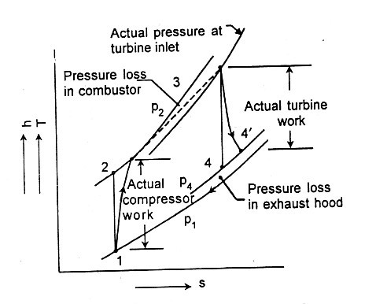
Figure 2.7 Actual Gas Turbine cycle representations on h-s diagram
The specific heat is defined as the amount of heat required to raise the temperature of a unit of mass of a substance by one degree. The specific heat of air is independent of pressure within the limits of gas turbine operation, but varies considerably with temperature. Furthermore, the internal combustion of fuel causes the expansion gas to contain products of combustion, principally CO2 and H2O vapor, both having higher values of specific heat than that of pure air. Previously, the specific heat has been taken to be constant throughout the cycle. This assumption would seem to introduce a considerable error, because the difference between the cold air and hot gas values is approximately 20%. However, although there is an error, it is much less than this value, because of the compensating effect of the varying specific heat ratio. As the specific heat increases with temperature, the isentropic index specific heat decreases along with the change in pressure for a given pressure ratio. The change of enthalpy then becomes neutralized, as it is temperature dependent. Actually, the specific heat of air and of combustion gases changes continually during compression and expansion and for a precise calculation, an integration process is required. The highest temperature in the cycle occurs at the end of the combustion process, and the maximum temperature that the turbine blades can withstand limits the system. This also limits the pressure ratios that can be used in the cycle. For fixed minimum and maximum temperatures, the Brayton cycle efficiency first increases with the pressure ratio, reaching a maximum, and then decreases. In most common designs, the pressure ratio of gas turbines ranges from about 11 to 16. Increasing the turbine inlet temperatures and, therefore, the pressure ratios has been the primary approach taken to improve gas-turbine efficiency. The inlet temperatures have increased from about 540°C (1000°F) in the 1940s to 1425°C (2600°F) today. The development of new materials and cooling techniques for critical components such as coating the turbine blades with ceramic layers and cooling the blades with the discharge air from the compressor made temperature increases possible. Maintaining high turbine inlet temperatures with an air cooling technique requires the combustion temperature to be higher to compensate for the cooling effect of the cooling air. But higher combustion temperatures increase the amount of nitrogen oxides (NOx), which are responsible for the formation of ozone at ground level and smog. Using steam as the coolant allows an increase in the turbine inlet temperatures by 200°F without an increase in the combustion temperature. Steam is also a much more effective heat transfer medium than air.

2.4. The Deviation of Actual Gas-Turbine Cycles from Idealized Ones: The actual gas turbine cycle differs from the ideal Brayton cycle. Some pressure drop during the heat addition and rejection processes is unavoidable. Under the cold-air assumptions, the thermal efficiency of an ideal Brayton cycle depends on the pressure ratio of the gas turbine and the specific heat ratio of the working fluid (if different from air). The thermal efficiency increases with both of these parameters, which is also the case for actual gas turbine.
The actual gas turbine cycle differs from the ideal Brayton cycle. Some pressure drop during the heat addition and rejection processes is unavoidable. The actual work input to the compress will be more, and the actual work output from the turbine will be less because of irreversibility. The deviation of actual compressor and turbine behavior from the idealized isentropic behavior can be accurately accounted for by utilizing the adiabatic efficiencies of the turbine and compressor defined as
$η_{t}= \frac{T_{3} –T_{4}'}{T_{3} –T_{4}}$ ….(2.6)
$η_{c}= \frac{T_{2} –T_{1}}{T_{2}' –T_{1}}$ ----(2.7)
Where states 2′ and 4′ are the actual exit states of the compressor and the turbine, respectively, and 2 and 4 are the corresponding states for the isentropic case.

2.5. Single Shaft Gas Turbine: Some of the work developed by the turbine is used to drive the compressor, and the remainder is available for useful work at the output flange of the gas turbine. Typically, more than 50% of the work developed by the turbine sections is used to power the axial flow compressor.
As shown in Figure2.8, single-shaft gas turbines are configured in one continuous shaft and, therefore, all stages operate at the same speed. These units are typically used for generator drive applications where significant speed variation is not required. A schematic diagram for a simple-cycle, two shaft gas turbine is shown in Figure2.7. . The low pressure or power turbine rotor is mechanically separate from the high-pressure turbine and compressor rotor. The low pressure rotor is said to be aerodynamically coupled. This unique feature allows the power turbine to be operated at a range of speeds and makes two shaft gas turbines ideally suited for variable speed applications. All of the work developed by the power turbine is available to drive the load equipment since the work developed by the high-pressure turbine supplies all the necessary energy to drive the compressor. On two-shaft machines the starting requirements for the gas turbine load train are reduced because the load equipment is mechanically separate from the high-pressure turbine.
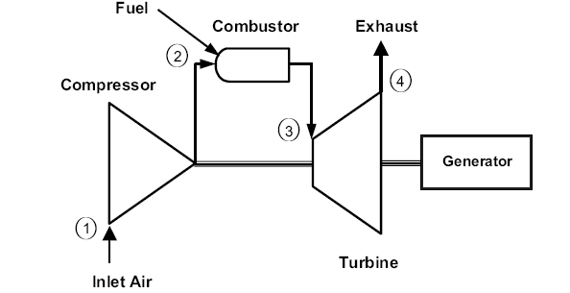

Fig.2.8 Simple-Cycle, Single- Shaft Gas Turbine

2.6. Effects of parameters of Gas Turbine: The various effects of parameters should be discussed below

2.6.1 Effect of compressor inlet temperature (T1): The first parameter of importance is the ambient temperature Ta (which dictates the compressor's inlet temperature T1), to which the performance of the gas turbine is particularly sensitive. The process of choosing the power stations in the regions where the inlet air temperature entering the compressor is high will lead to an increase in the specific air-consumption, which will require an increase in the working hours of the compressor. The inlet air temperature to the compressor has an effect on the cycle efficiency of the gas turbine. It can be seen that, with the increase of the compressor's inlet temperature, the compressor work is increased and the net turbine output is decreased, which will decrease the thermal efficiency. The inlet temperature of the air can be adjusted by providing a cooling system.
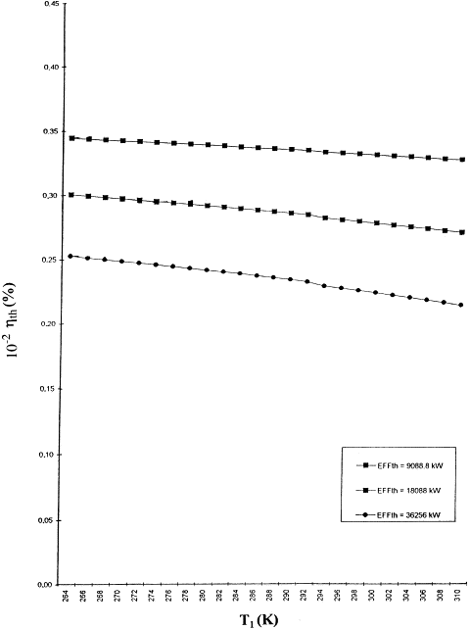

Fig. 2.9. Compressor inlet temperature (T1) against thermal efficiency (ηth) for different loads

2.6.2. Effect of compressor and turbine efficiencies (η_{T} and ηc, respectively)
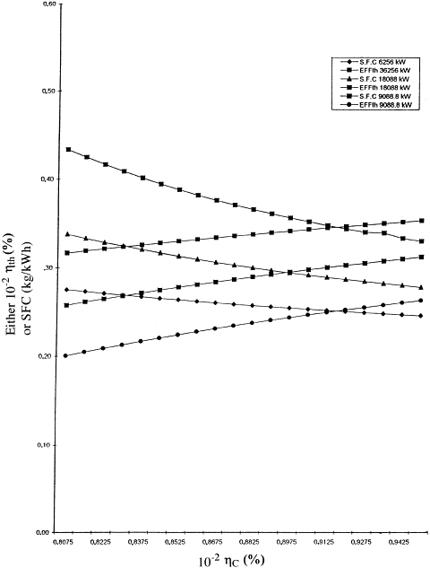
Fig. 2.10 Compressor efficiency (η_{c}) against thermal efficiency (η_{th}) and specific consumption (S.F.C) for different loads
Fig. 2.10 and Fig. 2.11 highlight the effect of the compressor and turbine efficiencies on the SFC and thermal efficiency. The thermal efficiency is increased and the SFC will be decreased with the increase in compressor and turbine efficiencies. Also Fig. 2.12 And Fig. 2.13 shows that the increases in η_{T} and η_{c} will decrease the cost of energy and lead to an increase in the net work out, i.e. thermal losses have been reduced in both compressor and turbine, respectively.

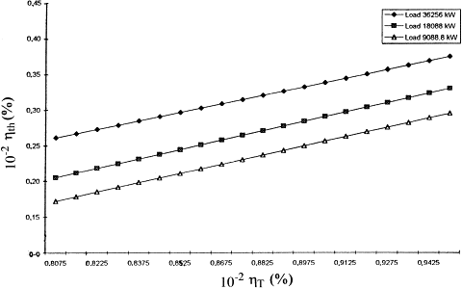 Figure 2.11 Turbine efficiency (η_{T}) against thermal efficiency (η_{thth}) for different loads.

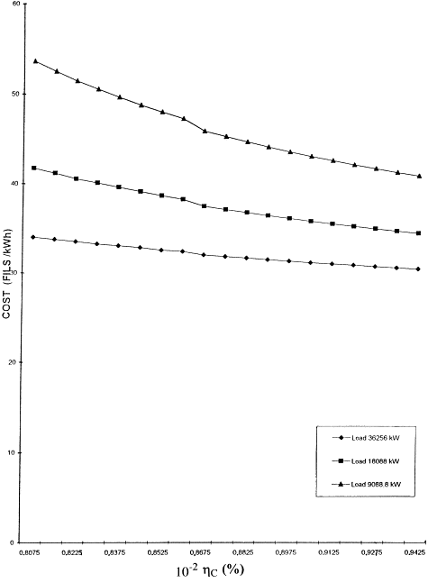
Fig.2.12. Compressor efficiency (η_{c}) against energy cost for different loads

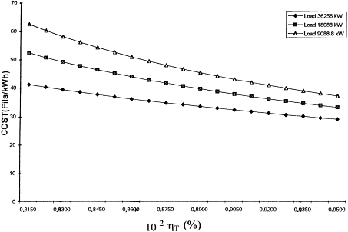
Fig. 2.13 Turbine efficiency (η_{T}) against energy cost for different loads

2.6.3. Effect of pressure ratio (r_{p})

For fixed values of the compressor and turbine efficiencies, the cycle efficiency can be plotted against pressure ratio for various loads as shown in Fig. 2.14. When component losses are taken into account, the efficiency of the gas-turbine cycle becomes dependent upon the maximum cycle temperature T₃ as well as the pressure ratio r_{p} (Fig.2.14 ). Furthermore, for each load, the efficiency has a peak value at a particular pressure ratio (r_{p}). The fall in efficiency at higher pressure ratios is due to the reduction in fuel supply to give a fixed turbine inlet temperature (T₃) resulting from the higher compressor delivery temperature (T₂) being outweighed by the increased work necessary to drive the compressor. The curves are fairly flat near the peak. Another method of presenting performance characteristics is to plot
the variation of specific fuel consumption (SFC) and pressure ratio together .In practice, it is usual to quote SFC rather than efficiency, not only because its definition is unambiguous, but also because it provides both a direct indication of fuel consumption and a measure of cycle efficiency to which it is inversely proportional

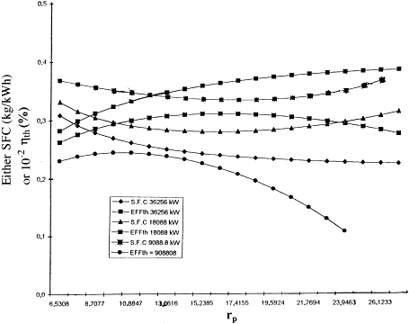
Fig. 2.14. Pressure ratio (rp) against thermal efficiency (ηth) and specific fuel consumption (SFC).

2.6.4. Effect of the turbine's inlet-temperature T₃ (i.e. maximum cycle temperature)

The effect of the turbine inlet temperature under different loads on the thermal efficiency, SFC and net work output can be calculated using basic cycle equations and thermodynamic properties from fig. 2.15., it can be noticed that higher turbine inlet temperatures increase the net work output. Also the net work output is greatest at the higher values of the turbine's inlet temperature. With the increase of the turbine's inlet temperature, the thermal efficiency will be increased while the SFC is decreased. Also, it should be noted that the optimum pressure ratio for maximum efficiency increases as T₃ is increased. The maximum cycle temperature is limited by metallurgical considerations. The blades of the turbine are under great mechanical stress and the temperature of the blade material must be kept at a safe working value. The temperature of the gases entering the turbine can be raised, provided a means of blade cooling is available.
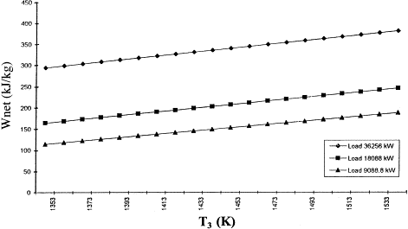
Figure 2.15. Turbine's inlet temperature (T₃) against net work output t.
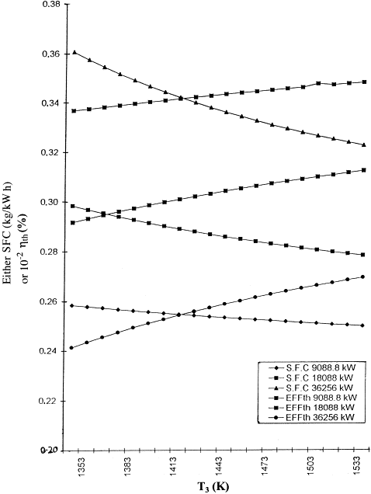
Fig.2.16. Turbine's inlet temperature (T₃) against thermal efficiency (η_{th}) and specific fuel consumption (SFC).
. 2.6.5. Effect of combustion efficiency (η_{comb}):

The combustion efficiency has an effect on the cycle efficiency and other parameters, such as turbine's inlet temperature T₃ and power output. In practice, combustion is almost (99%) complete. The combustion efficiency can be evaluated by testing the chamber; sections are traversed to obtain true mean readings of inlet and outlet temperatures, and the fuel and air
mass flow rates should also be measured. The temperature of the gases after combustion must be comparatively low to suit the highly-stressed turbine materials. Development of improved materials and methods of blade cooling, however, have enabled permissible combustor outlet temperatures to rise from about 1100 K to as much as 1850 K for aircraft applications.
2.7.1 Open Cycle Gas Turbine with Regeneration (Recuperation):In this method, the air delivered by the compressor passes through a heat exchanger (regenerator or recuperator) utilizing the gases exhausted from the turbine; the heated air then passes into the combustion chamber and part of it is employed to burn the fuel. Since some heat is added to the air in the heat exchanger itself, so the same turbine gas inlet temperature is attained as that when no heat exchanger is employed; with a lower fuel consumption, hence, the thermal efficiency will accordingly be higher. The compressor, turbine and net work are not affected by the addition of the recuperator or regenerator to the cycle, only the heat required to be supplied in the combustion chamber is decreased which gives the gain in thermal efficiency, figure 3.17(a)
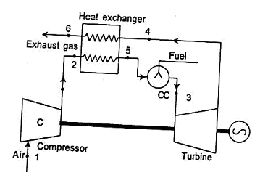
Figure 2.17(a) open cycle with regeneration

2.7.1.1 Ideal Cycle. Process 1-2-3-4--1 shows the ideal open cycle gas turbine as shown in Fig. The high pressure air at state 2 is passed through a regenerator (or heat exchanger) where it is heated at constant pressure p₂ from T₂ to T₅ due to which the exhaust gas from the turbine at state 4 is cooled from T₄ to T₆ With perfect heat exchange in the heat exchanger, in
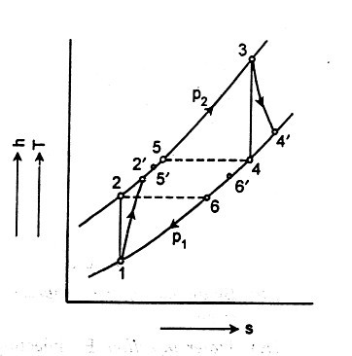
Figure 2.17 (b) Process on T-S Chart with Regeneration
the ideal case, the temperature of air leaving the heat exchanger will be equal to the temperature of exhaust gas entering the heat exchanger and the temperature of exhaust gas leaving heat exchanger will be equal to the temperature of air entering the heat exchanger, Thus, T₅ = T₄ and T₆ = T₂.
The air from the heat exchanger at temperature T₅ then passes through the combustion chamber where it is heated from temperature T₅ to T₃ . The advantage of exhaust heat exchange is that the amount of heat supplied in the combustion chamber is reduced from (h₃ –h₂ to (h₃ – h₅) i.e. from c_{p} (T₃ – T₂ to c_{p}(T₃ – T₅). Thus, the thermal efficiency is increased because the heat supplied is reduced.
Assuming 1 kg of air flowing through the compressor.
Net work = w_{net} = w_{t} - w_{c} = c_{p} [(T₃ - T₄) - (T₂ – T₁)] ......(2.8)
Heat supplied = h₃ – h₅ = c_{p}(T₃ – T₅) = c_{p}(T₃ – T₅) ….(2.9)
But we know that, $\begin{aligned}\left(\frac{T_{2}}{T_{1}}\right)= (r_{p}) ^{(γ–1)/γ} = \frac{T_{3}}{T_{4}}⇒ \frac{T_{2}–T_{1}}{T_{3}–T_{4}} = \frac{T_{1}}{T_{4}} \text{,,,,}(2\text{.}\text{11}) \\ \text{where} r_{p}= \left(\frac{p_{2}}{p_{1}}\right)\end{aligned}$
By putting the value of (T₂-T₁)/(T₃-T₄) in equation 2.10, we get
Let
Then, the thermal efficiency = η_{th} =

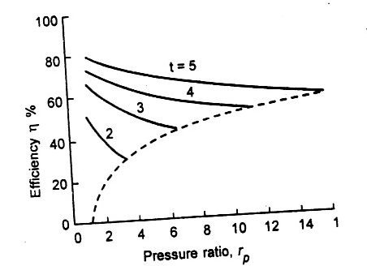

Figure 2.17 (c) . Thermal Efficiency of simple cycle Regeneration

Figure2.17 (c) shows the effect of pressure ratio, r_{p}, on thermal efficiency for various values of t (i.e. the ratio of turbine inlet temperature to compressor inlet temperature). The thermal efficiency increases with t with a decrease in pressure ratio.

2.7.1.2 Actual gas Turbine Cycle with Regeneration. 1-2`-3-4`-6’-1shows
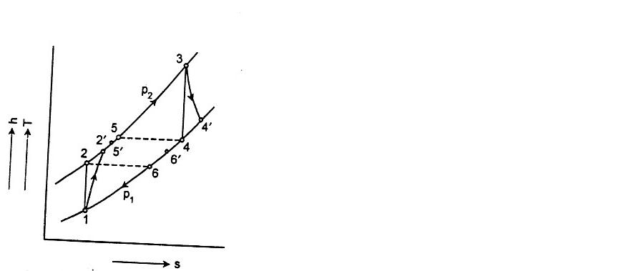
Figure 2.18. Process on T-S chart with Regeneration

the actual cycle as shown in the Fig. 2.18. In actual practice, the compression and expansion processes are not isentropic. Assuming 1 kg of air flowing through the compressor and if we neglect the mass of the fuel and assume the same value of c_{p} for air and exhaust gas, turbine and compressor work may be computed per kg of air as follows-
Actual net work = w_{neta} = w_{ta} - w_{ca} - c_{p}[(T₃ – T`₄) - (T₂' – T₁)] …..(2.15)
Actual heat supplied = q_{Aa} = h₃ – h₅' = c_{p} (T₃ – t₅') …..(2.16)

or
In actual practice, perfect heat exchange is never possible in the regenerator. As a result h₅'<h₄' and h₆>h₂ (i.e. T₅'<T₄' and T₆'>T₂') in the actual cycle. The regenerator effectiveness ∈_{r} is defined as
The actual heat exchange (h₅' - h₂') or (h₄` - h₆')
The maximum theoretical heat exchange = (h₄' – h₂)
If ∈ _{r} is known, t₅' can be found out and hence the thermal efficiency can be evaluated.

A drawback of such a heat exchanger, acting as a regenerator or recuperator, is the low overall heat transfer coefficient when both the heating and heated fluids are gases. Maximum effectiveness is about 75 per cent. This in turn requires a large heat exchange area. Another drawback is the resistance to flow of the gases, which causes a pressure drop in the compressed air, and increases the back pressure on the turbine. However, by careful design these losses can be kept low.
Fig.2.18. shows the effect of regeneration on the specific fuel consumption for various values of compression ratio. It is obvious from the figure that up to a certain value of compression ratio the specific fuel consumption is less except for much lower value of
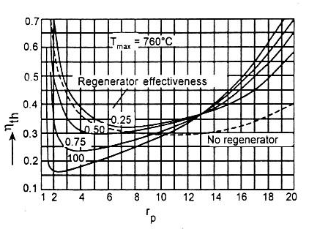
Figure .2.19: s.f.c .vs. Compressor pressure ratio
regenerator effectiveness. After certain value of pressure ratio, i.e, when the temperature of compressed air is more than the exhaust temperature of gas, the specific fuel-consumption increases. .Thus, we can say that the use of regenerator is limited by pressure ratio. Note that the specific fuel consumption is minimum at lower value of pressure ratio, i.e. a lower value of compressed air temperature.

2.7.2 Open Gas Turbine Cycle with Reheat.
By reheating or adding heat to the gases after they have passed through a part of the rows of the turbine blading, a further increase in work done is obtained. In reheating, the gas temperature, which has dropped due to expansion is brought back to approximately the initial temperature for the expansion in the next stage. Since the working fluid contains about 85 per cent air, additional fuel can be burnt by injecting it into the gases without any additional air supply. GT24 and GT26 models are a reheat gas turbines in operation.

2.7.2.1. Ideal Cycle. 1-2-3-4-5-6-1 shows the ideal cycle gas turbine with reheat as shown in Fig2.20 (a) and2.20 (b).

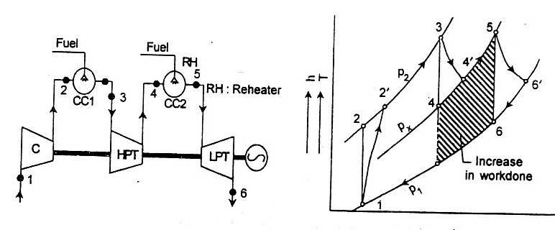
Figure 2.20(a). Open cycle gas turbine Fig. 2.20 (b) h-representation
With reheat of open cycle gas turbine with reheat

The combustion gas from the combustor (CC₁) at temperature T₃ is partially expanded in the HP. turbine from pressure p₂ to intermediate pressure p_{x.} After this it is then passed through combustion chamber CC₂ (reheater) where it is reheated or additional heat is added at constant pressure p_{x} so that the temperature of the gas is raised from T₄ to T₅ = T₃. After this the gas is expanded in the l.p. turbine from pressure p_{x} to p_{l} The net work done is more with reheat compared to the ideal cycle (without reheat). The efficiency with which the heat is added to the gas in the combustion chamber CC₂ at lower pressure p_{x} is lower than the efficiency when this heat is added to the gas in the combustion chamber CC₁ at higher pressure p₂. So, efficiency decreases as a result of reheating, only the net work is more by hatched area 4-5-6-7 shown in Fig.2.20 (b) However, in real cooled cycle it may increase efficiency at higher pressure ratio at a particular reheat pressure ratio.

Fig 2.21 (a) &2 .21 (b) show the variation of thermal efficiency and specific work with pressure ratio and both increase with the increase of t.

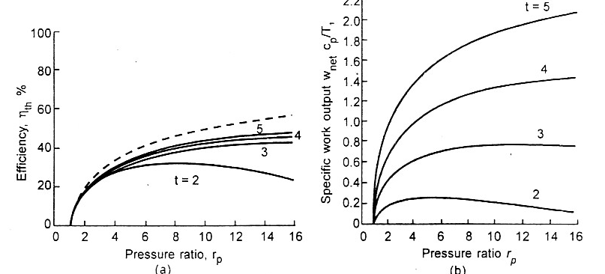

Fig.2.21(a) & 2 .21 (b). Thermal Efficiency and Specific Work with Pressure Ratio.

Net work =. w_{net} = (h₃ - h₄) + (h₅ –h₆)-(h₂-h₁). …..(2.22)
Heat supplied = q_{Aa} = (h₃-h₂+(h₅-h₄) …..(2.23)

For maximum output there must be an optimum pressure at which reheating should be done. As we know, the compressor work w_{c} is not affected by reheating, so for maximum output, we have to find the condition where turbine work w_{t} is maximum.
Here, T₃ = T₅ and c_{p}, T₃, p₁, p₂ are all constants. The only variable is P_{x}
For maximum work, differentiate w.r.t. p_{x} and equate to zero.

So, we can say that the optimum intermediate pressure is the square root of initial and final pressure i.e. the pressure ratio in each stage of turbine is equal to the square root of total pressure ratio. For finding out thermal efficiency for maximum output in this cycle, this value of intermediate pressure should be used.
2.7.2.2. Actual Cycle Gas Turbine with Reheat: l-2'-3-4'-5-6'-l shows the actual cycle with reheat as shown in figure 3.19 (b)
Actual turbine work = w_{ta} = (h₃ - h₄' ) + (h₅ - h₆') = c_{p}{(T₃ – T₄') + (T₅ - T₆')}…..(2.32)
Actual compressor work = w_{ca} = h₂' – h₁ = c_{p} (T₂' – T₁) …..(2.33)
Actual heat supplied = (h₃ - h₂') + (h₅ - h₄') = c_{p}{(T₃ – T₂') + (T₅ – T₄')} …..(2.34)
In this case also, the condition for maximum output will be the same.
Note :- With reheat system, two shafts system may be used; h.p. turbine compressor called compressor turbine and l.p. turbine may produce power generator called power turbine. Thus
w_{c} = (w_{t})_{ct} and power = (w_{t})_{pt} or (h₂-h₁) = (h₄-h₃) …..(2.37)
and power = (h₅-h₆), kj/kg = m(h₅-h₆), kW …..(2.38)
With two shafts system, the condition of maximum output will not be applicable as it may be possible that the compressor turbine may not be able to drive compressor.
2.7.3. Open Gas Turbine Cycle with Intercooling:
The net work of the gas turbine cycle may be increased by saving some compression work. This is done by using several stages of compression with intercooling of air between stages. The air from the low pressure stages compressor (LPC) is cooled in a intercooler approximately to initial temperature before entering to the high pressure stage compressor (HPC). Intercooling increases the net work and decrease the efficiency as compared to the simple ideal cycle without intercooling.
2.7.3.1. Ideal Cycle: 1-2-3-4-5-6-1 shows the ideal cycle gas turbine with intercooling as shown in fig.2.22and 2.23 In l.p. stage compressor, atmospheric air is compressed from P₁ to P₂, it is then cooled from temperature T₂ to T₃ = T₁ in the

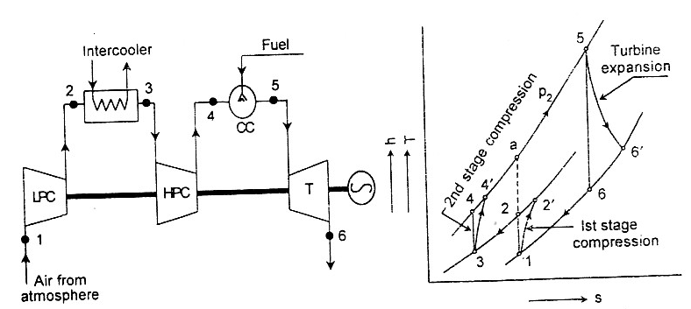

Fig. 2.22. open cycle Gas Turbine Fig. 2.23 h-s Representation of Gas with intercooling Turbine with intercooling

intercooler at constant intermediate pressure p_{x} and finally compressed from p_{x} to p₂ in the h.p. stage of compressor. At constant pressure p₂ heat is added in the Combustion chamber upto T₅ and after that it is expanded in the turbine from pressure p₂ and temperature T₅ to pressure P₁ It is evident from the Fig.2.23.The turbine work is the same as for the simple cycle but the work supplied to the compressor is reduced because the constant pressure lines converge towards the left. The work supplied to the compressor is saved due to intercooling which may be shown as area 2-3-4-a-2, so this is the amount by which net work of the cycle is increased as compared to ideal cycle without intercooling. But the heat supplied is increased by amount (h_{a} - h₄) because the compressed air delivered by second stage compressor is at lower temperature T₄ than in simple cycle. So, the effect of the intercooling is to decrease the thermal efficiency of the cycle. This result is to be expected because the heat supplied in the intercooler is a complete loss, no part of it is converted into useful work.
Turbine work = w_{t} = h₅ – h₆ = c_{p} (T₅ -T₆) …..(2.39)
Compressor work = w_{c} = (h₂ –h₁) + (h₄ - h₃) = c_{p}{(T₂ –T₁) + (T₄ –T₃)} …..(2.40)
Heat supplied = h₅ - h₄ = c _{p}(T₅ - T₄) …..(2.41)
So, the thermal efficiency=
For minimum compression work in the compressor or maximum work output in this cycle, only the compressor work is responsible. Here T₃ = T₁
Let c_{p}T₁ = A = constant and ( γ-1)/ γ = a
for maximum work output or minimum compression work, differentiate w_{c} w.r.t.to p_{x}
and equate to zero.
for n number of stage,
Thus, we see that for minimum compression work the optimum intermediate P_{x} is the square root of initial and final pressure. For maximum work output this value of intermediate pressure P_{x} is used.
2.7.3.2 Actual Cycle Gas Turbine with intercooling. 1-2`-3-4`-5-6`-1 shows the actual cycle gas turbine with intercooling as shown in Fig.3.21 .
Actual turbine work= w_{ta} = h₅-h₆`=c_{p}(T₅-T₆`) …..(2.48)
Actual compressor work =w_{ca}=(h₂`-h₁) +(h₄`-h₃)=c_{p}{(T₂`-T₁)+(T₄`-T₃)}…..(2.49)
Actual net work =c_{p} {(T₅-T₆`)-(T₄`-T₃)-(T₂`-T₁)} …..(2.50)
Actual heat Supplied =h₅-h₄`=c_{p} (T₅-T₄`) …..(2.51)
T₃ may be found from known value of intercooler effectiveness
in this case also, we can show that for minimum work input to the compressor
2.7.4 Open Gas Turbine Cycle with Reheat and Regeneration:
The power out put as well as the thermal efficiency of this cycle is more than the simple cycle. Output is increased due to reheat and thermal efficiency due to regeneration.
2.7.4.1. Ideal Cycle. Figure show an ideal cycle 1-2-3-4-5-6-7-8-1.

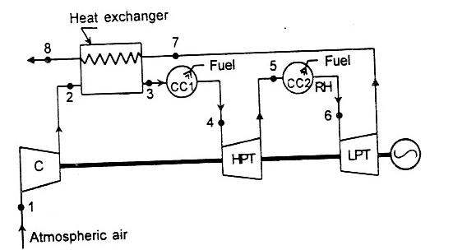
Fig.2.24. Gas Turbine with Reheat and Regeneration
Due to regeneration the temperature of air is increased from T₂ to T₃ at constant pressure while due to reheat the temperature of the gas is increased from T₅ to T₆ at constant pressure Px in the combustion chamber.
Turbine work = wt = (h₄ – h₅)+ (h₆-h₇) = Cp{(T₄ – T₅) +(T₆ –T₇)} …..(2.54)
Compressor work = wc = Cp(T₂ –T₁) …..(2.55)
Heat Supplied = (h₄ –h₃) +(h₆ –h₅) = Cp{(T₄ –T₃) + (T₆ – T₅) …..(2.56)

2.7.4.2. Actual Gas Turbine Cycle with Reheat and Regeneration:
1-2`-3`-4-5`-6-7`-8`-1. shows such cycle as shown in the Fig. 2.25.

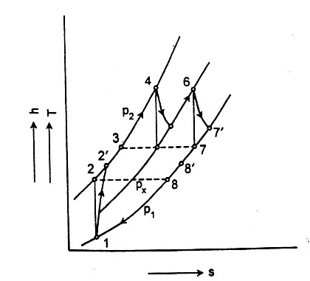

Fig. 2.25. h-s. Representation of Gas Turbine with Reheat and Regeneration

Actual turbine work= w_{ta} = (h₄-h₅`)+(h₆-h₇`) …..(2.58)
Actual compressor work =w_{ca}=(h₂`-h₁) =c_{p} (T₂`-T₁) …..(2.59)
Actual heat Supplied =q_{A} =(h₄-h₃`)+ (h₆-h₅`) …..(2.60)
In this case the higher exhaust gas temperature is now fully utilized in the regenerator and the increase in work output is no longer offset by the increase in heat supplied. With the introduction of regenerator the efficiency is higher with reheat.

2.7.5 Open Gas Turbine Cycle with Intercooling and Regeneration:
By using intercooling and regeneration system, the output and thermal efficiency are increased compared to simple cycle. The output is increased due to intercooling, and the efficiency due to regeneration.

2.7.5.1 Ideal Cycle. 1–2–3–4–5–6–7–8–1. Shows an ideal cycle as shown in the Fig.2.25 (a) & 2.25(b). Compressed air from 1.p. stage compressor is cooled in the intercooler from temperature T₂ to T₃ = T₁ at constant pressure p₂ = p₃ and after this it enters to the high pressure (h.p.) stage of compressor. Heat is added to the compressed air from the (h.p.) stage of compressor (HPC) in the regenerator from temperature T₄ to T₅ = T₇ at constant pressure p₄ = p₅. After this it goes to the combustion chamber and expands in the turbine.
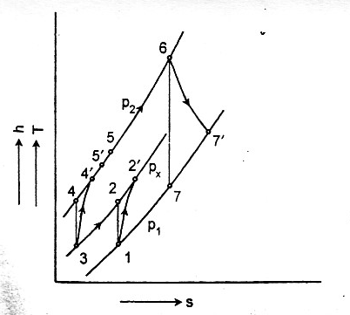

Fig.2.26 Open Gas Turbine Cycle with intercooling and Regeneration
Compressor work = w_{c} = (h₂ – h₁) + (h₄ – h₃) …..(2.62)
Turbine work = w_{t} = h₆ – h₇ = c_{p} (T₆ – T₇) …..(2.63)
Heat supplied = h₆ – h₅ = c_{p} (T₆ – T₅) …..(2.64)

$∴ η_{\text{th}} = \frac{(h_{6}– h_{7}) –(h_{2}– h_{1}) –(h_{4}– h_{3}) }{h_{6}– h_{5}}=\frac{(T_{6}– T_{7})–(T_{2}– T_{1})–(T_{4}– T_{3})}{(T_{6}– T_{5})}$…..(2.65)

2.7.5.2. Actual Gas Turbine Cycle with Intercooling and Regeneration.
1–2`–3–4`–5`–6–7`–8`–1 shows an actual cycle as shown in the Fig 2.25
Actual turbine work = w_{ta} = (h₆ – h_{7’}) = c_{p} (T₆ – T_{7’}) …..(2.66)
Actual compressor work = w_{ca} = (h₂’ – h₁) + (h₄ ’ – h₃) …..(2.67)
Actual heat supplied = q_{Aa} = (h₆ – h_{5’}) = c_{p} (T₆ – T_{5’}) …..(2.68)
$$η_{\text{th}} = \frac{w_{\text{neta}}}{q_{\text{Aa}}} =\frac{(h_{6}– h_{7}') –(h_{2}\text{'–} h_{1}) –(h_{4}\text{'–} h_{3}) }{h_{6}– h_{5}'}=\frac{(T_{6}– T_{7}')–(T_{2}\text{'–} T_{1})–(T_{4}\text{'–} T_{3})}{T_{6}– T_{5}'}$$
…..(2.69)

$\text{or} η_{\text{tha}} = \frac{(T_{6}– T_{7})η_{t}–(T_{2}– T_{1})/{η_{c}}–(T_{1}– T_{3})/{η_{c}}}{(T_{6}– T_{5}')}$ …..(2.70)
If the effectiveness of regenerator is known, T₅’ may be calculated. It is to be noted that in real cycle, the lower of low pressure compressor pressure ratio yields higher thermal efficiency but lower specific work.
2.7.6 Open Gas Turbine Cycle with Reheat and Inter-cooling:
The power output of this cycle is much more, and the thermal efficiency is less as compared to simple cycle. We have already seen that reheat and intercooling separately increase the output and decrease the thermal efficiency. The system is shown in Fig2.26.
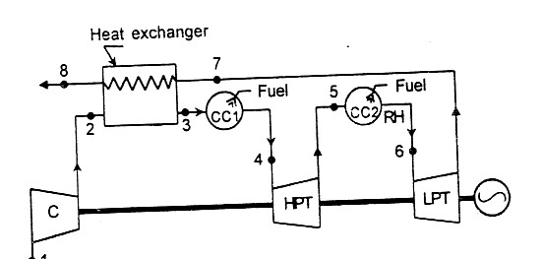
Fig. 2.27 Open gas Turbine Cycle with Reheat & Intercooling
2.7.6.1 Ideal Cycle. 1–2–3–4–5–6–7–8–1. shows such a cycle air from 1.p. stage compressor is cooled in the intercooler from temperature T₂ to T₃ = T₁ at constant pressure p₂ = p₃ = p_{x.} The gas after expanding in h.p. stage turbine is reheated in the combustion chamber (CC2) from temperature T₆ to T₇ = T₅ at constant pressure p₆ = p₇ = p_{x}
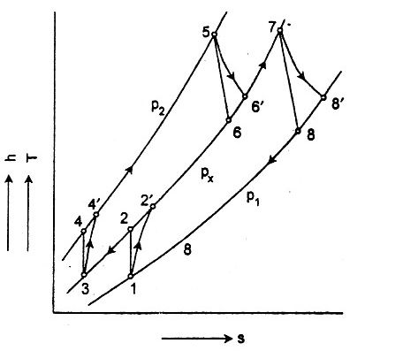
Fig. 2.28. h-s. Representation of open Gas Turbine with Reheat & Intercooling
Turbine work = w_{t} = (h₅ – h₆) + (h₇ – h₈) and …..(2.71)
Compressor work = w_{c} = (h₂ – h₁) + (h₄ – h₃) …..(2.72)
Heat supplied = q_{A} = (h₅ – h₄) + (h₇ – h₆) …..(2.73)
$η_{\text{th}} = \frac{(h_{5}– h_{6}) +(h_{7}– h_{8}) –(h_{2}– h_{1}) –(h_{4}– h_{3}) }{(h_{5}– h_{4}) + ((h_{7}– h_{6}) }$ …..(2.74)

$= \frac{(T_{5}– T_{6})+(T_{7}– T_{8})–(T_{2}– T_{1}) – (T_{4}– T_{3})}{(T_{5}– T_{4})– (T_{7}– T_{6})}$ …..(2.75)

2.7.6.2 Actual Gas Turbine Cycle with Reheat and Intercooling
1–2’–3–4’–5–6–7’–8’–1 shows an actual cycle as shown in the Fig 2.27
Actual turbine work = w_{ta} = (h₅ – h₆’) + (h₇ – h₈’) and …..(2.76)
Actual compressor work = w_{ca} = (h₂’ – h₁) + (h₄ ’ – h₃) …..(2.77)
Actual heat supplied = q_{Aa} = (h₅ – h₄’) + (h₇ – h₆’)) = c_{p} [(T₅ – T₄’) + (T₇ – T₆’) …..(2.78)

$η_{\text{tha}} = \frac{(h_{5}– h_{6}') +(h_{7}– h_{8}') –(h_{2}\text{'–} h_{1}) –(h_{4}\text{'–} h_{3}) }{(h_{5}– h_{4}')+(h_{7}– h_{6}') }$ …..(2.79)

$\text{or} η_{\text{tha}} = \frac{(T_{5}– T_{6}')+ (T_{7}– T_{8}')–(T_{2}\text{'–} T_{1}) –(T_{4}\text{'–} T_{3})}{(T_{5}– T_{4}')– (T_{7}– T_{6}')}$ …..(2.80)

$η_{\text{tha}} = \frac{(T_{5}– T_{6})η_{t}–(T_{7}– T_{8})η_{t} – (T_{2}\text{'–} T_{1})/{η_{c}}–(T_{4}– T_{3})/{η_{c}}}{(T_{5}– T_{4}')– (T_{7}– T_{6}')}$ …..(2.81)

2.7.7 Open Gas Turbine Cycle (OGTC) with Intercooling, Reheat and Regeneration.
The power output as well as the thermal efficiency of this cycle is much greater than that of the simple cycle. It is to be noted that the power output in increased due to reheat and intrcooling and thermal efficiency is due to regeneration.

2.7.7.1. Ideal Cycle:. Shows such a type of an ideal cycle as shown in fig 2..28 and (2.29). Following are the various processes.
Process 1-2. Isentropic compression of air in 1.p. stage compressor (LPC) For minimum compression work the pressure ratio r_{p1} of compressor (LPC) should be equal to $\sqrt{r_{p}}$
Process 2-3. Cooling of air in the intercooler at constant pressure p_{x} from Temperature T₂ to T₃ = T₁ .
Process 3-4. Isentropic compression of air in 1.p. stage compressor (HPC) For minimum compression work the pressure ratio r_{p2} of compressor (LPC) should be equal to $\sqrt{r_{p}}$.
Process 4-5. Heating of air in the regenerator at constant pressure p=₂, from temperature T₄ to T_{5.} For perfect heat exchange in the intercooler T₅ should be equal to T_{9.}
Process 5-6. Addition of heat at constant pressure p₂ in the combustion chamber (CCI) or from temperature T₅ to T₆ .
Process 6-7. Isentropic expansion of gas from pressure p₂ to px in the first stage of turbine. For maximum turbine work pressure ration, p₂/p_{x =} $\sqrt{r_{p}}$.
Process 7-8. Reheating of gas at constant pressure p_{x} in the combustion chamber (CC2) from temperature T₇ to T₈ = T₆ .
Process 8-9. Isentropic expansion of gas from pressure p_{x} to p₁ in the second stage of turbine, for maximum turbine work pressure ration, p_{x}/p₁ ₌ $\sqrt{r_{p}}$.
Process 9-10. Cooling of exhaust gas in the regenerator from temperature T₉ to T₁₀ . If there is a perfect heat exchange the regenerator T₁₀ = T₄ .
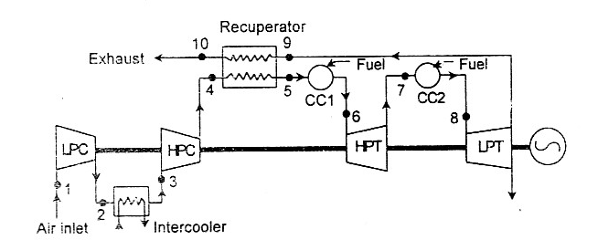
Fig. (2.29) OGTC with intercooling, Reheat and Regeneration (Complete Cycle)

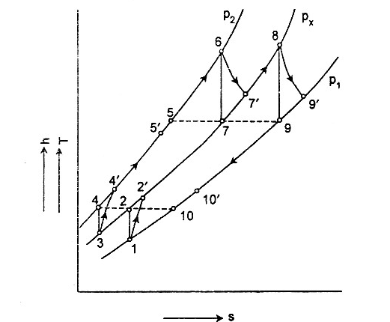

Fig 2.30 h-s Representation of OGTC with Intercooling, Reheat and Regeneration

Turbine work = w_{t} = (h₆ – h₇)+ (h₈ – h₉) and …..(2.82)
Compressor work = w_{c} = (h₂ – h₁) + (h₄ – h₃) …..(2.83)
Net work = w_{net} (h₆ – h₇)+ (h₈ – h₉) – (h₂ – h₁) – (h₄ – h₃) …..(2.84)
Heat supplied = q_{A} = (h₆ – h₅) + (h₈ – h₇) …..(2.85)
$$\begin{aligned}∴ η_{\text{th}} = \frac{(h_{6}– h_{7}) +(h_{8}– h_{9}) –(h_{2}– h_{1})–(h_{4}– h_{3}) }{(h_{6}– h_{5})+(h_{8}– h_{7})} \text{.}\text{.}\text{.}\text{.}\text{.}(2\text{.}\text{86}) \\ η_{\text{th}}= \frac{(T_{6}– T_{7})+(T_{8}– T_{9})–(T_{2}– T_{1})–(T_{4}– T_{3})}{(T_{6}– T_{5})+ (T_{8}– T_{7})} \text{.}\text{.}\text{.}\text{.}\text{.}(2\text{.}\text{87})\end{aligned}$$
2.7.7.2 Actual Gas Turbine Cycle with Regeneration, Reheat and Intercoling:
1–2′–3–4′–5′–6–7′–8–9′–10′–1 shows an actual cycle as shown in the Fig (2.30)
Actual turbine work = w_{ta} = (h₆ – h₇′) + (h₈ – h₉′) and …..(2.88)
Actual compressor work = w_{ca} = (h₂’ – h₁) + (h₄ ’ – h₃) …..(2.89)
Net Work = (h₆ – h₇’) + (h₈ – h₉’) – (h₂’ – h₁) + (h₄ ’ – h₃) …..(2.90)
Heat supplied = q_{Aa} = (h₆ – h₅’) + (h₈ – h₇’) …..(2.91)
Actual thermal efficiency =
$η_{\text{tha}} = \frac{(h_{6}– h_{7}') +(h_{8}– h_{9}') –(h_{2}\text{'–} h_{1}) –(h_{4}\text{'–} h_{3}) }{(h_{6}– h_{5}')+(h_{8}– h_{7}') }$ …..(2.92)

$η_{\text{tha}} = \frac{(T_{6}– T_{7}')+ (T_{8}– T_{9}')–(T_{2}\text{'–} T_{1}) –(T_{4}\text{'–} T_{3})}{(T_{6}– T_{5}')+ (T_{8}– T_{7}')}$ …..(2.93)

$η_{\text{tha}}= \frac{(T_{6}– T_{7})η_{t}+(T_{8}– T_{9})η_{t} – (T_{2}– T_{1})/{η_{c}}–(T_{4}– T_{3})/{η_{c}}}{(T_{6}– T_{5}')+ (T_{8}– T_{7}')}$ …..(2.94)
Regenertive effectiveness = ε_{r} = $\frac{h_{5}\text{'–} h_{4}'}{h_{9}\text{'–} h_{4}'} = \frac{h_{9}\text{'–} h_{\text{10}}'}{h_{5}\text{'–} h_{10}} = \frac{T_{5}\text{'–} T_{4}'}{T_{9}\text{'–} T_{4}'}$ …..(2.95)

If ε_{r} is known that T₅’ can be found out. Once T₅’ is known we can find out the thermal efficiency.
If the pressure loss in intercooler, combustion chambers, regenerator and exhaust hood are given the h-s representation will be modified accordingly.
It is worth to note that in real cycle for maximum efficiency the value of p_{x} (intercooling pressure or reheating pressure) will not be the geometric mean.

2.8. Effect of Regeneration, Intercooling and Reheating on efficiency:
It is evident from the curves that higher thermal efficiency is possible from cycle with regeneration, intercooling and reheats. It is also obvious that due to addition of regeneration, reheat and intercooling the peak value of thermal efficiency shifts towards lower pressure ratio compared to simple cycle.
In all these cases, thermal efficiency first increases with the pressure and reaches a maximum value and then decreases. The optimum pressure in each case is different and shift towards lower pressure ratio.
The effect of regeneration, intercooling and reheating on thermal efficiency is a function of turbine inlet temperature. In all the cases, thermal efficiency increases with turbine inlet temperature.

2.9. Effect of operating variable on Thermal Efficiency:
The thermal efficiency of an actual simple cycle gas turbine depends upon following operating variables.
- pressure ratio, rp= p2/p1
- Turbine efficiency, η_{t}
- Turbine inlet temperature,T3
- Compressor efficiency, η_{c}
- Compressor inlet temperature, T1= Tmin
- Specific fuel consumption
    - Effect of variation of turbine inlet temperature and pressure ratio:
Fig 2.31 shows that as the turbine inlet temperature increases the thermal efficiency increases with the other variables being held constant. For each value of turbine inlet temperature, the thermal efficiency first increases and after reaching a maximum value it decreases rapidly. Similar is the trend on effect of specific work. However , the optimum pressure ratio for the thermal efficiency and specific work is not same. The optimum pressure ratio for maximum work is at lower value as compared to for maximum efficiency at the same of turbine inlet temperature.
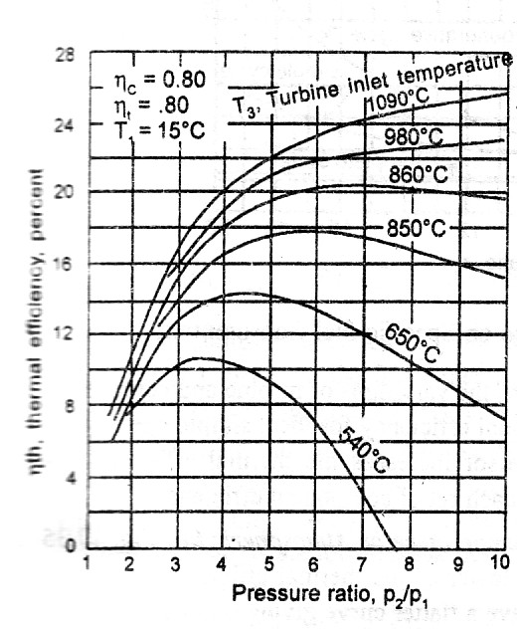
Fig.2.31. Effect of Turbine Inlet Temperature & Pressure Ratio

2.9.2 Effect of variation of turbine and compressor efficiency:
Fig 2.32.shows that the thermal efficiency is very much sensitive to the variation of turbine and compressor efficiency. The dotted line shows the thermal efficiency for ideal simple open cycle. As the efficiency of turbine and compressor increases the thermal efficiency increases. There is an optimum pressure for each set of component efficiency.
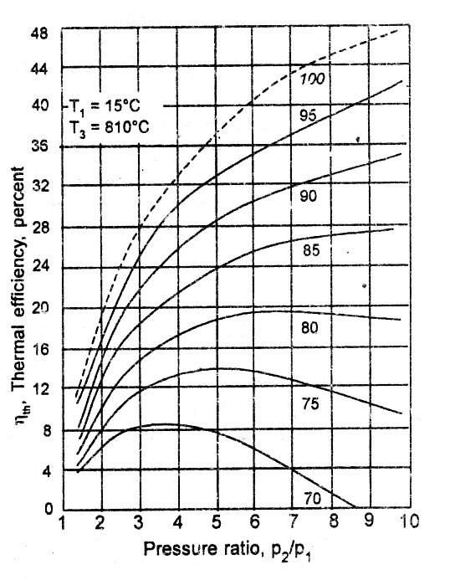
Fig.2.32. Effect of component Efficiencies

    - Effect of variation compressor inlet temperature or atmospheric air:
Fig2.33 shows that as the air inlet temperature is lowered, thermal efficiency increases. Peaks are at higher pressure ratio and have a flatter curve giving optimum value of pressure ratio at a greater range.

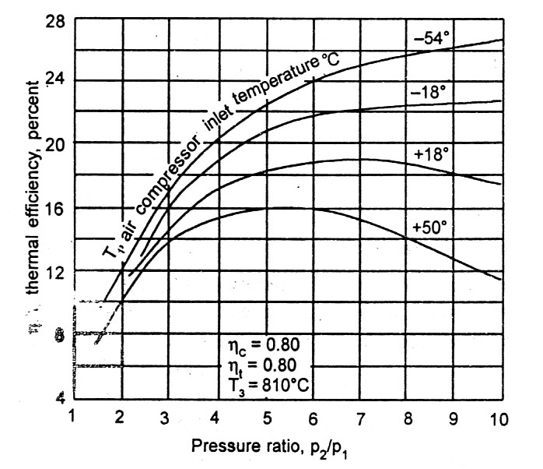
Fig. 2.33 Effect of compressor inlet Temperature

2.9.4 Effect of Specific fuel consumption: fig. 2.34 shows the effect of regenerative, simple and complete cycle on the specific fuel consumption. It suggests that for all values of pressure ratio the fuel consumption is minimum in complete cycle.i.e. with Regeneration, Reheat and Intercooling.
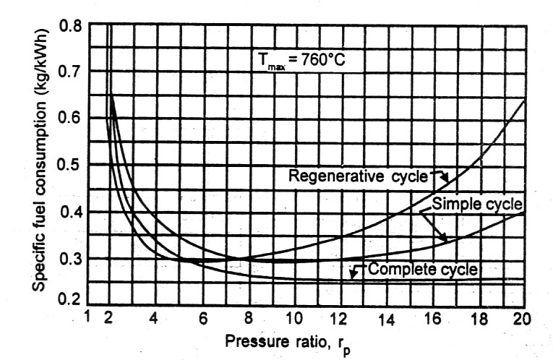
Fig.2.34. Effect of pressure Ratio on Specific fuel consumption

2.10 Effect of operating Variable on Air Rate:
2.10.1 Effect of Turbine inlet temperature and pressure ratio on the air rate: Figure2.35 shows that as the turbine inlet temperature increases the air rate decreases. It is also clear from the figure that as the pressure ratio increases, the air rate decreases to a minimum value first and after that it again increases.
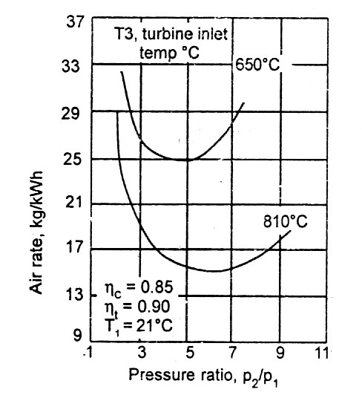
Figure. 2.35. Effect of Turbine Inlet Temperature & Pressure Ratio on Air Rate

2.10.2 Effect of compressor inlet temperature on the air rate:
Figure 2.36 shows that as the compressor inlet temperature increases the air rate increases. Increasing value of compressor inlet temperature reduces the net output because the power consumed by the compressor increases while turbine output is not affected. So, a good gas turbine requires lower value of compressor inlet temperature i.e. lower value of air rate.
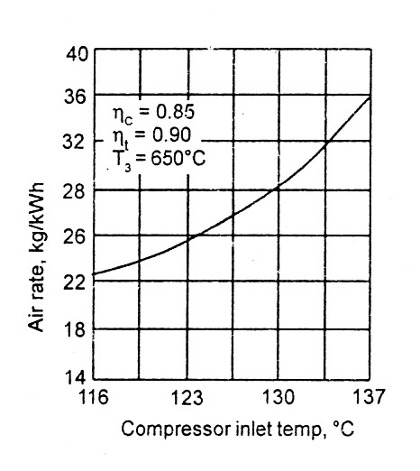

Fig. 2.36 Effect of Compressor inlet Temperature on air Rate

2.10.3 Effect of regeneration, intercooling and reheating on the air rate: A Comparison of the curves shown in fig. 2.37 shows that the main advantage of intercooling and reheating is to reduce the air rate. Air rate is lower in the case of an open cycle with regeneration, intercooler and reheater
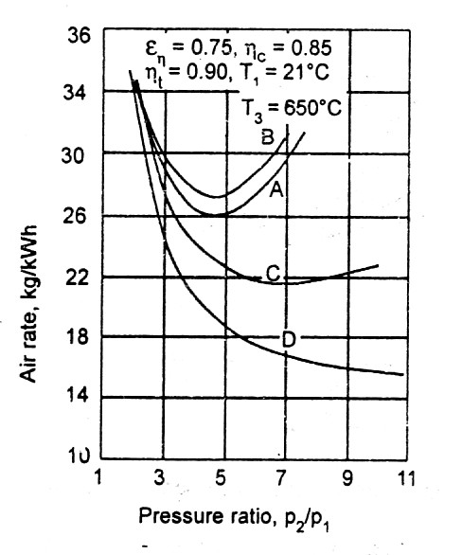
Fig. 2.37. Effect of Intercooling, Reheating &Regeneration

    - Effect of compressor and turbine efficiency on air rate: As the
efficiency of compressor and turbine increases, the air rate decreases as shown in fig.

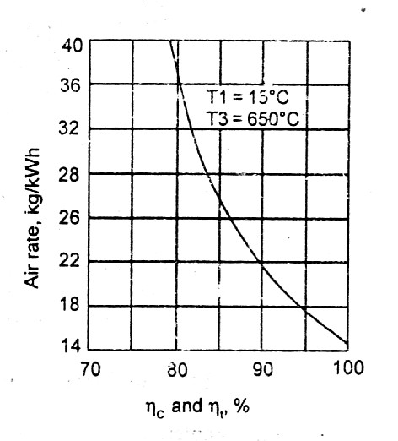
Fig. 2.38. Effect of component Efficiencies on Air Rate

2.11. Effect of operating variables on work ratio:
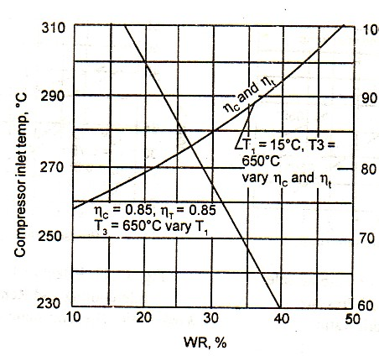2.11.1 Effect of compressor inlet temperature on the work ratio: Figure2.39 shows that as the compressor inlet temperature decreases the work ratio increases. This is due to the decreases in the power required by the compressor while the turbine output remains the same.
Fig. 2.39. Effect of Compressor Inlet Temperature on work Ratio
    - Effect of compressor and turbine efficiencies on the work ratio: The work ratio is much affected by the variation in the efficiencies of turbine and compressor . as shown in figure2.40 .It is obvious from the curve that as the turbine and compressor efficiencies increases the work ratio increases.

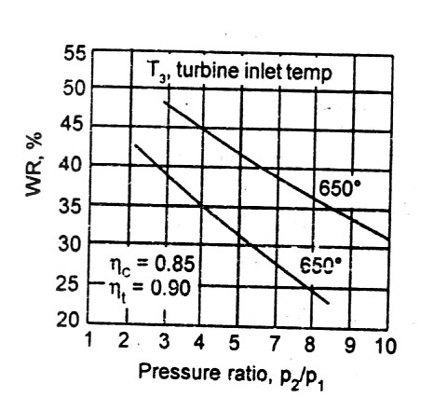
Figure. 2.40 Effect of Turbine Inlet Temperature & Pressure Ratio on Work Ratio

2.11.3 Effect of regeneration, intercooling and reheating on the work ratio:
Figure2.41. shows that maximum work is possible in simple cycle with reheat, intercooling and regeneration. Intercooler and reheater not only improve the work ratio but also decreases the slope of the curve to give a greater improvement in the efficiency as the work, where;
(A)Simple open Cycle (B) Simple cycle with Regeneration(C) Open cycle with Regenerator (D) Open cycle with Regenerator, Reheator and intercooler

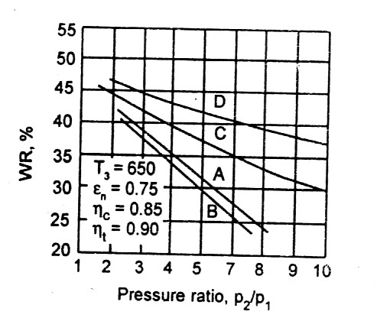
Figure 2.41. Effect of regeneration, intercooling and reheating on the work ratio:
2.12 Effect of Water injection: Another method of improving the performance of the gas turbine is to inject water into the working air at the entrance to the compressor. This way the compressed air cooled by the latent heat of vaporization of water. By injection of water the total mass flows of the working medium increased by the mass of the injected water and hence the power output of cycle is increased, the work ratio is increased and the air rate is lowered.
Water injection is commonly used as a power boost to take off and emergencies on jet propelled aircraft. It is possible for the marine or land based gas turbines to use water injection for long duration or continuous injection. The water to be injected should be pure, otherwise, it may cause corrosion or deposits on the blades.
2.13. CLOSED CYCLE GAS TURBINE: As it has been seen that in the open cycle, the exhaust gas from the turbine is rejected in to the atmosphere but in the case of closed cycle gas turbine, the same working fluid continuously circulates. The closed cycle gas turbine is similar to steam turbine because as in the latter case the working substance is confined within the plant.
Since the closed cycle gas turbine continuously circulates the same working fluid, gases of higher density than the air must be used as working fluid. The heat added must be supplied through heat exchanger from an external source and the heat rejected from the system must be through another heat exchanger with a cooling medium generally called precooler.
Figure2.42 shows a closed cycle gas turbine .The gas is compressed from pressure p1 to pressure p2 in the compressor. The compressed gas is heated in a air heater where fuel and air are supplied from outside, and the temperature of gas is increased from T2 to T3 at constant pressure. After this the compressed and heated gas expands in the turbine. The exhaust gas from the turbine is cooled in precooler from temperature T4 to T1 and is recirculated to the compressor.
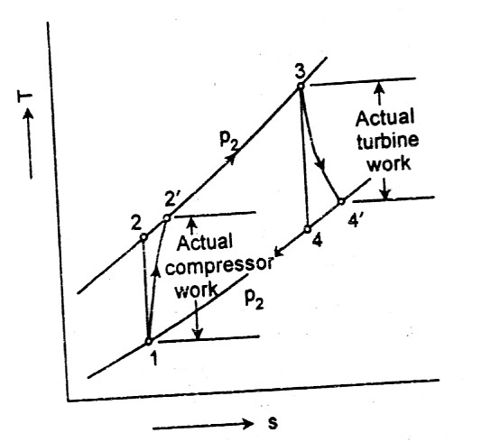

Fig.3.42 Closed Gas Turbine Cycle

NOTE: All the modification such as regenerative, intercooling and reheating are possible, in closed cycle.

2.14. Advantages of closed cycle gas turbine over the open cycle :

- Higher thermal efficiency: Appreciably higher thermal efficiencies are obtainable for the same maximum and minimum temperature limits as with the open cycle gas turbine.

- Improved heat transmission: The rate of heat transmission is improved.

- Lesser fluid friction loss: The fluid friction loss is reduced because of higher Reynolds number

- Greater output: Much greater outputs are possible and these do not involve excessive weight.

- Inexpensive fuel: Because of the closed cycle utilizes external heating, any inexpensive solid fuel as coal can be used to heat the working fluid.

- No loss of working medium: Since the working circuit is closed there is no loss of working medium.

- No contamination: No corrosive gas circulates through the closed system. As the working fluid does not contain the combustion gases, the turbine and regenerator are not subjected to carbon deposits and remain relatively clean. The compressor also remain free of dust and other foreign deposits because the working medium is cleaned before being put in to the system. This advantage plays an important part in increasing the life of plant as well as its efficiency compared to the open cycle plant.

- Improved part load efficiency: Part load efficiency of a closed cycle is improved as compared to the open cycle because the method of control of the output in the closed cycle does not vary the temperature and pressure ratio of the system, and the efficiency during the load change.

2.15. Disadvantages of closed cycle as compared to open cycle

- Dependent system: The closed cycle is dependent on cooling water which must be provided for the precooler. This eliminates the use of this system as an aeronautical engine. It is best suited for marine propulsion where the provision of cooling water is not a problem.

- Complexity: The load control of the system is complex and costly compared open system Since the initial pressure is high and the working fluid is other than the air, the system has to be gas tight against high pressure which increases its cost and also posses engineering problem.

- Air heater: A heavy and large air heater is required which is relatively inefficient compared to the internal combustion chambers of the open cycle
2.16. Semi Closed Cycle Gas Turbines:
When some part of the working fluid confined to the plant and another part flows in 2to and from the atmospheric air is called semi closed cycle. Figure shows such a cycle. It may be placed between the open and closed cycle so far the advantages and disadvantages are concerned. It is basically a high pressure system, and components parts are similar to that of an open cycle for the same power output. It gives a better part-load performance compared to open system. The air heater is smaller to that of closed cycle.
The basic working medium is air. Compressed air from auxiliary compressor and exhaust air of turbine driving compressor, passing through the precooler enters the high pressure air before entering the air heater splits in two parts, one part serving the power turbine is used for internal combustion in the air heater and another part which does not mix with the fuel is heated by the heat of external combustion so that all the time this part of air may be circulated in a closed system. The exhaust power turbine goes to atmosphere.
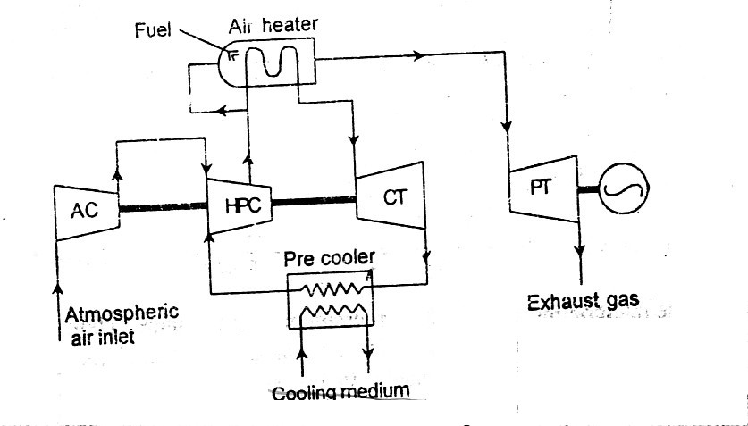

Fig. 2.43 Semi Closed Cycle Gas Turbine

2.17 Cost Penalty: Cost penalty has been defined as the variation in cost of generation due to variation in parameter. Total costs of electricity consist of fixed and operating cost.
Operating cost of electricity = Cost of Gas(Rs./Kg)*(Flow of gas(Kg/sec)*3600 …2.96
Kw generated in 1 hr

Efficiency of a plant = Kw generated ……..2.97
Flow of gas (Kg/Sec)* Calorific Value of Gas(Kj/Kg)

From eqution 2.96 & 2.97

Operating cost of electricity = Cost of Gas Rs./Kg*3600 ………2.98 Efficiency of plant* C.V(Kj/Kg)

Cost of the Gas & C.V. of the gas has been taken as Rs/Kg &Kj/Kg respectively

Chapter.3.
Modeling: Some time the Gas turbine power plants run at off-design condition and their parameters are away from the design values. Compressor inlet temperature depends on ambient conditions, similarly the case of temperature after intercooler. The temperature after Regenerator depends on effectiveness of it hence the variation may be taken place in the flue gas temperature after regenerator. The hp and lp turbine inlet temperatures also varies according to load. The effects of these parameters on the efficiency of turbine and cost of generation have been calculated by using computational technique. In a Simple open cycle Gas Turbine the actual inlet temperature varies from 15º to 40ºC because of seasonal variation in temperature. The relations used in this program have been discussed in chapter 2. Similarly, the turbine inlet temperature 1060º is not always constant in actual practice but varies. The variation in the efficiency and cost of generation on account of the variation from 1060 to 1050º centigrade have been estimated, keeping in mind the metallurgical limit of temperature as 1060 ºC.
In open Gas Turbine Cycle (OGTC) with Intercooling, Reheat & Regeneration, the power output as well as the thermal efficiency of this cycle is much greater than that of the simple cycle. It is to be noted that the power output is increased by reheat and intrcooling and thermal efficiency by using regeneration.
In order to simulate high pressure the actual condition high Compressor inlet temperatures, has been taken as variable it varies from 15º in winter to 40 º in summer. Similarly at optimum condition low pressure Turbine inlet temperatures is taken as equal to high pressure Turbine inlet temperatures, but practically both varies. Just to see the effect of these two temperatures on variation from 1060ºCto 1050ºC has been done.
In a Regeneration process in general low pressure Turbine exhaust temperature equal to Combustion chamber inlet temperature but due to effectiveness of regenerator it varies the thermal efficiency and cost of generation.
The programs have been written in the C++ language and the coding is given in the Annexure A &B. With the help of these programs, one can get the efficiency reduction and Cost penalty of each parameters. The flow chart of the program is shown in figure 3.1 & 3.2
START

Entered the constant values; η_{c,} η_{t,} Cp, P₂/P_{1 &} Rate of Gas
Entered the value of T1 & T3, dependent variable
Find T2 using formula T2 = T1 * (P2/P1) ^{0.286}
Find T2’,using Formula, T2’=T1+(T2-T1)/ η_{c}

Find T4 by using formula T4=T3/(P2/P1)^{0.286}
T4’ = T3-(T3-T4)*η_{t}
Turbine work= Wt=Cp*(T3-T4’)
Compressor Work= Wc=Cp*(T2’-T1)
Net Work= Wnet= Wt-Wc
Effective Heat Supplied= Qa=Cp*(T3-T2’)
η _{thermal =} (Wnet/Qa)

Cost of Generation= Rate of Gas* 3600
Cv* η _{thermal}
Want to Vary the Temperatures T1 from 15 to 40 &T3 from 1060 to 1050
Stop
ENTER THE VALUE OF T1, T3, T5, T7 & T9
WRITE P4: P4 = P1* (PRESSURE RATIO)^{.286}

WRITE T6: T6= T5(P6/P5)^{.286}

WRITE T6’ : T6’= T5+η_{T}*(T5- T6)

WRITE P2: P2= (P1*P4)½

WRITE T2: T2= T1*(P2/P1)^{.286}

Y
WRITE T2’ : T2’= T1+ (T2-T1)/ η_{C}

WRITE T4: T4=(T3/(P3/P4)^{.286})

WRITE T8 : T8= T7*(P8/P7)^{.286}

Y
ENTER THE CONSTANT VALUES:P1, PRESSURE RATIO, TURBINE EFFICIENCYη_{T}, COMPRESSOR EFFICIENCYη_{C}, REGENERATOR EFFECTIVENESS, Cp. COST OF GAS, CALORIFIV VALUE(C.V.)

START
X
WRITE T4’: T4’={ (T4-T3)/η_{C+}T3}

CHAPTER 4
WRITE TURBINE WORK: W_{TA}= CP*{(T5-T6’)+(T9-T8’)}

Z
WRITE COMPRESSOR WORK: W_{CA}= CP*{(T2’-T1)+(T4’-T3)}

WRITE NET WORK: W_{NET}= W_{TA}-W_{CA}

WRITE THERMAL EFFICIENCY: η_{THERMAL}= W_{NET}
Q_{A}

WRITE COST OF GENERATION= RATE OF GAS * 3600
CALORIFIC VALUE(C.V.)* : η_{THERMAL}

WANT FOR VARY THE VALUE OF T1, T3,T5,T7,T9 GO TO BLOCK 3 ELSE
X
STOP
STOP
stopsssssss
STOP
Z
WRITE T8’ : T8’= T7-η_{T}*(T7- T8)

WRITE T9’ :T9’= ε_{r}*(T8’-T4’)+T4’

WRITE EFFECTIVE HEAT SUPPLIED Q_{A}={(T5- T9’)+(T7-T6’)}*Cp

RESULTS AND DISCUSSIONS:

The results of the programs varying the compressor inlet ambient temperature T1, Turbine Inlet Temperatures T3 in a simple Gas Turbine Plant as well as Open Gas Turbine Cycle with Intercooling, Reheat and Regeneration have been discussed.
4.1 Effects in Simple Gas Turbine:
4.1.1 Effect of Compressor inlet Temperature in a simple Gas Turbine Cycle:
As shown in figure 4.1, the efficiency decreases with increase in compressor inlet temperature for each 5 ºC. increase in compressor inlet temperature efficiency decreases by0.002 and the cost of generation increases by Rs.0.01per kwhr, as shown in Figure 4.2 Cost penalty for a 200 Mw Plant in a DAY comes out to be Rs.1,09758 for 10ºC variation

Figure 4.1 Ambient Temperature (Kelvin) Vs Thermal Efficiency

Figure 4.2 Thermal Efficiency Vs Cost of Generation(Rs/Kwhr)

As the temperature increases the inlet point shift towards right the compressor with increases due to diverging nature of constant pressure line. This decrease the net work developed hence efficiency decreases. The efficiency improves if the inlet temperature decreases. The efficiency improves of the inlet temperature temperatue decreases the net work increases.
4.2 Effect of Turbine inlet Temperature in a simple Gas Turbine Cycle:

Figure 4.3 Turbine inlet Temperature Vs Thermal Efficiency

The efficiency increases with increase in turbine inlet temperature, figure 4.3 for each 2º C increase in turbine inlet temperature efficiency increases by0.0002 and the cost of generation decreased by Rs.0.001 per Kwhr. as shown in Figure 4.4 Cost penalty for a 200 MW Plant in a day comes out to be Rs. 24,995/- for each 10ºC temperature variation. But the temperature inlet to gas turbine can not increase beyond the metallurgical limit, if it decreases the inlet point shift towards left and work developed by turbine reduces and hence efficiency decreases.
Figure 4.4 Thermal Efficiency Vs Cost of Generation(Rs/Kwhr)

4.3 Effect of Compressor inlet Temperature in Open Cycle Gas Turbine with Intercooling, Regeneration and Reheating:
The effect of compressor inlet temperature in the complete cycle will also be the same as the in simple cycle. The efficiency decreases with increase in Compressor inlet temperature. For each 5ºC. increase in compressor inlet temperature efficiency decreases by 0.003 and the cost of generation increased by Rs.0.007 per Kwhr, as shown in Figure 4.4 Cost penalty for a 200 MW Plant in a day comes out to be Rs. 68,904 for each 10ºC variation in temperature.

Figure 4.5 Ambient Temperature Vs Thermal Efficiency

Figure 4.6 Thermal Efficiency Vs Cost of Generation(Rs/Kwhr)

4.4 Effect of Intercooler Exit Temperature in Open Cycle Gas Turbine
with Intercooling, Regeneration and Reheating:
The temperature of cooling medium used in intercooler is the ambient temperature and the air temperature at intercooler exit is always wise the than the ambient temperature. It also depends of the performance of intercooler. The efficiency decreases with increase in Compressor inlet temperature. Figure 4.7 shows for each 2ºC. increase in compressor inlet temperature efficiency decreases by0.0009 and the cost of generation increased by Rs.0.002 per Kwhr, as shown in Figure 4.8. Cost penalty for a 200 MW Plant in a day comes out to be Rs.64,160/- for variation of 10º C in intercooler exit temperature.

Figure 4.7 Intercooler Exit Temperature Vs Thermal Efficiency

Figure 4.8 Thermal Efficiency Vs Cost of Generation(Rs/Kwhr)

4.5 Effect of high pressure turbine inlet Temperature in Open Cycle Gas Turbine with Intercooling, Regeneration and Reheating:
As discussed in literature review the efficiency increases with increase in gas temperature at turbine inlet. But the maximum temperature is limited by the effect of gas turbine inlet temperature has been seen keeping the maximum temperature 1060º as shown in Figure 4.9 . For each 2ºC increase in high pressure turbine inlet temperature efficiency increases by 0.0003 and the cost of generation decreases by Rs.0.0008 Rs. per Kwhr as shown in Figure 4.10 Cost penalty for a 200 MW Plant in a day comes out to be Rs.18,210 for 10º variation in it..
4.9 Turbine Inlet Temperature Vs Thermal Efficiency

Figure 4.10 Thermal Efficiency Vs Cost of Generation (Rs/Kwhr

4.6 Effect of low pressure turbine inlet Temperature in Open Cycle Gas Turbine with Intercooling, Regeneration and Reheating:
The efficiency increases with increases in the low pressure turbine inlet temperature. For each 2ºC increases in low pressure turbine inlet temperature efficiency increases by 0.00016 and the cost of generation decreases by Rs.0.0004 per Kwhr, as shown in Figure 4.12. Cost penalty for a 200 MW plant in a day comes out to be Rs.8,880/- for each 10ºC variation in temperature . the effect of low pressure turbine inlet temperature ias also the same as article 4.5

Figure 4.11 Low pressure Turbine inlet Temperature Vs Thermal Efficiency

Figure 4.12 Thermal Efficiency Vs Cost of Generation(Rs/Kwhr)

Chapter 5
Conclusion:
The gas turbine plant with simple cycle and with intercooling,regeneration and reheating has been studied in detail. The performance of gas turbine varies with compressor inlet temperature, turbine inlet temperature, intercooling exit temperature etc. The variation in efficiency and cost penalty of each parameter has been determined. It has been kept in mind that during actual operation the temperature varies with atmospheric temperature and also some time due to operational problem. In a simple actual gas turbine power plant of 200 Mw. Varying the compressor inlet temperature and turbine exit temperature by 10ºC, the daily cost penalties are Rs. 1,09758 and Rs. 24,995, respectively. Similarly for modified gas turbine cycle, i.e. with intercooler, regenerator and reheater, the daily cost penalties for 1st compressor inlet, intercooler exit, H.P.T. gas inlet and L.P.T inlet temperatures are Rs 68,904, Rs. 64,160, Rs. 18,210 and Rs. 8,880 respectively for each 10º C variation in these parameters.
The above data reveals that the compressor inlet temperature is most sensitive temperature followed by intercooler exit temperature, H.P.T. inlet and L.P.T. inlet temperature.

References

1 Narula, R., Wen, H., and Himes, K., October 2001, “Economics of Greenhouse Gas Reduction—the Power Generating Technology Options,” presented at the World Energy Congress, Buenos Aires.

2 Technology Implications for the U.S. of the Kyoto Protocol Carbon Emission Goals, ASME 98-25, December 1998.

3 EIA, Monthly Energy Review, September 2001..

4 Janes J., Chemically recuperated gas turbine, California Energy Commission Staff Report P500-92-015, 1992.

5 Botros K.K., de Boer M.J., Fletcher H.G., Themodynamics, environmental economic assessment of CRGT for exhaust heat recovery in remote compressor station applications, in: Proceedings of ASME TURBO EXPO’97 Conference, Orlando, FL, USA, 1997, paper 97-GT-510.

6 Rostrup-Nielsen J.R., Aasberg-Petersen K., HojlundNielsen P.E., Chemical recuperation and gas turbines, in: Proceedings of the EPRI Conference on New Power Generation Technology, San Francisco, CA, USA, October 25–27, 1995.

7 Carcasci C., Facchini B., Harvey S., Modular approachto analysis of chemically recuperated gas turbine cycles, Energy Conversion and Management 39 (16–18)(1998) 1693–1703.

8 Dixon, Fluid Mechanics, Thermodynamics of Turbomachinery,3rd edition, Butterworth-Heinemann, Oxford, UK, 1978.

9 Abdallah H., Harvey S., Facchini B., Part load performance of chemically recuperated gas turbine cycles compared to other advanced cycles, in: Proceedings of the ASME TURBO-EXPO’98 Conference, Stockholm, Sweden,1998, paper 98-GT-37.

10 Yadav,R., 1984, Steam & Gas Turbine & Power Plant, Khanna Publisher, Allahabad, P 680 to 743.

11 Yahya, S.M.,2002, Turbine Compressors & Fans, Tata McGrow -Hill Publishing Company Ltd., p 85 to 115.

13 Nag, p.K, 2001, Power plant Engineering, TataMcGrow-Hill Publication Kharagpur P 763 to 777.

14 Ogaji, S. Sampath, R. Singh, 2005, Parameter selection for diagnosing a gas turbine’s performance, Transiction of A.S.M.E. journal, of turbomachinery , 35-40 .
15 Stript, M., Schulz,A., 2004, Surface roughness effect.

16 Abdallah H., Danes F., Facchini B., DeRuyck J.,Exergo-economic optimisation of intercooled reheat chemically recuperated gas turbine, Energy Management and Management 40 (15–16) (2001) 1679–1686.

17 Stecco S., Facchini B., Acomputer model for cooled expansion in gas turbines, in: Proceedings of the ASME Cogen-Turbo Symposium, Nice, France, 2002.

18 Elmasri M.A., On thermodynamics of gas turbine cycles: Part 2 — Amodel for expansion in cooled turbines,

19 Dixon, Fluid Mechanics, Thermodynamics of Turbomachinery,3rd edition, Butterworth-Heinemann, Oxford, UK, 1978.

20 Kotas T.J., The Exergy Method of Thermal PlantAnalysis, Krieger, Malabar, FL, USA, 1995.

21 Kesser K.F., Hoffman J.W., Baughn J.W., Analysisof a basic chemically recuperated gas turbine powerplant, ASME Journal of Engineering for Gas Turbines andPower 116 (2003) 277–284.

22 Gas Turbine world Hand book, vol. 19A, Requot publication, 1998-1999.

23 Kesser K.F., Hoffman J.W., Baughn J.W., Analysisof a basic chemically recuperated gas turbine powerplant, ASME Journal of Engineering for Gas Turbines andPower 116 (2004) 277–284.

25 Facchini B., Asimplified approach to off-designperformance evaluation of single shaft heavy duty gasturbines, in: Proceedings of the ASME Cogen-Turbo PowerConference, Bournemouth, UK, 2004, pp. 189–197.

26 Carcasci C., Facchini B., Harvey S., Design issues and performance of a chemically recuperated aero derivative gas turbine, Proc. IMechE A ,J. Power Energy 212 (2004)315–329.

ANNEXURE-A

#include<iostream.h>
#include<conio.h>
#include<math.h>
void main()
{ clrscr();
long int k,data,c;
float cog[100],cv= 35530,ucog,t10[100],t30[100],temp1[100],thereff[100],cp=1.005,network[100],efhs[100],t21[100],t41[100],temp4[100],temp2[100],temp3[100],pres1,pratio,effc,efft,gam=1.4;
cout<<"\n\n\n\t\t\t NUMBER OF DATAS YOU WANT \n\n\t\t\t\t";
cin>>data;
cout<<"\n\n\t\t\t ENTER THE PRESSURE RATIO\n\n\t\t\t\t";
cin>>pratio;
b:cout<<"\n\n\t\t\t ENTER THE EFFICIENCY OF COMPRESSOR\n\n\t\t\t\t";
cin>>effc;
if(effc<0 || effc>1)
{ cout<<"\n\n\t\t YOU HAVE NOT ENTERED THE CORRECT VALUE. CORRECT AND ENTER AGAIN";
goto b;
}
d:cout<<"\n\n\t\t\t ENTER THE EFFICIENCY OF TURBINE\n\n\t\t\t\t";
cin>>efft;
if(efft<0 || efft>1)
{ cout<<"\n\n\t\t YOU HAVE NOT ENTERED THE CORRECT VALUE. CORRECT AND ENTER AGAIN";
goto d;
}
cout<<"\n\n\t\t\t ENTER THE COST OF GAS PER UNIT kg\n\n\t\t\t\t";
cin>>ucog;
for(int i=0;i<data;++i)
{ x:clrscr();
cout<<"\n\n\n\t\t ENTER THE VALUE FOR DATA No. "<<i+1;
cout<<"\n\n\n\n\t\t TEMPERATURE DATA IS IN CELSIUS OR KELVIN \n\t\t\t (enter '1' for celsius, '2' for kelvin \n ";
cin>>k;
if(k==1){ c=273;}
if(k==2){ c=0;}
if(k!=1 && k!=2)
{ cout<<" \n\n\n\n\n\t\t\t you have entered the wrong choice please enter again \n";
goto x; }
cout<<"\n\n\t\t\tENTER THE INITIAL TEMPERATURE(T1) \n\n\t\t\t\t";
cin>>t10[i];
cout<<"\n\n\t\t\tENTER THE COMBUSTION TEMPERARURE(T3) \n\n\t\t\t\t";
cin>>t30[i];
temp1[i]=t10[i]+c;
temp3[i]=t30[i]+c;
temp2[i]=temp1[i]*(pow(pratio,(gam-1)/gam));
t21[i]=((temp2[i]-temp1[i])/effc)+temp1[i];
temp4[i]=temp3[i]/(pow(pratio,(gam-1)/gam));
t41[i]=temp3[i]-(efft*(temp3[i]-temp4[i]));
network[i]=cp*((temp3[i]-t41[i])-(t21[i]-temp1[i]));
efhs[i]=cp*(temp3[i]-t21[i]);
thereff[i]=network[i]/efhs[i];
cog[i]=(ucog*3600)/(thereff[i]*cv);

}
clrscr();
cout<<"\n \t\t\tPRESSURE RATIO = "<<pratio;
cout<<"\n \t\t\tEFFICIENCY OF COMPRESSOR= "<<effc;
cout<<"\n \t\t\tEFFICIENCY OF TURBINE ="<<efft;
cout<<"\n \t\t\tT1 - AMBIENT TEMPERATURE(Kelvin)";
cout<<"\n \t\t\tT2 - COMPRESSOR OUTLET TEMPERATURE(Kelvin)";
cout<<"\n \t\t\tT2' - ACTUAL COMPRESSOR OUTLET TEMPERATURE(Kelvin)";
cout<<"\n \t\t\tT3 - TURBINE INLET TEMPERATURE(Kelvin)";
cout<<"\n \t\t\tT4 - TURBINE EXIT TEMPERATURE(Kelvin)";
cout<<"\n \t\t\tT4' - ACTUAL TURBINE OUTLET TEMPERATURE(Kelvin)";
cout<<"\n \t\t\tCOST OF GAS IN RUPEES PER KILOWATTHOUR";
cout<<"\n\n\nT1 T3 T2' T4 T4' NETWORK EFFECTIVE THERMAL ";
cout<<"\n HEAT SUPP. EFFICIENCY ";
for(i=0;i<data;++i)
{ cout<<"\n\n"<<temp1[i]<<" "<<temp3[i]<<" "<<t21[i]<<" "<<temp4[i]<<" "<<t41[i]<<" "<<network[i]<<" "<<efhs[i]<<" "<<thereff[i];
}
cout<<"\n\n\n\t\t\t COST OF GAS";
for(i=0;i<data;++i)
{ cout<<"\n\n\t\t\t"<<cog[i];
}
getch();
}

AnnexuxureB
#include<iostream.h>
#include<conio.h>
#include<math.h>
void main()
{ clrscr();
int k,data,c;
char choice;
float t1[100],cog[10],rate,cv=35530,t3[100],t5[100],t7[100],t9[100], thereff[100],cp=1.005,efhs[100],t21[100],t41[100],t61[100],t81[100],t91[100];
float wca[100],wnet[100],wta[100],p1,p2,p3,p4,p5,p6,p7,p8,p9,pratio, effr,effc,efft,gam=1.4;
float temp1[10],temp2[10],temp3[10],temp4[10],temp5[10], temp6[10], temp7[10],temp8[10],temp9[10];
cout<<"\n\n\t\t\t NUMBER OF DATAS YOU WANT \n\n\t\t\t";
cin>>data;
cout<<"\n\n\t\t\t ENTER THE PRESSURE RATIO \n\n\t\t\t";
cin>>pratio;
cout<<"\n\n\t\t\t ENTER THE PRESSURE(P1)\n\n\t\t\t";
cin>>p1;
b:cout<<"\n\n\t\t\t ENTER THE EFFICIENCY OF COMPRESSOR\n\n\t\t\t";
cin>>effc;
if(effc<0 || effc>1)
{ cout<<"\n\n\t\t\t YOU HAVE NOT ENTERED THE CORRECT VALUE. CORRECT AND ENTER AGAIN";
goto b;
}
d:cout<<"\n\n\t\t\t ENTER THE EFFICIENCY OF TURBINE\n\n\t\t\t";
cin>>efft;
if(efft<0 || efft>1)
{ cout<<"\n\n\t\t\t YOU HAVE NOT ENTERED THE CORRECT VALUE. CORRECT AND ENTER AGAIN";
goto d;
}
v:cout<<"\n\n\t\t\t ENTER THE EFFECTIVENESS OF REGENERATOR\n\n\t\t\t";
cin>>effr;
if(effr<0 || effr>1)
{ cout<<"\n\n\t\t\t YOU HAVE NOT ENTERED THE CORRECT VALUE. CORRECT AND ENTER AGAIN";
goto v;
}
cout<<"\n\n\t\t\t ENTER THE COST OF UNIT GAS\n\n\t\t\t";
cin>>rate;
for(int i=0;i<data;++i)
{ x:clrscr();
cout<<"\n\n\t\t YOU ARE ENTERING THE VALUE No."<<i+1;
cout<<"\n\n\n\t\t\t TEMPERATURE DATA IS IN CELSIUS OR KELVIN \n\n\t\t\t (enter '1' for celsius, '2' for kelvin \n\n ";
cin>>k;
if(k==1){ c=273;}
if(k==2){ c=0;}
if(k!=1 && k!=2)
{ cout<<" \n\n\t\t\t you have entered the wrong choice please enter again \n";
goto x; }
cout<<"\n\n\t\t\tENTER THE INITIAL TEMPERATURE(T1)\n\n";
cin>>t1[i];
cout<<"\n\n\t\t\t ENTER THE HPC INLET TEMPERARURE(T3) \n\n";
cin>>t3[i];
cout<<"\n\n\t\t\t ENTER THE HPT INLET TEMPERARURE(T5)\n \n";
cin>>t5[i];
cout<<"\n\n\t\t\t ENTER THE LPT INLET TEMPERARURE(T7)\n \n";
cin>>t7[i];
l:clrscr();
cout<<"\n\n\n\t\t\t ARE YOU SURE THE DATA ENTERD BELOW IS CORRECT?";
cout<<"\n\n\t\t\t\t(enter 'Y' for 'YES', 'N' for 'NO')";
cout<<"\n\n\t\t\t VALUES ENTERED ARE";
cout<<"\n\n\t\t\t T1 = "<<t1[i];
cout<<"\n\n\t\t\t T3 = "<<t3[i];
cout<<"\n\n\t\t\t T5 = "<<t5[i];
cout<<"\n\n\t\t\t T7 = "<<t7[i]<<"\n\n\n\t\t ENTER YOUR CHOICE\n\n\t\t\t";
cin>>choice;
if(choice=='n'|| choice=='N')
{ goto x; }
if(choice!='n' && choice!='y' && choice!='N' && choice!='Y')
{ cout<<"\n\n\t\t\t YOU HAVE ENTERD THE WRONG CHOICE";
cout<<"\n\n\t\t\t PLEASE ENTER THE CORRECT CHOICE";
goto l;
}
temp7[i]=t7[i]+c;
temp1[i]=t1[i]+c;
temp3[i]=t3[i]+c;
temp5[i]=t5[i]+c;
p4=p5=p1*pratio;
p2=p3=p6=p7=pow(p1*p4,.5);p8=p1;
temp2[i]=temp1[i]*(pow(p2/p1,.286));
t21[i]=((temp2[i]-temp1[i])/effc)+temp1[i];
temp4[i]=temp3[i]/(pow(p3/p4,.286));
t41[i]=((temp4[i]-temp3[i])/effc)+temp3[i];
temp6[i]=temp5[i]*(pow(p6/p5,.286));
t61[i]=temp5[i]-(efft*(temp5[i]-temp6[i]));
temp9[i]=temp8[i]=temp7[i]*(pow(p8/p7,.286));
t81[i]=temp7[i]-(efft*(temp7[i]-temp8[i]));
t91[i]=(effr*(t81[i]-t41[i]))+t41[i];
efhs[i]=((temp5[i]-t91[i])+(temp7[i]-t61[i]))*cp;
wta[i]=((temp5[i]-t61[i])+(temp7[i]-t81[i]))*cp;
wca[i]=cp*((t21[i]-temp1[i])+(t41[i]-temp3[i]));
wnet[i]=wta[i]-wca[i];
thereff[i]=wnet[i]/efhs[i];
cog[i]=((rate*3600)/(cv*thereff[i]));
}
clrscr();
cout<<"\n\n \t\t\tPRESSURE RATIO = "<<pratio;
cout<<"\n\n \t\t\tEFFICIENCY OF COMPRESSOR= "<<effc;
cout<<"\n\n \t\t\tEFFICIENCY OF TURBINE ="<<efft;
cout<<"\n\n \t\t\tEFFECTIVENESS OF REGENERATION ="<<effr;
cout<<"\n\n\nT1 T2 T2' T3 T4 T4' T5=T7 T6";
for(i=0;i<data;++i)
{ cout<<"\n\n"<<temp1[i]<<" "<<temp2[i]<<" "<<t21[i]<<" "<<temp3[i]<<" "<<temp4[i]<<" "<<t41[i]<<" "<<temp5[i]<<" "<<temp6[i];
}
cout<<"\n\n\nT6' T8=T9 T8' T9' P1=P8 P2=P3=P6=P7 P4=P5";
for(i=0;i<data;++i)
{ cout<<"\n\n"<<t61[i]<<" "<<temp8[i]<<" "<<t81[i]<<" "<<t91[i]<<" "<<p1<<" "<<p2<<" "<<p4;
}
cout<<"\n\n\nWORK AT WORK AT NETWORK EFFECTIVE THERMAL COST OF GENERATION";
cout<<"\nTURBINE COMPRESSOR HEAT SUPPLIED EFFICIENCY(Rs/KG)";
for(i=0;i<data;++i)
{ cout<<"\n\n"<<wta[i]<<" "<<wca[i]<<" "<<wnet[i]<<" "<<efhs[i]<<" "<<thereff[i]<<" "<<cog[i];
}
getch();
}

