An Approach for Securely Sharing Data in an Encrypted Database

A Dissertation Submitted In Partial Fulfillment of The Requirement For The Award Of The Degree Of
Master of Engineering
In
Computer Technology and Applications
By
Venkateswara Santosh Koka
College Roll No. - 20/CTA/07
University Roll No. -12217
Under the esteemed guidance of
Mrs. Rajni Jindal

Department of Computer Engineering
Delhi College of Engineering
University of Delhi
(2008 – 2009)

CERTIFICATE
DELHI COLLEGE OF ENGINEERING
(Govt. of National Capital Territory of Delhi)
BAWANA ROAD, DELHI – 110042

Date: ___________

This is to certify that dissertation entitled “An approach for securely sharing data in an encrypted database” has been completed by Venkateswara Santosh Koka (20/CTA/07) in partial fulfillment of the requirement of Master of Engineering in Computer Technology & Applications.

This is a record of his work carried out by him under my supervision and guidance during the academic session 2008 -2009.

Mrs. Rajni Jindal
Assistant Professor
Dept. of Computer Engineering.
Delhi College of Engineering,
Delhi-110042

ACKNOWLEDGEMENT

It is my distinct pleasure to express my deep sense of gratitude and indebtedness to my learned supervisor Mrs. Rajni Jindal, Department of Computer Engineering, Delhi College of Engineering, for her invaluable guidance, encouragement and patient reviews. Her continuous inspiration only has made me complete this project. She kept on boosting me time to time for putting an extra ounce of effort to realize this work.

I would also like to thank Dr. Daya Gupta, HOD, Department of Computer Engineering, for her valuable suggestions.

I would also like to take this opportunity to present my sincere regards to all the teachers in the Department of Computer Engineering for their support and encouragement.

I would also like to thank my classmates for their unconditional support and motivation during this work.

Lastly, I would like to thank Almighty GOD for his countless blessings.

Venkateswara Santosh Koka
20/CTA/07
Master In Engineering
(Computer Technology & Applications)

ABSTRACT

Collaborative design and the integration of many applications are the causes for the demand of database security. Many database security techniques were developed which are having some vulnerabilities. So there is a need for database security technique which should provide both data privacy and should be able to protect the database from the attacks caused by intruders and malacious users. These are provided by Cryptographic techniques which can provide the database with high degree of security. Making the whole data encrypted is not advisable bacause of time constraint. So there is a trade of between performance and security. In this project there are two kinds of data one is personnal data and the other is common data. Personnal data gives the personnal details of each user which is very sensitive and the common data is a data which is non sensitive. So there is need of protecting only the personnal data. Therefore, personnal data is encrypted and stored in the database and decrypted while retrieval. This is how a compensation between security and performance is achieved. D.E.S(Data Encryption Standard) algorithm is used to encrypt the sensitive data which is stored in Oracle. For this an interface is made in JAVA to encrypt the data before stroing in the database. There are different kinds of users out of which administrator is one of the user and the administrator can give authorizations to the other users ie he has the right to give different combination of permissions on the attributes to the users. More over the user, who is the owner of his details, has the right to change permissions given by administrator over his data to other users. So even sharing becomes more secure because only the owner and the administrator has the right to give different set of permissions.

TABLE OF CONTENTS

1. INTRODUCTION
1.1. NEED FOR THE PROJECT..................................................................................2
1.2. COMPETITOR ANALYSIS AND MARKET......................................................2
1.3. DATABASE SECURITY………………………………………………………..3
1.4. ORGANIZATION OF THE REST OF THESIS…………………………………6

2. SYSTEM ANALYSIS
2.1 PROBLEM DEFINITION....................................................................................7
2.2 PROPOSED SYSTEM..........................................................................................7
2.3 REQUIREMENTS ANALYSIS..........................................................................14
2.4 HARDWARE REQUIREMENTS.......................................................................15
2.5 SOFTWARE REQUIREMENTS........................................................................15

3. SYSTEM DESIGN
3.1 CONCEPTUAL DESIGN...................................................................................19
  - LOGICAL DATABASE DESIGN......................................................................19
3.3 SCHEMA REFINEMENT..................................................................................19
  - PHYSICAL DATABASE DESIGN....................................................................20
  - SECURITY DESIGN..........................................................................................20
  - CODE DESIGN...................................................................................................20
3.7 UML DIAGRAMS..............................................................................................28

4. SYSTEM IMPLEMENTATION
4.1 SYSTEM TESTING............................................................................................38
4.2 TESTING STRATEGIES....................................................................................38
4.3 USER SCREENS.................................................................................................41

5. CONCLUSION AND FUTURE WORK
5.1 CONCLUSION………………………………………………………………..50
5.2 FUTURE WORK………………………………………………………………50

APPENDIX..................................................................................................................51

REFERENCES...........................................................................................................52

List of Figures

Figure 1.1: Components of Information Security……………………………………..3
Figure 2.1: D.E.S Algorithm…………………………………………………………..10
Figure 2.2: Permission Matrix………………………………………………………...12
Figure 2.3: Admin Permissions……………………………………………………….14
Figure 3.1: Usecase Diagram of Administrator……………………………………...28
Figure 3.2: Usecase Diagram of User…………………………………………………29
Figure 3.3: Sequence Diagrams for (i) Add User (ii)Modify/Delete User
(iii)View Details (iv) Change Password
By Administrator………………………………………………………...30
Figure 3.4: Sequence Diagrams for (i) Change Permissions
(ii) Change Password (iii) View Details
By User…………………………………………………………………….33
Figure 3.5: Class Diagram……………………………………………………………..36
Figure 3.6: Entity Relationship Diagram……………………………………………..37
Figure 4.1: Index Page…………………………………………………………………41
Figure 4.2: Login Page for both Admin and User……………………………………41
Figure 4.3: Admin Home Page………………………………………………………...42
Figure 4.4: Operations of Admin……………………………………………………...42
Figure 4.5: To view any employee details by Admin or User……………………….43
Figure 4.6: To Delete an employee by Admin………………………………………..43
Figure 4.7: Details of particular employee…………………………………………...44
Figure 4.8: To give permissions to other employees by Admin……………..............45
Figure 4.9: To change permissions by user over his details…………………………45
Figure 4.10: (i) To add an employee by Admin
(ii) Employee successfully added message……………………………...46
Figure 4.11: User Home Page………………………………………………………….47
Figure 4.12: Encrypted Details of Employees which are stores in
Database…………………………………………………………………..48
Figure 4.13: Permission Matrix in the Database……………………………...............49

1. INTRODUCTION

Database security is important for every organization to protect their data from unauthorized users. In this project Encryption plays a major role for protecting the data and securely sharing the data in the database. Encrypting the whole data in the database is not advisable because of the time it takes to encrypt the data. So only the sensitive data is encrypted and stored in the database. Whenever any malicious attacks happen on the database even if he opens the database the data in the database is encrypted which that malicious user / unauthorized user can’t understand. So any attacks on the database become useless for those who are attacking. There are different kinds of users out of which administrator is one of the user and the administrator can give permissions to the other users ie he has the right to give different combination of permissions on the attributes to the users.Whenever any authorized user enters with his valid id and password to view data according to the permissions given by administrator the data is decrypted then retrieved and shown to the user. Even the user who is the owner of his details can give permissions on his details which he wishes to other users. So sharing also becomes more secure because only the owner and the administrator has the right to give different combination of permissions.

Related work:
Database encryption is widely adopted to ensure data privacy. Access control model, 3SRBAC(Share Secret Securely Role-Based Access Control), which enables data sharing while guaranteeing privacy. Features of that model are concept of strong permission and weak permission, the hierarchy of database objects and keys; the permission and key inheritance; the binding of keys and permissions [2].
Efficiency of DBMS will fall as the SQL clauses cannot execute over the encrypted data directly, so secure cipher index with great efficiency over the encrypted character data is used to improve the performance of the encrypted database [3].

  - Need for Project:

There are many database security techniques but each of them having their own vulnerabilities. Many organizations are suffering from these vulnerabilities and are in immediate need of some database security technique that can ensure both data privacy and should be able to protect the database from the attacks caused by intruders and malacious users. Encryption is the only technique that provide both both data privacy and protect the database from the attacks caused by intruders and malacious users.So there is a immediate need for the organization for a database security technique that can defend all kinds of attacks.
Time also plays an important role in the organizations so encryption of the whole data is also not advisable and only data that is confidential / sensitive is encrypted [1].
Sharing of the data should also be secure only the authorized persons who are permitted should only view the data.
This is technique that provides both the protection from malicious user keeping the time constraint in mind and secure sharing of data.

  - Competitor Analysis and Market:

- Every organization is in need of a database security technique that can protect the data in the database securely and efficiently even while the data is being shared.
- It reduces lot of effort for the organization for maintaining the secure sharing of data once this technique is used.
- This encryption technique is a technique in which time constraint is also taken in to consideration which is very important for every organization.
- Encryption takes lot of time to encrypt the data but very secure. So only the sensitive / confidential data is encrypted and decrypted and it does not encrypt the data that is non sensitive
- The non sensitive data like Eid and Etype of the employees is not needed to be encrypted.
- The sensitive data like salary, names, designation of the employees is needed to be encrypted.
- Sharing of the data is also secure because only Administrator has right to give permissions and owner has the right to change the permissions.

1.3. Database Security:

Database security is the system, processes, and procedures that protect a database from unintended activity. Unintended activity can be categorized as authenticated misuse, malicious attacks or inadvertent mistakes made by authorized individuals or processes.

Information security means protecting information and information systems from unauthorized access, use, disclosure, disruption, modification, or destruction

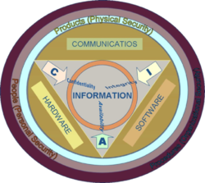

Figure 1.1: Components of Information Security

Information Security Components: whereas information is transmitted, stored, encrypted, or processed, its value derives from three main attributes or qualities, i.e., Confidentiality, Integrity and Availability (CIA). Information Systems are decomposed in three main portions, hardware, software and communications with the purpose to identify and apply information security industry standards, as mechanisms of protection and prevention, at three levels or layers: Physical, personal and organizational. Essentially, procedures or policies are implemented to tell people (administrators, users and operators)how to use products to ensure information security within the organizations.

Databases provide many layers and types of information security
- Encryption
- Access control
- Auditing
- Authentication
- Integrity

Encryption:
In cryptography, encryption is the process of transforming information (referred to as plaintext) using an algorithm (called cipher) to make it unreadable to anyone except those possessing special knowledge, usually referred to as a key. The result of the process is encrypted information (in cryptography, referred to as cipher text). In many contexts, the word encryption also implicitly refers to the reverse process, decryption (e.g. “software for encryption” can typically also perform decryption), to make the encrypted information readable again (i.e. to make it unencrypted).
Encryption has long been used by militaries and governments to facilitate secret communication. Encryption is now used in protecting information within many kinds of civilian systems, such as computers, networks (e.g. the Internet e-commerce), mobile telephones, wireless microphones, wireless intercom systems, Bluetooth devices and bank automatic teller machines. Encryption is also used in digital rights management to prevent unauthorized use or reproduction of copyrighted material and in software also to protect against reverse engineering.
Encryption, by itself, can protect the confidentiality of messages, but other techniques are still needed to protect the integrity and authenticity of a message; for example, verification of a message authentication code (MAC) or a digital signature.

Access Control:
Access control is the ability to permit or deny the use of something by someone.
Access Control Techniques:
Access control techniques are categorized as either discretionary or non-discretionary. They are
- Discretionary Access Control (DAC)
- Mandatory Access Control (MAC) and
- Role Based Access Control (RBAC)

MAC and RBAC are both non-discretionary.
Discretionary access control (DAC) is an access policy determined by the owner of an object. The owner decides who is allowed to access the object and what privileges they have.
Mandatory access control (MAC) is an access policy determined by the system, not the owner.
Role-based access control (RBAC) is an access policy determined by the system, not the owner. RBAC differs from DAC in that DAC allows users to control access to their resources, while in RBAC, access is controlled at the system level, outside of the user's control. Even RBAC is non discretionary, it can be distinguished from MAC mainly in the way permissions are handled. MAC controls read and write permissions based on a user's clearance level and additional labels. RBAC controls collections of permissions that may include complex operations such as an e-commerce transaction, or may be as simple as read or write.

Audit:
The most general definition of an audit is an evaluation of a person, organization, system, process, project or product. Audits are performed to ascertain the validity and reliability of information, and also provide an assessment of a system's internal control. The goal of an audit is to express an opinion on the person/organization/system etc. under evaluation based on work done on a test basis.

Authentication:
Authentication is the act of establishing or confirming something (or someone) as authentic, that is that claims made by or about the thing are true. Authenticating an object may mean confirming its provenance, whereas authenticating a person often consists of verifying their identity. Authentication depends upon one or more authentication factors.

There are many fields where authentication is necessary
- Products
- Money
- Credit cards
- Computer security
- Access control
- Two-factor authentication

Integrity:
Integrity is the basing of one's actions on an internally consistent framework of principles. Depth of principles and adherence of each level to the next are key determining factors. One is said to have integrity to the extent that everything one does and believes is based on the same core set of values. While those values may change, it is their consistency with each other and with the person's actions that determine the person's integrity.

1.4. Organization of the Rest of Thesis:

This thesis is organized as follows
Problem definition and General description of the working of this model is described in chapter 2. Designing of the database tables, authorizations and UML diagrams are described in chapter 3. Testing of the system and results obtained are described in chapter4. Finally Conclusion and Future work are mentioned in chapter 5.
In appendix, I have included the instructions to run the project.

2. SYSTEM ANALYSIS

2.1 Problem Definition:

Depending upon the data that is entered by the authorized user, the system should decide whether it is needed to be encrypted or need not be encrypted. If the authorized user requests for data it needs to check whether he is permitted to view the data from the permission matrix. According to the permissions given in the permission matrix, if he is permitted to view sensitive data then that data is needed to be decrypted and displayed, if it is non sensitive data then it is taken directly without any decryption. The administrator has the rights to add or delete an employee and while adding he gives permissions to view over the details of added user to others users, while the user can only view the data and can modify the permissions over his details that are viewed by other users.

2.2 Proposed System:

Many organizations are suffering from these vulnerabilities and are in immediate need of some database security technique that can ensure both data privacy and should be able to protect the database from the attacks caused by intruders and malacious users. Encryption is the only technique that provide both both data privacy and protect the database from the attacks caused by intruders and malacious users.

Encryption:

Encryption is the conversion of data into a form, called a cipher text that cannot be easily understood by unauthorized people. Decryption is the process of converting encrypted data back into its original form, so that it can be understood.
The use of encryption/decryption is as old as the art of communication. In wartime, a cipher, often incorrectly called a code, is used to keep the enemy from obtaining the contents of transmissions. Simple ciphers include the substitution of letters for numbers, the rotation of letters in the alphabet, and the "scrambling" of voice signals by inverting the sideband frequencies. More complex ciphers work according to sophisticated computer algorithms that rearranges the data bits in digital signals.
Encryption/decryption is especially important in wireless communications. This is because wireless circuits are easier to tap than their hard-wired counterparts. Nevertheless, encryption/decryption is a good idea when carrying out any kind of sensitive transaction, such as a credit-card purchase online, or the discussion of a company secret between different departments in the organization. The stronger the cipher that is, the harder it is for unauthorized people to break it -- the better, in general. However, as the strength of encryption/decryption increases, so does the cost.

Encryption algorithm:

A mathematical procedure of performing encryption on data through the use of an algorithm, information is made into meaningless cipher text and requires the use of a key to transform the data back into its original form.
In this project the encryption algorithm used is Data Encryption Standard (DES).

Data Encryption Standard (DES):

Algorithm:
The Data Encryption Standard (DES) is a cipher (a method for encrypting information) that was selected by NBS as an official Federal Information Processing Standard (FIPS) for the United States in 1976 and which has subsequently enjoyed widespread use internationally. It is based on a symmetric key algorithm that uses a 56-bit key. DES consequently came under intense academic scrutiny which motivated the modern understanding of block ciphers and their cryptanalysis [9].

DES is now considered to be insecure for many applications. This is chiefly due to the 56-bit key size being too small. The algorithm is believed to be practically secure in the form of Triple DES, although there are theoretical attacks. In recent years, the cipher has been superseded by the Advanced Encryption Standard (AES).
Working of DES:
Encryption of a block of the message takes place in 16 stages or rounds. From the input key, sixteen 48 bit keys are generated, one for each round. In each round, eight so-called S-boxes are used. These S-boxes are fixed in the specification of the standard. Using the S-boxes, groups of six bits are mapped to groups of four bits. The contents of these S-boxes have been determined by the U.S. National Security Agency (NSA). The S-boxes appear to be randomly filled, but this is not the case. Recently it has been discovered that these S-boxes, determined in the 1970s, are resistant against an attack called differential cryptanalysis which was first known in the 1990s.
The block of the message is divided into two halves. The right half is expanded from 32 to 48 bits using another fixed table. The result is combined with the sub key for that round using the XOR operation. Using the S-boxes the 48 resulting bits are then transformed again to 32 bits, which are subsequently permutated again using yet another fixed table. This by now thoroughly shuffled right half is now combined with the left half using the XOR operation. In the next round, this combination is used as the new left half. The figure in the next page should hopefully make this process a bit more clear. In the figure, the left and right halves are denotes as L0 and R0, and in subsequent rounds as L1, R1, L2, R2 and so on. The function f is responsible for all the mappings described above. DES is the archetypal block cipher an algorithm that takes a fixed-length string of plaintext bits and transforms it through a series of complicated operations into another cipher text bit string of the same length. In the case of DES, the block size is 64 bits. DES also uses a key to customize the transformation, so that decryption can supposedly only be performed by those who know the particular key used to encrypt.

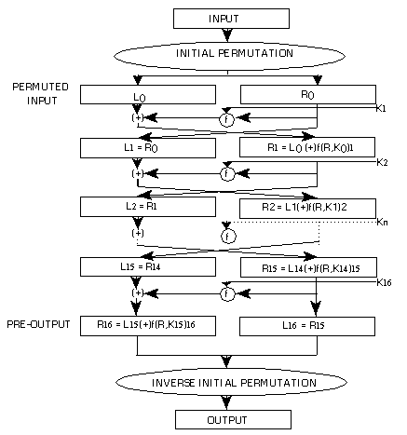
Figure 2.1: D.E.S Algorithm
Time also plays an important role in the organizations so encryption of the whole data is also not advisable and only data that is confidential / sensitive is encrypted. Encryption takes lot of time to encrypt the data but very secure. So only the sensitive / confidential data is encrypted and decrypted and it does not encrypt the data that is non sensitive. If the data like EId of the employees and EType which everyone can see ie the non sensitive data is not needed to be encrypted. If the data like salary, designation etc which are very sensitive are encrypted and while retrieval it is decrypted.

The attributes of the employees are
- Ename
- EType
- EId
- Password
- Salary
- Designation
- Address

Out of which EType and EId are non sensitive data and are not encrypted all others are encrypted.
Different Kinds of Users:
There are two kinds of users
- Administrator
- User
If he wants to add an administrator then he gives as Etype 1 otherwise Etype is 2.
Administrator:
Whenever Administrator enters using his valid user id and password then he has the options of add employee, delete employee, modify employee, view details of the employees. While he adds or modifies the details of the employees then that data is encrypted using DES algorithm mentioned above and stored in the database. Only the Admin can be able to add the employees. If he want to add another Admin then he gives the Etype as 1 otherwise 2.
If the EType is1 then no permissions are needed to be given because admin can view all the details of the employees no one can see his data, so if the added employee is an Admin then the sensitive details of the admin are encrypted and stored in the university table and non sensitive details are directly stored in the university table as shown in the figure 4.12.
If the EType is 2 then after entering the details of the user, Admin needs to give the permissions that how other users can view his details. These permissions are stored in the form of a matrix as shown in the figure 2.2.
User:
When user enters using his valid user id and password then he has the options of viewing his own details completely and viewing details of other user according to the permissions assigned. User who is the owner of his details can change the permissions of his details that how other users can view his details and are stored in the permission table which is shown in the figure 2.2 which will be in the database.
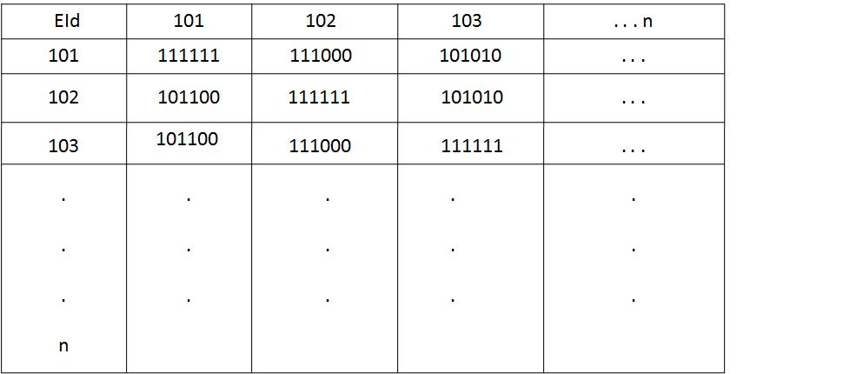
Figure 2.2: Permission Matrix
Figure 2.2 is a matrix in which all the permissions given by Admin and all the modifications made by the users are stored in the database. Here for suppose we take one value 111000 it means that first three attributes can be viewed and he can’t view the other three. While retrieval if one user wants to view details of another user then value is retrieved from permission matrix and the corresponding attributes are retrieved, decrypted and shown to the user.
Let us take an example from figure 2.2 if employee with EId 101 has entered and want to view details of employee 103 then it goes to tupple with EId 101 and attribute name is 103. The value retrieved is 101010 the corresponding values are retrieved,decrypted and shown to the employee with EId 101.
If an user want to make any modification then in the permissions then the corresponding value in the permission matrix is changed.
When we are adding one employee suppose we have 3 employees as shown in figure 2.2.Suppose we are 104 employee and the permissions given are 111100. So 104 is an new attribute created and the value 111100 is stored in the tupples 101,102,103 with the attribute name 104. But we also need to create a row with ID 104 and we need to insert the admin permissions in this row with attribute names 101,102,103. In 104 it is 111111. So there is a need to maintain another table Admin Permissions as shown in the figure 2.3.
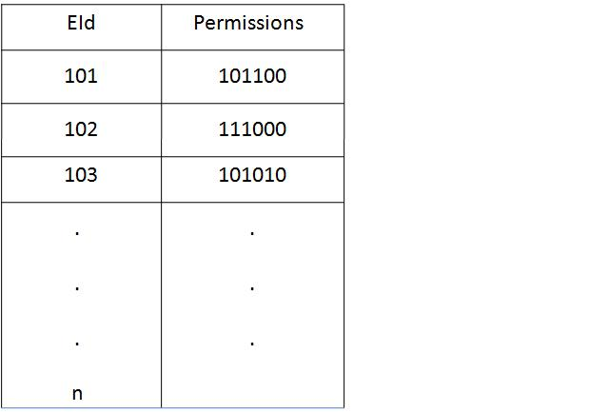
Figure 2.3: AdminPermissions

2.3 Requirements Analysis:

Requirement analysis is the software engineering task that bridges the gaps between system level requirements engineering and software design [4].

Requirement analysis allows the software engineer to refine the software allocation and build model of data, functional and behavioral domains that will be treated by the software. Software requirement analysis may be divided into five areas of effort:

- Problem recognition
- Evaluation and synthesis
- Modeling
- Specification
- Review

Here the requirements are analyzed in this project how the data is needed to be stored in the database. The data is encrypted and stored and while retrieval it should be decrypted and shown to the authorized user. The permissions that each user needs to have in viewing the data from the database are the most important requirements. All the use cases in the use case diagram which are shown in the figure 3.1 and 3.2 are also the main requirements of the project. So after getting these requirements there are two solutions which I found one is entering data from the database and encrypted while getting stored but this not efficient because it is not user friendly so in this project I designed a way to enter the details in the front end and stored in the database after encrypting and according to the authorization of the user it should be decrypted.

2.4 Hardware Requirements:

- Processor: Pentium 11 or above
- HDD capacity :10 GB or above
- Ram capacity: 64 MB or above

2.5 Software Requirements:

- Operating System: Windows 2000 or above
- HTML
- JSP
- Oracle
- APACHE TOMCAT Server

HTML:
HTML, an initialism of Hyper Text Markup Language, is the predominant markup language for Web pages HTML is written in the form of tags. HTML can also describe, to some degree, the appearance and semantics of a document, and can include embedded scripting language code (such as JavaScript) which can affect the behavior of Web browsers and other HTML processors [7].
Advantages of HTML:
- Time/Cost
- Quality design
- Easy updating
- Consistency

JSP:
Java Server Pages (JSP) technology provides a simplified, fast way to create dynamic web content. This application logic may involve JavaBeans, JDBC objects, Enterprise Java Beans (EJB), and Remote Method Invocation (RMI) objects, all of which can be easily accessed from a JSP page [6].

Advantages of using JSP:
- JSP pages easily combine static templates, including HTML or XML fragments, with code that generates dynamic content.
- JSP pages are compiled dynamically into servlets when requested, so page authors can easily make updates to presentation code. JSP pages can also be precompiled if desired.
- JSP tags for invoking JavaBeans components manage these components completely, shielding the page author from the complexity of application logic.

ORACLE:
Physical and logical structuring in Oracle
The Oracle RDBMS stores data logically in the form of table spaces and physically in the form of data files. Table spaces can contain various types of memory segments for example, Data Segments, Index Segments etc. Segments in turn comprise one or more extents. Extents comprise groups of contiguous data blocks. Data blocks form the basic units of data storage. At the physical level, data-files comprise one or more data blocks, where the block size can vary between data-files[5].
Advantages of Oracle:
Oracle has many advantages and features that make it popular One important aspect is Oracle databases tend to be backwards compatible. Also when Oracle releases a new version, their documentation contains a list of all the features new to that version thus makes it user friendly for one to learn the new features.
A reliable and adequate database system has the following properties:
- Atomic
- Consistency
- Isolation
- Durability
One of the main advantage of oracle over other databases is in its recent version oracle has the concept of Flashback technology. The Flashback provides an
- Efficient recovery from human errors
- Faster database recovery
- Helps in simplifying the management and administration processes.
TOMCAT:
Apache Tomcat is an implementation of the Java Servlet and Java Server Pages technologies. The Java Servlet and Java Server Pages specifications are developed under the Java Community Process[8].
Apache Tomcat is developed in an open and participatory environment and released under the Apache Software License. Apache Tomcat is intended to be a collaboration of the best-of-breed developers from around the world.
Tomcat should not be confused with the Apache web server, which is a C implementation of an HTTP web server; these two web servers are not bundled together. Apache Tomcat includes tools for configuration and management, but can also be configured by editing XML configuration files.

3. SYSTEM DESIGN

The database design process can be divided into six steps [5]. The ER model which is shown in the figure 3.6 is most relevant to the first three steps. The six stages are:

3.1 Conceptual Design:

The information gathered in the requirement analysis step that are shown in usecase diagram in the figures 3.1 and 3.2 is used to develop a high level description of the data to be stored in the database, along with the constraints that are known to hold over this data.
The data that is needed to be stored in the database is organized to store in the database. First the ER diagram is drawn and the data is collected and organized to be stored in the database and the ER diagram and usecase diagram are used for the requirements.

3.2 Logical Database Design:

We must choose a DBMS to implement our database design, and convert the conceptual database design into the database schema in the data model of the chosen DBMS, and therefore, the task in the logical design step is to convert an ER schema into the relational database schema.
Then the ER diagram which is the conceptual design is converted in to relational data model. Here the relation between the user admin is identified and tables like university, permissions and Admin permission and relationships between them are identified

3.3 Schema Refinement:

The third step in the database design is to analyze the collections of relations in our relational database schema to identify potential problems, and to refine it.
There is lot of redundancy that is there in the relational data model that means in this project there are different tables possible which I found and using normalization these redundancies are eliminated and most efficient model is developed.

3.4 Physical Database Design:

In this step we must consider typical expected workloads that our database must support and further refine the database design to ensure that it meets desired performance criteria. This step may simply involve a substantial redesign of parts of the database schema obtained from the earlier design steps.

3.5 Security Design:

In this step, we identify different user groups and different roles played by various users. For each role and user groups, we must identify the parts of the database that they must be able to access and the parts of the database that they should not be allowed to access, and take steps to ensure that they can access only the necessary parts.
In this project there are two kinds of roles ie admin and the user and according to their roles and the permissions assigned to them the data is shown where if it is admin he can view all the data and even he can modify those details and if he is user he can only view according to the permissions given.

3.6 Code Design:
The sql commands are used for capturing the information regarding to the ER diagrams, including constraints and key information. After getting the initial tables we check the tables for redundancy. We can refine the tables using schema refinement by normalization techniques.

Code for encryption and decryption:
Encryption:
package santu;
import
java.io.UnsupportedEncodingException;
import
java.sql.Connection;
import
java.sql.DriverManager;
import
java.sql.ResultSet;
import
java.sql.SQLException;
import
java.sql.Statement;
import
javax.crypto.Cipher;
import
javax.crypto.IllegalBlockSizeException;
import
javax.crypto.KeyGenerator;
import
javax.crypto.SecretKey;
import
javax.crypto.spec.SecretKeySpec;
import
org.apache.xml.security.exceptions.Base64DecodingException;
import
com.sun.org.apache.xerces.internal.impl.dv.util.Base64;
class
A {
Cipher
ecipher;
Cipher
dcipher;
A(SecretKey key) {
try {
ecipher = Cipher.getInstance("DES");
dcipher = Cipher.getInstance("DES");
ecipher.init(Cipher.ENCRYPT_MODE, key);
dcipher.init(Cipher.DECRYPT_MODE, key);
}
//try
catch (javax.crypto.NoSuchPaddingException e) {
e.printStackTrace();
}
catch (java.security.NoSuchAlgorithmException e) {
e.printStackTrace();
}
catch (java.security.InvalidKeyException e) {
e.printStackTrace();
}
}
//costruct
public String encrypt(String str) {
try {
// Encode the string into bytes using utf-8
byte[] utf8 = str.getBytes("UTF8");
// Encrypt
byte[] enc = ecipher.doFinal(utf8);
// Encode bytes to base64 to get a string
String enco =
new String(Base64.encode(enc));
return enco; //new sun.misc.BASE64Encoder().encode(enc);
}
//try
catch (javax.crypto.BadPaddingException e) {
}
catch (IllegalBlockSizeException e) {
}
catch (UnsupportedEncodingException e) {
}
catch (java.io.IOException e) {
}
return null;
}
//encrypt
}
//class A
public class Enc {
public String main_Encrypt(String arg) {
try {
// Generate a temporary key. In practice, you would save this key.
// See also e464 Encrypting with DES Using a Pass Phrase.
SecretKey key1 = KeyGenerator.getInstance(
"DES").generateKey();
// key1.
SecretKeySpec key =
new SecretKeySpec("12345678".getBytes("UTF-8"),
"DES");
A encrypter =
new A(key);
// Encrypt
String encrypted = encrypter.encrypt(
arg);
return encrypted;
}
//try
catch (Exception e) {
e.printStackTrace();
return null;
}
}
}

Decryption:
package santu;
import
java.io.UnsupportedEncodingException;
import
java.sql.Connection;
import
java.sql.DriverManager;
import
java.sql.ResultSet;
import
java.sql.SQLException;
import
java.sql.Statement;
import
javax.crypto.Cipher;
import
javax.crypto.IllegalBlockSizeException;
import
javax.crypto.KeyGenerator;
import
javax.crypto.SecretKey;
import
javax.crypto.spec.SecretKeySpec;
import
org.apache.xml.security.exceptions.Base64DecodingException;
import
com.sun.org.apache.xerces.internal.impl.dv.util.Base64;
class
B{
Cipher
ecipher;
Cipher
dcipher;
B(SecretKey key) {
try {
ecipher = Cipher.getInstance("DES");
dcipher = Cipher.getInstance("DES");
ecipher.init(Cipher.ENCRYPT_MODE, key);
dcipher.init(Cipher.DECRYPT_MODE, key);
}
//try
catch (javax.crypto.NoSuchPaddingException e) {
e.printStackTrace();
}
catch (java.security.NoSuchAlgorithmException e) {
e.printStackTrace();
}
catch (java.security.InvalidKeyException e) {
e.printStackTrace();
}
}
//costruct
public String decrypt(String str) {
try {
// Decode base64 to get bytes
byte[] dec = dcipher.doFinal(Base64.decode(str));
//new sun.misc.BASE64Decoder().decodeBuffer(str);
// Decrypt
//byte[] utf8 = dcipher.doFinal(dec);
// Decode using utf-8
return new String(dec, "UTF8");
}
//try
catch (javax.crypto.BadPaddingException e) {
e.printStackTrace();
}
catch (IllegalBlockSizeException e) {
}
catch (UnsupportedEncodingException e) {
}
catch (java.io.IOException e) {
}
// catch (Base64DecodingException e) {
// //
//TODO Auto-generated catch block
// e.printStackTrace();
// }
return null;
}
//decrypt
}
//class B
public class Dec {
public String main_Decrypt(String arg) {
try {
// Generate a temporary key. In practice, you would save this key.
// See also e464 Encrypting with DES Using a Pass Phrase.
SecretKey key1 = KeyGenerator.getInstance(
"DES").generateKey();
// key1.
SecretKeySpec key =
new SecretKeySpec("12345678".getBytes("UTF-8"),
"DES");
B decrypter =
new B(key);
// Encrypt
String decrypted = decrypter.decrypt(
arg);
return decrypted;
}
//try
catch (Exception e) {
e.printStackTrace();
return null;
}
}
}

3.7 UML Diagrams:

Usecase Diagrams:
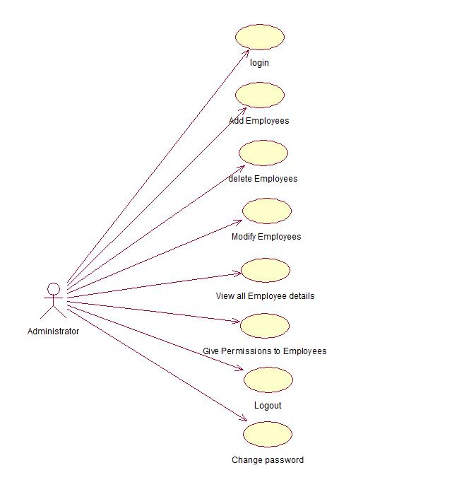

Figure3.1: Usecase Diagram of Administrator

Usecase diagram gives the requirements of the project. This is a use diagram for the administrator the use cases determine the functions that can be done by the administrator like login, add employees, delete employees, modify employees, view all employee details, give permissions to employees, logout etc.
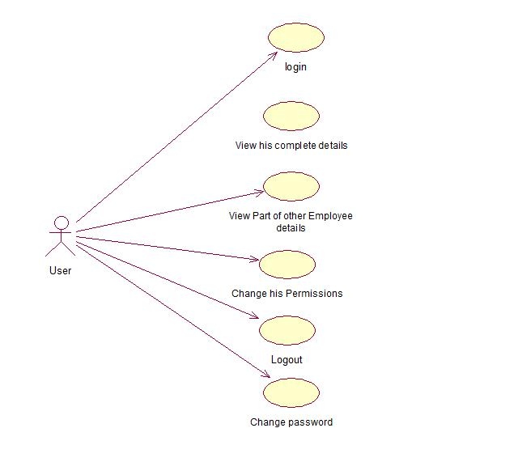
Figure 3.2: Use case diagram of User

This is a use case diagram of the user in which use cases determine the functions that can be done by the user like login, change password, logout, change permissions, view part of other employee details etc.

Sequence Diagrams for Admin:

These are the sequence diagrams of the admin which describes the sequence of actions that the admin can perform. The dog eared rectangle represents the event of a particular sequence diagram.
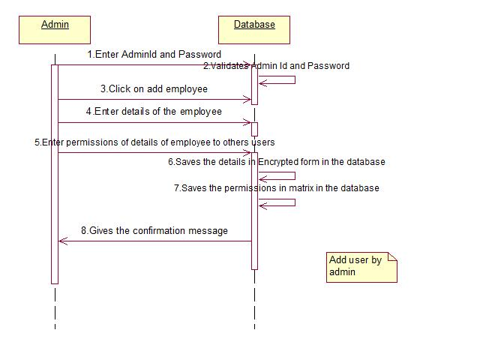
(i)
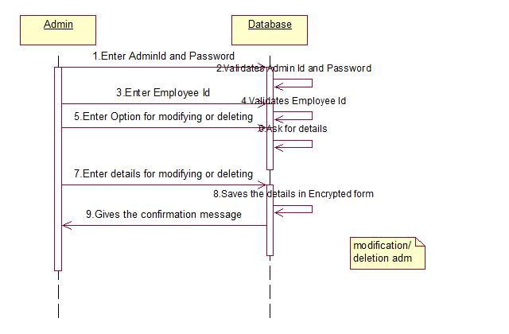
(ii)
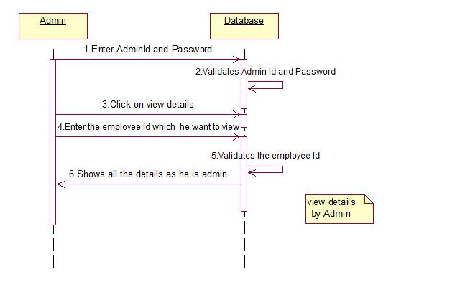
(iii)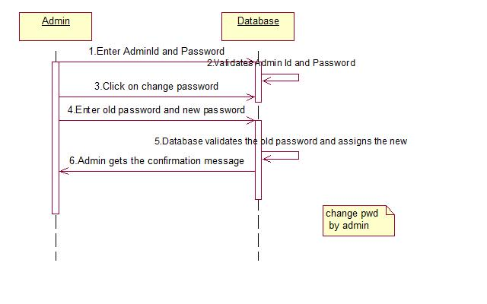(iv)
Figure 3.3: Sequence Diagram for Administrator’s events (i)Add user (ii)Modify/Delete User (iii)View Details (iv)Change Password

These are the events or operations that administrator can perform. The common things in all the sequence diagrams which are done by administrator and the database are
- Admin enters AdminId and Password.
- Database validates AdminId and Password.
After that the actions depends on the event that is needed to be done. First diagram is for adding the employee in which admin should give the details of the employee and the permissions for other user to view his details. Second diagram is for modification or deletion of an employee from the database for which after the first two steps admin needs to click on modify or delete employee button. Admin enters the empid which is validated by the database and if exists deletes the employee from the database. Third diagram is for viewing the details of the employee for which the admin clicks on view employee details and enters the empid for which he wants to view the details. Database validates the existence of the employee and if exists then shows the whole details of the employee because he is administrator. Fourth diagram is for change password first admin clicks on change password and then by giving old password, new password and confirming new password the password of admin is changed.

Sequence Diagrams for User:
These are the sequence diagrams of the user which describes the sequence of actions that the user can perform. The dog eared rectangle represents the event of a particular sequence diagram.

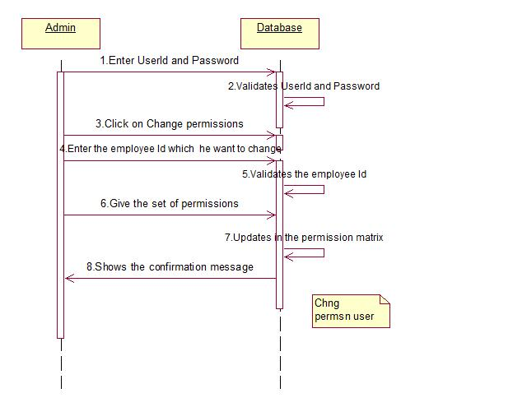
(i)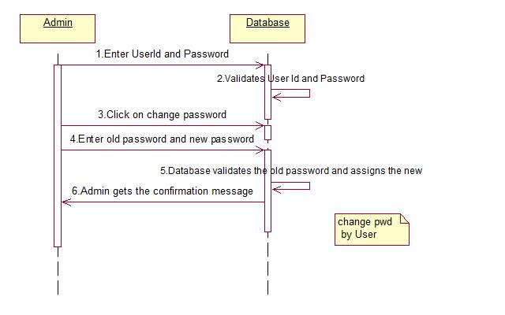
(ii)
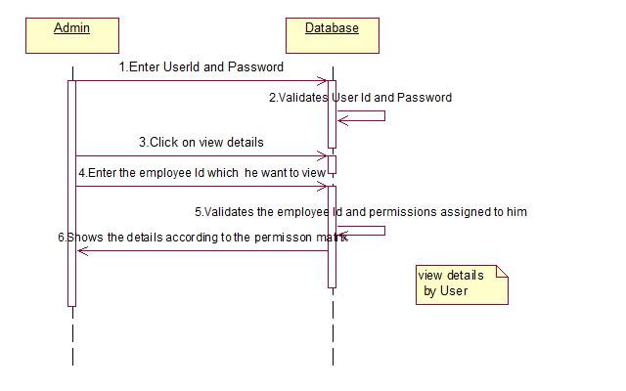
(iii)

Figure 3.4: Sequence Diagram for User’s events (i) Change Permissions (ii) Change Password (iii)View Details

These are the events or operations that user can perform. The common things in all the sequence diagrams which are done by user and the database are
- User enters UserId and Password.
- Database validates UserId and Password.

After that the actions depends on the event that is needed to be done. First diagram is for change permissions of other user to view his details for which after the first two steps user needs to click on change permissions button. User enters the empid which is validated by the database and if exists then the user can give the permissions which he deserves and they are updated in the permission matrix which is in the database. Second diagram is for change password first user clicks on change password and then by giving old password, new password and confirming new password the password of user is changed. Third diagram is for viewing the details of the employee for which the user clicks on view employee details and enters the empid for which he wants to view the details. Database validates the existence of the employee and if exists then shows the details of the employee for which he is permitted ie according to the permission matrix.

Class Diagram:
This diagram represents classes that are the real time entities. The class consists of three fields they are

- Class name.
- Attributes of the class.
- Operations of the class.
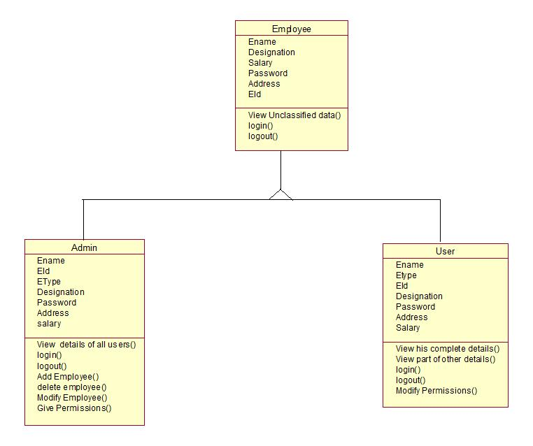

Figure 3.5: Class Diagram

Here employee is one class and Ename, EId, Password, Address, Salary, Designation represent the attributes of that class and view unclassified data(), login(), logout() represent the operations of the class employee. There is a relationship between employees, Admin, User classes which is known as generalization relationship that is inheritance relationship. Each of these classes Admin and user also has attributes and operations which are different a bit from employee attributes and operations.

Entity Relationship Diagram:

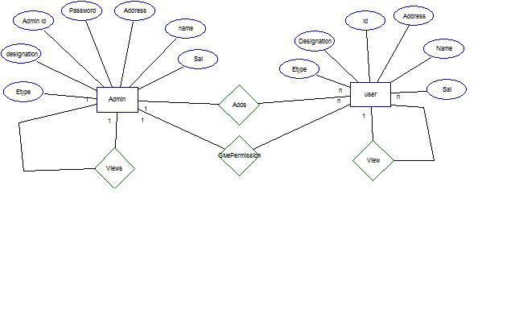
Figure 3.6: Entity Relationship Diagram

This Entity Relationship diagram represents the entities that are the users and the attributes are the properties of a particular entity. For example here Administrator is an entity where as designation, AdminId, Password, Address, name, Salary are the attributes of the administrator. There is a relationship between entity Administrator and the attributes name, address etc are connected to its entity through entity attribute relationship. The relationship between two entities is represented by rhombus as shown above. For example there is a relationship between the entities Administrator and user which is represented by rhombus and ‘adds’ is written in that entity which represents admin can add a new user. Anything written inside the rhombus should be verb which denotes the action that is done by the entity. The numbers on that relationship represents the cardinality which is the number of instances that are participating in the particular relationship, for example administrator adds new users here number of administrators participating in this relationship is one and the number of users that are getting added are n, this is the cardinality of this relationship.

4. SYSTEM IMPLEMENTATION

4.1 System Testing:

Software testing is a critical element of software quality assurance and represents the review of specification, design and coding. Testing is the process of executing a program with the intent of finding an error [4].

There are basically two types of testing approaches.
One is Black Box testing the specified function that a product has been designed to perform tests can be conducted that demonstrate each function is fully operated.
In this project the designer need not know the internal details of the encryption and decryption algorithms once the project is build because he needs to only pass the parameters from the front end that will be directly stored in the database after encryption and decrypted while retrieval. Even the permissions are also sent directly to the database without knowing the internal details of the coding.

The other is White-Box testing knowing the internal workings of the product, tests can be conducted to ensure that the internal operation of the product performs according to specifications and all internal components have been adequately exercised.
In this project when the encryption and decryption algorithms are being designed to execute these algorithms individually the designer should know the internal details of the algorithm in order to pass the parameters which is white box testing.

4.2 Testing Strategies

Testing is a set of activities that can be planned in advanced and conducted systematically. A strategy for software testing must accommodate low-level tests that are necessary to verify that a small source code segment has been correctly implemented as well as high-level tests that validate major system functions against customer requirements.

Software testing is one element of verification and validation. Verification refers to the set of activities that ensure that software correctly implements as specific function. Validation refers to a different set of activities that ensure that the software that has been built is traceable to customer requirements.

Unit Testing:

The first level of testing is called unit testing. Here different modules are tested against the specification produced during the design of the modules.
Unit testing was done to test the working of the individual modules with test oracles. The encryption and decryption algorithms are tested individually by passing parameters and sent to the database for storage and observed whether the data is getting encrypted and also seen with the decryption algorithm whether the data is getting decrypted. This system is tested using unit testing strategy by separately testing the modules of the system i.e., encryption, decryption, and authentication check.

Integration Testing:

The next level of testing is called the integration testing. In this many tested modules are combined into subsystems which were then tested. Situation like treating the modules when there is no data entered in the file was also tested. Integration testing is a systematic technique for constructing the program structure while at the same time conducting tests to uncover errors associated with interfacing.
Integration testing is that when there are more than one module we need to combine these modules while combining these modules there will be lot of errors during interfacing, for example in this project there are different modules like encryption, decryption, permissions. We unit test these modules that whether the data is correctly stored and retrieved from the database. But while integrating, we get some interfacing errors. By using integration testing we debug those errors. Here we encrypt data and store the encrypted data in the database, we retrieve the data for which the user is permitted and we decrypt that cipher text retrieved from the database so that we get the plain text.

System Testing:

The next level of testing was system testing. This testing was done to check if the system has met its requirements and to find the external behavior of the system. System testing validates software once it has been incorporated into a larger system.
In system testing the whole modules are integrated and tested at once and whole project is tested and debugged. In this project encryption, decryption, permission modules are combined and the front end html pages are combined and using apache tomcat server we test the whole software.

4.3 User Screens:
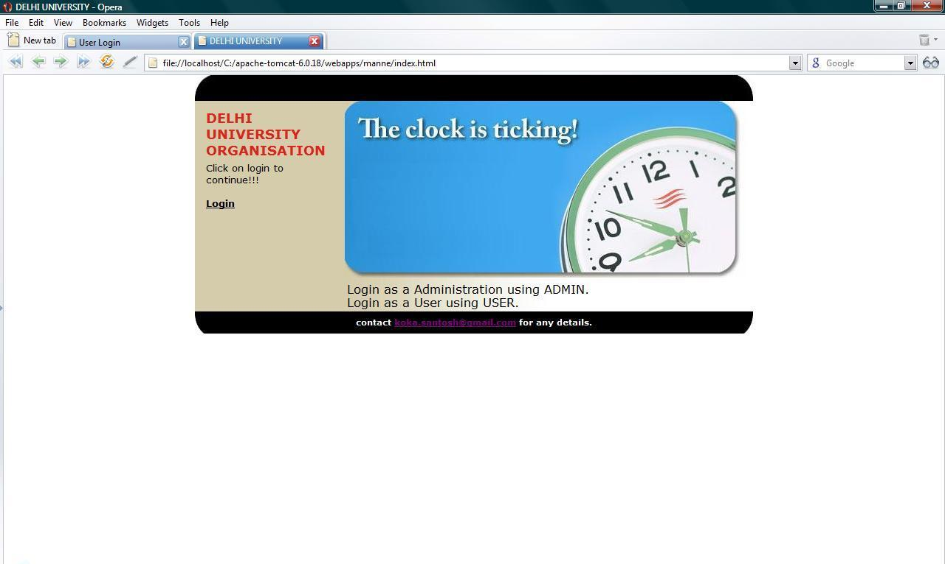

Figure 4.1: Index page

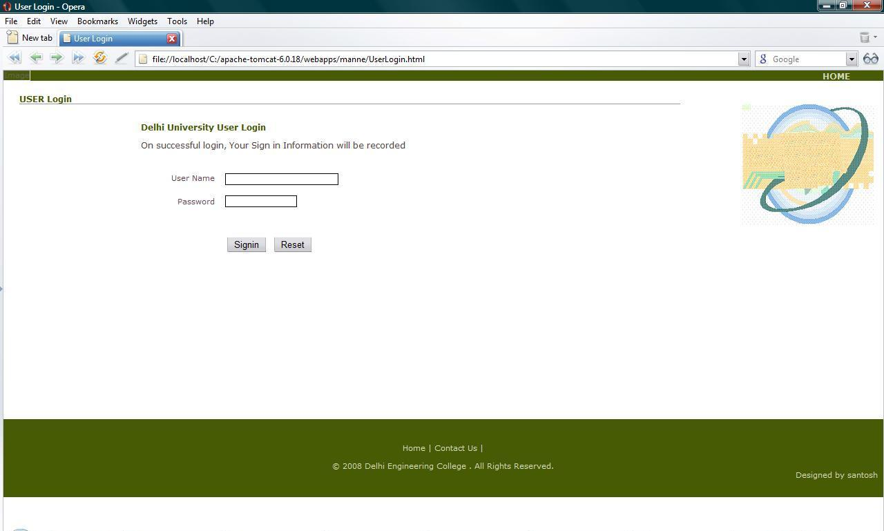

Figure 4.2: Login page for both Admin and user

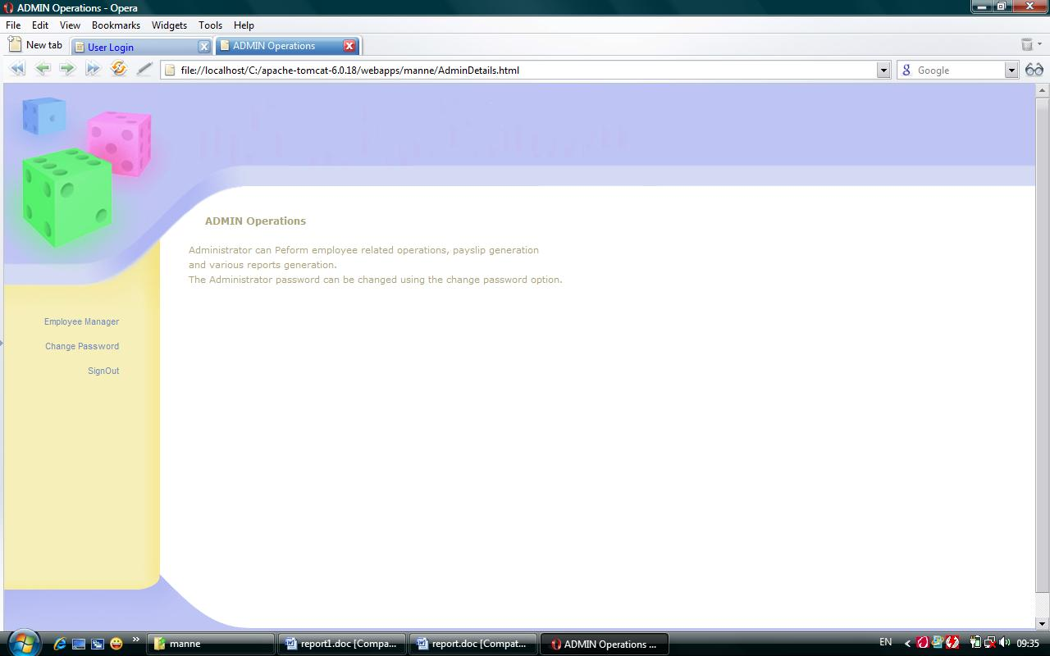
Figure 4.3: Admin Home page

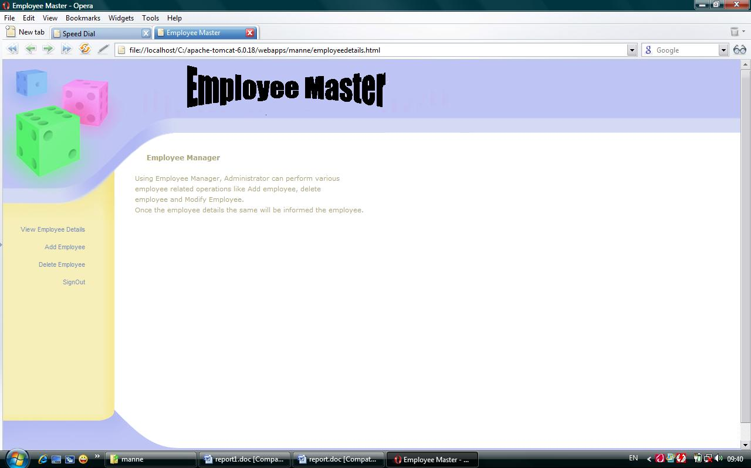
Figure 4.4: Operations of Admin
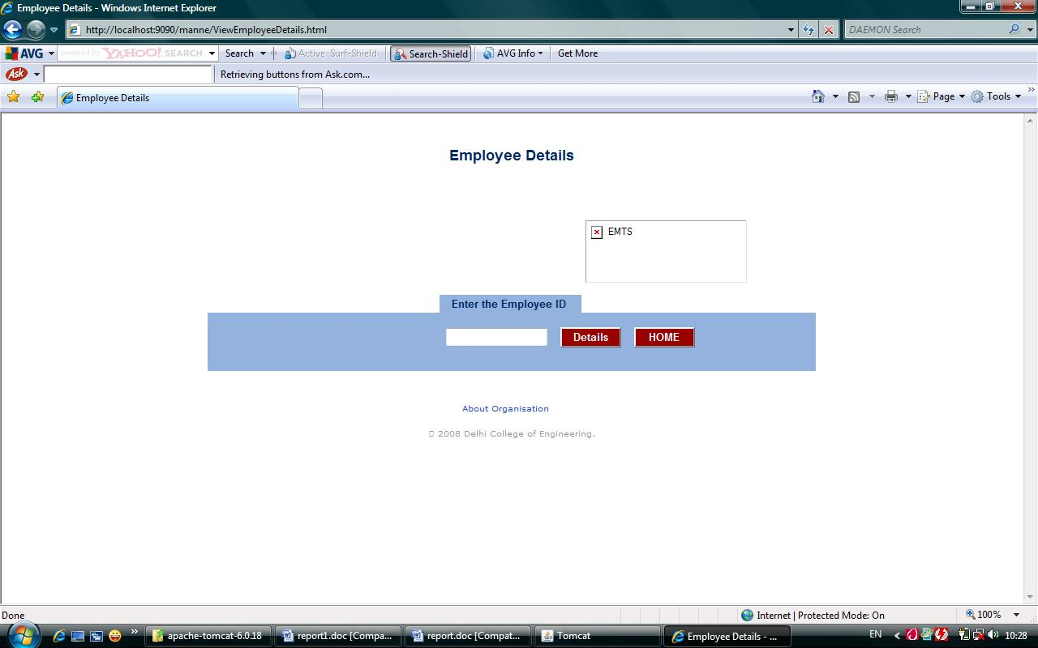
Figure 4.5: To view any employee details by user or admin

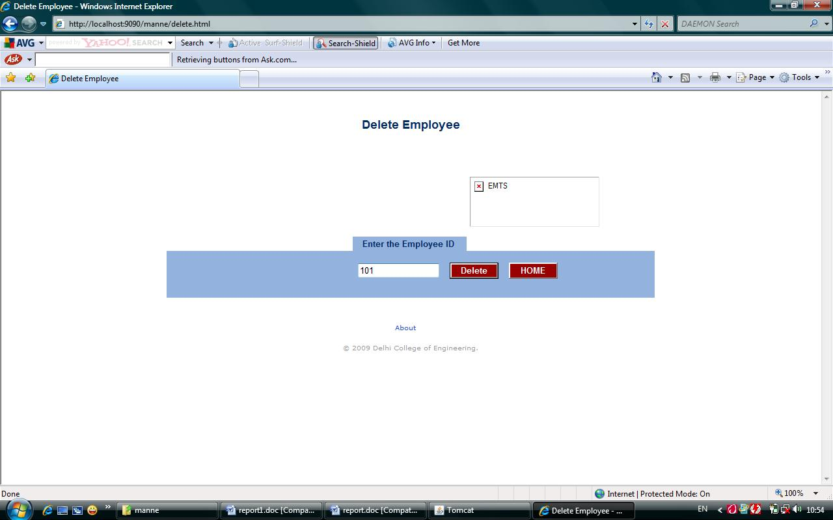

Figure 4.6: To delete an employee by administrator
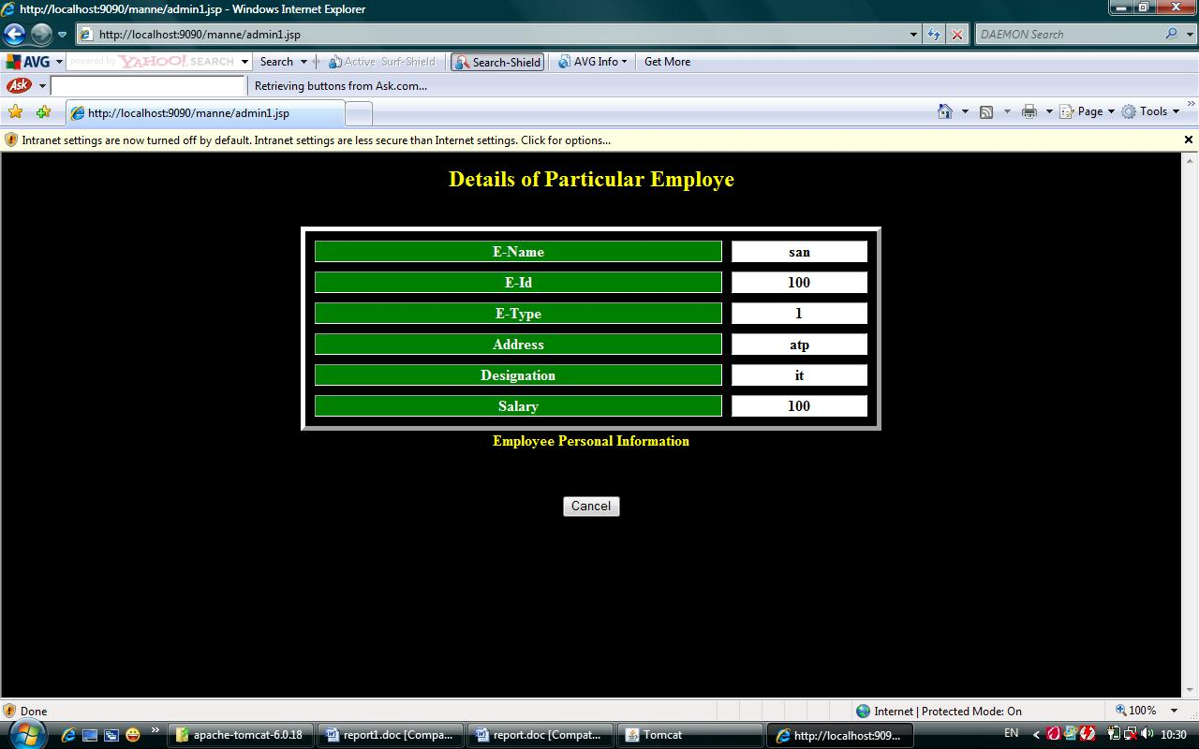

Figure 4.7: Details of particular employee

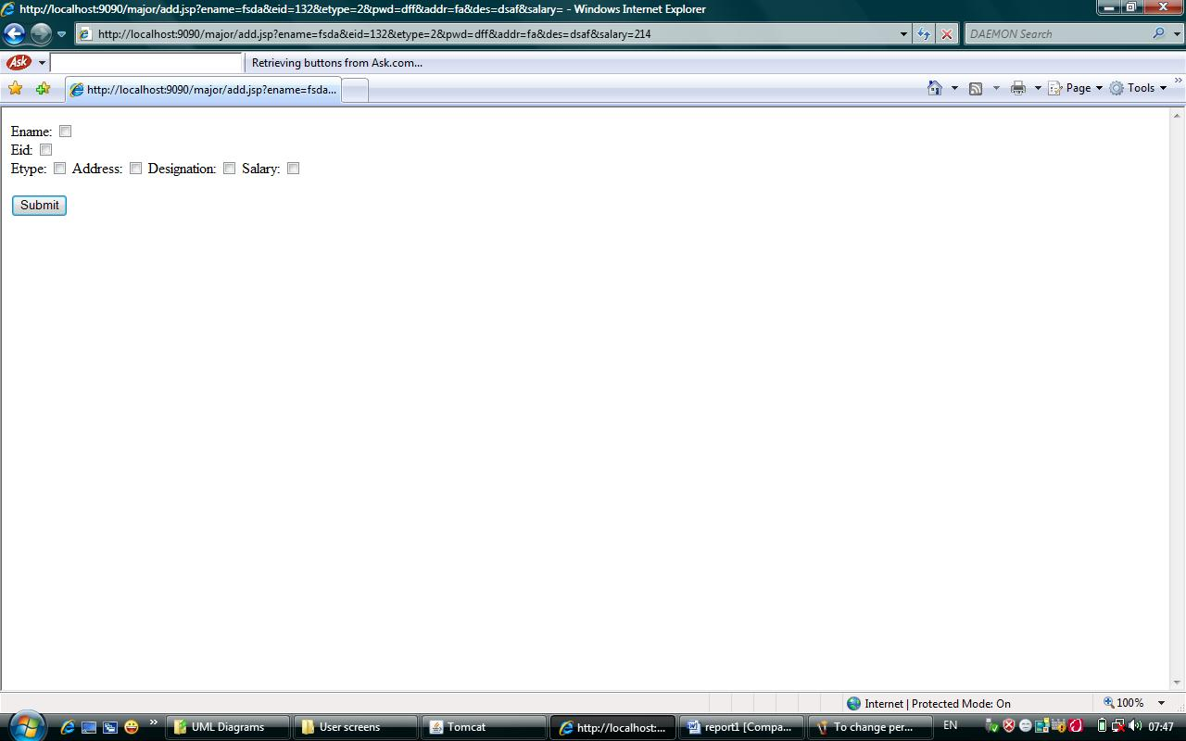
Figure 4.8: To give Permissions to other employees by admin

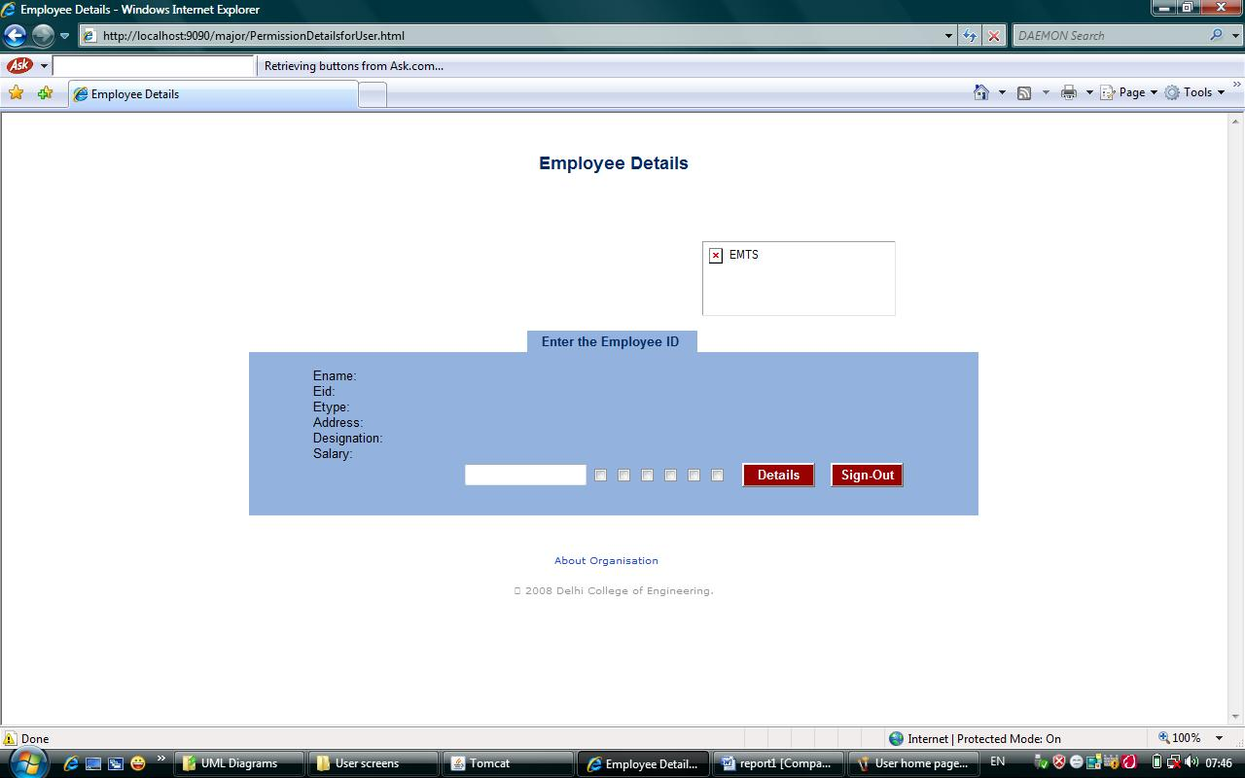
Figure 4.9: To change permissions by user over his details

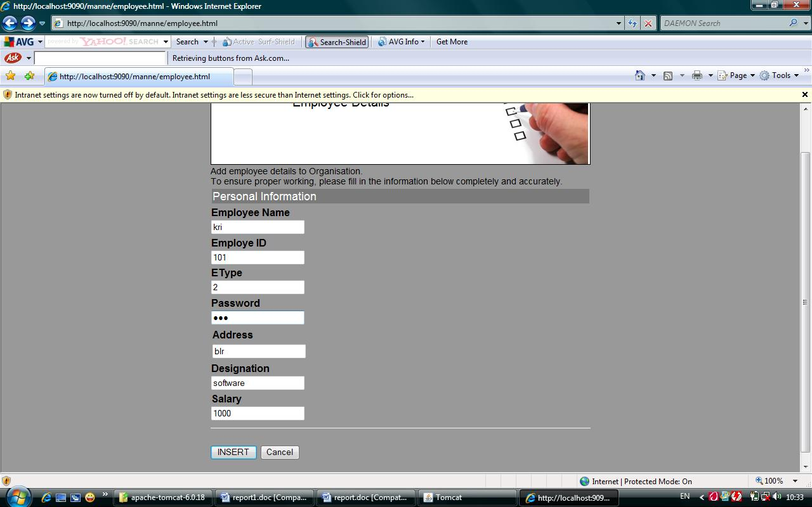

(i)

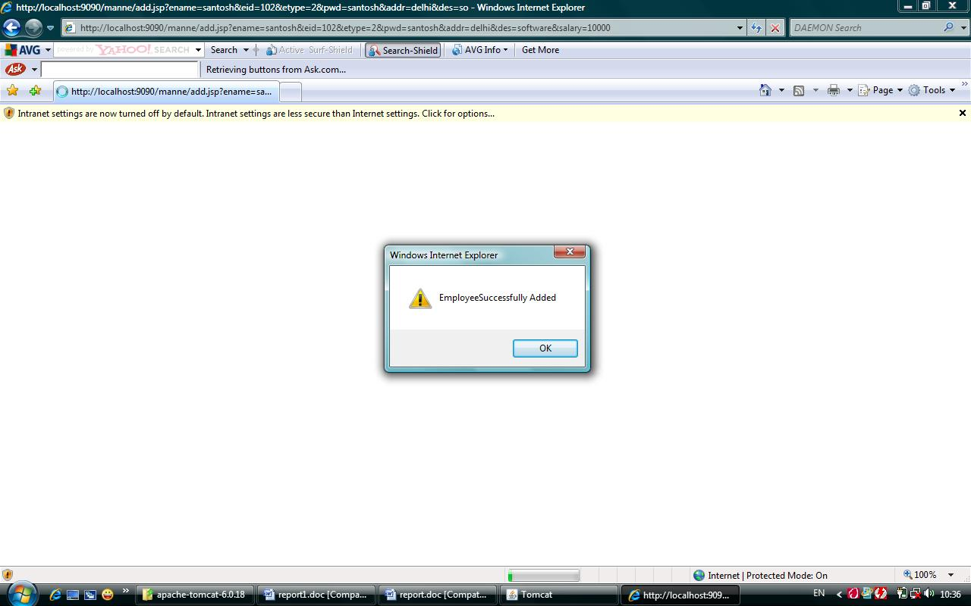

(ii)

Figure 4.10: (i)To add an Employee by Admin
(ii)Employee successfully added message

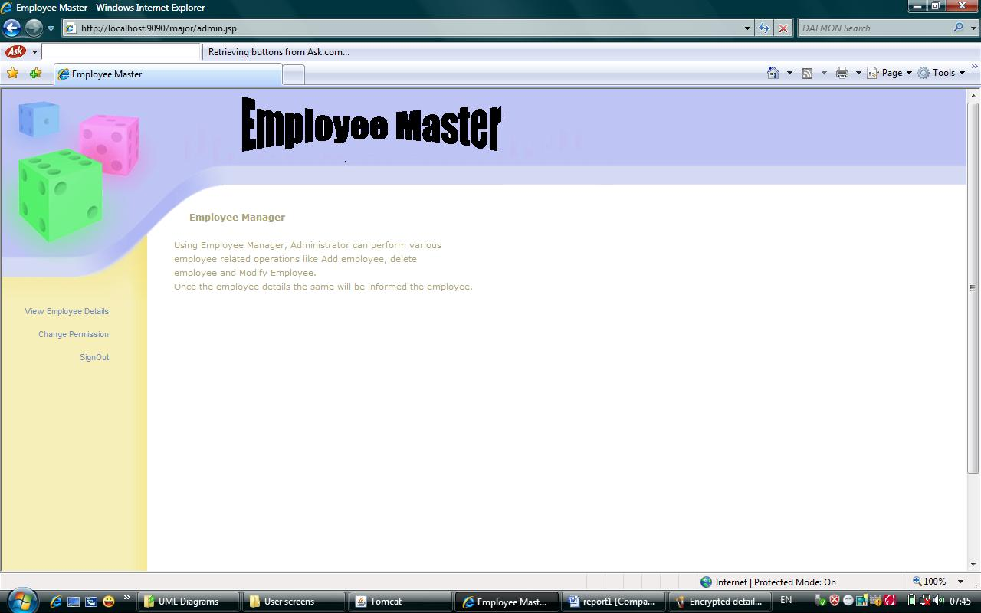

Figure 4.11: User Home Page

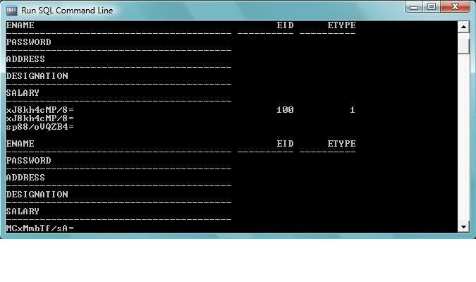
Figure 4.12: Encrypted Details of the employees which are stored in the database

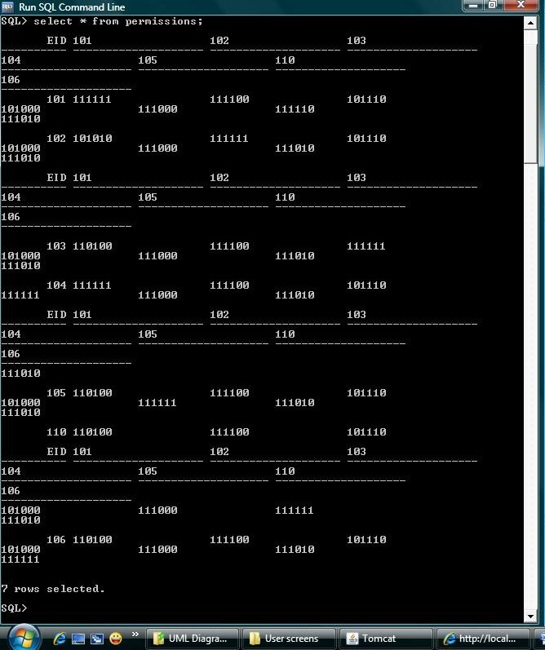

Figure 4.13: Permission Matrix in the database

5. CONCLUSION AND FUTURE WORK

5.1 CONCLUSION:

Many database security techniques were developed which are having some vulnerabilities no matter the amount of degree of security they provide. Cryptography is the technique which can provide both data privacy and is be able to protect the database from the attacks caused by intruders and malacious users. Encryption by itself, can protect the confidentiality of messages, but other techniques are still needed to protect the integrity and authenticity of a message. But if all the data in the database is encrypted then it reduces the performance. Therefore, only the sensitive/personnal data is encrypted. For retrival that data is decrypted. The nonsensitive/common data is not encrypted and is retrieved immediately while authorised user requests for it according to the permissions given to them. Even sharing of the data is also secure because only Administrator has right to give permissions and owner has the right to change the permissions. This increases the performance of the system.

5.2 FUTURE WORK:

In this thesis the encryption algorithm used is D.E.S(Data Encryption Standard) for encrypting the data. The model can be extended for different kinds of encryption algorithms. This thesis has been done on Employee database, the same work can be extended for any general database.

Appendix

How to operate the Project:

Make sure that Jdk-1.4, Oracle and Apache Tomcat Server are installed in the system.
- Copy project folder in webapps folder of apache tomcat server.
- Set environmental variables ie the jar files paths and the jar files used in this project are xmlsec.jar, classes1.jar, classes12.jar.
- Set the path of java, jdbc.jar which is in oracle folder and servlet.jar which is in Apache folder.
- Run Apache Server and open web browser.
- Type http://localhost:9090 in the address bar of the web browser.
- If Tomcat server runs then type http://localhost:9090/project in the address bar.
- Execute the project.

REFERENCES

[1] Sesai S, Yang Z, Chen J and Du Xu , “A Secure Database Encryption Scheme”,
Proceedings of IEEE, 26 Nov 2004, pp 49-53.
[2] Lihua Yu,Chen G, Ke Chen,Dong J, “Securely Sharing Data in Encrypted
Databases”, Proceedings of the 10th International Conference on Computer Supported
Cooperative work in Design, 2003.
[3] Yong Zhang, Wei-Xin Li, Xia-Mu Niu, “A Secure Cipher Index over Encrypted
Character Data in Database”, Proceedings of the Seventh International Conference on
Machine Learning and Cybernetics, Kunming, 12-15 July 2008, pp 1111-1116.
[4] Ian Somesville, “Software Engineering Pearson Education Asia”, Sixth edition 2001.
[5] Raghu Ramakrishna,Johannes Gehrke, “Database Management Systems”, McGraw
Hill International Editions, Second Edition 2000.
[6] Java Server Pages Technology, ”Sun Developer Network”,1994, [online document]
Available at: http://java.sun.com/products/jsp/index.jsp
[7] HTML, “WIKIPEDIA” june 2009, [online document] Available at:
http://en.wikipedia.org/wiki/HTML
[8] Apache Tomcat, ”WIKIPEDIA” june 2009, [online document] Available at:
http://en.wikipedia.org/wiki/Apache_Tomcat
[9] Data Encryption Standard, ”WIKIPEDIA” june 2009, [online document] Available at:
http://en.wikipedia.org/wiki/Data_Encryption_Standard

