ANALYSIS AND DESIGN OF RIVER DIVERSION WORKS USING STAAD-PRO AND PHASES SOFTWARE

A
Dissertation
Submitted in Partial Fulfillment of the Requirements
for Award of the Degree of

MASTER OF ENGINEERING
IN
HYDRAULICS & FLOOD CONTROL

By
MOHAMMAD SHAHID
University Roll No. 8871
College Roll No. 03/HYD/04

Under the Guidance of
Dr. RAKESH KUMAR



Department of Civil and Environmental Engineering
Delhi College of Engineering
Delhi University, Delhi-110042
JULY 2006

CERTIFICATE

This is to certify that the thesis entitled “River Diversion Works” is being submitted by Mohammad Shahid is a bonafide record of student’s own work carried by him under my guidance in partial fulfillment of requirement for the award of the Degree of Master of Engineering (Hydraulics & Flood Control), Dept. of Civil and Environmental Engineering, Delhi College of Engineering, Delhi.

The matter embodied in this dissertation has not been submitted for the award of any other degree.

Dr. Rakesh Kumar
Assistant Professor
Civil Engineering Department
Delhi College of Engineering,
Delhi-110042

ACKNOWLEDGEMENT

I express my sincere gratitude to my project guide Dr. RAKESH KUMAR, Civil and Environmental Engineering Department in Delhi College of Engineering, for his valuable guidance, keen interest and motivation throughout the project. I am highly grateful to him for his constant encouragement, valuable suggestions and prompt attention despite of his busy schedule.

I also express my grateful thanks to Shri.G.S.SIDHU, Sr. Design Engineer, J. P. Industries limited.

I also express my gratitude and thanks to Prof.S.K.SINGH and Dr.P.L.PATEL for their valuable suggestions and help, wherever needed.

I also express my gratitude to Library and Computer Center staff for their technical support, during the project.

I would like to thank my all friends for their kind help extended to me in carrying out the work for preparing the report.

MOHD. SHAHID
Roll No: 8871
(Class Roll No: 03/HYD/04)

ABSTRACT

The river diversion work plays a vital role in actual construction of any work in the bed of a natural river. Therefore to construct the dam, it will be necessary to divert the river from its natural bed to give access to the river bottom in a dewatered condition during the non-monsoon period.

The design of river diversion works and its various components depend upon numerous factors. The main component of the river diversion works are Coffer Dam, Inlet Structure and Tunnel Support.

There are different types of coffer dams such as Masonry/concrete/ colloidal concrete coffer dams, Earthfill/rockfill coffer dams, Steel coffer dams, and Timber coffer dams. The selection of a suitable type of coffer dam depends upon various factors such as availability of space, availability of materials, foundation characteristics and river flow condition etc. In the given project report the rockfill coffer dam is proposed to be provided and for which the general design requirements and design criteria are adopted in accordance with relevant IS-Codes, for the safety of concern dam.

The inlet structure is provided in order to provide smooth entry of river water into diversion tunnels. The design of inlet structures is performed using STAAD-Pro software and relevant IS-Codes for both earthquake and no earthquake condition and the results are compared.

The rock structure is very typical having a complex heterogeneous structure which requires the assistance of field rock mechanics experts to adjust the recommended tunnel support design criteria according to the actual field conditions encountered. When a tunnel opening is excavated in rock, the stress field is locally disturbed and a new set of stresses are induced in the rock surrounding the opening. The knowledge of these stresses is very important to insure the safety of tunnel. Therefore a two-dimensional hybrid model called ‘PHASES’ is used to calculate these different types of stresses and for different conditions and the results are compared.

The design of tunnel supports includes the design of rockbolts, shotcrete supports, steel ribs. The design of these components depends upon the various factors such as quality of rock mass encountered, rock load, rock cover etc. For fair to good reaches supports are provided on the basis of “Tunneling Quality Index, Q” in accordance with the provision given by Grimstad & Barton. For poor reaches steel ribs are designed using STAAD-Pro software.

CONTENTS
S.No. Page No.
1 | Introduction ……………………………………………………………………  1.1 General…………………………………………………………………….  1.2 Components of River Diversion Works…………………………………..  1.3 Present Study ………………………………………………………………  1.3.1 Coffer Dam …………………………………………………………..  1.3.2 Inlet Structure ……………………………………………………..  1.3.3 Tunnel Section………………………………………………….  1.3.4 Tunnel Support……………………………………………………... | 1 - 4  1  1  1  2  3  3  3
2 | Review of Literature …………………………………………………………..  2.1 Coffer Dam………………………………………………………………...  2.1.1 Types of Coffer Dams……………………………………………...  2.1.2 Guidelines for Selection……………………………………………  2.1.3. General Design Requirements………………………………….…..  2.1.4. Design Criteria for Coffer Dams…………………………………..  2.2 Types of Tunnel Sections………………………………………………….  2.2.1. Shapes………………………………………………………………  2.3 Tunnel Support…………………………………………………………….  2.3.1. Steel Support……………………………………………………….  2.3.2. Roof Bolts Support…………………………………………………  2.3.3. Shotcrete Support………………………………………………….. | 5 – 19  5  5  6  9  10  12  12  14  15  17  18
3 | Design of U/S and D/S Rockfill Coffer Dam…………………………….  3.1 Data Collected ………………………………………………………..  3.2 Design Criteria………………………………………………………..  3.2.1 Free Board…………………………………………..................  3.2.2 Top Width……………………………………………………….  3.2.3 Side Slopes………………………………………………………  3.3 Stability Calculations……………………………………………………... | 20 -29  20  20  20  22  22  22
4 | Design of Inlet Structures of Diversion Tunnels………………………  4.1 Data Collected …………………………………………………………..  4.2 General…………………………………………………………………...  4.3 Design Criteria of Inlet Structure………………………………………..  4.3.1 Loads ……………………………………………………………..  4.3.2 Critical Condition for Design…………………………………  4.3.3 Earthquake Effect………………………………………………  4.4 Analyses for Inlet Structures of Diversion Tunnels………………..  4.4.1 No Earthquake Case……………………………………………  4.4.2 Earthquake Case ………………………………………………  4.4.3 Comparison of Result for No Earthquake and Earthquake  Case ………………………………………………………….  4.5 Design of Pier……………………………………………………….  4.5.1 Critical Design Condition……………………………………  4.5.2 Checking against Sliding…………………………………….  4.5.3 Checking of Gate Groove Depth in Bearing………………..  4.5.4 Compressive Stress in Central Pier………………………… | 30 – 62  30  32  32  32  35  35  36  36  37  39  39  39  39  40  41
5 | Design of Tunnel Support………………………………………………..  5.1 Data Collected ………………………………………………………….  5.2 General……………………………………………………………….  5.3 Size of Tunnel……………………………………………………………..  5.4 Design of Steel Ribs for Poor Rock Condition………………………….  5.4.1 Rock Load for Design of Steel Ribs……………………………….  5.4.2 Design Parameters…………………………………………………  5.4.3 Analysis and Design of Ribs by Using STAAD-Pro…………….  5.5. Design of Permanent Supports for the Tunnels for Fair to  Good Rock Reaches…………………………………………………  5.6. Analysis for Stresses in Rock after Excavation………………...  5.6.1. The Assumptions made in the Analysis……………….…..  5.6.2. Insitu Stresses and Material Properties of Rock…………..  5.6.3. Idealisation of Structure………………………………………..  5.6.4. Computer Program and Analysis Philosophy………………………  5.6.5. Results and Discussions for Excavation of Cavity (Heading  Excavation)…………………………………………………………  5.6.6. Results and Discussions for Excavation of Cavity (Benching  Excavation)…………………………………………………………  5.6.7. Results and Discussions for Excavation of Cavity (Benching  Excavation with Heading Portion Provided with Rock Bolts)……..  5.6.8. Results for Minimum Value of Elasticity..……………………….  5.6.9. Conclusions……………………………………………………….. | 63 – 98  63  64  64  65  65  67  68  69  70  70  71  72  72  73  73  74  74  74
6 | Conclusions…………………………………………………………………….. | 99
7 | Scope for future work…………………………………………………………. | 100
8 | References …………………………………………………………………….. | 101-102

LIST OF FIGURES
FIGURES NO. | TITLE | PAGE  NO.
4.1 | Details of Inlet Structure | 31
4.2 | Model of Steel Rib with Shear Force and Bending Moment Diagram | 33
4.3 | Cross-Section and Pressure Diagram of Inlet Structure for  No Earthquake Case | 36
4.4 | Model of Inlet Structure with Shear Force and Bending Moment Diagram for No Earthquake Case | 37
4.5 | Cross-Section and Pressure Diagram of Inlet Structure for Earthquake Case | 38
4.6 | Model of Inlet Structure with Shear Force and Bending Moment Diagram for Earthquake Case | 38
5.1 | Finished Section of the Diversion Tunnel | 64
5.2 | Model of Steel Rib Support with Shear Force and Bending Moment Diagram | 68

LIST OF TABLES
TABLE NO. | TITLE | PAGE  NO.
3.1 | Data Collected for the Design of U/S and D/S Rockfill Coffer Dam | 20
3.2 | Calculations for F.O.S against Sliding for U/S Rockfill Coffer Dam | 24 – 25
3.3 | Calculations for F.O.S against Sliding for D/S Rockfill Coffer Dam | 26 – 27
3.4 | Stability Calculations of Water Side Slope for D/S Rockfill Coffer Dam | 28
3.5 | Stability Calculations of Dry Side Slope for D/S Rockfill Coffer Dam | 29
4.1 | Data Collected for the Design of Inlet Structure of Diversion Tunnel | 30
4.2 | Calculations for F.O.S against Sliding for Central Pier for No Earthquake Case | 42 – 43
4.3 | Calculations for F.O.S against Sliding for Central Pier for Earthquake Case | 44 - 46
5.1 | Data Collected for the Design of Tunnel Support | 63

LIST OF ANNEXURE
ANNEXURE No. | TITLE | PAGE  No.
4.1 | STAAD-Pro Modeling Details and Output for Analysis of Steel Ribs | 47 -53
4.2 | STAAD-Pro Modeling Details and Output for Analysis of Inlet Structure for No Earthquake Case. | 54 - 69
4.3 | STAAD-Pro Modeling Details and Output for Analysis of Inlet Structure for Earthquake Case. | 60 – 62
5.1 | STAAD-Pro Modeling Details and Output for The Design of Steel Ribs | 76 – 82
5.2 | Output Results from Phases Software | 83 - 98

CHAPTER 1
INTRODUCTION

1.1 GENERAL
Prior to the commencement of actual construction of any work in the bed of a natural river, it becomes obligatory in most cases to exclude temporarily the river flow away from the proposed work area during the construction period, so as to permit the work to be done in the dry or semi-dry areas. An efficient scheme of diverting the river flow away from the work area should be capable of limiting the seepage into the work area to a minimum, so that the work area can be kept dry with minimum pumping capacity.

1.2 COMPONENTS OF RIVER DIVERSION WORKS
A temporary river diversion scheme essentially consists of:
a) Coffer dam(s) built across a part of full width of the river to divert the flowing water away from the work area; and
b) Works to transfer the diverted water from upstream to the downstream of the work area without affecting the same, such as:
1) Diversion through (construction) sluices in the main work;
2) Diversion by one or more tunnels along the side of the main work area;
3) Diversion through low level blocks of the main structure left for the purpose or through channels excavated outside the main structure; and
4) Secluding part of the work area for construction and allowing the river to flow through the remaining work area.

1.3 PRESENT STUDY
The data used in the design of given River Diversion Works is of Baglihar Hydro-Electric Project. The site of the dam is a narrow valley with exposed rocks on both the banks. In the river bed portion, the overburden is about 12 m. Thus, the deepest foundation level will be about 12 to 15 m below the river bed. Keeping in view these constraints, it will be necessary to construct diversion tunnels of sufficient capacity to permit uninterrupted construction of the dam in its entire length during non-monsoon period.
The diversion works will consist of two 11 m circular tunnels excavated on the left bank, a 27.3 m high upstream coffer dam, and a 17 m high downstream coffer dam. These structures will be maintained for 3 non-monsoon seasons to allow completion of the dam sub-structure and the sluice spillway openings.
The diversion tunnel and coffer dams will provide full protection to construction works in the river bed only during the non-monsoon seasons. Because a diversion scheme providing year-round protection for two to three continuous years would have been very expensive. For this reason, it is proposed to allow both coffer dams to be overtopped during the monsoon period, as it will be more economical to repair them as required for the next working season.

1.3.1 Coffer Dam
Both the upstream and downstream coffer dam are of rockfill type. Based on the river bed EL 708.0 m at the upstream coffer dam location, the overall height of the structure will be approximately 27.3 m thus setting the crest elevation at 735.3 m. This elevation includes a freeboard of 3 m under design flood conditions. The top width of coffer dam is 8 m. The upstream coffer dam has slopes of 2:1 upstream and 1.5:1 downstream and will have rockfill on both the sides. The factor of safety against overturning is calculated as 2.19 and F.O.S against sliding is calculated as 5.69. The upstream and downstream faces of the coffer dam will be protected with gabions to allow overtopping during the monsoon season without major damage to the structure.
Similarly, for the downstream coffer dam based on the river bed EL 708.0 m at the downstream coffer dam location, the overall height of the structure will be approximately 17 m thus setting the crest elevation at 725m. This elevation includes a freeboard of more than 3 m under design flood conditions. The top width of coffer dam is 8 m. The downstream coffer dam has slopes of 2:1 upstream and 1.5:1 downstream and will have rockfill on both the sides. The factor of safety against overturning is calculated as 2.238 and F.O.S against sliding is calculated as 6.172. The slope stability calculation is also carried out for both upstream and downstream faces and F.O.S comes out to be 1.252 and 1.135 respectively.

1.3.2 Inlet Structure
For providing smooth entry of river waters into diversion tunnels and for housing gates and gate grooves, inlet structures are to be provided at the inlet ends of both of the diversion tunnels. The concrete inlet structures will have their top at EL 739.0 m where a working platform will be developed for erection, commissioning and operation of gates.
The design of inlet structure is performed using STAAD-PRO software for both earthquake and no earthquake cases, and the results are compared. It is seen that bending moments and shear forces due to earthquake are less than even 10% of those due to design external water pressures. Therefore earthquake case is not critical from the point of view of design of inlet structures.
The design of central pier is also done using data from STAAD-PRO output model prepared for inlet structure. And F.O.S against sliding is calculated for both earthquake and no earthquake cases, which come out to be 1.315 and 1.436 respectively.

1.3.3 Tunnel Section
The diversion of river during construction of main dam at Baglihar Project is proposed to be effected through 2 nos. concrete lined horse shoe tunnels with flat invert each having the same area as that of an 11 m dia circular tunnel. These tunnels will be excavated on the right bank of the river.

1.3.4 Tunnel Support
When a tunnel is excavated in a massive rock mass, which has different rock cover in entire length of reach consider and with varying various properties, it becomes necessary to provide support to the excavated in order to avoid the many types of failures that might occur. Therefore an adequate system of tunnel support is provided.
Rock at depth is subjected to stresses resulting from the weight of the overlying strata and from locked in stresses of tectonic origin. When a tunnel opening is excavated in this rock, the stress field is locally disrupted and a new set of stresses are induced in the rock surrounding the opening. The knowledge of the magnitudes and directions of these in situ and induced stresses is an essential component of underground excavation design since, in many cases, the strength of the rock is exceeded and the resulting instability can have serious consequences on the behavior of the tunnel openings.
Therefore in this project work a two-dimensional hybrid model called PHASES is used to know various above said things for two stages of excavation considered (Heading and Benching). Also two alternatives are considered in benching excavation viz with and without rock bolts. The analysis is carried out for both minimum and maximum values of modulus of elasticity and the result are compared.
The maximum compressive stress of the order of 12.5 MPa develop near sides of the tunnel and 15 MPa near corner develop. These are well below the compressive strength of the rock (100 MPa). The studies have also been conducted for minimum value of E i.e. 6360 MPa. On comparing these results with the results for E = 13000 MPa, it is seen that pattern and values of stresses remain same. However, the displacement values are proportionately higher being 9 mm at invert and crown both as against 4.4mm obtained for higher value of E.
The entire reach is divided into two categories, fair reaches having good rock quality and poor reaches. For good reaches support are provided in the form of rock bolts and shotcrete on the basis of rock mass classification based on the methodology given by Grimstad and Barton in the book of “Support of underground excavation” by Event-hook. And for poor reaches steel ribs are designed using STAAD-PRO software and the relevant IS-codes.

CHAPTER 2
LITERATURE REVIEW

2.1 COFFER DAM
The successful planning and construction of any major project depends on the proper design and execution of the coffer dam selected for the purpose of temporary river diversion. Hence, a safe design of coffer dam in order to avoid unanticipated/uncalculated risks and calamities during construction of the project is very important. However, it is paradoxical to note that in the design of a coffer dam, which is a temporary structure, certain calculated risks may have to be taken to effect economy on the overall cost of the project.

2.1.1 Types of Coffer Dams
The different types of coffer dams generally used are:
(i) Masonry/concrete/ colloidal concrete coffer dams,
(ii) Earthfill/rockfill coffer dams,
(iii) Steel coffer dams, and
(iv) Timber coffer dams.
For the details of these types of coffer dams refer IS: 9795(Part: 1)-1981. However, the earthfill/rockfill coffer dam is described here as it is proposed in this project report.

2.1.1.1. Earthfill/Rockfill coffer Dam - In addition to the usual type of earthfill/rockfill coffer dam with a central core of impervious soil, a coffer dam with single sheet pile at the centre, backed by earthfill/rockfill on either side of it is also used. A typical section of such a coffer dam is shown in Fig. below. Sometimes, a coffer dam with a single sheet pile at the centre, backed on either side by sand bags, caged suitably by G. I. wire mesh of appropriate gauge, is also adopted. However, due to the possibility of rotting of gunny bags and sand spreading thereby, this type of coffer darn can be suitable only for short durations. Where the height of the coffer dam is not more than 3 m and the foundations are impervious, a simpler type of coffer dam with two rows of parallel walls of sand bags with the space between them filled with impervious soil can also be adopted.
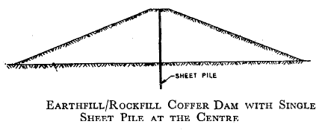

2.1.2 Guidelines for Selection
In addition to the criteria of the cost of the structure and the overall economy of the project, there are some specific guidelines which dictate the selection of a particular type of coffer dam. Among these are the availability of space and materials, construction programme, rate of construction, incorporation of coffer dam(s) as part of the main dam, foundation characteristics, river flow conditions and passing of floods. The final choice of the type of coffer dam may be made based on a study of relevant criteria and commensurate with economy.

2.1.2.1 Availability of Space - An earthfill/rockfill coffer dam requires more space due to its wider base. For the sites where only limited area is available for construction of the coffer dam over rocky foundations, in addition to masonry/ concrete/colloidal concrete coffer dams, steel and timber coffer dams are also suitable. However, since the latter types can be considered only for depths up to 2 m, for conditions of limited area and rocky foundations, a masonry/concrete coffer dam is better suited than other types. However, where there is no problem of space for the location of the coffer dam(s), an earthfill/rockfill coffer dam may be the suitable choice. In alluvial foundations, where limited space is available for construction of coffer dam(s) due to the construction of certain structures like navigation facilities, etc, a double wall steel sheet pile coffer dam with proper earth/sand backing may be preferable.

2.1.2.2 Availability of Materials - Where construction materials like earth, rockfill, steel and timber for the construction of coffer dam (s) are not easily available, if foundation conditions and other relevant criteria are satisfied; a masonry/concrete/ colloidal concrete coffer dam may be chosen. However, where sufficient quantities of embankment materials and equipment for the construction of the embankment (s) are easily available an earthfill/rockfill coffer dam is preferable. The selection of a steel coffer dam will depend on the easy availability of the required steel sections and the necessary accessories in sufficient quantity, besides satisfying the other criteria like depth of water, foundation conditions, etc. In the alluvial reaches, the suitability of steel sheet pile coffer dam will depend on the easy availability of the required sheet pile sections, its quantity and driving equipment and transportation there of to the site. The availability of the required amount of foreign exchange needed for procurement of sheet piles and their driving equipment is also a factor to be taken care. Subject to satisfying other criteria, a timber coffer dam may be chosen where timber is cheap and available in plenty.

2.1.2.3 Construction Programme - Where the coffer dam needs to be retained for more than one working season, a masonry/concrete/colloidal concrete coffer dam is preferable, as it can be made to withstand overtopping with proper protection. However, with the recent advancement in construction techniques, rockfill coffer dams are also sometimes allowed to be overtopped by provision of adequate crated protection. Under such circumstances, rockfill coffer dams may also be considered where they are required to be retained for more than one working season. Where a cellular type of steel sheet pile coffer dam is preferred due to other criteria, proper protection against overtopping needs to be provided in addition to increased depth of driving and other protective works.

2.1.2.4 Incorporation of Coffer Dam as Part of the Main Structure - Where a diversion coffer dam of appreciable volume is to be built up, it can be economically incorporated in the main dam with proper care taken in the design of the main structure. This type of construction is more suitable for earthfill/rockfill dams, than for masonry/concrete/colloidal concrete coffer dams.

2.1.2.5 Rate of Construction - As the progress of construction of an earthfill/rockfill coffer dam can be maintained at comparatively higher rates, this type of coffer dam is preferable where the time available for the construction of coffer dam is very limited, subject to availability of space. As it takes comparatively more time for the construction of a masonry/concrete/colloidal concrete dam than for the other types of coffer dams, the availability of construction time for the coffer dams needs to be kept in view while selecting this type of coffer dam. However, in underwater works, either a earthfill/rockfill coffer dam or a concrete coffer dam may be preferred. The choice of any of these types depends on the different relevant aspects outlined in this standard.

2.1.2.6 Foundation Characteristics - Where a rocky foundation is available at the bed level of the river or at very shallow depths, masonry/concrete/colloidal concrete coffer dam, steel and timber coffer dams may be preferable for certain considerations. However, from considerations of depth of water, availability of materials, etc, generally steel and timber coffer dams may not find favour. An earthfill/rockfill coffer dam is suitable for almost any kind of foundation. Steel sheet pile coffer dams are preferable for rivers with alluvial beds of great depths and with higher depths of flow in the lean period.

2.1.2.7 River Flow Conditions - Where the depth of flowing water in the lean season is low and suitable rocky foundations are available at shallow depths, masonry/concrete/colloidal concrete coffer dams and steel and timber coffer dams may be preferable. However, subject to the availability of materials, steel and timber coffer dams are not generally useful for depths of water more than 2 m. However, where suitable rocky or boulder foundations are available at shallow depths, but the depth of flowing water in the lean season is more, concrete coffer dams may be useful. In alluvial reaches, for construction of structures across rivers where the flow during lean period would not go down low at any time, steel pile coffer dams are preferable. For depths of water up to 6 to 8 m, double wall steel sheet pile coffer dams are suitable. Where the depth of water exceeds this value, cellular coffer dams are preferable. In alluvial reaches where the estimated scour is of the order of 6 m and more below the river bed during the period of construction and the coffer dam has to remain in position for more than one season, it is preferable to adopt a cellular sheet pile coffer dam.

2.1.3. General Design Requirements
The safety of the coffer dam against failures depends on proper hydraulic and structural designs. The hydraulic design relates to the behaviour of the river during the different seasons of the year, bed profiles, scouring, silting, velocity, afflux, etc. The structural design relates to the overall stability and safety of the coffer dam structure as a whole and also of each one of its members. Since a wrong hydraulic design and/or a faulty structural design may lead to structural failure and consequential costly and time-consuming remedial measures.

2.1.3.1 Design flood - The coffer dam being a temporary structure is normally designed for a flood with frequency less than that for the design of the main structure. The choice of a particular frequency shall be made on practical judgments keeping in view the construction period and the stage of construction of the main structure and its importance. Accordingly, the design flood is chosen. For seasonal coffer dams and the initial construction stages of the main structure, a flood frequency of 20 years or more can be adopted. For coffer dams to be retained for more than one season and for the advanced construction stage of the main structure, a flood of 100 year frequency may be adopted.

2.1.3.2 Effect of Wind - While fixing up the top level of the coffer dam, adequate free board shall be kept, so that over-topping of the coffer dam due to waves created by wind action is avoided. The height of the waves may be calculated by the formula,
h_{w} = 0.0322 $\sqrt{\text{FV}}$ + 0.763 -0.271$\sqrt[4]{F}$
Where,
h_{w} = height of waves in m measured between trough and crest
F = Fetch of reservoir in km
V = Velocity of wind on the water surface in km per hour
However for fetches of more than 32 km,
h_{w} may taken as 0.0322 $\sqrt{\text{FV}}$
A free board of 1.5 h_{w} may be provided.

2.1.3.3 Effect of Earthquake - As coffer dams are temporary structures, generally earthquake factor need not be considered in the designs.

2.1.3.4 Seepage - Although the area enclosed by the coffer dam is supposed to be dry, nevertheless seepage takes place through the body and foundation of the coffer dam. This may be kept to the minimum by suitably treating the foundations by grouting, sheet piling, diaphragm, etc, if considered necessary and by proper selection of construction materials and methods.

2.1.3.5 Scouring - In the design of coffer dams, it becomes essential to consider various possible and feasible alternative sequences of construction. A preliminary and quick design of the various alternatives has to be done to assess whether the sequence conceived is feasible hydraulically and to choose the best scheme of construction from among them. For this purpose, an estimation of the scouring by any of the available standard method may be done.

2.1.3.6 Obstruction to River Flow during Working and Monsoon Seasons - An idea of the waterway available in the river section after the construction of the coffer dam as compared to what was originally available needs to be obtained for some selected discharges and for all construction stages during both working and monsoon seasons. It has to be ensured that sufficient waterway (including allowance of discharges over constructed portion of the main structure) has been provided for the flow, so that problems due to excess velocities, scours, etc may not arise.

2.1.4. Design Criteria for Coffer Dams
For the design criterion for different types of coffer dam refer IS: 10084 (Part.1)-1982. However, the criterion for design of earthfill/rockfill coffer dam is described here as it is proposed in this project report.

2.1.4.1 Rockfill Coffer Dam - For a safe and stable rockfill coffer dam, the following criteria shall generally be observed:
a) Sufficient free board shall be provided for the coffer dam so that no overtopping occurs due to the anticipated design construction flood and wave action. However, where an overtopping type of rockfill coffer dam is proposed, adequate crated protection shall be provided;
b) The foundation shall not be subjected to material settlement or to erosion from seepage passing through or/and under it;
c) The upstream and downstream slopes of the rockfill coffer dam shall be suitable for the material proposed to be used in the construction of the coffer dam;
d) The rockfill coffer dam shall be safe against sliding;
e) For minimizing the seepage through the body of the coffer dam, an impervious central earth core or upstream impervious membrane formed of (i) earth (ii) wood, (iii) bituminous concrete, or (iv) concrete shall be provided. If concrete facing is proposed to be used as an upstream impervious membrane, all the specifications and precautions for reinforced concrete laid down in the relevant Indian Standards shall be observed; and
f) Adequate provision for passage of the diverted river discharge shall be made.

2.1.4.1.1 Preliminary Dimensions - Certain preliminary dimensions of parameters, such as free board, top width, side slopes, and impervious central core/upstream impervious facing, may be assumed to get an approximate section of the rockfill dam which shall be further analyzed for stability of slopes. If the analysis indicates any modifications to be done to the assumed section, these may be incorporated for further review and adoption for construction. Guidelines for fixing these preliminary dimensions are given below.

2.1.4.1.1.1 Free board - The free board for the coffer dam may be adopted as per 3.2; while fixing the free board, the possible settlement of the fill should be kept in view.

2.1.4.1.1.2 Top width - The top width of the rockfill coffer dam normally depends on stability and practical requirements for safe passage of all heavy equipment moving over the coffer dam and practicability of construction.

2.1.4.1.1.3 Side slopes - The upstream slope generally varies from 1.5:1 to 1: l, depending on the position of the impervious material used in the section, that is, upstream membrane or central core and conditions of construction, that is, under water or in dry condition. The downstream slope may vary between 1.25:1 and l.5:1.

2.1.4.1.1.4 Impervious central core &stream facing - The rockfill coffer dam may be made watertight by provision of an impervious central core/impervious facing on the upstream slope placed in such a manner as to obtain some degree of flexibility up to the cut-off wall at the upstream toe. The facing may be of earth, wood, concrete or bituminous concrete, etc.

2.2 TYPES OF TUNNEL SECTION
2.2.1. Shapes
The following shapes are the generally used for tunnel cross sections. However for a particular project the judgment of the designer is required for making a final choice of a section considering the prevailing site conditions; since no general recommendations can be made to fit in each and every individual case.
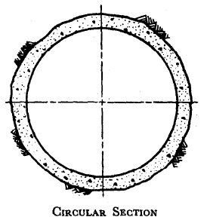
2.2.1.1 Circular section - The circular section is most suitable from structural considerations. However, it is difficult for excavation, particularly where cross-sectional area is small. .For tunnels which are likely to have to resist heavy inward or outward radial pressures, it is desirable to adopt a circular section. In case where the tunnel is subjected to high internal pressure, but does not have good quality of rock and/or adequate rock cover around it, circular section is considered to be the most suitable.

2.2.1.2 D Section - D section would be found suitable in tunnels located in massive igneous, hard, compacted, metamorphic and good quality sedimentary rocks. Where the external pressures due to water or unsound strata upon the lining is slight and also where the lining is not required to be designed against internal pressure. The principal advantages of this section over horse-shoe section are the added width of the invert which gives more working floor space in the heading during driving and the flatter invert which helps to eliminate the tendency of wet concrete to slump and draw away from the tunnel sides after it has been screeded.
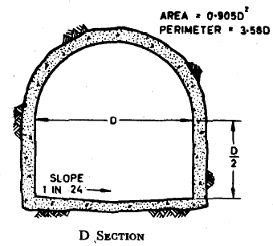

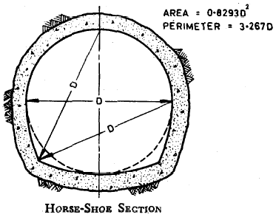
2.2.1.3 Horse-shoe section and Modified horse-shoe section - These sections are a compromise between circular and D sections. These sections are strong in their resistance to external pressures. Quality of rock and adequate rock cover in terms of the internal pressure to which the tunnel is subjected govern the use of these sections. Modified horse-shoe section offers the advantage of flat base for constructional ease and change over to circular section with minimum additional expenditure in reaches of inadequate rock cover and poor rock formations.
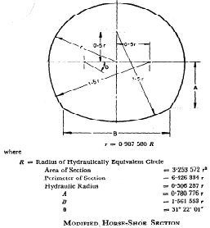

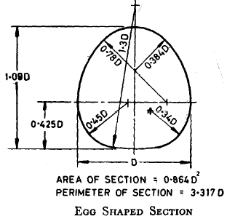
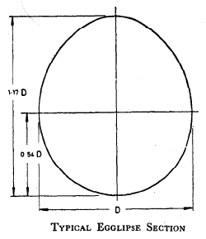
2.2.1.4 Egg shaped section and Egglipse section - Where the rock is stratified, soft and very closely laminated (as laminated sand stones, slates, micaceous schists, etc) and where the external pressures and tensile forces in the crown are likely to be high so as to cause serious rock falls, egg shaped and egglipse sections should be considered. In the case of these sections there is not much velocity reduction with reduction in discharge. Therefore, these sections afford advantage in cases of sewage tunnels and tunnels carrying sediments. Egglipse has advantage over egg shaped section as it has a smoother curvature and is hydraulically more efficient.

2.2.1.5 Other section- In addition to the sections mentioned above there may be other composite geometrical sections which may be adopted particularly for tunnels which are free flowing and often only partly lined. If characteristics of a rock formation are fairly well known it may be possible to evolve a section which is likely to fit the shape in which the rock will break naturally. Thus, while a horse-shoe or D section is fairly easy to obtain in some formations there are others where the tunnel crown tends to break into a form more nearly square, and if there is no risk of heavy external pressure upon the lining or if the tunnel is to be unlined there is no reason why the designed cross section should not be made to suit the-characteristics of the rock.

2.3 TUNNEL SUPPORT
Very few tunnels are located in perfectly intact strata throughout their whole lengths, the vast magnitude being driven through rock with defects of one kind or another and requiring some support until the permanent lining can be placed. Even intact rock in areas of high initial stresses may require support to prevent popping. Moreover, construction of tunnels involves a large number of problems because of the great longitudinal extent of the work and many kinds of conditions are encountered which for maximum economy should be treated differently. In view of this it has been appreciated that it would be futile to prepare a rigid set of rules or procedures which shall be enforced without leaving any latitude for the exercise of discretion by the site engineer.

2.3.1. Steel Support
In view of the inherent advantages of steel supports over timber supports, the use of the former is recommended. In olden days timber was used in tunnel supports but now steel has become almost universally adopted as the standard material for supporting tunnels.
Steel supports have the following advantages over timber supports:
a) Steel ribs are easier to handle and require much less storage space;
b) Steel ribs when compared to timber would be smaller section wise and as such overall cross-sectional area of excavation wil1 be less;
c) Steel ribs become a part of permanent lining and also act as reinforcement. Thus, the thickness of lining will be less;
d) Steel ribs do not deteriorate like timber;
e) Steel ribs can be fabricated to the required shape in the shop and therefore their erection is faster; and
f) No especially skilled personnel are required for erection of steel supports.
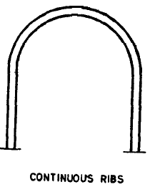
2.3.1.1. Types of steel support systems - Rock tunnel support systems of steel may be generally classified into the following principal types:
a) Continuous ribs: - This type can be erected more rapidly than the other types and is generally recommended for use in rocks whose bridge action period is long enough to permit removal of gases and mucking. Invert strut may be used in addition where mild side pressures are encountered
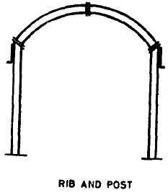
b) Rib and post: - This type is generally recommended for use in tunnels whose roof joins the side walls at an angle instead of a smooth curve. It may also be used in large tunnels, such as double-track rail road or two-lane highway tunnels, to keep the size of the -rib segments within handling and transporting limitations. Invert strut may be used in addition where mild side pressures are encountered

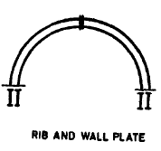
c) Rib and wall plate: - This type is generally recommended for use in tunnels with a large cross section with high straight sides through good rock or in large circular tunnels, where it is possible to support the wall plate by pins and where the stratum below the wall plate does not require support. This type of support may also be used for tunneling through spalling rock, provided spalling occurs only in the roof. However, in many cases it is extremely difficult to establish adequate support for the wall plate at any point above the floor-line due to irregularity of the over break.
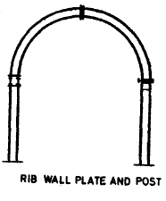
d) Rib, wall plate and post: - This type of support permits post spacing to be different from the rib spacing and is generally recommended for use in tunnels with high vertical sides. Invert strut may be used in addition, where mild side pressures are encountered.

e) Full circle rib: - This type is recommended for use in tunnels in squeezing, swelling and crushed rock, or any rock that imposes considerable side pressure.
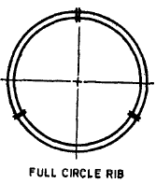

2.3.2. Roof Bolts Support
Roof bolting follows the principle of fastening the loose rocks near the surface to the solid rock above, by means of anchor bolts instead of supporting it from below. Roof bolts not only support the surface rock but also assist it to act as a load carrying element.

2.3.2.1 Types of Roof Bolts - The types of roof bolts used commonly have been described below.
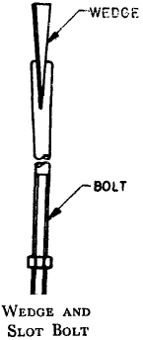
2.3.2.1.1. Wedge and Slot Bolts: - These consist of mild-steel rod, threaded at one end, the other being split into halves for about 125 mm length. A wedge made from 20 mm square steel and about 150 mm long shall be inserted into the slot and then the bolt driven into the hole which will make the split end to expand and fit tight into the hole forming the anchorage. Thereafter, a 10 mm plate washer of size 200 * 200 mm shall be placed and the nut tightened. The efficiency of the splitting of the bolt by the wedge depends on the strata at the end of the hole being strong enough to prevent penetration by the wedge end and on the accuracy of the hole drilled for the bolt. The diameter of such bolt may be 25 mm or 30 mm
.
2.3.2.1.2 Wedge and Sleeve Bolt: - This generally consists of a 20 mm diameter rod at one end of which is a cold rolled- threaded portion. The other end of tile rod is shaped to form a solid wedge forged integrally with the bolt and over this wedge a loose split sleeve of 33 mm external diameter is fitted. The anchorage is provided in this case by placing the bolt in the hole and pulling it downwards while holding the sleeve by a thrust tube. Split by the wedge head of the bolt, the sleeve expands until it grips the sides of the tube.
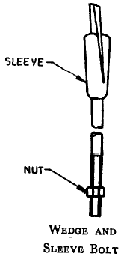

2.3.2.1.3 Perfo Bolts: - This method of bolting consists of inserting into a hole a perforated cylindrical metal tube which has been previously filled with cement mortar and then driving into the tube a plain or ridged bolt. This forces part of the mortar through the perforations in the tube and into intimate contact with the sides of the bore hole thus cementing the bolt, the tube and the rock into one homogeneous whole.
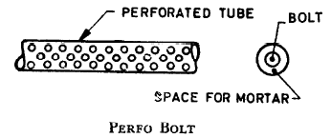

2.3.3. Shotcrete Support
Shotcrete for tunnel supports may be used by itself as thin skin type reinforcement or used in combination with rock bolts, wire mesh and other more conventional tunnel reinforcements. Details are given below:
a) Shotcrete is forced into open joints, fissures, seams and irregularities in the rock surface and in this way serves the same binding function as mortar in a stone wall.
b) Shotcrete hinders water seepage from joints and seams in the rock and thereby prevents piping of joint filling materials and air and water deterioration of the rock
c) Shotcrete’s adhesion to the rock surface and its own shear strength provide a considerable resistance to the fall of loose rock blocks from the roof of a tunnel.
d) A thicker shotcrete layer 150 to 250 mm provides structural support, either as a closed ring or as an arch type member.

2.3.3.1 Shotcrete Mix - Shotcrete shall be mixture of cement, sand and aggregate. The proportion of cement to aggregate in shotcrete may be normally 1 : 3 or 1 : 4; the aggregate being a mixture of sand and about 20 percent aggregate varying from 5 to 20 mm. The dry mixture of shotcrete shall be applied under pressure of about 3.5 kg/cm² by means of a nozzle through a concrete gun. To this nozzle, water shall be added also under pressure through a separate pipe. A quick setting agent shall be added to the dry mixture.

2.3.3.2 Shotcrete Thickness - The thickness of shotcrete required depends upon the type of rock, the extent of stratification and/or joints, blockiness and also the size of the tunnel. The thickness may normally range from 50 to 150 mm and whether it should be used plain or with wire-mesh anchored to rock will depend upon the actual site conditions in each case.

CHAPTER 3
DESIGN OF U/S AND D/S ROCKFILL COFFER DAM

3.1 DATA COLLECTED
The following data has been collected for the design of the coffer dam:
TABLE 3.1
1. | COFFER DAM | U/S | D/S
1.1 | River Bed Elevation | 708.00 m | 708.00 m
1.2 | Top Elevation Level | 735.30 m | 725.00 m
1.3 | Total Height of Dam | 27.30 m | 17.00 m
1.4 | Free Board included | 3.00 m | Above 3.00 m
2. | Maximum Fetch Length | 1.5 Km
3. | Angle of Internal Friction of rock | 40⁰
4. | Density of Rock | 2.1 t/m³

3.2 DESIGN CRITERIA
For safe and stable rockfill coffer dam, the design criteria will generally follow the guidelines given in IS: 10084 (Part-1) - 1982. "Criteria for Design of Diversion Works - Part I Coffer Dams".

3.2.1 Free Board
Sufficient free board is to be provided for the coffer dam so that no overtopping occurs due to the anticipated design construction flood and wave action.
As per clause 4.1.2 of IS: 10084 (Part-I) 1982, while fixing up the top level of Coffer dam, adequate free board is to be kept so that overtopping of the coffer dam due to waves created by wind action is avoided.

The height of the waves is calculated by the formula:
h_{w} = 0.0322 $\sqrt{\text{FV}}$ + 0.763 -0.271$\sqrt[4]{F}$ [Ref. Clause 4.1.2 of IS
10084 (Part 1)-1982]

Where,
h_{w} = height of waves in m measured between trough and crest
F = Fetch of reservoir in km
V = Velocity of wind on the water surface in km per hour
A free board of 1.5 h_{w} is required to be provided as per Clause 4.1.2 of IS: 10084 (Part I)_1982
Basic wind speed V_{b} = 39 m /sec (As per Figure 1 of IS: 875 (Part -3) - 1987) or 140.4 km/hour
Design wind speed (V₂) = V_{b} K₁ K₂ K₃
(As per clause of 5.3 of IS: 875 (part-3) - 1987;
K₁ = Probability factor (risk coefficient)
K₂ = Terrain, height and structure size factor
K₃ = Topography factor
As Per 5.3.1, refer Table-1, Risk Coefficient (K₁ factor) for different classes of structures in different wind speeds:
Class of Structures | k1 factor
For temporary sheds, structures such as those used during construction operations, structures during construction stages and boundary walls having mean probable life upto 5 years. | 0.76

As per 5.3.2, refer Table-2, factors to obtain design wind speed variation with height in different terrains for different classes of structure are given. For terrain Category 1 (the exposed open terrain with few or no obstructions), Class A (structure of less than 20m height) K₂ = 1.12.
As per clause 5.3.3. Topography factor (K₃) = 1.0
V₂ = 140.4 × 0.76 × 1.12 ×1 = 1195km/hr
F = Max Fetch = 1.5 km
Height of waves h_{w} = 0.0322 $\sqrt{\text{FV}}$ + 0.763 -0.271$\sqrt[4]{F}$

= 0.0322 (1.5 × 119.5)^{1/2} + 0.763 - 0.271 (1.5)^{1/4}
= 0.906 m
Therefore Freeboard to be provided = 1.5 h_{w}
= 1 5 × 0.906 = 1.358 m say 1.4m.
Thus, the top level of all the coffer dams is to be fixed ensuring a minimum free board of 1.4m.

3.2.2 Top Width
The top width of coffer dam normally depends on stability, practical requirements for safe passage of all heavy equipments likely to pass over the coffer dam and practicability of construction. A top width of 8m is assumed for both u/s and d/s rockfill coffer dams which is considered adequate.

3.2.3 Side Slopes
The upstream and downstream slopes of the rockfill coffer dam shall be suitable for the material proposed to be used in the construction of coffer dam. As per clause 7.4.2.4 of IS: 10084 (Part 1), u/s slopes varies from 1.5.1 to 1:1 and the d/s slope from 1.25:1 to 1.5:1. it is, however, proposed to provide a slope of 2:1 on u/s (water side) and a slope of 1.5:1 on d/s (dry side), which is slightly flatter than above and, therefore, on safer side.

3.3 STABILITY CALCULATIONS
3.3.1 The rockfill coffer dam must be safe against sliding and factor of safety against sliding may be computed as given in clause 7.2.7.2.2 of IS: 10084 (Part 1) 1982.
$$F=\frac{(W−U)\text{tan}ϕ+\text{CA}}{P}$$
F = factor of safety
W = total weight of the dam
U = total uplift force
tan φ = coefficient of internal friction of the material

C = cohesion of the material at the plane considered, if existing
A = area under compression; and
P = total horizontal force, including earthquake forces, considered, if any
As the rockfill coffer dams are being built on river bed, the value of cohesion may be adopted as C = 0 and angle of internal friction φ = 40°. The factor of safety (FOS) against sliding is prescribed to be not less than 3.0 in Clause 7.2.9.3 of IS: 10084 (Part I)-1982. FOS against sliding has been checked for u/s rockfill coffer dam (Ref. Table-3.2) and for d/s rockfill coffer dam (Ref. Table-3.3) and is seen to be much more than 3.

3.3.2 Calculations for slope stability for D/S coffer dam are given in Table-3.4 and Table-3.5 respectively for water side and dry side slopes. Both the slopes are seen to be adequately stable.

3.3.3 Earthquake force is not considered in either of the above calculations as the coffer dams are temporary structures for which effect of earthquake is not required to be considered as Per clause 4.1.3 of IS: 10084 (Part-1) - 1982

TABLE No. 3.2

U/S ROCKFILL COFFER DAM
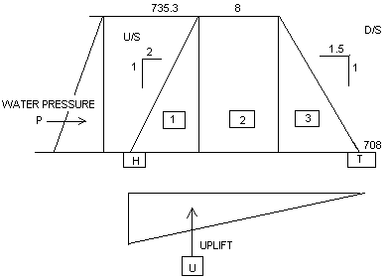
INPUT DATA
TOP EL | 735.30 | m
BOTTOM EL | 708.00 | m
U/S SLOPE (H:V) | 2.00
D/S SLOPE (H:V) | 1.50
WIDTH AT TOP | 8.00 | m
DENSITY | 2.10 | t/m³

CALCULATIONS
HEIGHT OF DAM | 27.30 | m
U/S TRIANGLE
WIDTH | 54.60 | m
AREA | 745.29 | m²
W1 | 1565.10 | t
X1 | 67.15 | m
Y1 | 9.10 | m

MIDDLE RECTANGLE
WIDTH | 8 | M
AREA | 218.40 | m²
W2 | 458.64 | t
X2 | 44.95 | m
Y2 | 13.65 | m

D/S TRIANGLE
WIDTH | 40.95 | m
AREA | 558.96 | m²
W3 | 1173.83 | t
X3 | 27.30 | m
Y3 | 9.10 | m

TOTAL BASE WIDTH | 103.55 | m
W TOTAL WIGHT | 3197.57 | t

CG OF DAM
X | 49.34 | m
Y | 9.75 | m

FORCES
WATER PRESSURE
P | 372.64 | t
Y_{P} | 9.10 | m
WEIGHT OF WATER
AREA | 745.29 | m²
W_{W} | 745.29 | t
X_{W} | 85.31 | M

UPLIFT
U | 1413.45 | t
X_{U} | 69.03 | m

Name of the Force | Notation | Magnitude of Force (t) |  |  |  | Lever Arm | Moments About Toe
Name of the Force | Notation | Vertical |  | Horizontal |  | Lever Arm | Clockwise +ve
Name of the Force | Notation | Down +ve |  | Towards U/S –ve |  | (m) | Anticlockwise -ve
Name of the Force | Notation | Up –ve |  | Towards D/S +ve |  | (m) | t – m
WEIGHT OF ROCKFILL | W |  | 3197.57 |  |  | 49.336 |  | -157755.31
WATER PRESSURE | P |  |  |  | 372.645 | 9.10 |  | 3391.07
WATER PRESSURE | W_{w} |  | 745.29 |  |  | 85.31 |  | -63580.69
UPLIFT | U |  | -1413.45 |  |  | 69.03 |  | 97570.45

OVERTURNING
Mr | 221336 | t - m
Mo | 100961.52 | t – m
FOS | Mr/Mo | 2.19
SLIDING
TOTAL VERTICAL FORCE | 2529.41 | t
TOTAL HORIZONTAL FORCE | 372.645 | t
Ф | 40 | º
C | 0 | kg/cm²
C | 0 | t/m²
AREA IN CONTACT | 103.55 | m²
FOS AGAINST SLIDING | ((W-U)tanf + CA)/P
 | 5.69

TABLE No. 3.3
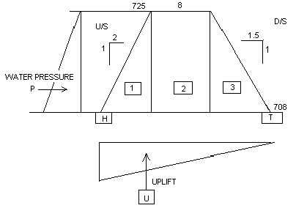
D/S ROCKFILL COFFER DAM
INPUT DATA
TOP EL | 725.00 | m
BOTTOM EL | 708.00 | m
U/S SLOPE (H:V) | 2.00
D/S SLOPE (H:V) | 1.50
WIDTH AT TOP | 8.00 | m
DENSITY | 2.10 | t/m³

CALCULATIONS
HEIGHT OF DAM | 17.00 | m
U/S TRIANGLE
WIDTH | 34.00 | m
AREA | 289.00 | m²
W1 | 606.90 | t
X1 | 44.83 | m
Y1 | 5.66 | m

MIDDLE RECTANGLE
WIDTH | 8.00 | m
AREA | 136.00 | m²
W2 | 285.60 | t
X2 | 29.50 | m
Y2 | 8.50 | m

D/S TRIANGLE
WIDTH | 25.50 | m
AREA | 216.75 | m²
W3 | 455.17 | t
X3 | 17.00 | m
Y3 | 5.66 | m

TOTAL BASE WIDTH | 67.50 | m
W TOTAL WIGHT | 1347.67 | t

CG OF DAM
X | 32.18 | m
Y | 6.00 | m

FORCE
WATER PRESSURE
P | 144.50 | t
Y_{P} | 5.66 | m
WEIGHT OF WATER
AREA | 289.00 | m²
W_{W} | 289.00 | t
X_{W} | 56.16 | m

UPLIFT
U | 573.75 | t
X_{U} | 45.00 | m

Name of the Force | Notation | Magnitude of Force (t) |  |  |  | Lever Arm | Moments About Toe
Name of the Force | Notation | Vertical |  | Horizontal |  | Lever Arm | Clockwise +ve
Name of the Force | Notation | Down +ve |  | Towards U/S –ve |  | (m) | Anticlockwise -ve
Name of the Force | Notation | Up –ve |  | Towards D/S +ve |  | (m) | t – m
WEIGHT OF ROCKFILL | W |  | 1347.68 |  |  | 32.18 |  | -43372.53
WATER PRESSURE | P |  |  |  | 144.50 | 5.67 |  | 818.83
WATER PRESSURE | W_{w} |  | 289.00 |  |  | 56.17 |  | -16232.17
UPLIFT | U |  | -573.75 |  |  | 45.00 |  | 25818.75

OVERTURNING
Mr | 59604.69 | t - m
Mo | 26637.58 | t – m
FOS | Mr/Mo | 2.238
SLIDING
TOTAL VERTICAL FORCE | 1062.93 | t
TOTAL HORIZONTAL FORCE | 144.50 | t
Ф | 40 | º
C | 0 | kg/cm²
C | 0 | t/m²
AREA IN CONTACT | 67.5 | m²
FOS AGAINST SLIDING | ((W-U)tanf + CA)/P
 | 6.172

TABLE No. 3.4
STABILITY OF UPSTREAM (WATER SIDE) SLOPE OF DOWNSTREAM ROCKFILL COFFER DAM

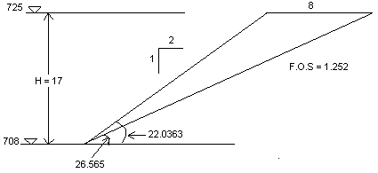
INPUT:
HEIGHT OF OVERALL SLOPE OR OF EACH BENCH | H | 17.00 m
ANGLE OF SLOPE FACE MEASURED FROM HORIZONTAL | φ_{f} | 26.575
ANGLE OF FAILURE SURFACE MEASURED FROM HORIZONTAL | φ_{p} | 22.036
DEPTH OF WATER ON FAILURE SURFACE | Z_{w} | 14.00 m
HORIZONTAL EARTHQUAKE ACCELERATION | α | 0.00
UNIT WEIGHT OF ROCK | γ_{r} | 0.021 MN/m³
UNIT WEIGHT OF WATER | γ_{w} | 0.010 MN/m³
COHESIVE STRENGTH ALONG SLIDING SURFACE | c | 0.00
FRICTION ANGLE ALONG SLIDING SURFACE | ф | 40.00
FORCE APPLIED BY ANCHOR SYSTEM | T | 0.00
INCLINATION OF ANCHOR | θ | 0.00

INPUT CALCULATIONS:
WEIGHT OF ROCKFILL WEDGE RESTING ON FAILURE SURFACE | W | 3.557 MN
BASE AREA OF WEDGE | A | 15.310 m²
UPLIFT FORCE DUE TO WATER PRESSURE ON FAILURE SURFACE | U | 1.306 MN

CALCULATIONS:
$\text{FACTOR OF SAFETY}=\frac{\text{cA}+(W({\text{cos}ϕ}_{p}−{α\text{sin}ϕ}_{p})−U+T\text{cos}θ)\text{tan}φ}{W({\text{sin}ϕ}_{p}+{α\text{cos}ϕ}_{p})−T\text{sin}θ}$ = 1.252

TABLE No. 3.5
STABILITY OF DOWNSTREAM (DRY SIDE) SLOPE OF DOWNSTREAM ROCKFILL COFFER DAM
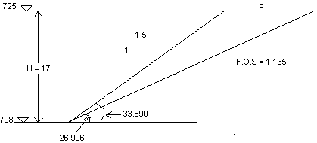

INPUT:
HEIGHT OF OVERALL SLOPE OR OF EACH BENCH | H | 17.00 m
ANGLE OF SLOPE FACE MEASURED FROM HORIZONTAL | φ_{f} | 33.690
ANGLE OF FAILURE SURFACE MEASURED FROM HORIZONTAL | φ_{p} | 26.906
DEPTH OF WATER ON FAILURE SURFACE | Z_{w} | 8.50 m
HORIZONTAL EARTHQUAKE ACCELERATION | α | 0.00
UNIT WEIGHT OF ROCK | γ_{r} | 0.021 MN/m³
UNIT WEIGHT OF WATER | γ_{w} | 0.010 MN/m³
COHESIVE STRENGTH ALONG SLIDING SURFACE | c | 0.00
FRICTION ANGLE ALONG SLIDING SURFACE | ф | 40.00
FORCE APPLIED BY ANCHOR SYSTEM | T | 0.00
INCLINATION OF ANCHOR | θ | 0.00

INPUT CALCULATIONS:
WEIGHT OF ROCKFILL WEDGE RESTING ON FAILURE SURFACE | W | 1.428 MN
BASE AREA OF WEDGE | A | 37.567 m²
UPLIFT FORCE DUE TO WATER PRESSURE ON FAILURE SURFACE | U | 0.399 MN

CALCULATIONS
$\text{FACTOR OF SAFETY}=\frac{\text{cA}+(W({\text{cos}ϕ}_{p}−{α\text{sin}ϕ}_{p})−U+T\text{cos}θ)\text{tan}φ}{W({\text{sin}ϕ}_{p}+{α\text{cos}ϕ}_{p})−T\text{sin}θ}$ = 1.135

CHAPTER 4
DESIGN OF INLET STRUCTURES OF DIVERSION TUNNELS

4.1 DATA COLLECTED
The following data has been collected for the design of the inlet structure of diversion tunnel:
TABLE 4.1
1. | Maximum Reservoir Elevation |  |  | 815.0 m
2. | Top E.L. of Inlet Structure |  |  | 739.0 m
3. | Bottom E.L. of Inlet Structure |  |  | 710.0 m
4. | Length of Inlet Structure |  |  | 15.3 m
5. | Transition (2 nos.) | U/S Transition is from 15m(W)×13m(H) to 11m(W)×11m(H) Rectangular Section | D/S Transition is from  11m(W)×11m(H) Rectangular to required Flat Invert Shoe Shape of Size 10.481m(W)×10.637m(H)
6. | Size of Gate Opening (2 nos.) |  |  |  | 3.5m(W)×11m(H)
7. | Central Pier Thickness |  |  |  | 4.0 m
8. | Thickness of Side Walls |  |  |  | 2.5 m
9. | Thickness of Gate Groove |  |  |  | 1.2 m
10. | Depth of Gate Groove |  |  |  | 0.7 m
11. | Radius at the Nose of Central Pier |  |  |  | 2.0 m

On the basis of collected data a Fig. no.4.1 is prepared showing the details of inlet structure as shown below.

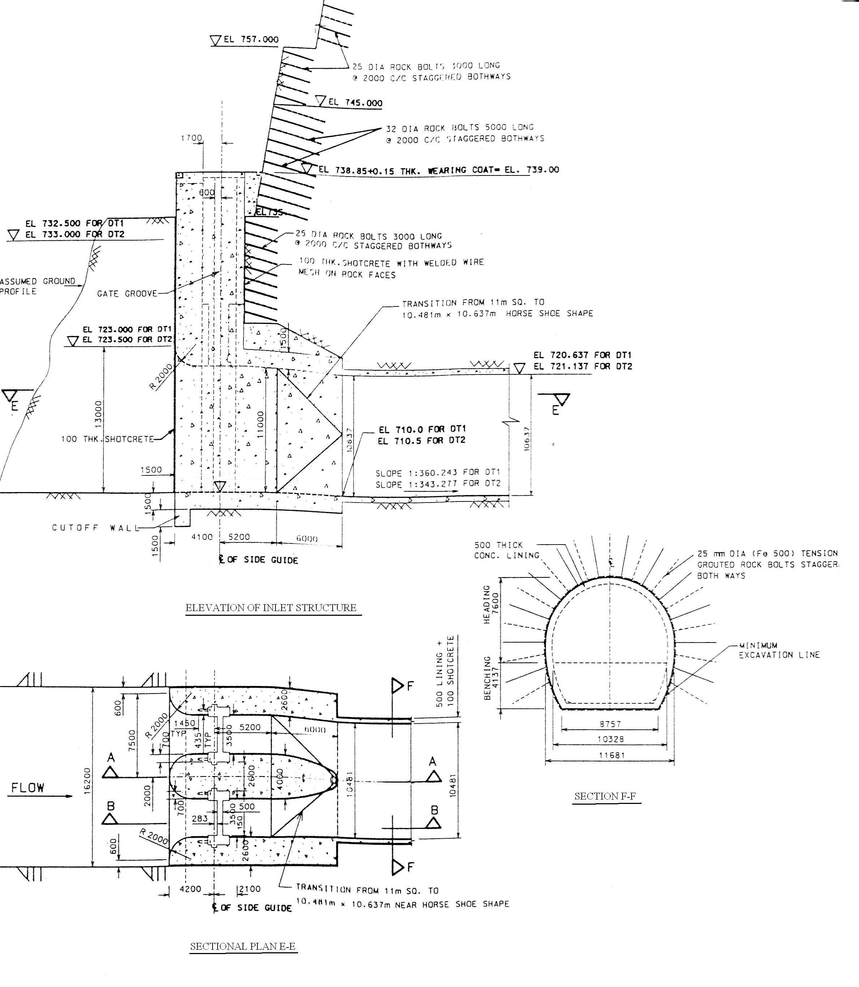

FIG. 4.1 DETAILS OF INLET STRUCTURE
4.2 GENERAL
For providing smooth entry of river waters into diversion tunnels and for housing gates and gate grooves, inlet structures are to be provided at the inlet ends of both of the diversion tunnels. The concrete inlet structures will have their top at EL 739.0 m where a working platform will be developed for erection, commissioning and operation of gates.
The inlet structure will be constructed partly underground, the portion which is on the downstream side of the gate grooves and will admit waters of the river through a channel of 15m base width excavated in rock up to the river. There will be an open rock face on hill side of working platform of each inlet structure, which will be cut and treated to remain stable.

4.3 DESIGN CRITERIA OF INLET STRUCTURE
4.3.1 Loads
In addition to self weight of concrete, the inlet structure is subjected to following loads/pressures.
i) External rock load
ii) External water pressure
iii) Internal water pressure

4.3.1.1 External rock load - External rock loads have not been considered in the design of diversion tunnel. It is considered that the rock supports provided during excavation will take care of these loads. However, the force transmitted by steel ribs proposed to support rock on the downstream side of the gate grooves i.e., in the underground portion of the inlet structures, have been considered to calculate rock pressures on side walls to be on safer side.
The load coming from steel ribs placed at 0.5 m c/c is as given below:
The analysis of steel ribs is performed by using STAAD-Pro. The modeling details and output is shown in Annexure 4.1 and the model with Shear Force and Bending Moment diagram is shown below in Fig. no.4.2.

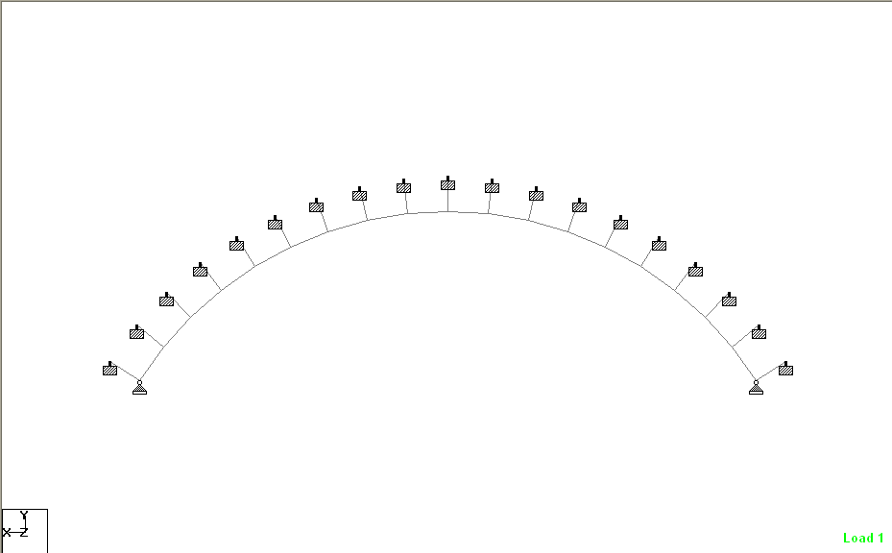
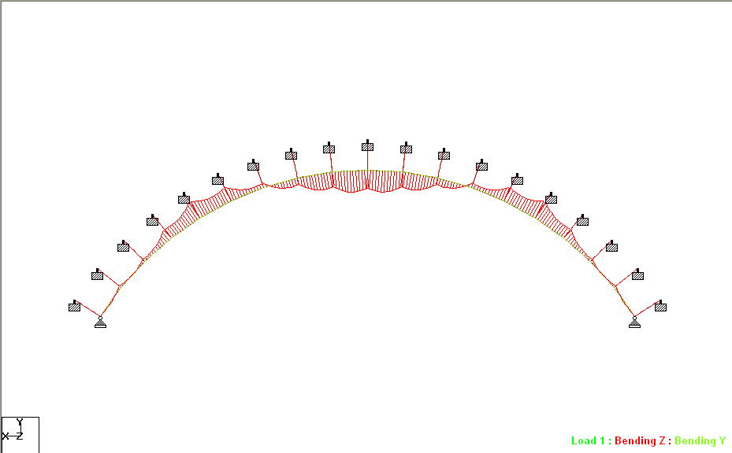
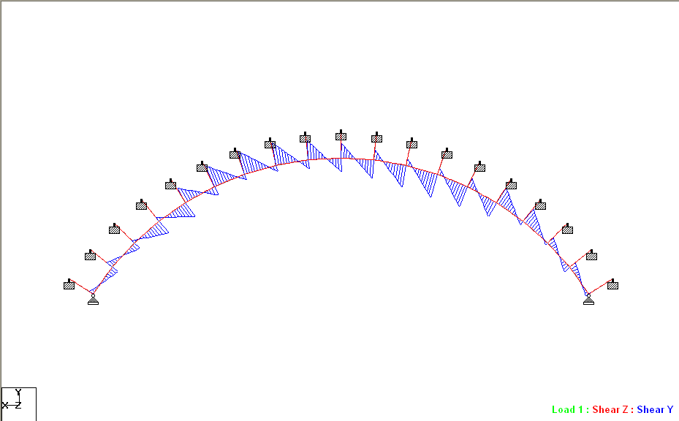
FIG. 4.2 MODEL WITH S.F.D. AND B.M.D

Horizontal component = 744.83 KN per rib
1489.66 KN per meter length
Vertical component = 1060.46 KN per rib
2120.92 KN per meter length
The horizontal component is acting outwards and is ignored to be on safer side. The vertical component will cause inward horizontal pressure which is calculated ignoring cohesion in rock mass and cohesion between wall & rock. The angle of internal friction of rock is assumed to be 35º. The surface of wall is also assumed smooth so that there is no wall friction.
Assuming slide plane in rock mass to be at 45º to horizontal.
Let the reaction of rock on sliding wedge = Pr and
Reaction of wall on sliding wedge of rock = Pw
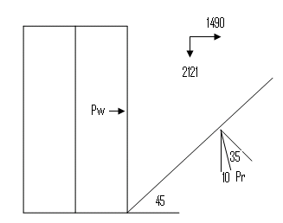

For equilibrium -
Pr cos10º = 2120.92 kN ……….. (1)
Pr sin 1 = Pw………………..... (2)
Dividing equation (2) by (1)
$$\frac{\text{prSin}\text{10}°}{\text{prCos}\text{10}°}=\frac{{{}_{p}}_{w}}{\text{2120}\text{.}\text{92}}$$
Or Pw = 2120.92 tan 10 kN
= 373.98 kN
Now by dividing P_{W} by the height of side wall, the lateral rock pressure on each side wall due to vertical force transmitted by rib per meter height of side wall works out to be
$$\frac{\text{373}\text{.}\text{98}}{\text{12}\text{.}5}=\text{29}\text{.}\text{92}{\text{kN}}/m$$
It may be mentioned that actual rock pressure transmitted will be even smaller in magnitude because of wall friction and cohesion of rock which have been ignored.

4.3.1.2 External water pressure - External water pressure will be important and critical in the portion of inlet structure d/s of the inlet gates after the gates are lowered down and the tunnels are emptied. External water pressure on the inlet structure will develop due to seepage of reservoir water through the joints in rock. This seepage and correspondingly water pressure takes some time to develop. The assessment of this water pressure is difficult and has to be based or judgment. In this connection, the following facts are required to be kept in mind.
i) It is proposed to grout the rock mass around the inlet structure upto a suitable depth. It is also proposed to ream and redrill further the grout holes on the downstream side of gate grooves upto a suitable.
ii) However, drainage holes will relieve the surrounding rocks of water pressure to a great extend. The extent of relief is a matter of judgment. In the case of dams the relief in uplift pressure due to seepage through foundations, at the line of drainage holes, for purposes of design is assumed to be 2/3rd i.e. 66.7% of the differential between reservoir level and tail water level. In the case of inlet structures only 50% relief due to drainage holes has been assumed in external water pressure although actual relief is expected to be much more than this. As such maximum design external water pressure for the inlet structure has been assumed to be 50% of that corresponding to the reservoir water surface El 815m

4.3.1.3 Internal water pressure - Internal water pressure will be acting on the inlet structure when its ducts are running full. But they have not been considered in design as these will be balanced by corresponding external water pressures and support of the surrounding rock mass.

4.3.2 Critical condition for design
It transpires from the above that the critical condition for the design of inlet structures may be taken as that occurring in the short duration of tunnels remaining empty before being concrete plugged and the structure in that case Should be assumed to be subjected to50% of external water pressure Corresponding to reservoir El815.0m and in addition external rock pressure due to forces transmitted by steel ribs (which is equal to 29.92 KN/m).

4.3.3 Earthquake effect
For the short duration of tunnels remaining empty before being concrete plugged when the inlet structure will be subjected to critical condition for design, only the effect of design basis earthquake (DBE) will be considered. It is felt that for such a short duration, the effect of maximum credible earthquake (MCE) need not be considered. The value of effective peak ground horizontal acceleration corresponding to DBE for design of dam is to be taken as 0.11 g. No further consideration of the seismic zone factor and importance factor are required over it and soil foundation factor may be taken as per IS: 1893-1984 which incidentally is 1 for rock or hard soils. Vertical earthquake acceleration is to be taken as 2/3 of horizontal earthquake acceleration.
As per note given in Table-2/C1 3.4.2.1 of IS:1893-1984 for underground structures and foundations at 30m depth or below, the basic seismic coefficient may be taken as 0.5 α_{o} and for structures placed between ground level and 30 m depth, the basic seismic co-efficient may be linearly interpolated between α_{o} and 0.5 α_{o}.
The depth to centre of inlet structure below ground is about 23m. As such horizontal earthquake coefficient is to be taken as:
= $1−\frac{\text{23}\text{.}0}{\text{30}}∗(1−\text{.}5)$
= 1-0.38 = 0.62
The horizontal ground acceleration for design of inlet structure is therefore to be taken as:
= 0.62 × 0.11g = 0.068 g
The vertical ground acceleration for design may be taken as:
= $\frac{2}{3}∗\text{.}\text{068}g$ = 0.045g
It may, however, be mentioned that design ground accelerations are to be used for calculating inertia forces only. For calculating hydro dynamic forces that would act through the gates, horizontal seismic acceleration = 0.11 g only would be used because the body of water in the reservoir is seated directly on ground and not inside ground.

4.4 ANALYSES OF INLET STRUCTURES
4.4.1 No earthquake case
Design of inlet structure has been done by the limit state method of design using a load factor of 1.5. STAAD-Pro software has been used for analyzing the structure. The cross-section & water pressure diagram is shown below in Fig. no. 4.3. The input file, geometry and results of analysis are given in Annexure 4.2 and the model with Shear Force and Bending Moment diagram is shown in Fig. no. 4.4.
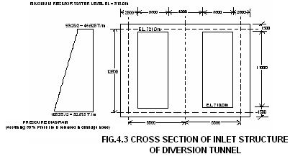

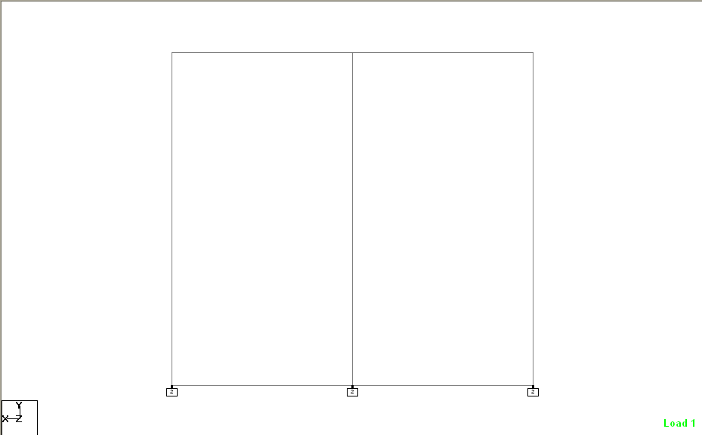
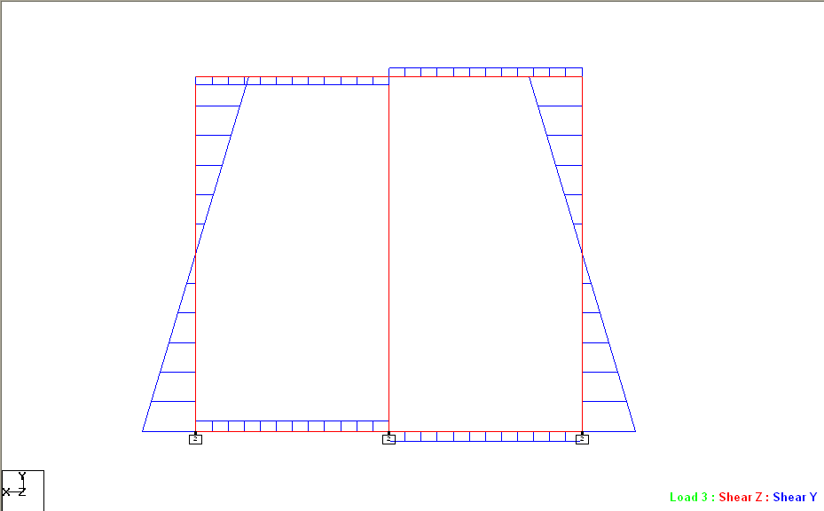
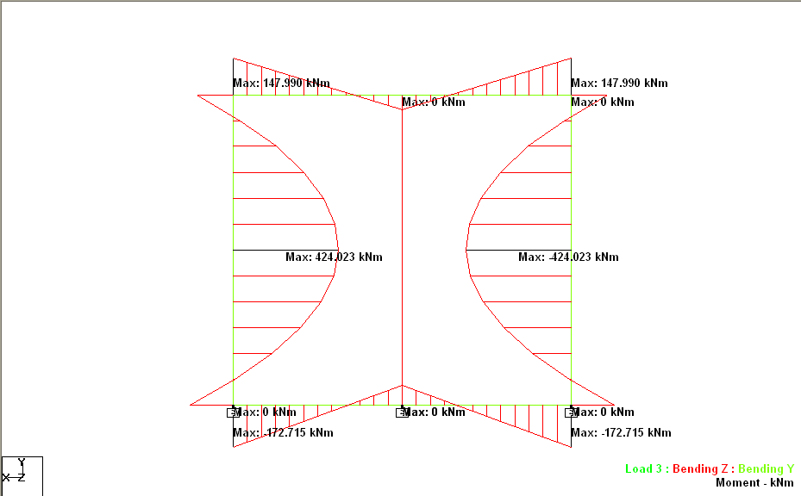

FIG. 4.4 MODEL WITH S.F.D. AND B.M.D

4.4.2 Earthquake case
4.4.2.1 Calculation of forces
[A]. Due to horizontal around acceleration: Calculations for forces due to horizontal earthquake are as given below. 1 m length of structure along the direction of flow has been considered.
a) Horizontal force on side walls
Thickness of each side wall = 2.5 m
Lateral force on each side wall due to horizontal ground acceleration due to earthquake.
2.5×1×1×2.4×0.068
= 0.408 t/m
= 4.08 kN/m
b) Horizontal force on central pier
Thickness of pier = 4m
lateral force on the pier due to horizontal ground acceleration due earthquake.
= 4×1×1×2.4×0.068
= 0.6528 T/m
= 6.528 KN/m
c) No hydro dynamic water pressures are required to be considered due to seepage water in rock as per clause 7.3.1.3 of IS: 1893-1984.

[B] Due to vertical ground acceleration:
Earthquake forces due to vertical ground acceleration have not been considered. These will have the effect of only increasing or decreasing momentarily the weight of the structure by 0.045 times which is insignificant.
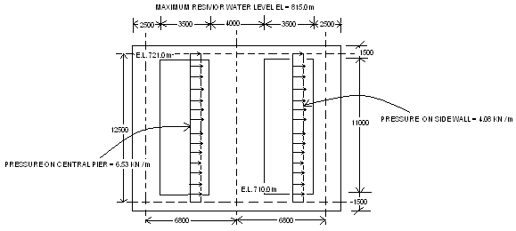
The analysis of structure for earthquake forces has been carried out by software STAAD-Pro. The load diagram is shown below in Fig. no. 4.5.and input file, geometry and results of analysis are given in Annexure 4.3 and the model with Shear Force and Bending Moment diagram is shown in Fig. no. 4.6.

FIG. 4.5 EARTHQUAKE FORCES ON INLET STRUCTURE

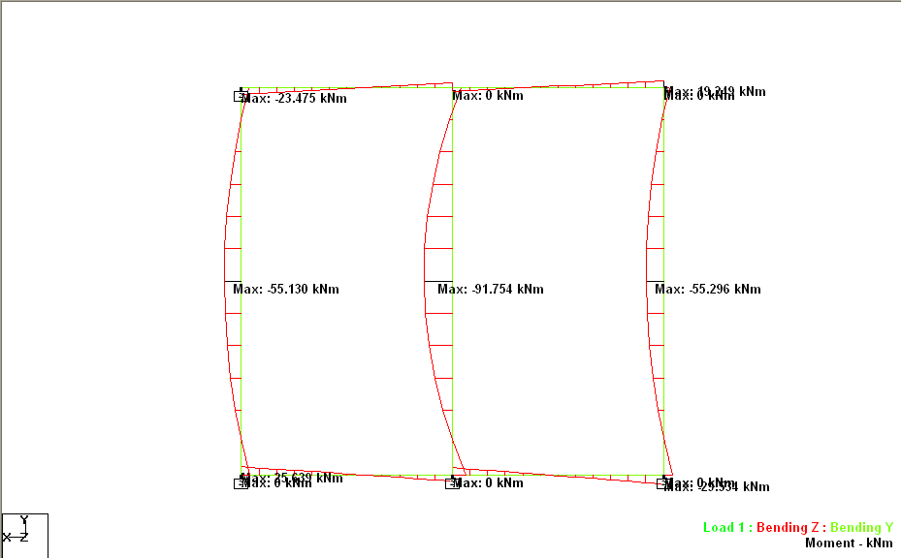
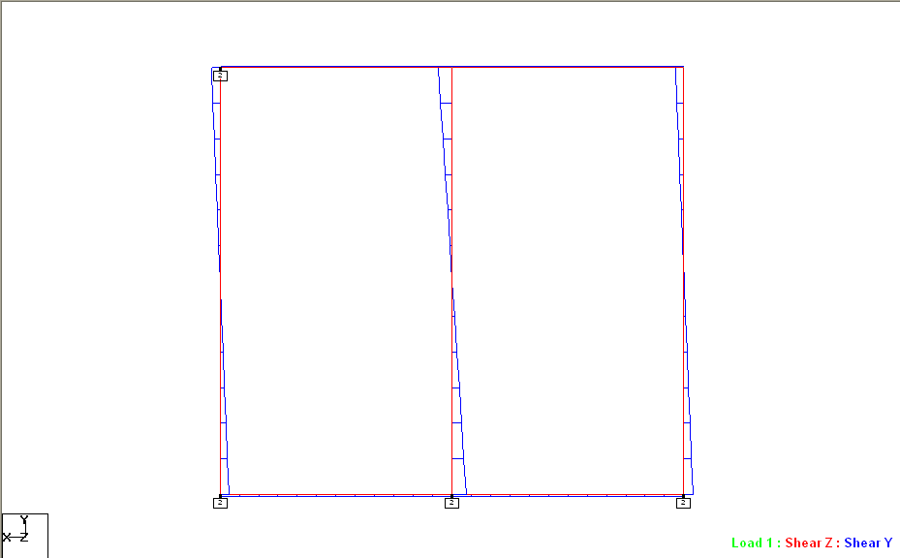
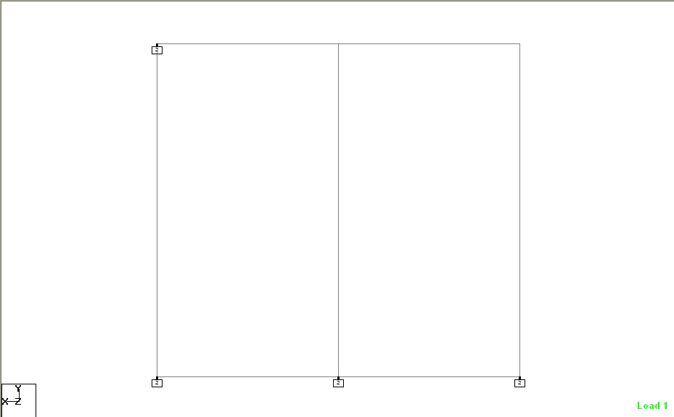
FIG. 4.6 MODEL WITH S.F.D. AND B.M.D

4.4.3 Comparison of result for no earthquake and earthquake case
It is seen that bending moments and shear forces due to earthquake are less than even 10% of those due to design external water pressures, whereas 33% increase in allowable stresses is permissible in earthquake case for working stress method of design and 30% reduction in load factor in limit state method of design is permitted as per CI. 3.3.1 of IS⁻.1 893 and 35.4.1 of IS 456-2000. As such earthquake case is not critical from the point of view of design of inlet structures.

4.5 DESIGN OF PIER
4.5.1 Critical Design Condition
The design of central pier of inlet structure is critical for the horizontal pressure which is transferred to it through the inlet gates and directly to its nose. Horizontal water pressure for a reservoir water level of EL 81 5.0m has been considered in design.

4.5.2 Checking against Sliding
The central pier has been checked for sliding resistance to the water pressure so that it may not slide against the top and bottom slabs corresponding to the critical deign condition mentioned above. Resistance in sliding of pier will be provided by friction and cohesion of concrete developing at the surfaces of possible sliding i.e. at its contact with top and bottom slabs.
Safety against tendency to slide has been ensured by checking shear friction factor of safety defined as below.
F=(C*A+W*tan (φ))/H
Where
F = Factor of safety against sliding
A = Area under consideration for cohesion
W = Total Weight of structure
tan (φ) = Coefficient of internal friction
C = Cohesion of concrete
H = Total Horizontal force
The factor of safety against sliding works out to be 1.436 (Table 4.2) when no earthquake effect is considered and 1.315 (Table 4.3) when earthquake effect is also considered.

4.5.3 Checking of Gate Groove Depth in Bearing
700 mm deep gate groove is provided in pier as well as side walls. Total hydraulic pressure on one gate will be transferred half to side wall groove & half to pier groove. Maximum pressure will be transmitted near bottom corresponding to a head of El. 815 - 710m = 105m i.e. equal to 105 t/m² of gate.
[A] For normal case without earthquake
Force on bottom 1 m height of one groove
= $\text{105}∗1∗\frac{3\text{.}5}{2}$
= 183.75 t
Bearing pressure on gate groove
= 183.75/1m×0.7m
= 262.5 t/m²
= 2.625 N/mm²
Which is less than permissible value of 5N/mm² (Ref. Table 15 of IS 456:2000)
[B] For earthquake case
Force on bottom 1 m height of one groove
= $(\text{105}+8\text{.}4)∗1∗\frac{3\text{.}5}{2}$
= 198.45 t
Bearing pressure on gate groove
= 198.45/1m×0.7m
= 283.5 t/m²
= 2.84 N/mm²
Which is less than permissible value of 5N/mm² (Ref. Table 15 of IS 456:2000)

4.5.4 Compressive Stress in Central Pier
From Annexure 4.3, it is seen that there is no bending moment in pier and that it is subjected to a direct thrust of 3794.06 KN. Compressive stress induced due to this direct thrust in pier
= 3794.06/(4x1)
= 948.52 kN/m²
= 0.949 N/mm²
Which is well within permissible limit of 5N/mm^{Z} for M20 grade concrete (Ref -Table 15 of IS 456: 1978).

TABLE 4.2
Design of Central Pier
Checking Against sliding - Normal case
- Calculations for area of pier in contact with top and bottom slabs
Area of central pier at bottom
rectangular |  | 4.00 | 7.30 | 29.20 | m²
less groove | 2 nos | 0.70 | 1.20 | -1.68 | m²
semicircle |  | 2.00 | Π=3.14 | 6.28 | m²
transition portion |  |  |  | 18.27 | m²
bottom area |  |  |  | 52.07 | m²
Area of central pier at top |  |  |  | 52.07
total area , A |  |  |  | 104.14 | m²

- Calculations for horizontal forces
Forces
a water head | 815.00 | 715.50 | 99.50 | m
area of one gate | 3.50 | 11.00 | 38.50 | m²
horizontal force from gates, H1 |  |  | 3830.75 | t
area of pier | 4.00 | 11.00 | 44.00 | m²
horizontal force directly to pier, H2 |  |  | 4378.00 | t
 |  | Total force | 8208.75 | t

- Calculations for weight on pier
 | Area(m²) | height (m) | density(t/m³) | load(tons)
Loads on central pier | 52.07 | 11 | 2.4 | 1374.66
Total Vertical forces, W |  |  |  | 1374.66

- Calculation for sliding factor of safety
C | 1000 | KN/m²
φ | 45.00 | degree
A | 104.14 | m²
W | 13746.6 | KN
H | 82087.5 | KN
F | 1.436 | Safe

F = (C*A+ (W)*TAN (φ))/H
Where,
F = Factor of safety against sliding
C = Cohesion of the material at the plane considered
A = Area under consideration for cohesion
W = Total Weight of structure
tan (φ) = Coefficient of internal friction of the material
H = Total Horizontal force

.

TABLE 4.3
Design of Central Pier
Checking Against sliding - Earthquake case
- Calculations for area of pier in contact with top and bottom slabs
Area of central pier at bottom
rectangular |  | 4.00 | 7.30 | 29.20 | m²
less groove | 2 nos | 0.70 | 1.20 | -1.68 | m²
semicircle |  | 2.00 | Π=3.14 | 6.28 | m²
transition portion |  |  |  | 18.27 | m²
bottom area |  |  |  | 52.07 | m²
Area of central pier at top |  |  |  | 52.07
total area , A |  |  |  | 104.14 | m²

- Calculations for horizontal forces
Forces
A] water head | 815.00 | 715.50 | 99.50 | m
area of one gate | 3.50 | 11.00 | 38.50 | m²
horizontal force from gates, H1 |  |  | 3830.75 | t
area of pier | 4.00 | 11.00 | 44.00 | m²
horizontal force directly to pier, H2 |  |  | 4378.00 | t
B] hydrodynamic pressure as per IS 1893, see page 3 of this table |  |  | 8.430 | t/m²
Area of gate + pier on which hydrodynamic pressure will act |  |  | 82.50 | m²
Horizontal hydrodynamic force, H3 |  |  | 750.75 | t
 |  | Total force | 8959.50 | t

- Calculations for weight on pier
 | Area(m²) | height (m) | density(t/m³) | load(tons)
Loads on central pier | 52.07 | 11 | 2.4 | 1374.66
Total Vertical forces,W |  |  |  | 1374.66

- Calculation for sliding factor of safety
C | 1000 | KN/m²
φ | 45.00 | degree
A | 104.14 | m²
W | 13746.6 | KN
H | 89595.0 | KN
F | 1.315 | Safe

F = (C*A+ (W)*TAN (φ))/H
Where,
F = Factor of safety against sliding
C = Cohesion of the material at the plane considered
A = Area under consideration for cohesion
W = Total Weight of structure
tan (φ) = Coefficient of internal friction of the material
H = Total Horizontal force

HYDRODYNAMIC FORCES ON GATE OF INLET STRUCTURE

α_{h} = 0.11; C_{m} = 0.73; H = 105.0 m
Y  (A) | Y/H  (B) | 2-Y/H  (C) | Y/H(2-Y/H)  (D) | Sqrt(Y/H(2-Y/H))  (E) | (D)+(E) | C_{S} | P = C_{S}×α_{h}×W×H (10E4 N/m²)
0.00 | 0.00 | 2.00 | 0.00 | 0.00 | 0.00 | 0.00 | 0.00
4.04 | 0.04 | 1.96 | 0.07 | 0.27 | 0.35 | 0.13 | 1.47
8.48 | 0.08 | 1.92 | 0.15 | 0.39 | 0.55 | 0.20 | 2.31
18.44 | 0.18 | 1.82 | 0.32 | 0.57 | 0.89 | 0.32 | 3.74
28.40 | 0.27 | 1.73 | 0.47 | 0.68 | 1.15 | 0.42 | 4.85
38.36 | 0.36 | 1.63 | 0.56 | 0.77 | 1.37 | 0.50 | 5.77
48.32 | 0.46 | 1.54 | 0.71 | 0.84 | 1.55 | 0.56 | 6.54
58.28 | 0.55 | 1.44 | 0.80 | 0.89 | 1.67 | 0.62 | 7.15
68.24 | 0.65 | 1.35 | 0.87 | 0.93 | 1.81 | 0.66 | 7.65
94.00 | 0.89 | 1.10 | 0.99 | 0.99 | 1.98 | 0.72 | 8.36
99.50 | 0.95 | 1.05 | 0.99 | 0.99 | 1.99 | 0.73 | 8.41
105.00 | 1.00 | 1.00 | 1.00 | 1.00 | 2.00 | 0.73 | 8.43

P = C_{S}×α_{h}×W×H
Where,
P = Hydrodynamic pressure at depth Y
C_{S} = Coefficient which varies with shape and depth
α_{h} = Design horizontal seismic Coefficient
W = Unit weight of water
H = Depth of reservoir
C_{m} = Maximum value of C_{S} obtained from fig. 10 of IS: 1893
PAGE NO. 1

****************************************************
* *
* STAAD.Pro *
* Version 2003 Bld 1001.US *
* Proprietary Program of *
* Research Engineers, Intl. *
* Date= JUN 26, 2006 *
* Time= 14:11:29 *
* *
* USER ID: *
****************************************************

1. STAAD PLANE *STEEL RIBS FOR INLET STRUCTURE OF DIVERSION TUNNEL (RIB_IN.ST
2. START JOB INFORMATION
3. ENGINEER DATE 05-APR-01
4. END JOB INFORMATION
5. INPUT WIDTH 79
6. UNIT METER KN
7. JOINT COORDINATES
8. 1 8.850 5.647 0.000
9. 2 8.167 6.596 0.000
10. 3 7.383 7.464 0.000
11. 4 6.507 8.238 0.000
12. 5 5.551 8.911 0.000
13. 6 4.525 9.473 0.000
14. 7 3.444 9.917 0.000
15. 8 2.320 10.238 0.000
16. 9 1.167 10.433 0.000
17. 10 -0.000 10.498 0.000
18. 11 -1.167 10.433 0.000
19. 12 -2.320 10.238 0.000
20. 13 -3.444 9.917 0.000
21. 14 -4.525 9.472 0.000
22. 15 -5.551 8.911 0.000
23. 16 -6.507 8.238 0.000
24. 17 -7.383 7.464 0.000
25. 18 -8.167 6.596 0.000
26. 19 -8.850 5.647 0.000
27. 20 9.693 6.185 0.000
28. 21 8.945 7.225 0.000
29. 22 8.086 8.174 0.000
30. 23 7.127 9.023 0.000
31. 24 6.079 9.759 0.000
32. 25 4.957 10.375 0.000
33. 26 3.772 10.862 0.000
34. 27 2.541 11.214 0.000
35. 28 1.278 11.427 0.000
36. 29 -0.000 11.498 0.000
37. 30 -1.278 11.427 0.000
38. 31 -2.541 11.214 0.000
*STEEL RIBS FOR INLET STRUCTURE OF DIVERSION TUNNEL (RIB -- PAGE NO. 2

39. 32 -3.772 10.862 0.000
40. 33 -4.957 10.375 0.000
41. 34 -6.079 9.759 0.000
42. 35 -7.127 9.023 0.000
43. 36 -8.086 8.174 0.000
44. 37 -8.945 7.225 0.000
45. 38 -9.693 6.185 0.000
46. MEMBER INCIDENCES
47. 1 1 2
48. 2 2 3
49. 3 3 4
50. 4 4 5
51. 5 5 6
52. 6 6 7
53. 7 7 8
54. 8 8 9
55. 9 9 10
56. 10 10 11
57. 11 11 12
58. 12 12 13
59. 13 13 14
60. 14 14 15
61. 15 15 16
62. 16 16 17
63. 17 17 18
64. 18 18 19
65. 19 1 20
66. 20 2 21
67. 21 3 22
68. 22 4 23
69. 23 5 24
70. 24 6 25
71. 25 7 26
72. 26 8 27
73. 27 9 28
74. 28 10 29
75. 29 11 30
76. 30 12 31
77. 31 13 32
78. 32 14 33
79. 33 15 34
80. 34 16 35
81. 35 17 36
82. 36 18 37
83. 37 19 38
84. MEMBER PROPERTY INDIAN
85. 1 TO 18 TABLE TB ISMB300 WP 0.3 TH 0.016
86. 19 TO 22 34 TO 37 PRIS YD 0.108 ZD 1
87. 23 TO 33 PRIS YD 0.001 ZD 0.001
88. CONSTANTS
89. E STEEL MEMB 1 TO 18
90. DENSITY STEEL MEMB 1 TO 18
91. POISSON STEEL MEMB 1 TO 18
92. E 6.0E+006 MEMB 19 TO 37
93. DENSITY 27 MEMB 19 TO 37
*STEEL RIBS FOR INLET STRUCTURE OF DIVERSION TUNNEL (RIB -- PAGE NO. 3

94. POISSON 0.2 MEMB 19 TO 37
95. MEMBER TRUSS
96. 19 TO 37
97. SUPPORTS
98. 1 19 PINNED
99. 20 TO 38 FIXED
100. LOAD 1 DEAD LOAD
101. SELFWEIGHT Y -1
102. MEMBER LOAD
103. 1 TO 18 UNI PY -100
104. PERFORM ANALYSIS

P R O B L E M S T A T I S T I C S
-----------------------------------

NUMBER OF JOINTS/MEMBER+ELEMENTS/SUPPORTS = 38/ 37/ 21
ORIGINAL/FINAL BAND-WIDTH= 19/ 2/ 6 DOF
TOTAL PRIMARY LOAD CASES = 1, TOTAL DEGREES OF FREEDOM = 53
SIZE OF STIFFNESS MATRIX = 1 DOUBLE KILO-WORDS
REQRD/AVAIL. DISK SPACE = 12.1/ 1148.6 MB, EXMEM = 684.0 MB

105. PRINT SUPPORT REACTION

SUPPORT REACTIONS -UNIT KN METE STRUCTURE TYPE = PLANE
-------------------

JOINT LOAD FORCE-X FORCE-Y FORCE-Z MOM-X MOM-Y MOM Z

1 1 -744.83 1060.46 0.00 0.00 0.00 0.00
19 1 744.83 1060.46 0.00 0.00 0.00 0.00
20 1 0.00 1.46 0.00 0.00 0.00 0.00
21 1 -65.67 -51.63 0.00 0.00 0.00 0.00
22 1 -65.18 -64.37 0.00 0.00 0.00 0.00
23 1 -30.49 -37.15 0.00 0.00 0.00 0.00
24 1 0.00 0.00 0.00 0.00 0.00 0.00
25 1 0.01 0.01 0.00 0.00 0.00 0.00
26 1 0.01 0.03 0.00 0.00 0.00 0.00
27 1 0.01 0.05 0.00 0.00 0.00 0.00
28 1 0.01 0.06 0.00 0.00 0.00 0.00
29 1 0.00 0.07 0.00 0.00 0.00 0.00
30 1 -0.01 0.06 0.00 0.00 0.00 0.00
31 1 -0.01 0.05 0.00 0.00 0.00 0.00
32 1 -0.01 0.03 0.00 0.00 0.00 0.00
33 1 -0.01 0.01 0.00 0.00 0.00 0.00
34 1 0.00 0.00 0.00 0.00 0.00 0.00
35 1 30.38 -37.01 0.00 0.00 0.00 0.00
36 1 65.26 -64.46 0.00 0.00 0.00 0.00
37 1 65.69 -51.65 0.00 0.00 0.00 0.00
38 1 0.00 1.46 0.00 0.00 0.00 0.00

************** END OF LATEST ANALYSIS RESULT **************
*STEEL RIBS FOR INLET STRUCTURE OF DIVERSION TUNNEL (RIB -- PAGE NO. 4

106. PRINT MEMBER FORCES ALL

MEMBER END FORCES STRUCTURE TYPE = PLANE
-----------------
ALL UNITS ARE -- KN METE

MEMBER LOAD JT AXIAL SHEAR-Y SHEAR-Z TORSION MOM-Y MOM-Z

1 1 1 1294.63 14.07 0.00 0.00 0.00 0.00
2 -1238.08 26.63 0.00 0.00 0.00 -7.34

2 1 2 1236.97 25.10 0.00 0.00 0.00 7.34
3 -1177.78 28.37 0.00 0.00 0.00 -9.25

3 1 3 1177.81 10.51 0.00 0.00 0.00 9.25
4 -1118.90 56.16 0.00 0.00 0.00 -35.93

4 1 4 1120.15 16.99 0.00 0.00 0.00 35.93
5 -1064.33 62.30 0.00 0.00 0.00 -62.42

5 1 5 1064.61 57.34 0.00 0.00 0.00 62.42
6 -1014.67 33.85 0.00 0.00 0.00 -48.68

6 1 6 1012.14 79.17 0.00 0.00 0.00 48.68
7 -970.55 22.08 0.00 0.00 0.00 -15.32

7 1 7 966.97 86.12 0.00 0.00 0.00 15.32
8 -935.73 23.28 0.00 0.00 0.00 21.41

8 1 8 932.58 80.23 0.00 0.00 0.00 -21.41
9 -913.12 34.80 0.00 0.00 0.00 47.97

9 1 9 911.29 67.44 0.00 0.00 0.00 -47.97
10 -904.73 50.44 0.00 0.00 0.00 57.91

10 1 10 904.73 50.41 0.00 0.00 0.00 -57.91
11 -911.30 67.48 0.00 0.00 0.00 47.93

11 1 11 913.13 34.77 0.00 0.00 0.00 -47.93
12 -932.58 80.27 0.00 0.00 0.00 21.33

12 1 12 935.74 23.24 0.00 0.00 0.00 -21.33
13 -966.98 86.15 0.00 0.00 0.00 -15.44

13 1 13 970.54 22.82 0.00 0.00 0.00 15.44
14 -1012.21 78.41 0.00 0.00 0.00 -47.93

14 1 14 1014.71 33.06 0.00 0.00 0.00 47.93
15 -1064.59 58.17 0.00 0.00 0.00 -62.61

15 1 15 1064.35 62.27 0.00 0.00 0.00 62.61
16 -1120.17 17.02 0.00 0.00 0.00 -36.16

*STEEL RIBS FOR INLET STRUCTURE OF DIVERSION TUNNEL (RIB -- PAGE NO. 5

MEMBER END FORCES STRUCTURE TYPE = PLANE
-----------------
ALL UNITS ARE -- KN METE

MEMBER LOAD JT AXIAL SHEAR-Y SHEAR-Z TORSION MOM-Y MOM-Z

16 1 16 1118.91 56.32 0.00 0.00 0.00 36.16
17 -1177.82 10.35 0.00 0.00 0.00 -9.29

17 1 17 1177.78 28.40 0.00 0.00 0.00 9.29
18 -1236.98 25.07 0.00 0.00 0.00 -7.34

18 1 18 1238.08 26.63 0.00 0.00 0.00 7.34
19 -1294.63 14.07 0.00 0.00 0.00 0.00

19 1 1 0.78 1.23 0.00 0.00 0.00 0.00
20 0.78 1.23 0.00 0.00 0.00 0.00

20 1 2 85.36 1.13 0.00 0.00 0.00 0.00
21 -83.52 1.13 0.00 0.00 0.00 0.00

21 1 3 93.67 1.02 0.00 0.00 0.00 0.00
22 -91.60 1.02 0.00 0.00 0.00 0.00

22 1 4 50.34 0.90 0.00 0.00 0.00 0.00
23 -48.06 0.90 0.00 0.00 0.00 0.00

23 1 5 0.00 0.00 0.00 0.00 0.00 0.00
24 0.00 0.00 0.00 0.00 0.00 0.00

24 1 6 -0.02 0.00 0.00 0.00 0.00 0.00
25 0.02 0.00 0.00 0.00 0.00 0.00

25 1 7 -0.03 0.00 0.00 0.00 0.00 0.00
26 0.03 0.00 0.00 0.00 0.00 0.00

26 1 8 -0.05 0.00 0.00 0.00 0.00 0.00
27 0.05 0.00 0.00 0.00 0.00 0.00

27 1 9 -0.06 0.00 0.00 0.00 0.00 0.00
28 0.06 0.00 0.00 0.00 0.00 0.00

28 1 10 -0.07 0.00 0.00 0.00 0.00 0.00
29 0.07 0.00 0.00 0.00 0.00 0.00

29 1 11 -0.06 0.00 0.00 0.00 0.00 0.00
30 0.06 0.00 0.00 0.00 0.00 0.00

30 1 12 -0.05 0.00 0.00 0.00 0.00 0.00
31 0.05 0.00 0.00 0.00 0.00 0.00

31 1 13 -0.03 0.00 0.00 0.00 0.00 0.00
32 0.03 0.00 0.00 0.00 0.00 0.00
*STEEL RIBS FOR INLET STRUCTURE OF DIVERSION TUNNEL (RIB -- PAGE NO. 6

MEMBER END FORCES STRUCTURE TYPE = PLANE
-----------------
ALL UNITS ARE -- KN METE

MEMBER LOAD JT AXIAL SHEAR-Y SHEAR-Z TORSION MOM-Y MOM-Z

32 1 14 -0.02 0.00 0.00 0.00 0.00 0.00
33 0.02 0.00 0.00 0.00 0.00 0.00

33 1 15 0.00 0.00 0.00 0.00 0.00 0.00
34 0.00 0.00 0.00 0.00 0.00 0.00

34 1 16 50.16 0.90 0.00 0.00 0.00 0.00
35 -47.87 0.90 0.00 0.00 0.00 0.00

35 1 17 93.79 1.02 0.00 0.00 0.00 0.00
36 -91.72 1.02 0.00 0.00 0.00 0.00

36 1 18 85.39 1.13 0.00 0.00 0.00 0.00
37 -83.56 1.13 0.00 0.00 0.00 0.00

37 1 19 0.78 1.23 0.00 0.00 0.00 0.00
38 0.78 1.23 0.00 0.00 0.00 0.00

************** END OF LATEST ANALYSIS RESULT **************

107. PRI DIS

JOINT DISPLACEMENT (CM RADIANS) STRUCTURE TYPE = PLANE
-------------------

JOINT LOAD X-TRANS Y-TRANS Z-TRANS X-ROTAN Y-ROTAN Z-ROTAN

1 1 0.0000 0.0000 0.0000 0.0000 0.0000 -0.0001
2 1 0.0405 -0.0293 0.0000 0.0000 0.0000 -0.0001
3 1 0.0776 -0.0567 0.0000 0.0000 0.0000 0.0000
4 1 0.1140 -0.0804 0.0000 0.0000 0.0000 0.0002
5 1 0.1172 -0.1470 0.0000 0.0000 0.0000 0.0010
6 1 0.0696 -0.3149 0.0000 0.0000 0.0000 0.0018
7 1 0.0075 -0.5637 0.0000 0.0000 0.0000 0.0022
8 1 -0.0309 -0.8281 0.0000 0.0000 0.0000 0.0019
9 1 -0.0297 -1.0280 0.0000 0.0000 0.0000 0.0011
10 1 0.0002 -1.1024 0.0000 0.0000 0.0000 0.0000
11 1 0.0301 -1.0281 0.0000 0.0000 0.0000 -0.0011
12 1 0.0314 -0.8284 0.0000 0.0000 0.0000 -0.0019
13 1 -0.0069 -0.5644 0.0000 0.0000 0.0000 -0.0022
14 1 -0.0689 -0.3163 0.0000 0.0000 0.0000 -0.0018
15 1 -0.1169 -0.1474 0.0000 0.0000 0.0000 -0.0010
16 1 -0.1140 -0.0804 0.0000 0.0000 0.0000 -0.0002
17 1 -0.0776 -0.0567 0.0000 0.0000 0.0000 0.0000
18 1 -0.0405 -0.0293 0.0000 0.0000 0.0000 0.0001
*STEEL RIBS FOR INLET STRUCTURE OF DIVERSION TUNNEL (RIB -- PAGE NO. 7

JOINT DISPLACEMENT (CM RADIANS) STRUCTURE TYPE = PLANE
-------------------

JOINT LOAD X-TRANS Y-TRANS Z-TRANS X-ROTAN Y-ROTAN Z-ROTAN

19 1 0.0000 0.0000 0.0000 0.0000 0.0000 0.0001
20 1 0.0000 0.0000 0.0000 0.0000 0.0000 0.0000
21 1 0.0000 0.0000 0.0000 0.0000 0.0000 0.0000
22 1 0.0000 0.0000 0.0000 0.0000 0.0000 0.0000
23 1 0.0000 0.0000 0.0000 0.0000 0.0000 0.0000
24 1 0.0000 0.0000 0.0000 0.0000 0.0000 0.0000
25 1 0.0000 0.0000 0.0000 0.0000 0.0000 0.0000
26 1 0.0000 0.0000 0.0000 0.0000 0.0000 0.0000
27 1 0.0000 0.0000 0.0000 0.0000 0.0000 0.0000
28 1 0.0000 0.0000 0.0000 0.0000 0.0000 0.0000
29 1 0.0000 0.0000 0.0000 0.0000 0.0000 0.0000
30 1 0.0000 0.0000 0.0000 0.0000 0.0000 0.0000
31 1 0.0000 0.0000 0.0000 0.0000 0.0000 0.0000
32 1 0.0000 0.0000 0.0000 0.0000 0.0000 0.0000
33 1 0.0000 0.0000 0.0000 0.0000 0.0000 0.0000
34 1 0.0000 0.0000 0.0000 0.0000 0.0000 0.0000
35 1 0.0000 0.0000 0.0000 0.0000 0.0000 0.0000
36 1 0.0000 0.0000 0.0000 0.0000 0.0000 0.0000
37 1 0.0000 0.0000 0.0000 0.0000 0.0000 0.0000
38 1 0.0000 0.0000 0.0000 0.0000 0.0000 0.0000

************** END OF LATEST ANALYSIS RESULT **************

108. FINISH

*********** END OF THE STAAD.Pro RUN ***********

**** DATE= JUN 26,2006 TIME= 14:11:30 ****

************************************************************
* For questions on STAAD.Pro, please contact : *
* Research Engrs Pvt Ltd., email : support@reiworld.com *
* E2/4,Block GP, Sector-V,Salt Lake, CALCUTTA - 700 091 *
* India : TEL:(033)357-3575 FAX:(033)357-3467 *
* US : Ph-(714) 974-2500, Fax-(714) 921-0683 *
************************************************************

PAGE NO. 1

****************************************************
* *
* STAAD.Pro *
* Version 2003 Bld 1001.US *
* Proprietary Program of *
* Research Engineers, Intl. *
* Date= JUL 24, 2006 *
* Time= 12:45:32 *
* *
* USER ID: *
****************************************************

1. STAAD PLANE
2. *STAAD-PRO OUTPUT FOR THE ANALYSIS OF INLET STRUCTURE
3. START JOB INFORMATION
4. ENGINEER DATE 14-JUN-06
5. END JOB INFORMATION
6. INPUT WIDTH 72
7. UNIT METER KN
8. JOINT COORDINATES
9. 1 0 0 0
10. 2 6.8 0 0
11. 3 13.6 0 0
12. 4 0 12.5 0
13. 5 6.8 12.5 0
14. 6 13.6 12.5 0
15. MEMBER INCIDENCE
16. 1 1 4
17. 2 2 5
18. 3 3 6
19. 4 4 5
20. 5 5 6
21. 6 1 2
22. 7 2 3
23. MEMBER PROPERTY INDIAN
24. 4 TO 7 PRIS YD 1.5 ZD 1
25. 1 3 PRIS YD 2.5 ZD 1
26. 2 PRIS YD 4 ZD 1
27. CONSTANTS
28. E CONC ALL
29. DENSITY CONC ALL
30. POI CONC ALL
31. SUPPORTS
32. 1 TO 3 FIXED BUT FZ MX MY MZ
33. LOAD 1 SELF WEIGHT
34. SELFWEIGHT Y -1
35. LOAD 2 WATER PRESSURE
36. MEMBER LOAD
37. 4 5 UNI GY -466.25
38. 6 7 UNI GY 528.75
39. 1 LIN Y -528.75 -466.25
40. 3 LIN Y 528.75 466.25
41. LOAD 3 ROCK
STAAD PLANE -- PAGE NO. 2
*STAAD-PRO OUTPUT FOR THE ANALYSIS OF INLET
42. MEMBER LOAD
43. 1 UNI GX 29.92
44. 3 UNI GX -29.92
45. LOAD COMB 4 SELF + WATER + ROCK
46. 1 1.0 2 1.0 3 1.0
47. PERFORM ANALYSIS

P R O B L E M S T A T I S T I C S
-----------------------------------

NUMBER OF JOINTS/MEMBER+ELEMENTS/SUPPORTS = 6/ 7/ 3
ORIGINAL/FINAL BAND-WIDTH= 3/ 3/ 10 DOF
TOTAL PRIMARY LOAD CASES = 3, TOTAL DEGREES OF FREEDOM = 12
SIZE OF STIFFNESS MATRIX = 1 DOUBLE KILO-WORDS
REQRD/AVAIL. DISK SPACE = 12.0/ 1131.8 MB, EXMEM = 721.5 MB

48. PRINT MEMBER FORCES

MEMBER END FORCES STRUCTURE TYPE = PLANE
-----------------
ALL UNITS ARE -- KN METE

MEMBER LOAD JT AXIAL SHEAR-Y SHEAR-Z TORSION MOM-Y MOM-Z

1 1 1 851.65 -17.48 0.00 0.00 0.00 -107.35
4 -115.35 17.48 0.00 0.00 0.00 -111.16
2 1 1952.43 3217.50 0.00 0.00 0.00 4080.84
4 -1952.43 3001.25 0.00 0.00 0.00 -3543.04
3 1 30.69 188.98 0.00 0.00 0.00 172.71
4 -30.69 185.02 0.00 0.00 0.00 -147.99
4 1 2834.77 3389.00 0.00 0.00 0.00 4146.20
4 -2098.47 3203.75 0.00 0.00 0.00 -3802.19

2 1 2 1428.03 0.00 0.00 0.00 0.00 0.00
5 -249.95 0.00 0.00 0.00 0.00 0.00
2 2 2436.15 0.00 0.00 0.00 0.00 0.00
5 -2436.15 0.00 0.00 0.00 0.00 0.00
3 2 -61.38 0.00 0.00 0.00 0.00 0.00
5 61.38 0.00 0.00 0.00 0.00 0.00
4 2 3802.79 0.00 0.00 0.00 0.00 0.00
5 -2624.71 0.00 0.00 0.00 0.00 0.00

3 1 3 851.65 17.48 0.00 0.00 0.00 107.35
6 -115.35 -17.48 0.00 0.00 0.00 111.16
2 3 1952.43 -3217.50 0.00 0.00 0.00 -4080.84
6 -1952.43 -3001.25 0.00 0.00 0.00 3543.04
3 3 30.69 -188.98 0.00 0.00 0.00 -172.71
6 -30.69 -185.02 0.00 0.00 0.00 147.99
4 3 2834.77 -3389.00 0.00 0.00 0.00 -4146.20
6 -2098.47 -3203.75 0.00 0.00 0.00 3802.19
STAAD PLANE -- PAGE NO. 3
*STAAD-PRO OUTPUT FOR THE ANALYSIS OF INLET

MEMBER END FORCES STRUCTURE TYPE = PLANE
-----------------
ALL UNITS ARE -- KN METE

MEMBER LOAD JT AXIAL SHEAR-Y SHEAR-Z TORSION MOM-Y MOM-Z

4 1 4 17.48 115.35 0.00 0.00 0.00 111.16
5 -17.48 124.97 0.00 0.00 0.00 -143.87
2 4 3001.25 1952.43 0.00 0.00 0.00 3543.04
5 -3001.25 1218.07 0.00 0.00 0.00 -1046.24
3 4 185.02 30.69 0.00 0.00 0.00 147.99
5 -185.02 -30.69 0.00 0.00 0.00 60.71
4 4 3203.75 2098.47 0.00 0.00 0.00 3802.19
5 -3203.75 1312.36 0.00 0.00 0.00 -1129.40

5 1 5 17.48 124.97 0.00 0.00 0.00 143.87
6 -17.48 115.35 0.00 0.00 0.00 -111.16
2 5 3001.25 1218.07 0.00 0.00 0.00 1046.24
6 -3001.25 1952.43 0.00 0.00 0.00 -3543.04
3 5 185.02 -30.69 0.00 0.00 0.00 -60.71
6 -185.02 30.69 0.00 0.00 0.00 -147.99
4 5 3203.75 1312.36 0.00 0.00 0.00 1129.40
6 -3203.75 2098.47 0.00 0.00 0.00 -3802.19

6 1 1 0.00 114.01 0.00 0.00 0.00 107.35
2 0.00 126.32 0.00 0.00 0.00 -149.20
2 1 0.00 -2233.89 0.00 0.00 0.00 -4080.84
2 0.00 -1361.61 0.00 0.00 0.00 1115.08
3 1 0.00 -36.86 0.00 0.00 0.00 -172.71
2 0.00 36.86 0.00 0.00 0.00 -77.96
4 1 0.00 -2156.75 0.00 0.00 0.00 -4146.20
2 0.00 -1198.43 0.00 0.00 0.00 887.91

7 1 2 0.00 126.32 0.00 0.00 0.00 149.20
3 0.00 114.01 0.00 0.00 0.00 -107.35
2 2 0.00 -1361.61 0.00 0.00 0.00 -1115.08
3 0.00 -2233.89 0.00 0.00 0.00 4080.84
3 2 0.00 36.86 0.00 0.00 0.00 77.96
3 0.00 -36.86 0.00 0.00 0.00 172.71
4 2 0.00 -1198.43 0.00 0.00 0.00 -887.91
3 0.00 -2156.75 0.00 0.00 0.00 4146.20

************** END OF LATEST ANALYSIS RESULT **************

49. LOAD LIST 4
50. SECTION 0.06 0.26 MEMB 1 TO 3
51. PRINT MEMBER SECTION FORCES LIST 1 TO 3
STAAD PLANE -- PAGE NO. 4
*STAAD-PRO OUTPUT FOR THE ANALYSIS OF INLET

MEMBER FORCES AT INTERMEDIATE SECTIONS
--------------------------------------
ALL UNITS ARE -- KN METE

MEMB LOAD SEC SHEAR-Y SHEAR-Z MOM-Y MOM-Z

1 4 0.06 2971.40 0.00 0.00 1761.23
0.26 1599.73 0.00 0.00 -3946.18

2 4 0.06 0.00 0.00 0.00 0.00
0.26 0.00 0.00 0.00 0.00

3 4 0.06 -2971.40 0.00 0.00 -1761.23
0.26 -1599.73 0.00 0.00 3946.18

************** END OF LATEST ANALYSIS RESULT **************

52. SECTION 0.74 0.94 MEMB 1 TO 3
53. PRINT MEMBER SECTION FORCES LIST 1 TO 3

MEMBER FORCES AT INTERMEDIATE SECTIONS
--------------------------------------
ALL UNITS ARE -- KN METE

MEMB LOAD SEC SHEAR-Y SHEAR-Z MOM-Y MOM-Z

1 4 0.74 -1564.79 0.00 0.00 -3960.99
0.94 -2830.22 0.00 0.00 1539.28

2 4 0.74 0.00 0.00 0.00 0.00
0.94 0.00 0.00 0.00 0.00

3 4 0.74 1564.79 0.00 0.00 3960.99
0.94 2830.22 0.00 0.00 -1539.28

************** END OF LATEST ANALYSIS RESULT **************

54. SECTION 0.184 0.706 MEMB 4 6
55. PRINT MEMBER SECTION FORCES LIST 4 6

STAAD PLANE -- PAGE NO. 5
*STAAD-PRO OUTPUT FOR THE ANALYSIS OF INLET

MEMBER FORCES AT INTERMEDIATE SECTIONS
--------------------------------------
ALL UNITS ARE -- KN METE

MEMB LOAD SEC SHEAR-Y SHEAR-Z MOM-Y MOM-Z

4 4 0.18 1470.88 0.00 0.00 1569.21
0.71 -309.57 0.00 0.00 -491.88

6 4 0.18 -1539.40 0.00 0.00 -1833.90
0.71 212.00 0.00 0.00 521.95

************** END OF LATEST ANALYSIS RESULT **************

56. SECTION 0.186 0.294 MEMB 5 7
57. PRINT MEMBER SECTION FORCES LIST 5 7

MEMBER FORCES AT INTERMEDIATE SECTIONS
--------------------------------------
ALL UNITS ARE -- KN METE

MEMB LOAD SEC SHEAR-Y SHEAR-Z MOM-Y MOM-Z

5 4 0.19 677.94 0.00 0.00 -129.26
0.29 309.57 0.00 0.00 -491.88

7 4 0.19 -574.36 0.00 0.00 233.20
0.29 -212.00 0.00 0.00 521.95

************** END OF LATEST ANALYSIS RESULT **************

58. SECTION 0.252 0.748
59. PRINT MEMBER SECTION FORCES LIST 1 TO 3

MEMBER FORCES AT INTERMEDIATE SECTIONS
--------------------------------------
ALL UNITS ARE -- KN METE

MEMB LOAD SEC SHEAR-Y SHEAR-Z MOM-Y MOM-Z

1 4 0.25 1654.00 0.00 0.00 -3783.49
0.75 -1616.01 0.00 0.00 -3801.95

2 4 0.25 0.00 0.00 0.00 0.00
0.75 0.00 0.00 0.00 0.00

3 4 0.25 -1654.00 0.00 0.00 3783.49
0.75 1616.01 0.00 0.00 3801.95

************** END OF LATEST ANALYSIS RESULT **************

60. SECTION 0.39
61. PRINT MEMBER SECTION FORCES LIST 4 6

STAAD PLANE -- PAGE NO. 6
*STAAD-PRO OUTPUT FOR THE ANALYSIS OF INLET

MEMBER FORCES AT INTERMEDIATE SECTIONS
--------------------------------------
ALL UNITS ARE -- KN METE

MEMB LOAD SEC SHEAR-Y SHEAR-Z MOM-Y MOM-Z

4 4 0.39 768.25 0.00 0.00 0.92

6 4 0.39 -848.23 0.00 0.00 -161.61

************** END OF LATEST ANALYSIS RESULT **************

62. PRINT JOINT DISPLACEMENTS

JOINT DISPLACEMENT (CM RADIANS) STRUCTURE TYPE = PLANE
------------------

JOINT LOAD X-TRANS Y-TRANS Z-TRANS X-ROTAN Y-ROTAN Z-ROTAN

1 4 0.0000 0.0000 0.0000 0.0000 0.0000 -0.0007
2 4 0.0000 0.0000 0.0000 0.0000 0.0000 0.0000
3 4 0.0000 0.0000 0.0000 0.0000 0.0000 0.0007
4 4 0.0669 -0.0568 0.0000 0.0000 0.0000 0.0006
5 4 0.0000 -0.0462 0.0000 0.0000 0.0000 0.0000
6 4 -0.0669 -0.0568 0.0000 0.0000 0.0000 -0.0006

************** END OF LATEST ANALYSIS RESULT **************

63. PRINT SUPPORT REACTION

SUPPORT REACTIONS -UNIT KN METE STRUCTURE TYPE = PLANE
-----------------

JOINT LOAD FORCE-X FORCE-Y FORCE-Z MOM-X MOM-Y MOM Z

1 4 -3389.00 678.03 0.00 0.00 0.00 0.00
2 4 0.00 1405.94 0.00 0.00 0.00 0.00
3 4 3389.00 678.03 0.00 0.00 0.00 0.00

************** END OF LATEST ANALYSIS RESULT **************

64. FINISH

*********** END OF THE STAAD.Pro RUN ***********

**** DATE= JUL 24,2006 TIME= 12:45:33 ****

************************************************************
* For questions on STAAD.Pro, please contact : *
* Research Engrs Pvt Ltd., email : support@reiworld.com *
* E2/4,Block GP, Sector-V,Salt Lake, CALCUTTA - 700 091 *
* India : TEL:(033)357-3575 FAX:(033)357-3467 *
* US : Ph-(714) 974-2500, Fax-(714) 921-0683 *
************************************************************
PAGE NO. 1

****************************************************
* *
* STAAD.Pro *
* Version 2003 Bld 1001.US *
* Proprietary Program of *
* Research Engineers, Intl. *
* Date= JUN 25, 2006 *
* Time= 18:22:14 *
* *
* USER ID: *
****************************************************

1. STAAD PLANE
2. START JOB INFORMATION
3. ENGINEER DATE 14-JUN-06
4. END JOB INFORMATION
5. INPUT WIDTH 72
6. UNIT METER KN
7. JOINT COORDINATES
8. 1 0 0 0
9. 2 6.8 0 0
10. 3 13.6 0 0
11. 4 0 12.5 0
12. 5 6.8 12.5 0
13. 6 13.6 12.5 0
14. MEMBER INCIDENCES
15. 1 1 4
16. 2 2 5
17. 3 3 6
18. 4 4 5
19. 5 5 6
20. 6 1 2
21. 7 2 3
22. MEMBER PROPERTY INDIAN
23. 4 TO 7 PRIS YD 1.5 ZD 1
24. 1 3 PRIS YD 2.5 ZD 1
25. 2 PRIS YD 4 ZD 1
26. CONSTANTS
27. E CONC ALL
28. DENSITY CONC ALL
29. POI CONC ALL
30. SUPPORTS
31. 1 TO 3 6 FIXED BUT FZ MX MY MZ
32. LOAD 1 SEISMIC LOAD
33. MEMBER LOAD
34. 1 3 UNI GX 4.08
35. 2 UNI GX 6.528
36. PERFORM ANALYSIS

STAAD PLANE -- PAGE NO. 2

P R O B L E M S T A T I S T I C S
-----------------------------------

NUMBER OF JOINTS/MEMBER+ELEMENTS/SUPPORTS = 6/ 7/ 4
ORIGINAL/FINAL BAND-WIDTH= 3/ 3/ 8 DOF
TOTAL PRIMARY LOAD CASES = 1, TOTAL DEGREES OF FREEDOM = 10
SIZE OF STIFFNESS MATRIX = 1 DOUBLE KILO-WORDS
REQRD/AVAIL. DISK SPACE = 12.0/ 1148.8 MB, EXMEM = 720.0 MB

37. PRINT MEMBER FORCES

MEMBER END FORCES STRUCTURE TYPE = PLANE
-----------------
ALL UNITS ARE -- KN METE

MEMBER LOAD JT AXIAL SHEAR-Y SHEAR-Z TORSION MOM-Y MOM-Z

1 1 1 4.73 26.32 0.00 0.00 0.00 29.53
4 -4.73 24.68 0.00 0.00 0.00 -19.25

2 1 2 0.95 42.03 0.00 0.00 0.00 43.43
5 -0.95 39.57 0.00 0.00 0.00 -28.06

3 1 3 0.00 25.67 0.00 0.00 0.00 25.64
6 0.00 25.33 0.00 0.00 0.00 -23.48

4 1 4 24.68 4.73 0.00 0.00 0.00 19.25
5 -24.68 -4.73 0.00 0.00 0.00 12.92

5 1 5 64.25 5.68 0.00 0.00 0.00 15.14
6 -64.25 -5.68 0.00 0.00 0.00 23.48

6 1 1 0.00 -7.67 0.00 0.00 0.00 -29.53
2 0.00 7.67 0.00 0.00 0.00 -22.60

7 1 2 0.00 -6.83 0.00 0.00 0.00 -20.84
3 0.00 6.83 0.00 0.00 0.00 -25.64

************** END OF LATEST ANALYSIS RESULT **************

38. PRINT JOINT DISPLACEMENT
STAAD PLANE -- PAGE NO. 3

JOINT DISPLACEMENT (CM RADIANS) STRUCTURE TYPE = PLANE
------------------

JOINT LOAD X-TRANS Y-TRANS Z-TRANS X-ROTAN Y-ROTAN Z-ROTAN

1 1 0.0000 0.0000 0.0000 0.0000 0.0000 0.0000
2 1 0.0000 0.0000 0.0000 0.0000 0.0000 0.0000
3 1 0.0000 0.0000 0.0000 0.0000 0.0000 0.0000
4 1 0.0019 -0.0001 0.0000 0.0000 0.0000 0.0000
5 1 0.0013 0.0000 0.0000 0.0000 0.0000 0.0000
6 1 0.0000 0.0000 0.0000 0.0000 0.0000 0.0000

************** END OF LATEST ANALYSIS RESULT **************

39. PRINT SUPPORT REACTION

SUPPORT REACTIONS -UNIT KN METE STRUCTURE TYPE = PLANE
-----------------

JOINT LOAD FORCE-X FORCE-Y FORCE-Z MOM-X MOM-Y MOM Z

1 1 -26.32 -2.94 0.00 0.00 0.00 0.00
2 1 -42.03 1.78 0.00 0.00 0.00 0.00
3 1 -25.67 6.83 0.00 0.00 0.00 0.00
6 1 -89.57 -5.68 0.00 0.00 0.00 0.00

************** END OF LATEST ANALYSIS RESULT **************

40. FINISH

*********** END OF THE STAAD.Pro RUN ***********

**** DATE= JUN 25,2006 TIME= 18:22:14 ****

************************************************************
* For questions on STAAD.Pro, please contact : *
* Research Engrs Pvt Ltd., email : support@reiworld.com *
* E2/4,Block GP, Sector-V,Salt Lake, CALCUTTA - 700 091 *
* India : TEL:(033)357-3575 FAX:(033)357-3467 *
* US : Ph-(714) 974-2500, Fax-(714) 921-0683 *
************************************************************

CHAPTER 5
DESIGN OF TUNNEL SUPPORT
5.1 DATA COLLECTED
The following data has been collected for the design of the inlet structure of diversion tunnel:
TABLE 5.1
1. | Size of Tunnel, Diameter | 11 m
2. | Radius of Rib | 5.075 m
3. | Height of Curved Circular Portion | 5.277 m
4. | Total Height of tunnel | 10.637 m
5. | Total Width | 10.481 m
6. | Type of Rock mass encountered | Thick Grey Quartzite / Phyllitic- Quartzite
7. | Tunnel Quality Index, Q Value | 3.4 to 10
8. | Poisson Ratio of Rock | 0.20
9. | Unit Weight of Rock | 2.70 T/m²
10. | Young Modulus of Rock | 8×10⁶ KN/m²
11. | Uniaxial Compressive Strength of Rock | 100 MPa
12. | Maximum Value of Deformability Modulus of Rock | 13000 MPa
13. | Minimum Value of Deformability Modulus of Rock | 6360 MPa
14. | Surface Ground Elevation above the Tunnel | 200 m
15. | Center to Center Spacing of Tunnel | 60 m
16. | Elasticity of Steel | 200000 N/mm²
17. | Load Split for Heading Excavation | 0.35
18. | Load Split for Benching Excavation | 0.65

5.2 GENERAL
The two diversion tunnels will be excavated by heading and benching operations. In the first stage the heading excavation in top 7.5 metre height will be done by drill & blast method with the 2-boom hydraulic jumbo which has a maximum reach for drilling up to 8 metre height. After completing the heading, benching will follow.

5.3 SIZE OF TUNNEL
The finished section of the two diversion tunnels is similar and shown below in Fig 5.1
The ruling parameters for design of Diversion Tunnels have been taken as:
Width B = 12 m
Height H_{t} = 12 m
Unit weight of rock = 2.7 t/m³
(Width and height as assumed for design purposes are slightly larger than actual to account for any overbreaks which might occur during excavation)

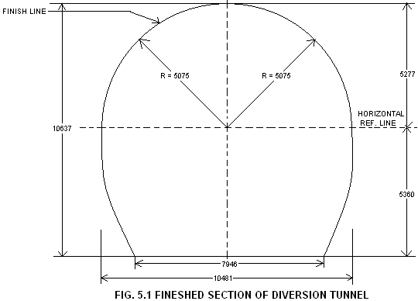

5.4 DESIGN OF STEEL RIBS FOR POOR ROCK CONDITION
The 'Q' values of rock as computed from surface geological observations are expected to range from 3.4 to 10 representing fair to good rock conditions along the tunnels which indicate only systematic bolting and shotcrete supports in the diversion tunnels. However, assuming that some 10 percent of the lengths of tunnels may be encountered with poor rock condition and may need steel rib supports.

5.4.1 Rock Load for Design of Steel Ribs
The rock loads for design of steel rib supports have been adopted according to the following stipulations based on various practices.
a) Rock loads according to the provisions of clause B-3.1.1 of IS:4880 (Part IV), “Code of Practice for Design of Tunnels Conveying Water”,wich state that rock loads for rock cover less than or equal to 1.5 (B+H_{t}) may be taken equal to depth of actual rock cover where B is the width and H_{t} is the height of the tunnel opening.
Thus, the maximum rock load intensity = 2.7×1.5× (12+12)
= 97.2 T/m²
This provision does not take into account the quality of actual rock mass encountered. This approach generally leads to excessive rock loads in case of good rock like phyllitic quartzite existing at the outlet of Diversion Tunnels.
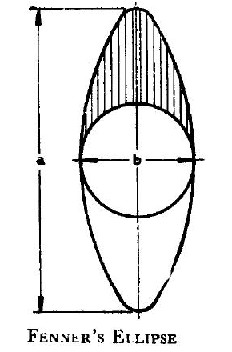
b) Rock loads according to the provisions of clause B-3.1.2 of IS:4880 (Part IV), which state that rock loads can also be worked out using Fenner's ellipse by the following equation:
a = (m-2) x b/2
Where, a = Main Axis of the ellipse of rock load,
b = Excavated tunnel diameter,
m = Inverse of Poisson's Ratio of rock mass

Here, Tunnel dia (Excavated) b = 12 m
Poisson’s ratio = 0.20
m = $\frac{1}{0\text{.}2}$ = 5
CORRECT a = $\frac{\text{12}∗(5−2)}{2}$ = 18 m
Total weight of rock mass within ellipse is given by
W = r .π (ab-b²)/8
Where, r = unit weight of rock mass
Total weight of rock = 2.7 × [π (12 × (18 - 12)]/8 = 76.34 T/m
Rock load Intensity = 76.34/12 = 6.36 T/m²
This method also neither accounts for type of rocks nor the actual rock cover available.
c) According to the provisions of Clause B-3.1.3 of IS: 4880 (Part IV) using Russian Practice
According to this, the rock loads may be taken as that for rock area enclosed by a parabola starting from intersection points of the rupture planes with horizontal length drawn to the crown of the tunnel section. The dimensions of the parabola are given by the following equation:
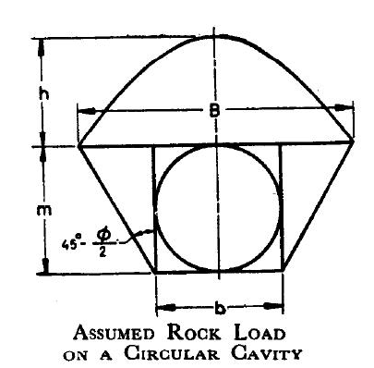
Height of parabola, $h=\frac{B}{2f}$
Where,
B = Base width of parabola
= b + 2m Tan {45-ф/2)
b = width of the tunnel
m = height of the tunnel
ф = angle of friction of rock mass
f = strength factor of rock mass
Here,
b = 12m
m = 12m
Ф = 25 º (assumed)
f = 8 (for weathered granite)
Unit weight of rock mass r = 2.7 T/m²
B = 12 + 2 × 12 Tan (45 – 25/2)
= 27.29 m
H = $\frac{\text{27}\text{.}\text{29}}{2∗8}$ = 1.71 m CORRECT
Therefore, maximum rock load intensity = 2.7 × 2 × 1.71
= 9.23 T/m²
d) ‘Proctor and White’ in their book, “Rock Tunnelling with steel supports” for moderately jointed and seamy rock mass, have recommended the rock load intensity for covers of more than 1.5 times (width+depth) of the excavation as varying from 0.25 to 0.35 ×(width+height). Adopting 0.3× (Width + Height), the mean value of the range,
Rock load intensity = 2.7 × 0.3 × (12+12)
= 19.44 T/m²
Say 20 T/m²
These are all experience based provisions and at best, they can be taken as a guide/tool to assist in arriving at a rational and acceptable judgmental figure for rock loads.
In view of the type of rock mass encountered being massive quartzitic rocks around the Diversion Tunnels, the design rock load of 20 T/m² has been considered in the design. There should, however, be no rigidity about the supports thus calculated. They may be modified according to rock response at site during construction.
Thus, a rock load of 20 T/m² is considered for rib design for poor reaches. For assumed 450 mm spacing of ribs,
Load intensity = 20 * 0.45
= 9 T/m

5.4.2 Design Parameters
Following parameters have taken in design of ribs:
Young’s modulus of Rock (Er) = 8 x 10⁶ kN/m²
Poisson’s ratio of rock (μ_{r}) = 0.2
Radius of rib = 5.075m
α = $\frac{\text{180}°}{\text{12}}=\text{15}°$
[Assuming 12 segments of a rib, each segment (b) =1.328m]
Radial spring stiffness (k_{r}) $=\left[\frac{E_{r}∗b∗α(\text{rad})}{1+μ_{r}}\right]=\left[\frac{8∗{\text{10}}^{6}∗1\text{.}\text{328}∗\text{15}∗(π/{\text{180}})}{1+0\text{.}2}\right]$

=2316622.22 KN/m CORRECT

Radial spring stiffness (k_{r}) =$\frac{A∗E_{r}}{L}$ CORRECT
Where, A = Area of spring
And L = Length of spring = 1 m (assumed)

Thus $A=\frac{L∗k_{r}}{E_{r}}=\frac{1∗\text{2316622}\text{.}\text{22}}{8∗{\text{10}}^{6}}=0\text{.}\text{289}m^{2}$ CORRECT

Each side of spring element of assumed square cross-section
= $\sqrt{0\text{.}\text{289}}=0\text{.}\text{537}m$

5.4.3 Analysis and Design of Ribs by Using STAAD.Pro
Assuming ISHB 150 @ 34.6 Kg/m with 200 mm wide x 10 mm thick @450 c/c the analysis and design of ribs have been performed using STAAD-Pro Software.
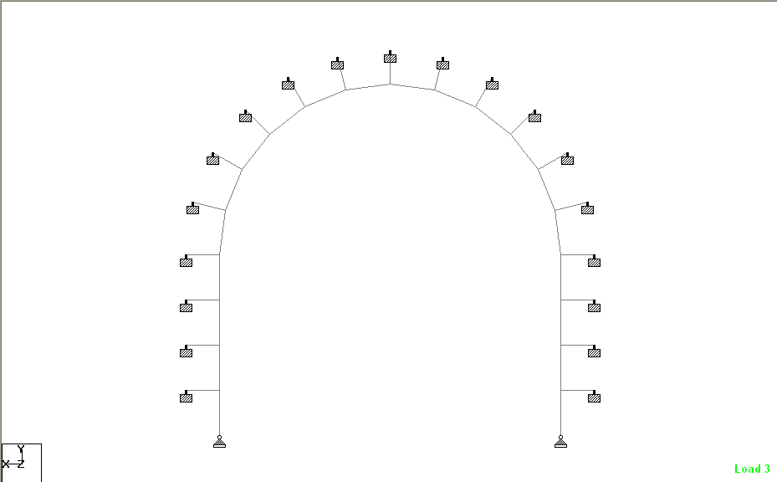
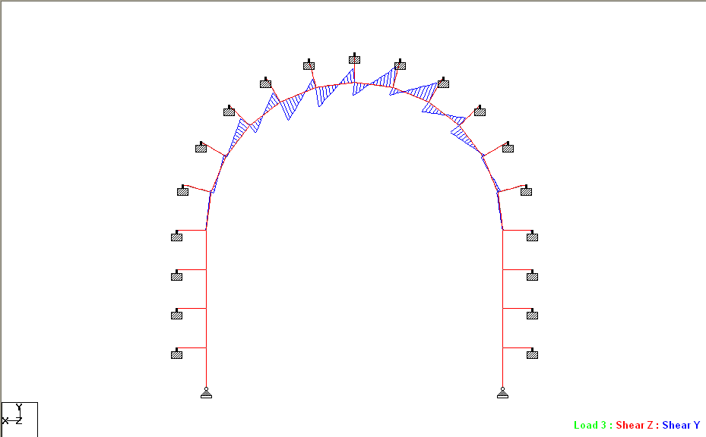
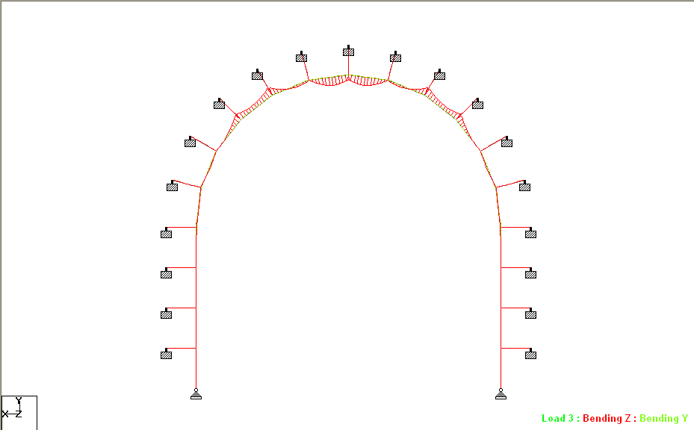
The blocking points to ribs are provided at 15° in the circular portion, and at every one fourth of vertical height in the sides. The modeling details including node and member numbers and results of analysis are shown in Annexure 5.1 and the model with Shear Force and Bending Moment diagram is shown below in Fig. no. 5.2.

FIG. 5.2 MODEL WITH S.F.D. AND B.M.D

5.5. DESIGN OF PERMANENT SUPPORTS FOR THE TUNNELS FOR FAIR TO GOOD ROCK REACHES
The rock mass to be encountered in the access tunnel is thick grey quartzite/ phyllitic-quartzite. The permanent supports will be provided in the form of rockbolts and shotcrete as per standard modern practice. The spacing, number and length of rockbolts depends upon rock mass quality encountered. As the excavation proceeds, the quality, of the rock in terms of Q values will be assessed at site in consultation with the field geologists and the supports shall be provided as per recommendations of Grimstad and Barton.
Accordingly, the following support system is proposed to be adopted. There should, however, be no rigidity about the proposed support system, which may be modified according to rock response at site during construction in consultation with the field geologists:

SL No. | 'Q' Value | Shotcrete (mm) | Rock Bolts
1. | More than 40 | 50 mm thick shotcrete without reinforcement | Spot bolting 25mm dia (Fe 415), 4000 mm long as required.
2. | 40 - 10 | 50 mm thick shotcrete without reinforcement | 25 mm dia (Fe 415) untensioned grouted rock bolts 4000 mm deep@ 2000 c/c both ways(staggered).
3. | 10 – 4 | 100 mm thick shotcrete welded mesh | 25 mm dia (Fe 415) tensioned grouted rock with bolts 4000 mm deep @ 2000 c/c both ways (staggered).
4. | 4 – 1 | 125 mm thick shotcrete with welded mesh | 25 mm dia tensioned and grouted rock bolts 4000 mm long @ 1500 c/c both ways (staggered).
5. | 1 – 0.1 | 150 mm thick shotcrete with welded mesh | 25 mm dia (Fe 415) tensioned grouted rock bolts 4000 mm deep @ 1250 c/c both ways.
6. | Less then 0.1 | 50mm thick shotcrete and ISHB 200 @ 40 kg/m steel ribs @ 400 mm to 600 mm c/c with blocking concrete.

5.6. ANALYSIS FOR STRESSES IN ROCK AFTER EXCAVATION
FEM analysis of diversion tunnels has been carried out using software 'PHASES'. For the linear analysis, the finite element model is formulated as two dimensional, plane strain problem since the tunnel cavities are long compared to their other two dimensions,
The two diversion tunnels are parallel to each other and centre to centre spacing is 60m. The clear rock mass between the two tunnel cavities is, thus, 48 m which is 4 times the size of each cavity. As such influence zones of excavations of either tunnel have negligible interference with each other and can be analyzed separately. Accordingly only one tunnel having greater rock cover has been analyzed.
The finite element analysis is carried out for the determination of the state of stress around this cavity without supporting system and with supporting system with the following objectives:
a) To determine the distribution and magnitude of critical stresses around the cavity.
b) To plot the major and minor principal stresses to understand the overall behaviour of the rock mass under given in-situ stress condition.
c) To check the deformation pattern around cavity by plotting displacement contours.

5.6.1. The assumptions made in the analysis are indicated herein below.
a) The load deformation relationship is assumed to be linear and the parameters viz modulus of elasticity, shear modulus and poisson's ratio remain constant.
b) Two stages of excavation have been considered in the analysis
Stage I - Heading Excavation
Stage II - Benching excavation
(Two alternatives have been considered in benching excavation viz with and without rock bolts installed in heading portion).
Load split for stage I and stage II have been assumed to be 0.35 and 0.65 respectively.
5.6.2. Insitu Stresses and Material Properties of Rock
a) Insitu Stresses
Over-burden (m) | Vertical  Stress  σ_{v}  (MPa) | Ratio  k = σ_{h /} σ_{v}  (Assumed) | Maximum Horizontal Stress  σ_{h}  (MPa)
200 | 5.4 | 0.5 | 2.7

b) Rock properties
i) Density of overburden = 2.7 t/m³ = 0.027 Mpa
ii) Ground surface elevation = 200m above the tunnel
iii) Name of Material = Quartzite with slate
iv) Material type = Isotropic
v) Poisson’s ratio (μ) = 0.2 (assumed)
vi) Uniaxial compressive strength of rock (σ_{c}) = 100 MPa
vii) Modulus of elasticity of surrounding rock (E)
The analysis has been performed adopting the maximum and minimum values of deformability modulus as given below.
Maximum value of deformability modulus E = 13000 MPa
Minimum value of deformability modulus E = 6360 MPa
Values of deformability modulus have been used in place of modulus of elasticity in analysis to account for the heterogeneous character of rock.
Vii) Failure criterion = Hoek – brown

5.6.3. Idealisation of Structure
Diversion Tunnel is long as compared to its other two dimensions. Hence, a two dimensional analysis of a body of rock with its plane perpendicular to the main axis of cavity is considered as representative of important stress and deformation pattern to be examined. For the above purpose finite element model was prepared.
The rock immediately surrounding the excavation is modeled using 3-noded triangular elements which allow complex material behaviour to be analysed. The finite element discretization adopted is shown in Annexure 5.2.1. The total number of finite elements is 1600 while number of boundary elements is 44.
The finite element mesh for model has been generated keeping a fair balance between economy and accuracy. For this purpose, 3 noded triangular, 2D solid iso-parametric elements are chosen for idealization of model. Care is taken to have small dimension elements near the boundary of the cavity where stress concentration is expected. The rock-bolts have been provided on the side walls and roof of the cavity with following details:
Dia of Rock bolt = 25 mm (assumed)
Elasticity of steel = 200000 N/mm²
Spacing = 2 m C/C (assumed)

5.6.4. Computer Program and Analysis Philosophy
The computer program, called "PHASES" used for the analysis is a standard two-dimensional finite-element/boundary element program for calculating stresses and estimating support requirement around underground excavations. It uses the three-noded / six-noded triangular-plain strain element in two dimensions. It has been used for the analysis of several underground caverns and has given reasonably good results.
The main feature of this software is that, it performs hybrid finite analysis in which the outer boundary of the finite element mesh becomes coupled to a geometrically coincident boundary element mesh. The purpose of this coupling is to model the infinite extents of typical geotechnical problems properly.
The 2-dimensional computer analysis for the finite element model has been carried out as a plane strain problem. The unit thickness of the rock mass is considered along the main axis of Diversion Tunnel.
The computer output gives major and minor principal stresses, and deflections at every point of the finite element mesh.

5.6.5. Results and Discussions for Excavation of Cavity (Heading Excavation)
(E = 13000 MPa)
The major and minor principal stresses obtained from FEM Analysis of model are graphically represented in Annexure 5.2.2 and 5.2.3 and displacements are given in Annexure. 5.2.4.
- Major Principal Stresses (Annexure. 5.2.2)
The maximum compressive stresses of 1.5 MPa develop near the crown of the cavity, which increases upto 7.5 MPa on side walls near springing level.
- Minor Principal Stresses (Annexure. 5.2.3)
From Annexure. 5.2.3, it can be seen that tension of the order of 1.2 MPa occurs near the bottom of the cavity. Sides starting from very near to crown develop a tension of 0.03 to 0.42.
- Displacements (Annexure. 5.2.4)
The maximum displacements occur near crown portion (2.8 mm).

5.6.6. Results and Discussions for Excavation of Cavity (Benching Excavation)
(E = 13000 MPa)
The major and minor principal stresses obtained from FEM analysis of Model are graphically represented in Annexure 5.2.5 and 5.2.6 respectively and displacements in Annexure. 5.2.7.
- Major Principal Stresses (Annexure. 5.2.5)
The maximum compressive stresses developing at the sides of the cavity are 10 to 12.5 MPa which reduce to zero at crown and increase upto 15 MPa near corner junction with invert.
- Minor Principal Stresses (Annexure. 5.2.6)
From Annexure. 5.2.6, it can be seen that no tension develops anywhere around the tunnel.
However, the crown and bottom portion are under a small compressive stress of 0 to 1 MPa.
- Displacements (Annexure. 5.2.7)
The maximum displacement of 4.4 mm occurs at the crown of the Cavity.

5.6.7. Results and Discussions for Excavation of Cavity (Benching Excavation with heading portion provided with rock bolts)
(E = 13000 MPa)
The major and minor principal stresses obtained from FEM analysis of Model are graphically represented in Annexure 5.2.8 and 5.2.9, respectively and displacements in Annexure. 5.2.10
- Major Principal Stresses (Annexure. 5.2.8)
The maximum compressive stresses developing at the side of the cavity are 10 to 12.5 MPa which reduce to 0 at crown and increase upto 15 MPa near corner junction with invert.
- Major Principal Stresses (Annexure. 5.2.9)
From Annexure. 5.2.9, it can be seen that no tension develops anywhere around the tunnel.
However, the crown and bottom portion develop small compressive stresses of 0 to 1 MPa.
- Displacements (Annexure. 5.2.10)
The maximum displacements in crown portion of the cavity vary from 3.3 to 3.9 mm while maximum displacement occurs at invert which is equal to 4.4 mm.

5.6.8. Results for Minimum Value of Elasticity
(E = 6360 MPa)
The studies have also been conducted for minimum value of E i.e. 6360 MPa. The results are depicted in Annexure 5.2.11 through 5.2.16 for heading and benching. On comparing these results with the results for E = 13000 MPa, it is seen that pattern and values of stresses remain same. However, the displacement values are proportionately higher being 9 mm at invert and crown both as against 4.4mm obtained for higher value of E. As such depending on rock response at site, the spacing of rock bolts may be decreased to limit the displacements.

5.6.9. Conclusions
The maximum compressive stress of the order of 12.5 MPa develop near sides of the tunnel and 15 MPa near corner develop. These are well below the compressive strength of the rock (100 MPa). However, the development of tension and displacements obtained at sides and crown of the cavity, immediately after excavation need to be taken care of by provision of shotcrete with wire mesh, soon after the excavation.
PAGE NO. 1

****************************************************
* *
* STAAD.Pro *
* Version 2003 Bld 1001.US *
* Proprietary Program of *
* Research Engineers, Intl. *
* Date= JUL 5, 2006 *
* Time= 23:13:57 *
* *
* USER ID: *
****************************************************

1. STAAD PLANE
2. START JOB INFORMATION
3. ENGINEER DATE 05-JUL-06
4. END JOB INFORMATION
5. INPUT WIDTH 79
6. SET NL 2
7. UNIT METER MTON
8. JOINT COORDINATES
9. 1 0 0 0; 2 10.15 0 0; 3 0 1.34 0; 4 0 2.68 0; 5 0 4.02 0; 6 0 5.36 0
10. 7 0.17293 6.6735 0; 8 0.67992 7.8975 0; 9 1.48643 8.94857 0
11. 10 2.5375 9.75509 0; 11 3.7615 10.2621 0; 12 5.075 10.435 0
12. 13 6.3885 10.2621 0; 14 7.6125 9.75509 0; 15 8.66357 8.94857 0
13. 16 9.47008 7.8975 0; 17 9.97707 6.6735 0; 18 10.15 5.36 0; 19 10.15 4.02 0
14. 20 10.15 2.68 0; 21 10.15 1.34 0; 22 -1 1.34 0; 23 -1 2.68 0; 24 -1 4.02 0
15. 25 -1 5.36 0; 26 -0.793 6.9323 0; 27 -0.1861 8.3975 0; 28 0.77933 9.65567 0
16. 29 2.0375 10.6211 0; 30 3.5027 11.228 0; 31 5.075 11.435 0
17. 32 6.6437 11.228 0; 33 8.1125 10.6211 0; 34 9.37067 9.65567 0
18. 35 10.3361 8.3975 0; 36 10.943 6.9323 0; 37 11.15 5.36 0; 38 11.15 4.02 0
19. 39 11.15 2.68 0; 40 11.15 1.34 0
20. MEMBER INCIDENCES
21. 1 1 3; 2 3 4; 3 4 5; 4 5 6; 5 6 7; 6 7 8; 7 8 9; 8 9 10; 9 10 11; 10 11 12
22. 11 12 13; 12 13 14; 13 14 15; 14 15 16; 15 16 17; 16 17 18; 17 18 19
23. 18 19 20; 19 20 21; 20 21 2; 21 3 22; 22 4 23; 23 5 24; 24 6 25; 25 7 26
24. 26 8 27; 27 9 28; 28 10 29; 29 11 30; 30 12 31; 31 13 32; 32 14 33
25. 33 15 34; 34 16 35; 35 17 36; 36 18 37; 37 19 38; 38 20 39; 39 21 40
26. *STEEL
27. DEFINE MATERIAL START
28. ISOTROPIC MATERIAL1
29. E 2.09042E+007
30. POISSON 0.3
31. DENSITY 7.85181
32. *ROCKS
33. ISOTROPIC MATERIAL2
34. E 800000
35. POISSON 0.2
36. DENSITY 2.7
37. END DEFINE MATERIAL
38. CONSTANTS
39. MATERIAL MATERIAL1 MEMB 1 TO 20
40. MATERIAL MATERIAL2 MEMB 21 TO 39
41. MEMBER PROPERTY INDIAN
STAAD PLANE -- PAGE NO. 2

42. 21 TO 39 PRIS YD 0.537 ZD 0.537
43. 1 TO 20 TABLE TB ISHB150B WP 0.2 TH 0.01
44. MEMBER COMPRESSION
45. 21 TO 39
46. SUPPORTS
47. 22 TO 40 FIXED
48. 1 2 PINNED
49. LOAD 1
50. SELFWEIGHT Y -1
51. PERFORM ANALYSIS

P R O B L E M S T A T I S T I C S
-----------------------------------

NUMBER OF JOINTS/MEMBER+ELEMENTS/SUPPORTS = 40/ 39/ 21
ORIGINAL/FINAL BAND-WIDTH= 19/ 2/ 6 DOF
TOTAL PRIMARY LOAD CASES = 1, TOTAL DEGREES OF FREEDOM = 59
SIZE OF STIFFNESS MATRIX = 1 DOUBLE KILO-WORDS
REQRD/AVAIL. DISK SPACE = 12.1/ 1588.9 MB, EXMEM = 755.5 MB

**START ITERATION NO. 2
**START ITERATION NO. 3
**START ITERATION NO. 4

**NOTE-Tension/Compression converged after 4 iterations, Case= 1

52. CHANGE
53. MEMBER COMPRESSION
54. 21 TO 39
55. LOAD 2
56. MEMBER LOAD
57. *SPACING 450MM C/C (20*0.45=9T/M)
58. 5 TO 16 UNI PY -9
59. PERFORM ANALYSIS
**START ITERATION NO. 2
**START ITERATION NO. 3
**START ITERATION NO. 4
**START ITERATION NO. 5
**START ITERATION NO. 6
**START ITERATION NO. 7

**NOTE-Tension/Compression converged after 7 iterations, Case= 2

60. CHANGE
61. MEMBER COMPRESSION

STAAD PLANE -- PAGE NO. 3

62. 21 TO 39
63. LOAD COMBINATION 3
64. 1 1.0 2 1.0
65. PERFORM ANALYSIS
66. CHANGE
67. MEMBER COMPRESSION
68. 21 TO 39
69. LOAD LIST 3
70. PRINT MEMBER FORCES ALL

MEMBER END FORCES STRUCTURE TYPE = PLANE
-----------------
ALL UNITS ARE -- MTON METE

MEMBER LOAD JT AXIAL SHEAR-Y SHEAR-Z TORSION MOM-Y MOM-Z

1 3 1 64.71 0.03 0.00 0.00 0.00 0.00
3 -64.62 -0.03 0.00 0.00 0.00 0.04

2 3 3 64.24 0.03 0.00 0.00 0.00 -0.04
4 -64.15 -0.03 0.00 0.00 0.00 0.09

3 3 4 63.76 0.03 0.00 0.00 0.00 -0.09
5 -63.67 -0.03 0.00 0.00 0.00 0.13

4 3 5 63.28 0.03 0.00 0.00 0.00 -0.13
6 -63.19 -0.03 0.00 0.00 0.00 0.17

5 3 6 63.36 -0.12 0.00 0.00 0.00 -0.17
7 -61.73 0.33 0.00 0.00 0.00 -0.13

6 3 7 61.26 1.01 0.00 0.00 0.00 0.13
8 -56.97 0.77 0.00 0.00 0.00 0.03

7 3 8 56.66 0.51 0.00 0.00 0.00 -0.03
9 -50.83 3.97 0.00 0.00 0.00 -2.26

8 3 9 50.63 3.42 0.00 0.00 0.00 2.26
10 -44.81 4.15 0.00 0.00 0.00 -2.75

9 3 10 44.21 7.23 0.00 0.00 0.00 2.75
11 -39.97 3.03 0.00 0.00 0.00 0.03

10 3 11 39.34 7.03 0.00 0.00 0.00 -0.03
12 -37.78 4.78 0.00 0.00 0.00 1.52

11 3 12 37.78 4.78 0.00 0.00 0.00 -1.52
13 -39.34 7.03 0.00 0.00 0.00 0.03

12 3 13 39.96 3.03 0.00 0.00 0.00 -0.03
14 -44.21 7.23 0.00 0.00 0.00 -2.75

STAAD PLANE -- PAGE NO. 4

MEMBER END FORCES STRUCTURE TYPE = PLANE
-----------------
ALL UNITS ARE -- MTON METE

MEMBER LOAD JT AXIAL SHEAR-Y SHEAR-Z TORSION MOM-Y MOM-Z

13 3 14 44.81 4.15 0.00 0.00 0.00 2.75
15 -50.63 3.42 0.00 0.00 0.00 -2.26

14 3 15 50.83 3.97 0.00 0.00 0.00 2.26
16 -56.66 0.51 0.00 0.00 0.00 0.03

15 3 16 56.97 0.77 0.00 0.00 0.00 -0.03
17 -61.26 1.01 0.00 0.00 0.00 -0.13

16 3 17 61.73 0.33 0.00 0.00 0.00 0.13
18 -63.36 -0.12 0.00 0.00 0.00 0.17

17 3 18 63.19 -0.03 0.00 0.00 0.00 -0.17
19 -63.28 0.03 0.00 0.00 0.00 0.13

18 3 19 63.67 -0.03 0.00 0.00 0.00 -0.13
20 -63.76 0.03 0.00 0.00 0.00 0.09

19 3 20 64.15 -0.03 0.00 0.00 0.00 -0.09
21 -64.24 0.03 0.00 0.00 0.00 0.04

20 3 21 64.62 -0.03 0.00 0.00 0.00 -0.04
2 -64.71 0.03 0.00 0.00 0.00 0.00

21 3 3 0.00 0.00 0.00 0.00 0.00 0.00
22 0.00 0.00 0.00 0.00 0.00 0.00

22 3 4 0.00 0.00 0.00 0.00 0.00 0.00
23 0.00 0.00 0.00 0.00 0.00 0.00

23 3 5 0.00 0.00 0.00 0.00 0.00 0.00
24 0.00 0.00 0.00 0.00 0.00 0.00

24 3 6 8.42 0.39 0.00 0.00 0.00 0.00
25 -8.42 0.39 0.00 0.00 0.00 0.00

25 3 7 14.72 0.38 0.00 0.00 0.00 0.00
26 -14.52 0.38 0.00 0.00 0.00 0.00

26 3 8 13.57 0.34 0.00 0.00 0.00 0.00
27 -13.18 0.34 0.00 0.00 0.00 0.00

27 3 9 5.92 0.28 0.00 0.00 0.00 0.00
28 -5.37 0.28 0.00 0.00 0.00 0.00

28 3 10 0.00 0.00 0.00 0.00 0.00 0.00
29 0.00 0.00 0.00 0.00 0.00 0.00

STAAD PLANE -- PAGE NO. 5

MEMBER END FORCES STRUCTURE TYPE = PLANE
-----------------
ALL UNITS ARE -- MTON METE

MEMBER LOAD JT AXIAL SHEAR-Y SHEAR-Z TORSION MOM-Y MOM-Z

29 3 11 0.00 0.00 0.00 0.00 0.00 0.00
30 0.00 0.00 0.00 0.00 0.00 0.00

30 3 12 0.00 0.00 0.00 0.00 0.00 0.00
31 0.00 0.00 0.00 0.00 0.00 0.00

31 3 13 0.00 0.00 0.00 0.00 0.00 0.00
32 0.00 0.00 0.00 0.00 0.00 0.00

32 3 14 0.00 0.00 0.00 0.00 0.00 0.00
33 0.00 0.00 0.00 0.00 0.00 0.00

33 3 15 5.92 0.28 0.00 0.00 0.00 0.00
34 -5.37 0.28 0.00 0.00 0.00 0.00

34 3 16 13.57 0.34 0.00 0.00 0.00 0.00
35 -13.18 0.34 0.00 0.00 0.00 0.00

35 3 17 14.72 0.38 0.00 0.00 0.00 0.00
36 -14.52 0.38 0.00 0.00 0.00 0.00

36 3 18 8.42 0.39 0.00 0.00 0.00 0.00
37 -8.42 0.39 0.00 0.00 0.00 0.00

37 3 19 0.00 0.00 0.00 0.00 0.00 0.00
38 0.00 0.00 0.00 0.00 0.00 0.00

38 3 20 0.00 0.00 0.00 0.00 0.00 0.00
39 0.00 0.00 0.00 0.00 0.00 0.00

39 3 21 0.00 0.00 0.00 0.00 0.00 0.00
40 0.00 0.00 0.00 0.00 0.00 0.00

************** END OF LATEST ANALYSIS RESULT **************

71. CHECK CODE MEMB 1 TO 20
STAAD PLANE -- PAGE NO. 6

STAAD.Pro CODE CHECKING - (ISA )
***********************

ALL UNITS ARE - MTON METE (UNLESS OTHERWISE NOTED)

MEMBER TABLE RESULT/ CRITICAL COND/ RATIO/ LOADING/
FX MY MZ LOCATION
=======================================================================

1 TB ISHB150B PASS IS-7.1.1(A) 0.522 3
64.62 C 0.00 -0.04 1.34
2 TB ISHB150B PASS IS-7.1.1(A) 0.523 3
64.15 C 0.00 -0.09 1.34
3 TB ISHB150B PASS IS-7.1.1(A) 0.524 3
63.67 C 0.00 -0.13 1.34
4 TB ISHB150B PASS IS-7.1.1(A) 0.525 3
63.19 C 0.00 -0.17 1.34
5 TB ISHB150B PASS IS-7.1.1(A) 0.526 3
63.36 C 0.00 -0.17 0.00
6 TB ISHB150B PASS IS-7.1.1(A) 0.504 3
61.26 C 0.00 0.13 0.00
7 TB ISHB150B PASS IS-7.1.1(B) 0.672 3
50.83 C 0.00 2.26 1.32
8 TB ISHB150B PASS IS-7.1.1(B) 0.685 3
44.81 C 0.00 2.75 1.32
9 TB ISHB150B PASS IS-7.1.1(B) 0.680 3
44.21 C 0.00 2.75 0.00
10 TB ISHB150B PASS IS-7.1.1(B) 0.642 3
38.43 C 0.00 -2.80 0.77
11 TB ISHB150B PASS IS-7.1.1(B) 0.642 3
38.43 C 0.00 -2.80 0.55
12 TB ISHB150B PASS IS-7.1.1(B) 0.680 3
44.21 C 0.00 2.75 1.32
13 TB ISHB150B PASS IS-7.1.1(B) 0.685 3
44.81 C 0.00 2.75 0.00
14 TB ISHB150B PASS IS-7.1.1(B) 0.672 3
50.83 C 0.00 2.26 0.00
15 TB ISHB150B PASS IS-7.1.1(A) 0.504 3
61.26 C 0.00 0.13 1.32
16 TB ISHB150B PASS IS-7.1.1(A) 0.526 3
63.36 C 0.00 -0.17 1.32
17 TB ISHB150B PASS IS-7.1.1(A) 0.525 3
63.19 C 0.00 -0.17 0.00
18 TB ISHB150B PASS IS-7.1.1(A) 0.524 3
63.67 C 0.00 -0.13 0.00
19 TB ISHB150B PASS IS-7.1.1(A) 0.523 3
64.15 C 0.00 -0.09 0.00
20 TB ISHB150B PASS IS-7.1.1(A) 0.522 3
64.62 C 0.00 -0.04 0.00

************** END OF TABULATED RESULT OF DESIGN **************
STAAD PLANE -- PAGE NO. 7

72. FINISH

*********** END OF THE STAAD.Pro RUN ***********

**** DATE= JUL 5,2006 TIME= 23:13:58 ****

************************************************************
* For questions on STAAD.Pro, please contact : *
* Research Engrs Pvt Ltd., email : support@reiworld.com *
* E2/4,Block GP, Sector-V,Salt Lake, CALCUTTA - 700 091 *
* India : TEL:(033)357-3575 FAX:(033)357-3467 *
* US : Ph-(714) 974-2500, Fax-(714) 921-0683 *
************************************************************

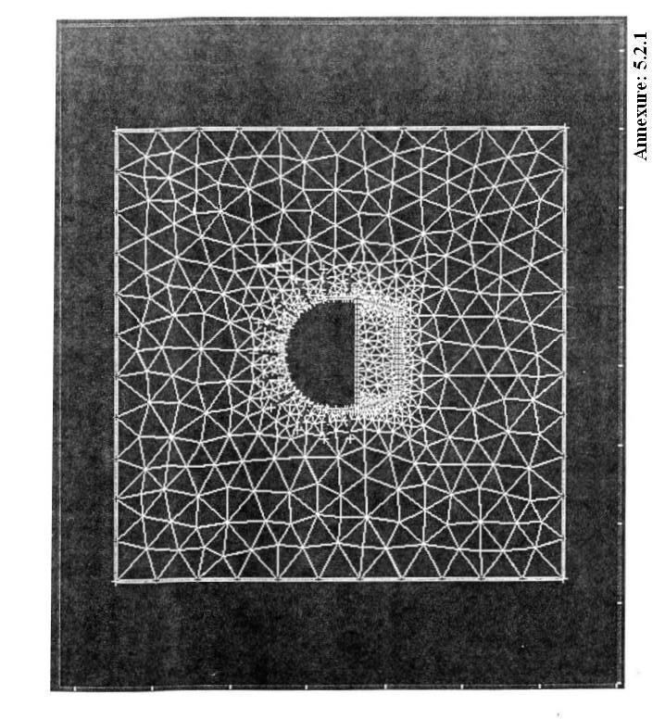

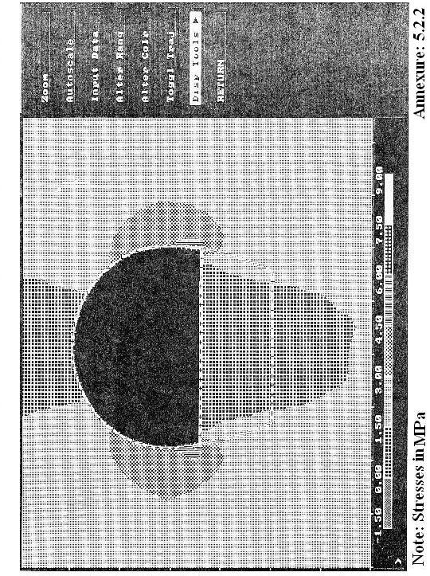
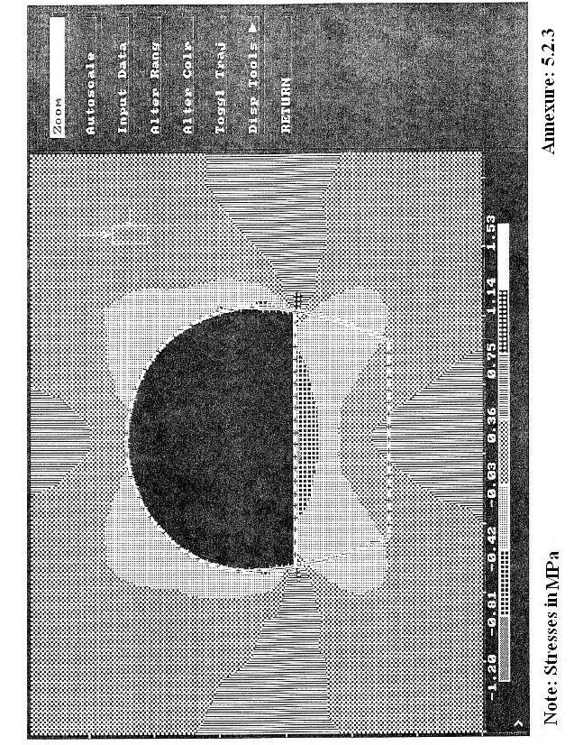
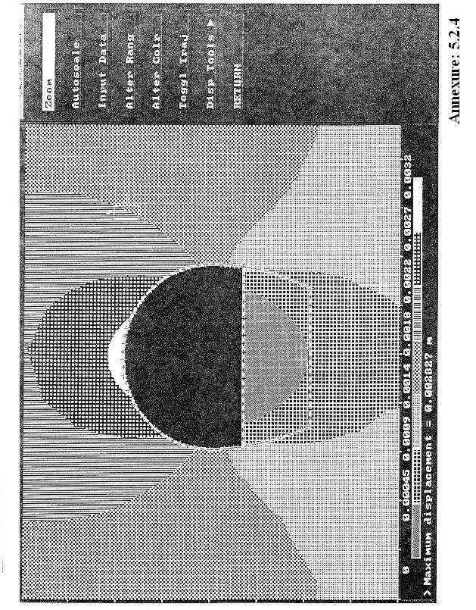
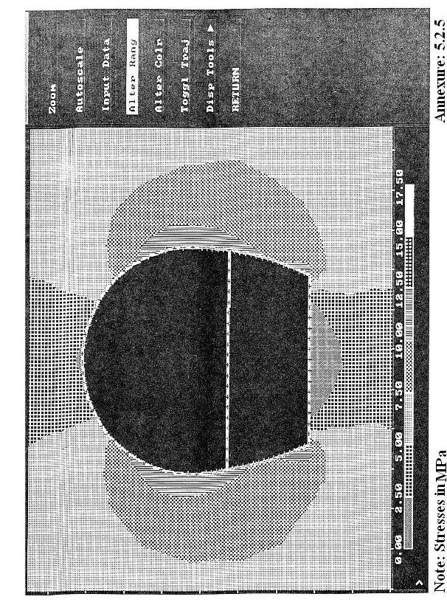
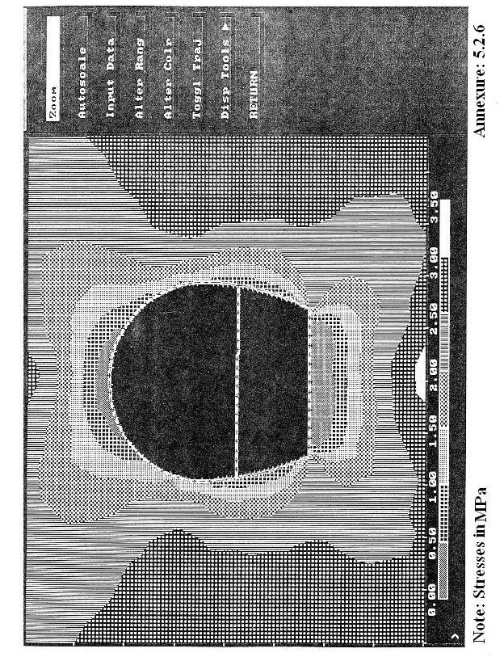
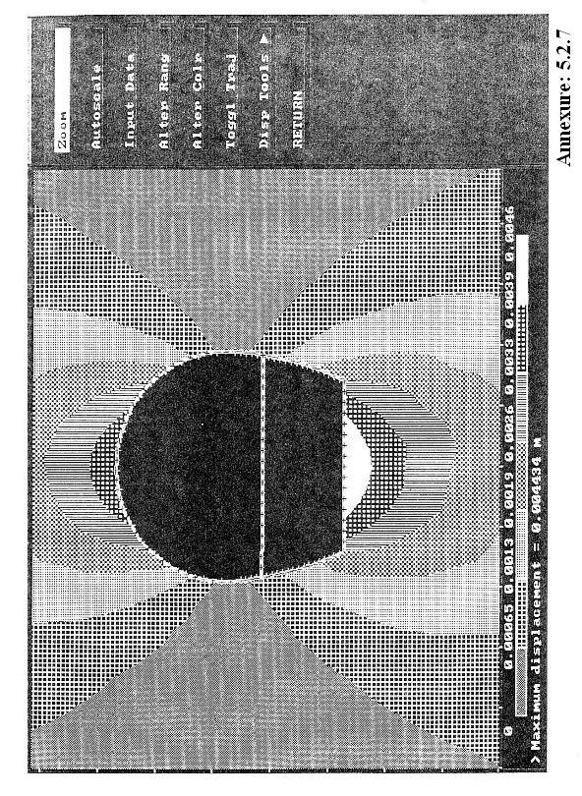
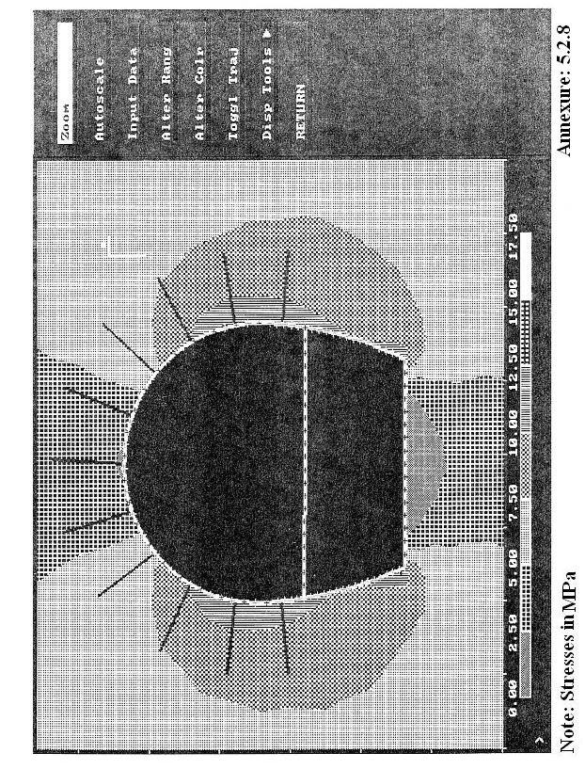
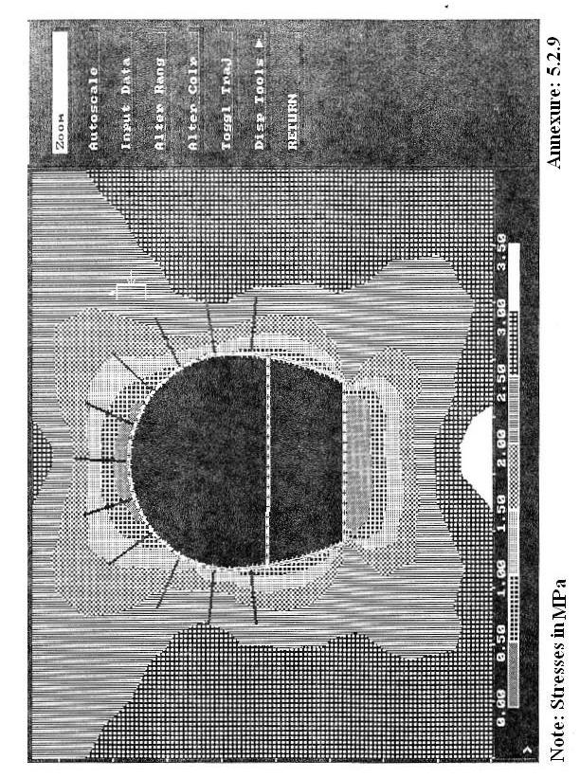
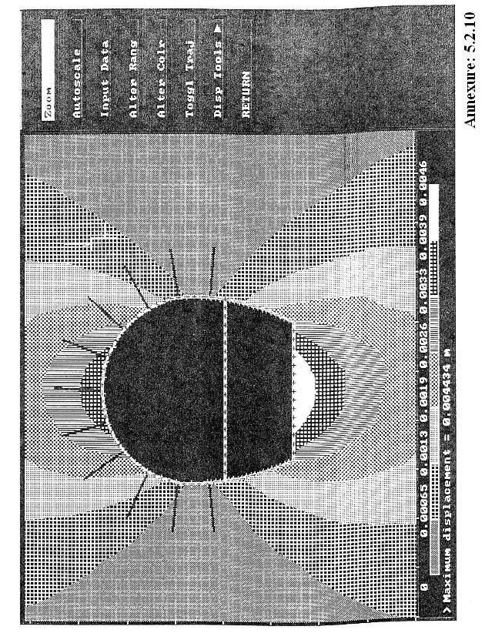
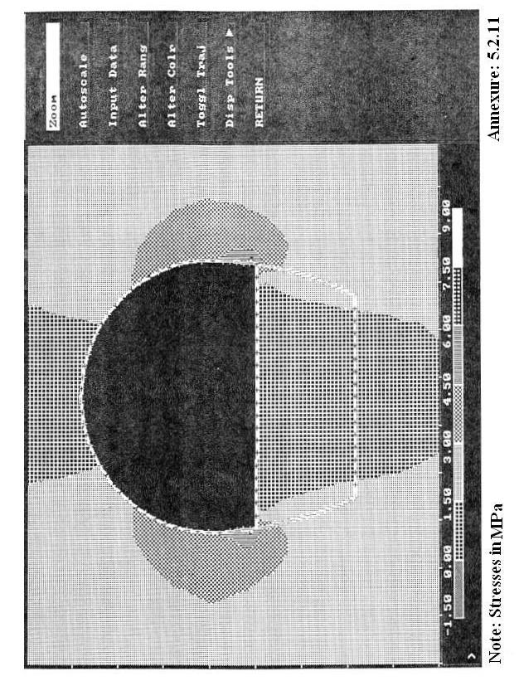
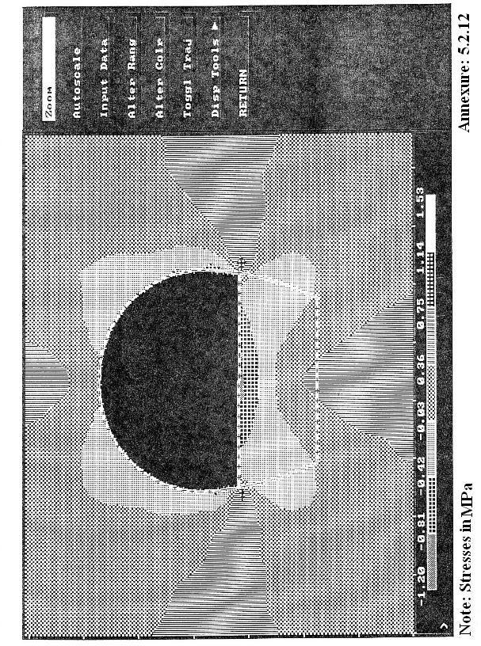
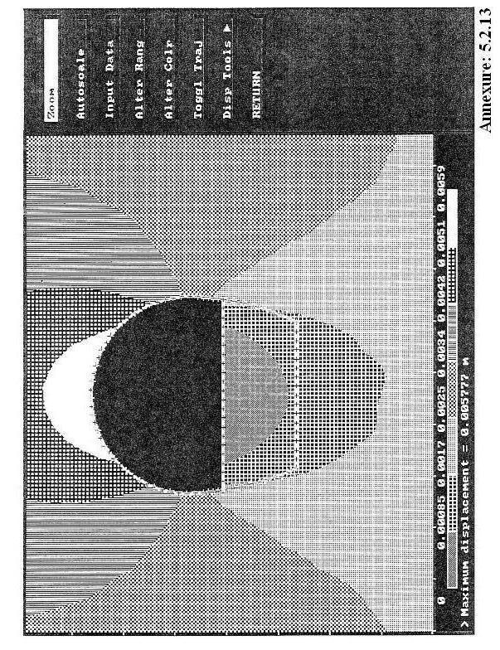
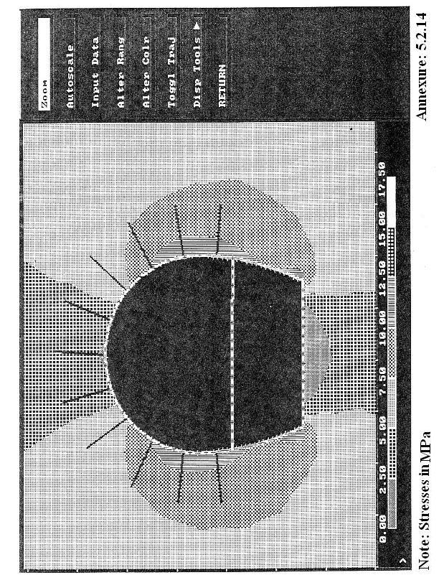
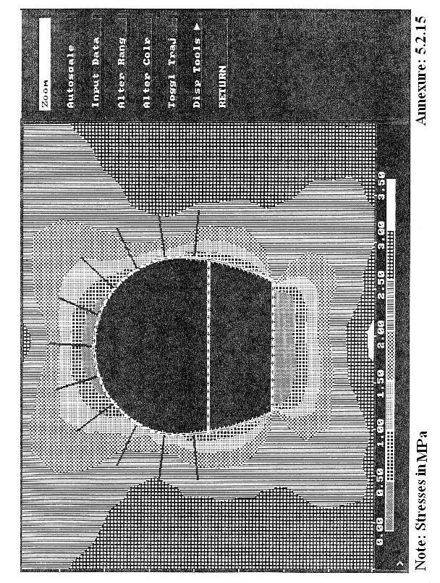
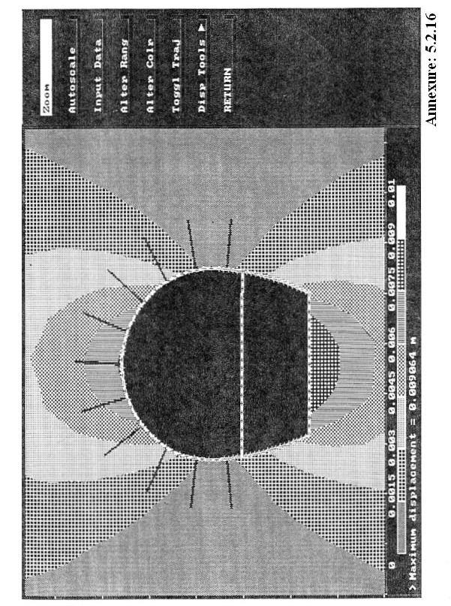

CONCLUSION

River diversion works are of considerable importance in the design of works in the bed of any river. The following important conclusions are drawn from this project through comparative study.

The earthquake case is not critical from the point of view of design of inlet structures, because it is seen that bending moments and shear forces due to earthquake are less than even 10% of those due to design external water pressure.

The analysis of induced stresses in rock mass after excavation is analyzed by “PHASES” software. The maximum compressive stress developed are of 12.5 Mpa, near the sides of tunnel and 15 Mpa near corner. These are well below the compressive strength of rock (100 Mpa). But the development of tension and displacements obtained immediately after excavation need to be taken care by shotcrete with wire mesh.

The studies have also been conducted for minimum value of E. On comparing these results with the result obtained with the higher value of E, it is seen that the pattern and values of stresses remain same. but the magnitude of displacement are proportionally higher being 9 mm at invert and crown both as against 4.4 mm obtained for higher value of E. Therefore depending on rock response at site, the spacing of rock bolts may be decreased to limit the displacement.

SCOPE FOR FUTURE WORK

There are certain things which will give more dimension and accuracy to this project which we can do in future. The following points could be added as the future work:-

- The analysis of structurally controlled instability could be carried out by using UNWEDGE software. The software allows wedges to be scaled down to more realistic sizes if it is considered that maximum wedges are unlikely to form.

- The three-dimensional boundary element programs,”EXIMINE and MAP” could be applied instead of PHASES program. Such three-dimensional analysis provides a clear indication of stress concentration and influence of the three dimensional geometry problems.

- The layout and hydraulic design of tunnel section could be carried out after the collection of relevant data.

- The lining of tunnel section could be design.

- The concrete plugs could be designed for the tunnel.

REFERENCES
- Bickel, O John., “Handbook on Tunnel Engineering”.
- Hoek. Event., “Support of Underground Excavation in Hard Rock”.
- Procter & White., “Rock Tunneling With Steel Support”.
- Sharma, R.K., “Water Power Engineering”.
- USBR Manual on “Design of Gravity Dams”.
- Garg, S.K., “Irrigation Engineering and Hydraulic Structure”.
- Indian Standard Code:10084 (Part-1)- 1982., “Criteria for Design of Diversion Works,- Coffer Dams”.
- Indian Standard Code: 9795 (Part-1)- 1981., “Guidelines for the Choice of the Type of Diversion Works”.
- Indian Standard Code: 5878 (Part-4)- 1971., “Code of Practice for Construction of Tunnels Conveying Water”.
- Indian Standard Code:4880 (Part-1)- 1987., “Code of Practice for Design of Tunnels Conveying Water,- General Design”.
- Indian Standard Code:4880 (Part-2)- 1987., “Code of Practice for Design of Tunnels Conveying Water,- Geometric Design”.
- Indian Standard Code:4880 (Part-4)- 1987., “Code of Practice for Design of Tunnels Conveying Water,- Structural Design of Concrete Lining in Rock”.
- Indian Standard Code:4880 (Part-6)- 1987., “Code of Practice for Design of Tunnels Conveying Water,- Tunnel Supports”.
- Indian Standard Code: 1893- 1984., “Criteria for earthquake Resistant Design of Structure”.
- Indian Standard Code: 875 (Part-3)- 1987., “Code of Practice for Design Loads (other than earthquake) for Building & Structure”.
- Indian Standard Code: 456- 2000., “Code of Practice for Plain and Reinforced Concrete”.
- Indian Standard Code: 800- 1987., “Code of Practice for General Construction in Steel”.

